SYSC 5104

Modeling Discrete-Event Systems Using DEVS

November 17, 2007

Assignment2: Persian Tapestry

Mohammad Moallemi

100744163

Carleton University

Table of Contents

1. Conceptual Model 4
2. Cell-DEVS Model 5
3. Formal Specifications 5
4. Implementation with CD++ 7
5. Simulation Results with CD++ Modeller 7
6. DEVS-View Implementation of the Model 15
7. References 21

Table of Figures

Figure 1. Tapestry architecture- initial state 4
Figure 2. Step 8 of tapestry with 64x64 dimensions and 4 ones in the center 8
Figure 3. Step 9 of tapestry with 64x64 dimensions and 4 ones in the center 8
Figure 4. Step 10 of tapestry with 64x64 dimensions and 4 ones in the center 9
Figure 5. Step 11 of tapestry with 64x64 dimensions and 4 ones in the center 9
Figure 6. Step 12 of tapestry with 64x64 dimensions and 4 ones in the center 10
Figure 7. Step 13 of tapestry with 64x64 dimensions and 4 ones in the center 10
Figure 8. Step 8 of tapestry with 64x64 dimensions and 16 ones in the center 11
Figure 9. Step 10 of tapestry with 64x64 dimensions and 16 ones in the center 11
Figure 10. Step 11 of tapestry with 64x64 dimensions and 16 ones in the center 12
Figure 11. Step 12 of tapestry with 64x64 dimensions and 16 ones in the center 12
Figure 12. Step 13 of tapestry with 64x64 dimensions and 16 ones in the center 13
Figure 13. Step 14 of tapestry with 64x64 dimensions and 16 ones in the center 13
Figure 14. Step 30 of tapestry with 64x64 dimensions, 4 ones in the center and wrapped borders 14
Figure 15. Step 31 of tapestry with 64x64 dimensions, 4 ones in the center and wrapped borders 14
Figure 16. Step 32 of tapestry with 64x64 dimensions, 4 ones in the center and wrapped borders 15
Figure 17. DEVS-View implementation of 16x16 tapestry step 1 16
Figure 18. DEVS-View implementation of 16x16 tapestry step 2 16
Figure 19. DEVS-View implementation of 16x16 tapestry step 3 17
Figure 20. DEVS-View implementation of 16x16 tapestry step 4 17
Figure 21. DEVS-View implementation of 64x64 tapestry step 6 18
Figure 22. DEVS-View implementation of 64x64 tapestry step 8 18
Figure 23. DEVS-View implementation of 64x64 tapestry step 9 19
Figure 24. DEVS-View implementation of 64x64 tapestry step 10 19
Figure 25. DEVS-View implementation of 64x64 tapestry step 10, a side view 20
Figure 26. DEVS-View implementation of 64x64 tapestry step 10, close side view from behind (rear plane in front) 20
Figure 27. DEVS-View implementation of 64x64 tapestry step 10, very close side view from behind (rear plane in front) 21

- Conceptual Model

Cellular automata can be used to model tapestries by implementing them as a 3-D cell space [1]. The tapestry is represented by three planes (tapestry plane, front plane and rear plane) each containing n by n cells. Initially all cells of front plane are set to zero except for m central cells, where m < n. Figure 1 represents the initial scenario of both front and rear planes.
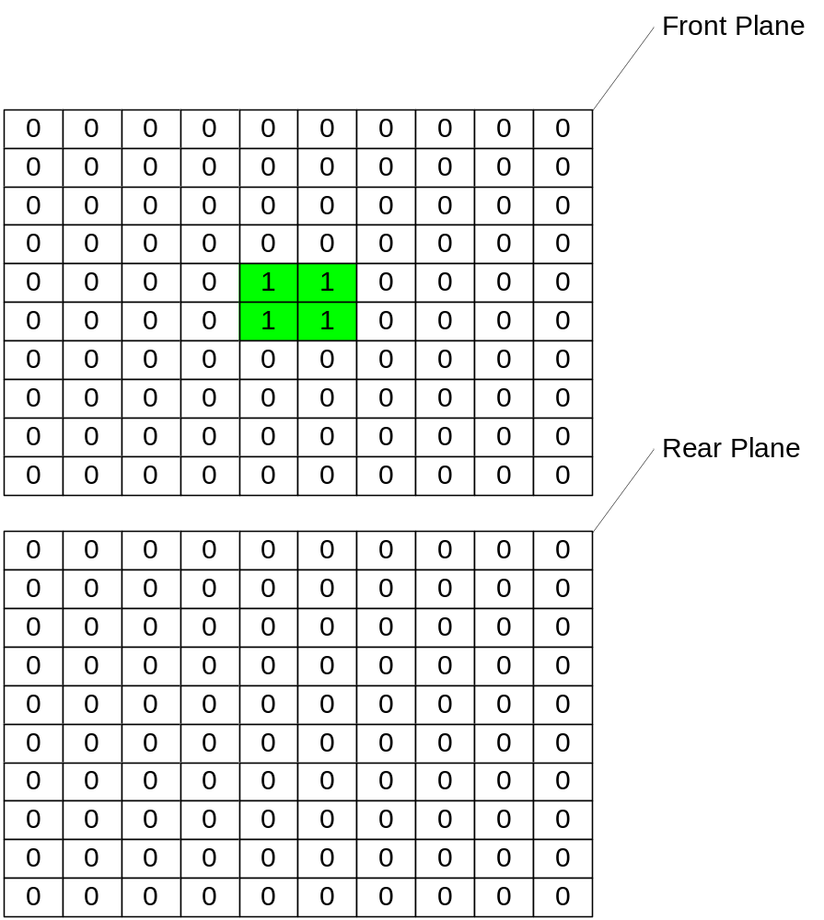
Figure 1. Tapestry architecture- initial state

Each cell in front plane has four neighbours: N, E, S, and W (Von Neumann neighbours) and also two corresponding cells from rear and tapestry plane. After initialization phase, each cell in front plane counts the number of cells in its neighbourhood whose value is 1. If the cell is surrounded by even number of alive (one) cells, the cell is set to 1, otherwise it is set to zero. On the other hand, the second plane (rear plane) works as a mentor and updates its cells accordingly by watching the state changes of the cells in front plane. Thus, rear plane takes on the old values form front plane right before changes occur to front plane’s cells. Meanwhile the third plane (tapestry plane) which represents the design of tapestry is made by getting four values 0, 1, 2 and three representing colors white, green, blue and red respectively. As simulations goes forwards deferent shapes of tapestry are made. The color scheme that is used in tapestry plane to differentiate cell state changes is as follows:
White: a zero in a cell of the front plane and a zero in the corresponding cell of the rear plane.
Green: a one in a cell of the front plane and a zero in the corresponding cell of the rear plane.
Blue: a zero in a cell of the front plane and a one in the corresponding cell of the rear plane.
Red: a one in a cell of the front plane and a one in the corresponding cell of the rear plane.
Different scenarios can be modeled by changing the dimensions and number of central cells which are first initialized to one. This will lead to different patterns of tapestry. e.g. 8 or 16 ones in the center, in the initial phase.

- Cell-DEVS Model
The Cell-DEVS model will be based on three, two-dimensional square grids. The grid dimensions are at first 64x64. As mentioned before the first plane (front plane) is responsible for changes in Von Neumann neighborhood with the rules that says if the cell has odd number of true neighbors changes its value to zero, and if it has even number of true neighbors in the same plane changes its value to one.
The second plane (rear plane) always copies the old values of on step behind the first plane. The third plane which is the tapestry plane makes the final shape of tapestry by taking four values corresponding to four states that might happen in two corresponding cells of first and second planes. This way, four colors are shown on the tapestry.

- Formal Specifications
The formal specification of a Cell-DEVS model for the following neighbor cells is given by
M=<I,X,Y,Xlist,Ylist,η, N,{n1,n2,n3}, C, B, Z, select>

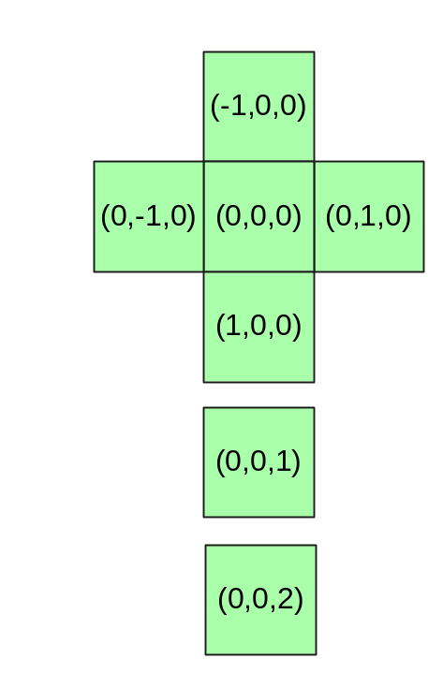
Figure 3: Neighbor cells

Where:
Xlist=Φ
Ylist=Φ
η=7
I=<P^{X},P^{y}>,with P^{X}={Φ},P^{y}={Φ};
N={(-1,0,0),(0,-1,0),(0,0,0),(0,1,0),(1,0,0),(0,0,1),(0,0,2)}
X=Y= {0, 1, 2, 3};
{n1, n2, n3} = {64, 64, 3}
B= {Cij / (i = 1v i = 64) ∧ (j = 1v i = 64)} nowrapped;
C={Cijz / iε[1,64], jε[1,64], z ε[1,3]}

Z:
Pijz Y1 → Pi,j-1z X1  Pijz Y2 → Pi+1,jz X2  Pijz Y3 → Pi,j+1z X3  Pijz Y4 → Pi-1,jz X4  Pijz Y5 → Pijz X5 | Pi,j+1z Y1 → Pijz X1  Pi-1,jz Y2 → Pijz X2  Pi,j-1z Y3 → Pijz X3  Pi+1,jz Y4 → Pijz X4  Pijz Y5 → Pijz X5

Select ={(-1,0,0),(0,-1,0),(0,0,0),(0,1,0),(1,0,0),(0,0,1),(0,0,2)}

For the model’s specification, please refer to the file – PersianTapestry64.ma
Important Values in third plane:
0 (white): a zero in a cell of the first plane and a zero in the corresponding cell of the second plane.
1 (green): a one in a cell of the first plane and a zero in the corresponding cell of the second plane.
2 (blue): a zero in a cell of the first plane and a one in the corresponding cell of the second plane.
3 (red): a one in a cell of the first plane and a one in the corresponding cell of the second plane.

- Implementation with CD++
This model has been implemented in CD++ with dimensions of 3 planes each 64x64 cells. In two cases borders have been set to no wrapped and one case to wrapped, with default delay time of 1 millisecond. Plane 0 is considered as front plane and four central cells (31, 31), (31, 32), (32, 31) and (32, 32) have been set to 1, others set to zero. In one case there are 16 ones in the center. Plane 1 is considered as rear plane and plane 2 is considered as tapestry plane.
Rules for each plane are as follows:
%[rearplane]
rule : {(0,0,-1)} 100 { cellpos(2) = 2 }

%[tapestryplane]
rule : 0 100 { cellpos(2) = 0 and (0,0,1)=0 and (0,0,2)=0 } %white
rule : 1 100 { cellpos(2) = 0 and (0,0,1)=1 and (0,0,2)=0 } %Green
rule : 2 100 { cellpos(2) = 0 and (0,0,1)=0 and (0,0,2)=1 } %Blue
rule : 3 100 { cellpos(2) = 0 and (0,0,1)=1 and (0,0,2)=1 } %Red

%[frontplane]
rule : 1 100 { cellpos(2) = 1 and even(truecount - (0,0,0) - (0,0,1) - (0,0,-1) ) }
rule : 0 100 { cellpos(2) = 1 and odd(truecount - (0,0,0) - (0,0,1) - (0,0,-1) ) }

- Simulation Results with CD++ Modeller
After running the simulation (that takes almost half an hour), as time advances many nice tapestry designs are made. With larger dimensions we could have nicer and more detailed shapes but because of memory and processing time limitations I couldn't get results with 100x100 or more.
Figure 1Figure 2, Figure 3, Figure 4, Figure 5, Figure 6 and Figure 7 show order of steps in which some models of tapestry with 64x64 dimensions and four ones in the center with no wrapped borders are made:
Figure 8. Step 8 of tapestry with 64x64 dimensions and 16 ones in the centerFigure 9, Figure 10, Figure 11, Figure 12 and Figure 13 show order of steps in which some models of tapestry with 64x64 dimensions and 16 ones in the center with no wrapped borders are made:
Figure 14, Figure 15 and Figure 16 show order of steps in which some models of tapestry with 64x64 dimensions and 4 ones in the center with wrapped borders are made:
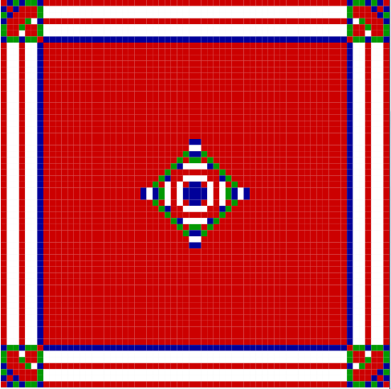
Figure 2. Step 8 of tapestry with 64x64 dimensions and 4 ones in the center

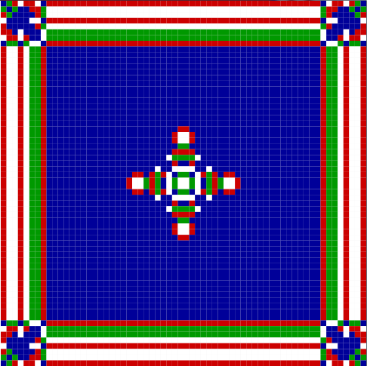
Figure 3. Step 9 of tapestry with 64x64 dimensions and 4 ones in the center
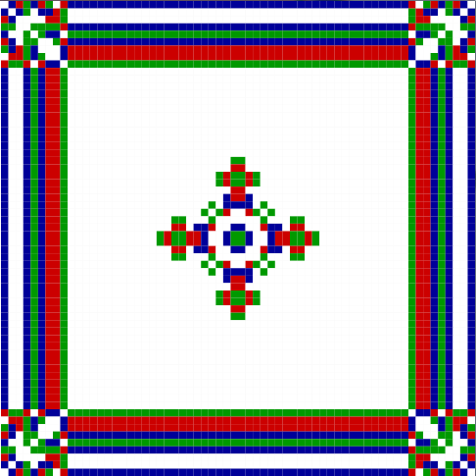
Figure 4. Step 10 of tapestry with 64x64 dimensions and 4 ones in the center

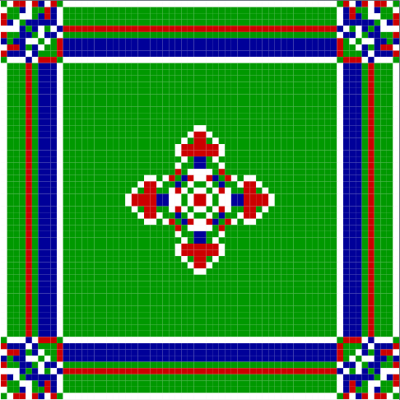
Figure 5. Step 11 of tapestry with 64x64 dimensions and 4 ones in the center
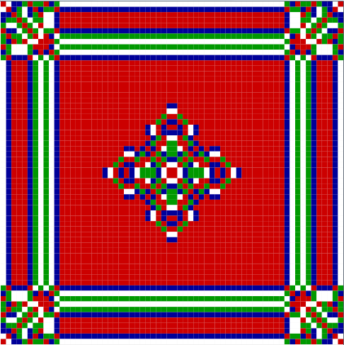
Figure 6. Step 12 of tapestry with 64x64 dimensions and 4 ones in the center

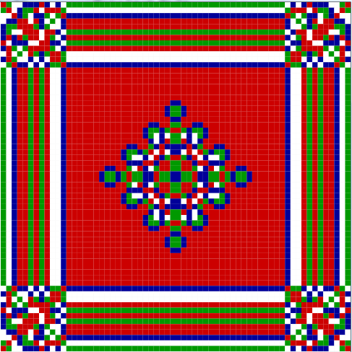
Figure 7. Step 13 of tapestry with 64x64 dimensions and 4 ones in the center
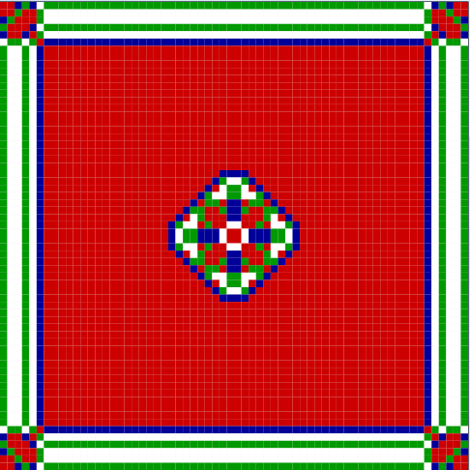
Figure 8. Step 8 of tapestry with 64x64 dimensions and 16 ones in the center

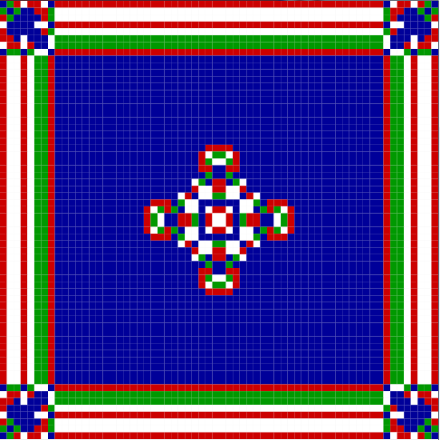
Figure 9. Step 10 of tapestry with 64x64 dimensions and 16 ones in the center
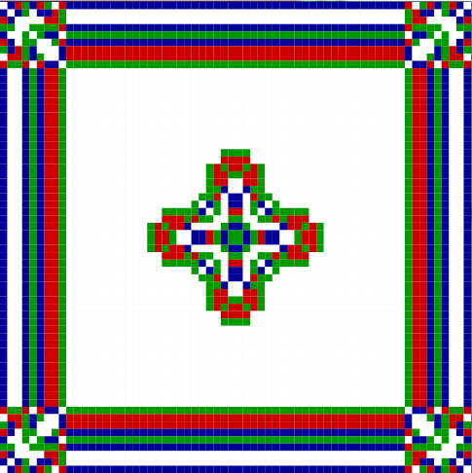
Figure 10. Step 11 of tapestry with 64x64 dimensions and 16 ones in the center

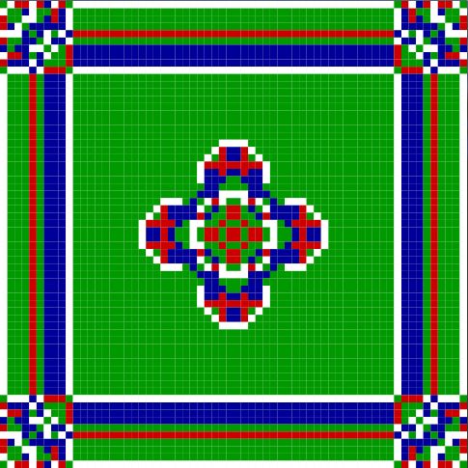
Figure 11. Step 12 of tapestry with 64x64 dimensions and 16 ones in the center
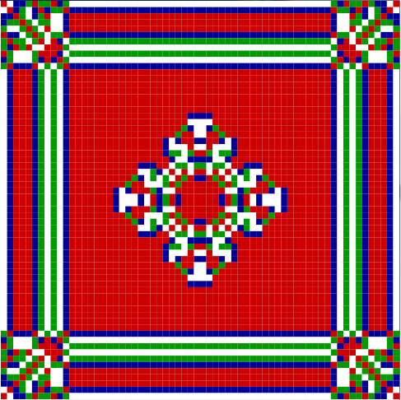
Figure 12. Step 13 of tapestry with 64x64 dimensions and 16 ones in the center

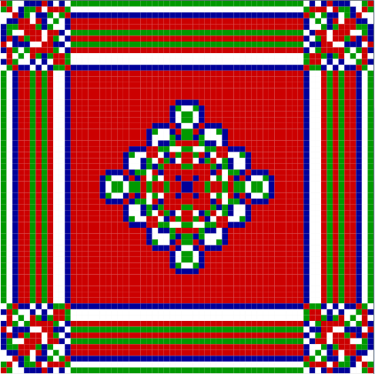
Figure 13. Step 14 of tapestry with 64x64 dimensions and 16 ones in the center
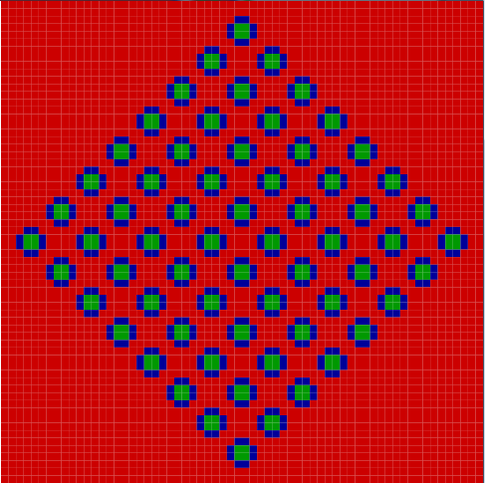
Figure 14. Step 30 of tapestry with 64x64 dimensions, 4 ones in the center and wrapped borders

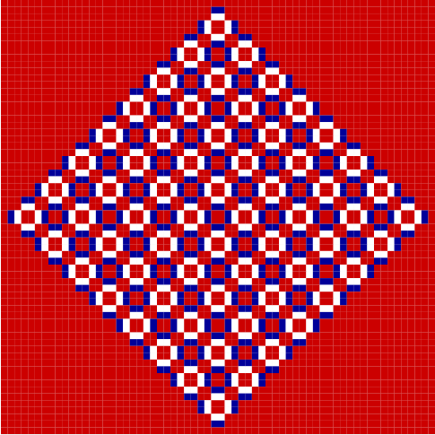
Figure 15. Step 31 of tapestry with 64x64 dimensions, 4 ones in the center and wrapped borders

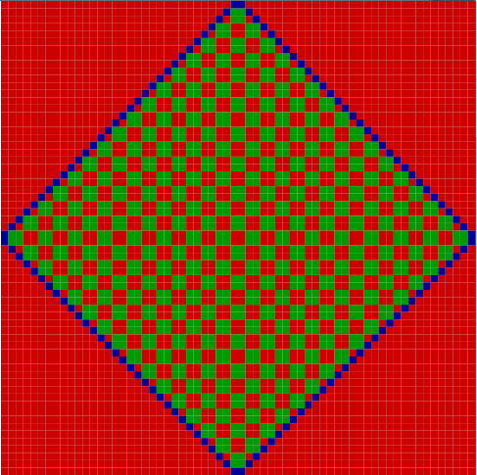
Figure 16. Step 32 of tapestry with 64x64 dimensions, 4 ones in the center and wrapped borders

- DEVS-View Implementation of the Model
Persian tapestry model has been implemented in DEVS-View 3D viewer. Because of memory limitations and long processing time, a smaller version with dimensions of 16x16 blocks has been modeled in DEVS-View. After that there is also implementation results of the model with 64x64 dimensions and 4 ones in the middle.

Figure 17, Figure 18, Figure 19 and Figure 20 show implementation of the model in DEVS-View with 16x16 dimensions. The three planes are connected to each other such that you can see the third plane (tapestry plane) in front and second and first planes at the back of this plane.

Figure 21, Figure 22, Figure 23, Figure 24, Figure 25, Figure 26 and Figure 27 show implementation of the model in DEVS-View with 64x64 dimensions from different angles. The three planes are connected to each other such that you can see the third plane (tapestry plane) in front and second and first planes at the back of this plane.

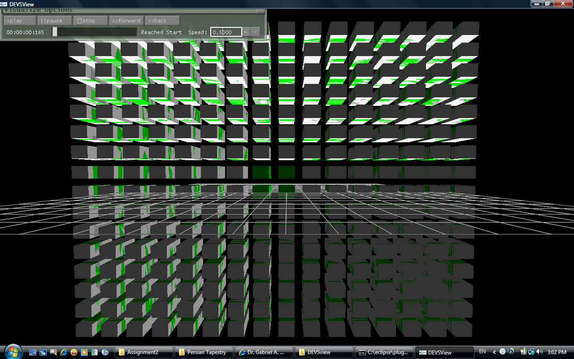
Figure 17. DEVS-View implementation of 16x16 tapestry step 1

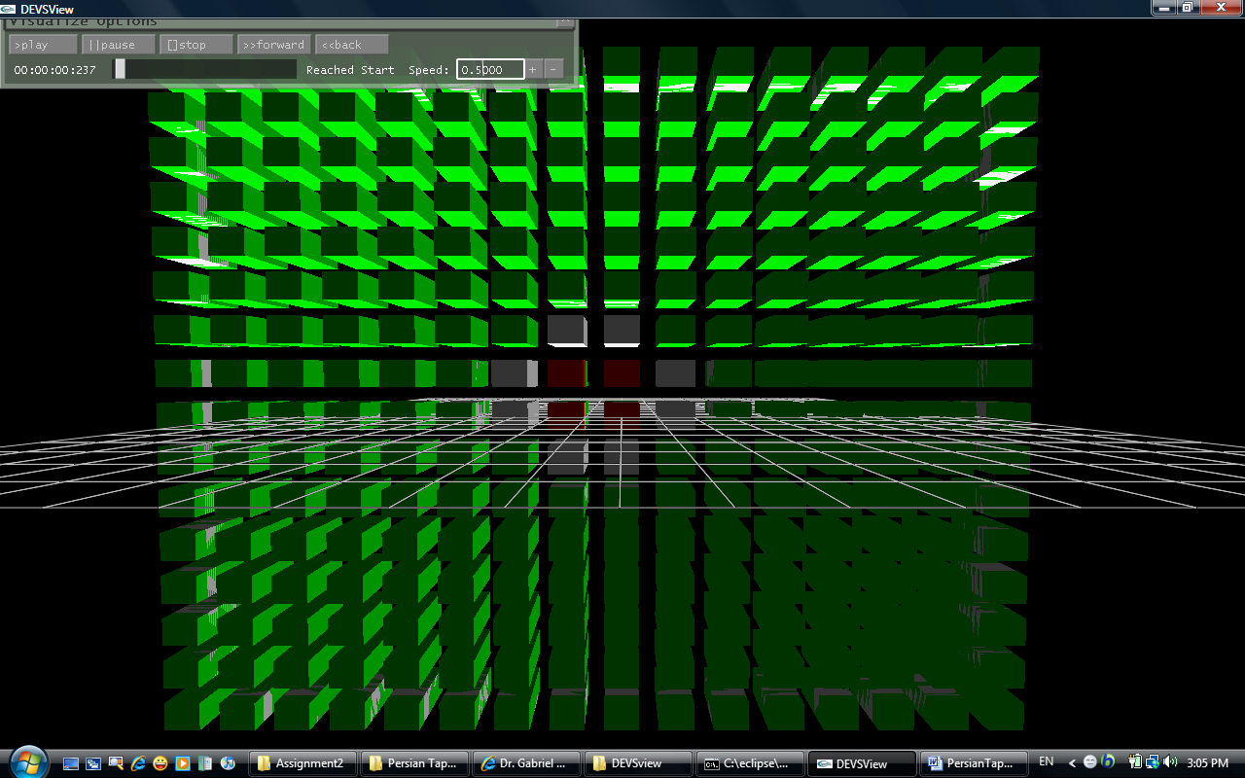
Figure 18. DEVS-View implementation of 16x16 tapestry step 2

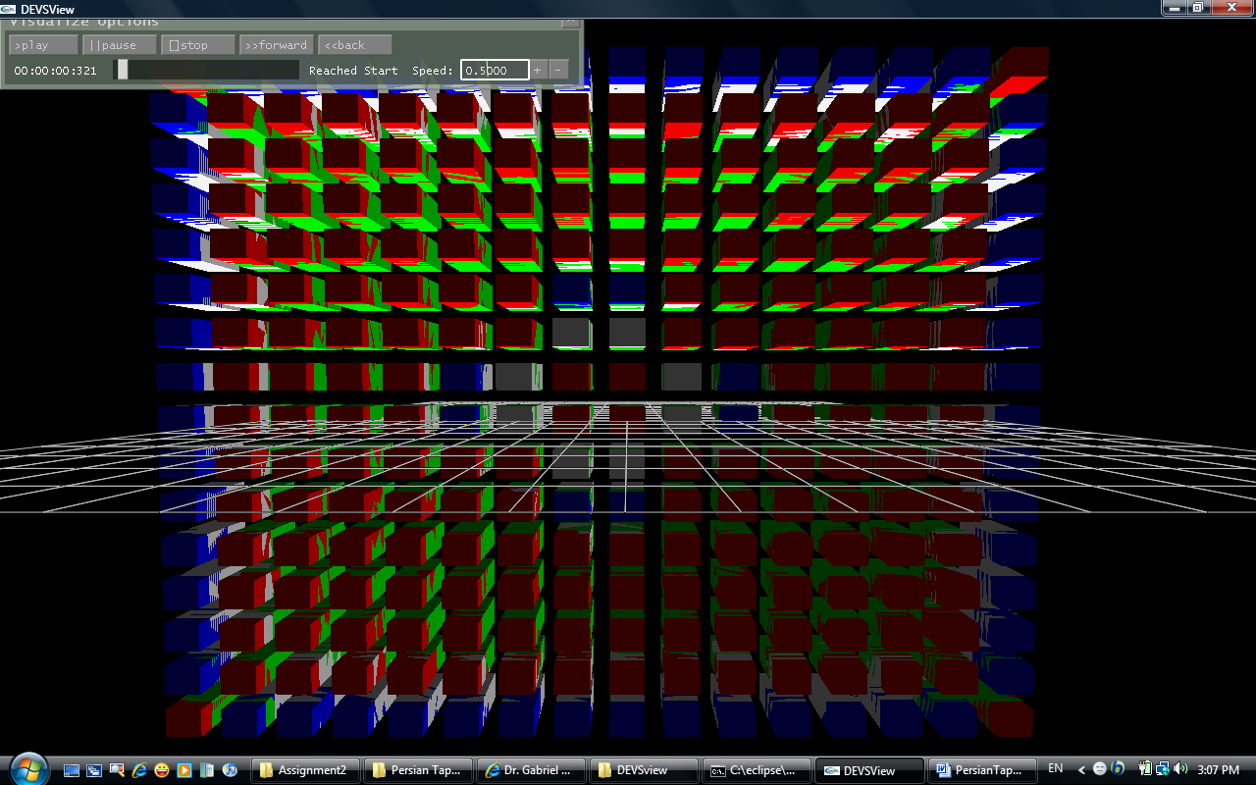
Figure 19. DEVS-View implementation of 16x16 tapestry step 3

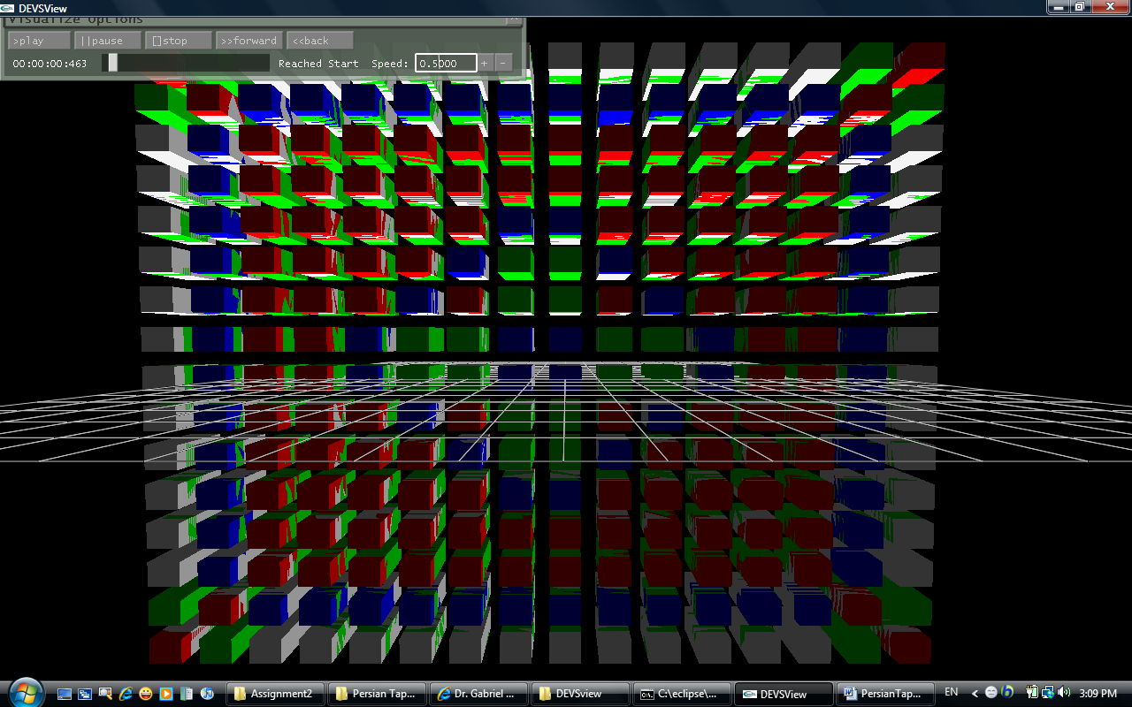
Figure 20. DEVS-View implementation of 16x16 tapestry step 4

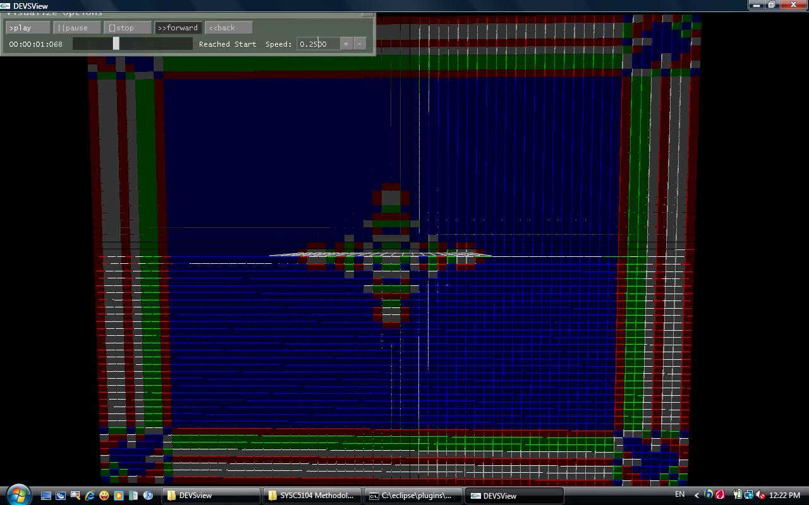
Figure 21. DEVS-View implementation of 64x64 tapestry step 6

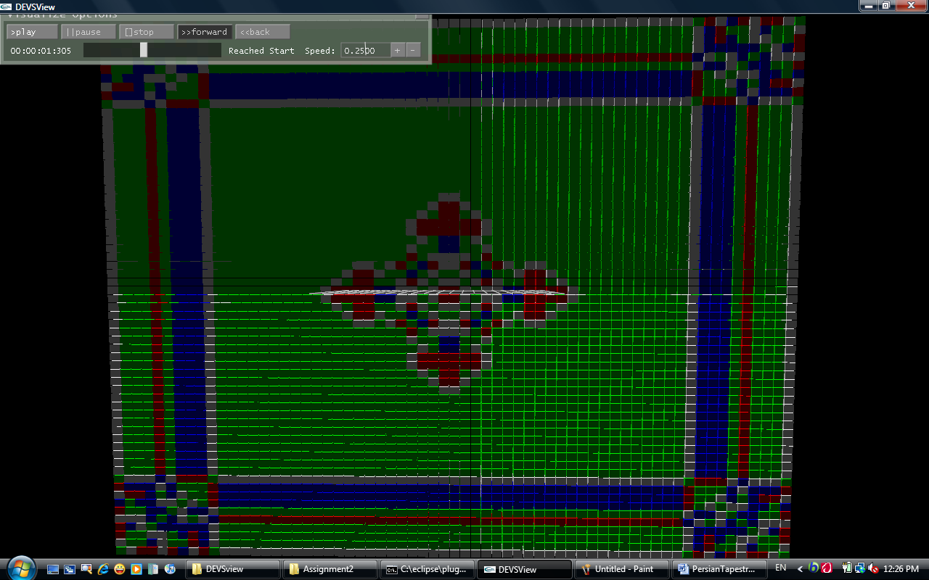
Figure 22. DEVS-View implementation of 64x64 tapestry step 8
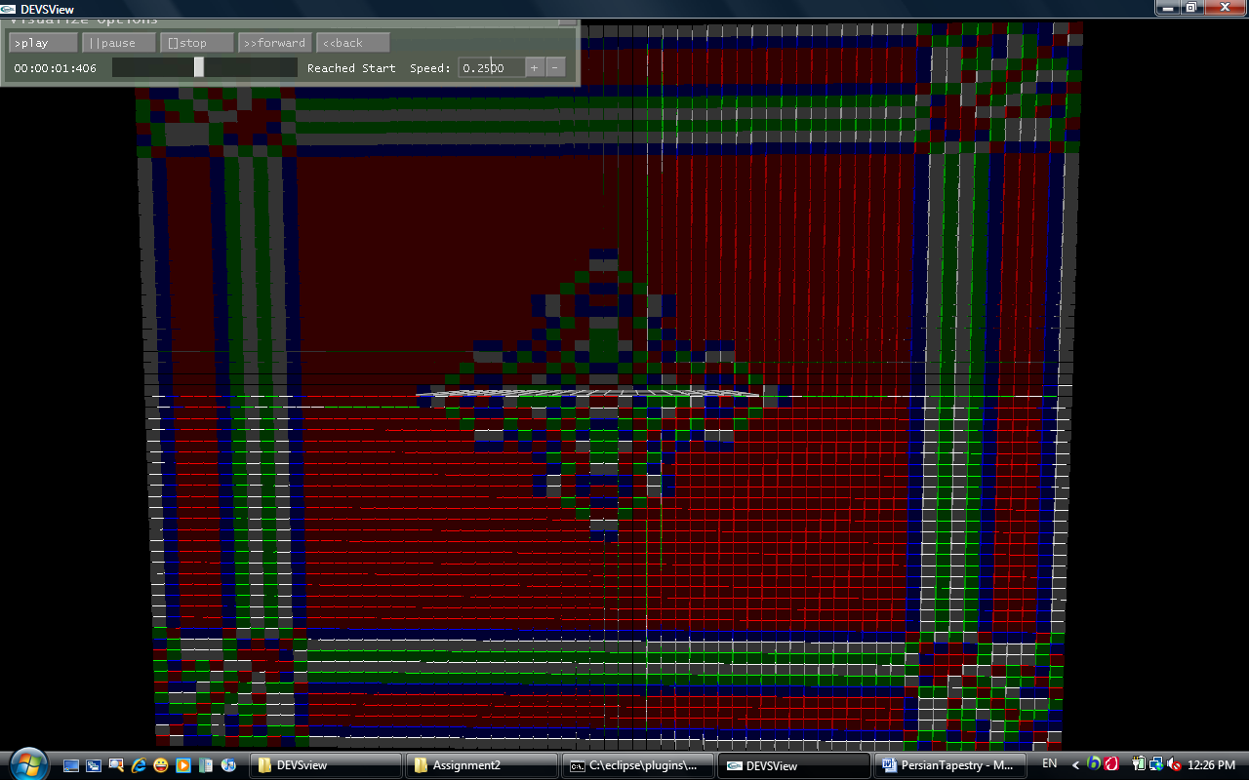
Figure 23. DEVS-View implementation of 64x64 tapestry step 9

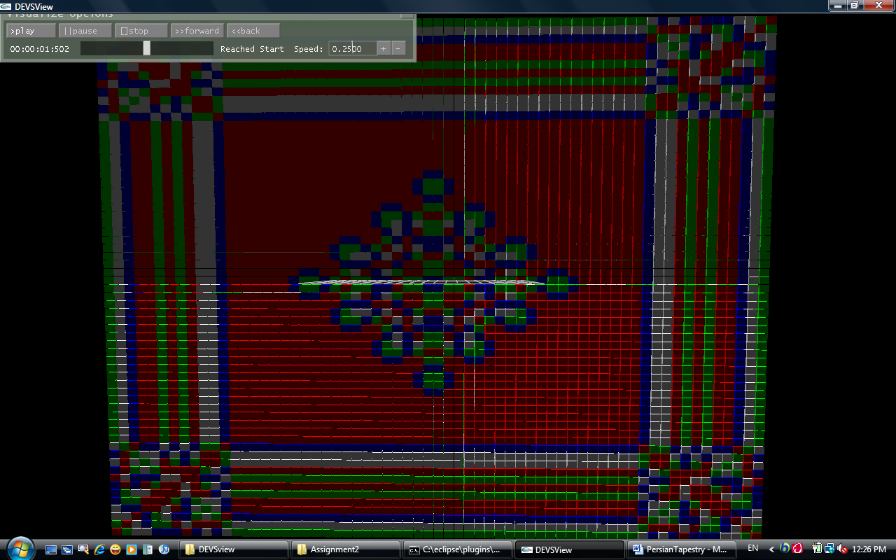
Figure 24. DEVS-View implementation of 64x64 tapestry step 10
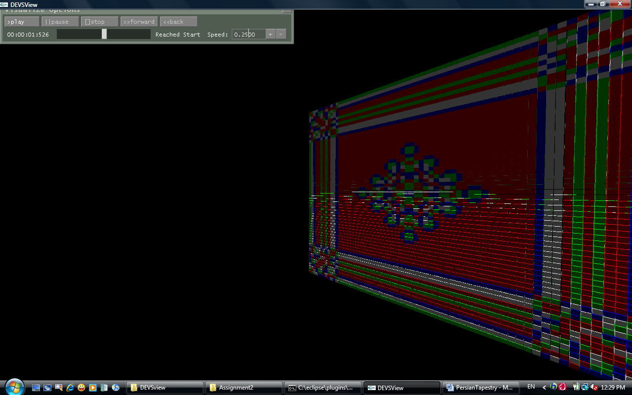
Figure 25. DEVS-View implementation of 64x64 tapestry step 10, a side view

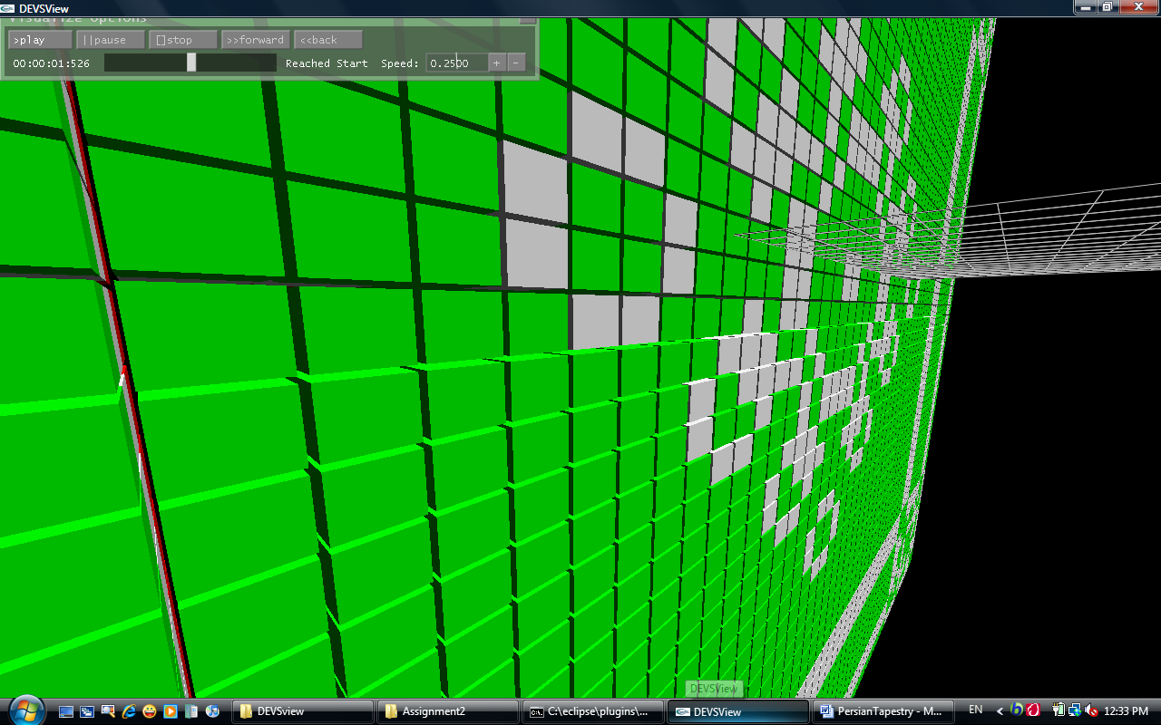
Figure 26. DEVS-View implementation of 64x64 tapestry step 10, close side view from behind (rear plane in front)
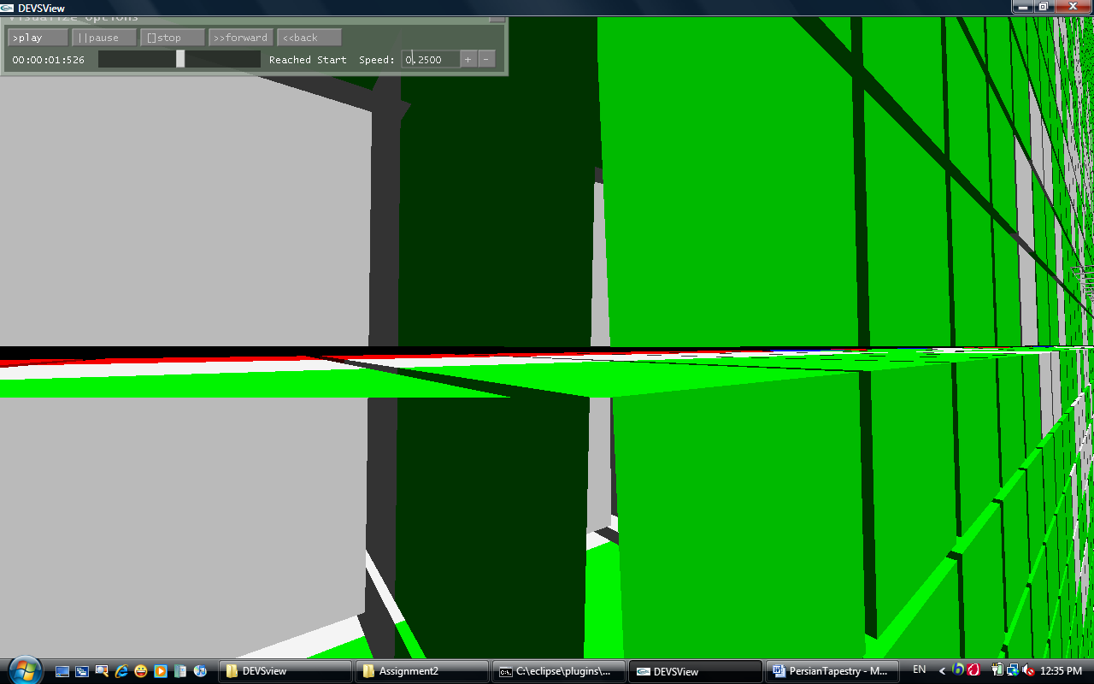
Figure 27. DEVS-View implementation of 64x64 tapestry step 10, very close side view from behind (rear plane in front)

- References
[1] The Use of Cellular Automata in the Classroom, Lilly, H.A.;Supercomputing, 1995. Proceedings of the IEEE/ACM SC95 Conference.

