CARLETON UNIVERSITY
Department of Systems and Computer Engineering

COURSE 94.587

Advanced Topics in Computer Systems: Methodological aspects of modeling and simulations.

Report for term project:

CD++ Petri Net Library

Prepared by
Christian Jacques

03 December 2001

Table of Contents

Table of Contents 1
1. Introduction 2
2. Petri Net Characteristics 2
2.1. Static Characteristics 2
2.2. Dynamic Characteristics 3
2.3. Extended Petri Net Characteristics 3
3. Model Descriptions 4
3.1. Petri Net Place Model Description 5
3.1.1. Formal Specification 5
3.2. Petri Net Transition Model Description 6
3.2.1. Formal Specification 7
3.3. Coupling Transitions and Places 9
4. Execution of a Petri Net 9
4.1. Implementing the Dynamic Characteristics of a Petri Net 9
4.2. Robustness Issues 11
5. Analyzing Simulation Results 11
6. Validation of Models 12
6.1. pnPlaceTest1 12
6.2. pnTransTest1 13
6.3. pnTest1 14
6.4. pnTest2 15
6.5. pnTest3 16
6.6. pnTest4 17
7. Simulation Examples 18
7.1. Mutual Exclusion Scenario 18
7.1.1. Results Analysis 19
7.2. Elevator 19
7.2.1. Results Analysis 19
7.3. Two-Unit Asynchronous Pipeline 20
7.3.1. Results Analysis 21
7.4. Multiprocessing 21
7.4.1. Results Analysis 21
7.5. Priority Scheduling 22
7.5.1. Analysis of results 22
8. Conclusion 23

Introduction

The aim of this term project is to develop DEVS models which can be used by engineers and scientists to create Petri Nets to model real systems and run simulations of these models using the CD++ tool. From a certain point of view, it could be said that the goal of this project is to create a Petri Net flavoured wrapper around the DEVS based CD++ tool. This report assumes the reader has a basic understanding of Petri Nets. If this is not the case then reference [1] should be consulted before proceeding further.

In addition to meeting the requirements stated in section 2, a very important factor for this project was to deliver something which can truly make the CD++ tool accepted as a useful Petri Net modelling and simulation tool. This meant delivering something that:

- Has the look and feel of Petri Nets so Petri Net modellers are comfortable using the CD++ tool.
- Allows the creation of Petri Net models in a simple manner.
- Allows easy analysis of simulation results.
- Is robust enough to be used by the engineering community in general.

Petri Net Characteristics

The aim of this section is to describe the Petri Net characteristics which were used as the basis for creating the DEVS model presented in section 3. Not all characteristics of Petri Nets are described here because some do not affect the behaviour of the proposed DEVS model. For example, the characteristic whereby transitions can only connect to places and vice versa is not enforced in the DEVS model. Figure 1 illustrates a typical Petri Net. It is used in this section as a reference to describe the characteristics of a Petri Net.

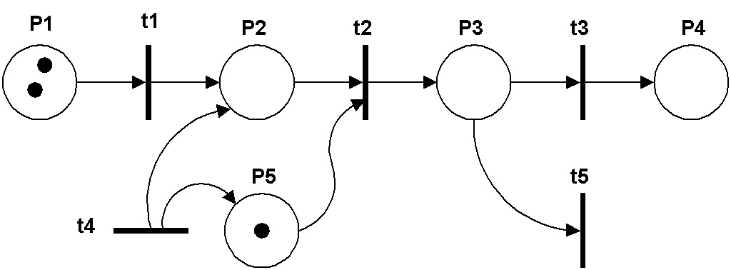
Figure 1. Typical Petri Net

Static Characteristics

- A place may have zero or more inputs. For example, P1, P4 and P2 have zero, one and two inputs respectively.
- A place may have zero or more outputs. For example, P4, P5 and P3 have zero, one and two outputs respectively.
- A place may contain zero or more tokens. For example, P2, P5 and P1 contain zero, one and two tokens respectively.
- A transition may have zero or more inputs. For example, t4, t3 and t2 have zero, one and two inputs respectively. A transition with no inputs is called a source.
- A transition may have zero or more outputs. For example, t5, t1, t4 have zero, one and two outputs respectively. A transition with no outputs is called a sink.
- A transition is either enabled or disabled. A transition is enabled if all of its input places contain at least one token. A source transition is always enabled hence it can be used as an infinite source of tokens.

Dynamic Characteristics

- A Petri Net is executed by firing enabled transitions, one at a time, for as long as there is at least one enabled transition.
- When more than one transition is enabled at any given time, the one that fires is selected in a non deterministic manner.
- When a transition fires, a token is removed from each one of its input places and a token is deposited in each one of the output places. Source and sink transitions are exceptions to this rule.
- Transition firing is instantaneous meaning that tokens are removed from input places and deposited in the output places at exactly the same time.

Extended Petri Net Characteristics

Some extensions to Petri Nets have been introduced over the years. The Petri Net model proposed in section 3 supports two of them:

- Inhibitor arc: It is an arc between a place and a transition which enables the transition only if the place is empty as opposed to containing at least one token. Figure 2 illustrates a Petri Net containing such an arc. For t1 to be enabled, P1 must be empty and P2 must contain at least one token..
- Multiple Arcs: They are arcs connecting a place and a transition indicating the number of tokens being transferred is more than one. Figure 3 illustrates a Petri Net with multiple arcs where transition t1 requires three tokens from P1 and two from P2 to be enabled. When it fires, t1 deposits two tokens in P3.

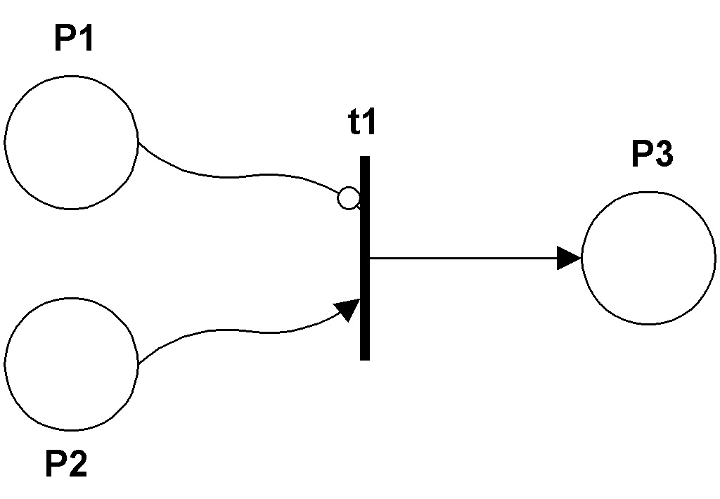
Figure 2. Inhibitor Arc
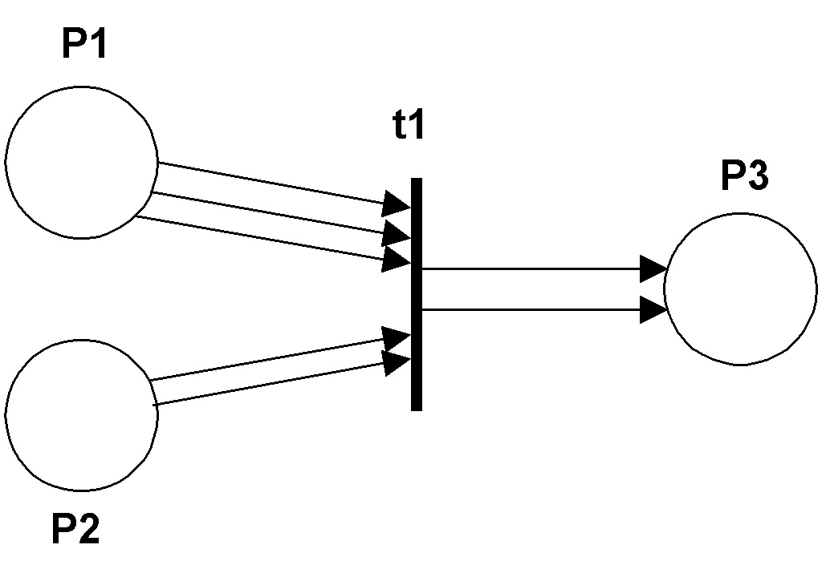
Figure 3. Multiple Arcs

Model Descriptions

This section describes the models that were created to allow modelling of systems using Petri Nets with the CD++ tool. These models presented are based on the lessons learned from the creation and utilization of about four different prototypes for each model. the initial prototypes were used to validate ideas while the later ones consisted in enhancements to make the models simpler to use. The factor which affects the complexity of the models the most is definitely the support of the Petri Net extensions described in section 2.3. This is because a transition cannot simply assume it has to remove only one token from its input places and deposit one token in its output places when it fires.

The chosen solution for modelling Petri Nets was to create two DEVS atomic models. One to represent a place and one to represent a transition. This is very versatile because any Petri Net can be constructed by coupling the two types of DEVS atomic models in a manner very similar to how places and transitions are coupled in a “real” Petri Net. Furthermore, it makes it easy for someone to map a Petri Net into the proper .ma file necessary for the CD++ tool to execute the Petri Net. That is, for every place or transition in the Petri Net there will be an atomic model and every arc is represented by a link between the atomic models.

Petri Net Place Model Description

Figure 4 illustrates the black box diagram for the model proposed for a Petri Net place. It has one input port and one output port described below.

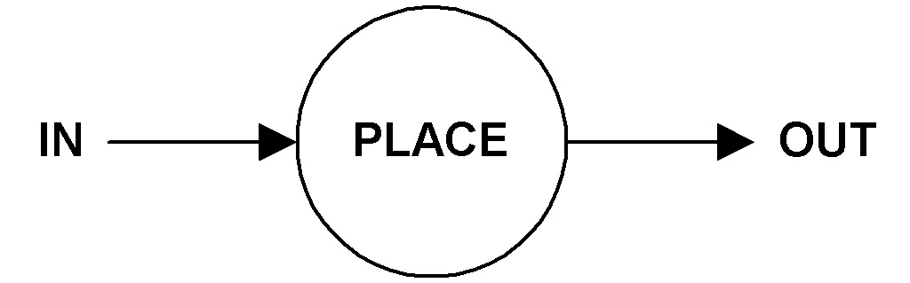
Figure 4. Place Conceptual Model

IN: This input is used to receive tokens from zero or more Petri Net transitions. It is also used to tell the place to loose tokens such as when a transition fires. The message format determines whether the place increments or decrements the number of tokens it contains by the value specified in the message. This is how the model supports multiple arcs.

OUT: This output is used by the place to advertise the number of tokens it contains so transitions that are connected to it can determine if they are enabled. This process is executed every time the number of tokens in the place is modified and when the model is initialised at the beginning of simulation.

Formal Specification

This section provides the formal DEVS specification for the Petri Net place model.

M = < X, S, Y, δ_{int}, δ_{ext}, D, λ > where:

X = {IN ∈ N⁺}
Y = {OUT ∈ N⁺}
S = {{tokens ∈ N₀⁺} ∪ {id ∈ N⁺} ∪ {phase ∈ {active, passive}}
Where tokens is the number of tokens contained in the place and id is the identifier of the place as assigned by the simulator.

δ_{ext} (s,e,x) {

retrieve id and number of tokens from message
case id
0 /* generic message */

increment tokens
hold in active 0 /* to advertise the number of tokens */

!= 0 /* specific message */
id matches id of this place?
no: disregard the message
yes: Decrement tokens by the number of tokens specified if there are enough. Otherwise throw an exception.
hold in active 0 /* to advertise the number of tokens */

}end of external transition function

δ_{int} (s) {
passivate /* wait for the next external event */
}

λ(s) {
combine id and tokens state variables in one message and send on the OUT port.
}

Petri Net Transition Model Description

Figure 5 illustrates the black box diagram of the model proposed for a Petri Net transition. It has five input ports and five output ports described below.

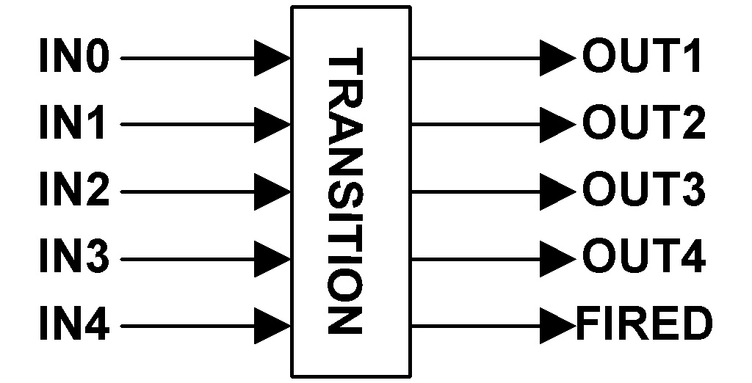
Figure 5. Transition Conceptual Model

IN1: This input port is used to be notified of the number of tokens contained in the place(s) which have their OUT port connected to this input. Places which connect to this port do so because the connection consists of a single connecting arc. That is, if the transition fires, only one token will be removed from the input place(s).

IN2: This input port serves the same function as the IN1 port except that the connection consists of a double connecting arc which implies the input place(s) will loose two tokens if the transition fires.

IN3: This input port serves the same function as the IN1 port except that the connection consists of a triple connecting arc which implies the input place(s) will loose three tokens if the transition fires.

IN4: This input port serves the same function as the IN1 port except that the connection consists of a quadruple connecting arc which implies the input place(s) will loose four tokens if the transition fires.

IN0: This input port serves the same function as the IN1 port except that the connection consists of an inhibitor arc. That is, the input place must contained zero token for the transition to fire and when it does, no token is removed from the place.

OUT1: This output is used to feed 1 token to all the places which have their IN port connected to this port.

OUT2: This output is used to feed 2 tokens to all the places which have their IN port connected to this port.

OUT3: This output is used to feed 3 tokens to all the places which have their IN port connected to this port.

OUT4: This output is used to feed 4 tokens to all the places which have their IN port connected to this port.

FIRED: This output is used to remove tokens from the input places which must have their IN port connected to this output port in addition to being connected to one of the input ports. Section 3.3 describes couplings in more details.

A relevant question here would be to ask why use five inputs. It seems like using a single one is possible and would not have the restriction where the maximum arc width consists of four tokens. This solution was actually tried in a prototype but was found to be more complex for the modeller. The reality is that the arc width information has to be encoded somewhere so the transition knows how many tokens are necessary to determine if a place has enough of them to potentially enable the transition. If this information is not inherent to the input port used (as in the model presented), then the modeller has to provide this information via initialisation parameters. Therefore, in addition to specifying the links between a place and a transition, the modeller would be required to specify the width of these links. This approach was found to be much less user friendly than the one presented here. The same principles apply on the output which is why there are four OUTX ports.

As for the FIRED port, only one is required because the model knows what its input transitions are and it knows the width or the connecting arcs. Therefore it can send individual messages to the input places to tell them to remove tokens.

Formal Specification

This section provides the formal DEVS specification for the Petri Net transition model.

M = < X, S, Y, δ_{int}, δ_{ext}, D, λ > where:

X = {IN0 ∈ N⁺, IN1 ∈ N⁺, IN2 ∈ N⁺, IN3 ∈ N⁺, IN4 ∈ N⁺}
Y = {OUT1 = 1, OUT2 = 2, OUT3 = 3, FIRED ∈ N⁺}
S = {{inputs ∈ N₀⁺} ∪ {enabled ∈ bool}
Where inputs is the number of input places the transition has and enabled indicates if the transition is enabled or not.

δ_{ext} (s,e,x) {
case port
IN0: set arc width (temp var) to 0.
IN1: set arc width (temp var) to 1.
IN2: set arc width (temp var) to 2.
IN2: set arc width (temp var) to 3.
IN4: set arc width (temp var) to 4.

- extract id of the place sending the message. If this is the first message we get from this id, increment inputs.
- save id along with arc width in a database.
- extract from the message and save in the database the number of tokens contained in the place which sent the message.
- scan the entire database to determine if all input places have enough tokens to enable the transition.

transition is enabled ?
yes: set enabled to true
hold in active for a random amount of time (0 – 60 seconds)
no: set enabled to false
passivate
}end of external transition function

δ_{int} (s) {
if inputs = 0, i.e. transition is a source, hold in active for a random amount of time. (0 to 60 seconds)
otherwise passivate
}

λ(s) {
send 1 on OUT1 port.
send 2 on OUT2 port.
send 3 on OUT3 port.
send 4 on OUT4 port.

go through the database and send a message to every input place via the FIRED port.
} /* end of output function */

Coupling Transitions and Places

Figure 6 illustrates an example of how transition and place models are meant to be coupled to create a Petri Net. Note that for clarity reasons two FIRED ports where used but the model actually only has one as mentioned previously. The figure shows a transition which is enabled when P1 has no token, P2 has at least two tokens and where P3 will receive three tokens when the transition fires. Additionally, P2 will loose two tokens because the FIRED port of the transition is connected to its IN port. P1 obviously would not loose tokens since it is connected to t1 via an inhibitor arc.

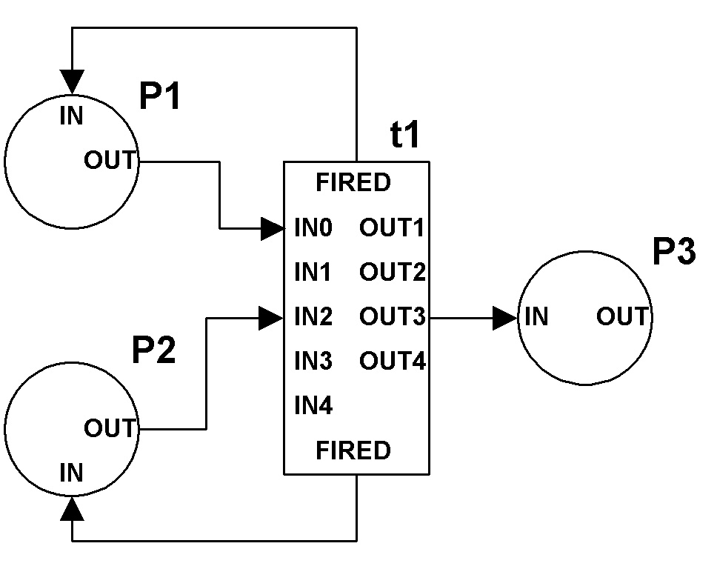  Figure 6. Coupling places and transitions | [top]  components : P1@pnPlace P2@pnPlace P3@pnPlace t1@pnTrans  Link : out@P1 in0@t1  Link : out@P2 in2@t1  Link : out3@t1 in@P3  Link : fired@t1 in@P1  Link : fired@t1 in@P2  [P2]  tokens : 3  [t1]  inputplaces : 2

Beside the figure is the corresponding .ma file. Places use the pnPlace model while transitions use the pnTrans model. Note the use of two optional initialisation parameters. by default, a place is created with zero tokens. In the case of P2, this has been overridden by the modeller by specifying “tokens : 3” such that at the beginning of the simulation the place would contain three tokens. Another optional parameter is the inputplaces parameter which indicates the maximum number of input places that can connect to the transition. By default the maximum is 10 but this can be changed to a lesser or larger value. The only reason this parameter exists is to limit the amount of memory the transition model dynamically allocates to create the database it uses to keep information about its input places. It is believed modellers will rarely need to specify an inputplaces parameter.

Execution of a Petri Net

Implementing the Dynamic Characteristics of a Petri Net

The execution of a Petri Net consists in firing enabled transitions for as long as there is at least one that is enabled. This is easily achievable with the CD++ tool simulator by mapping an enabled transition into a scheduled internal event. Therefore, when there are no enabled transitions, there are no internal events scheduled and the simulation automatically ends. For Petri Nets which always have at least one enabled transition, the end of simulation is controlled by the modeller when invoking the simulator.

One factor that is more complicated is the fact that when two or more transitions are enabled, one must be chosen and fired in a non deterministic manner. This implies that a controlling agent, aware of the state of all transitions in the model, would be required to determine which one should fire. The idea of creating an atomic model for such an agent was contemplated but was found to introduce too much complexity because the modeller would have had to connect every transition to this agent. Instead, the transition model was implemented to schedule its own firing a random amount of time (0 – 60 seconds) after it was established that the transition was enabled. Given that all transitions do the same, this result in a near non-deterministic decision process. The reason this is not truly non-deterministic is best explained using a timing graph as the one illustrated in Figure 7.

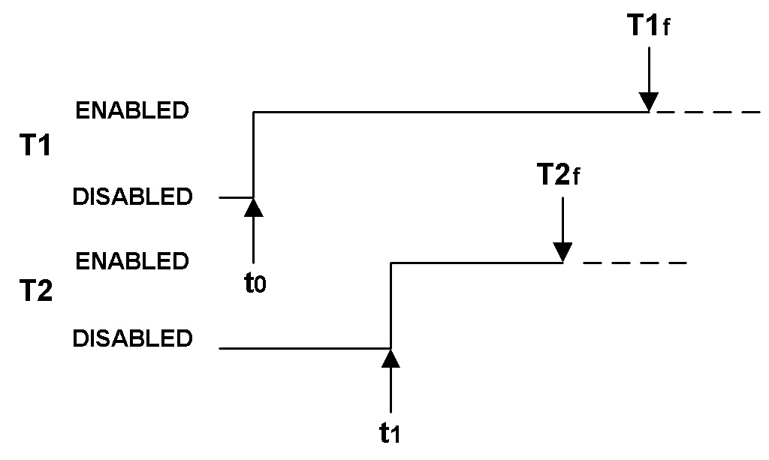
Figure 7. Firing Timing

As shown, T1 becomes enabled at t₀ and schedules itself to fire at T1_{f}. This provides a window of time ( T1_{f} - t₀ ) where another transition, such as T2, can become enabled (t₁) (due the firing of other transitions in the system) and schedule itself to fire (T2_{f}) before T1. As time advances, the window decreases in size such that the is less probability that a third transition could become enabled and schedule its firing before T1’s or T2’s for that matter. Therefore it can be said that as time advances, the transition which has been in the enabled state the longest has more chances of being the next one to fire.

Another issue with the technique used to achieve non-determinism is the fact two transitions may attempt to fire at the same time which is not permitted in a Petri Net. However, because of the select functionality of the DEVS formalism, the simulator would actually process the two events one after the other such that the transition firings are not really concurrent even though they are processed during the same time index.

Robustness Issues

When a Petri Net is simulated, it is possible that an attempt is made to remove tokens from a place which does not have enough of them if the modeller made a mistake when defining the links between the places and transitions. This type of error is detected by the place model and an exception is thrown to stop the simulation and explain the problem.

It is also possible that a modeller connects more input places to a transition then the maximum allowed (inputplaces parameter described in section 3.3). This type of error is detected by the transition model and an exception is thrown to stop the simulation and explain the problem.

The last robustness issue has to do with the fact a place cannot advertise that it contains more than 999 tokens even though it does. This is because the message format it sends on its output port is limited to three digits for the number of tokens. The remaining digits are used to identify the place sending the message. Even though it can only advertise a maximum of 999, the place actually keeps the proper count internally.

Analyzing Simulation Results

Unfortunately the nature of Petri Net makes the analysis of simulation results difficult with the CD++ tool because one needs to analyse the rather cryptic and large .log file resulting from the simulation. Another solution is to define extra output ports to which places and transitions are connected so the simulation results can be analysed using the .out file. Using this method is error prone and adds complexity for the modeller given the extra links that need to be defined in the .ma file.

As mentioned in section 1, one of the goals of this project was to deliver something that made it easy to analyse simulation results. Therefore a TCL tool (pnmark.tcl) was developed to assist modellers in doing so. Given that what is of interest is the marking of the Petri Net and the firing of the transitions, the tool provides this information in a clear and concise manner as can be seen in Table 1. The tool does this by parsing the .ma file to determine the names of the places and transitions used in the model and by parsing the .log file resulting from a simulation. Since an .out file is not required, the modeller need not add output ports in the .ma file. The tool was written in TCL due to its portability across computing platforms and was tested and used on both UNIX and Windows NT.

As can be seen in Table 1, the first two lines list the name of the places and transitions which make up the model. Then the initial marking of the Petri Net is shown. In this case, p1 = 5, p2 = 3 and p3 = 0. Then t1 is seen to fire which results in a (2,1,4) marking. From this one can conclude p1 and p2 are input places to t1 while p3 is an output place of t1. Furthermore, p1 has a triple arc to t1 because it lost 3 tokens due to the firing, p2 has a double arc and p3 has a quadruple arc.

Petri Net places: p1 p2 p3
Petri Net transitions: t1

(5,3,0)
|
|
t1
|
V
(2,1,4)
Table 1. Output of the pnmark.tcl tool

To invoke the tool: ->wish pnmark.tcl file.ma file.log [file.pn]

The order of the files is not important since the tool uses the extension names to determine the type of file. The file.pn argument is optional. It tells the tool where to output the results. If it is not specified, the output goes to stdout.

The subsequent sections of this document use the output of the pnmark tool to analyse results.

Validation of Models

This section describes the tests that were performed to validate the design and implementation of the place and transition models.

pnPlaceTest1

The aim of this test is to verify the functionality of the place atomic model. The test can be run by executing the pnPlaceTest1 batch file. The test generates a pnPlaceTest1.log and a pnPlaceTest1.out file.
The following test cases are performed:

Test Cases | Test Results
Verify the optional tokens parameter can be processed correctly. | PASS. The .out file shows the model advertising it contains 2 tokens at time index 00:00:00:000. Note that the value of 2002 indicates that place ID 2 has 2 tokens.
Verify that when the place receives a generic message it increments its token count by the value specified in the message. | PASS. The .out file shows the model advertising it contains four tokens after receiving a message at time index 00:00:01:000.
Verify that when the place receives a fired message it decrements its token count by the value specified in the message if the message is destined for the place. | PASS. The .out file shows the model advertising it contains 0 tokens after receiving a message at time index 00:00:02:000
Verify the place disregards fired messages which are not destined for it. | conditional PASS. The message at time index 00:00:03:00 did not cause the token count to be modified but it caused the place to send an output message advertising its token count anyway. This is harmless but not required.
Verify the place advertises its token count every time it changes. | PASS. the .out shows the place advertising the proper token counts at the right times.
Verify an exception is thrown when an attempt is made to remove more tokens than there are in the place. | PASS. The simulation stops and a description of the problem is displayed on the console.

pnTransTest1

The aim of this test is to verify the functionality of the transition atomic model. The test can be run by executing the pnTransTest1 batch file. The test generates a pnTransTest1.log and a pnTransTest1.out file. The following test cases are performed:

Test Cases | Test Results
Verify the optional inputplaces parameter is processed correctly. | PASS. The external event at time index 15:00:00:000 simulated a sixth input place sending a message to the transition. This caused an exception confirming the “inputplaces : 5” was processed properly.
Verify every input so as to disable and then enable the transition. | PASS: The external messages sent at time indices 00:00:00:000, 03:00:00:00, 06:00:00:00, 09:00:00:000 and 12:00:00:000 indeed disabled the transition since the log file shows t1 setting its sigma to infinite (i.e. transition is disabled) after processing these messages. Other external messages all caused t1 to set its sigma to a value between 0 and 60 (i.e. transition is enabled) according to the log file.
Verify the transition sends messages to deposit tokens when it fires. | PASS: The .out file shows the transition depositing tokens using the four OUTX ports the nine times it fired.
Verify the transition sends messages to remove tokens when it fires. | PASS: The .out shows the transition sending fired messages the nine times it fires.
Verify the transition keeps track of it input places. | PASS: According to the .out file, the transition sends fired messages only to the transitions from which it has received an message previously.
Verify an exception is thrown when the number of input places connected to the transition exceed the maximum. | PASS: The simulation ends with an exception and an indication is displayed on the console.

pnTest1

The aim of this test is to verify the integration of a place with a transition using the simple Petri Net shown below. The test can be run by executing the pnTest1 batch file which generates a pnTest1.log file. The results are analysed using the output of the pnmark tool which needs to parse two files: pnTest1.log and pnTest1.ma. The following test cases are performed:

Test Cases | Test Results
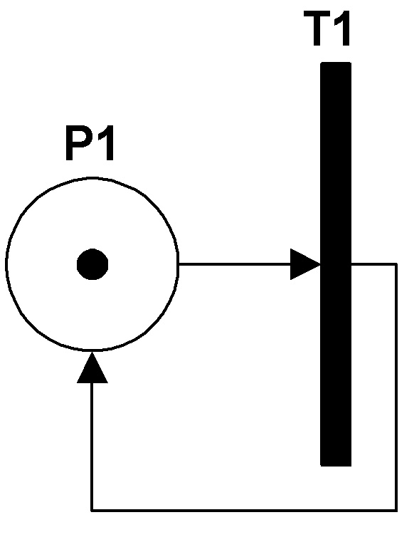  - Verify the transition fires continuously  - Verify the marking of the net constantly stays at (1) | PASS: According to the pnmark tool output:  Petri Net places: p1  Petri Net transitions: t1  (1)  |  |  t1  |  V  (1)  |  |  t1  |  V  Some of the contents of original file deleted because it was repetitive  (1)  |  |  t1  |  V

pnTest2

The aim of this test is to verify the integration of a places and transitions using the Petri Net shown below. The test can be run by executing the pnTest2 batch file which generates a pnTest2.log file. The results are analysed using the output of the pnmark tool which needs to parse two files: pnTest2.log and pnTest2.ma. The following test cases are performed:

Test Cases | Test Results
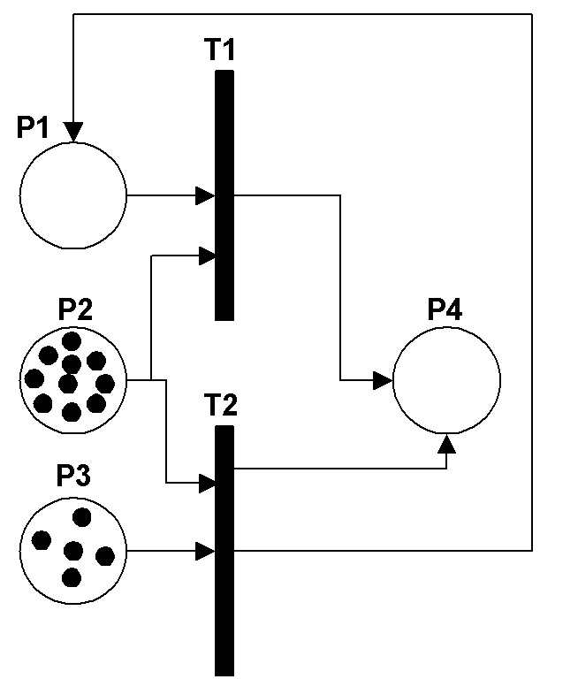  - Verify t2 is the first transition to fire.  - Verify t1 and t2 fire five times each in a non deterministic manner when they are both enabled at the same time.  - Verify the initial marking is (0, 10, 5, 0)  - Verify the final marking is (0, 0, 0, 10) | PASS: According to the pnmark tool output:  Petri Net places: p1 p2 p3 p4  Petri Net transitions: t1 t2  (0,10,5,0)  |  |  t2  |  V  (1,9,4,1)  |  |  t1  |  V  (0,8,4,2)  |  |  t2  |  V  (1,7,3,3)  some contents from the original file deleted to shorten the table  (1,1,0,9)  |  |  t1  |  V  (0,0,0,10)

pnTest3

The aim of this test is to verify the integration of a places and transitions using the Petri Net shown below. The test can be run by executing the pnTest3 batch file which generates a pnTest3.log file. The results are analysed using the output of the pnmark tool which needs to parse two files: pnTest3.log and pnTest3.ma. The following test cases are performed:

Test Cases | Test Results
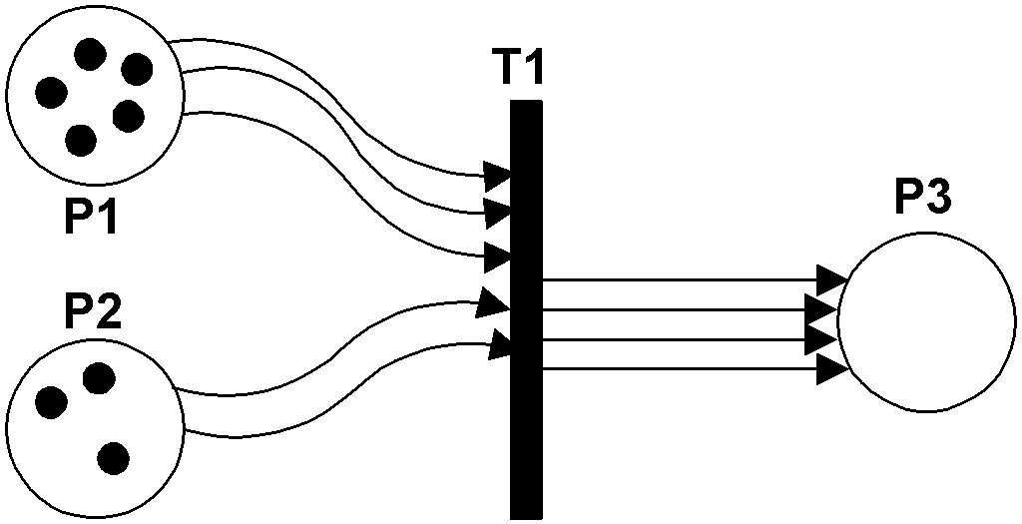  - Verify initial marking is(5, 3, 0)  - Verify t1 fires only once.  - Verify P1 and P2 loose 3 and 2 tokens respectively.  - Verify P3 receives 4 tokens.  - Verify final marking is (2, 1, 4) | PASS: According to the output of the pnmark tool:  Petri Net places: p1 p2 p3  Petri Net transitions: t1  (5,3,0)  |  |  t1  |  V  (2,1,4)

pnTest4

The aim of this test is to verify the integration of a source transition and a place. The test can be run by executing the pnTest4 batch file which generates a pnTest4.log file. The results are analysed using the output of the pnmark tool which needs to parse two files: pnTest4.log and pnTest4.ma. The following test cases are performed:

Test Cases | Test Results
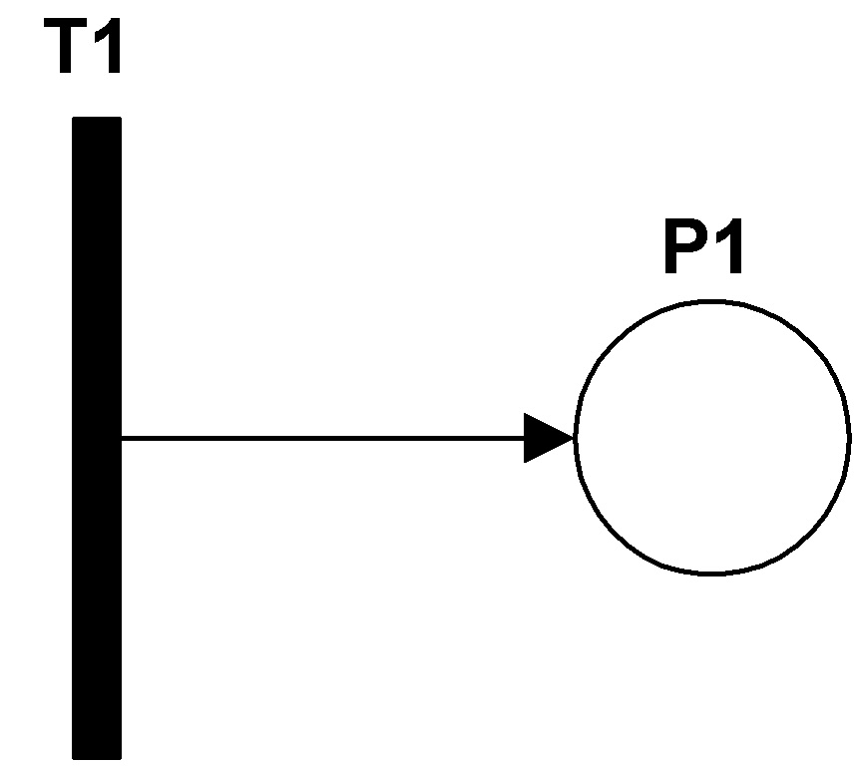  - Verify t1 fires continuously  - Verify P1’s token count keep incrementing. | PASS: According to the pnmark tool output:  Petri Net places: p1  Petri Net transitions: t1  (0)  |  |  t1  |  V  (1)  |  |  t1  |  V  (2)  |  |  t1  |  V  (3)  Some of the contents of the original file were removed due to the repetitive information.  (19)  |  |  t1  |  V  (20)

Simulation Examples

This section describes the results obtained from simulating Petri Net models of real systems.

Mutual Exclusion Scenario

Figure 8 illustrates where two processes have to execute critical sections of code (places P3 and P4) but are not allowed to do it at the same time. That is, P3 and P4 must be mutually exclusive. To enforce this rule the processes must therefore grab a semaphore (P5) before entering their critical section (t1 or t2) and release the semaphore after exiting their critical section (t3 or t4). This Petri Net was taken from [1]. To run the simulation execute batch file mutual_exclusion. The simulation generates a mutual_exclusion.log file. results were analysed using the pnmark tool which needs to parse two files: mutual_exclusion.log and mutual_exclusion.ma. The simulation starts with the following marking: (1, 1, 0, 0, 1).

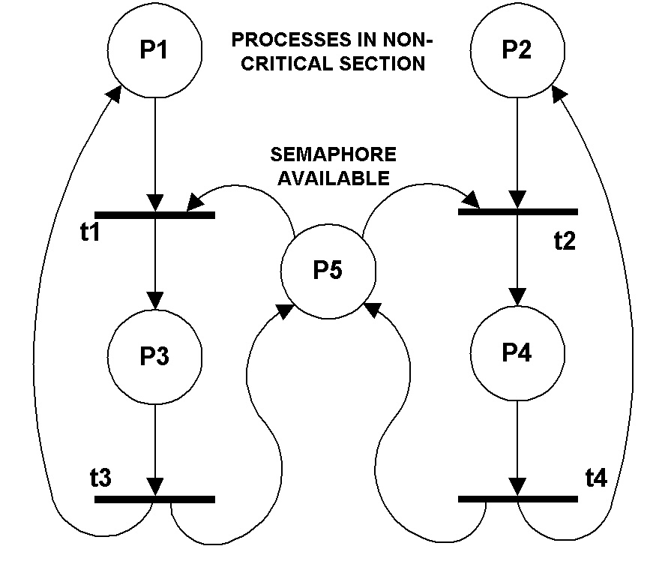
Figure 8. Mutual Exclusion Scenario

Results Analysis
The set of markings (mutual_exclusion.pn file) generated by the pnmark tool show that t1 fired first resulting in a marking of (0, 1, 1, 0, 0). Then t3 fired to bring the Petri Net back to its initial marking. This was followed by the firing of t2 resulting in a marking of (1, 0, 0, 1, 0). t4 then fired bringing the net back to its initial marking. In all cases the marking obtained after the firings was exactly like what was expected.

The rest of the markings are simply a repetition of the above except for the order in which the processes successfully take the semaphore. Sometimes a process may get the semaphore just after releasing it which is also expected since transitions t1 and t2 are always enabled at the same time and the decision to fire one or the other is made in a non deterministic manner.

Elevator

Figure 9 illustrates the elevator system that was studies in class. This version is known to be flawed so the main purpose of running this simulation is to see if the problems can be identified. To run the simulation execute batch file elevator. The simulation generates a elevator.log file. Results were analysed using the pnmark tool which needs to parse two files: elevator.log and elevator.ma. The simulation starts with the door closed and 10 people arriving: (1, 0, 0, 10, 0, 0).

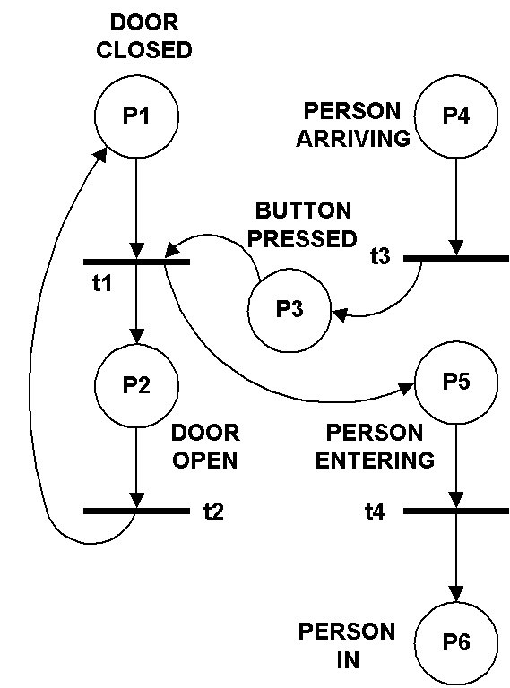
Figure 9. Elevator system

Results Analysis
The set of markings (elevator.pn file) generated by the pnmark tool show the following problems with the Petri Net:

- The door can go from open to close (t2 fires) even if the button is pressed (P3 not empty). Typically the door of an elevator stays opened as long as the button is pressed.
- The door can be closed (P1 = 1) while someone is entering the elevator (P5 not empty). This problem is a known flaw of the model and was discussed in class.
- The button can be pressed many times (P3 can be > 1). While this is physically possible for the button to be pressed many times, in reality an elevator button is pressed or not. That is, if it is pressed and someone presses it again it stays pressed, nothing more. I.e. its state is really Boolean.
- No one ever gets out of the elevator.

Two-Unit Asynchronous Pipeline

Figure 10 illustrates a two-unit asynchronous pipeline. This model is a modified version of an example found in [1]. Please see that reference for more details about the expected behaviour of that model and the type of real system it is meant to model. To run the simulation execute batch file pipeline. The simulation generates a pipeline.log file. Results were analysed using the pnmark tool which needs to parse two files: pipeline.log and pipeline.ma. The simulation starts with all input and output registers empty: (0, 0, 0, 0, 1, 1, 0, 0, 0, 0, 1, 0).
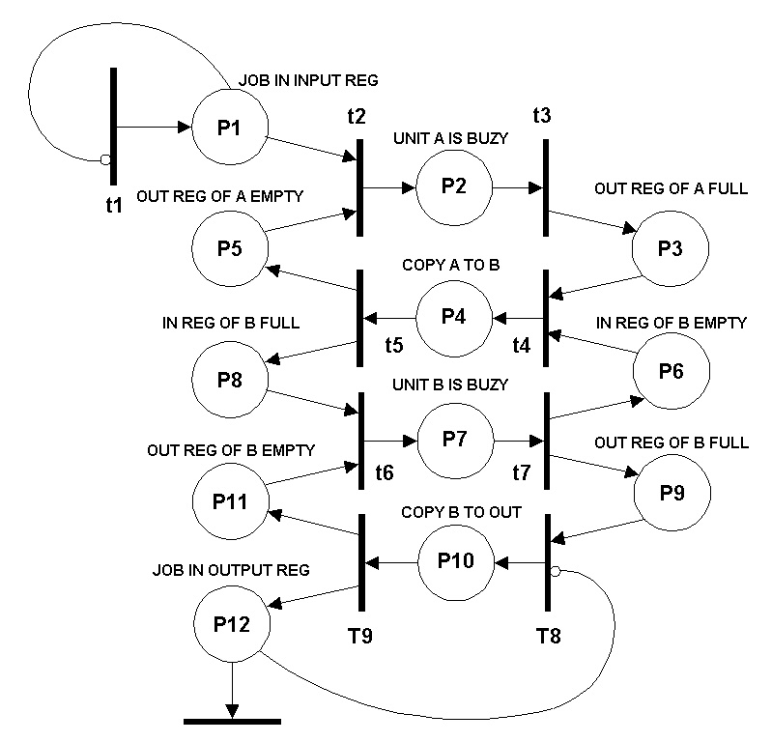
Figure 10. Two-unit asynchronous pipeline

Results Analysis
The set of markings (pipeline.pn file) generated by the pnmark tool show that the model behaved as expected. More specifically:
- None of the places contain more than one token at any given time.
- A unit’s input register is never empty and full at the same time. That is P3 and P5, P6 and P8, P9 and P11 are respectively mutually exclusive.

Multiprocessing

Figure 11 illustrates a multi-processing example. Whenever a task is ready, it is dispatched to either CPU A or CPU B if its is idle (waiting for a task to execute). The CPU then executes the task and becomes idle when the task pends for the availability of a resource, like a semaphore for example. Once the resource is freed, the task goes to the ready state and can be dispatched to one of the CPU again. The simulation generates a multiprocessing.log file. Results were analysed using the pnmark tool which needs to parse two files: multiprocessing.log and multiprocessing.ma. The simulation starts with five ready tasks, five pended tasks and idle CPUs: (5, 5, 0, 1, 0, 1)

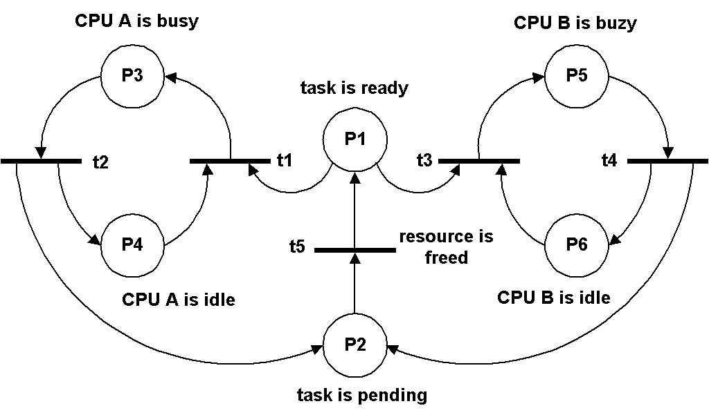
Figure 11. Multi-processing example

Results Analysis
The set of markings (multiprocessing.pn file) generated by the pnmark tool show that the model behaved as expected except it is possible for a task to go from the pended to the ready state while another task is ready and a CPU is idle. This is not an error per say but shows what could be considered an inversion in priority. Dispatching a task to a CPU should have higher priority than making a task ready. I.e. transitions t1 and t3 should have priority over t5 when they are enabled together.

Priority Scheduling

Figure 12 illustrates the model of a priority scheduler. Tasks of three different priorities (high, medium, low) can be ready to run. The aim is to dispatch to the CPU the one with the highest priority. Source transitions (t5, t6, t7) are used to simulate new tasks becoming ready to run. The simulation generates a scheduling.log file. Results were analysed using the pnmark tool which needs to parse two files: scheduling.log and scheduling.ma. The simulation starts with the CPU idle: (0, 1, 0, 0, 0)

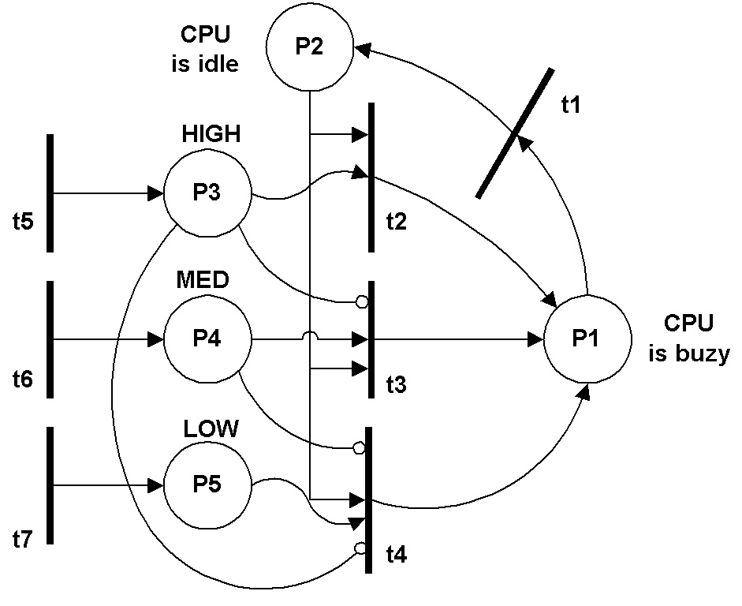
Figure 12. Priority scheduling

Results Analysis
The set of markings (scheduling.pn file) generated by the pnmark tool shows that t5 fired first generating a marking of (0, 1, 1, 1, 1) while (0, 1, 1, 0, 0) is expected from such a firing. In reality this is not a model or simulation problem but rather a bug in the pnmark tool. When more than one transition fires during the same time index, the tool only recognizes the first firing. In this case t5. Looking at the log file it can be seen that t5, t6, and t7 fired at index 00:00:57:000 which is why the second marking of the simulation is (0, 1, 1, 1, 1). This issue highlights the fact the transition atomic model uses time of day to seed the random number generator used to schedule firings. In this case, time of day was the same for all three transitions (t5, t6, t7) causing them all schedule a firing 00:00:57:000.

Another interesting issue is the fact low and medium priority tasks never get dispatched because high priority tasks come in faster than the CPU can execute them. The reason is because it only takes one firing (either t5, t6 or t7) to input a new task in the system while it takes two (either t2, t3, or t3 AND t1) to completely process a task.

During the entire simulation, t2 fired 23 times. Using this in conjunction with the final marking (0, 1, 31, 50, 52) one can see that t3, t4, t5, which always enabled, fired 54, 50 and 52 times. This fairly uniform distribution confirms the technique used to select transitions in a non deterministic manner is effective.

Conclusion

After reviewing the requirements listed in sections 1 and 2, it can be concluded that this assignment was completed successfully. Based on the results obtained with the simulation runs described in section 7 it is believed the atomic models and the pnmark tool will be truly useful for Petri Net modellers wishing to simulate Petri Nets using the CD++ tool.

That being said, the following enhancements are suggested:

- The pnTrans model should use the ID of the model (as assigned by the simulator) in addition to the time of day to seed the random number generator. This would prevent transitions from scheduling firings at identical times for scenarios such as the one described in section 7.5.1.
- In order to prevent two or more pnTrans models to fire at identical times, the ID of the model should be converted to millisecond and added to the scheduled firing time.
- Petri Nets should be made into a new model type (i.e. specify “Type : PN” in the .ma) and the simulator should be modified to be more intelligent regarding Petri Nets. For example, the active/passive state should be made equivalent to enabled/disabled for transitions. This way the simulator would know which transitions are candidates for firing and it could decide which one should go next. This would remove all problems associated with concurrent firings as well as fixing the shrinking timing window described in section 4.1 because a “lottery” would be held by the simulator for each firing. Therefore the fact a transition has not fired for a long time would not increase the possibility that it will be the next one to fire. Also, the simulator should know that when a link is made between the output of a place and the input of a transition, a reverse link exists so that tokens can be removed from the input place. This would prevent having the modeller specifically list the links like: Link : fired@pnTrans in@pnPlace.
- The inputplaces parameter of the pnTrans model need not exist since it is related to the implementation of the transition and offers no added value to the modeller. If the transition model were modified to use a linked list as opposed to an array for its database, nodes (one for each input place) could simply be added dynamically.

References
- Peterson, James L. “Petri Nets”. ACM Computing Surveys, Vol 3, No. 5. September 1977. pp 221-252.

