94.587 Modelling Discrete-Event Systems Using DEVS (2008 Fall)

Assignment#2

Cell-DEVS Photo Resist Etching Model

Ahmad Mizan

Carleton University

1. Brief description of conceptual models

Etching is a process frequently used in chemical processing of semiconductor materials. In these processes a chemical material is used to dissolve layers of semiconductor and metal to form them into a desirable shape. A photo-resist is used to conduct the etchant material to the desired areas and to prevent unwanted surfaces from etching.
In our 2D modelling, a photo-resist is divided into a matrix of identical square cells with side length a. As the etchant material flows from the adjacent cells to an unetched cell, the cell starts being etched. The local state of each cell at time t, C_{i,j} (t), is defined as the ratio of the etched cell area to the total area:
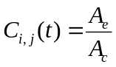
A_{e} and A_{c} are the etched and total cell areas, respectively. During the simulation, C_{i,j} varies from 0 (unetched ) to 1 (fully etched). An etching rate, R_{i,j} is attributed to each cell (i,j) which determines the speed in which the cell is etched. The etching rate is provided by an etch-rate distribution function. The state of the (i, j) cell at time t=t₁ +T is:
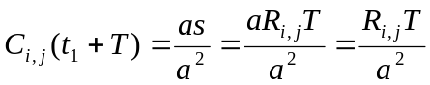
where s is the distance in the (i, j) cell covered by the etchant in time T.
A cell’s neighborhood consists of itself, plus the three squares immediately to its north, east, or west.

 | (i-1, j)
(i, j-l) | (i, j) | (i, j+l)

Neighbourhood of the etching cell

Cellular Automata provides a very complex solution for modelling this process. In CA, times steps are constant, therefore, in one time step the cell might be either partially etched or over etched. This has resulted to creation of an undetermined number of states. In Cell-DEVS modelling we take the time step as large as the time required to fully etch a cell and only deal with fully etch and unetched cell states.

1.1 Different forms of getting etched from neighbours:
1.1.2 Etching of a boundary cell with one adjacent cell. The coloured cell is unetched whereas the white cell is fully etched

1.1.2 Etching of a boundary cell with two adjacent cell

1.1.3 Etching of a boundary cell with three adjacent cell

`

The rules for cellular etching are as follows:

- An unetched cell starts getting etched when at least one of its neighbors is completely etched
- The etching rate corresponding to the location of a cell determines its etching time step
- The etch rate is twice when two neighboring cells are etched
- The etch rate is three times when three neighbors are etched
- Etch rate is not fixed and is determined by the etch distribution function
This system is closed and no input and outputs are requited. An initial value for a set of cells at the surface is provided. Etching gets started from then on and finished when all cells are etched.

2. Cell-DEVS Model

The Cell-DEVS model will be based on a two-dimensional square grid. The etching rate of each cell depends of its location. An etch-rate distribution function, which is defined as a macro, provides this value for this model. For different application this function should be provided by corresponding discipline.

2.1 Formal Specification

The formal specification of the coupled Cell-DEVS model is given by

GCC = <Xlist, Ylist, I, X, Y, η, N, {f, c}, C, B, Z, select>

Where:

Xlist = { }; %No input
Ylist = { } ; %No output
X = Y = { 0, 1 }; % etched and un etched

I = <P^{X} , P^{Y}>, with P^{X} = { }; P^{Y} = { };
η = 5;
N = { (-1,0) , (0,-1) , (0,0) , (0,1) , (1,0) };
f = c = 20;
C = { Cij / i ε [ 1,20] , j ε [1,20] };
B = { }; (unwrapped)
Z :

Pij Y1 → Pi,j-1 X1  Pij Y2 → Pi+1,j X2  Pij Y3 → Pi,j+1 X3 | Pi,j+1 Y1 → Pij X1  Pi-1,j Y2 → Pij X2  Pi,j-1 Y3 → Pij X3

Select = { (-1,0) , (0,1) , (0,0) , (0,1) , (1,0) };

CD++ implementation of the model is as follows:
include(var.inc)

[top]
components : PEtch

[PEtch]
type : cell
dim : (20,20)
delay : inertial
defaultDelayTime : 100
border : nowrapped
neighbors : PEtch(-1,0)
neighbors : PEtch(0,-1) PEtch(0,0) PEtch(0,1)
neighbors : PEtch(1,0)

initialvalue : 0

initialrowvalue : 0 00001111111111110000
localtransition : EtchBehavior
%initialCellsValue : PEtch.val

[EtchBehavior]
rule : 1 {#macro(T)} {(0,0)=0 and (-1,0)=1 and (0,-1)=0 and (0,1)=0}
rule : 1 {#macro(T)} {(0,0)=0 and (-1,0)=0 and (0,-1)=1 and (0,1)=0}
rule : 1 {#macro(T)} {(0,0)=0 and (-1,0)=0 and (0,-1)=0 and (0,1)=1}

rule : 1 {2*#macro(T)} {(0,0)=0 and (-1,0)=1 and (0,-1)=0 and (0,1)=1}
rule : 1 {2*#macro(T)} {(0,0)=0 and (-1,0)=1 and (0,-1)=1 and (0,1)=0}
rule : 1 {2*#macro(T)} {(0,0)=0 and (-1,0)=0 and (0,-1)=1 and (0,1)=1}

rule : 1 {3*#macro(T)} {(0,0)=0 and (-1,0)=1 and (0,-1)=1 and (0,1)=1}

rule : {(0,0)} 0 { t }

The macro functions provide the delay, T, determined by etching distribution factions. Two different delay based on two different etch distribution function are tested in this project:
#BeginMacro(T)
5000/(20/((abs(cellpos(1)+(-10)+0.5))))
#EndMacro

#BeginMacro(TT)
5000/(5/exp((cellpos(1)+(-10)+0.5)*(cellpos(1)+(-10)+0.5)))
#EndMacro

Rules:
- If the state of a cell is 0 (unetched), it changes to 1 after a delay of T, which depends on the cell location, when at least one of its neighbors is 1.
- If two neighbors of a cell are 1, its delay is reduced to one half
- If three neighbors of a cell are 1, its delay is reduced to one third

3. Testing strategy and the model execution results

The etching model is tested with different etching distribution functions. The following result is obtained with distribution function of “1/x”, where x is horizontal location of a cell.

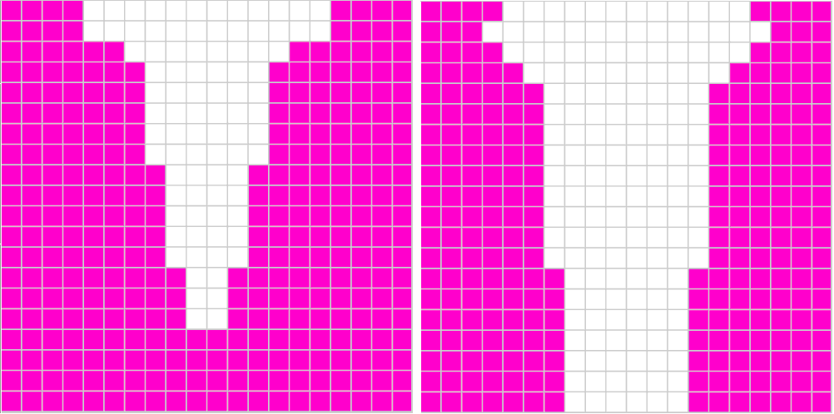
When exponential distribution function ( exp(-x) ) is used the following result is obtained:

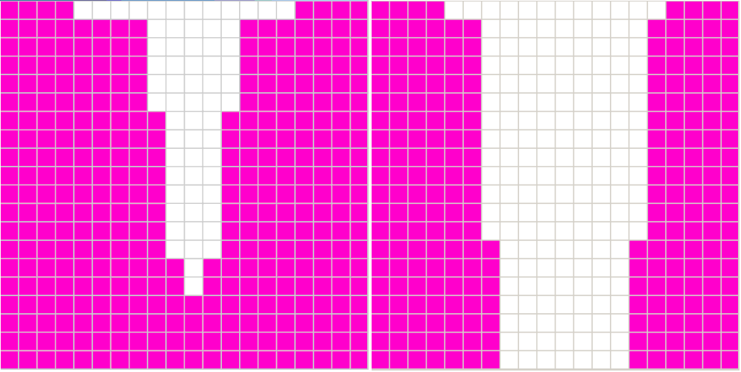

4. Variations made to the original specification
- The original specification considers effects of 9 neighbors including the diagonal neighbors. In an etching process these cells shouldn’t have significant effect since diagonal connection does not create enough connection surface between the two cells.
- State variable is analog and a method has chosen to determine when a cell is over-etched, the excessive etching gets transferred to the next adjacent neighbor. In Cell-DEVS there are two states of etched and unetched and time step to change step is variable.

5. Reference:
Zai-fa Zhou et. al. , “A Two Dimensional Dynamic Cellular Automata Model for Simulation of Photoresist Etching Process”, Solid atete and integrated circuits technology, Vol. 2, 18-21 Oct. 2004, page(s): 1076-1079

