SYSC-5807 METHODOLOGICAL ASPECTS OF MODELLING AND SIMULATION

Assignment 2

Pengfei Wu Student#:100258560

Xiuping Wu Student#:100258863

{pfwu, xpwu}@sce.carleton.ca

November 12, 2003

Systems and Computer Engineering, Carleton University

Part I: Description of the Conceptual Model
Introduction:
This assignment is based on the paper “Free-form Shape Modeling by 3D Cellular Automata” (International Conference on Shape Modeling and Applications March 01 - 04, 1999, Aizu-Wakamatsu, Japan). We consider the deformation in a 2D space using Margolus neighborhood. The deformation modeling proposed in the paper is based on simple distribution rules of virtual clay. When the density of virtual clay in all cells is under a certain threshold, the whole space is stable and keeps the current shape. Each cell in the space is assigned a value which represents the mass of virtual clay that it holds. Each cell can hold a certain amount of mass and will distribute it to its neighbors when the mass is over its threshold. Its neighbors can accept extra mass only if they are under the threshold. A pushing operation on the surface will lead to its deformation. The deformation is transported from high density potion to low density portion. However, the total mass of virtual clay within the object must be conserved.

Margolus Neighborhood:

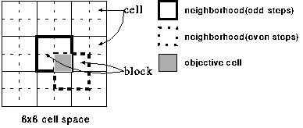
Fig.1. 2D Margolus neighborhood
Fig.1 shows an example of 2D Margolus neighborhood. In 2D Margolus neighborhood, the adjacent 4 cells form one block, transitions of all cells within a block are performed in one step. The boundaries of blocks are changed step by step as shown in Fig.1. Hence each cell alternates its neighborhood in every transition step.

Transition rule:
The state transition rule for virtual clay distribution is as follows. Let the state of a cell be 1 if its virtual clay is over the threshold. Otherwise, let the state be 0.
[Step 1] For each cell in one block k of which state is 1,
mk =(1 – alpha) *mk
where mk is the mass of virtual clay of cell k, and alpha is a rate constant for distribution (0 < alpha < 1).
[Step 2] For each cell j in one block of which state is 0,
dmk = alpha *mk, (k=1, 2, 3)
mj = mj + ((dm1 + dm2 + ... + dmr) / n),
where n is the number of the cells in one block whose state is 0, and r is the number of the cells in one block whose state is 1.
In addition, for each block, no transitions will happen if all cells in the block are state 1 (over threshold), or all cells in the block are state 0 (under threshold).

Operation description:
The plastic deformation of a virtual clay object is based on a push operation by using a moving plate. The push operation is realized by transferring all virtual clay in a cell into the adjacent cells along the direction of pushing. The surface of a virtual clay object can be pushed at most one cell in depth per step.

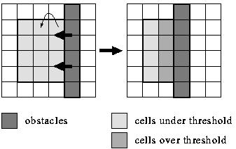
Fig 2. Push operation by a moving plate.

Fig 2. shows an example of the push operation by a moving plate. As a result of pushing, some cells will become over threshold and its virtual clay will be distributed around according to the transition rule described above. The state transitions are repeated until no cells over threshold.
Parameters selection:
The parameter alpha selected is 0.3. The initial values of each cell within the object are 20, and threshold is 21.

Part II: Formal Specification of the Coupled Cell-DEVS model
In order to model the behavior of the deformation of virtual clay, three planes have been used: plane 0 are the cells that represent the virtual clay, plane 1 controls alternating boundaries of Margolus neighborhood and plane 2 controls the moving plate. In our case, the plate moves along the direction from South to North (upwards).
*
Plane 0: Cells of virtual clay

Fig 3 Neighborhood Cells in Plane 0

M=<I,X,Y,Xlist,Ylist,η, N,{m,n}, C, B, Z, select>
Xlist=Φ
Ylist=Φ
η=12
I=<P^{X}, P^{y}>, with P^{X}=Φ, P^{y}=Φ;
N={(-1,-1,0), (-1,0,0),(-1,1,0), (0,-1,0), (0,0,0), (0,1,0), (1,-1,0), (1,0,0), (1,1,0),(2,-1,0), (2,0,0), (2,1,0)}
X={x | x ε R₀⁺};
Y={y | y ε R₀⁺};
m=10; n=9;
B={ (Cij | i =1, 10; j ε[1, 9]), (Cij | j=1,9; i ε[1, 10]) };
C={Cij / iε[1,10], jε[1,9]}
Z:
P_{ij}^{Y1}→P_{i,j-1}^{X1} P_{i,j+1}^{Y1}→Pij^{X1}
P_{i}j^{Y2}→P_{i+1,j}^{X2} P_{i-1,j}^{Y2}→P_{ij}^{X2}
P_{ij}^{Y3}→P_{i,j+1}^{X3} P_{i,j-1}^{Y3}→Pij^{X3}
P_{ij}^{Y4}→P_{i-1,j}^{X4} P_{i+1,j}^{Y4}→P_{ij}^{X4}
P_{ij}^{Y5}→P_{ij}^{X5} P_{ij}^{Y5}→P_{ij}^{X5}
P_{ij}^{Y6}→P_{i+1,j+1}^{X6} P_{i-1,j-1}^{Y6}→P_{ij}^{X6}
P_{ij}^{Y7}→P_{i-1,j-1}^{X7} P_{i+1,j+1}^{Y7}→P_{ij}^{X7}
P_{ij}^{Y8}→P_{i+1,j-1}^{X8} P_{i-1,j+1}^{Y8}→P_{ij}^{X8}
P_{ij}^{Y9}→P_{i-1,j+1}^{X9} P_{i+1,j-1}^{Y9}→P_{ij}^{X9}
Select={(0,0,1),(0,0,2), (-1,-1,0), (-1,0,0),(-1,1,0), (0,-1,0), (0,0,0), (0,1,0), (1,-1,0), (1,0,0), (1,1,0),(2,-1,0), (2,0,0), (2,1,0)}

Plane 1: Cells that controls the boundary of Margolus block in plane 0
*

Fig 4 Neighborhood Cells in Plane 1

The cells in this plane take value of 0 or 1 alternatively so that the boundary of the Margolus neighborhood is changing alternatively.

M=<I,X,Y,Xlist,Ylist,η, N,{m,n}, C, B, Z, select>
Xlist=Φ
Ylist=Φ
η=1
I=<P^{X}, P^{y}>, with P^{X}=Φ, P^{y}=Φ;
N={(0,0,1)}
X=Y= {0,1};
m=10; n=9;
B={ (Cij | i =1, 10; j ε[1, 9]), (Cij | j=1,9; i ε[1, 10]) };
C={Cij / iε[1,10], jε[1,9]}
Z:
P_{ij}^{Y1}→P_{ij}^{X1}
Select={(0,0,1)}

Plane 2: Cells that controls the plate moving from South towards North (upwards).
The cells in this plane take value of 0 or 1 alternatively so that the new position of plate changes to the top layer while the mass from the top layer added to the second top layer.

*

Fig 5 Neighborhood Cells in Plane 2

M=<I,X,Y,Xlist,Ylist,η, N,{m,n}, C, B, Z, select>
Xlist=Φ
Ylist=Φ
η=1
I=<P^{X}, P^{y}>, with P^{X}=Φ, P^{y}=Φ;
N={(0,0,2)}
X=Y= {0,1};
m=10; n=9;
B={ (Cij | i =1, 10; j ε[1, 9]), (Cij | j=1,9; i ε[1, 10]) };
C={Cij / iε[1,10], jε[1,9]}
Z:
P_{ij}^{Y1}→P_{ij}^{X1}
Select={(0,0,1)}

Part III The Simulation Results
Some Explanation to the rules:

The transition rules for deformation are as follows:
1) If the cell in plane 0 is above threshold 21 and there exists at least one of the Margolus neighbors within the block is lower than threshold, do the following:
mk = 0.7 * mk; where mk is the mass value of that cell.
2) If the cell in plane 0 is under threshold 21 and there exists at least one of the Margolus neighbors within the block is above threshold, do the following:
mk = mk + 0.3*(the mass of the neighbors above threshold 21 within the block)/(number of neighbors under 21 including itself).
3) Otherwise, the cell in plane 0 keeps current state.

Note: there is one exception here. If the cells above threshold are adjacent to the plate (or at the edge of the object), it won’t distribute the mass to its neighbors. As in this case, the neighbors are cells in the position of plate or at the bottom edge.

Since the boundary of the Margolus neighborhood is changing in each step alternatively, every time the cell in plane 0 needs to check the value of its neighbor (0,0,1) which is in the second plane. An example of cells within one Margolus block is shown in Figure 5. The value of cells in this plane is taking value 0 or 1 alternatively. The following two rules implement this.

1
0
0
0
0
1
1
1

Fig 6 An example of cell values in one Margolus block in plane 1

rule : 1 100 { cellpos(2)=1 and (0,0,0)=0 }
rule : 0 100 {cellpos(2)=1 and (0,0,0)=1}
Figure 7 and 8 illustrates the plate moving in one step. After moving, the cells in the column of East most will be added to the second column to the South most.

20
20
20
20
20
20
20
20
20
20
20
20
20
20
20
20
40
40
40
40
0
0
0
0

Figure 7: Cells before plate moving Figure 8: Cells after plate moving

The plate moving is implemented using the following rules:

%step 1: add the first row to the second row

rule : {(0,0,0)+(1,0,0)} 100 {(0,0,2) = 1 and cellpos(2)=0 and cellpos(0) < 8 and ((2,-1,0)=0 and (2,0,0)=0 and (2,1,0)=0 )and ((1,0,0)>0 or (1,-1,0)>0 or (1,1,0)>0)}

%step2 :change the first row to 0

rule : 0 100 {(0,0,2) = 1 and cellpos(2)=0 and cellpos(0) < 9 and ((1,-1,0)=0 and (1,0,0)=0 and (1,1,0)=0 ) and ((0,0,0)>0 or (0,-1,0)>0 or (0,1,0)>0)}

%update the cells in plane 2 which controls plate moving

rule : 1 3000 { cellpos(2)=2 and (0,0,0)=0 }
rule : 0 100 {cellpos(2)=2 and (0,0,0)=1}

To run the model, the initial values in plane 0 looks like the following:

1
0
0
0
0
0
0
0
0
0
2
0
0
0
20
20
20
0
0
0
3
0
0
0
20
20
20
0
0
0
4
0
0
0
20
20
20
0
0
0
5
0
0
0
20
20
20
0
0
0
6
0
0
0
20
20
20
0
0
0
7
0
0
0
20
20
20
0
0
0
8
0
0
0
20
20
20
0
0
0
9
0
0
0
20
20
20
0
0
0
0
0
0
0
0
0
0
0
0
0
1
2
3
4
5
6
7
8
0

Figure 9 Initial values in plane 0

The initial values in plane 1 looks like the following:

1
0
0
0
0
0
0
0
0
0
2
0
0
0
0
0
0
0
0
0
3
0
0
0
0
0
0
0
0
0
4
0
0
0
0
0
0
0
0
0
5
0
0
0
0
0
0
0
0
0
6
0
0
0
0
0
0
0
0
0
7
0
0
0
0
0
0
0
0
0
8
0
0
0
0
0
0
0
0
0
9
0
0
0
0
0
0
0
0
0
0
0
0
0
0
0
0
0
0
0
1
2
3
4
5
6
7
8
0

Figure 10 Initial values in plane 1

The initial values in plane 2 looks like the following:

1
1
1
1
1
1
1
1
1
1
2
1
1
1
1
1
1
1
1
1
3
1
1
1
1
1
1
1
1
1
4
1
1
1
1
1
1
1
1
1
5
1
1
1
1
1
1
1
1
1
6
1
1
1
1
1
1
1
1
1
7
1
1
1
1
1
1
1
1
1
8
9
0
1
2
3
4
5
6
7
8
0
1
1
1
1
1
1
1
1
1
1
1
1
1
1
1
1
1
1
1
1
1
1
1
1
1
1
1
1
1
1
1
1
1
1
1
1
1
1
1
1
1
1
1
1
1
1
1
1
1
1
1
1
1
1

Figure 11 Initial values in plane 2

Part of the output in plane 0 which is our focus is explained as follows:

Time: 00:00:00:000
0.000 0.000 0.000 0.000 0.000 0.000 0.000 0.000 0.000
0.000 0.000 0.000 20.000 20.000 20.000 0.000 0.000 0.000
0.000 0.000 0.000 20.000 20.000 20.000 0.000 0.000 0.000
0.000 0.000 0.000 20.000 20.000 20.000 0.000 0.000 0.000
0.000 0.000 0.000 20.000 20.000 20.000 0.000 0.000 0.000
0.000 0.000 0.000 20.000 20.000 20.000 0.000 0.000 0.000
0.000 0.000 0.000 20.000 20.000 20.000 0.000 0.000 0.000
0.000 0.000 0.000 20.000 20.000 20.000 0.000 0.000 0.000
0.000 0.000 0.000 20.000 20.000 20.000 0.000 0.000 0.000
0.000 0.000 0.000 0.000 0.000 0.000 0.000 0.000 0.000

The above are the initial values defined in plane 0. The plate which is now adjacent to the ninth row and is going to move towards the upper layer.

Time: 00:00:00:100
0.000 0.000 0.000 0.000 0.000 0.000 0.000 0.000 0.000
0.000 0.000 0.000 20.000 20.000 20.000 0.000 0.000 0.000
0.000 0.000 0.000 20.000 20.000 20.000 0.000 0.000 0.000
0.000 0.000 0.000 20.000 20.000 20.000 0.000 0.000 0.000
0.000 0.000 0.000 20.000 20.000 20.000 0.000 0.000 0.000
0.000 0.000 0.000 20.000 20.000 20.000 0.000 0.000 0.000
0.000 0.000 0.000 20.000 20.000 20.000 0.000 0.000 0.000
0.000 0.000 0.000 40.000 40.000 40.000 0.000 0.000 0.000
0.000 0.000 0.000 0.000 0.000 0.000 0.000 0.000 0.000
0.000 0.000 0.000 0.000 0.000 0.000 0.000 0.000 0.000

At time 00:00:00:100, the plate is moving to one layer up. We can see that the cells in the eighth row that had values of 20 before are now having values of 40. And the cells in the ninth row that has values of 20 now change to 0.

Time: 00:00:00:200
0.000 0.000 0.000 0.000 0.000 0.000 0.000 0.000 0.000
0.000 0.000 0.000 20.000 20.000 20.000 0.000 0.000 0.000
0.000 0.000 0.000 20.000 20.000 20.000 0.000 0.000 0.000
0.000 0.000 0.000 20.000 20.000 20.000 0.000 0.000 0.000
0.000 0.000 0.000 20.000 20.000 20.000 0.000 0.000 0.000
0.000 0.000 0.000 20.000 20.000 20.000 0.000 0.000 0.000
0.000 0.000 0.000 20.000 20.000 20.000 0.000 0.000 0.000
0.000 0.000 0.000 40.000 40.000 40.000 0.000 0.000 0.000
0.000 0.000 0.000 0.000  0.000 0.000  0.000 0.000 0.000
0.000 0.000 0.000 0.000 0.000 0.000 0.000 0.000 0.000

At time 00:00:00:200, the two boxes shown above indicate the Margolus neighbourhood at this time. Since the pushing is upwards, the mass distribution is upwards as well. According to the transition rule, the cells in the block won’t distribute anything to its neighbours. In block , although the cells in the eighth row have values of 40 which are above the threshold 21, the neighbours in that block which are under the threshold, the pushing direction is upwards, therefore, the over threshold cells will not distribute the mass to neighbours in the lower layer. In block , the same thing for the lower layer, and we do not want to distribute the mass to the side in this case since all the neighbours are having values of zero.

Time: 00:00:00:300
0.000 0.000 0.000 0.000 0.000 0.000 0.000 0.000 0.000
0.000 0.000 0.000 20.000 20.000 20.000 0.000 0.000 0.000
0.000 0.000 0.000 20.000 20.000 20.000 0.000 0.000 0.000
0.000 0.000 0.000 20.000 20.000 20.000 0.000 0.000 0.000
0.000 0.000 0.000 20.000 20.000 20.000 0.000 0.000 0.000
0.000 0.000 0.000 20.000 20.000 20.000 0.000 0.000 0.000
0.000 0.000 4.000 24.000 32.000 32.000 0.000 0.000 0.000
0.000 0.000 4.000 28.000 28.000 28.000 0.000 0.000 0.000
0.000 0.000 0.000 0.000 0.000 0.000 0.000 0.000 0.000
0.000 0.000 0.000 0.000 0.000 0.000 0.000 0.000 0.000

At this time, we can see the Margolus neighbourhood has now changed as shown in the boxes above. The cells above threshold have now distributed some of the mass to the neighbours in one block according to the transition rule. The cells having values of 40 before now become 28 (40 * 0.7 =28). Those under threshold in the block have received the extra mass (i.e. in the left box, 0 + 40*0.3/3 =4,
20 + 40*0.3/3=24. In the right box, 20+(40*0.3 + 40*0.3)/2=32.) The total mass is conserved.

Time: 00:00:00:400
0.000 0.000 0.000 0.000 0.000 0.000 0.000 0.000 0.000
0.000 0.000 0.000 20.000 20.000 20.000 0.000 0.000 0.000
0.000 0.000 0.000 20.000 20.000 20.000 0.000 0.000 0.000
0.000 0.000 0.000 20.000 20.000 20.000 0.000 0.000 0.000
0.000 0.000 0.000 20.000 20.000 20.000 0.000 0.000 0.000
0.000 0.000 0.000 28.400 28.400 23.200 3.200 0.000 0.000
0.000 0.000 4.000 16.800 22.400 22.400 3.200 0.000 0.000
0.000 0.000 4.000 28.000 28.000 28.000 0.000 0.000 0.000
0.000 0.000 0.000 0.000 0.000 0.000 0.000 0.000 0.000
0.000 0.000 0.000 0.000 0.000 0.000 0.000 0.000 0.000

At this time, the cells over threshold distribute mass further in the changed Margolus neighborhood according to the transition rules. The total mass is conserved. The detailed analysis is similar to that explained above at time 00:00:00:300.

For the rest the output, the cells keep changing according to the transition rules explained before. The total mass is always conserved. We can see the distribution is along the pushing direction which is upwards.

As the time step advances, the boundary of the Margolus neighborhood is changing as well. The deformation distribution is carried out alternatively in the odd time step and even time step. The test case that we have given here has tested all the possible rules as time advances.

Time: 00:00:00:500
0.000 0.000 0.000 0.000 0.000 0.000 0.000 0.000 0.000
0.000 0.000 0.000 20.000 20.000 20.000 0.000 0.000 0.000
0.000 0.000 0.000 20.000 20.000 20.000 0.000 0.000 0.000
0.000 0.000 0.000 20.000 20.000 20.000 0.000 0.000 0.000
0.000 0.000 2.840 22.840 27.740 27.740 0.000 0.000 0.000
0.000 0.000 2.840 19.880 19.880 16.240 3.200 0.000 0.000
0.000 0.000 6.800 19.600 22.400 22.400 3.200 0.000 0.000
0.000 0.000 6.800 19.600 28.000 28.000 0.000 0.000 0.000
0.000 0.000 0.000 0.000 0.000 0.000 0.000 0.000 0.000
0.000 0.000 0.000 0.000 0.000 0.000 0.000 0.000 0.000

Time: 00:00:00:600
0.000 0.000 0.000 0.000 0.000 0.000 0.000 0.000 0.000
0.000 0.000 0.000 20.000 20.000 20.000 0.000 0.000 0.000
0.000 0.000 0.000 20.000 20.000 20.000 0.000 0.000 0.000
0.000 0.000 0.000 27.587 27.587 22.774 2.774 0.000 0.000
0.000 0.000 2.840 15.988 19.418 19.418 2.774 0.000 0.000
0.000 0.000 2.840 22.120 22.120 18.480 5.440 0.000 0.000
0.000 0.000 6.800 21.840 15.680 15.680 5.440 0.000 0.000
0.000 0.000 6.800 19.600 28.000 28.000 0.000 0.000 0.000
0.000 0.000 0.000 0.000 0.000 0.000 0.000 0.000 0.000
0.000 0.000 0.000 0.000 0.000 0.000 0.000 0.000 0.000
Time: 00:00:00:700
0.000 0.000 0.000 0.000 0.000 0.000 0.000 0.000 0.000
0.000 0.000 0.000 20.000 20.000 20.000 0.000 0.000 0.000
0.000 0.000 2.759 22.759 27.554 27.554 0.000 0.000 0.000
0.000 0.000 2.759 19.311 19.311 15.942 2.774 0.000 0.000
0.000 0.000 5.052 18.200 21.630 21.630 2.774 0.000 0.000
0.000 0.000 5.052 15.484 15.484 20.692 5.440 0.000 0.000
0.000 0.000 8.984 15.288 24.080 24.080 5.440 0.000 0.000
0.000 0.000 8.984 21.784 19.600 19.600 0.000 0.000 0.000
0.000 0.000 0.000 0.000 0.000 0.000 0.000 0.000 0.000
0.000 0.000 0.000 0.000 0.000 0.000 0.000 0.000 0.000
Time: 00:00:00:800
0.000 0.000 0.000 0.000 0.000 0.000 0.000 0.000 0.000
0.000 0.000 0.000 27.547 27.547 22.755 2.755 0.000 0.000
0.000 0.000 2.759 15.931 19.288 19.288 2.755 0.000 0.000
0.000 0.000 2.759 21.474 21.474 18.105 4.937 0.000 0.000
0.000 0.000 5.052 20.363 15.141 15.141 4.937 0.000 0.000
0.000 0.000 5.052 17.892 17.892 23.100 7.848 0.000 0.000
0.000 0.000 8.984 17.696 16.856 16.856 7.848 0.000 0.000
0.000 0.000 8.984 21.784 19.600 19.600 0.000 0.000 0.000
0.000 0.000 0.000 0.000 0.000 0.000 0.000 0.000 0.000
0.000 0.000 0.000 0.000 0.000 0.000 0.000 0.000 0.000
Bonus Part: Using VRML GUI
We have successfully installed the GUI at home, and found that it took for ever to load the draw file (plastic.drw) because the size of file is too big. Therefore, we tried another example to identify if there are any problems with the GUI. Below are some screenshots for the example Clouds from the website.

Debug report:

- Failed in netscape 6.2 on windows 2000 professional system. When we try to run it there is “Entry Point Not found” error message. The information is “The procedure entry point DdEntry1 could not be located in the dynamic link library GDI32.dll” and “The procedure entry point GetRawInputDeviceList could not be located in the dynamic link library USER32.dll”
- Failed in one IE on windows XP. Cannot browse the file when we wanted to load the draw file.

- Suggestion: If the size of draw file is too big, the tool should report “file is too big, stop loading…” or sth. like this after some time, instead of just prompting “Please Wait” and nothing happens after hours.

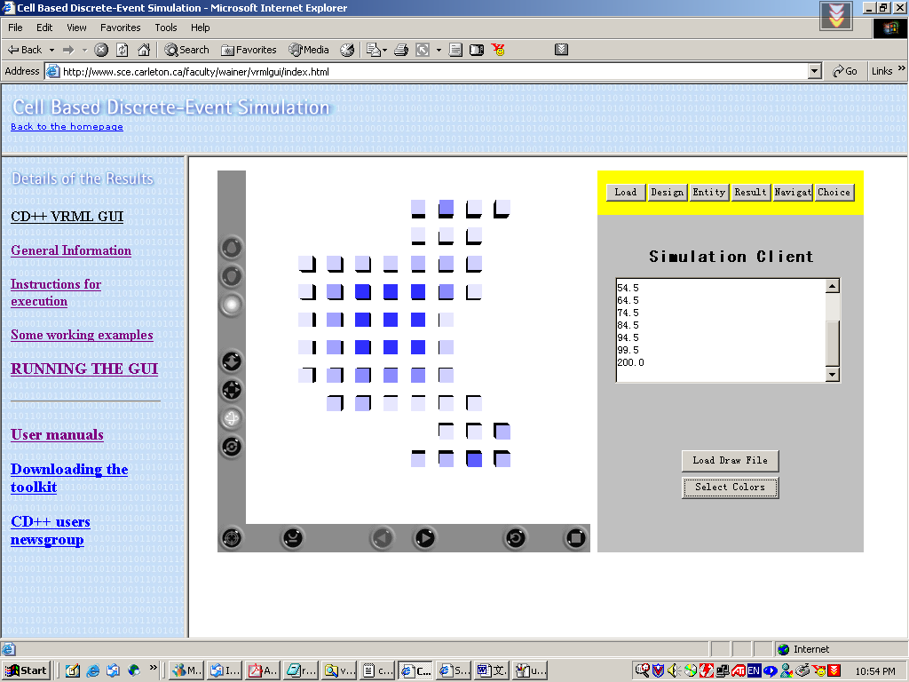

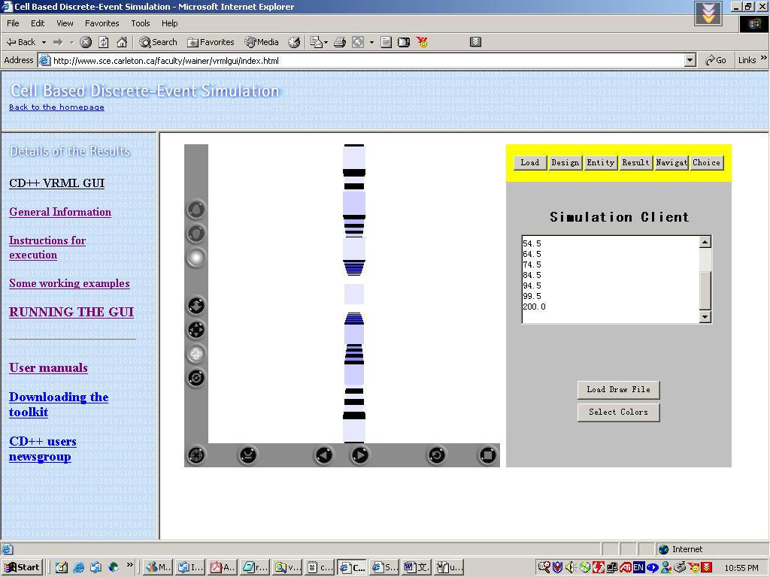

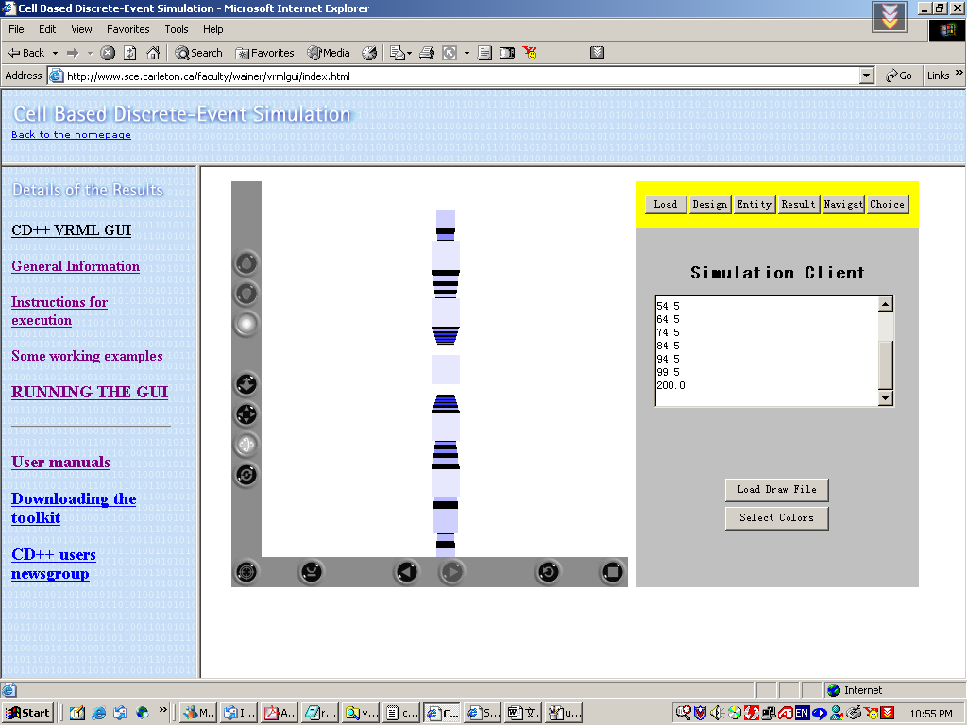

After choosing fit, the following screenshot is obtained.

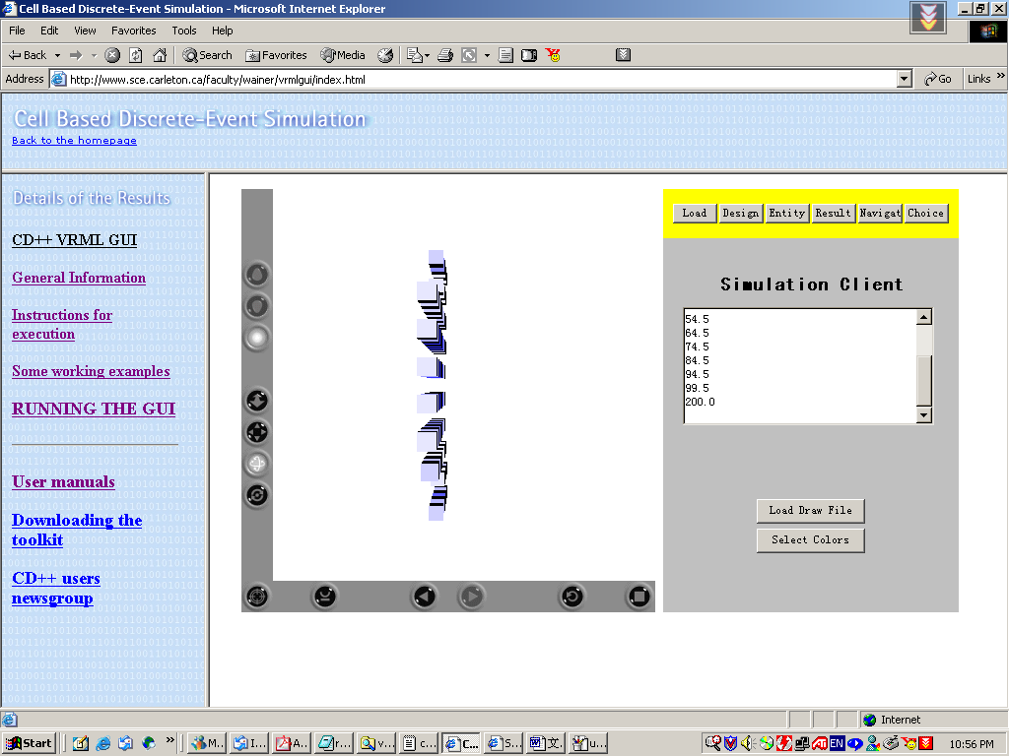

Assuming the rain is coming and cloud is dark, we changed the cloudsPalette.pal file. The following screenshots have been obtained :

Initially,

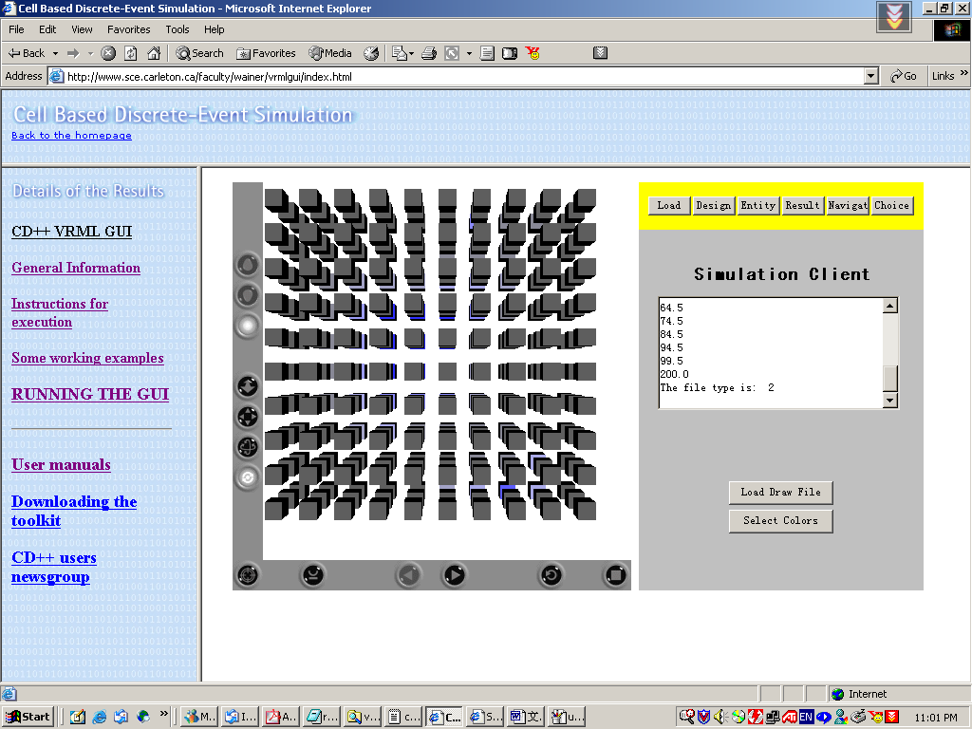

After choosing “fit”,
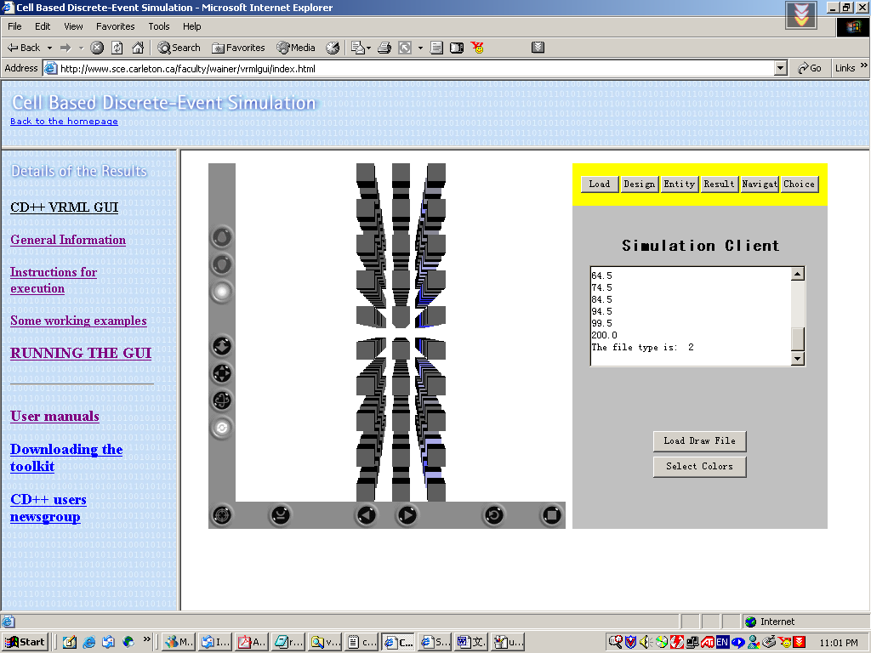

Roll it:
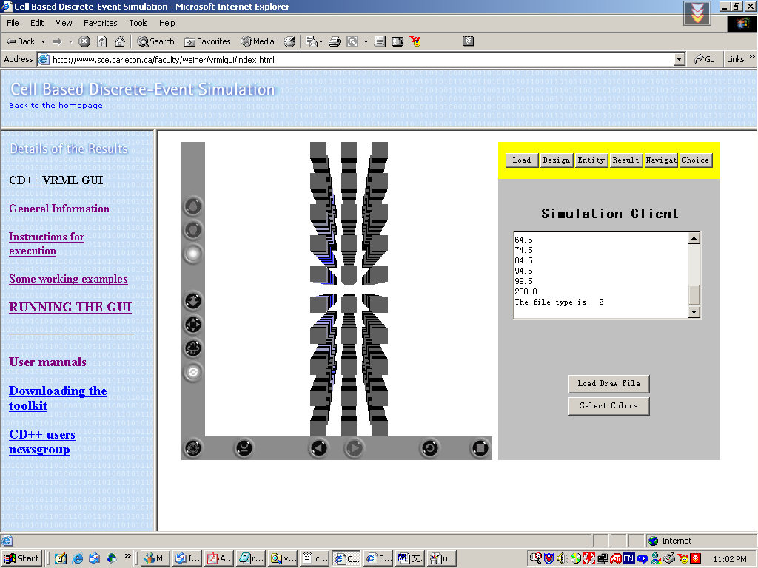

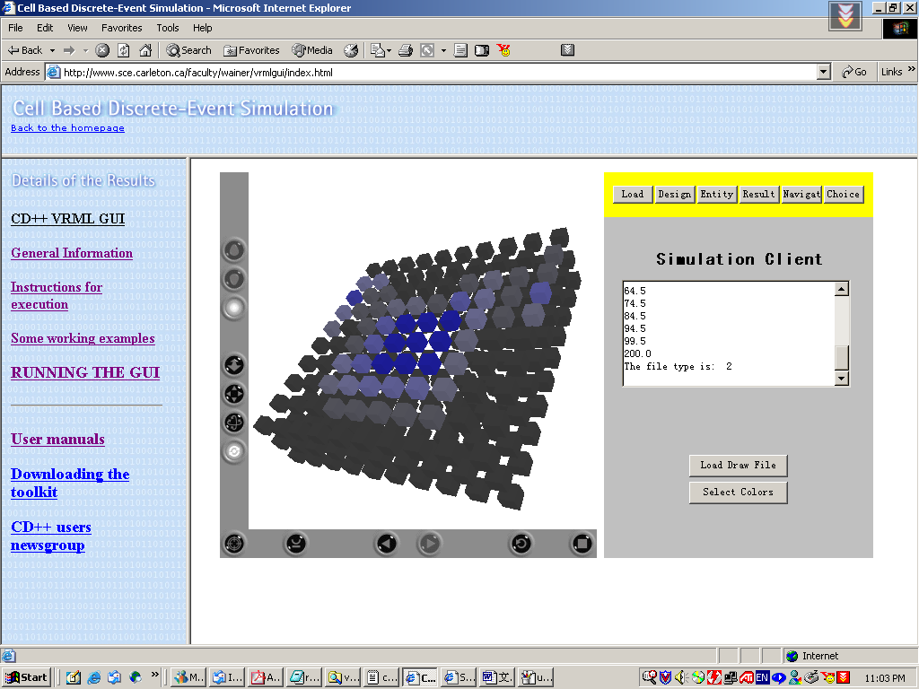

We attaché new “pal” file with name of “cloudsRaining.pal”

