Fly! Legacy
Aerodynamics and Kinematics Model
(Version 0.3)

Even Åby Larsen (even.larsen@losmail.no)

1 Simulation process overview 2
1.1 Loading 2
1.2 The simulation loop 2
2 Post-loading steps 3
2.1 Aircraft preparation 3
2.2 Position and orientation 4
3 Timeslice steps 7
3.1 Get “External” Inputs 7
3.2 Simulate Systems 8
3.3 Update Mass and Moments of Inertia 8
3.4 Calculate Forces and Moments 8
3.5 Integration 12
4 Literature 14
5 Appendices 15
5.1 Reference Frames and Coordinate Systems 15
5.2 Vectors 18
5.3 Matrices 18
5.4 Quaternions 21
5.5 Derivation of equations of motion 22
5.6 Integration methods 24

Simulation process overview
This section contains an overview of the simulation process with cross references

Loading
The following steps must be carried out after loading the situation and aircraft files, and before the simulation starts:
- Convert aircraft component (wings, engines, gear etc..) coordinates to a consistent right-handed system, using SI (metric) measurement units.
- Initialize inertial position and orientation with associated matrices and quaternions.
These additional steps will always yield the same result, so performance will be better if they are done before the simulation starts:
- Compute rotation matrices for aircraft WingSections.

The simulation loop
The aircraft objects Timeslice() method is called to perform one time-step of the aircraft simulation. Due to the integration method used Timeslice() must be called at regular intervals. In other words: The time-step simulated by a Timeslice() call must always be the same length.
Timeslice() perform the following steps:
- Simulate aircraft systems
- Calculate propulsive forces and moments
- Calculate aerodynamic forces and moments
- Calculate ground forces and moments
- Update mass and moments of inertia
- Calculate gravity
- Calculate sum of forces and moments
- Update position, orientation and velocity by numerical integration, and make the data available for the display code.

Post-loading steps
These steps are done after the situation file, and all aircraft stream files have been loaded, and before the simulation starts.

Aircraft preparation

Coordinates
- Convert to right handed coordinate system (see 5.1.6)
- Convert all measurements to SI primary units: m, kg, m/s, N etc.
- Convert all angles to radians.
- Convert all coordinates to visual model coordinates (see 5.1.5)

Mass and Moments of Inertia
The mass of the aircraft is the sum of the empty mass and the sum of all variable load items and all fuel.
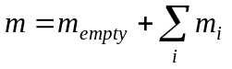
The centre of gravity is calculated in aircraft coordinates as the average position of mass:
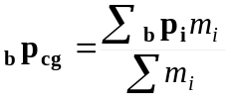
The mass moment of inertia about an axis is the mass times the distance from the axis squared:
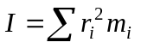
If we add an object to our system, its contribution to the moment of inertia is the sum of the effect of the objects mass and the objects own moment of inertia about its centre of gravity: 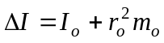
Using this relationship twice we get the moments of inertia about the aircraft’s c.g (still using aircraft coordinates):
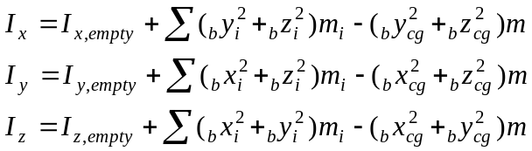
The first two terms give I about the origin. (Important: the empty mass is one of the m_{i}s.)
The third term subtracts the effect of the cg’s distance from the origin, leaving us with the I about an axis through the cg.
Sym | Description | c++ var
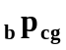 | C.g. position in aircraft coordinates.
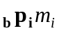 | Position and mass of a variable load item or fuel tank in aircraft coordinates.
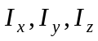 | Moment of inertia about aircraft c.g.
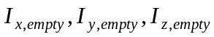 | Moment of inertia of empty aircraft from WGH file (probably about empty c.g.)
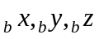 | Aircraft visual model coordinates.

Rotation Matrices for Wing Panels
The air speed vector must be transformed to a local coordinate system for each wing panel. The wing panels are fixed, so the rotation matrices can be computed before the simulation starts to save a little time in the timeslice.
The bAngMatrix in each CAeroModelWingSection must be set using matrix definitions from section 5.3.2.

Position and orientation
When a situation is loaded, the aircraft position and orientation must be converted to inertial coordinates before the simulation starts.

Aircraft orientation in Inertial Coordinates
The goal here is to set the start value of the “master” representation of aircraft orientation, which is a quaternion. The quaternion represents the orientation of the aircraft relative to the inertial coordinate system.
The easiest way to prime the quaternion is with quaternion multiplication. The inertial coordinate system can be aligned with the aircraft coordinate system with a sequence of five rotations:
- Rotate the longitude angle about the inertial z-axis. The x-axis now points at the meridian of the aircraft, and 90 degrees more to make the y-axis point away from the aircraft.
- Rotate 90 degrees about the new x-axis, and back the latitude angle to make the z-axis point towards the aircraft and the y-axis point north.
- Rotate aircraft heading angle about the new z-axis. The y-axis now has the same heading as the aircraft.
- Rotate pitch angle about new x-axis to align the y-axis with the aircraft centreline.
- Rotate bank angle about the new y-axis to align the x- and z-axis with the aircraft coordinate system.
This can be represented as the quaternion multiplication:
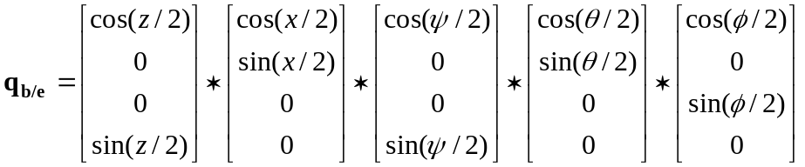
The multiplication is shown in 5.4.2, but it is probably easier to use the quaternion class to do the multiplication.
Sym | Description | C++ Var
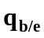 | The ECEF to aircraft rotation quaternion.
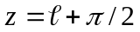 | The angle to rotate about the z-axis
 | Longitude, positive east. From SIT-file.
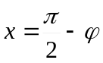 | The angle to rotate about the x-axis.
 | Latitude, positive north. From SIT-file.
 | Heading: Nose-left rotation about the z-axis. From SIT-file
 | Pitch angle: Nose-up rotation about the x-axis. From SIT-file
 | Bank angle: Right-wing down rotation about the y-axis. From SIT-file
The latitude and longitude come from the <geop> tag in the situation file.
Heading, pitch and bank come from the iAng tag.

Aircraft position in Earth-Centred Earth-Fixed (ECEF) Coordinates
Position is easy:
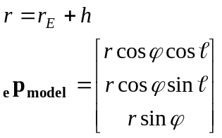
This is the position of the visual mode. We need the position of the c.g. so we must add the visual model to c.g. vector, properly converted to ECEF coordinates:
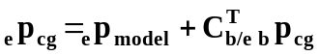
Sym | Description | c++ var
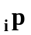 | Aircraft position in inertial coordinate system (unit metre)
r | Aircraft distance from centre of Earth (m)
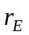 | Radius of Earth (m)
h | Aircraft altitude MSL (m)
 | Latitude (rad)
 | Longitude (rad)
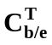 | The transpose of the ECEF to aircraft rotation matrix. The matrix is found from the orientation quaternion as described in 5.4.3
The latitude and longitude come from the <geop> tag in the situation file.

Timeslice steps
This chapter describes the calculations that take place in every timeslice.

Get “External” Inputs

Get Control Inputs
Reminder: Make sure control devices (joysticks etc.) are polled.

Get Environment
Get local atmospheric conditions (local wind, atmospheric pressure, density etc..
Get wind vector in local coordinates:
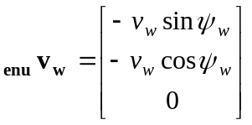
Transform wind vector to inertial coordinates, by multiplying the wind vector in local coordinates with the transpose of the inertial-to-local rotation matrix (note: It is not necessary to explicitly transpose the matrix. The matrix class has a method for multiplying a vector with its transpose):
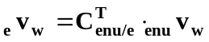
The velocity vector of the aircraft relative to the air mass (true airspeed) is aircraft velocity minus wind (using the same coordinate system for both):
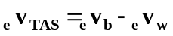
The true airspeed is computed early because it may be needed by subsystems and engines. The aerodynamic code and possibly some subsystems need the true airspeed in aircraft coordinates, which is obtained by multiplying with the inertial to aircraft rotation matrix:
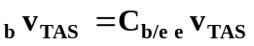

Sym | Description | C++ Var
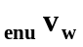 | The wind vector in local coordinates. (The velocity vector of the air mass)
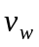 | The wind speed in m/s
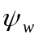 | The wind direction (the compass heading the wind is coming from, converted to radians)
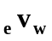 | The wind vector in ECEF coordinates
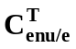 | The transpose of the ECEF-to-local rotation matrix. The derivation of this matrix is shown in section 5.3.3.
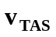 | Velocity of aircraft relative to air mass.
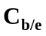 | ECEF to aircraft rotation matrix.

Simulate Systems
Outside scope of this document, but should happen first because input from some systems is needed later.

Update Mass and Moments of Inertia
In practice only a few items (most likely fuel tanks) will change during a timeslice, so it is faster to just add up the changes:
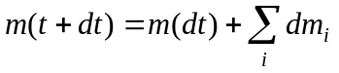
Where dm_{i} is the change in mass of an item.
Again, if only a few items change it may be faster to compute the centre of gravity using the changes (still working in aircraft coordinates. Just dropping the _{b} subscript for clarity):
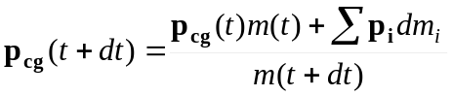
That is: old total moment is old cg times old mass, add moment of changes and divide by new mass to get new cg.
The change in moments of inertia may be computed using these equations (still working in aircraft coordinates. Just dropping the _{b} subscript for clarity):
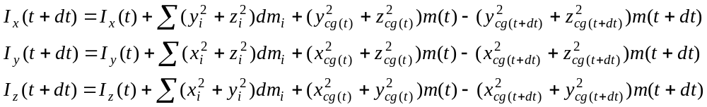
Sym | Description | c++ var
dm_{i} = m_{i} (t+dt)- m_{i}(t) | The change in mass of e.g. a fuel tank since last timeslice.
dt | length of the timeslice

Calculate Forces and Moments

Engines
Each engine produces a thrust force, a torque and it has spin (angular momentum). These effects are computed by the engine model.
The thrust vector is the total force produced by the engines.
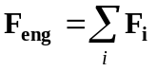
Note that the thrust can work in any direction, e.g. up for a helicopter.
Torque (moment) is produced in two ways:
- Propeller blades have component of both lift and drag acting in the plane of the propeller disk. These forces works against the motion of the propeller. The forces from the individual blades balance each other so there is no net force, but there is a torque that tries to roll the aircraft. The calculation is part of the propeller model
- Unless the thrust works exactly through the centre of gravity the thrust force will also generate a torque.
Total torque (moment) due to engines is given by:
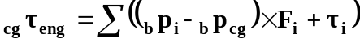
The rotating engine and propulsion part have a rotational inertia which may influence the behaviour of the aircraft. This effect is most noticeable with very high rates of rotation or high moments of inertia (e.g. heavy, large diameter propellers, or helicopter rotors, or WWI rotary engines. The angular momentum of the engines is given by:
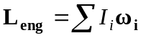
Sym | Description | c++ var
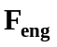 | Total forces due to engines.
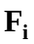 | Force produced by one engine.
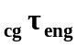 | Total moment about c.g. due to engines
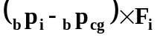 | Moment due to asymmetric position of engine i.
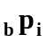 | Position of engine i in aircraft coordinates.
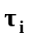 | Propeller torque of engine i. This may not be available?
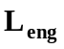 | Angular momentum of rotating engine parts.
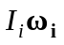 | Moment of inertia of rotating parts, and rpm (converted to rad/s) of engine i. May not be available.

Aerodynamic Forces and moments
The contribution of each wing panel must be computed:
- If the aircraft is rotating each wing panel will see an extra wind component due to the rotation:
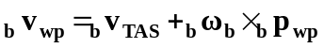
- Compute the velocity of the wing panel relative to air, in wing panel coordinates:
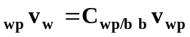
- Get mach number by dividing wind speed by local speed of sound:
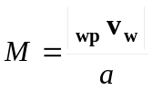
- Get angle of attack and sideslip (see 5.3.4):
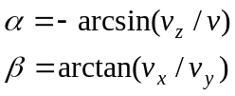
- Compute lift and drag coefficients:
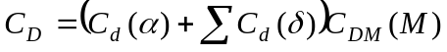
- Compute dynamic pressure and magnitude of lift and drag:
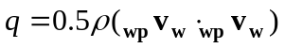
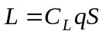
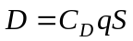
- The force vector in local wing panel coordinates is (see 5.3.4):
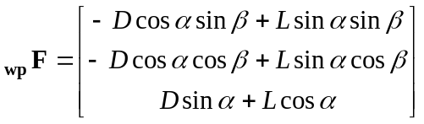
The force must be converted to aircraft coordinates:
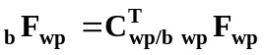
- The aerodynamic pitching moment is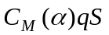 along the wind x-axis:
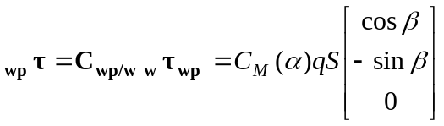
which must be converted to aircraft coordinates in the same way.
The total aerodynamic force and moment about the c.g. due to wing panels are:
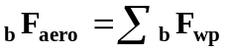
Sym | Description | c++ var
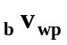 | The true air velocity of the wing panel in aircraft coordinates).
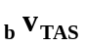 | True air velocity of aircraft
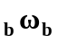 | Rotational velocity vector of aircraft.
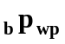 | Position of the wing panel.
M | Mach number
a | Local speed of sound, from atmosphere model
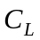 | Total wing panel lift coefficient
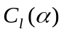 | Lift coefficient contribution from angle of attack
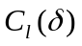 | Lift coefficient contribution from control surface deflection.
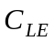 | Lift efficiency factor.
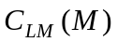 | Mach dependent lift change factor.
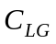 | Ground effect lift change factor.
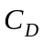 | Total wing panel drag coefficient.
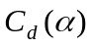 | Drag coefficient contribution from angle of attack.
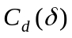 | Drag coefficient contribution from control deflection.
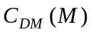 | Mach dependent drag change factor.
q | Dynamic pressure.
ρ | Air density from atmosphere model.
S | Wing panel area.
L, D | Lift and drag magnitude.
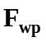 | Total force on wing panel (includes lift and drag)
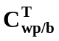 | Transpose of aircraft to wing panel rotation matrix
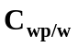 | Wind coordinate to wing panel rotation matrix (see 5.3.4)

Gear and Contact Points
The possible forces on gear and contact points are impact forces, friction and aerodynamic drag. The total force on each contact point is the sum of these. The forces also produce a moment about the c.g. given by:
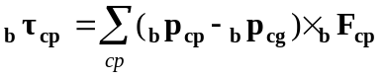

Impact and friction
These forces apply when the contact point/gear is in contact with the ground. Landing gear may have continuous ground contact even when the aircraft is moving slightly up and down because of the suspension springs. Other contact points are rigid.
Friction works along the ground, opposing the velocity.
Impact is perpendicular to the ground. TODO – find out how to deal with this complex subject.
Random thoughts:
At rest total “impact” force equals aircraft weight. When landing/crashing the impact force stops the aircraft. The force must be greater than weight to produce upwards acceleration.
Stopping means the suspension damping absorbs energy. If other contact points (e.g. wing tips) hit the ground they can only absorb energy by bending metal, i.e. damage.
If force is to big or works for too long the aircraft will bounce unrealistically. Issue with timeslice here.

Aerodynamic drag
Extended gear produces aerodynamic drag. Other contact points do not. Drag is calculated as for wing panels (see 3.4.2)

Integration

Linear acceleration and velocity
Using Newton’s second law the acceleration in ECEF coordinates is:
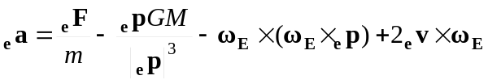
The first term is the acceleration due to the sum of forces (aerodynamic, engine thrust, ground contact. The second term is gravitational acceleration. The third term is centrifugal acceleration and the last term is Coriolis’ acceleration.
Using the Adams-Bashforth linear multistep integreation method (see 5.6) we get the following expression for updating aircraft velocity and position vectors:
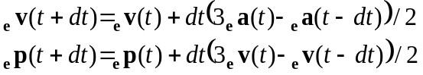
This will find the position of the centre of gravity. The display code needs the position of the visual model centre, rather than the cg position:
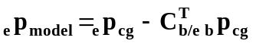
(i.e. convert the model centre to cg vector to ECEF coordinates and subtract it)

Sym | Description | c++ var
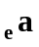 | Aircraft acceleration vector in ECEF coordinates
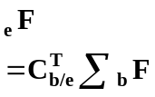 | The sum of forces due to aerodynamics, engines etc, converted to ECEF coordinates by multiplying by the transpose of the ECEF to aircraft matrix
m | Aircraft mass.
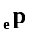 | Aircraft position vector in ECEF coordinates.
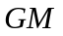 | The product of the universal gravitational constant and the mass of the earth.  In WGS-84 GM is defined as 3986004.418*10⁸ m³/s²
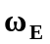 | Earths sidereal rotation vector. Defined in WGS-84 as 7.2921150*10⁻⁵ rad/s (about our z-axis)
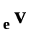 | Aircraft velocity vector in inertial coordinates

Angular acceleration and velocity
Angular acceleration is determined using Euler’s equations (see 5.5.1):
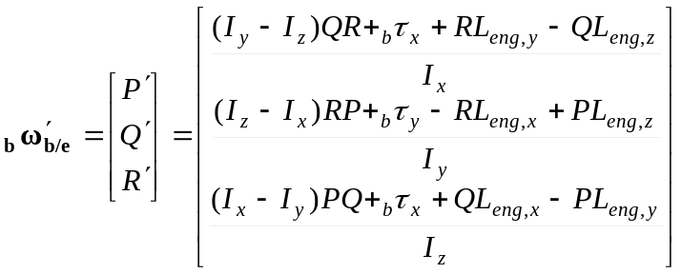
The angular velocity is updated using Adams-Bashforth LMM:
The derivative of the orientation quaternion is given by:
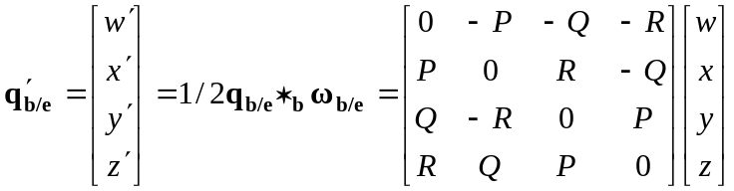
And the orientation quaternion is updated with:

Sym | Description | c++ var
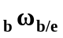 | Aircraft angular velocity in aircraft coordinates.
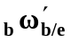 | Angular acceleration (derivative of angular velocity)
P, 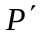 | X-component of angular velocity (pitch rate) and acceleration
Q, 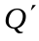 | Y- component of angular velocity (roll rate) and acceleration
R, 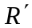 | Z component of angular velocity (yaw rate) and acceleration
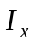, 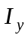, 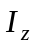 | Aircraft moment of inertia about x-, y- and z-axis
 | Sum of angular momentum of rotating engine parts. Components denoted by x,y,z subscripts.
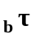 | The sum of aerodynamic, engine etc. moments about the centre of gravity in aircraft coordinates. Components denoted by x,y,z subscripts.
,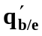 | Aircraft orientation quaternion and its derivative.

Literature

Brian L. Stevens and Frank L. Lewis:
Aircraft Control and Simulation, 2nd edition
Published by Wiley, ISBN 0-471-37145-9
This book contains every formula you need for the aerodynamics and kinematics simulation.
It uses right-handed coordinate systems, but the convention is different from ours: x-forward, y-right, z-down, so the equations must be worked on a bit. Unfortunately for us this seems to be the standard in aerodynamics textbooks.

Chris Carpenter:
Flightwise vol. 1: Principles of Aircraft Flight
Airlife, ISBN 1 83510 719 0

Flightwise vol. 2: Aircraft Stability and Control
Airlife, ISBN 1 85310 870 7
These books give an excellent explanation of aerodynamics with almost no math. Very good for understanding what is going on.
Coordinate systems are forward-right-down here too.

Wikipedia (http://www.wikipedia.org/)
Good explanations of most mathematical terms.

Appendices

Reference Frames and Coordinate Systems

Frames of reference
The aerodynamics and physics code uses three frames of reference:
- The inertial frame of reference (a frame of reference where Newton’s laws apply) is used in the rigid body dynamics code
- The aircraft itself is used as the frame of reference in the aerodynamics code
- The earth is used as a frame of reference is used to specify aircraft position.

Coordinate systems
A coordinate system is used measure positions relative to a frame of reference. There are an infinite number of possible coordinate systems for any frame of reference. The simulation uses right-handed Cartesian coordinate systems, with these conventions:
Axis | Positive direction in aircraft frame | Positive direction in earth-fixed frame | Positive direction of rotation
X | right | east | pitch nose-up
Y | forward | north | roll right-wing-down
Z | up | up | yaw nose-left
The order of rotation is yaw/heading (about z-axis), pitch (about x-axis), roll (about y-axis).
Beware: One confusing (at least to me) consequence of this convention is that heading (rotation about the z-axis) will have the opposite sign of compass headings.

The “Inertial” Frame of Reference
This is a frame of reference where Newton’s laws are valid.

The Earth-Centred Inertial (ECI) coordinate system.
A reasonable approximation to an inertial system is a coordinate system with the origin in the centre of earth, but which does not rotate with.
An ECI system is used in the derivation of equations of motion in appendix 5.5, and is denoted by a left subscript i: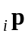. It is not used in the simulation code.

The Earth as a Frame of Reference
We are using two kinds of Earth-fixed coordinate systems: A geographical coordinate system for positions, and a local coordinate system for aircraft orientation.

The Earth-Centred Earth-Fixed (ECEF) coordinate system.
This coordinate system is used for the primary representation of aircraft position and orientation:
- The origin is in the earth’s centre of mass.
- The X-axis points to the equator at 0° longitude.
- The Y-axis points to the equator at 90° East longitude.
- The Z-axis points along the earth’s axis of rotation, towards the North Pole.
The inertial coordinate system is denoted by a left subscript e:.
Note that this is not a real inertial system because it is fixed to, and rotates with the Earth. We have to add centrifugal and Coriolis’ “forces” to gravity to compensate.

The Geographical Coordinate System
This is a polar coordinate system (latitude, longitude, altitude) with its origin in the earth’s centre of mass.
The geographical coordinate system is denoted by a left subscript geo: 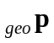.

The Local Coordinate Systems
These are Cartesian coordinate systems. They are used to represent aircraft orientation.
- The origin is placed at sea level directly below the aircraft).
- The X-axis points east, the Y-axis north, and the Z-axis up. (The x- and y-axis define the horizontal plane.)
The local coordinate system is denoted by a left subscript enu (for east-north-up): 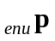.
The aircraft orientation (attitude) is given in this system as (pitch, bank, heading).
The aircraft position is always (0, 0, altitude)
Though we are (mathematically) using a new coordinate system in every timeslice, it is easier to think of it as something that slides along the earth surface below the aircraft.

The Aircraft as a Frame of Reference
These coordinate systems all have x-axis pointing right, y-axis pointing forward, and z-axis pointing up.

The Visual Model Coordinate System
This coordinate system of the visual model is used as the primary coordinate system for fixing positions of items on the aircraft. (Rationale: Let’s do away with the intermediate coordinate systems used in the stream files. We have to work back to visual model coordinates for display anyway)
The visual model (or body) coordinate system is denoted by a left subscript b (for body): 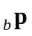.

The CG Coordinate System
This is a translation of the visual model coordinate system. The origin is the actual (instantaneous) centre of gravity. This coordinate system is used for calculating forces and moments. The math for the rigid body dynamics is much simpler in this coordinate system.
This coordinate system is denoted by a left subscript cg: 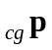.

Wing Panel Coordinate Systems
The aerodynamic code computes the forces on each wing panel independently. The calculations for each wing panel are carried out in a coordinate system with the origin in the aerodynamic centre of the wing panel (on the mid-span of the quarter-chord line). The coordinate system is rotated relative to the visual model/C.G. coordinate systems according to the dihedral and sweep of the wing panel.
The wing panel coordinate system is denoted by a left subscript wp: 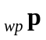.

Wind Coordinate Systems
This coordinate system is used to calculate the lift and drag forces on a wing panel. It is oriented with the y-axis pointing directly into the wind. It can be seen as a rotation of the wing panel coordinate system, the steps are (see also 5.3.4):
- A rotation –α (negative of angle of attack) about the wing panel x-axis (pitch). This aligns the xy-plane with the wind vector.
- A rotation β (the angle of sideslip) about the new z-axis to align the y-axis with the wind vector.
The lift vector is parallel to the wind z-axis, and the drag vector is parallel to the wind y-axis. The wing section pitching moment is about the wind x-axis.
The wind coordinate system is denoted by a left subscript w: 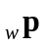.

Coordinate Systems used in Aircraft Stream Files
These are left-handed coordinate systems used in the aircraft definition files. They are not used in the simulation code, but they must be taken into account in the conversion process after loading the aircraft.

The Empty CG System
This is a translation of the visual model system. The origin is specified by the CofG tag in the SVH-file. It is used to specify locations of variable load items in the VLD-file, and fuel tanks in the GAS-file.
Coordinates in the visual model system can be found by adding the value of the CofG tag to the value of the bPos tag of each item.
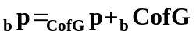

The Aerodynamic Datum System
This coordinate system is used in the WNG-file to specify the location of wing panels. The origin is specified (relative to the CofG tag) by the DofA tag in the WNG-file. The aerodynamic datum can be further shifted fore and aft by the +ac+ tag.
Coordinates are converted to visual model coordinates by adding the values of the DofA tag, +ac+ tag (converted to full vector), and CofG tag to the bPos tag of each wing panel.
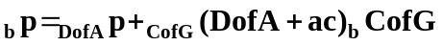

Conversion from Fly! to Legacy! coordinates
Fly! II uses a left handed coordinate system, while Legacy! uses a right handed coordinate system. When a Fly! II aircraft is loaded in Legacy! the coordinates must be converted from Fly! IIs system to Legacy!s.
The conventions for positive values in Fly! are:
Axis | Direction | Rotation
x | Right | Pitch nose-down
y | Up | Heading change nose-right
z | Forward | Bank left wing down

The conventions in Legacy! are:
Axis | Direction | Rotation
x | Right | Pitch nose-up
y | Forward | Bank right wing down
z | Up | Heading change nose-left

Then the conversion of positions is simply a swap of y- and z-axis:
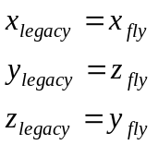
Fortunately the Euler angle order is heading-pitch-bank in both cases, so the conversion of orientations is fairly simple too:
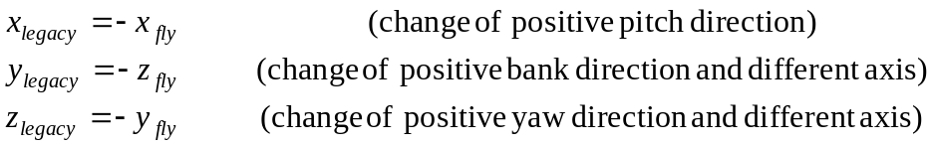

Vectors
Vector (cross) product:
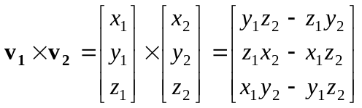
This can also be expressed with a cross-product matrix:
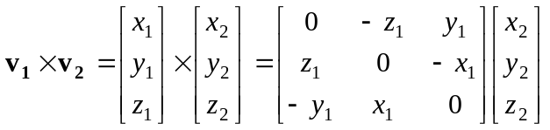
Scalar (dot) product:
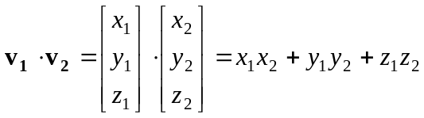
Length of a vector:
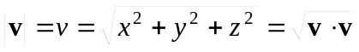

Matrices
Matrix basics, conventions used and derivation of equations for later reference.

Matrix multiplication
Matrices are used to transform column vectors:
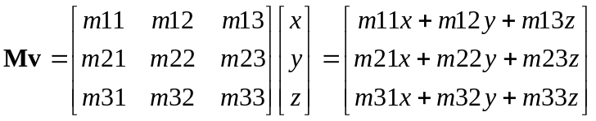
Matrices can be multiplied by repeating the pattern for each column.
The inverse of a matrix (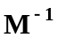) transform back, e.g. if 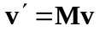 then 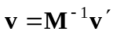.
Rotation matrices are orthogonal, so the inverse is the same as the transpose which is very easy to find:
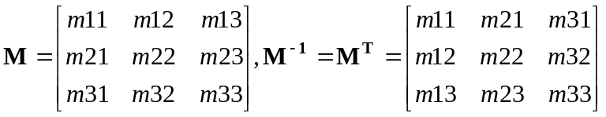

Derivation of Euler angle rotation matrix
This is a derivation of the rotation matrix in terms of the Euler angles. This matrix is used to compute coordinates in a rotated coordinate system. (e.g. to convert vectors from inertial to aircraft coordinates). It is based on Stevens and Lewis page 26.
Note: The rotation matrix depends on the choice of coordinate system (left-/right-handed and orientation of axis). For any coordinate system there are 12 different conventions for the Euler angles. Consequently the derivation is valid only for our choice of coordinate system and Euler angle convention and is not directly comparable to other conventions.
Note 2: We never calculate the rotation matrix directly from Euler angles. It is derived from the orientation quaternion.
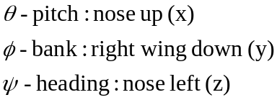
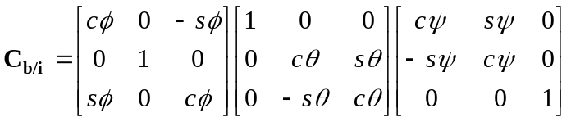
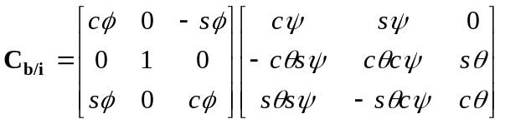
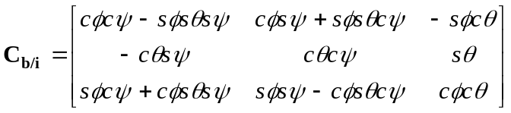
Given a rotation matrix:
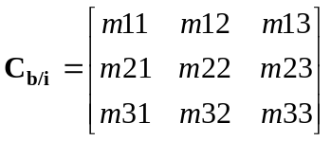
We can find the heading-pitch-bank Euler angles:
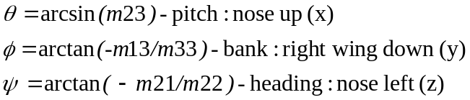
Sym | Description | Variable
 | The rotation matrix to convert from Inertial to Aircraft Coordinates
 | Pitch angle: Nose-up rotation about the x-axis.
 | Bank angle: Right-wing down rotation about the y-axis
 | Heading: Nose-left rotation about the z-axis.

Derivation of Inertial to Local Coordinates rotation matrix
To align the inertial coordinate system with the local coordinate system, we must rotate the coordinate system longitude+90 degrees around the z-axis to make the y-axis point away from the aircraft, and then rotate around the new x-axis until the z-axis points at the aircraft.
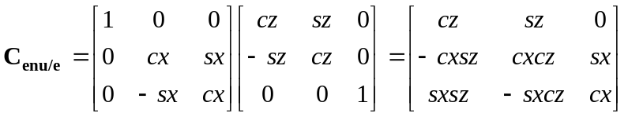
where
 | The angle to rotate about the z-axis
 | Longitude, positive east.
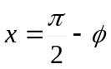 | The angle to rotate about the x-axis.
 | Latitude, positive north.

Calculations of angles of attack and sideslip
The angles of attack α, and sideslip β, are the angles of rotation needed to align the wind axis with the wing panel coordinate system. The conventions are chosen to get a positive angle of attack in normal flight.
The wind system is first rotated β radians about the z-axis, and then α radians about the new x-axis.
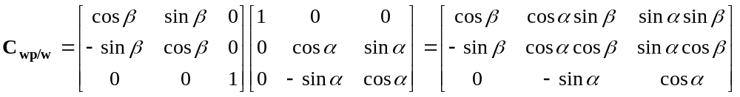
In the wind coordinate system the x- and z-components of v are zero, so:
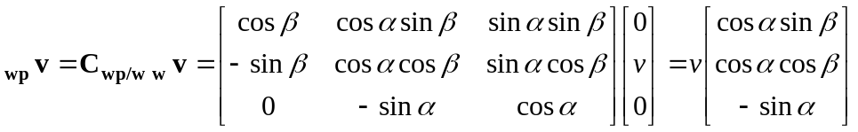
This gives equations for finding α and β, using the x,y and z components of 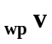:
We can use the fact that lift works along the z-axis, and drag along the y-axis of the wind system to express the total aerodynamic force on the wing panel in wing panel coordinates in terms of α and β:
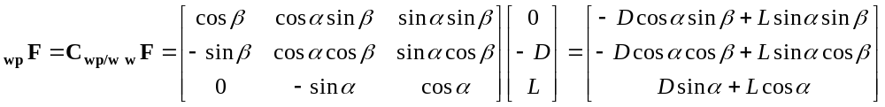

Quaternions
Quaternions are used to represent aircraft orientation. Vectors can be rotated using quaternions, but it is usually faster to convert the quaternion to a rotation matrix, in particular if many vectors are rotated.

Quaternion Product
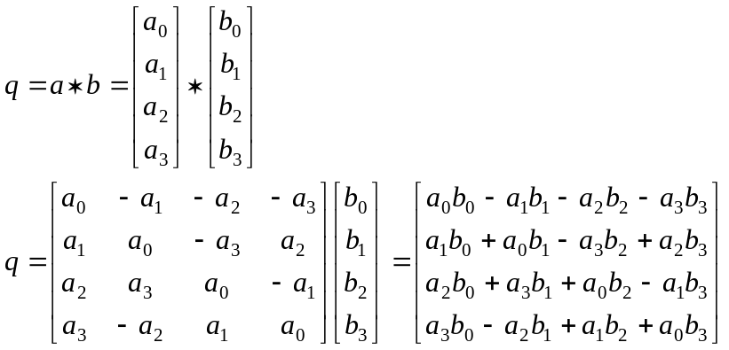
Note at a*b and b*a are not the same (just like the vector cross product)

Derivation of Inertial-to-Aircraft Rotation Quaternion
Using:
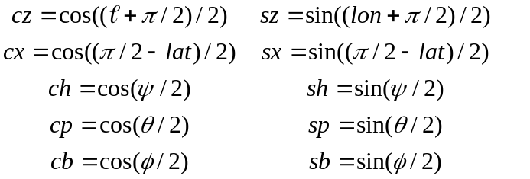
The rotation quaternion is:
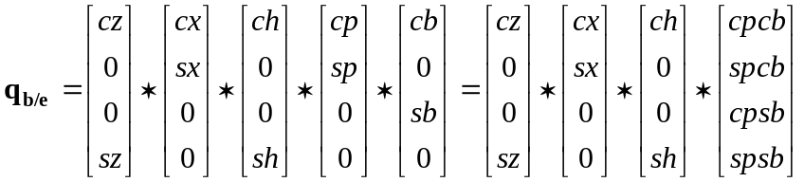
The last factor here is the Euler angle quaternion:
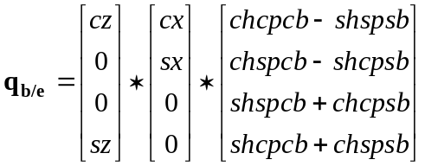
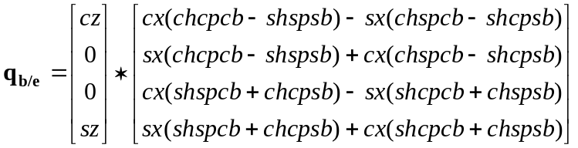
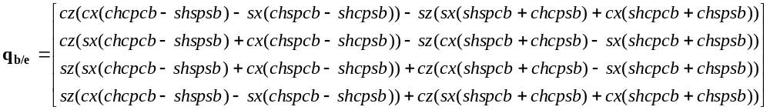

Quaternion to Rotation Matrix
Given the quaternion:
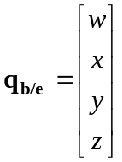
The equivalent rotation matrix is:
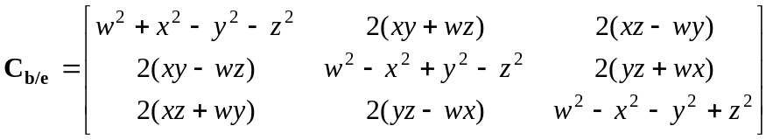
This conversion is independent of the choice of Euler angles.

Derivation of equations of motion

Angular acceleration
Angular motion (rotation) of the aircraft relative the inertial frame is represented by an angular velocity vector:
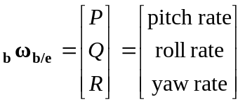
Angular momentum is a preserved quantity. The angular momentum is:
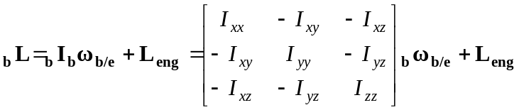
Ignoring the cross-moments of inertia this reduces to:
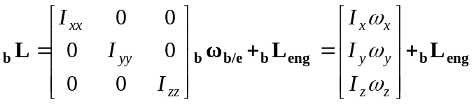
Note: We have no choice here. The cross-moments of inertia are not specified in the aircraft definition files. Most aircraft are symmetrical about the centre (yz) plane, so Ixy and Ixz will be zero and can be safely ignored. If Iyz is small, we’re ok.
Taking the time derivative of this equation and rearranging a bit gives the state equation for angular velocity (Stevens & Lewis, p. 44). Using the moment of inertia simplification above it reduces to Euler’s equations of motion:
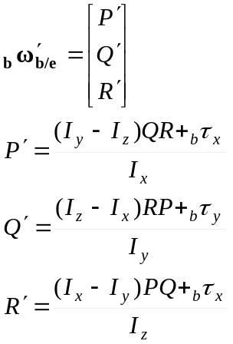
If we take into account the angular momentum of the engines, the equations become:
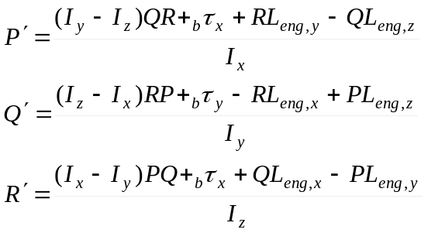

Angular velocity
The quaternion state equation (Stevens & Lewis p34) give the relationship between angular velocity and change in orientation:

Linear acceleration
Linear acceleration must be computed in an inertial frame, using Newton’s second law. The state equation is given in Stevens and Lewis page 50:
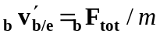

Integration methods
We are trying to compute numerical solutions to differential equations of the form:
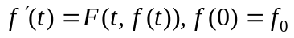
In plain language: The time derivative of a function f, depends on time and the value of the function itself. This is expressed as a function F. For example acceleration (the derivative of velocity) is a function of velocity, because the aerodynamic forces depend on velocity.
The simplest numerical method is Euler integration:
Euler integration is not very accurate unless the timestep dt is very small. Better accuracy can be achieved by using the average of the derivative at the start and end of the timeslice:
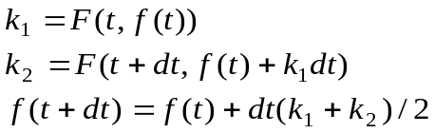
Unfortunately this requires that the aerodynamic model is computed twice per timeslice. The accuracy can be further improved with the 4th order Runge-Kutta method which computes the derivative at the midpoint of the timeslice twice.
Computationally it is more efficient, but less accurate to use a linear multistep method, such as the 2nd order Adams-Bashforth method, which reuses the derivative computations from the previous timeslice to improve accuracy:
This formula cannot be used for the very first timeslice (because f’(t-dt) is undefined), but I think we can assume that the derivatives are zero at the start (i.e. the aircraft is not manoeuvring.

