

Anchor Pro
Full User Manual

Production Planning & Service Operation Platform
Edition: June 2026 | Version 1.0

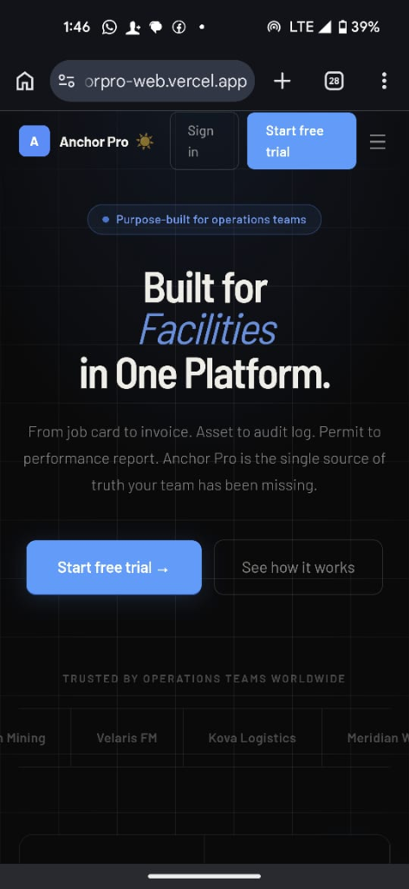
Figure 1 – Anchor Pro landing page (mobile view)

Table of Contents
1 Getting Started – Logging In
2 Understanding the Dashboard
3 Service Orders (Job Cards)
3.1 Creating a New Service Order
3.2 Scheduling & Assigning Technicians
3.3 Technician Execution Workflow
3.4 Real-Time Supervisor Monitoring
4 Asset Registry
5 Inventory & Parts
5.1 Issuing Parts to a Service Order
5.2 Bulk Import / Export
6 Tools Registry
7 Procurement Hub
8 CRM & Customers
9 Downtime Log
10 Settings & Administration
10.1 User Management
10.2 Dynamic Nomenclature
11 Roles & Permissions Summary
12 Frequently Asked Questions

1. Getting Started – Logging In
Anchor Pro is a web-based platform accessible from any modern browser (Chrome, Edge, Firefox, Safari). There is no software to install. You can also install it as a Progressive Web App (PWA) directly from your phone's browser for a native app experience.

Accessing the Platform
# | Action
1 | Open your browser and navigate to: https://anchorpro-web.vercel.app
2 | Click Sign In in the top navigation bar.
3 | Enter your registered email address and password.
4 | Click Continue to log in. You will land on the Dashboard.
5 | OPTIONAL – On mobile: tap the browser menu → 'Add to Home Screen' to install the PWA icon.

ℹ If you have forgotten your password, click 'Forgot Password?' on the login screen. A reset link will be emailed to you within 2 minutes.

2. Understanding the Dashboard
The Dashboard is the first page you see after logging in. It provides a live overview of all operations currently running in your organization.

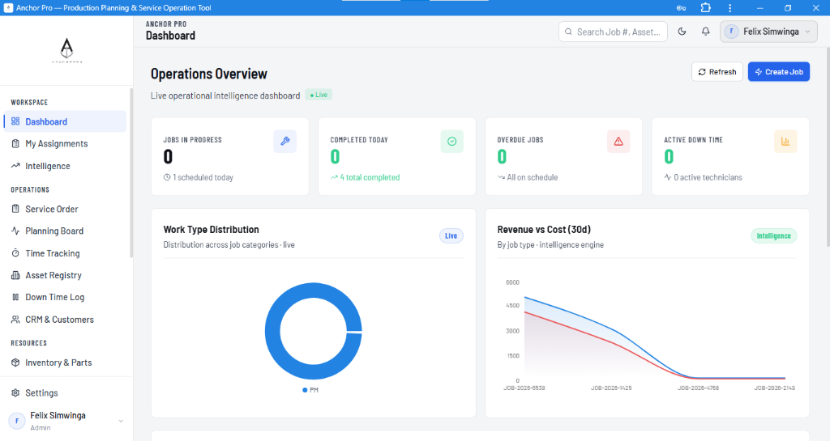
Figure 2 – Operations Dashboard showing live KPI cards, Work Type Distribution chart, and Revenue vs Cost trend

Key Dashboard Elements
KPI Card | What it shows | When to act
Jobs In Progress | Number of Service Orders actively being worked on right now. | Monitor for overdue jobs highlighted in red.
Completed Today | Jobs closed in the last 24 hours. | Track team productivity against daily targets.
Overdue Jobs | Jobs that have passed their scheduled end date. | Immediately assign or re-schedule overdue orders.
Active Downtime | Assets currently offline due to a reported breakdown. | Escalate high-priority breakdowns immediately.

Navigation Sidebar
The left sidebar groups all modules. Click any module name to navigate there instantly.
Section | Modules
WORKSPACE | Dashboard, My Assignments, Intelligence
OPERATIONS | Service Order, Planning Board, Time Tracking, Asset Registry, Downtime Log, CRM & Customers
RESOURCES | Inventory & Parts, Tools Registry
 | Settings | User Account

3. Service Orders (Job Cards)
Service Orders (also called Job Cards) are the primary unit of work in Anchor Pro. Every piece of maintenance activity, breakdown repair, or inspection is captured as a Service Order.

3.1 Creating a New Service Order
You can create a new Service Order from either the Dashboard (click + Create Job) or from the Service Order list page (click + New Service Order).

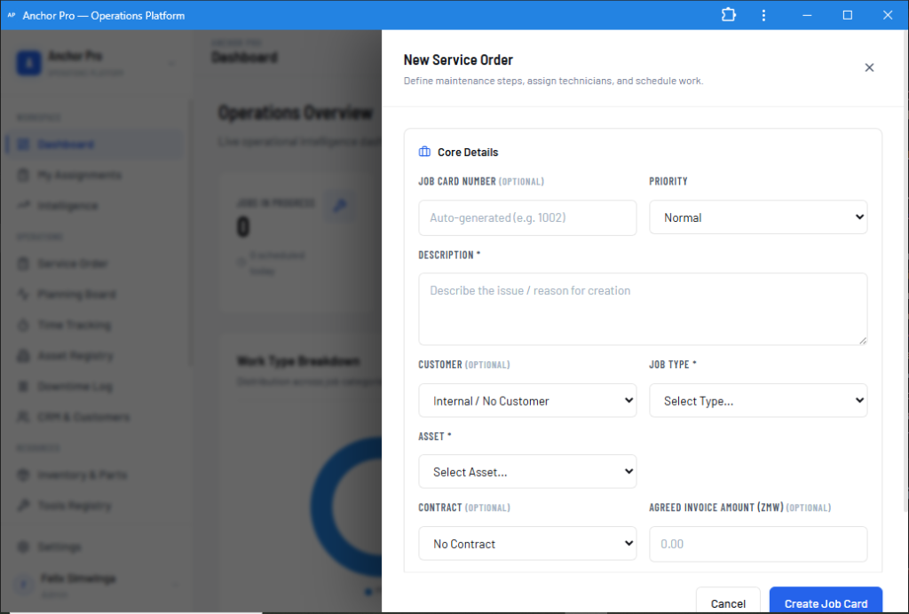
Figure 3 – 'New Service Order' creation form showing core fields

# | Action
1 | Click '+ Create Job' on the Dashboard (or '+ New Service Order' from the Service Order list).
2 | The 'New Service Order' panel slides open from the right.
3 | Job Card Number: Leave blank – the system auto-generates a sequential number (e.g. 1001, 1002).
4 | Description*: Type a brief description of the work to be done (e.g. '60,000 km oil change – CAT 797').
5 | Customer: Select the customer account, or leave as 'Internal / No Customer' for in-house maintenance.
6 | Job Type*: Select the maintenance category – Preventative Maintenance (PM), Breakdown, Inspection, etc.
7 | Asset*: Select the equipment/asset this job applies to from the dropdown.
8 | Contract (optional): Link to an existing contract for billing purposes.
9 | Agreed Invoice Amount (optional): Enter the expected invoice value for this job.
10 | Click 'Create Job Card' to save. The system creates the order and opens the Job Details Page.

ℹ Required fields are marked with *. Additional items (checklist tasks, technician assignments, parts requests) are added from the Job Details Page after creation.

3.2 Scheduling & Assigning Technicians
After creating a Service Order, use the Planning Board to schedule it and assign the right technician.
# | Action
1 | Navigate to Operations → Planning Board in the sidebar.
2 | Find your newly created (Unscheduled) order in the 'Unscheduled' column on the right.
3 | Drag and drop the order onto the calendar grid for the intended date.
4 | Click the order card to open its details and assign a Lead Technician.
5 | The system will warn you if the chosen technician already has concurrent jobs scheduled.
6 | The order status automatically updates from 'Unscheduled' to 'Scheduled'.

3.3 Technician Execution Workflow
Technicians access their assigned jobs via My Assignments, accessible on both desktop and mobile.
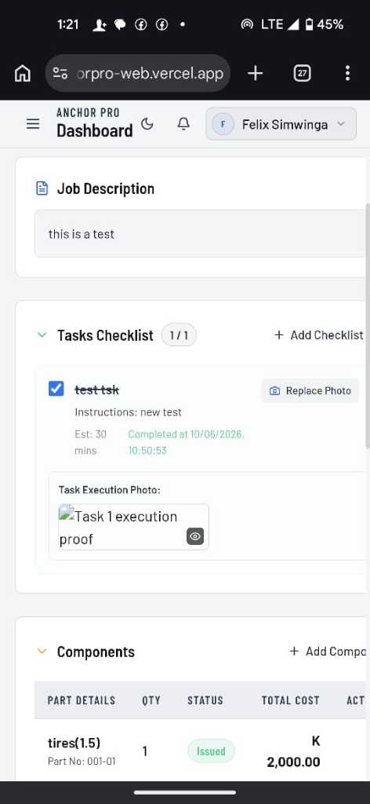
Figure 4 – Technician view on mobile: Task Checklist with photo proof and Parts Issued section

# | Action
1 | Tap My Assignments in the sidebar (or navigate from the Dashboard shortcut).
2 | Tap the assigned Service Order to open Job Details.
3 | Tap Start Execution – this changes status to 'In Progress' and starts the labor timer.
4 | Work through the Tasks Checklist one by one, ticking each task as it is completed.
5 | For tasks requiring photo proof: tap Attach Photo → take photo or upload from gallery.
6 | If a part is needed: tap Request Part → search the part → enter quantity → Submit.
7 | If a breakdown occurs: tap Report Downtime → select category → enter start time and notes.
8 | Once all tasks are checked, tap Complete Job to move the order to 'Completed'.
9 | The Supervisor receives a real-time notification and can review and close the job.

3.4 Real-Time Supervisor Monitoring
Supervisors can monitor technician progress from their desktop without refreshing the page.
ℹ The Job Details page auto-refreshes every 5 seconds. As technicians tick tasks, upload photos, or request parts in the field, those updates appear on the supervisor's screen instantly.

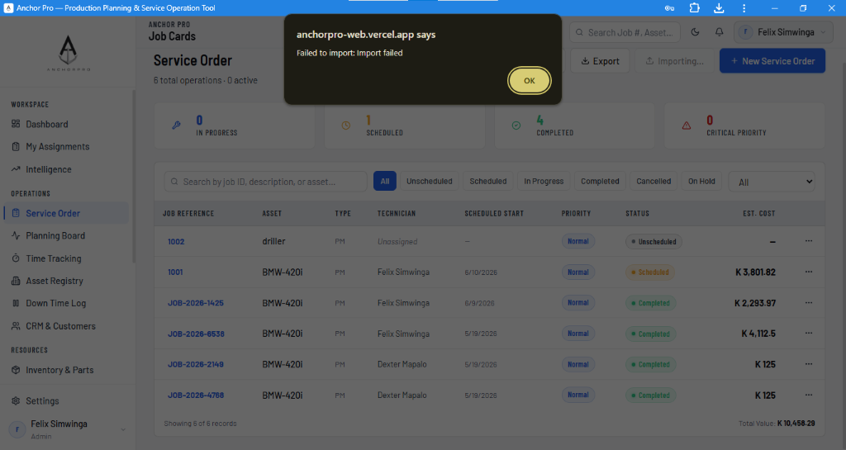
Figure 5 – Service Order list showing job reference numbers, asset, status badges, and estimated cost

4. Asset Registry
The Asset Registry stores all equipment, vehicles, machinery, and infrastructure items your organization maintains. Every Service Order must be linked to a registered asset.

Registering a New Asset
# | Action
1 | Navigate to Operations → Asset Registry.
2 | Click + Add Asset (top right).
3 | Enter the Asset Name (e.g. 'CAT 797F Haul Truck'), Asset Type, and Serial Number.
4 | Set the initial Status: Available, In Maintenance, or Damaged.
5 | Upload a photo of the asset (optional but recommended for quick identification).
6 | Click Save. The asset is now available for selection when creating Service Orders.

Bulk Importing Assets
# | Action
1 | Navigate to Operations → Asset Registry.
2 | Click Export Template to download a pre-formatted Excel (.xlsx) file.
3 | Fill in the required columns: Name, Type, Serial Number, Status.
4 | Save the file and click Import → Select your filled file → Confirm.
5 | The system validates each row and imports valid assets. Any errors are reported in a summary.

ℹ Use the Export button to back up all your existing asset records as an Excel spreadsheet at any time.

5. Inventory & Parts
The Inventory & Parts module is used by Storemen to manage stock levels, receive goods, and issue parts to Service Orders.

5.1 Issuing Parts to a Service Order
When a technician requests a part during job execution, the request appears in the Service Order's Parts section for the storeman to action.
# | Action
1 | Navigate to Resources → Inventory & Parts.
2 | You will see items listed with their current Stock Qty, Unit Cost, and Reorder Point.
3 | Open the Service Order that has a pending part request (a badge will show 'Requested').
4 | Scroll to the Parts Requests & Issuing section on the Job Details page.
5 | Review the item and quantity requested by the technician.
6 | Click Issue Part to confirm the issuing.
7 | The system deducts the quantity from stock and records the cost against the Service Order.

ℹ When stock falls below the Reorder Point for any item, the platform highlights it in orange/red to prompt a restock Purchase Order.

5.2 Bulk Import / Export of Inventory
You can bulk-load your full parts catalogue into Anchor Pro using an Excel template. The template is generated live by the system and reflects your exact column format.
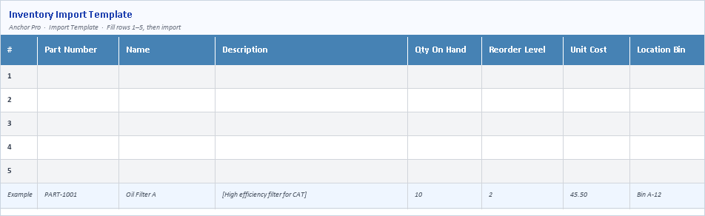
Figure 6 – Inventory Import Template (downloaded directly from the Anchor Pro API): columns # • Part Number • Name • Description • Qty On Hand • Reorder Level • Unit Cost • Location Bin

# | Action
1 | Navigate to Resources → Inventory & Parts.
2 | Click Export Template to download the Excel import template (inventory-import-template.xlsx).
3 | Open the file in Microsoft Excel or WPS Office.
4 | Fill in from Row 1: Part Number, Name, Description, Qty On Hand, Reorder Level, Unit Cost, Location Bin.
5 | The last row is a greyed-out Example row — leave it or delete it; it will be skipped on import.
6 | Save the file (keep the .xlsx format).
7 | Back in Anchor Pro, click Import → select your filled template → click Confirm.
8 | Review the import summary: successful rows are shown in green, failed rows list the reason for rejection.
9 | Click Export at any time to download your current full inventory as a spreadsheet backup.

6. Tools Registry
The Tools Registry tracks all tools and equipment issued from the store to technicians. It prevents tool losses and provides a full issue/return audit trail.

Issuing a Tool
# | Action
1 | Navigate to Resources → Tools Registry.
2 | Click Issue Tool next to the tool you want to issue.
3 | Select the technician or team member the tool is being issued to.
4 | Enter the expected return date (optional).
5 | Click Confirm. The tool status changes to 'Issued' and the technician's name is recorded.

Recording a Tool Return
# | Action
1 | Navigate to Resources → Tools Registry.
2 | Find the issued tool (filter by Status: Issued).
3 | Click Return → optionally add a condition note (e.g. 'minor wear on handle').
4 | Click Confirm. The tool status returns to 'Available'.

Bulk Importing Tools
Use the Tools Import Template to register many tools at once.
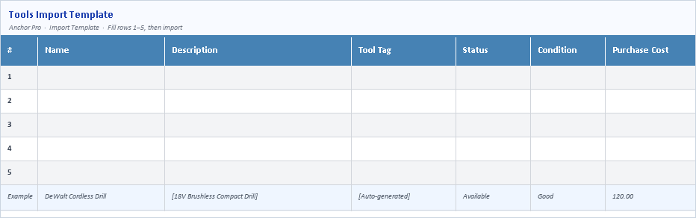
Figure 7 – Tools Import Template (live from API): columns # • Name • Description • Tool Tag • Status • Condition • Purchase Cost

# | Action
1 | Click Export Template to download the tools import file (tools-import-template.xlsx).
2 | Fill in: Name, Description, Tool Tag (or leave blank for auto-generation), Status, Condition, Purchase Cost.
3 | Save and click Import to upload your completed file.

7. Procurement Hub
The Procurement Hub is used by Purchasing Officers and Supervisors to raise Purchase Orders (POs) for inventory replenishment, direct job purchases, and subcontracting.

Raising a Purchase Order
# | Action
1 | Navigate to Operations → Procurement (may be labelled 'Procurement Hub' in your workspace).
2 | Click + New Purchase Order.
3 | Select the PO Type:  • Inventory Replenishment – restock warehouse items  • Direct Purchase – non-stock items for a specific job  • Subcontracting – outsourced labor or services
4 | Select the Supplier from the dropdown. If the supplier is not registered:  → Click Add New Supplier inline → fill in Name, Category, Contact → Save.
5 | Add line items: Part/Service description, Quantity, and Unit Price.
6 | Link the PO to a Service Order if applicable (Direct Purchase or Subcontracting).
7 | Click Submit PO to create. The PO can now be tracked and marked as Received.
8 | When goods/services are delivered, open the PO and click Mark as Received.  → Inventory items auto-update stock levels.  → Subcontracting costs sync to the linked Service Order's financial totals.

ℹ The Financial Cost Trinity on each Service Order automatically totals: Internal Labor Cost + Parts Issued Cost + Direct Purchase / Subcontracting Cost.

8. CRM & Customers
The CRM module manages your customer accounts and contracts. All Service Orders can be linked to a customer for billing and reporting.

Adding a Customer
# | Action
1 | Navigate to Operations → CRM & Customers.
2 | Click + Add Customer.
3 | Enter the Company Name, Contact Person, Phone, and Email.
4 | Click Save. The customer account is now available for selection in Service Orders and POs.

Managing Contracts
# | Action
1 | Open a Customer record and click the Contracts tab.
2 | Click + New Contract → enter the contract reference, start/end dates, and agreed value.
3 | When creating a Service Order, link it to this contract to track billable vs. actual costs.

9. Downtime Log
The Downtime Log records every instance an asset goes offline. It drives fleet availability and MTTR (Mean Time To Repair) analytics in the Intelligence module.

# | Action
1 | Navigate to Operations → Downtime Log.
2 | Downtime events auto-populate when a Technician taps 'Report Downtime' inside a Service Order.
3 | Alternatively, click + Log Downtime to manually record an event.
4 | Select the Asset, Downtime Category (Mechanical, Electrical, Operator Error, etc.), and start time.
5 | When the asset is operational again, find the record and click Mark Resolved → enter the end time.
6 | The system calculates the total downtime duration and displays it in fleet analytics.

10. Settings & Administration
The Settings module is only accessible to users with the Administrator or Owner role. It controls workspace-wide configuration.

10.1 User Management
# | Action
1 | Navigate to Settings → Users & Roles.
2 | Click + Invite User → enter their email address.
3 | Select their Role: Administrator, Supervisor, Technician, Storeman, or Purchasing Officer.
4 | Click Send Invite. The user receives an email with a link to set their password and join.
5 | To remove a user: click the three-dot menu (⋯) next to their name → Remove User.

10.2 Dynamic Nomenclature (Custom Labels)
Anchor Pro adapts its terminology to match your industry's language. Administrators can rename standard terms across the entire platform from Settings → Nomenclature.

Default Term | Examples of Custom Label | Where it Appears
Job Card / Service Order | Work Order, Procedure, Maintenance Request | Sidebar, page titles, forms, buttons
Equipment / Asset | Vehicle, Medical Device, Machine | Asset Registry, Service Order form
Technician | Engineer, Operator, Nurse, Mechanic | Assignments, Planning Board
Inventory & Parts | Supplies, Consumables, Spare Parts | Sidebar, stock tables
Customer | Client, Site, Department | CRM & Customers module

ℹ After saving a nomenclature change, all page titles, sidebar labels, form field names, and button text update instantly across the platform for all users in your workspace.

11. Roles & Permissions Summary
Anchor Pro uses Role-Based Access Control (RBAC). Each user is assigned one role that determines which modules and actions they can access.

Role | Can Create Jobs | Can Manage Inventory | Can Access Settings
Administrator / Owner | ✓ Yes | ✓ Yes | ✓ Yes – full access
Supervisor / Manager | ✓ Yes | ✓ View only | ✗ No
Technician | ✗ No (assigned by supervisor) | ✓ Request parts | ✗ No
Storeman / Warehouse | ✗ No | ✓ Full issue & receive | ✗ No
Purchasing Officer | ✗ No | ✓ Raise POs | ✗ No

12. Frequently Asked Questions

Q: Can I use Anchor Pro offline?
A: The platform requires an internet connection for core functions. However, if you install it as a PWA on your phone, the app shell loads quickly even on slow connections. Data submitted while temporarily offline will sync automatically when connection is restored.

Q: What happens if I enter the wrong information in a Service Order?
A: Most fields are editable after creation by users with Supervisor or Administrator roles. Open the Service Order → click the Edit icon (✏) next to the field → make your changes → Save.

Q: How do I export my data?
A: Every list view (Service Orders, Assets, Inventory, Tools) has an Export button that downloads the current filtered view as an Excel (.xlsx) file.

Q: My import failed – what do I do?
A: Download the Export Template first to ensure the column headers match exactly. Common errors: missing required fields (marked *), invalid status values (must match the dropdown options exactly), or dates in wrong format (use YYYY-MM-DD).

Q: Can multiple technicians work on the same Service Order?
A: Yes. The Lead Technician is assigned during scheduling. Additional technicians can be added from the Job Details page. Each technician's time is tracked separately via the Time Tracking module.

Q: How is labor cost calculated?
A: Internal labor cost = (total logged hours on the job) × (technician's hourly charge rate). Charge rates are set per user by the Administrator in Settings → Users & Roles.

Q: Can I rename 'Job Card' to 'Work Order' in our workspace?
A: Yes. Go to Settings → Nomenclature. Change the label to your preferred term. The change takes effect immediately across the entire platform for all users.

Q: Is my data secure?
A: Yes. Anchor Pro is a multi-tenant SaaS platform. Your workspace data is fully isolated from all other organizations. All data is encrypted in transit (HTTPS/TLS 1.3) and at rest (AES-256).

──────────────────────────────────────────────────────────────────────────────────────────
Anchor Pro | User Manual | June 2026
https://anchorpro-web.vercel.app | support@anchorpro.io

