FLIM Studio
User Manual
Version 0.12.1
Every control, panel, and mode of operation in FLIM Studio's desktop interface.

Contents

(Right-click this list in Word and choose “Update Field” to populate/refresh it.)

1. Window layout
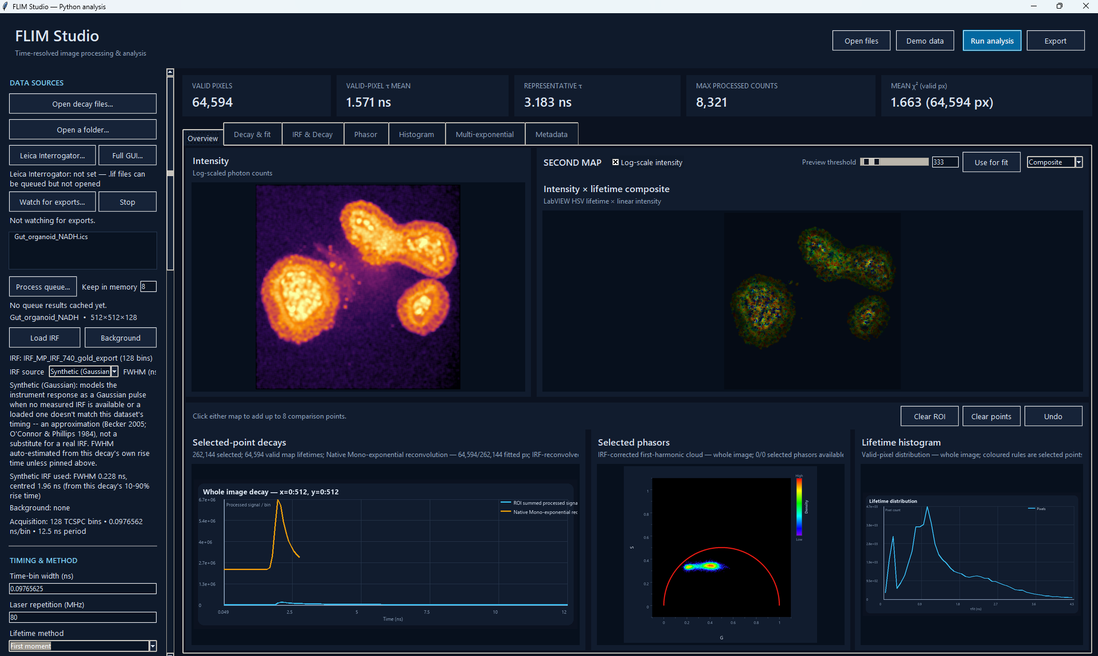
FLIM Studio main window, Overview tab
The window has four regions:
- Header (top) — quick-access buttons: Open files, Demo data, Run analysis, Export.
- Sidebar (left) — every analysis setting, organised into sections (§3).
- Content area (right) — a metrics strip plus a tabbed set of views (§5).
- Status bar (bottom) — current status message and a progress bar.

2. Loading data

Opening files
- Open decay files… (sidebar or header) — pick one or more decay files. Multiple selections fill the queue list, and the first one loads automatically. .lif files (raw Leica acquisitions) can be selected here too — see §2.3.
- Open a folder… — queues every supported file in a folder (.ics/.ids, .npy/.npz, .tif/.tiff, .csv/.txt, .lif). If a .ics header and its .ids companion are both present, only the .ics is queued.
- The queue list shows every queued file. Click an entry to load and analyse it (or show a cached result — see §6.2). A ● marker means a cached result already exists for that entry; ◇ marks a .lif entry (see §2.3) — it isn't directly analysable data. Ctrl/shift-click to select more than one entry (this doesn't load/show anything while multiple are selected), then Remove selected to drop just those from the queue — their cached results, if any, go with them. Clear queue empties it entirely. Neither touches anything on disk.

Reference data
- Load IRF — the instrument response function for reconvolution fitting and phasor IRF correction. Required for any FLIMLib reconvolution/global/apply-model method (§4) — unless the sidebar's Synthetic (Gaussian) IRF source is selected instead (§3), which removes that requirement entirely.
- Background — a dark/background acquisition subtracted from every sample before any other processing (§6.1).
Both accept the same file types as sample data, and can be a single decay trace, a per-pixel cube matching the sample's shape, or (for background) a flat scalar via the Additional scalar background field instead of a file.

2.3 Leica .lif files (via Leica Interrogator)
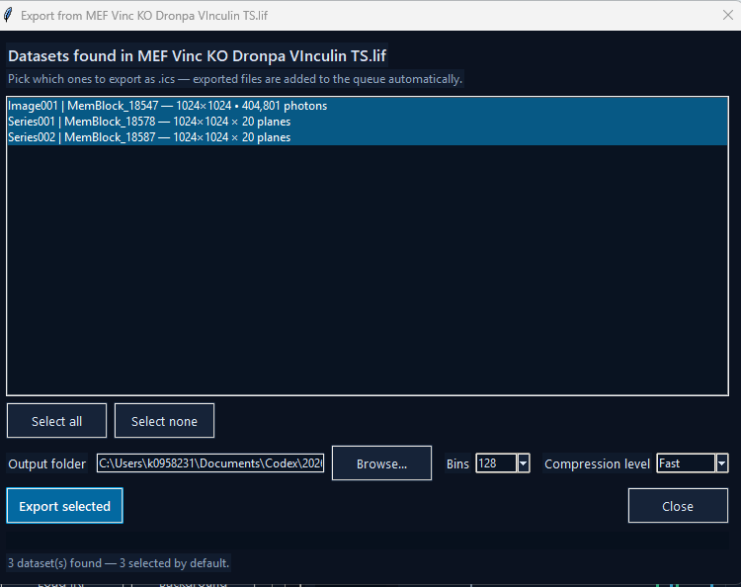
Exporting datasets from a .lif file
FLIM Studio doesn't decode Leica's raw .lif format itself. Instead it calls a Leica Interrogator converter — running as an isolated subprocess, the same crash-isolation approach used for native FLIMLib fitting — to turn .lif acquisitions into .ics files it can analyse normally, without leaving FLIM Studio for the common case.
No setup needed for the common case: a packaged FLIM Studio build already includes a built-in .lif reader, so queuing and exporting a .lif (below) just works, with nothing to install or configure first. Leica Interrogator… (sidebar, DATA SOURCES) only needs to be set if you also want Interrogator's own Full GUI… for manual preview — that's a separate, full installation of "Leica Interrogator Desktop" with its own Python environment, and it takes priority over the built-in reader whenever it's configured (so if the picker below behaves unexpectedly after setting it, an easy check is clearing that field again to fall back to the built-in reader).
Exporting a `.lif` (the quick path):
- Queue the .lif via Open decay files…/Open a folder… — it shows up marked ◇.
- Click it in the queue. FLIM Studio scans it and opens a picker listing every FLIM dataset found inside — a single .lif commonly contains many (multiple series, timepoints, channels/detectors), so this lets you choose which ones matter rather than exporting everything blind.
- Tick the ones you want (all are selected by default), set an output folder, Bins, and Compression level (Fast/Balanced/Max — trades export speed against file size; decoding time, not compression, is the main cost for large multi-plane series).
- Export selected — progress streams live (a message plus a progress bar) rather than appearing to hang while a large series decodes. Exported .ics files are added straight to the main queue automatically, ready to analyse — no manual re-import step.
Full GUI… (next to the Leica Interrogator button) launches Interrogator's own standalone application instead, for when you'd rather preview/browse there before exporting anything.
Watch for exports… / Stop — point this at a folder (e.g. wherever the full Interrogator GUI saves its exports) and FLIM Studio polls it every couple of seconds, adding any new .ics files it finds straight to the queue automatically. This is specifically for the Full GUI… path — the picker dialog above already adds its own exports to the queue without needing a watch folder.
Batch operations (Process queue…, Process & export queue, §6.2) skip .lif entries with a clear message rather than failing on them — export to .ics first.

3. Sidebar reference
The sidebar, top to bottom:
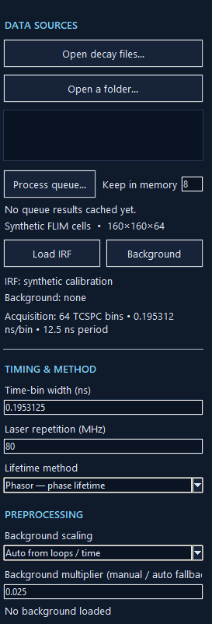
Sidebar: Data sources, Timing & method, top of Preprocessing
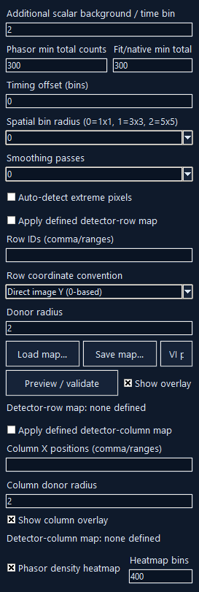
Sidebar: rest of Preprocessing, including the row/column maps
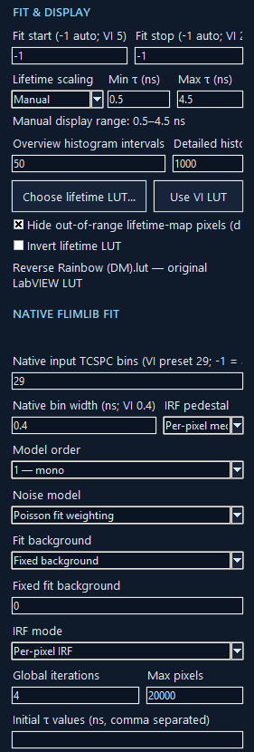
Sidebar: Fit & display, Native FLIMLib fit
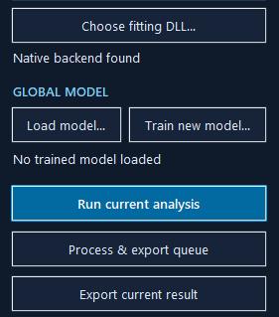
Sidebar: fitting DLL selector, Global model, action buttons

SETTINGS PRESET
The very top of the sidebar. Every choice covered in this section — every control below, in every section — can be saved to and loaded from a plain .ini file:
- Load… / Save as… — pick any .ini file to load from or save the current sidebar state to.
- Save as default — saves to default.ini next to the application (the project folder when running from source, or next to FLIM Studio.exe in a packaged build). This file loads automatically every time FLIM Studio starts, so it's how you make your own settings the ones you see on launch instead of the built-in defaults — no need to re-enter them each session, or hand them to a colleague running the same acquisition setup: give them the .ini file (or drop it next to their copy of the exe as default.ini).
- Reset — reverts every control back to FLIM Studio's own built-in defaults (not default.ini, if one was loaded — use Load… on a saved file to go back to that instead).
A settings file only covers analysis choices — method, timing, thresholds, spatial binning, native fit conditions, display ranges, IRF source, and so on. It doesn't include anything about a specific loaded file (the sample/IRF/background paths, or the queue) — those aren't “initial values for a choice” so much as “whatever happens to be open right now”. Loading one that's missing or has an unrecognised value for some field (e.g. saved by a newer version with a choice this one predates) skips just that field with a warning, rather than failing the whole load.

DATA SOURCES
Covered in §2 and §2.3 (Open decay files…, Open a folder…, Leica Interrogator…, Full GUI…, Watch for exports…/Stop, Load IRF, Background), plus:
- Keep in memory — how many queue results Process queue… keeps cached at once (§6.2).
- IRF source — Loaded file (default) uses whatever's loaded via Load IRF, or nothing if none is loaded. Synthetic (Gaussian) ignores any loaded file entirely and models the instrument response as a Gaussian pulse instead:
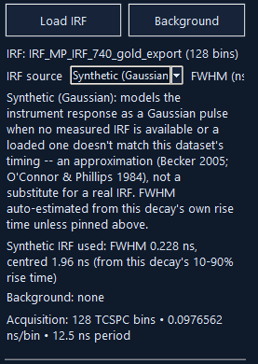
The IRF source control and its auto-estimated summary
This is a standard TCSPC/FLIM approximation (Becker, Advanced TCSPC Techniques, 2005; O'Connor & Phillips, Time-Correlated Single Photon Counting, 1984) for when no measured IRF is available, or a loaded one doesn't match the current dataset's timing/bin count. FWHM (ns, -1=auto) — leave at -1 to auto-estimate the width from this decay's own 10–90% rise time (for the large majority of FLIM data, that rise is dominated by the instrument response, not the fluorescence itself — the standard practical estimator when no real IRF exists), or enter a known value to pin it. After a run, a summary line reports what was actually used, e.g. “Synthetic IRF used: FWHM 0.228 ns, centred 1.96 ns (from this decay's 10-90% rise time)” — see the IRF & Decay tab (§5.3) to check it visually against the real decay. It's an approximation, not a substitute for a real measured IRF — it can't capture a genuine detector afterpulsing tail or real pulse asymmetry.

TIMING & METHOD
- Time-bin width (ns) / Laser repetition (MHz) — acquisition timing, pre-filled from the loaded file's metadata but editable.
- Lifetime method — selects the analysis mode; see §4 for what each one does.

PREPROCESSING
- Background scaling — Auto from loops / time derives the background subtraction multiplier from acquisition metadata (loop count / integration time); Manual multiplier lets you set it directly via the Background multiplier field below it.
- Background multiplier (manual / auto fallback) — the scale factor applied to the loaded background before subtraction; also the fallback value if auto-derivation isn't possible.
- Additional scalar background / time bin — a flat per-bin offset subtracted everywhere, independent of any loaded background file.
- Phasor min total counts / Fit/native min total counts — per-pixel intensity thresholds below which a pixel is excluded from the phasor calculation or the fit, respectively.
- Timing offset (bins) — shifts the decay (and IRF) along the time axis by a (possibly fractional) number of bins, applied right after background subtraction.
- Spatial bin radius — 0 = no binning, 1 = sums a 3×3 neighbourhood into each pixel, 2 = 5×5, etc. This is a rolling window centred on every pixel, not traditional block-binning — the lifetime/intensity maps stay at the acquisition's full resolution at any radius (a 512×512 acquisition stays 512×512), with each pixel's own value becoming the sum of its local neighbourhood for better per-pixel photon statistics. Edge/corner pixels sum whatever's actually within the array bounds (their true spatial support) rather than a padded/fabricated neighbourhood. ROI and whole-image aggregate sums (total photon counts, the summed decay curve, etc.) are computed independently of this and are unaffected by the radius you choose.
- Smoothing passes — number of light spatial-smoothing passes applied before binning.
- Auto-detect extreme pixels — automatically finds and replaces dead/outlier pixels with a local median before smoothing.
Detector-row map — corrects known bad/dead detector rows on your array by interpolating them from neighbouring rows:
- Apply defined detector-row map — enables the correction.
- Row IDs (comma/ranges) — e.g. 4, 10-12, 30 — the rows to replace.
- Row coordinate convention — whether row IDs are direct image-Y (0-based) or the original LabVIEW detector-row numbering (mirrored).
- Donor radius — how many neighbouring rows on each side to interpolate from.
- Load map… / Save map… — persist a row map to/from a file.
- VI preset — loads the row map matching the original LabVIEW VI's hardcoded bad-row list, for parity with legacy processing.
- Preview / validate — checks the map against the current dataset's dimensions and previews its effect.
- Show overlay — draws the affected rows on the intensity/second map views.
Detector-column map — the same correction, along columns instead of rows: Apply defined detector-column map, Column X positions, Column donor radius, Show column overlay.
Row/column correction runs after background subtraction and before smoothing/binning — see the exact order in §6.1.
- Phasor density heatmap — colours the phasor plot by point density (a LUT-coloured heatmap) instead of plotting discrete dots. Heatmap bins sets its resolution.

FIT & DISPLAY
- Fit start / Fit stop — the bin range used for mono-exponential and moment fitting (-1 = auto-detect from the decay peak).
- Lifetime scaling — Auto sets the lifetime-map colour range from the data; Manual uses the Min τ / Max τ (ns) fields you set.
- Overview histogram intervals / Detailed histogram bins — bin counts for the small Overview-tab histogram vs. the full Histogram tab.
- Choose lifetime LUT… / Use VI LUT — load a custom 256-colour ImageJ .lut file for lifetime-map colouring, or revert to the bundled default (matching the original LabVIEW VI's LUT).
- Hide out-of-range lifetime-map pixels — display-only: pixels outside the Min τ/Max τ range are hidden rather than clamped to the end colour.
- Invert lifetime LUT — flips the colour ramp direction.

NATIVE FLIMLIB FIT
Settings for FLIMLib reconvolution fitting (mono/bi/tri-exponential), run via the native DLL in an isolated subprocess:
- Native input TCSPC bins — how many leading time bins to hand to the native fit (-1 = all).
- Native bin width mode — Auto (default) makes the native fit assume the same bin width as Time-bin width (§3, TIMING & METHOD), updating automatically if that changes; Manual instead uses whatever's typed into Native bin width (ns) below it, ignored entirely in Auto mode. A summary line reports which is actually in effect and its resolved value. Leave this on Auto unless you have a specific reason the native fit needs a different bin width than the data's own — a mismatch here silently scales every reconvolution-fit lifetime by the ratio between the two, which is essentially never what you want.
- Native bin width (ns) — the bin width the native fit assumes, when Native bin width mode above is set to Manual.
- IRF pedestal — how to remove a DC offset from the IRF before fitting: Per-pixel median, Tail median (median of the last few bins), or None.
- Reconvolution fit worker processes — 1 (default) fits the whole image in one subprocess call, same as always. A higher value splits the image into that many row-bands and fits each concurrently in its own subprocess — real wall-clock speedup on a multi-core machine, with identical results (every pixel is already fitted fully independently, so this is exact, not an approximation). Only applies to FLIMLib — reconvolution — the global/apply-model methods fit one τ jointly across every selected pixel and always stay single-process, since chunking those would silently compute a different τ per chunk.
- Model order — 1 — mono, 2 — bi, or 3 — tri exponential components.
- Distribution model — only affects Train new model… and Lifetime method FLIMLib — global shared τ; no effect on reconvolution or apply-trained-model analysis. Multi-exponential (discrete τ) (default) uses Model order discrete lifetimes. Stretched exponential (distribution) fits one lifetime as a (τ, h) distribution instead of a discrete component (I(t) = Z + A·exp(-(t/τ)^(1/h)); h=1 is a plain exponential, h>1 a broader spread of rates) and forces Model order to 1 — mono — always exactly one component. Multi-stretched exponential (independent components) extends this to up to 3 independently-distributed (τ, h) components summed together; set Model order to how many (2–3). For this option, the Training dialog’s own Auto-seed from phasor analysis checkbox (see §4.6 step 4) is the recommended way to start the fit — it reliably finds every component with no manual guess needed, which plain unseeded fitting is not always guaranteed to do at Model order 3.
- Noise model — Poisson MLE, Poisson fit weighting, Poisson data weighting, or Constant weighting.
- Fit background — Fit / free background lets the fit solve for its own background level; Fixed background uses the value in Fixed fit background instead.
- IRF mode — Global IRF uses one shared IRF for the whole image; Per-pixel IRF uses a per-pixel IRF cube if the loaded IRF file has matching spatial dimensions.
- Global iterations / Max pixels — iteration cap and a pixel-count cap (for performance, not correctness) used by the global-fitting methods (FLIMLib — global shared τ, and global model training). Max pixels = 0 removes the cap entirely — every valid pixel from every image is used, at the cost of a slower run. With a nonzero cap and more than one training image, the budget is split fairly across all of them rather than spent entirely on whichever image comes first.
- Initial τ values (ns, comma separated) — starting lifetime guesses for multi-exponential fitting. Leave blank for the ordinary unseeded search, or (for global model training with the multi-stretched distribution model) check the Training dialog’s own Auto-seed from phasor analysis box instead of typing values here — see §4.6 step 4 for all three seeding options.
- Choose fitting DLL… — point at a specific flimfit_labview.dll if it isn't auto-detected; the status line below shows which one is active.

GLOBAL MODEL
- Load model… — load a previously trained/saved global model (.json) for Application mode (§4.7).
- Train new model… — opens the Training dialog (§4.6).

4. Modes of operation (Lifetime method)
Select via the sidebar's Lifetime method dropdown.

4.1 Phasor — phase lifetime / 4.2 Phasor — modulation lifetime
Computes the first-harmonic phasor (G, S) per pixel from the Fourier transform of each decay, optionally IRF-corrected (per-pixel or global, depending on IRF mode; loaded file or synthetic Gaussian, depending on IRF source — §3). Reports lifetime from either the phase angle (arctan(S/G)) or the modulation depth (|G+iS|). Fast, vectorised, no iterative fitting — good for a quick look or for phasor-space analysis (see the Phasor plot, §5.4).

4.3 Mono-exponential fit
A fast, vectorised weighted log-linear fit of a single exponential decay per pixel over the Fit start/stop bin range. No native DLL or IRF deconvolution involved.

4.4 First moment
Computes lifetime from the decay's first temporal moment (mean photon arrival time relative to the IRF's own centroid, if an IRF is loaded or synthesised).

4.5 FLIMLib — reconvolution
A single-component (mono-exponential) fit against the IRF, run through the native FLIMLib DLL in a subprocess (crash-isolated from the main GUI). Requires an IRF — either loaded, or the sidebar's Synthetic (Gaussian) IRF source (§3). Uses the NATIVE FLIMLIB FIT settings (noise model, background mode, IRF mode, etc.).

4.6 FLIMLib — global shared τ
Bi- or tri-exponential fitting (per Model order) where the component lifetimes (τ) are shared/fixed across every pixel in the image and only the per-pixel amplitudes vary — this is what populates the Multi-exponential tab (§5.6). Requires an IRF (loaded or synthetic, as above).
This is not the same as multi-image global-model training below — this method fits one image's own pixels together; training fits several images' pixels together to produce a reusable model.
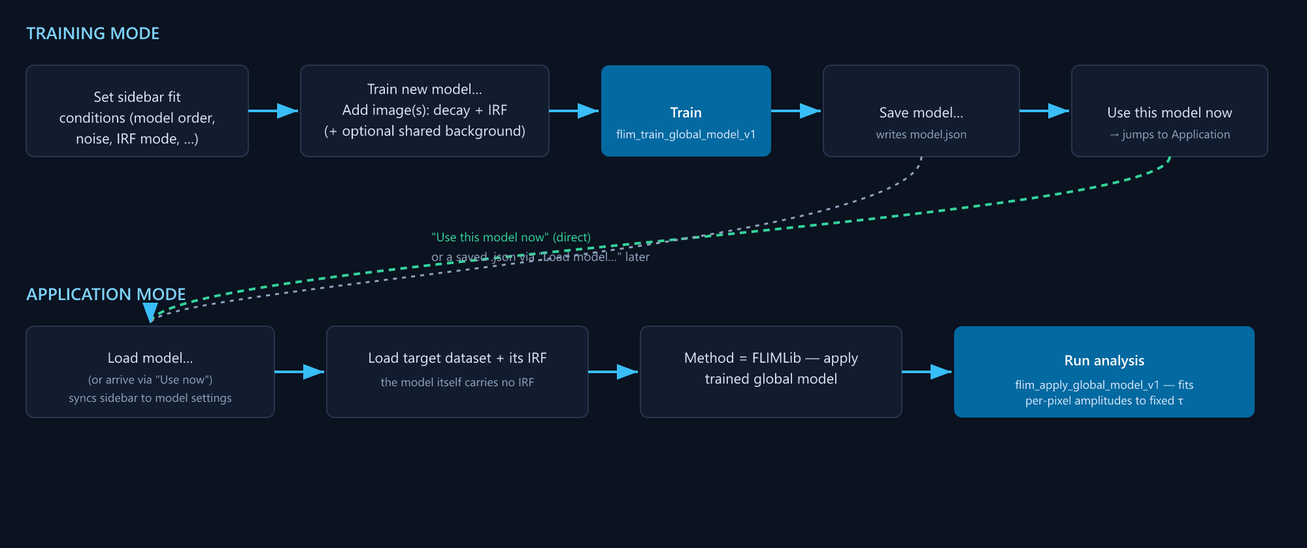
Global model training and application workflow — schematic diagram (no Training-dialog screenshot supplied yet)
Training mode — click Train new model… in the GLOBAL MODEL section to open the Training dialog:
- Optionally set a Shared IRF / Shared background at the top of the dialog to reuse the same reference data for every training image, instead of being asked per image.
- Click Add image(s)… to build the training set — each row needs a decay file and an IRF (background optional). All training images must share the same number of time bins and the same time-bin width (ns) — Train refuses to proceed otherwise, naming the mismatched file. The file picker accepts multiple files at once (ctrl/shift-click) — with a Shared IRF/Shared background set per step 1, every selected file is added straight in with no further prompts; without one, each file still gets its own IRF/background prompt, same as adding one at a time.
- Training uses whatever Model order, Noise model, Fit background, IRF mode, Global iterations, and Max pixels are currently set in the main window's sidebar — set those first, since the dialog doesn't duplicate those controls. Time-bin width is the one exception: training always uses the added images' own bin width (validated in step 2 above), never whatever the sidebar's Time-bin width field happens to show — that field reflects whichever dataset is loaded in the main window, which has no necessary connection to this dialog's training set.
- There are three ways for a global/multi-stretched fit to get its starting τ (and, for the multi-stretched distribution model, h) values — pick one before clicking Train. Unseeded (the default): leave the sidebar’s Initial τ values field blank and this dialog’s own Auto-seed from phasor analysis box unchecked — the native fit searches from several built-in starting points on its own and keeps whichever converges best. Reliable for Model order 1–2; for Model order 3 (three independently-distributed components, multi-stretched distribution model only) this can miss one component — prefer one of the two options below for that case. Manual: type comma-separated starting values into the sidebar’s Initial τ values field (τ, h pairs for the multi-stretched distribution model; plain τ values for ordinary multi-exponential). Use this when you already know roughly what lifetimes to expect — an explicit value here always takes priority over the phasor option below. Auto-seed from phasor analysis (this dialog’s own checkbox, multi-stretched distribution model only): leave Initial τ values blank and check this box instead. Derives a starting (τ, h) guess for every component automatically from this training set’s own phasor structure — no manual guess needed, and reliably finds all the components (including for Model order 3, where plain unseeded fitting can miss one). Falls back to the ordinary unseeded search if a usable seed can’t be derived from this particular data (e.g. too few valid pixels) rather than failing outright.
- Set a Model name (or leave blank for an auto-generated one), then click Train. This calls flim_train_global_model_v1 in the native DLL, fitting shared τ values across every pixel of every training image at once — up to the sidebar's Max pixels cap in total, split fairly across however many images are in the table (each gets its own random share of that budget), so every training image actually contributes to the fit regardless of its size or position in the list.
- Once training finishes, the Px used/total column reports exactly how many of each image's pixels went into the fit — every row should show a non-trivial share; if one shows 0, something about that image (its mask, minimum-count threshold, or IRF) excluded it entirely. Save model… writes the result to a .json file. Use this model now wires the just-saved model straight into the main window's Application mode without a separate load step.

4.7 FLIMLib — apply trained global model (Application mode)
Applies a previously trained model's fixed τ values to a new dataset (via flim_apply_global_model_v1), fitting only per-pixel amplitudes against those fixed lifetimes.
- Load model… (or arrive here via Use this model now from Training) to select the .json model file.
- Loading a model automatically syncs the sidebar's Model order, Noise model, Fit background, IRF mode, thresholds, fit bin range, and native-fit bin settings to match what the model was trained with — applying under different conditions than training would give invalid results, so these are locked to the model rather than left editable.
- You still need to Load IRF for the dataset you're applying to (and load the sample data itself) — the model doesn't carry the IRF itself, only the fitting conditions and fixed τ values. Applying with the synthetic Gaussian IRF source is possible but not recommended here: the model's fixed τ values were calibrated against whatever real IRF it was trained with, so a different (synthetic) IRF at apply time can give inconsistent results.
- Run the analysis as normal (Run analysis / Run current analysis).

5. Viewing results
After a run, the metrics strip (top of the content area) shows valid-pixel count, mean τ, a representative τ, max processed counts, and mean χ². Below it, seven tabs:

5.1 Overview
See the screenshot in §1 — this tab is what's shown there.
The main working view:
- Intensity map (left) and a second map (right) — the second map's mode is chosen via the top-right dropdown: Intensity, Intensity with threshold, Lifetime, or Composite (intensity-weighted lifetime colour).
  - Log-scale intensity checkbox toggles both intensity displays between linear and log scaling.
  - Intensity with threshold shows a Preview threshold slider/entry; Use for fit copies that live threshold value into the sidebar's fit/phasor minimum-count fields.
  - Available before running analysis, not just after: as soon as a dataset is loaded, switching the second map to Intensity or Intensity with threshold previews raw photon counts (summed over time, spatially binned exactly as Spatial bin radius — §3, Preprocessing — is currently set) — so you can pick a sensible threshold, and see how it interacts with binning, before spending time on a full run. Changing the spatial bin radius live-updates this preview. It's still only a preview: background subtraction, the timing offset, and row/column interpolation aren't applied until a real analysis run, which is what actually determines which pixels get fitted.
- Selected-point decays (bottom-left) — decay curves for every point you've clicked, plus the ROI's mean decay if one is drawn.
- Selected phasors and Lifetime histogram (bottom-right) — the phasor cloud and lifetime distribution for the current selection (whole image, ROI, or selected points), shown side by side.
- Toolbar: Undo (last point), Clear points, Clear ROI.
Map interactions (on the Intensity/second map):
- Click — add a comparison point (shown in Selected-point decays).
- Click + drag — draw a rectangular ROI.
- Right-click (no drag) — clear the current ROI/points on that map.
- Right-click + drag — pan when zoomed in.
- Scroll wheel — zoom in/out (1×–16×), centred on the cursor.
- Click the yellow zoom-percentage badge (top-right, appears when zoomed) to reset zoom.

5.2 Decay & fit
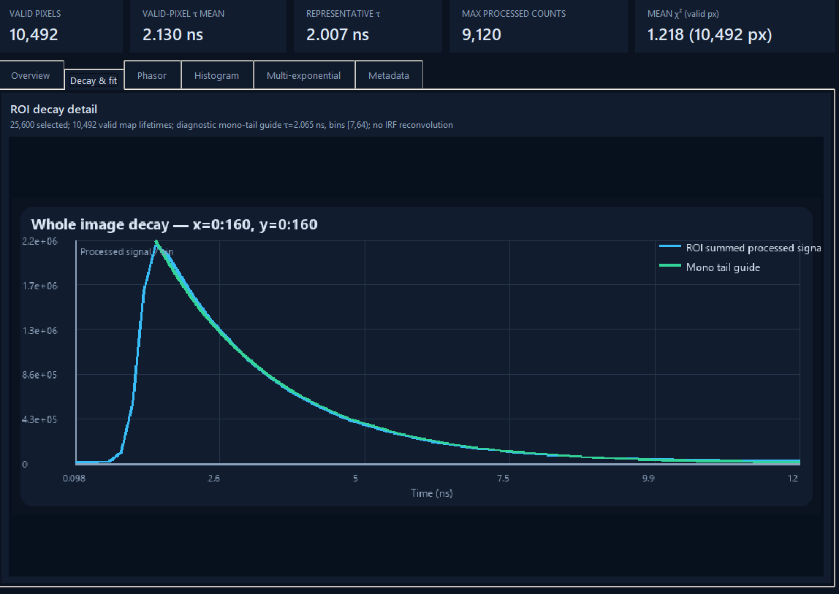
Decay & fit tab
A larger single view of the ROI decay detail — drag a region on an Overview map to populate it.

5.3 IRF & Decay
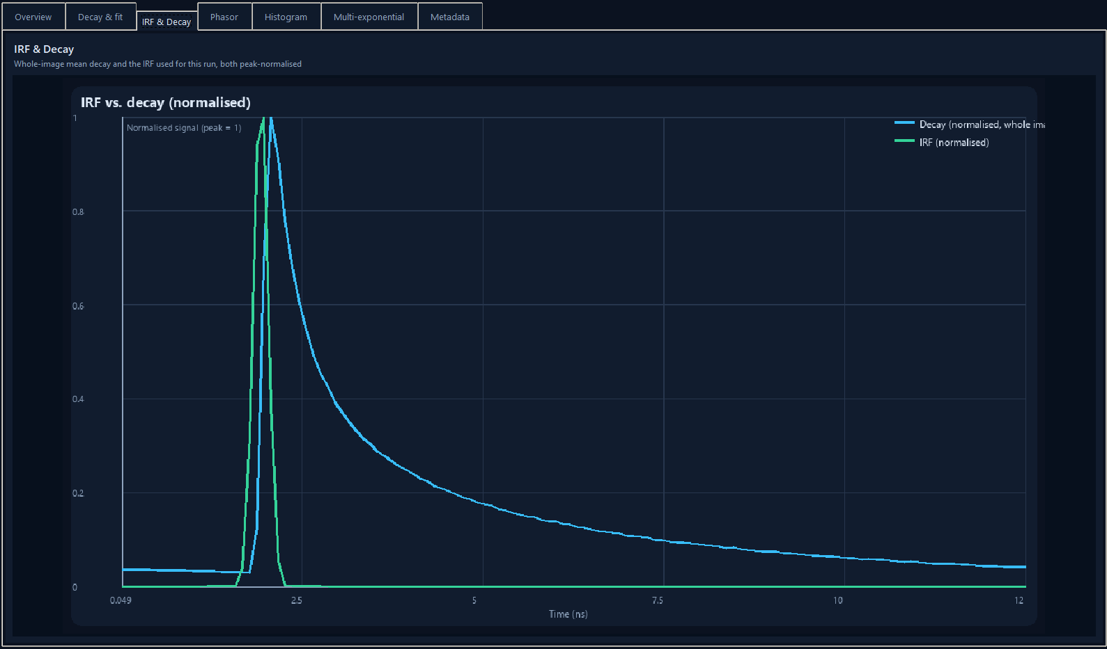
IRF & Decay tab
The whole-image mean decay and the IRF actually used for the current run (loaded file or synthetic Gaussian, whichever applies — §3), both peak-normalised onto the same 0–1 scale so their relative timing and width can be compared directly, regardless of the very different absolute magnitudes a measured decay and an IRF trace naturally have. If no IRF was used at all, only the decay curve is shown, with the title noting that. Updates automatically after every run.

5.4 Phasor
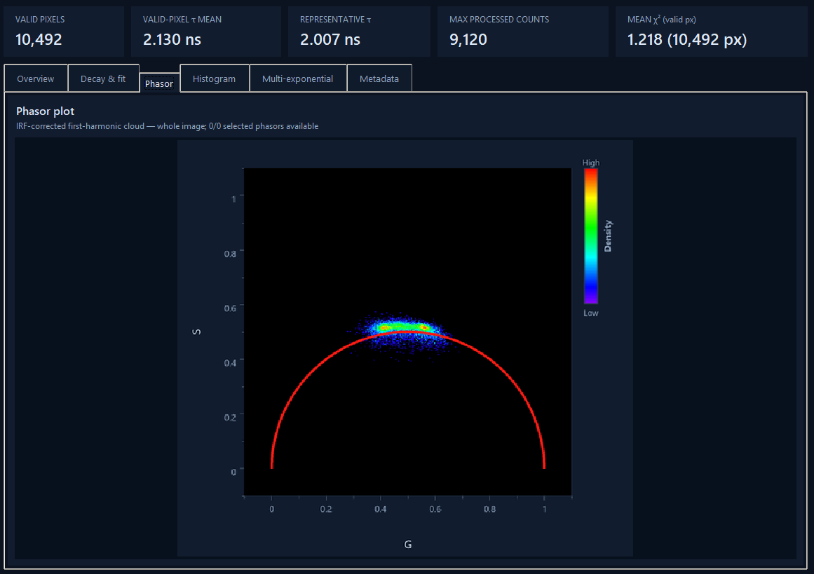
Phasor tab
The full-size phasor plot: first-harmonic (G, S) cloud on the universal semicircle, coloured by density if Phasor density heatmap is enabled.

5.5 Histogram
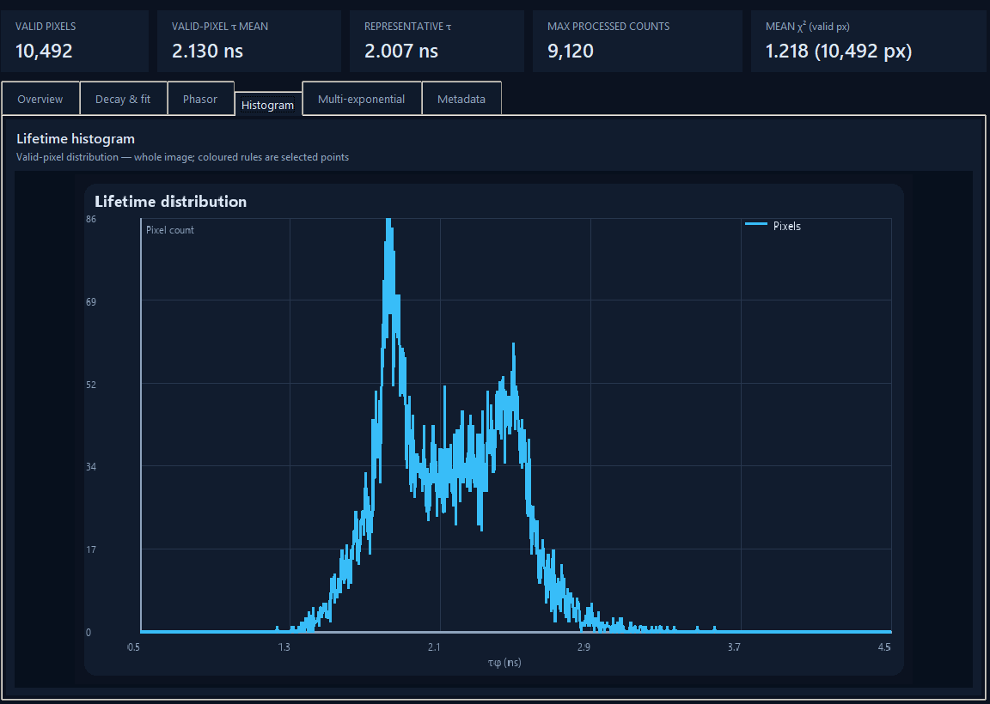
Histogram tab
The full-size lifetime histogram (uses Detailed histogram bins).

5.6 Multi-exponential
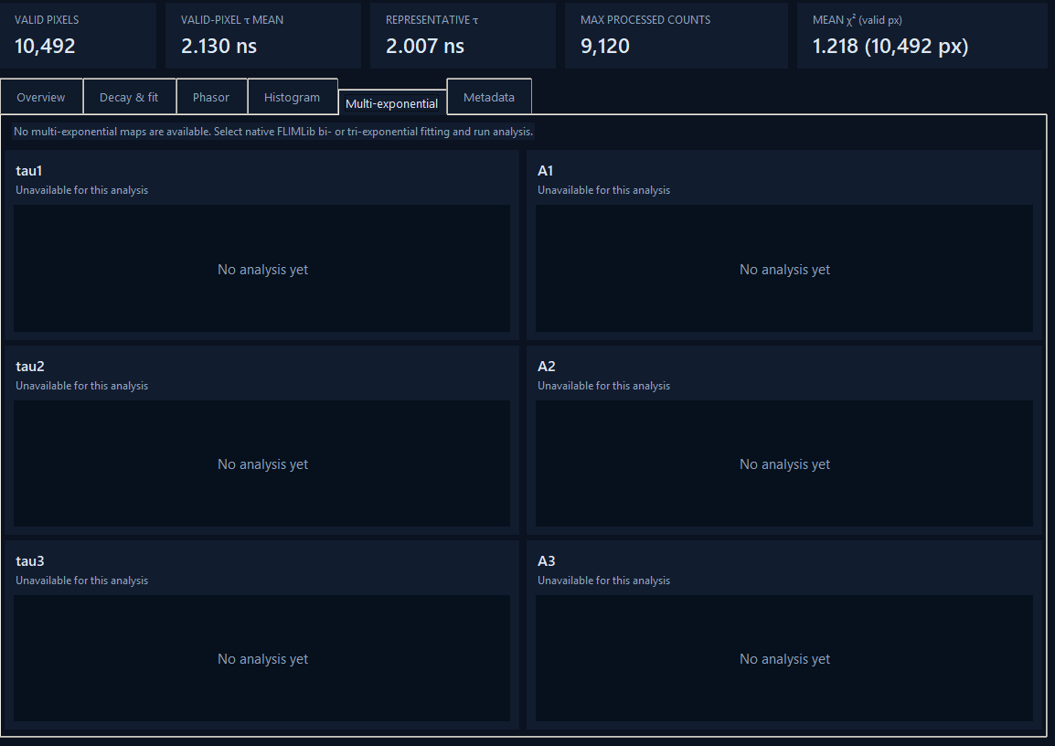
Multi-exponential tab, empty state — populates after a bi/tri-exponential native fit
Populated after a bi- or tri-exponential native fit (§4.6): a grid of τ and amplitude maps, one row per fitted component (τ1/A1, τ2/A2, τ3/A3 as applicable).

5.7 Metadata
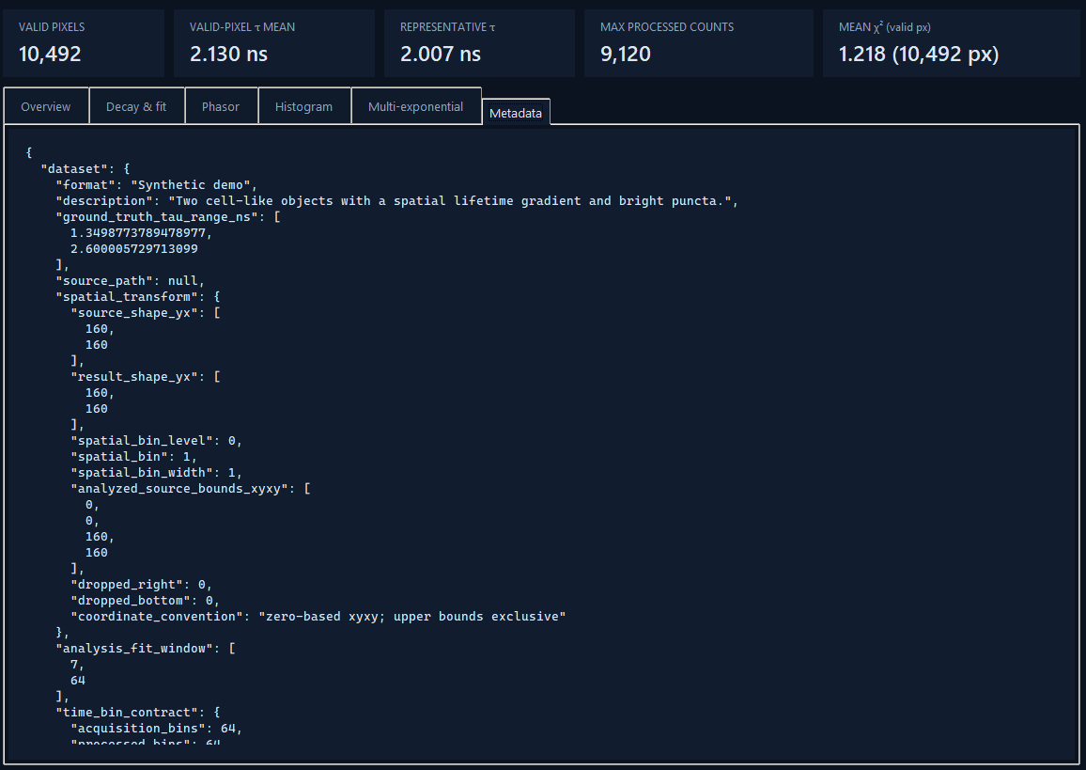
Metadata tab
Full JSON provenance for the current result — every setting used, background-correction details (applied multiplier, formula, fraction of bins clipped), interpolation-map details, DLL hash, the synthetic IRF's estimated parameters (if used), etc. Useful for confirming exactly how a result was produced.

6. Processing pipeline reference

6.1 Order of operations
- Background subtraction and zero-clipping
- Timing shift
- Detector-row interpolation (if enabled)
- Detector-column interpolation (if enabled)
- Automatic extreme-pixel interpolation (if enabled)
- Smoothing
- Spatial binning (a rolling window — see §3; the image size is unchanged by this step)
- Phasor calculation and/or fitting (using the synthetic Gaussian IRF here, if that's the selected IRF source — generated at this point from the fully-preprocessed decay, so it always matches this run's own timing exactly)
Background subtraction happens first and applies to everything downstream — see the Metadata tab's background_correction block for the exact formula and stats from any given run.

6.2 Queue processing: three ways to run multiple files
- Selecting an unprocessed queue entry — loads and displays it, but doesn't run analysis automatically; use Run analysis. (A .lif entry instead opens the Leica export picker — §2.3.)
- Process queue… — runs analysis on every queued file and keeps up to Keep in memory results cached (an LRU cache: least-recently-viewed results are evicted first once the cap is hit). Click any ● entry afterwards to view its cached result instantly, no re-run. Nothing is written to disk by this button. .lif entries are skipped with a clear message.
- Process & export queue — runs analysis on every queued file and writes each result straight to disk (§6.3) as it completes, without keeping them in memory. Use this for a full batch export. .lif entries are skipped the same way.

6.3 Exporting
Export (current result) or Process & export queue (per file) write, per dataset, into the chosen folder:
- <name>_analysis.npz — raw arrays (intensity, lifetime, valid mask, G/S, phase/modulation τ, χ², mean decay/fit, fit diagnostics).
- <name>_summary.json — the same provenance shown in the Metadata tab.
- PNGs: intensity, lifetime, composite, histogram, phasor, decay_fit, dashboard, and (for multi-exponential results) one lifetime map per component.
- <name>_lifetime_histogram.csv — histogram bin centres and counts.
If an ROI or selected points are active when using Export, their own decay/analysis data is exported alongside the main result.

7. Keyboard shortcuts
- Ctrl+O — Open decay files
- Ctrl+R — Run analysis
- Ctrl+E — Export current result
- Esc — Clear ROI

8. Standalone executable
FLIM Studio can be packaged as a standalone .exe that runs without a Python installation — see BUILDING.md (in the project folder) for build steps and troubleshooting.

9. A note on the diagrams
Every panel/tab image in this manual is a real screenshot. The one exception is the Training/Application workflow diagram in §4.6, which is still a schematic flowchart since no screenshot of the Training dialog has been supplied yet. Send one (and any others you'd like added — e.g. the row/column-map preview overlay) and it'll get dropped in the same way these were.

