**Employee Contact Lists**

**Introduction**

As part of this project I implemented the following:

* CRUD for Departments.
* CRUD for Employees with contact information (address, email id and phone number).
* Employee and Department are linked each other.
* Able to view the list of employees associated with each department.
* Used ASP.NET MVC, C# and entity framework.

**CRUD for Employees:**

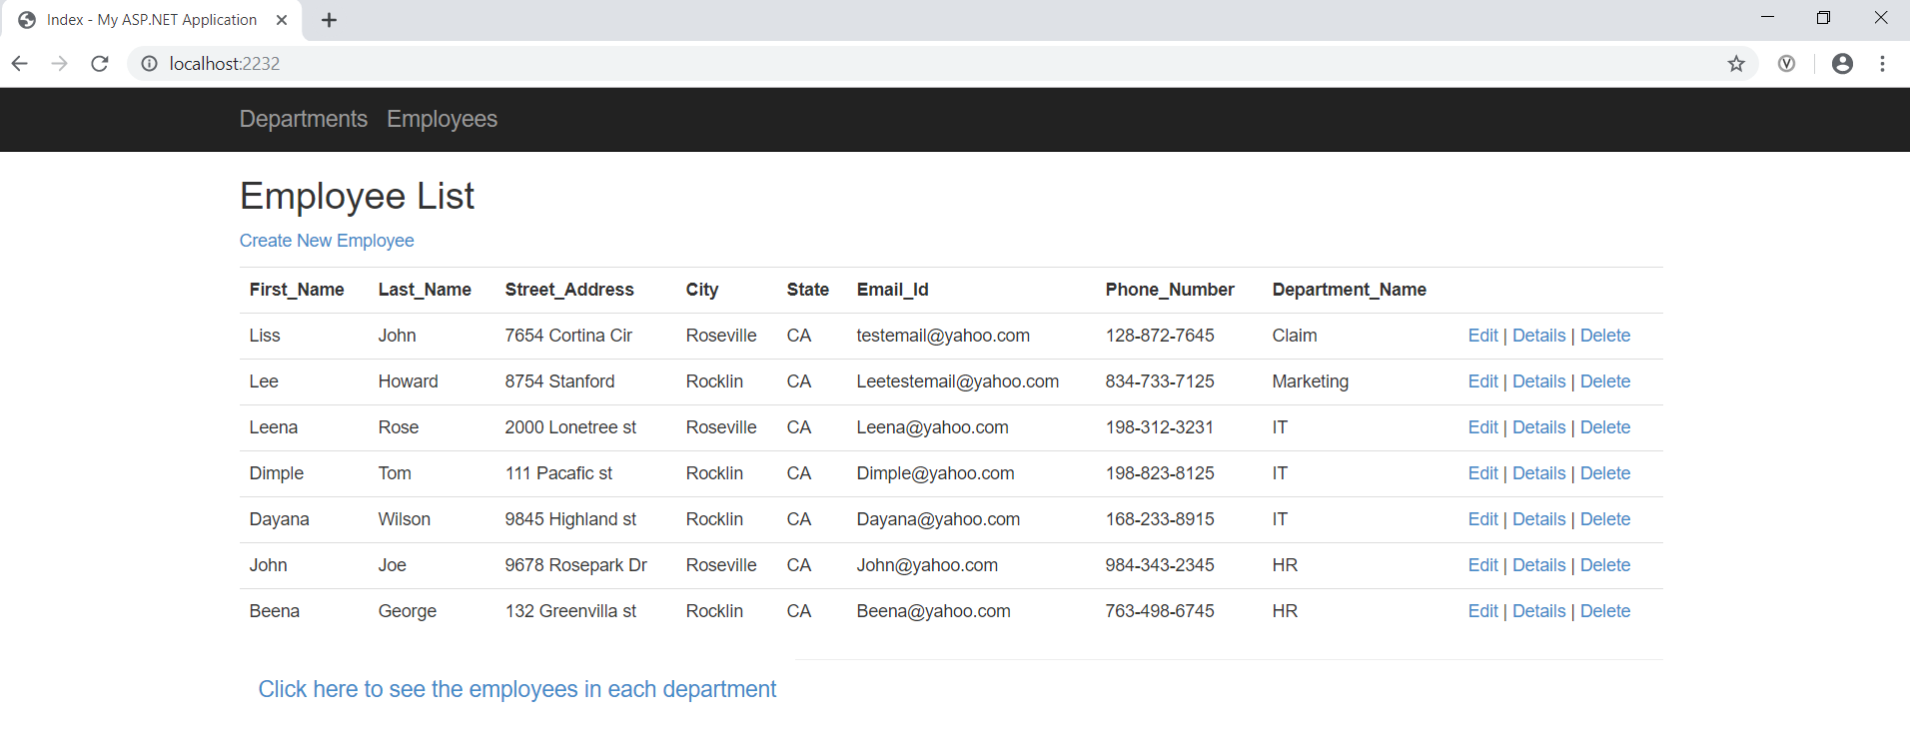

Here the links  will redirect to department list and employees list accordingly.

Create New Employee link,edit,Details and Delete links will do the CRUD for employees.

The link “Click here to see the employees in each department” will redirect to a page with all departments and on selecting each department we can see the employees associated with the selected department. I added validations in Employee model.

1.Create an employee:

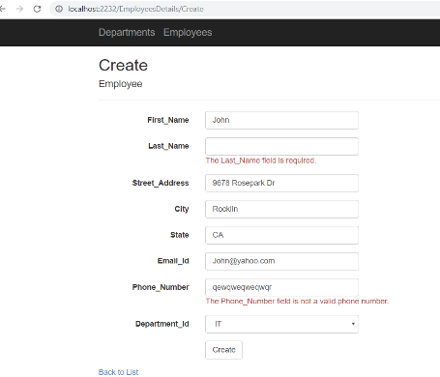

2.View employee details:

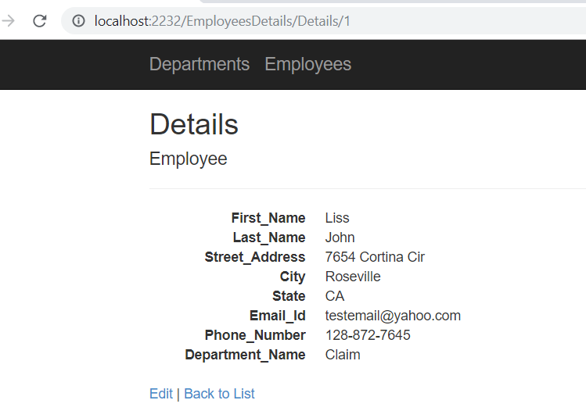

3.Edit an employee:

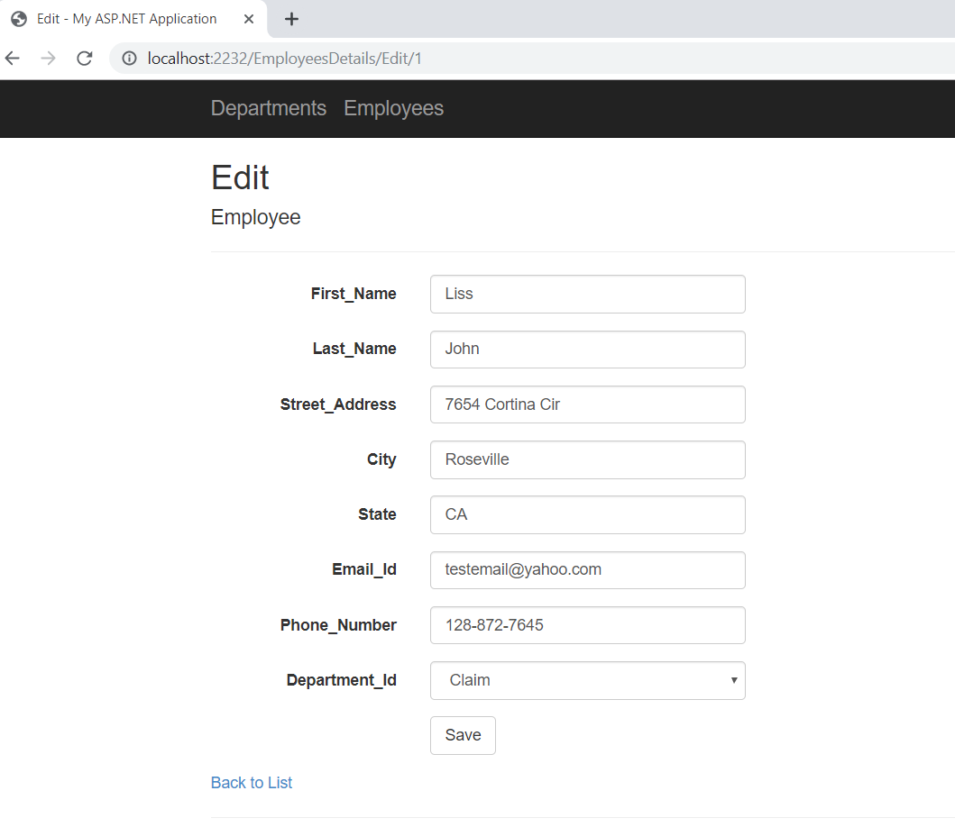

4.Delete an employee:

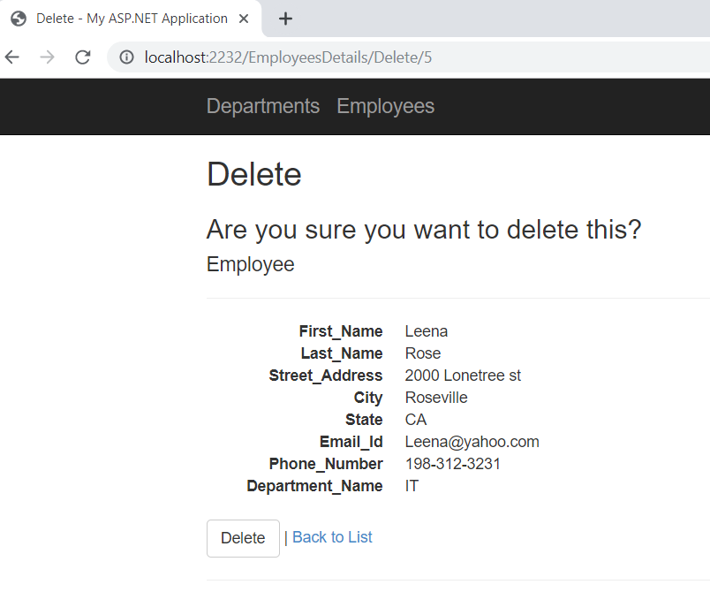

5.View the employees in each department:

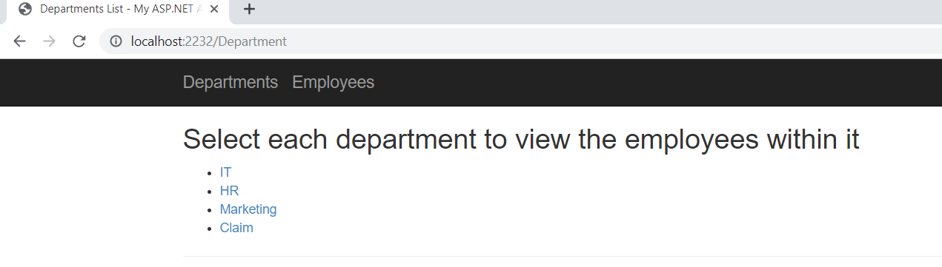

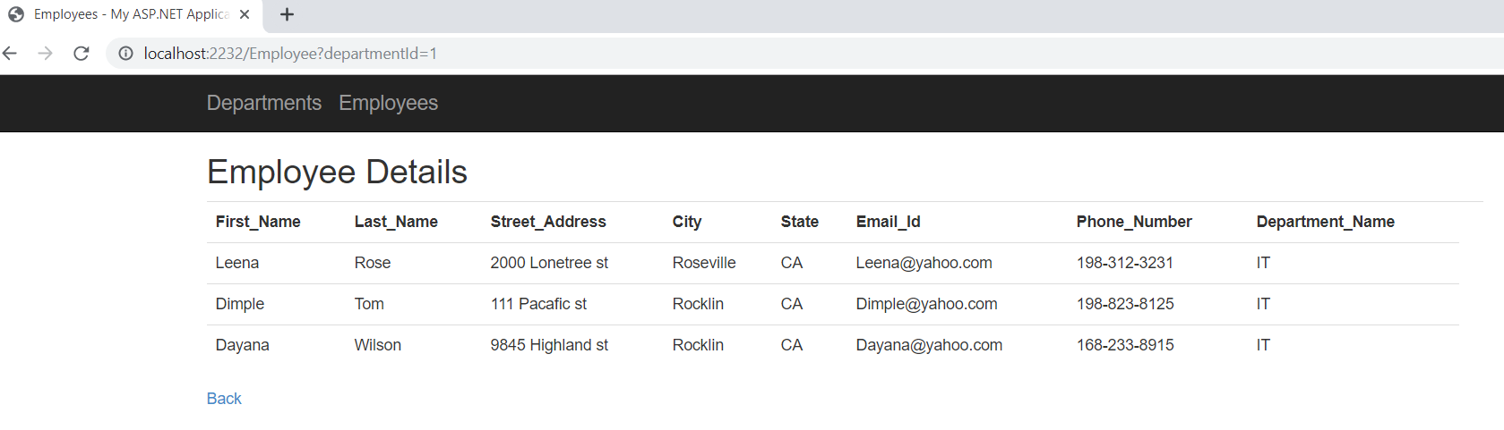

**CRUD for departments**

Here the Departments link in  will display the list of all department where we can do the CRUD operations

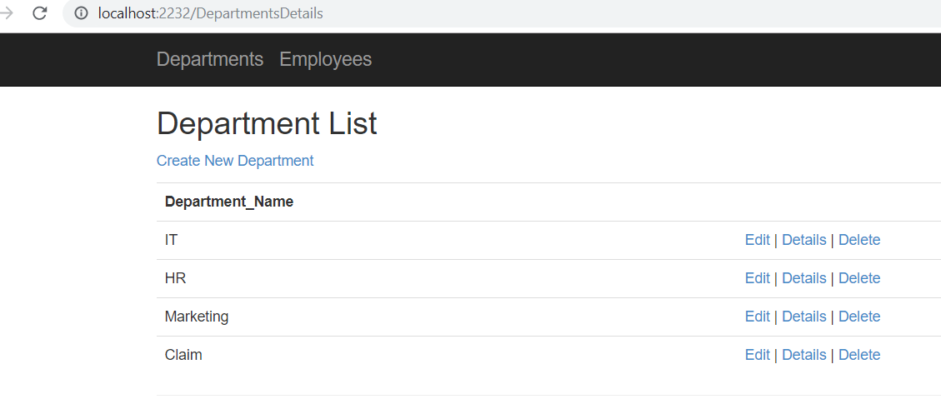

1.Create new department:

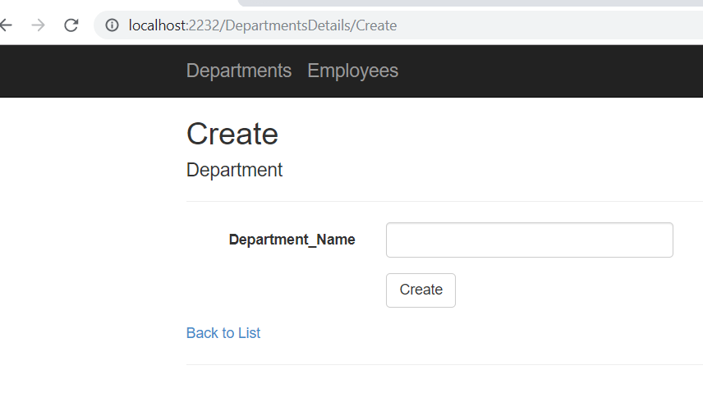

2.To View the department details:

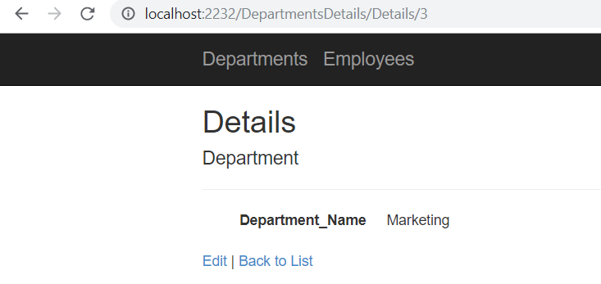

3.Edit a department:

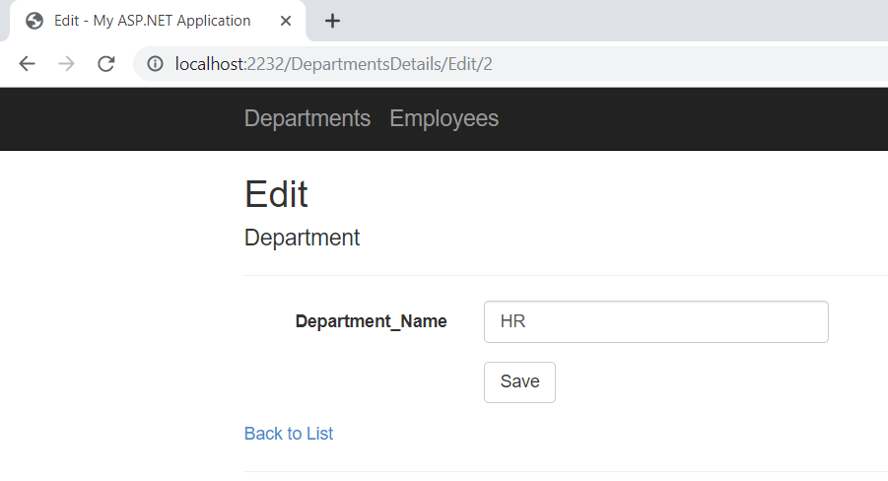

4.Delete a department:

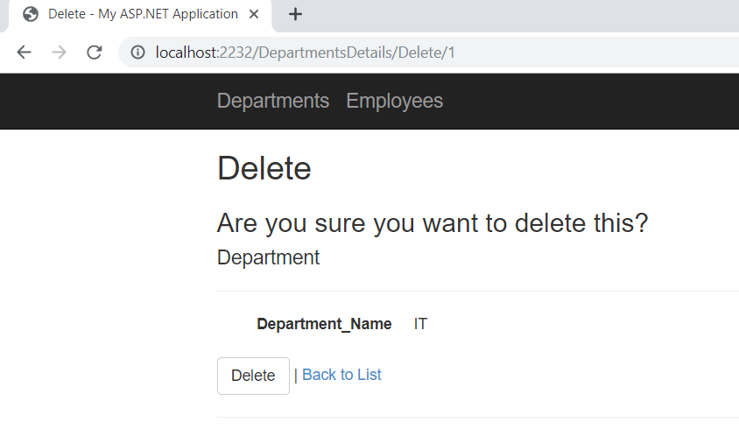

**Unit Test:**

I added a unit test project and included four test cases to get and create employee and department respectively.

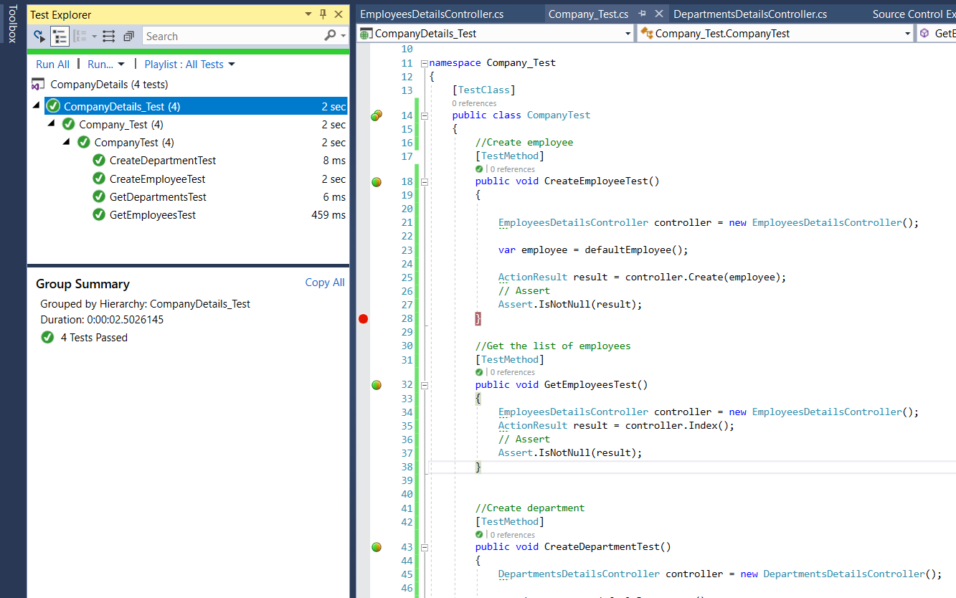

**Note:** I was not able to add the test project in the GitHub so, I uploaded the project,app.config and the test class(Company_Test.cs).

**RouteConfig.cs**

Used EmployeesDetailsController in routeconfig class.

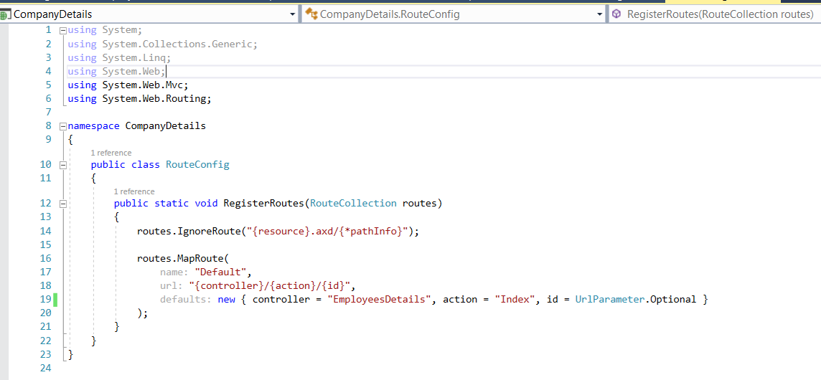

**Solution explorer:**

Here is the project structure,

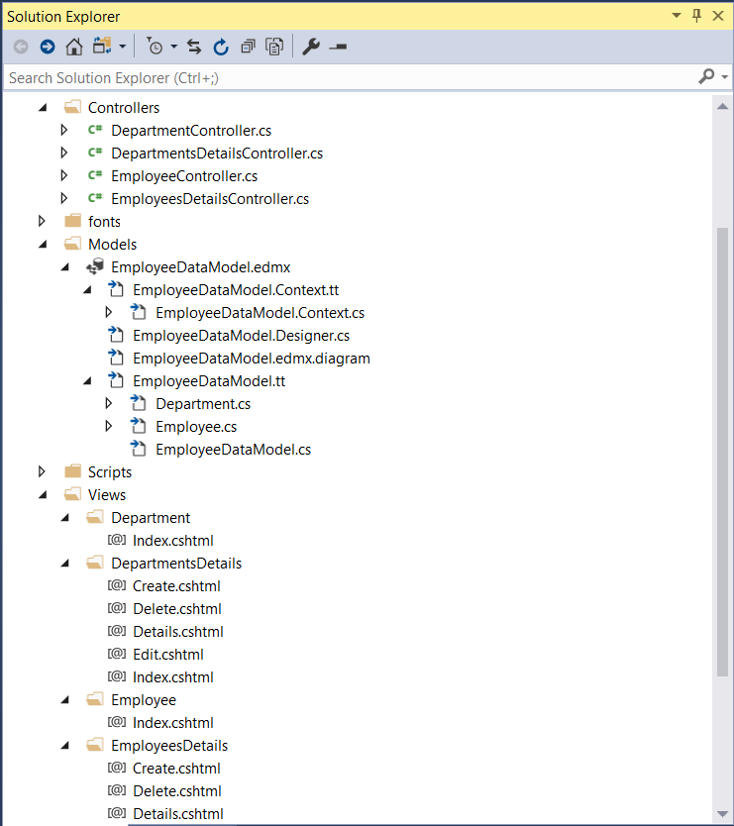

**Database:**

I used SQL Server 2017.Created a database named Company with two tables named Employee and Department.

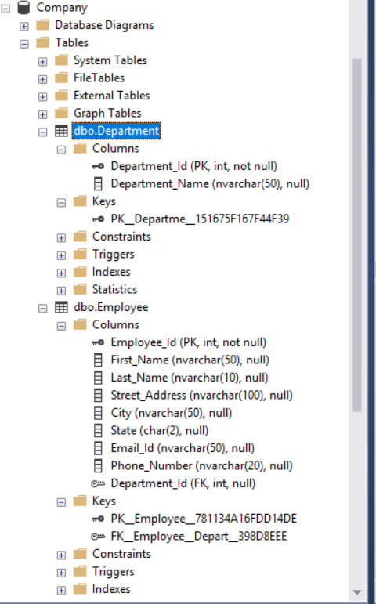

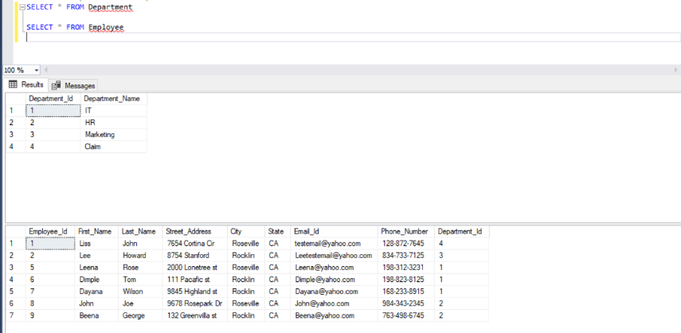

**Web.Config:**

In web.config file, I masked my database server name,please update it accordingly.

<connectionStrings>

<add name="EmployeeDBContext" connectionString="metadata=res://*/Models.EmployeeDataModel.csdl|res://*/Models.EmployeeDataModel.ssdl|res://*/Models.EmployeeDataModel.msl;provider=System.Data.SqlClient;provider connection string=&quot;data source=*********;initial catalog=Company;integrated security=True;MultipleActiveResultSets=True;App=EntityFramework&quot;" providerName="System.Data.EntityClient" />

</connectionStrings>