**BANK LOAN REPORT QUERY DOCUMENT**

**1) Total Loan Application**

select count(id) as Total_Loan_Application from bank_loan_data;



**2) MTD Loan Applications**

select count(id) as MTD_Total_Loan_Application from bank_loan_data

where MONTH(issue_date) = 12 AND YEAR(issue_date) = 2021;



**3) PMTD Loan Application**

select count(id) as PMTD_Total_Loan_Application from bank_loan_data

where MONTH(issue_date) = 11 AND YEAR(issue_date) = 2021;



**4) Total Funded Received**

SELECT SUM(loan_amount) AS Total_Funded_Amount FROM bank_loan_data;



**5) MTD Total Funded Amount**

select sum(loan_amount) as MTD_Total_Funded_Amount from bank_loan_data

where MONTH(issue_date) = 12 and YEAR(issue_date) = 2021;



**6) PMTD Total Funded Amount**

select sum(loan_amount) as PMTD_Total_Funded_Amount from bank_loan_data

where MONTH(issue_date) = 11 and YEAR(issue_date) = 2021;



**7) Total Amount Recieved**

select sum(total_payment) as Total_Amount_Collected from bank_loan_data;



**8) MTD Total Amount Received**

SELECT SUM(total_payment) AS Total_Amount_Collected FROM bank_loan_data

WHERE MONTH(issue_date) = 12 and YEAR(issue_date) = 2021;



**9) PMTD Total Amount Recieved**

SELECT SUM(total_payment) AS Total_Amount_Collected FROM bank_loan_data

WHERE MONTH(issue_date) = 11 and YEAR(issue_date) = 2021;



**10) Average Interest Rate**

SELECT AVG(int_rate)*100 AS Avg_Int_Rate FROM bank_loan_data;



**11) MTD Average Interest**

SELECT AVG(int_rate)*100 AS MTD_Avg_Int_Rate FROM bank_loan_data

WHERE MONTH(issue_date) = 12 and YEAR(issue_date) = 2021;



**12) PMTD Average Interest**

SELECT AVG(int_rate)*100 AS PMTD_Avg_Int_Rate FROM bank_loan_data

WHERE MONTH(issue_date) = 11 and YEAR(issue_date) = 2021;



**13) Avg DTI**

SELECT AVG(dti)*100 AS Avg_DTI FROM bank_loan_data;



**14) MTD Avg DTI**

SELECT AVG(dti)*100 AS MTD_Avg_DTI FROM bank_loan_data

WHERE MONTH(issue_date) = 12 and YEAR(issue_date) = 2021;



**15) PMTD Avg DTI**

SELECT AVG(dti)*100 AS PMTD_Avg_DTI FROM bank_loan_data

WHERE MONTH(issue_date) = 11 and YEAR(issue_date) = 2021;



**16) Good Loan Percentage**

SELECT

(COUNT(CASE WHEN loan_status = 'Fully Paid' OR loan_status = 'Current' THEN id END) * 100.0) /

COUNT(id) AS Good_Loan_Percentage

FROM bank_loan_data;



**17) Good Loan Applications**

SELECT COUNT(id) AS Good_Loan_Applications FROM bank_loan_data

WHERE loan_status = 'Fully Paid' OR loan_status = 'Current';



**18) Good Loan Funded Amount**

SELECT SUM(loan_amount) AS Good_Loan_Funded_amount FROM bank_loan_data

WHERE loan_status = 'Fully Paid' OR loan_status = 'Current';



**19) Good Loan Amount Received**

SELECT SUM(total_payment) AS Good_Loan_amount_received FROM bank_loan_data

WHERE loan_status = 'Fully Paid' OR loan_status = 'Current';



**20) Bad Loan Percentage**

SELECT

(COUNT(CASE WHEN loan_status = 'Charged Off' THEN id END) * 100.0) /

COUNT(id) AS Bad_Loan_Percentage

FROM bank_loan_data;



**21) Bad Loan Applications**

SELECT COUNT(id) AS Bad_Loan_Applications FROM bank_loan_data

WHERE loan_status = 'Charged Off';



**22) Bad Loan Funded Amount**

SELECT SUM(loan_amount) AS Bad_Loan_Funded_amount FROM bank_loan_data

WHERE loan_status = 'Charged Off';



**23) Bad Loan Amount Received**

SELECT SUM(total_payment) AS Bad_Loan_amount_received FROM bank_loan_data

WHERE loan_status = 'Charged Off';



**24) LOAN STATUS**

SELECT

loan_status,

COUNT(id) AS LoanCount,

SUM(total_payment) AS Total_Amount_Received,

SUM(loan_amount) AS Total_Funded_Amount,

AVG(int_rate * 100) AS Interest_Rate,

AVG(dti * 100) AS DTI

FROM

bank_loan_data

GROUP BY

loan_status;

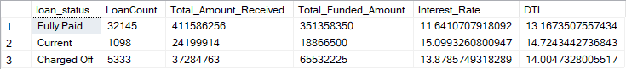

SELECT

loan_status,

SUM(total_payment) AS MTD_Total_Amount_Received,

SUM(loan_amount) AS MTD_Total_Funded_Amount

FROM bank_loan_data

WHERE MONTH(issue_date) = 12

GROUP BY loan_status;

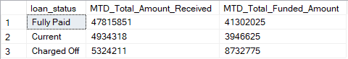

**25) MONTH**

SELECT

MONTH(issue_date) AS Month_Munber,

DATENAME(MONTH, issue_date) AS Month_name,

COUNT(id) AS Total_Loan_Applications,

SUM(loan_amount) AS Total_Funded_Amount,

SUM(total_payment) AS Total_Amount_Received

FROM bank_loan_data

GROUP BY MONTH(issue_date), DATENAME(MONTH, issue_date)

ORDER BY MONTH(issue_date);

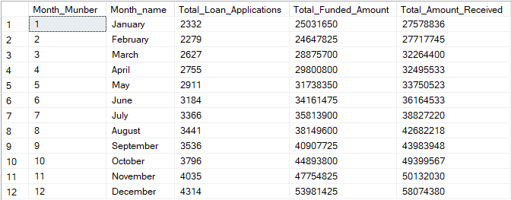

**26) STATE**

SELECT

address_state AS State,

COUNT(id) AS Total_Loan_Applications,

SUM(loan_amount) AS Total_Funded_Amount,

SUM(total_payment) AS Total_Amount_Received

FROM bank_loan_data

GROUP BY address_state

ORDER BY address_state;

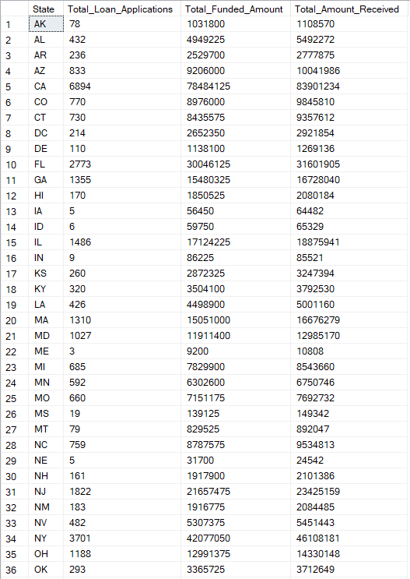

**27) TERM**

SELECT

term AS Term,

COUNT(id) AS Total_Loan_Applications,

SUM(loan_amount) AS Total_Funded_Amount,

SUM(total_payment) AS Total_Amount_Received

FROM bank_loan_data

GROUP BY term

ORDER BY term;



28) EMPLOYEE LENGTH

SELECT

emp_length AS Employee_Length,

COUNT(id) AS Total_Loan_Applications,

SUM(loan_amount) AS Total_Funded_Amount,

SUM(total_payment) AS Total_Amount_Received

FROM bank_loan_data

GROUP BY emp_length

ORDER BY emp_length;

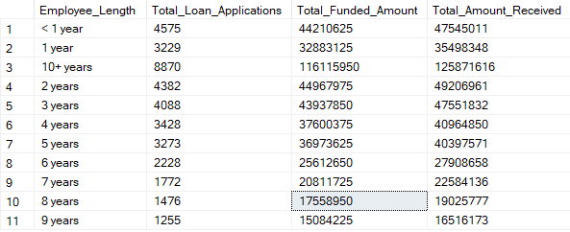

**29) PURPOSE**

SELECT

purpose AS PURPOSE,

COUNT(id) AS Total_Loan_Applications,

SUM(loan_amount) AS Total_Funded_Amount,

SUM(total_payment) AS Total_Amount_Received

FROM bank_loan_data

GROUP BY purpose

ORDER BY purpose;

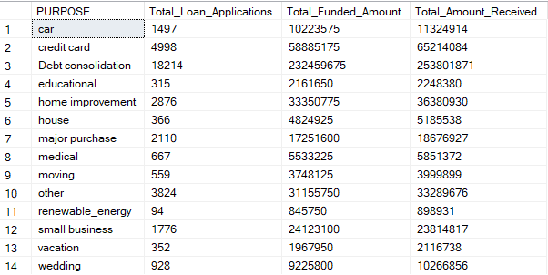

**30) HOME OWNERSHIP**

SELECT

home_ownership AS Home_Ownership,

COUNT(id) AS Total_Loan_Applications,

SUM(loan_amount) AS Total_Funded_Amount,

SUM(total_payment) AS Total_Amount_Received

FROM bank_loan_data

GROUP BY home_ownership

ORDER BY home_ownership;

