Lab 3 – Tests

Testing will consist of testing: (1) Inserting a record, (2) Inserting a record with missing information, (3) Deleting a (newly added) record with no error, (4) Deleting a record with an error, (5) Edit an order for existing Product, (6) Change (remove) the category of an item, and (7) Change ProductID with a non-numeric and also removing it entirely as well as attempting to Change (remove) the ProductName which are non null fields in the table

Test 1 – Insert Record

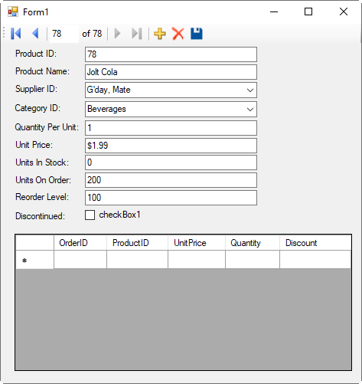

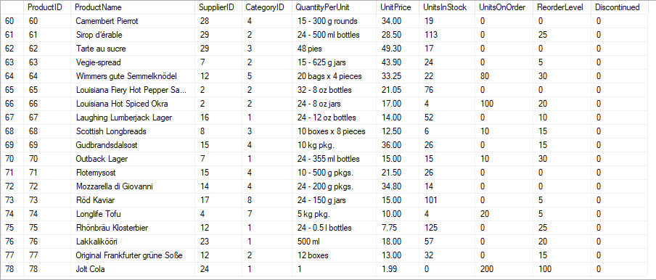

Test 2 – Insert Record with null

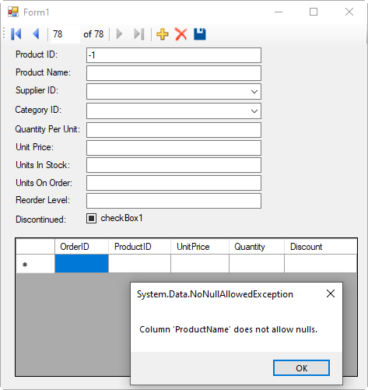

Test 3 – Delete Record (no error)

This one is hard to capture: I deleted the record I just created and ran the SQL query to verify the results

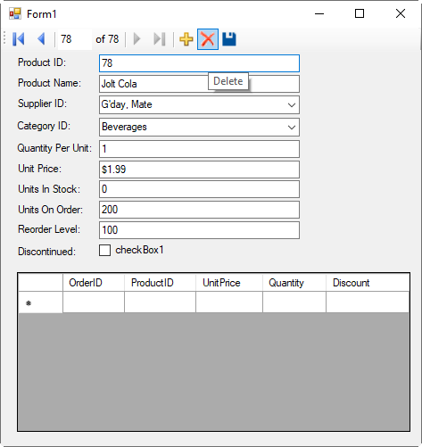



Test 4 – Delete existing record (Generating an error)

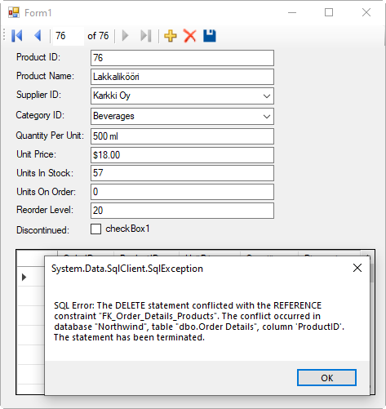

Test 5 –Edit an order:

Tried to double click cells, input random characters while cell was highlighted.

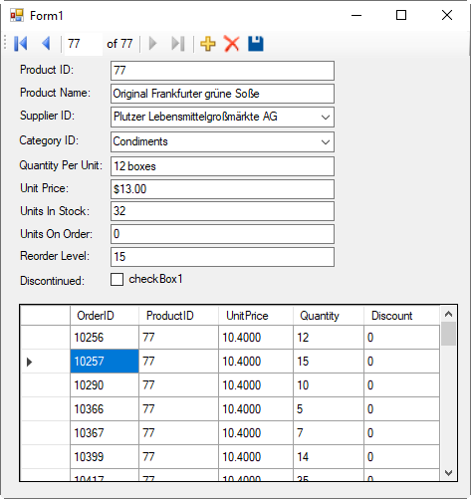

Test 6 – Change Category

I was able to delete the category information and Save it (Validation should probably catch this… Although is a Nullable field)

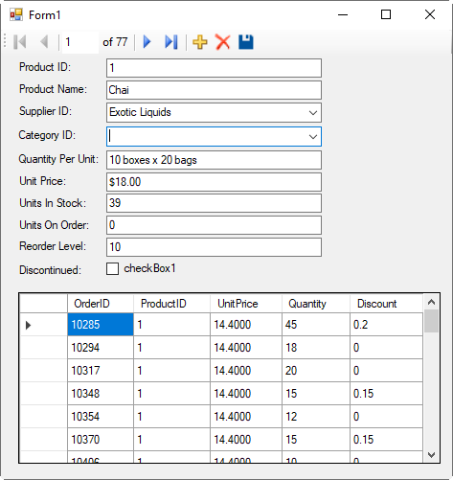

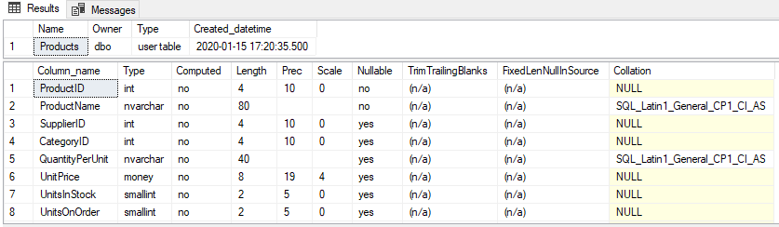

Test 7 – Change/Null ProductID and Product Name

Trying to change ProductID by deleting it or changing it to a non-numeric value – Was able to click on save button with no errors, however the record did not update in the database. Unsure why the operation did not complete or thrown an error

However deleting the Product Name and saving was successful, which I believe should have caused an error based on the field not being Nullable

Further validation is required

