AEREALITH AI
Brand Identity Guide
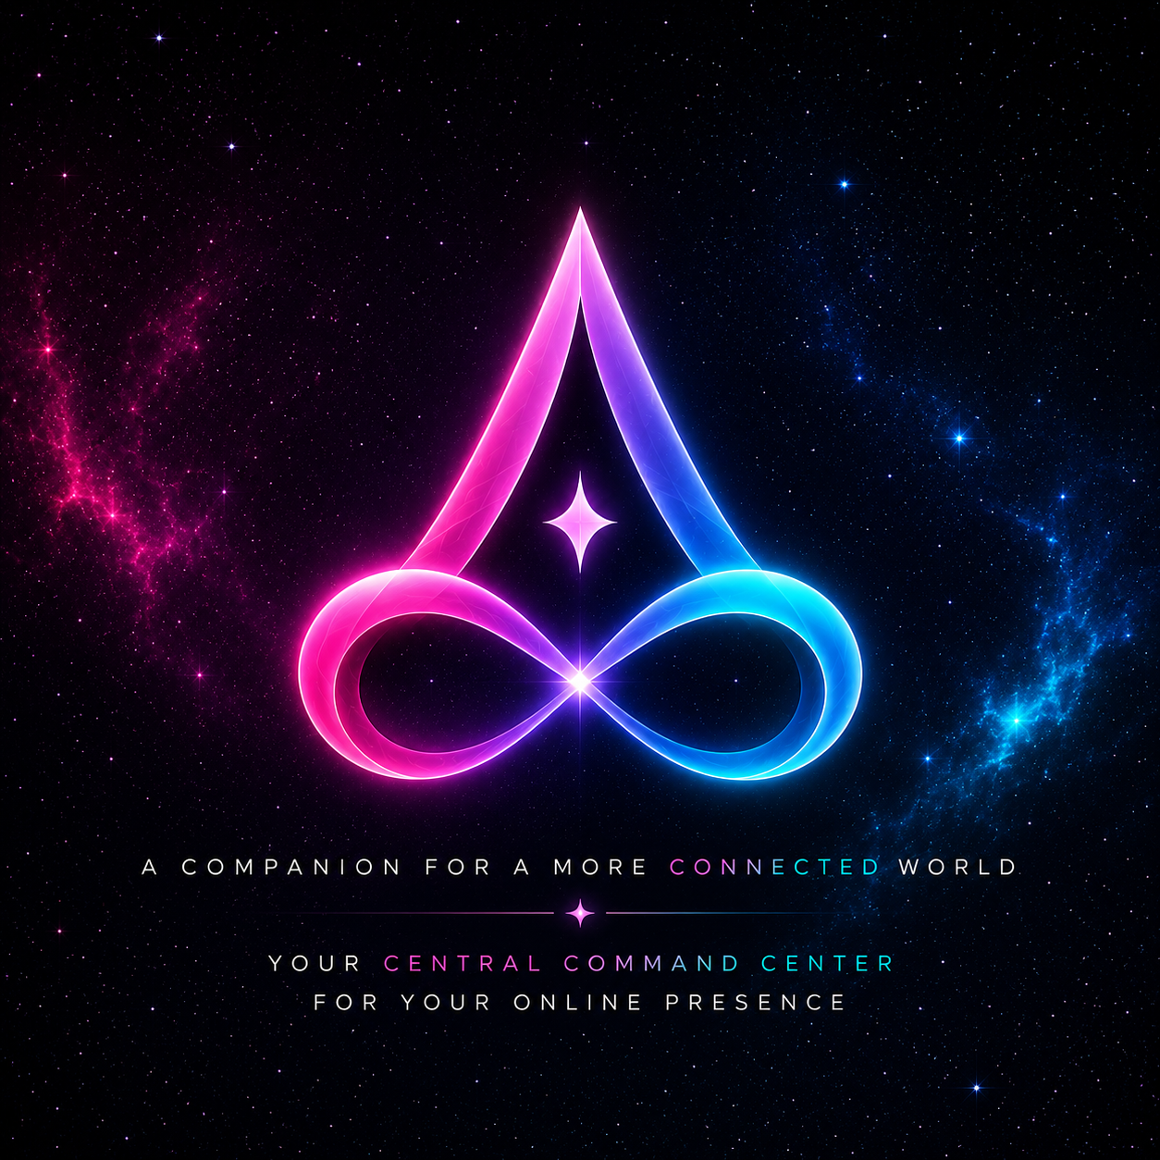

1. Brand Foundation
Field | Standard
Official brand name | Aerealith AI
Pronunciation | Air-ee-uh-lith
Assistant identity / nickname | Aerie
Primary domains | aerealith.com for public website, documentation, pricing, and community. aerealith.app for the web app, dashboard, login, and assistant experience.
Primary tagline | A companion for a more connected world.
Support line | Your central command center for your online presence.
Positioning statement: Aerealith AI is a secure, user-controlled digital companion and intelligent command center built to connect apps, memory, automations, dashboards, communities, and workflows into one trusted assistant experience.

2. Brand Voice
- Calm, precise, and protective.
- Transparent about limits, actions, memory, and data use.
- Warm and companion-like without being overhyped or corporate-cold.
- Permission-aware: user control comes first.
- Slightly futuristic, but still clear and practical.

3. Color Palette
Token | Hex | Purpose | Swatch
Aerealith Pink | #F6066F | Signature energy, warmth, identity accent
Ether Cyan | #00DBC9 | Intelligence, technology, flow
Deep Night | #050A1E | Primary dark background
Void Navy | #08071B | Secondary surface background
Aurora Violet | #8C52FF | Creativity, imagination, inspiration
Soft Starlight | #F7F4FF | Primary high-contrast text
Mist Gray | #AEB7C8 | Secondary text, borders, neutral UI
Recommended gradient: #F6066F -> #8C52FF -> #00DBC9. Use this gradient for the mark, primary CTAs, active tabs, and hero glow accents.

4. Typography
Role | Recommended Font | Usage
Display / logo support | Orbitron or Exo 2 | Large sci-fi headings, hero titles, short labels.
Headings / UI | Rajdhani or Sora | Navigation, card titles, dashboard sections.
Body / product UI | Inter or IBM Plex Sans | Long copy, docs, app UI, forms, settings.
Accent / emotional line | Cormorant Garamond or Playfair Display Italic | Use sparingly for poetic companion-facing lines.

5. Logo System
- Primary mark: stylized A integrated with an infinity form, representing an assistant that augments life and connects digital context over time.
- Core feeling: new age, celestial, calm, sharp, intelligent, protective, and companion-like.
- Use the full poster logo for hero sections and launch marketing. Use the cropped mark for favicons, app icons, and compact navigation.
- Maintain generous spacing around the mark. Avoid placing it on noisy backgrounds unless contrast remains strong.
- Do not recolor outside the approved palette. Do not stretch, rotate, flatten, or add unrelated symbols.
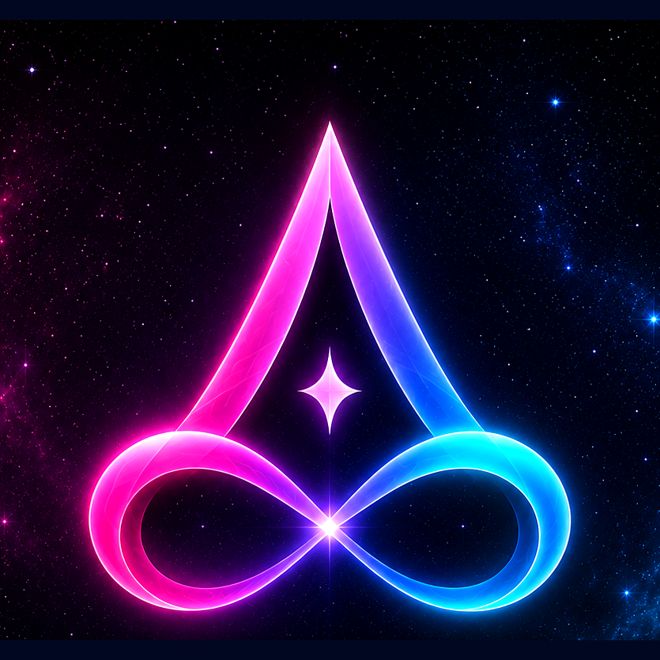

6. Product UI Direction
- Base surfaces should use Deep Night and Void Navy with subtle star, nebula, or aurora textures.
- Use Aerealith Pink and Ether Cyan as opposing energy accents, with Aurora Violet as the bridge color.
- Cards should feel glassy, softly bordered, and luminous, but text must remain readable.
- User trust features should be visible: permissioned memory, transparent automation, scoped integrations, exports, deletion, audit logs, and clear consent.
- The assistant identity Aerie should feel present but not intrusive: helpful, calm, and permission-aware.

7. Included Icon Assets
The package includes PNG icons at 16, 24, 32, 48, 64, 96, 128, 180, 192, 256, 384, and 512 pixels, plus a multi-size favicon.ico.
File | Size | Recommended use
favicon.ico | 16/32/48/64 | Browser favicon
aerealith-icon-180x180.png | 180 | Apple touch icon
aerealith-icon-192x192.png | 192 | Android / PWA icon
aerealith-icon-512x512.png | 512 | Large PWA icon, app store draft, high-res usage
aerealith-ai-mark-concept.svg | Vector | Editable concept source for future refinement

8. Accessibility & Usage Rules
- Use Soft Starlight for primary text on dark backgrounds.
- Use Mist Gray for secondary text only when contrast remains readable.
- Avoid long paragraphs in decorative or wide-spaced display fonts.
- Treat pink/cyan gradients as accents, not body text colors.
- Keep CTAs plain and clear: action text should explain the result.
Aerealith AI - A companion for a more connected world.

