GRIDPULSE
Evidence-governed grid intelligence
for data-centre development
Technical white paper and development roadmap
Turning fragmented public grid evidence, chronological backtesting and synthetic flexibility studies into a defensible pre-application decision system.
Prepared for investor discussion · August 2026
Sina Khedmati · CTO, GridPulse
CORE BOUNDARY
GridPulse does not claim public maps reveal free capacity.
The present platform screens evidence, forecasts published upstream constraint events, and validates capacity and flexibility methods on synthetic networks. Confirmed site-specific MW remains an operator decision.

EXECUTIVE SUMMARY

The investment thesis
Data-centre development increasingly depends on whether large electrical loads can obtain a technically feasible and commercially usable grid connection. Yet early-stage developers face a fragmented evidence problem: public maps describe infrastructure, market platforms publish system-level conditions, and operators hold the decisive topology, loading, queue and protection information. GridPulse is building the evidence and modelling layer between property screening and the formal operator study.
WHAT EXISTS TODAY
A working research platform, not a slide-deck concept.
The separate GridPulse backtest laboratory contains immutable source capture, publication-time event reconstruction, rolling out-of-sample models, AC N-0/N-1 synthetic benchmarks, queue simulations, bounded DeFlex optimization, operator-data contracts and 121 passing tests.

The product wedge
GridPulse can already support public site screening, evidence completeness, upstream constraint history, comparative investigation and customer-defined flexibility scenarios. Its defensible near-term value is reducing uncertainty and improving the quality of connection applications - not replacing the DSO or TSO.

The decisive milestone
The next value inflection is a confidential operator pilot. With anonymized topology, equipment ratings, historical loading, outages, queues and connection outcomes, the same architecture can move from synthetic validation to operator-model validation and historical reconciliation.
Capability | Current evidence class | Readiness
Public site and constraint screening | Public/operator-published context | Available
50Hertz constraint-event risk | Experimental estimate | Research-ready; release gate failed
AC capacity and DeFlex | Synthetic benchmark | Implemented and tested
Operator network analysis | Operator-model unvalidated | Awaiting operator package
Confirmed connection capacity | Operator-confirmed | Unavailable

1. The problem GridPulse addresses

A high-value decision made with incomplete evidence
A data-centre site can be attractive on land, fiber, cooling, permitting and market access while remaining commercially stranded by its grid connection. The relevant decision is not simply whether a transmission line or substation is nearby. It depends on the operator-selected connection point, normal and contingency states, ratings, voltage and protection limits, prior commitments, reinforcement timing and the customer's load behavior.
- Public infrastructure proximity is a screening signal, not proof of electrical connectivity or capacity.
- National load and bidding-zone data describe shared system context, not local substation loading.
- Redispatch and outage publications reveal constraint context, but do not expose residual connection MW.
- A battery or flexible workload can reshape demand; it cannot manufacture network capacity.

Why now
The IEA identifies large, spatially concentrated loads such as data centres as a growing power-system challenge and estimates that grid constraints could delay about 20% of planned global data-centre capacity through 2030. Grid expansion often takes materially longer than data-centre construction, increasing the value of earlier, evidence-based qualification and flexible-connection design.
COMMERCIAL OPPORTUNITY
A faster and more defensible path from site shortlist to operator dialogue.
GridPulse can help developers rank investigation priorities, expose missing evidence, quantify scenario sensitivity, prepare staged or flexible connection requests, and preserve a reproducible record of what was known when each decision was made.

2. Product and evidence architecture
The product is designed as four non-interchangeable evidence layers. Each layer has a distinct source class, permissible language and release gate.
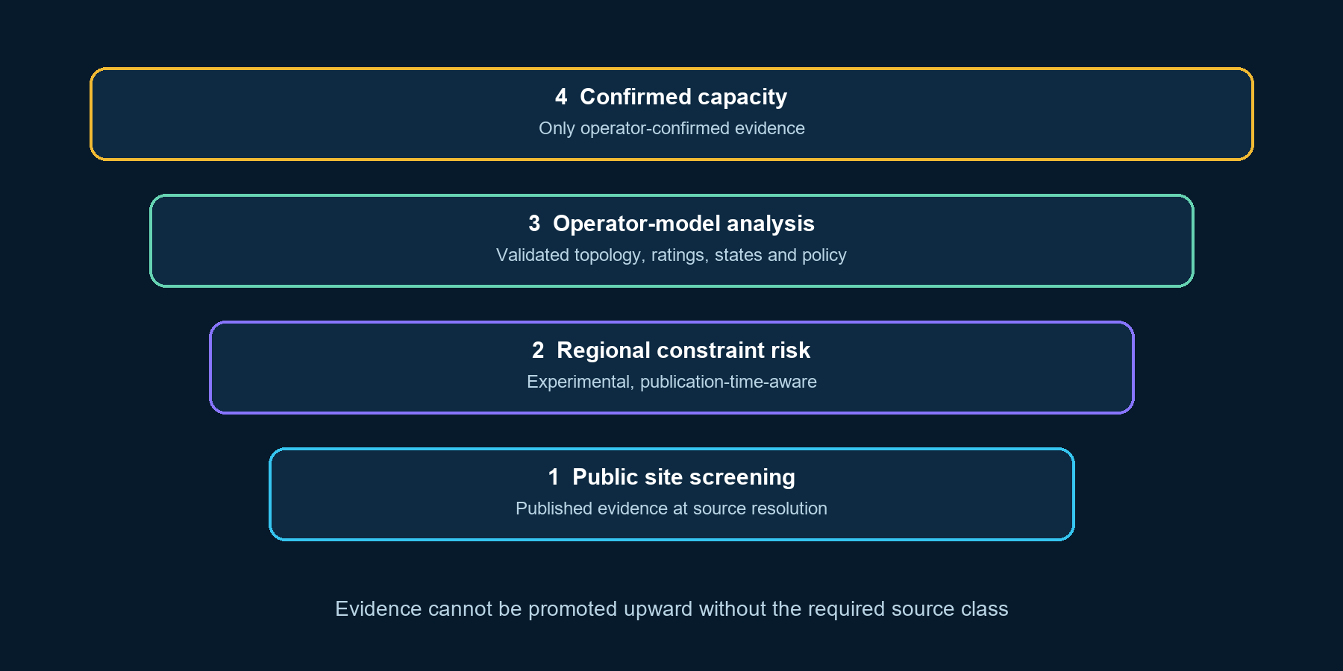
Figure 1. GridPulse evidence stack. Higher layers require stronger evidence; lower-layer results cannot be relabelled as confirmed capacity.
Layer | Permitted output | Prohibited interpretation
Public constraint context | Published upstream congestion, outage or planning context | Available MW or connection feasibility
Regional risk | Probability of a published event within a defined horizon | Nodal loading or headroom
Synthetic flexibility | Comparative behavior under explicit mock envelopes | Real Berlin or Brandenburg network result
Operator-confirmed capacity | Operator-reviewed firm or conditional MW | Available until explicit operator evidence exists

3. End-to-end technical system
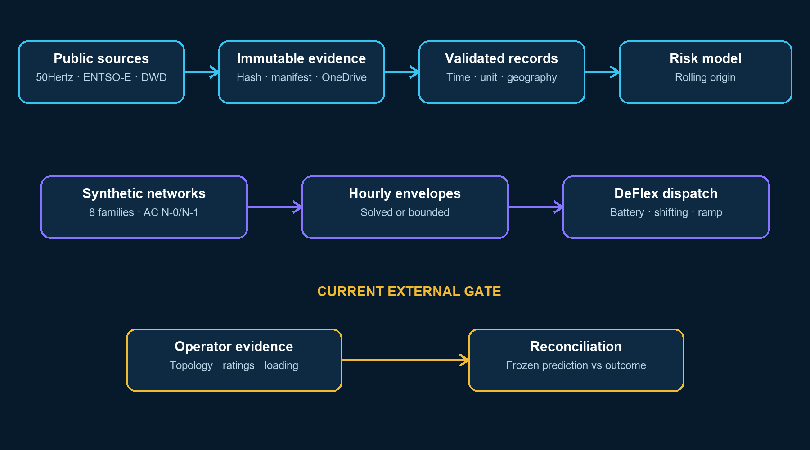
Figure 2. Real public evidence and synthetic electrical studies remain separate until a controlled operator-validation path is available.

3.1 Immutable evidence capture
Downloads are staged locally, hashed, copied atomically to a OneDrive-backed research store and read back for verification. Raw payloads, normalized records, features, models, predictions and simulations occupy separate namespaces. Retrieval observations are preserved even when the underlying payload hash is identical.
Control | Purpose
SHA-256 content addressing | Detect mutation and avoid duplicate physical payloads
Retrieval manifest | Preserve URL, retrieval time, request parameters and limitations
Raw/normalized separation | Prevent a transformation from overwriting source evidence
OneDrive durable root | Keep large research data out of Git and synchronized to Microsoft cloud storage
Local disposable work root | Keep temporary downloads, caches and active databases out of cloud sync

3.2 Admission before modelling
Availability is not the same as admissibility. A source must establish its publisher, geographic resolution, units, timestamp semantics, revision behavior, missing-versus-zero meaning, licence and allowed uses. If any decisive field cannot be validated, training fails closed.

4. Publication-time-aware regional constraint modelling

4.1 Canonical event contract
The canonical event schema retains source and event identifiers, every observed revision, retrieval and publication times, effective interval, operator, control area, region, affected assets and geography, event type, direction, MW/MWh, reason, status, geographic resolution, identity confidence, truth class, source URL, snapshot hash and validation warnings. Unknown MW and unknown geography remain null.
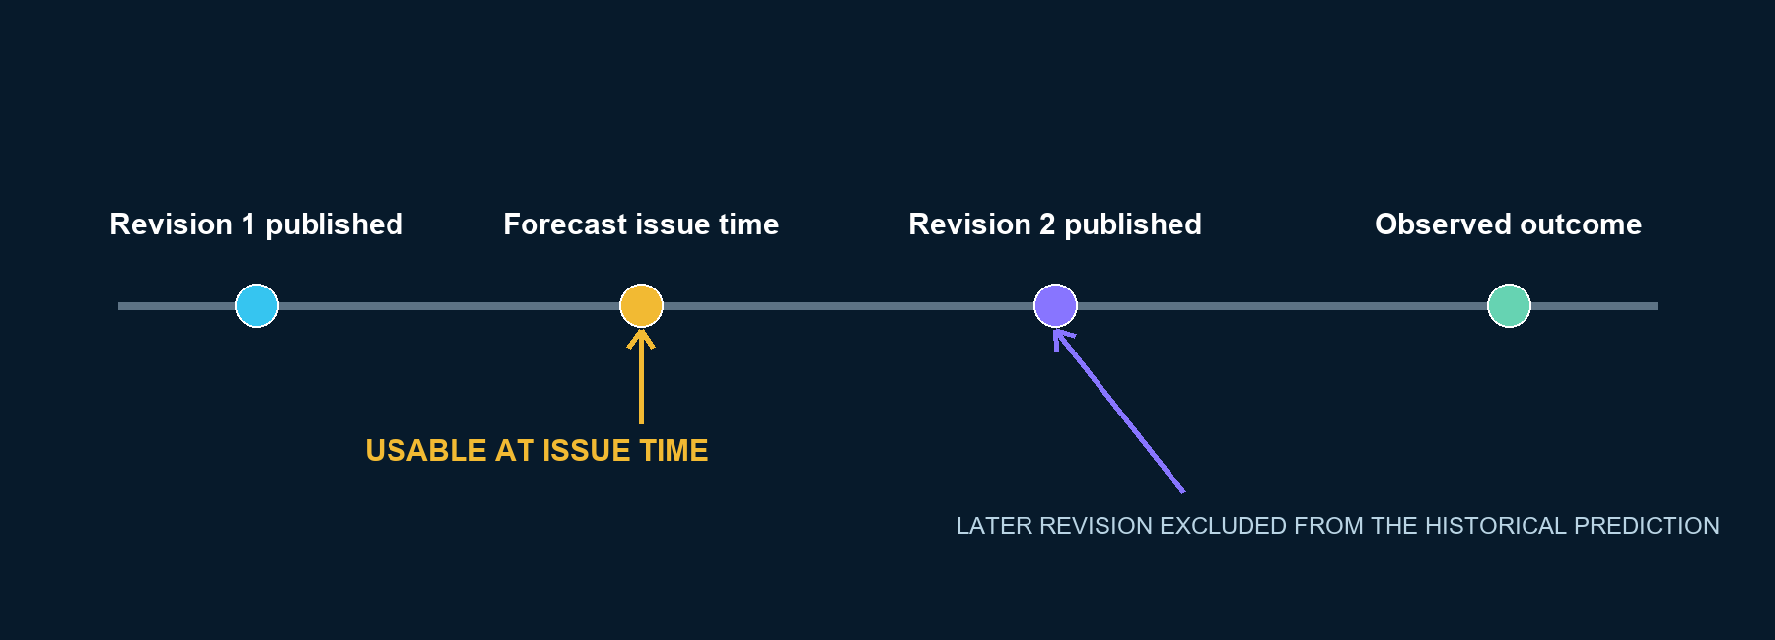
Figure 3. Historical predictions use the latest revision actually published by the issue time; later corrections are excluded.

4.2 Hourly dataset
The current experimental dataset covers the 50Hertz control area from 7 October 2021 through mid-August 2026. Targets represent future non-zero published redispatch intervals, not national-load percentiles. Features are restricted to information available by the forecast issue time.
Forecast horizon | Rows | Positive targets | Rows with missing features
1 hour | 42,576 | 10,307 | 8,615
6 hours | 42,571 | 15,148 | 8,614
24 hours | 42,553 | 25,738 | 8,613
48 hours | 42,529 | 31,849 | 8,610

4.3 Models and validation
Transparent baselines precede more complex methods: historical event rate, seasonal/calendar rate, logistic regression and a regularized tree baseline. Calibration is fitted only on periods before the held-out period. Whole years are held out in rolling origin; random temporal splits are prohibited.
- Primary rare-event metrics: precision, recall, false-negative rate and PR-AUC.
- Probability quality: Brier score, calibration error and reliability analysis.
- Robustness views: year, season, region/operator, lead time and missing-source periods.
Current interpretation: one- and six-hour yearly precision is comparatively stable in the experimental run, while 24- and 48-hour precision varies materially. Complete publisher-side revision retention, deletion semantics and reuse permission are unresolved, so operational release is not justified.

5. Public data foundation
Source | What GridPulse uses | Resolution | Current limitation
50Hertz congestion management | Quarter-hour increase/reduction and revision chains | TSO control area | Not nodal; archive completeness and reuse unresolved
50Hertz outages | Published event versions and named assets | Transmission asset/context | Rolling feed is not a complete historical archive
50Hertz vertical load | 2012-partial 2026 quarter-hour MW | TSO control area | DST folds, missing intervals, publication timing
ENTSO-E Transparency | DE-LU load/generation and latest event documents | Bidding zone / published asset | Superseded document reconstruction not proven
DWD | Historical weather observations and past-only lags | Station / gridded context | Not grid loading or capacity
SMARD / Bundesnetzagentur | National market and redispatch context | Germany / bidding zone | Not local network truth
DSO publications | Planning, procedures and reinforcement context | Service area / named plan | No loading, queues or confirmed headroom

The strongest current real dataset is the 50Hertz congestion-management history: 171,160 unique quarter-hours from 28 September 2021 to 16 August 2026, with 37,612 intervals whose final revision exceeds one. This supports control-area constraint research, not a Berlin-node model.

6. Synthetic AC network benchmark

6.1 Why synthetic networks are necessary
Real operator topology and operating states are unavailable. GridPulse therefore uses explicitly labelled synthetic networks to validate the mechanics of candidate ranking, AC power flow, contingency selection, uncertainty and flexibility. Public map features provide geographic anchors only; electrical impedances, ratings and loading remain mock parameters.

6.2 Electrical method
The benchmark spans eight connected network families and 15 non-slack candidates. For each operating scenario and candidate, pandapower solves AC N-0 and N-1 cases and checks convergence, islanding, bus voltage and equipment thermal limits. Graph algorithms may select likely contingencies, but only the power-flow solver calculates synthetic MW. Exhaustive N-1 cases remain the audit truth.
Validation dimension | Method | Current finding
Network generalization | Leave one network family out | Implemented across eight families
Candidate breadth | All 15 non-slack candidates | Exceeds ten-candidate minimum
Contingency selection | Compare selected cases with exhaustive N-1 | V4 recall 100%; 51.21% mean reduction
Hourly approximation | Compare annual proxy with solved hourly AC | 95.83% overstatement; gate failed
Truth boundary | All records synthetic_benchmark | No real-network or capacity claim

TECHNICAL LEARNING
A fast proxy is not automatically a safe envelope.
The representative hourly audit found a 41.02 MW mean absolute error and 146.01 MW maximum overstatement for the annual-package approximation. The repository correctly blocks this approximation from becoming a flexibility or connection-capacity boundary.

7. DeFlex: data-centre flexibility under constrained envelopes

7.1 Modelled resources
DeFlex does not apply an arbitrary uplift to an N-1 capacity number. It performs chronological dispatch against an hourly envelope with explicit physical and service constraints.
Input group | Examples
Demand | 10, 25, 50, 100 and 200 MW; critical and flexible workload
Interruption | Maximum fraction, consecutive duration and annual hour budget
Recovery | Rebound demand, workload deadline and recovery backlog
Battery | MW, MWh, charge/discharge efficiency, reserve SOC and degradation
Operations | Import ramp, unserved energy and optional backup scenario
Network | Time-varying synthetic N-0/N-1 envelopes and binding constraints

7.2 Optimized dispatch
The latest bounded HiGHS linear-program benchmark evaluated 40 seven-day cases: eight network families by five data-centre sizes. The optimizer produced zero envelope-overstatement hours, shifted 3,375.93 MWh, and explicitly exposed both critical and flexible unserved energy.
Site size | Aggregate unserved energy in latest 168-hour synthetic run
10 MW | 0 MWh
25 MW | 0 MWh
50 MW | 0 MWh
100 MW | 6,112.44 MWh
200 MW | 64,522.04 MWh

These values are not Berlin forecasts. Their business meaning is methodological: flexibility can make some constrained envelopes workable, but it cannot close every gap. Large sites remain sensitive to topology, outage state, duration and recovery obligations.

8. Development readiness
GridPulse is beyond concept validation but not yet at operator-grade capacity prediction. The appropriate description is an evidence-governed research prototype with production-relevant data contracts and a completed synthetic workflow benchmark.
Workstream | Level | Evidence | Next gate
Immutable data platform | Advanced prototype | OneDrive storage, hashes, manifests, verification | Long-run monitoring and governance
Public source adapters | Advanced prototype | 50Hertz, ENTSO-E, DWD and contextual publications | Licensing and historical completeness
Regional constraint risk | Experimental model | Rolling temporal evaluation at control-area resolution | Admitted archive and stable multi-period release
Synthetic AC benchmark | Validated research method | Eight families, 15 candidates, exhaustive audits | Replace unsafe hourly proxy
Synthetic DeFlex | Validated research method | Chronological bounded dispatch and LP optimization | Real operator envelope and customer profile
Operator-model ingestion | Contract-ready | JSON/CGMES intake and validation gates | First confidential operator package
Operator reconciliation | Workflow-ready | Frozen predictions and outcome schema | Historical operator decisions
Confirmed capacity product | Not available | Correctly blocked | Operator-reviewed connection result

READINESS STATEMENT
What investors should understand.
The platform has de-risked architecture, provenance, chronology, synthetic physics and flexibility mechanics. The remaining uncertainty is not whether code can be written; it is whether decisive operator evidence and validation partnerships can be secured.

9. Data required to reach the next evidence level

9.1 From Stromnetz Berlin, E.DIS and the relevant DSO
- Operator-selected candidate connection point and stable anonymized asset identifiers.
- Anonymized connectivity, normal topology and timestamped switching states.
- Normal and emergency line and transformer ratings, units and validity periods.
- Historical hourly or 15-minute loading and voltage with quality flags.
- Planned and unplanned outages with knowledge time, effective interval and revision.
- Applicable N-1, voltage, thermal, protection and short-circuit policy.
- Contracted demand, accepted-but-not-connected demand, queues and reservations.
- Pseudonymized historical connection requests and their firm, conditional or rejected outcomes.

9.2 From 50Hertz or the relevant TSO
- Upstream network model or approved reduced model, boundary conditions and transfer limits.
- Historic operating states, outage revisions and remedial-action context.
- Security criteria and the interaction between TSO constraints and the DSO connection study.

9.3 From the data-centre developer
- Real hourly or 15-minute IT and facility load profile, ramp and growth plan.
- Critical-load floor, flexible workload, deadlines and service-level penalties.
- UPS/battery telemetry, efficiencies, reserve requirements and degradation economics.
- Backup-generation availability and legal/contractual operating limits.
- Target date, staged MW/MVA request, power factor and minimum acceptable partial capacity.

10. Operator pilot design
The minimum viable pilot does not require public release of confidential network data. It can run inside an operator-approved secure environment with stable random identifiers and agreed geographic aggregation.
Phase | Activity | Output
1. Intake | Validate schema, hashes, units, time zones and permitted uses | Operator-model unvalidated package
2. Historical reconstruction | Rebuild only the topology, outages, loading and queue state known at each issue time | Leakage-safe historical states
3. Frozen predictions | Generate risk and connection-envelope predictions before reading outcomes | Auditable prediction ledger
4. Reconciliation | Compare with actual operator study outcomes and binding constraints | Error, calibration and constraint-match metrics
5. Review | Operator reviews method, caveats and permissible output language | Potential operator-reconciled release

Customer identities, exact topology, loading, queues, protection settings and commercially sensitive connection outcomes would never be published. Public outputs would contain only operator-approved aggregate validation metrics.

11. Product roadmap and investable milestones
Milestone | Deliverable | Success criterion
M1 Evidence operations | Continuous 50Hertz/ENTSO-E snapshots and consolidated report index | Complete monitoring ledger; no stale-report ambiguity
M2 Public screening product | Regional evidence, risk and missing-data UI | No available-MW claim; reproducible evidence trail
M3 Safe hourly synthetic benchmark | Solved/bounded AC envelopes used by DeFlex | Overstatement and coverage gates pass on unseen families
M4 Operator pilot | Confidential DSO/TSO package and frozen historical predictions | Operator accepts data contract and evaluation protocol
M5 Historical reconciliation | Comparison against connection decisions | Stable results by period and network area
M6 Operator-confirmed workflow | Site-specific reviewed output | Operator explicitly confirms permissible MW statement

Commercialization before operator integration
GridPulse does not need to wait for full DSO integration to create customer value. It can sell evidence-led site screening, comparative investigation, connection-application preparation and customer-defined flexibility analysis. The output must consistently state that available MW is unknown until operator confirmation.

12. Risk register
Risk | Why it matters | Mitigation
Operator access | Decisive data is non-public | Confidential pilot, anonymization and in-boundary execution
False precision | MW outputs can be commercially misleading | Truth classes, null unknowns and release gates
Temporal leakage | Later revisions can inflate historical performance | Publication-time revision reconstruction
Geographic misattribution | Control-area events are not node measurements | Preserve source resolution and identity confidence
Synthetic-to-real gap | Mock physics may not transfer | Leave-family-out tests plus operator reconciliation
Licensing | Public access does not guarantee reuse | Explicit admissibility and permitted-use records
Flexibility overstatement | Power and energy duration are easily confused | Chronological dispatch, SOC, recovery and unserved energy

13. Technical verification record
Check | Audit result
Git state | Clean branch codex/capacity-backtest-foundation at 08d18e4
Unit and fixture tests | 121 passed in 40.45 seconds
Ruff lint | Passed
Ruff format | 22 pre-existing files would be reformatted
Type checking | No repository type-check command configured
Current synthetic selector | V4 contingency recall 100% in 64 exhaustive audits
Confirmed capacity | Unavailable; available_capacity_mw remains null

14. Conclusion
GridPulse is developing a defensible grid-intelligence layer for large-load development. Its technical differentiation is not a single capacity algorithm. It is the combination of immutable provenance, publication-time reconstruction, fail-closed source admission, temporal backtesting, AC contingency analysis, bounded flexibility optimization and strict separation between public context, experimental risk, synthetic studies and operator-confirmed outcomes.
The platform is ready to support pre-application screening and structured flexibility discussions. It is not yet entitled to state free capacity at a specific location. The fastest credible path to that capability is a confidential pilot with a German DSO and the relevant TSO, using anonymized historical network states and connection outcomes.
INVESTOR TAKEAWAY
The next milestone is evidence access, not a change in scientific principle.
GridPulse has built and tested the research machinery. Capital and partnerships should now concentrate on continuous evidence operations, safe productization, and securing the first operator validation dataset.

Appendix A. Modelling definitions
Term | Definition
N-0 | Network operation with all modelled components in service.
N-1 | Operation after loss of one relevant component, evaluated through contingency power flow.
Firm envelope | Import level intended to remain feasible under the defined security cases and assumptions.
Conditional envelope | Import permitted only under defined time, topology, curtailment or flexibility conditions.
PR-AUC | Area under the precision-recall curve; useful when constraint events are imbalanced.
Brier score | Mean squared error of probabilistic predictions; lower is better.
Calibration | Agreement between predicted probability and observed frequency.
Truth class | Evidence label controlling how a result may be interpreted or released.
Publication-time leakage | Use of information or revisions that were unavailable when a historical prediction would have been issued.

Appendix B. White-paper design basis
The document structure follows authoritative technical-report principles rather than a commercial downloadable template. NIST technical-series guidance calls for ordered report components and reproducible technical reporting. European Commission evaluation criteria emphasize an executive summary, explicit context and limitations, clear linkage between data, interpretation and conclusions, and technical detail in appendices. This paper adapts those principles to an investor audience while retaining GridPulse's evidence boundaries.

References
- GridPulse Capacity Backtest Lab. Repository README, implementation reports and audited source code, commit 08d18e4, August 2026.
- NIST Research Library. Technical Series Publications Author Instructions, updated June 2024. https://www.nist.gov/nist-research-library/nist-technical-series-publications-author-instructions
- European Commission. Quality Assessment Form / criteria for final evaluation reports. https://transport.ec.europa.eu/document/download/86ff7486-711c-423e-8d88-0f5d915d5b37_en
- International Energy Agency. Energy and AI: AI and energy security. https://www.iea.org/reports/energy-and-ai/ai-and-energy-security
- International Energy Agency. Germany 2025 and Electricity 2026: grids and flexibility. https://www.iea.org/reports/germany-2025 and https://www.iea.org/reports/electricity-2026
- 50Hertz Transmission GmbH. Engpassmanagement and measures under Section 13 EnWG. https://www.50hertz.com/de/Transparenz/Kennzahlen/Engpassmanagement
- SimBench project. Documentation and datasets. https://simbench.de/en/download/
- pandapower documentation. Contingency analysis. https://pandapower.readthedocs.io/en/v2.14.7/contingency.html
- ENTSO-E Transparency Platform. Web API and transparency publications. https://transparency.entsoe.eu/
- Deutscher Wetterdienst. Climate Data Center Open Data. https://opendata.dwd.de/climate_environment/CDC/

