IAPS Guidelines

Each picture in the IAPS is rated by a large group of people for the feelings of pleasure and arousal that the picture evokes during viewing. The pictures are then numbered (4 digits) and catalogued according to the mean and standard deviation of these affective ratings.

Self-assessment manikin (SAM)

SAM is a graphical figure that ranges from smiling and happy to frowning and unhappy representing the ‘valance’ dimension. For arousal, SAM ranges from excitement and wide eye to relaxed and sleepy.

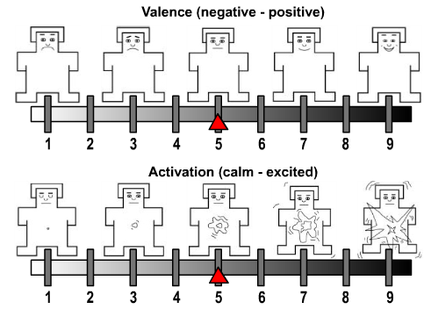

Rating Guidelines:
- The participant can fill any of the five figures, resulting in a 9-point rating scale for each dimension.
- Participants should be informed about the range of contents that may be presented.
- In each picture set, 3 practice pictures are viewed prior to the experimental rating. These pictures illustrate the range of contents that will be presented.
- Each trial begins with a 5s preparatory cue (“Get ready to rate the next picture).
- Participant is given 6s presentation of the to-be-rated picture.
- Participant is given 15s to make rating of pleasure and arousal using SAM.

Characteristics of Ratings:
- Pictures rated more pleasant or more unpleasant, arousal ratings increase.
- Pictures rated natural tend to be low in arousal.
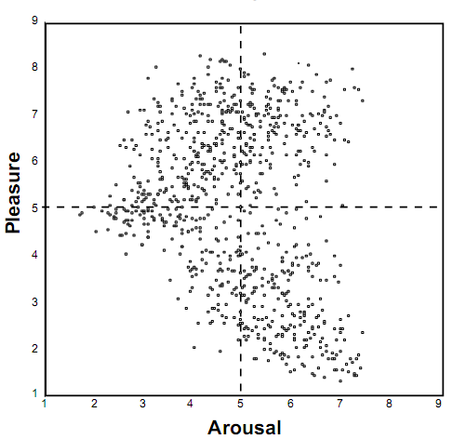
Physiological Rating

EMG Activity: The pattern of facial corrugator supercilii muscle activity strongly parallels reports of pleasure. As pictures are rated as increasingly unpleasant, activity in the corrugator muscle, also increases. Moreover, pictures rated as most pleasant promt decreased corrugator EMG activity, providing a bidirectional change from neutral pictures.

Authentic smile involves activity around eyes, as well as in the lower face. Changes in the zygomaticus major (smile) EMG activity related to reports of pleasure. Moreover, for the most unpleasant pictures, EMG activity measured over this zygomatic muscle shoes a slight increase. Activity over the orbicularis oculi muscle is measured during picture viewing together with zygomatic and corrugator EMG, so that specific patterns of facial activity can be recorded.
Pleasantness
EMG Activity
zygomatic
corrugator
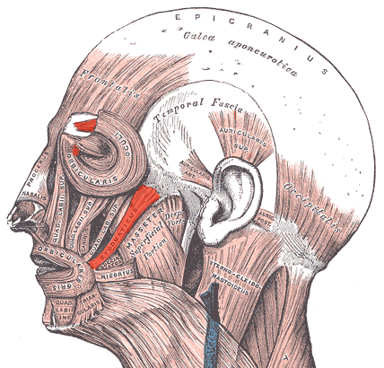
The corrugator supercilii is a small, narrow, pyramidal muscle, locates just above the eyebrow.The zygomatic major is a muscle of facial expression which draws the angle of the mouth superiorly and posteriorly. The zygomaticus extends from each zygomatic arch (cheekbone) to the corners of the mouth. It raises the corners of the mouth when a person smiles. The orbicularis oculi is a muscle in the face that closes the eyelids, beneath the eye.
Skin Conductance: Skin conductance changes strongly covary with reports of emotional arousal. Skin conductance responses are significantly elevated primarily for pictures of erotica. For unpleasant contents, skin conductance activity is again highlighted for most arousing contents.

Experiments that do not include highly arousing erotics and mutilation/threat contents will prompts little difference in skin conductance activity.
Skin Conductance
Pleasant - Neutral - Unpleasant

Experiment that include few erotic but many threatening stimuli will find increased skin conductance for unpleasant compared with pleasant.

Heart Rate: When viewing picture for 6s duration, initial deceleration of heart beat followed by an acceleratory component and then by a secondary decelerative component.

- Unpleasant stimuli produces more initial deceleration. Initial deceleration is consistently obtained on both occasions.
- Pleasant stimuli produces greater peak acceleration. Initial deceleration is enhanced during the second session, with the most arousing contents.

Heart Rate Change
Time
Neutral
Pleasant
Unpleasant

“Pictures may truly be worth a thousand words…”

