**Theory:**

The schematic of a reactor is shown in the figure below:

NC (Inlet flow) NC (Outlet flow)

Reactor with specific T, P

The mass balance for the reactor is written as follows:

Last Session, we define as extent of reaction, and it is written as follows:

Thie main task is to find using equilibrium data in the outlet flow of the reactor.

The first thing we must know is *how many reactions we need to fully define the system*. To find the number of reactions, we can use this formula:

And [A] term is the rank of A matrix (matrix of species). It shows how many nonlinear independent elements we have.

The next issue is how to find . With Gibbs-free energy versus Reaction Coordinate plot, we can determine with calculate global minimum of this plot, which mathematically is described as follows:

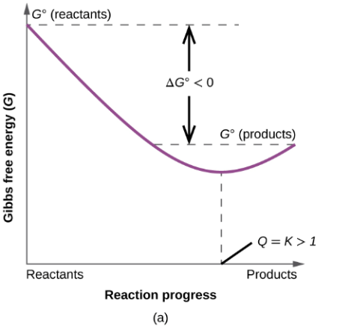

Next step is to calculate partial derivative of this equation:

The chemical Potential () cannot be calculated directly. Respect to Lewis’s equation we have:

The ratio “” described as activity coefficient (ai­)

Thus, the equation will be converted to:

Additionally, the equation above will be converted to:

In thermodynamics we have 3 cases in order to determine fugacity:

*In Ideal Mixture – Real Gas case, the value of fugacity is fixed.*

By knowing the fugacity of each component, we can determine the fugacity of mixture. This is very complicated from the numerical point of view.

Let’s study on the effect of Pressure and Temperature on the system:

1. **Temperature effect @ constant Pressure:**

Vant Hoff equation:

If , it indicates that we have an exothermic reaction. The increasing of T leads to decreasing .

Otherwise, we have an endothermic reaction. The decreasing of T leads to increasing .

1. **Pressure effect @ constant Temperature:**

Suppose a reaction like this:

The equilibrium constant will be expressed as follows:

if c+d > a+b: With increasing pressure, the term will be decreased (favor the product).

If c+d < a+b: With increasing pressure, the term will be increased.

Else: With increasing pressure, the term will be constant.

The schematic of all system is shown in the figure below:

Reactor no. 2 is adiabatic!

The thermodynamic scheme that we assume is IM, RG.

The y1 stream consists of CO, CO2, H2, H2O, CH4, CH3OH, N2

The A matrix is:

Rank(A) is calculated using MATLAB.

The reactions are written as follows:

To find y2, we must write a mass balance:

To find y1, we must assign a basis of calculation, e.g. 100 mol/s. Therefore, the n1=100 mol/s

The outlet molar flow is needed, because of this equation:

For each reaction, the thermodynamic equilibrium condition is:

Since calculating the is difficult and needs more time, this value will be given at exam session!

The value comes from …. of EOS.

**The second part of the problem is to calculate the amount of heat of *Reactor 1*.**

To do this, we have to write an energy balance. We need Control Volume (CV), the reference condition, the convention, and the thermodynamic scheme!

Assume elementary species as ideal gas at T= 298 K.

The convention will tell us the type of reaction in case of endothermic or exothermic. When we remove heat, Q > 0.

The energy balance will be written as follows:

The term hR refers to residual enthalpy and in general, we will neglect from calculating it! Moreover, the above equation will be converted to:

**The final part is to calculate the conversion through 2 reactors!**