**Theory:**

The schematic of Problem is shown in the figure below:

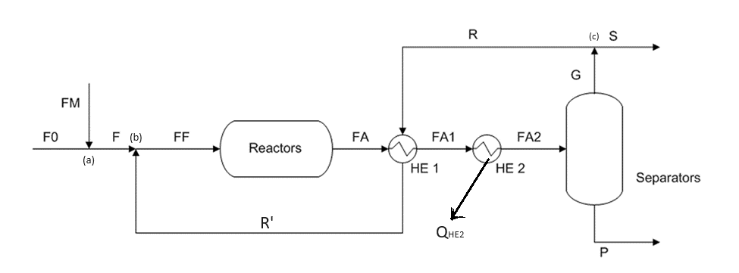

The **F0** stream is known because we take a basis for our calculations.

In **FM** stream, the temperature and purity of CO2 are known (yCO2 = 1).

In **FF** stream, we know the temperature and recycle modulus (M = 3 = ).

In **FA** stream, we just know the temperature.

In the second H.Ex., the stream is cooled down!

In the reactor, two simultaneous reactions are occurring:

In the case of separation unit, we assign some values for components:

The CO conversion defined as:

The MeOH yield with respect to Carbon equals to

We will define a recycle fraction (). Once we have defined this, we want to find the value of to have .

The second duty is to calculate all the flow rates.

Third request is to find the recycle ratio (= ). Then, we have to know the conversion of CO as a function of recycle fraction ( ), inert fraction as a function of recycle fraction( ) and recycle ratio as a function of recycle fraction ( ).

We should know the , and exchanged heat of 2nd H.Ex.

We can start by writing the material balance:

At point (a):

At point (b):

At reactive section:

At H.Ex.1:

At H.Ex.2:

At Separation system:

At point (c):

The modulus defined as:

The CO conversion defined as:

The overall conversion of CO defined as:

The MeOH yield with respect to Carbon defined as:

We rewrite the material balance equations for *CO*:

At point (a):

FMCO = 0 (because its rich of CO2)

At point (b):

At reactive section:

At 2 H.Ex. & separation system:

PCO = 0 (in liquid stream there’s no CO)

At point (c):

The recycle fraction for CO is defined as:

Hence, a point (c):

We have 6 unknowns () and 5 equations! For the 1 missing equation, we can add this equation:

The first aim is to solve M.B for key component (CO). Then, we have to do this for other components (inert components).

Material Balance for inert:

Material Balance for :

Again, for CO component in reactor, we write:

For MeOH yield, we can write:

Then, we rewrite the modulus:

Therefore, we can apply the equation above for CO2, MeOH, H2, CO and create a set of equations:

Once we know the lambda, we can address every single stream in the layout!

The CO conversion versus recycle fraction plot is:

In this part, we want to calculate unknown temperatures ().

The schematic of an ideal H.Ex. is shown in the figure below:

We took a control volume surround of H.Ex.. The reference condition is FA stream condition!

Energy Balance for 1st H.Ex.:

Energy Balance for 2nd H.Ex.:

**Calculating the 2nd H.Ex. duty:**

The reference condition is FA, and Q>0 when removed!