# **1. Introduction**

European Union increasingly politicized, legitimacy challenged, public communication and justification becomes increasingly relevant!

Supranational actors face strong structural obstacles in engaging with the European public:

* Fragmented, national public spheres
* Media biases to national executives and challenger actors
* Technocratic approach to communication (late, complex, hard to understand)
* Propaganda vs responsive engagement and justification

Social media may be a particularly relevant sphere of communication for supranational actors

* Not so strongly fragmented along national borders
* Less (or at least different) selection biases
* Encourages actors to present concise and clear messages.
* Is in principle interactive, enables responsiveness in principle

So for supranational actors, in principle, social media offer a highly promising arena for engaging and engaging with the European citizen. And indeed, many supranational institutions as well as the individual persons filling them have accounts or even dedicated social media strategies. Bit of literature view to that effect here.

RQ: But how do they actually use social media and is this geared to engaging and engaging with the European citizen?

To tackle this question, this paper present s a thick quantitative desricption of the behaviour of supranational actors on Twitter, based on the more than 1 million tweets from 115 supranational accounts (institutional and personal) in the period XXX.

Along this data, we show ...

# **2. How should engaging communication on Twitter look like?**

Engaging with the citizen: Responsiveness ??? [this is the part I am not so sure about)

* Interaction with current debates and other political actors:   
  Responses, Retweets, (Hashtags)

Engaging the citizen

* Policy responsibility / clarification ???
* Clear language: reading ease
* Exploit interactive potential of the medium: mentions, hashtags, urls
* Exploit audio-visual potential of the medium: emojis/symbols, pictures, video
* Citizen engagement can be estimated on the platform:
  + Favorite counts: Expression of favourable opinion
  + Retweets: Relavance (shareworthiness) of information
  + Quotes: Substantial engagement (may be positive or negative) with the message of supranational actors
* Describe (and benchmark) how supranational actors do these things and estimate whether they are linked to engagement on the platform in the short term

# **3. Data and indicators**

Sample of supranat accounts (prepare inst. / personal distinction)

Describe Academic API access and data collection

Benchmarking:

We have no absolute thresholds for the criteria of engaging social media usage defined above. To provide a fair assessment of supranational actors’ behaviour on Twitter, we thus compare it against meaningful benchmarks.

First, a random sample of XXX (English language) tweets to see what is ‘normal’ on Twitter. But clearly supranational actors do not necessarily resemble ‘normal’ Twitter users: they are political executives in a multi-level governance. That’s why we benchmark them against twitter behaviour of national executives and international organisations ... UK sample derive by ... IO sample based on Ecker-erhardt (XXX) and collected via Academic API ...

DESCRIPTIVE TABLE OF THE FOUR DATA SETS HERE

Indicators:

Briefly describe data extraction and text pre-processing (probably along the prepared example table). Emphasize difficulties / hacks / and lessons

# **4. Description and benchmarking**

Maybe indicator description can also be integrated in this section ...

*Output*

Daily supranational tweet volume, weekdays, benchmarking daily n of tweets against IO and UK

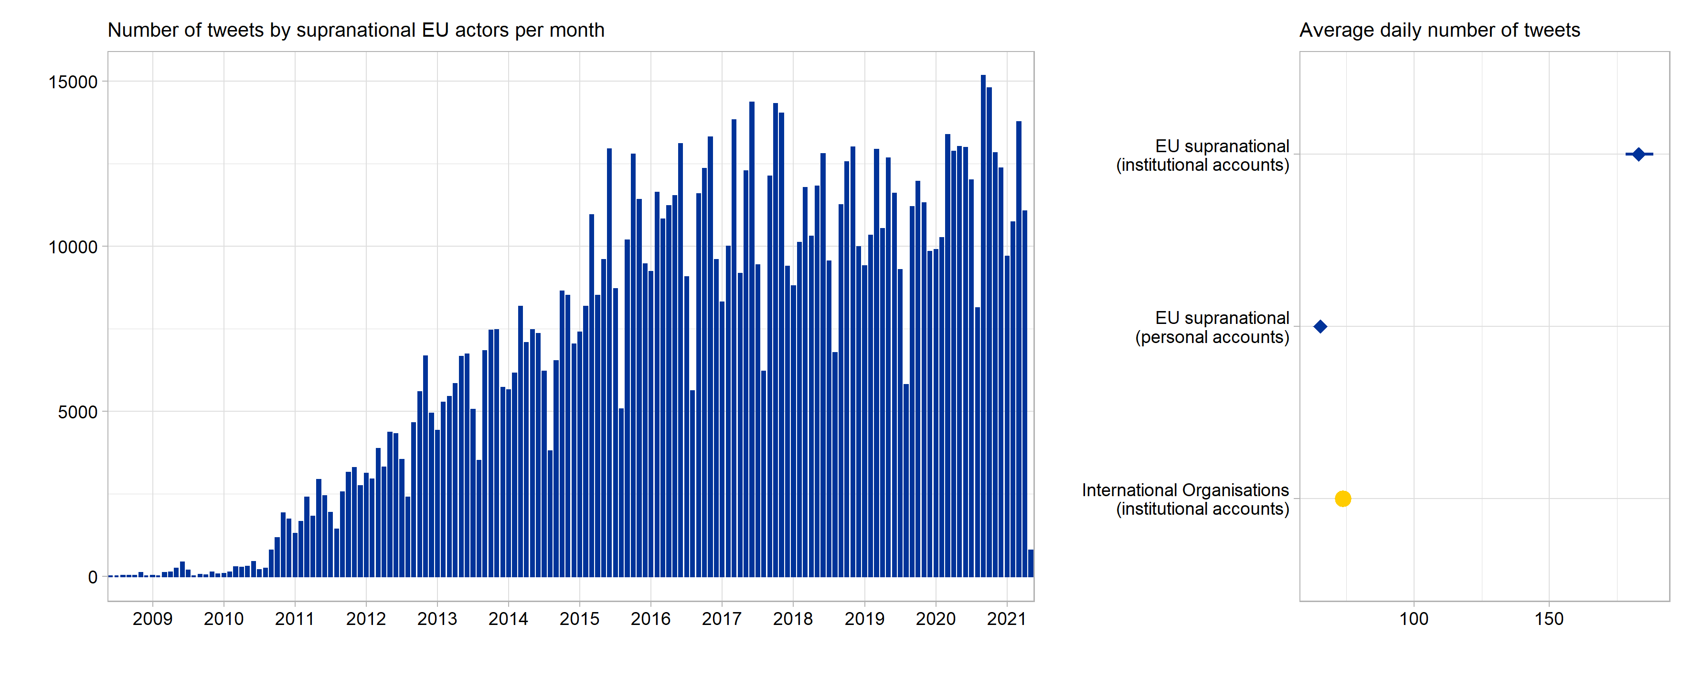

*Interactivity*

Means and benchmarks for reply shares, retweet shares, mentions, hashtags

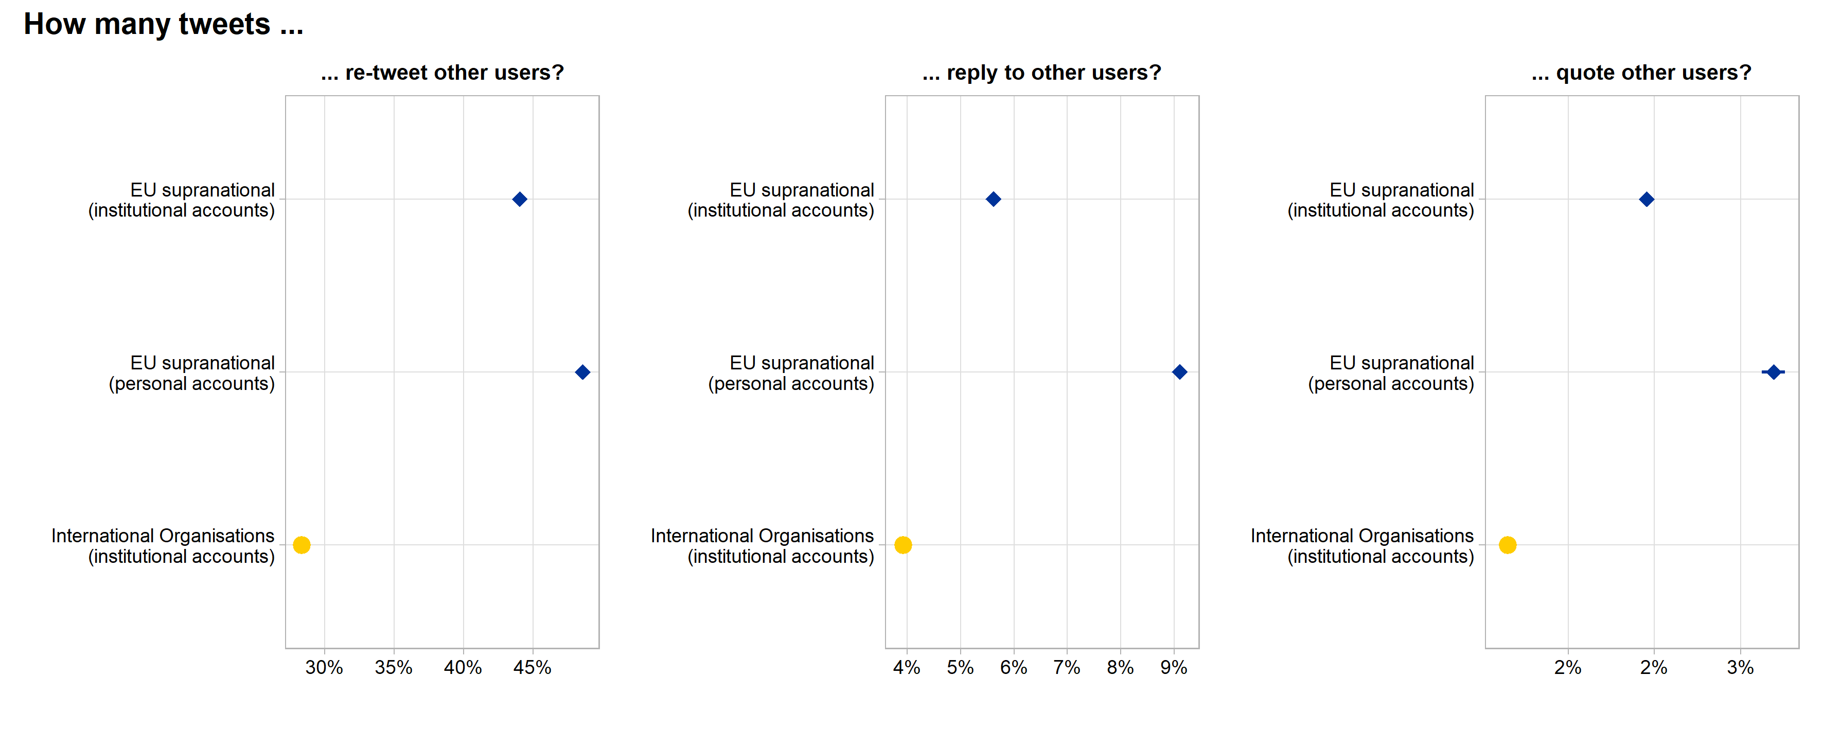

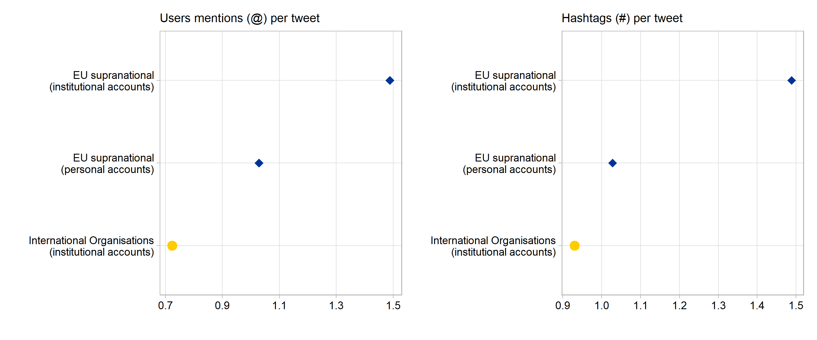

Qualitative information (most frequent mentions and hashtags, e.g.)

*Media*

Means and benchmarks for emoji, pics, video and external URL counts

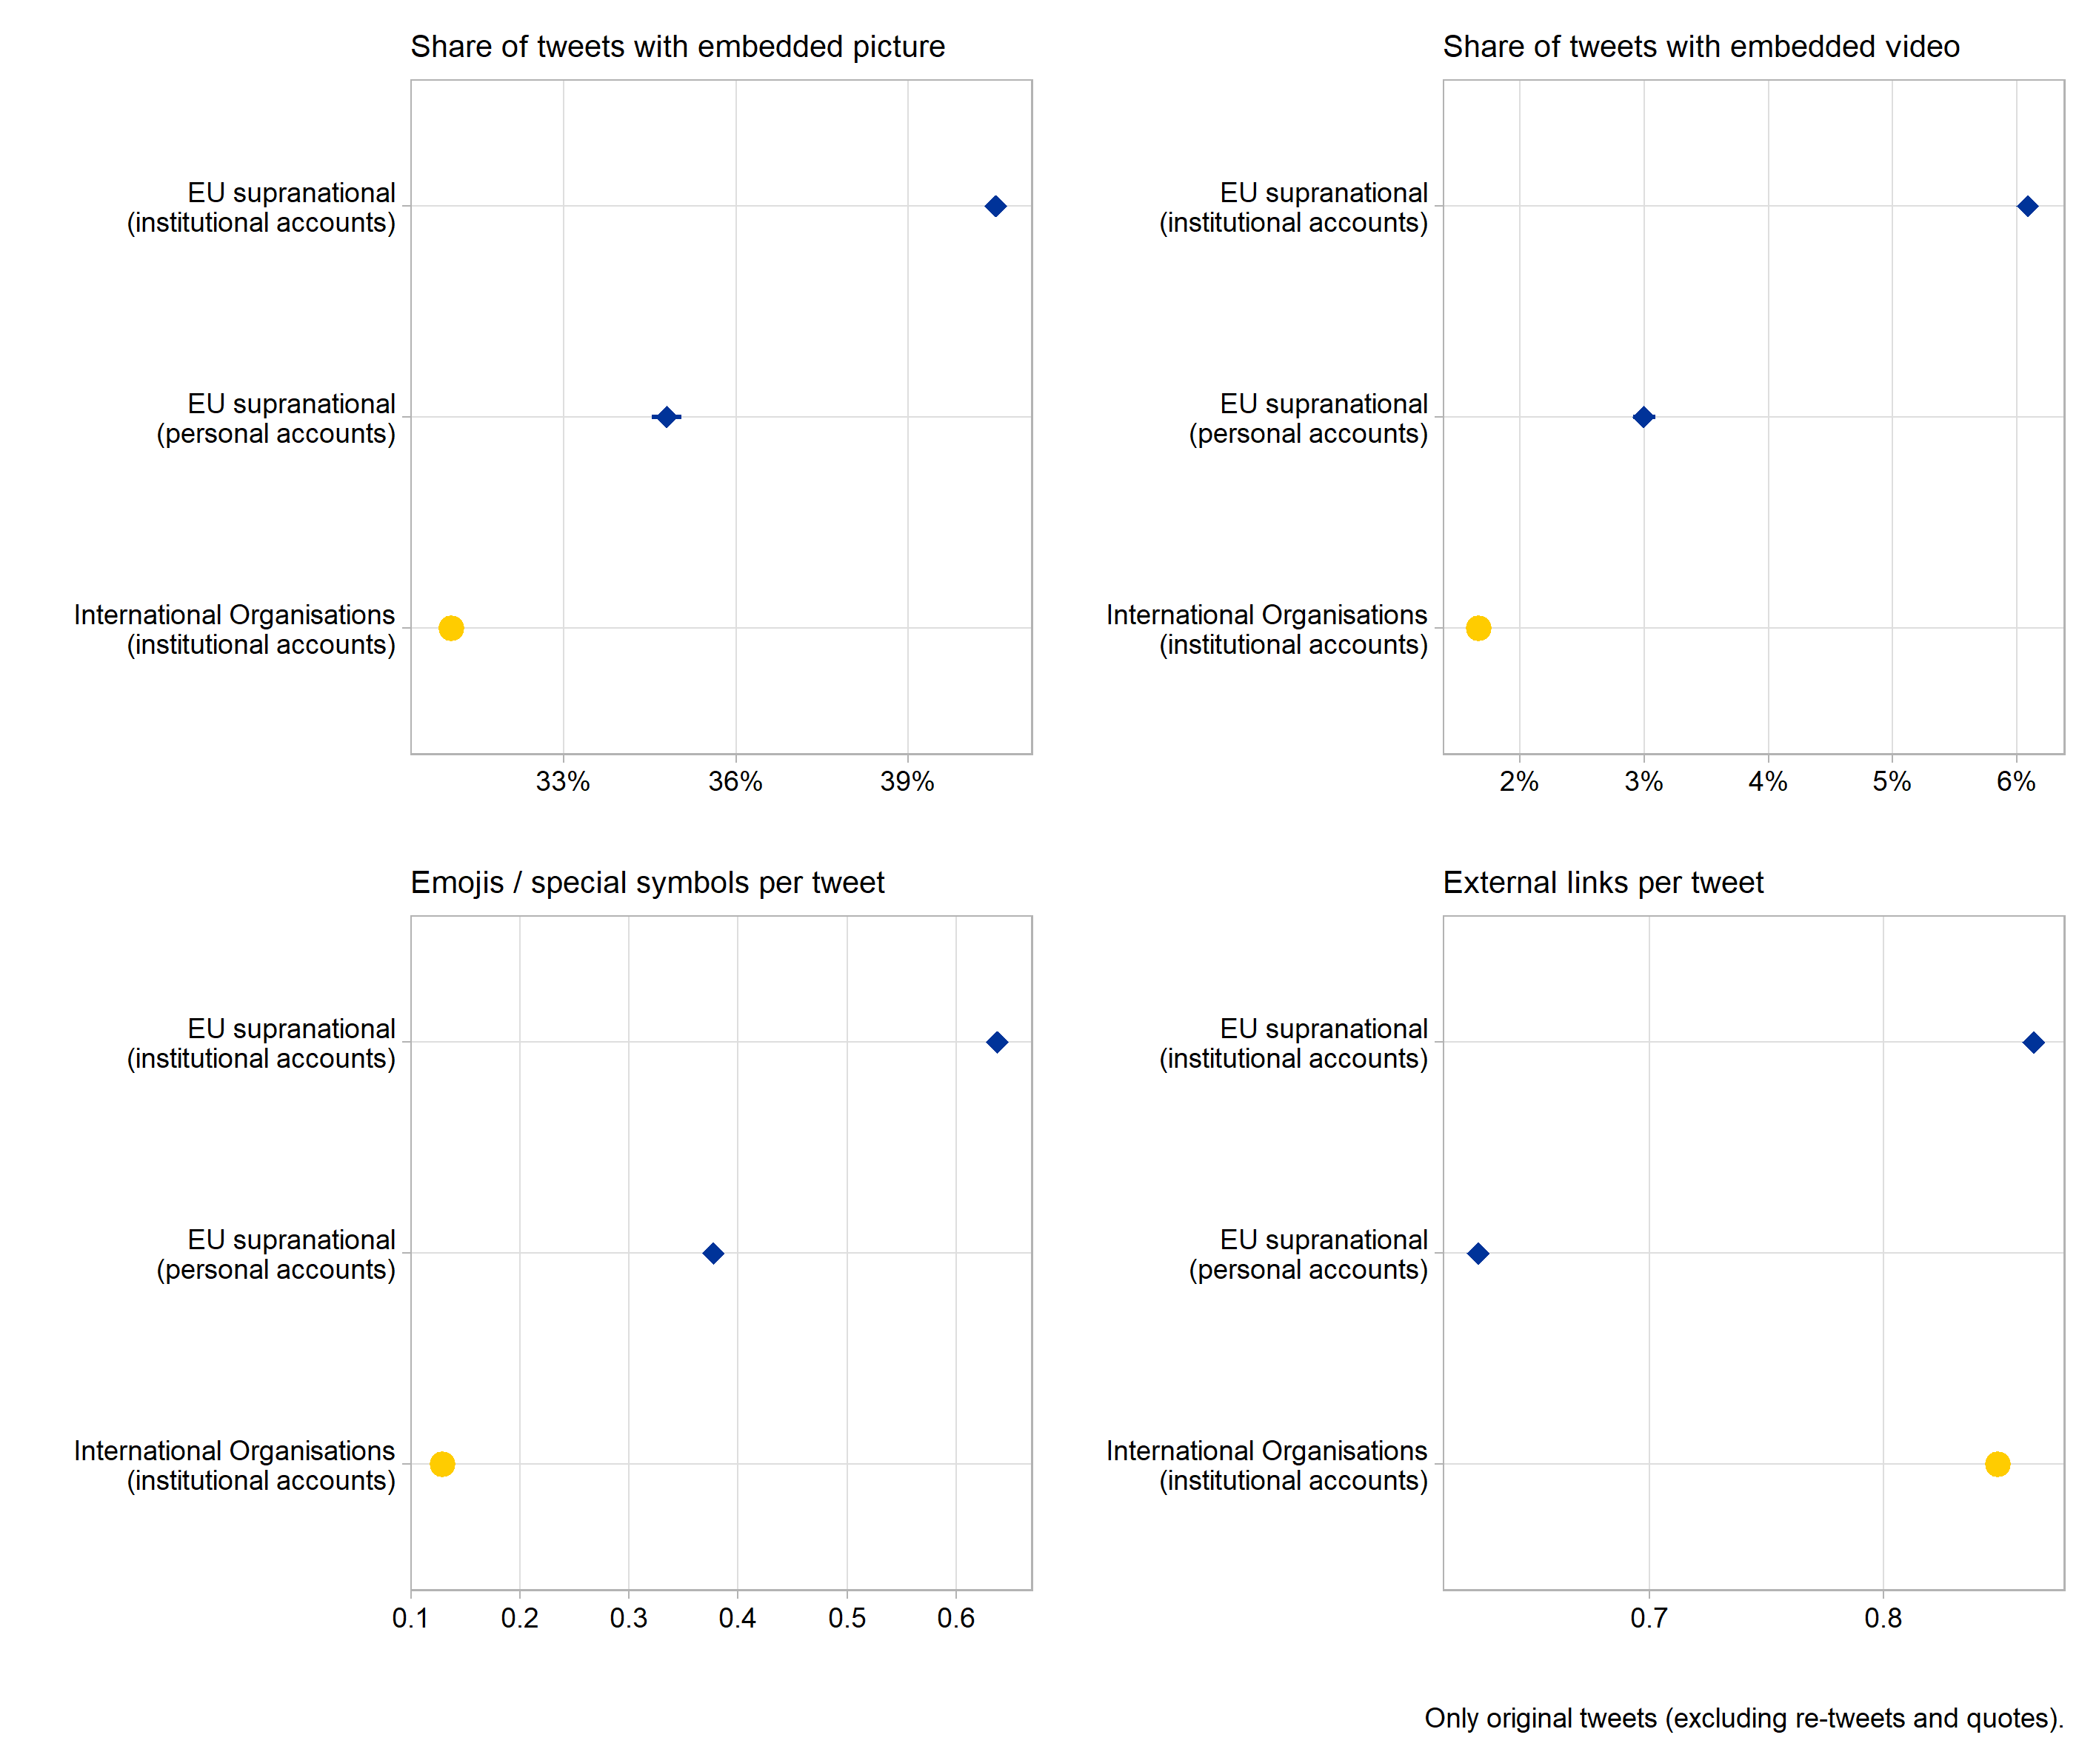

Qualitative info on emojis and most frequently linked urls ...

*Language*

Means and benchmarks for reading ease, word familiarity, verbal style, sentiment, policy content (?)

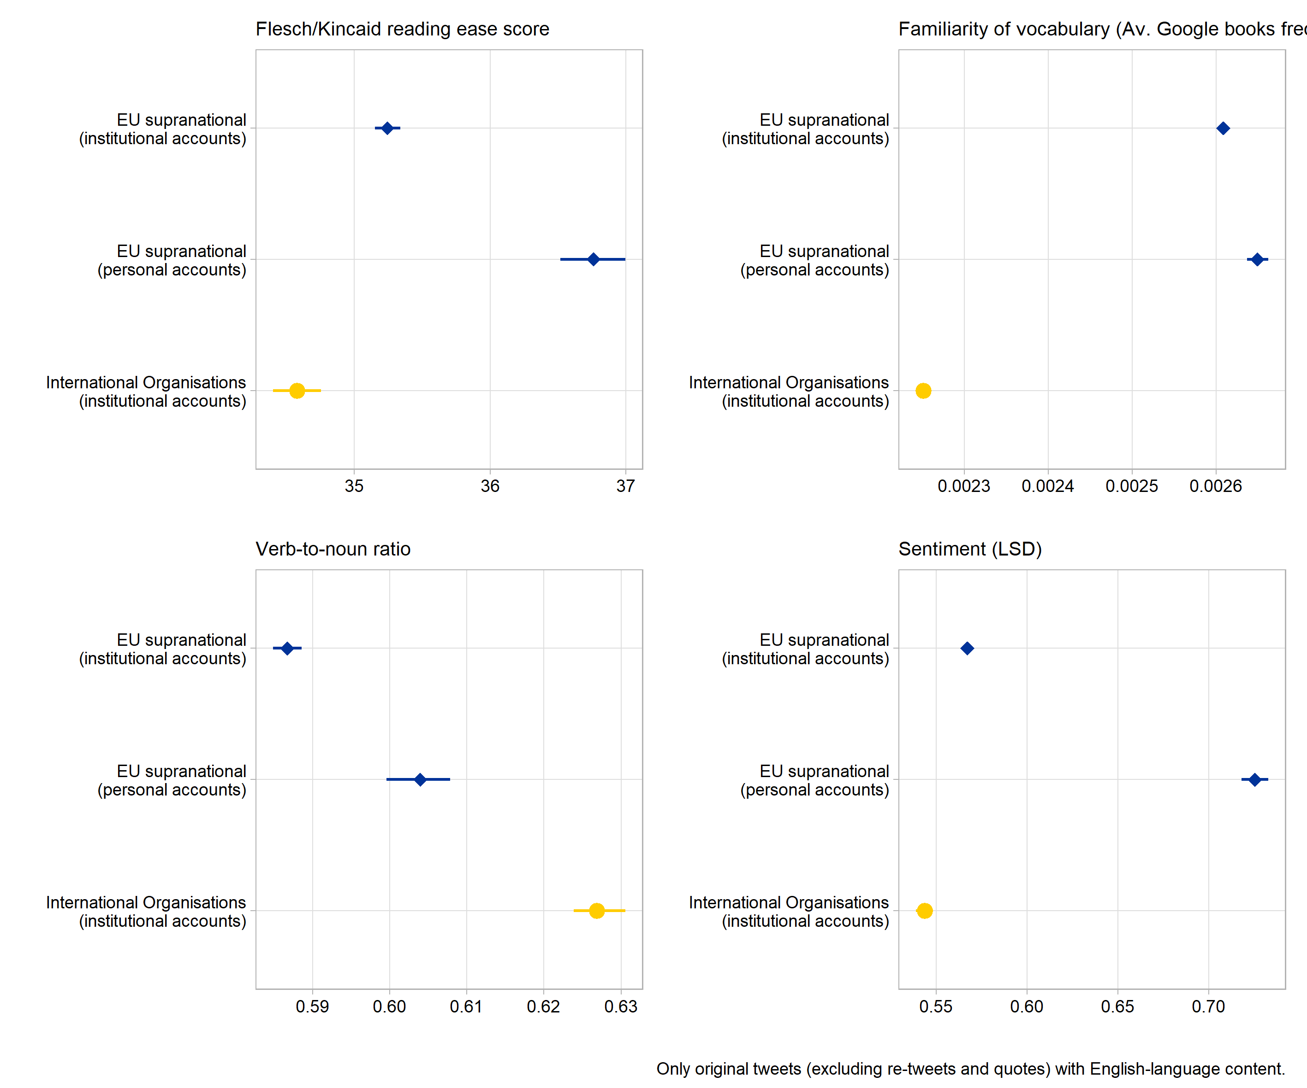

# **5. Engagement analyses**

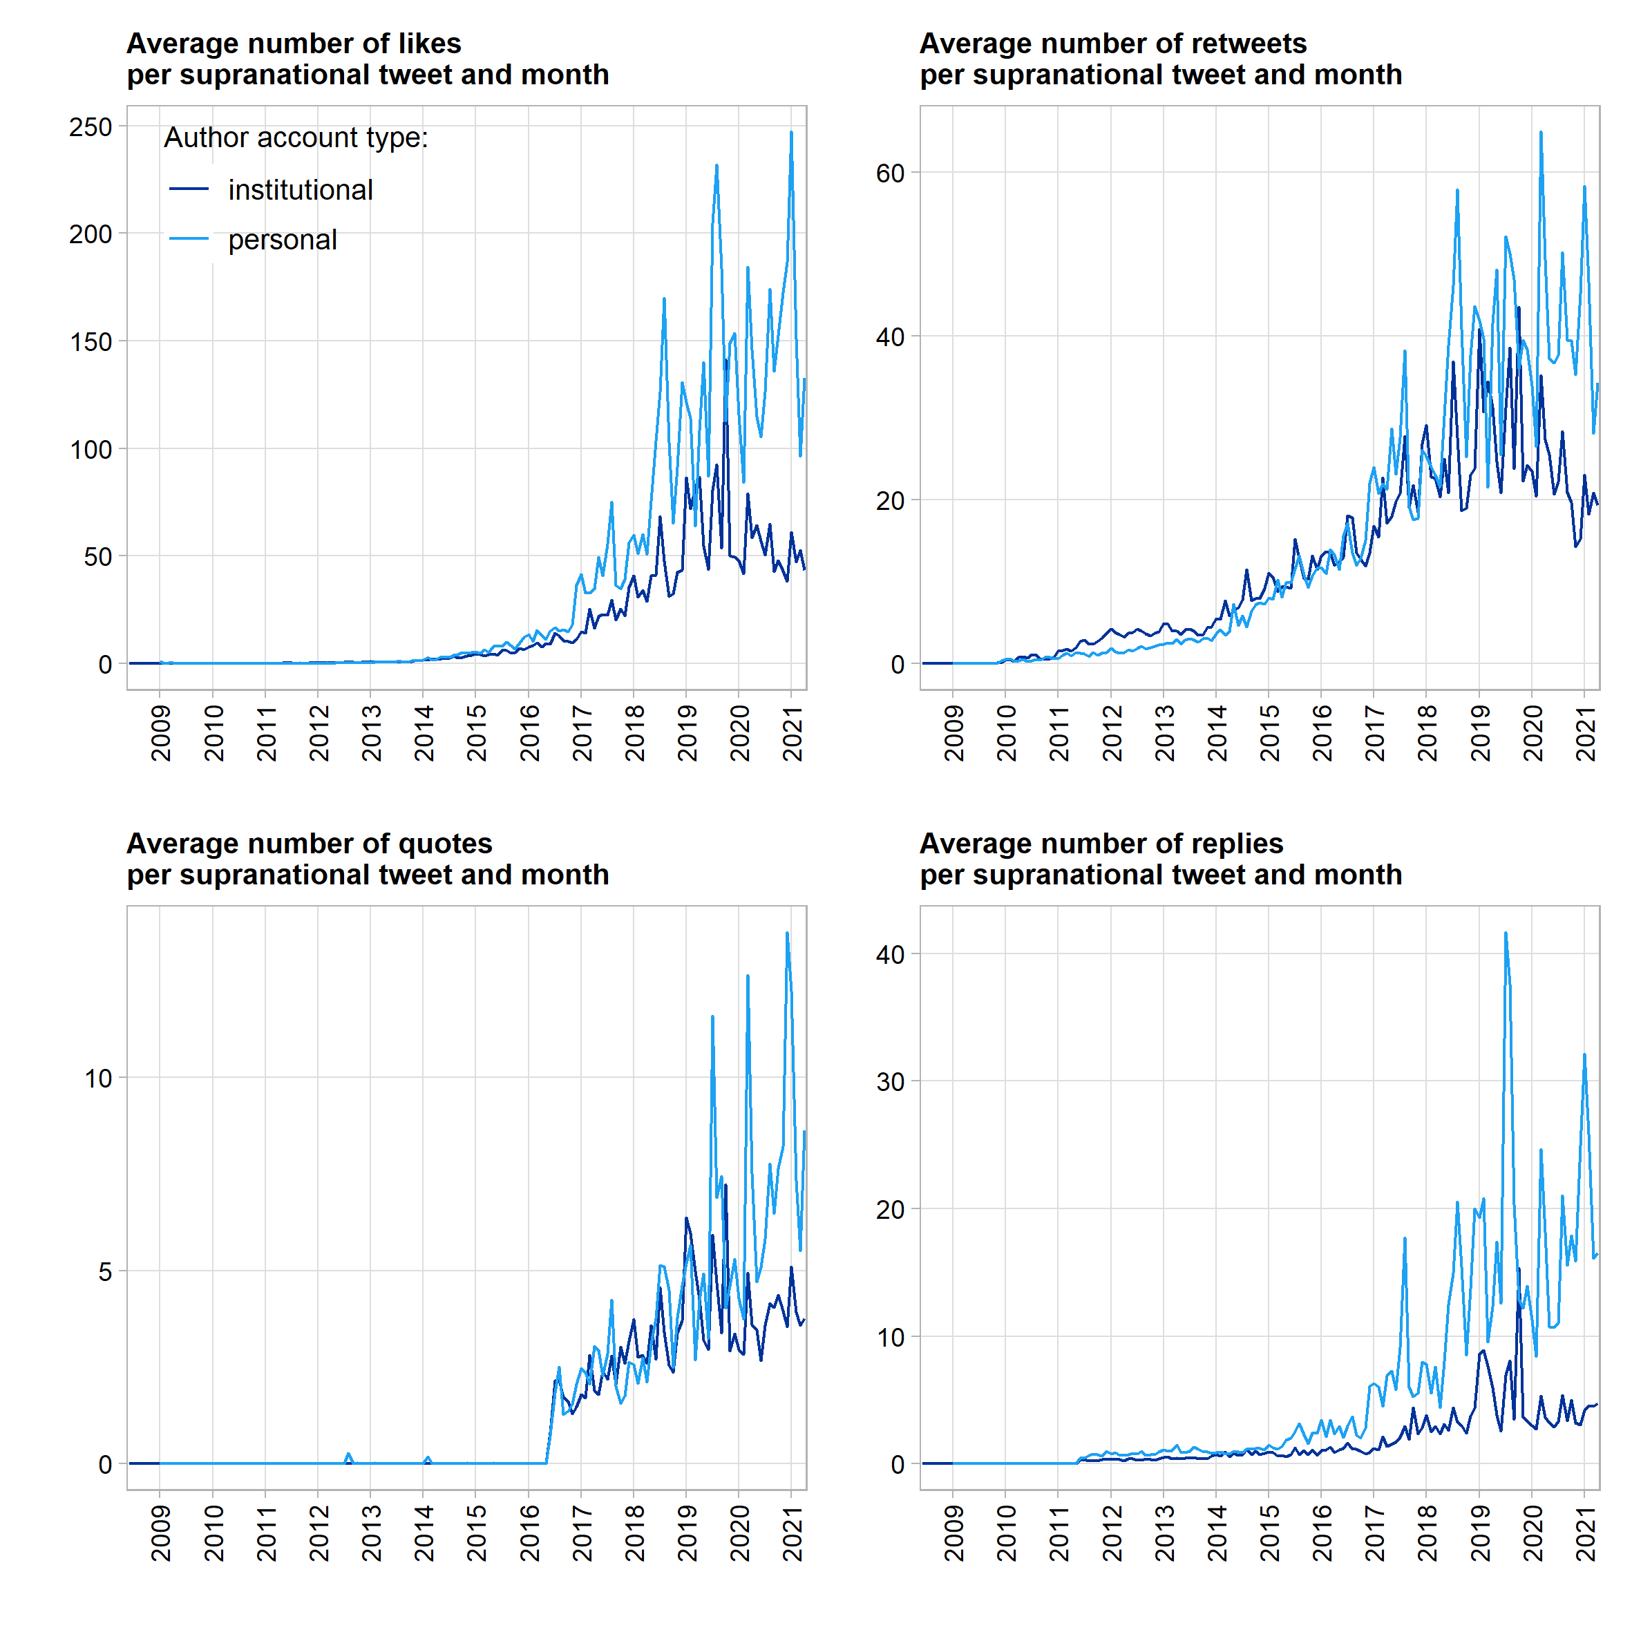

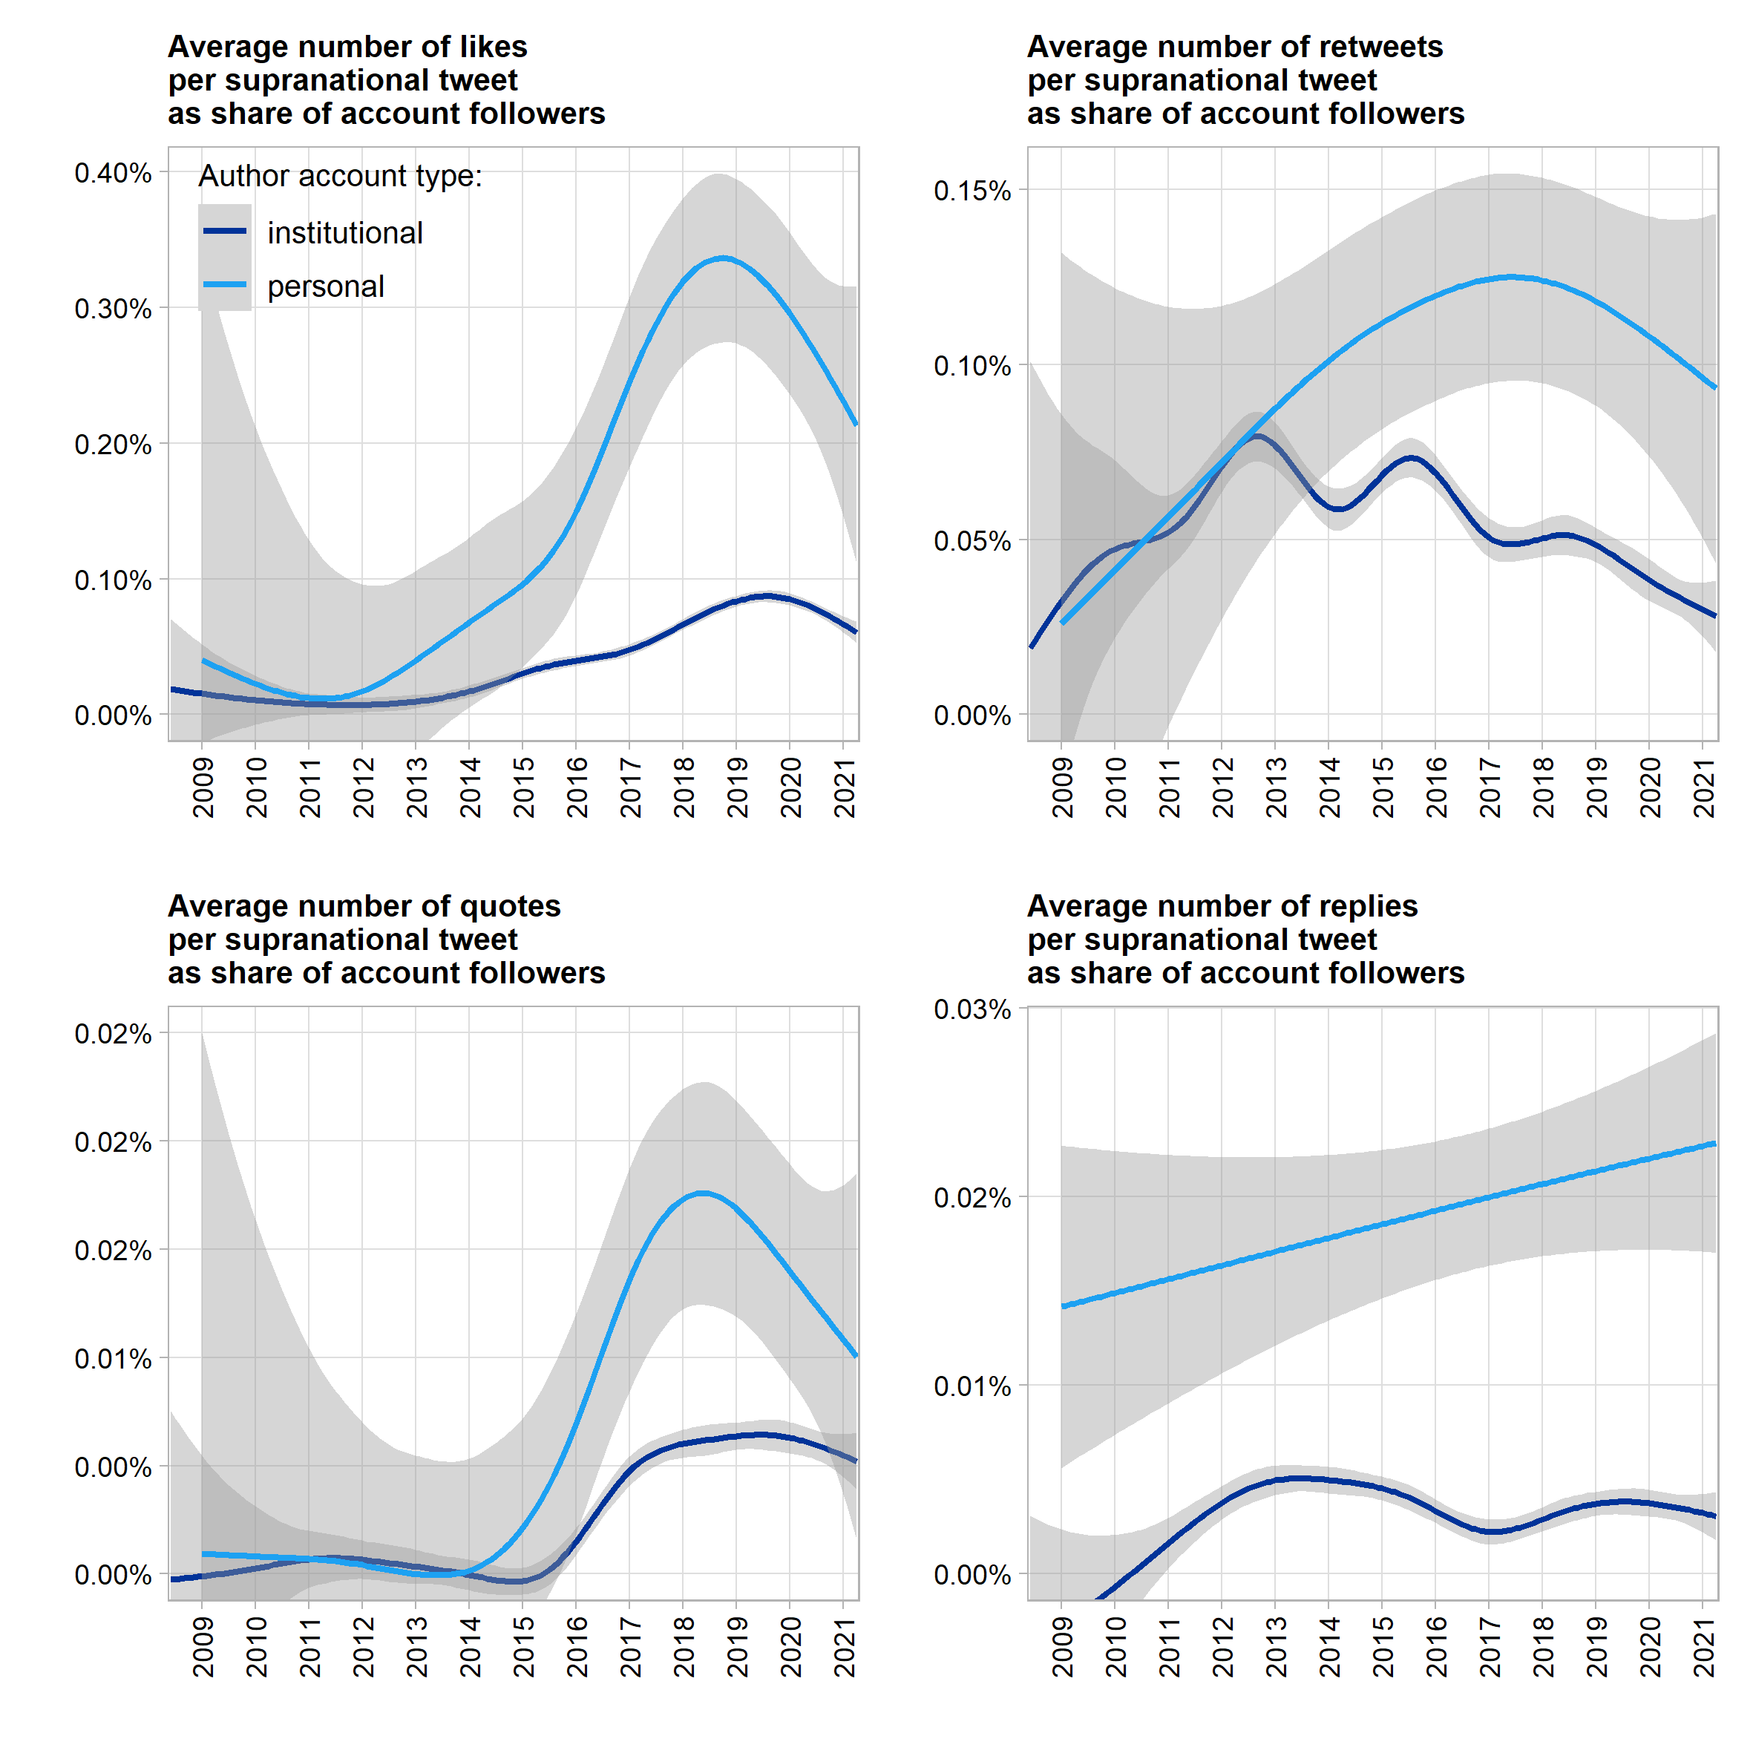

Semi-explorative model of engagement with supranational tweets

DVs: favorites, retqweets, quotes normalized by follower counts on tweet day

IVs (with presumed positive effect, partially quoting marketing literature)

* Personal accounts generate higher engagement (less propaganda suspicion)
* Media usage (emoji, pics, videos separately) create engagement
* Interactivity (mentions, hashtags) increase engement
* Negativity creates engagement (sentiment)
* External URLs?
* Policy responsibility?
* FEs / random intercepts by account?

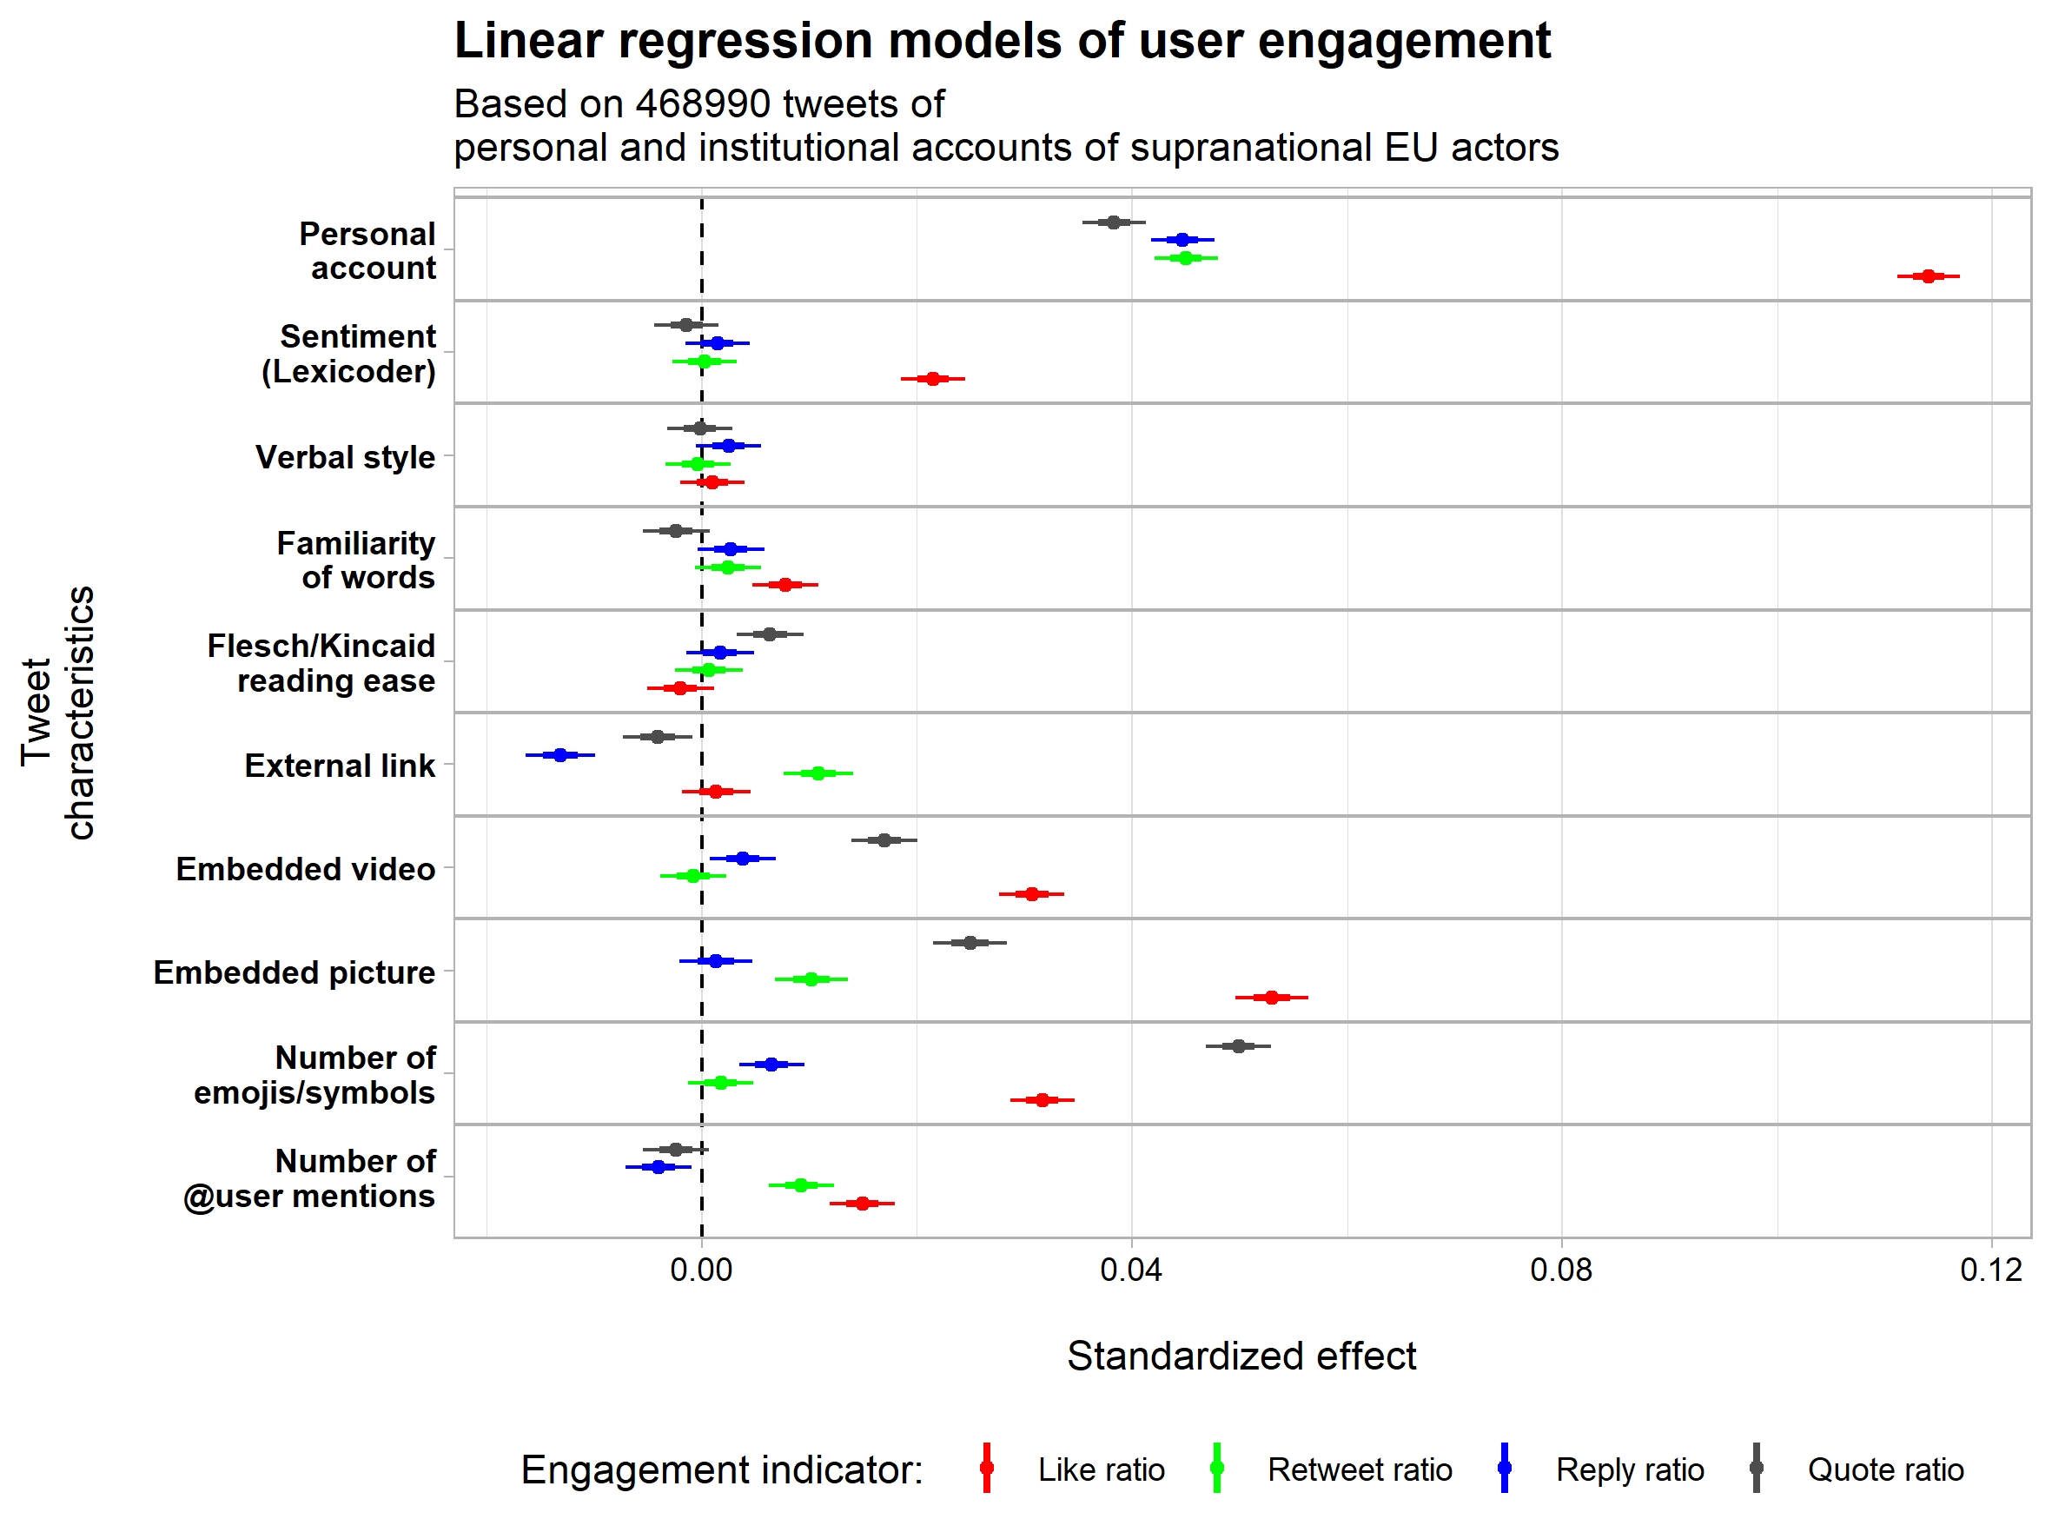

Qualitative presentation/discussion of extraordinarily viral tweets (exceeding n of followers by x)

# **6. Conclusions**

See what we find 😉