Com_qual_v1

Sina Özdemir[1]

Christian Rauh[2]

5/14/2021

# Introduction

## Para 1:

* the EU is irreversably policitised. Its legitimacy is challenged on many fronts

## Para 2:

* The EU has internal and external problems with communicating its legitimacy

## Para 3:

* Social media offers unique solutions to external communication problems

## Para 4:

* What we do in the article

## Para 5:

* Organization of the article

# Legitimacy deficit of the EU

## Para 1:

* Introduction: what kind of legitimacy problem

## Para 2:

* Legitimacy deficit: input legitimacy

## Para 3:

* Legitimacy deficit: output legitimacy

## Para 3:

* Legitimacy deficit: throughput legitimacy

## Para 4:

* Legitimacy deficit: communication deficit

# Public communication and the EU’s legitimacy

## Para 1:

* Communication deficit: internal problems

## Para 2:

* Communication deficit: external problems

## Para 3:

* Attempts at remedying communication deficit

## Para 4:

* How can public communication via social media help with legitimacy deficit
  + Meritocratic legitimacy (Meyer 1999)
  + SoMe: direct communication with citizens, thus a solution to external communication problems
  + Volume: telling what the EU does helps with output legitimacy
  + Ease-of-reade: makes the EU politics comprehensible
  + Interactivity: build connection with the audience so that audience feels heard
  + Political responsiblity reporting: Helps with transparency, because now the audience knows who is responsible for what

# Data collection

## Supranational tweets and relevant benchmarks

To study supranational communication on Twitter, our data collection starts with identifying the population of relevant accounts. Our selection follows two basic considerations. Firstly, we want to gain a clear picture of the EU’s public communication as a polity [CITATION HERE]. The accounts we analyze should thus collectively reflect the branches of the EU that exercise political authority (in the sense of taking or at least contributing to collective decision-making in the supranational polity). Secondly, extant research highlights that especially the executive branches of the EU (i.e. the supranational institutions in the narrow sense) such as the Commission and the ECB for example, are often the core subjects of EU politicization in national media. It is often the institutional legitimacy of executive EU actors that is questioned and equated with the overall EU legitimacy in minds of citizens [@Silvia2021].

Accordingly, we identified the Twitter accounts of the EU’ supranational institutions (e.g. @EU_Commission), their sub-branches (e.g. *@EUHomeAffairs*) and dedicated EU agencies (e.g. *@Frontex*), as well as the personal accounts of the individuals heading these institutions such as Commissioners (e.g. *@TimmermansEU*), Director-Generals (e.g. *@lemaitre_eu*), or agency heads (e.g. @stefanomanservi). Including only accounts that are verified by Twitter to be actually owned by the person or organization they claim to represent (as indicated by the blue check mark badge on the platform), we end up with *115 active supranational Twitter accounts*. The full list is provided in Appendix XXX. For each of these supranational accounts we have then collected all tweets between the date an account was created and May 3 2021 through the Twitter API 2.0 academic track, resulting in a dataset of *1,065,203 individual tweets*.

While this offers a thus far unprecedented empirical perspective on the social media messages of supranational actors, the information it contains cannot be easily assessed in some absolute sense. Thus, to put supranational communication behavior on Twitter into perspective, we collected *three additional benchmark datasets*.

The first benchmark simply aims to establish what constitutes ‘normal’ behavior on the platform through a by-and-large *random sample of tweets*. To construct this sample, we streamed in tweets from 26 of the EU countries for a week with five-minute windows through Twitter Decahose API. This generates X,XXX,XXX tweets that we can use as a baseline for ‘typical’ tweet features.

More importantly, however, we have to note above that the particular legitimacy challenges that EU actors face emerge from the fact that – in Delors’ words – the EU is an unidentified object. On the one hand, its competencies approximate that of a nation state. On the other hand, it carries significant markers of an international organization where member states guide and decide on how the political authority will be exercised. Our other two benchmark data sets thus focus on comparing supranational media communication to exactly these different levels of governance.

To approximate communication of national governments, we target the current UK government ministers, ministries, executive offices, agencies and individuals who are in charge of these institutions (see appendix XXX for the full list of XXX accounts). Collecting the data analogously to the supranational EU actors above, this results in a benchmark of XXX,XXX tweets. To approximate communication of international organizations, we identified IOs that have a roughly similar policy scope as the EU, picking those organizations that are in the range of one standard deviation around the EU with regard to the number of policy areas covered as provided in the MIA data set (Hooghe et al., 2017). We identified their Twitter accounts along the list collected and kindly shared by Matthias Ecker-Erhardt (2020; full list in Appendix XXX). This results in 55 accounts for which we could analogously collect 294,219 individual tweets for our final benchmark.

## Indicators

Besides describing and comparing the volume of supranational communication via Twitter, our primary interest lies in charting the characteristics of the collected tweets with a focus on what they can tell us about engaging with and engagement of citizens on this interactive platform. Along our discussion above, three blocks of indicators are of key interest here.

*Textual message content:* As noted above a necessary condition for engaging messages is that the message is easily understandable and graspable in the first place. Exploiting the validations and tools provided by Benoit, Spirling, and Munger (2019) we thus extract two features from the English-language elements of each Tweet (for details on text-preprocessing please refer to Appendix XXX and the scripts in the replication package). First, we measure syntactic and grammatical complexity by the Flesh/Kincaid reading ease score. This compound indicator of sentence and word length captures the cognitive mobilization (often described by anchoring it in education levels) to grasp the textual content of a message. Second, we measure familiarity of the vocabulary supranational actors use. This is proxied by the average frequency by which the words in a given tweet occur in the overall Google Books corpus as the broadest available representation of the English language. The intuition is that words that are more common in the English language (as opposed to rarer technical and specialized jargon) are better known and thus more readily understandable by a broad audience. Furthermore, we assess whether a particularly positive or negative tone of the message is related to engagement by extracting the sentiment of expressed in its textual component along the Lexicoder Sentiment Dictionary (Young & Soroka, 2012).

*Multimedia message content*: Beyond text, the Twitter platform allows (or even encourages) various means of multimedia messaging. Symbols, pictures, or videos can transmit a large amount of information (Tang & Hew, 2018), rendering their usage also relevant for engaging political communication at least in principle. Thus, we initially extract and count the number of emoticons and other special symbols from the content of each tweet by resorting to the relevant Unicode blocks (see Appendix XXX as well as the replication scripts for details). We also store whether a Tweet contains embedded pictures and/or videos as well as links to external URLs from the entities URL field offered by the Twiter API.

*Engagement with other users and debates*: As a decidedly interactive platform, Twitter offers supranational actors not only the possibility to propagate their own messages but also allows them to amplify (retweet), respond to (reply), or contextualize (quote) the messages of other platform users. To see to what extent supranational actors make use of these more dialogue-oriented features of the platform, we study the shares of retweets, replies, and quotes in the overall amount of supranational messages. In addition, we extract direct, linked references to other Twitter users – so-called @-mentions – from the tweets as they also indicated the willingness to actively speak about and with other actors. Finally, we consider the number of hashtags per tweet, a common way to cross-reference a message to a specific subject or theme debated on the platform.

*Engagement of other users*: Ultimately, we want to study in how far supranational messages result in user engagement. We focus on the main engagement tools that the platform offers. Likes (or favorites in Twitter parlance) allow the user to express a favorable attitude towards a given message through a red heart button. Retweets allow users to amplify the message by directly sharing it, again with a simply click of a button. More proactive forms of engagement that also allow critical stances in principles are quotes and replies. Here users can either contextualize or directly respond to the message with own bits of texts and/or symbols. For each tweet, thus, we extract the counts of likes, retweets, quotes and replies from the user engagement statistics fields supplied by the Twitter API.

# Results and discussion

**Broad overview of the data**

## Within sample comparision: communication performance of different EU accounts

### Ease of read:

### Interactivity:

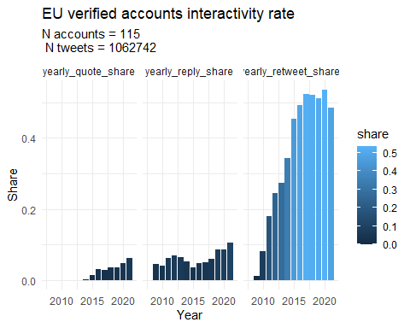

## `summarise()` has grouped output by 'Actor_type'. You can override using the `.groups` argument.

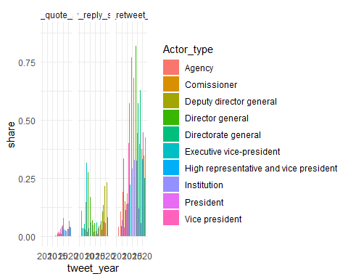 **This is not a good graph**

### Political responsiblity reporting:

## Benchmarks: communication performance of the EU compared to IOs and national governments

### Ease of read

### Interactivity

### Political responsibility reporting:

# Conclusion

# References

1. PhD Candidate, Department of Sociology and Political Science, Norwegian University of Science and Technology
2. Prof., Global Governance Unit, Social Science Center Berlin