**Politics and Governance (ISSN: 2183-2463)  
Year, Volume, Issue, Pages X–X  
https://doi.org/10.17645/pag.vXiX.XXX**

Article

**A bird’s eye view: How supranational EU actors use Twitter.**

Sina F. Özdemir1,* and Christian Rauh2

1 Department of Sociology and Political Science, Norwegian University of Science and Technology Trondheim; E-Mail: [sina.ozdemir@ntnu.no](mailto:sina.ozdemir@ntnu.no)

2 Research Unit Global Governance, WZB Berlin Social Science Center, Germany; E-Mail: [christian.rauh@wzb.eu](mailto:christian.rauh@wzb.eu); Web: [www.christian-rauh.eu](http://www.christian-rauh.eu)

* Corresponding author

**Abstract**

Against the politicization of European integration, public communication of the European Union matters. Especially for usually rather detached supranational executives, social media platforms offer unique opportunities to communicate to and to engage European citizens. Yet, how do these actors actually use social media? This article provides a bird’s eye view and quantitatively describes more than one million tweets from 115 supranational EU accounts in the 2009-2021 period, benchmarking key message characteristics against large samples of tweets from national executives, international organizations, and random twitter users. We show that supranational Twitter activity has grown markedly, relies strongly on the multimedia features the platform offers, and also outperforms other political executives on many dimensions. However, we also find that supranational interaction with other Twitter users comparatively rare and somewhat concentrated, while the high complexity of the supranational messages’ textual content limits engagement of other users. We discuss these findings in the light of the legitimacy and public accountability challenges that supranational EU actors face.

**Keywords**

European Union; social media; political communication; politicization; text analysis; ...

© Year by the author(s); licensee Cogitatio (Lisbon, Portugal). This article is licensed under a Creative Commons Attribution 4.0 International License (CC BY).

**1. Introduction: Why we should care about supranational Twitter activity**

The European Union (EU) has an increasingly precarious relationship with the citizens it governs. The politicization of European integration in public debates has markedly increased in recent years. This indicates that the EU has a veritable popular legitimacy problem. Incidences such as the failure of constitutional referenda in 2005, the raging debates about supranational authority during the Euro- and Schengen crises after 2009 and 2015, the infamous Brexit decision of 2016, and more generally the rise of Eurosceptic mobilization in national and European election campaigns clearly illustrate that the EU can no longer rely on a permissive consensus among the wider citizenry (De Wilde and Zürn 2012; Hooghe and Marks 2009; Rauh 2021a). In such controversial debates, especially the EU’s rather detached supranational institutions are frequently addressed and become targets of blame-shifting (Gerhards *et al.* 2009).

Supranational actors, however, are not only at the receiving end of such controversial debates. In principle, they can try to defend themselves in public, trying to nurture popular legitimacy of the EU by giving account of how they exercise their political authority. Faced with public politicization, thus, also political institutions beyond the level of the nation state have discovered the need to invest in public communication (Ecker-Ehrhardt 2018; Ecker-Ehrhardt 2020).

Yet, supranational EU institutions face notable obstacles in effectively communicating with the wider European citizenry. Part of these obstacles are internal. Public communication is often subject to internal conflicts and competition over limited resources (Altides 2009; Bijsmans and Altides 2007; Hartlapp *et al.* 2014: ch. 9). In institutions with delegated powers that often involve high levels of expertise, consensus-orientation, and diplomatic restraint, public outreach has traditionally not been a primary concern (Brüggemann 2010; Meyer 1999). When facing controversial public debates, moreover, supranational institutions may have incentives to avoid clear communication in their strategic efforts to calm controversial debates (Biegoń 2013; Bressanelli *et al.* 2020; De Wilde and Zürn 2012; Schimmelfennig 2020). In effect, supranational communication efforts are thus often rather inaccessible to the wider public as they use highly-codified, complex technocratic language ladened with jargon (Rauh *et al.* 2019; Rauh 2021b).

Beyond internal constraints, supranational institutions face notable communication obstacles in their environment as well. While supranational institutions are tasked to defend the European interest in their policy areas, mass-mediated public spheres tend to be fractured along national borders, languages, and media systems (Koopmans and Statham 2010; Risse 2014; Trenz 2004; Walter 2015). National media are furthermore rather selective in covering EU affairs where traditional journalistic selection logics are often biased to national interests, as well as domestic executives and their challengers (De Vreese 2001; De Vreese *et al.* 2006; Trenz 2008). Along this line, media coverage of the EU is primarily driven by controversial and contested events such as summits of the heads of state and government, EP elections, and scandals on the European level (Boomgaarden *et al.* 2013). In the environment of traditional media systems, thus, supranational institutions have a hard time to get their message across.

Against these constraints, social media platforms should be a promising channel for supranational public communication. With a view to the external constraints that supranational institutions face, social media are attractive as they allow citizens to engage with content beyond national boundaries (Bossetta et al., 2017). Social media furthermore imbue users with a degree of gatekeeping power (Wallace, 2018). The decentralized structure of these platforms, where users themselves can choose which messages will be allowed and amplified in the information environment, gives supranational EU actors some freedom to determine which issues to inject and how to best generate engagement. This allows them to circumvent traditional media selection logics to some extent, to generate attention on their preferred topics (which might create additional incentives for journalistic coverage, XYZ), and to reach out to European citizens more directly.

With a view to the internal constraints, social media are attractive to supranational communication as well. The platforms usually reward clear and concise messaging. In addition, they offer multimedia features such as pictures, videos, or symbols that may also be beneficial for accessible and engaging communication. And importantly, social media offer comparatively cost-efficient communication tools. It takes mere minutes to set up an account and they are often very easy to maintain, thus also limiting internal gatekeeping. Lastly, social media provide a low-hurdle and continuous information source for the users. Unlike static webpages of web 2.0, social media do not require the user to consciously search for information about supranational activity in the EU. Users may encounter EU messages in their timelines or could simply follow social media accounts by one click if they deem them interesting.

Social media are hardly the panacea to all the public communication ailments of the EU, but these key features should make them an attractive additional communication channels for supranational institutions willing to defend themselves in a politicized climate. Yet, to what extent and how do supranational actors actually use this potential?

While extant research has generated insights into the grand social media strategies of European institutions (Asimina and others XXX), large-scale systematic evidence on the *actual behavior of supranational actors on social media platforms* is rare (XXX). This article focusses on Twitter, a highly prominent international microblogging platform featuring lots of public and publicly visible political debate (XXX). We analyze more than one million public messages (tweets) issued by 115 supranational institutions and individual executives in the 2009-2021 period. This allows us to describe the volume, the language quality, and the multimedia usage of supranational messaging as well as the degree to which supranational actors engage and engage with other users on the platform. To put this supranational Twitter activity into perspective, we benchmark our indicators against large samples of tweets from national and international institutions and executives as well as random Twitter users.

This hitherto most encompassing description of supranational EU activity on of the key social media platforms initially shows a drastically increasing volume of supranational messaging. Both in terms of volume and multimedia usage, supranational actors outperform domestic and international actors. Yet, the text of supranational messages is comparatively less accessible which also limits the engagement of other users with these messages. XXX Sketch other findings here XXX. For the question of whether this form of public supranational communication is geared to nurturing popular legitimacy of the EU, we thus have mixed findings … XXX.

**2. Data collection: Supranational tweets and relevant benchmarks**

Our data collection starts with identifying the population of official supranational Twitter accounts, following two basic considerations. First, our interest is in supranational institutions in the narrow sense, i.e. the executive branches of the EU which control independent delegated powers. Institutions such as the European Commission or the ECB are often core addressees of public politicization and are equated with EU legitimacy more broadly in the minds of citizens (Silva *et al.* 2021). Second, we want to cover the EU polity as broadly as possible by reflecting all executive branches exercising political authority.

Accordingly, we identified the main Twitter accounts of the institutions falling under these definitions (e.g., @EU_Commission), their individual sub-branches (e.g., @EUHomeAffairs) and dedicated EU agencies (e.g., @Frontex), as well as the personal accounts of the individuals heading these institutions as Presidents (e.g., *@vonderleyen*), Commissioners (e.g., @TimmermansEU), Director-Generals (e.g., @lemaitre_eu), or agency heads (e.g., @stefanomanservi). We include only accounts that are official verified by Twitter to be owned by the person or organization they claim to represent (as indicated by the blue check mark badge on the platform). This results *115* supranational Twitter accounts active in the beginning of 2021 (full list in Appendix XXX). For each of these accounts we then collected the full corpus of tweets the have issued between the date the respective account was created and May 3, 2021, through the Twitter API 2.0 academic track. In total, this approach gives us 1,065,203 individual supranational social media messages for analysis.

While this offers a thus far unprecedentedly broad empirical perspective supranational behavior on social media, we cannot meaningfully analyze the characteristics of these messages in isolation or some absolute sense. To see what the aggregate these messages tell us, we need to put them into perspective. Thus, we collected three additional benchmark datasets.

The first on simply is a by-and-large random sample of tweets which aims to establish what constitutes ‘normal’ behavior on the platform. To construct this benchmark, we streamed in tweets from 26 EU countries with repeated five-minute windows for a whole week through Twitter Decahose API. This generates 83,823 tweets that we can use as a baseline for typical characteristics of public messages on Twitter.

The theoretically more meaningful benchmarks, however, are geared to locate supranational social media communication within a broader population of actors holding executive political powers. After all, public politicization, legitimacy challenges, and the need for effective communication with citizens emerge from the EU’s nature as an unidentified political object, to use Delors’ famous description. On the one hand, the political authority of the EU approximates that of a executive in nation state on many accounts. On the other hand, the EU still carries significant markers of an international organization where member states delegate and control how the political authority is exercised. Two additional benchmark data sets thus focus on comparing supranational media communication to exactly these different levels of governance.

To approximate communication of national governments, we target executive political institutions and actors in the United Kingdom (UK). We identify the Twitter accounts of government ministries, executive offices, agencies and individuals who are in charge of these institutions (see appendix XXX for the full list of 168 accounts). Collecting the data analogously to the supranational EU actors above, this results in a benchmark of 1,510,064 tweets. To approximate the social media communication of international organizations, we first identified IOs that have a roughly similar policy scope as the EU, picking those organizations that are in the range of one standard deviation around the EU with regard to the number of policy areas covered as provided in the MIA data set (Hooghe *et al.* 2017). We identified their Twitter accounts along the list collected and kindly shared by Matthias Ecker-Erhardt (2020; full list in Appendix XXX). This results in 55 accounts for which we could analogously collect 294,219 individual tweets for our final benchmark. Table 1 summarizes the observations available for comparative analysis in the subsequent sections.

|  |  |  |
| --- | --- | --- |
| **Actor type** | **Twitter  accounts** | **Tweets** |
| EU (inst. account) | 70 | 789,006 |
| EU (pers. account) | 45 | 276,197 |
| UK (inst. account) | 69 | 654,520 |
| UK (pers. account) | 99 | 855,544 |
| IO (inst. account) | 48 | 269,219 |
| IO (pers. account) | 7 | 25,000 |
| Random tweets | 37,849 | 83,823 |

**Table 1:** Tweet samples available for comparative analysis

**3. Key characteristics of supranational Twitter activity in comparative perspective**

*3.1. Volume of supranational messages on Twitter*

On a very basic level, the volume of messages provides a first answer to our overarching question on how supranational EU actors use the public communication potential of social media. Figure 1 thus shows the average number of tweets per account and day.

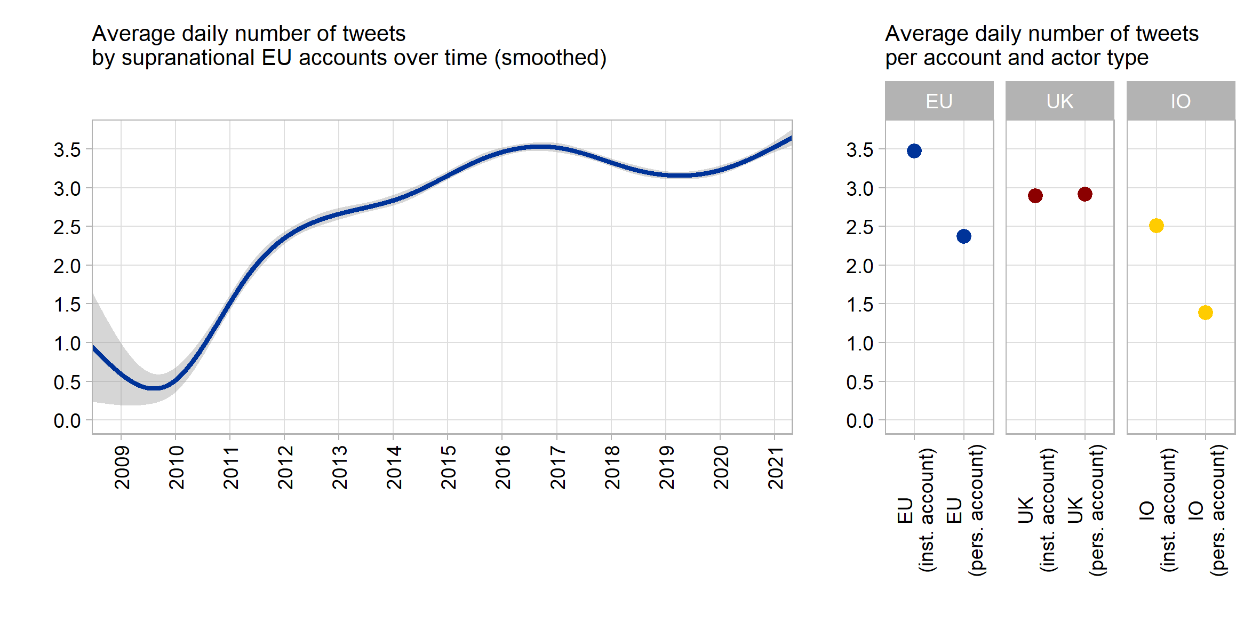

**Figure 1**: Number of tweets per day and account

The left panel initially indicates that supranational actors have markedly increased the number of messages they publish on Twitter. While there was only roughly one tweet every second day during the very early phase of supranational Twitter presence this has increased by almost a factor of seven to 3 to 3.5 tweets per day in the more recent periods. It should be noted that the major increase in supranational Twitter messaging happened during the 2010-2016 period, a phase of strongly surging public EU politicization amidst the Euro- and Schengen crises. Yet, this major increase also coincides with a period in which the European Commission has reduced its output of traditional press releases notably (Rauh 2021b), possibly indicating a re-distribution of internal communication resources.

The comparative perspective in the right panel of Figure 1 furthermore highlights that supranational tweet volume is driven by institutional accounts to a large extent, indicating a centralized and probably professionalized approach to supranational social media presence (XXX). Institutional EU accounts emit around 3.5 tweets per day, while supranational actors tweeting in personal capacity issue around one daily tweet less.

We must note that these highly aggregated averages hide significant variation within our population of supranational actors on Twitter. Among the most avid tweeters are the Commission’s Directorate-General for Digital Policies (CONNECT, @DigitalEU) with 13.7 tweets per day, but also the official account of the whole EU Commission run by the spokespersons service (@EU_Commission) with 10.4 tweets a day. On the lower end of the distribution, we find the European Court of Justice (@EUCourtPress) with around one tweet every second day or, further down the line, the Euratom Supply Agency (@EuratomA) issuing a message only around very 10th day on average. Yet, this variation in the tweet volume across supranational EU actors (standard deviation is 2.58 tweets per day) is not systematically distinct from our UK benchmark sample (2.23 daily tweets) and markedly lower than in sample of tweets from international organizations (SD: 4 daily tweets).

In fact, the variation across our benchmark samples is more interesting, as the left panel of Figure 1 highlights: The volume of tweets from supranational accounts clearly exceeds the tweet volume of international organizations and actors, while it is at least on par when compared to national executives in the United Kingdom. With regard to volume, thus, we can clearly state that supranational actors try to exploit the communication potentials of this particular social medium.

*3.2. The language of supranational messages on Twitter*

Is this increasing amount of supranational communication on Twitter geared to be understandable to the average European citizen? In this section we look at the language quality of the textual content of supranational tweets in comparative perspective.

For this part of the analysis extensive pre-processing of the tweets’ contents are required. In general, our aim has been to isolate and represent the textual content as good as possible to ensure reliable extraction of the language indicators discussed below. To this end, we removed all non-textual symbols, media, and external links (separately analyzed in other sections below), treated hashtags as individual or multiple words (if camel cased), and ensured proper punctuation. The replication scripts provide the full detail but Table 2 illustrates our pre-processing along two random examples from the supranational EU corpus. All benchmark samples were processed alike.

| **Original tweet** | **Extracted text** |
| --- | --- |
| I fell asleep hoping to wake up from a bad dream.Europe is full of wonders that no one will bring us back. Preserving with #digitization is important for us & for future generations. Close to the Parisians. With #NotreDame we've lost a piece of our history https://t.co/hQRqMGSsq3 https://t.co/CPLs1DqEcl | I fell asleep hoping to wake up from a bad dream. Europe is full of wonders that no one will bring us back. Preserving with digitization is important for us & for future generations. Close to the Parisians. With Notre Dame we've lost a piece of our history. |
| 🤝 Sharing risk. 🌍 Maximising impact.  Today we’ve signed 4 new guarantee agreements under the EU External Investment Plan to create more 💡 opportunities for people in countries near the EU and in Africa.   Read more ➡https://t.co/YY3zPWSti4 📈 #InvestGlobal #EIP https://t.co/HvYWuoVEOC | Sharing risk. Maximising impact. Today we’ve signed 4 new guarantee agreements under the EU External Investment Plan to create more opportunities for people in countries near the EU and in Africa. Read more. Invest Global EIP. |

**Table 2:** Tweet text processing examples

This part of the analysis resorts to English-language content of all covered tweets (detected on sentence level with Google’s compact language detector 2 as implemented in the cld2 R package, XXX). English is clearly the lingua franca of supranational actors on Twitter. In total 82% of all supranational tweets were solely written in English while 88.2% contained at least on English sentence. Other languages appear much less frequently: we detected French in about 4% of Tweets, Italian and Polish in around 1.5%, as well as Italian, Swedish and German in around 1%. All other European languages are used even less frequently.

This initially seems to suggest that supranational actors do not respect linguistic diversity of the EU. Yet, this should also not be overstated. Virtually all Twitter end-user applications offer reliable auto-translation at the click of a button. More importantly, especially the European Commission retains representations in all member states, often with dedicated Twitter accounts that communicate in the country’s main languages but that are not part of our account selection here.

Much more substantial, language quality …

a necessary condition for engaging messages is that the message is easily understandable and graspable in the first place. Exploiting the validations and tools provided by Benoit, Spirling, and Munger (2019) we thus extract two features from the English-language elements of each Tweet (for details on text-preprocessing please refer to Appendix XXX and the scripts in the replication package). First, we measure syntactic and grammatical complexity by the Flesh/Kincaid reading ease score. This compound indicator of sentence and word length captures the required cognitive mobilization (often described by anchoring it in education levels) to grasp the textual content of a message. Second, we measure familiarity of the vocabulary supranational actors use. This is proxied by the average frequency by which the words in a given tweet occur in the overall Google Books corpus as the broadest available representation of the English language. The intuition is that words that are more common in the English language (as opposed to rarer technical and specialized jargon) are better known and thus more readily understandable by a broad audience

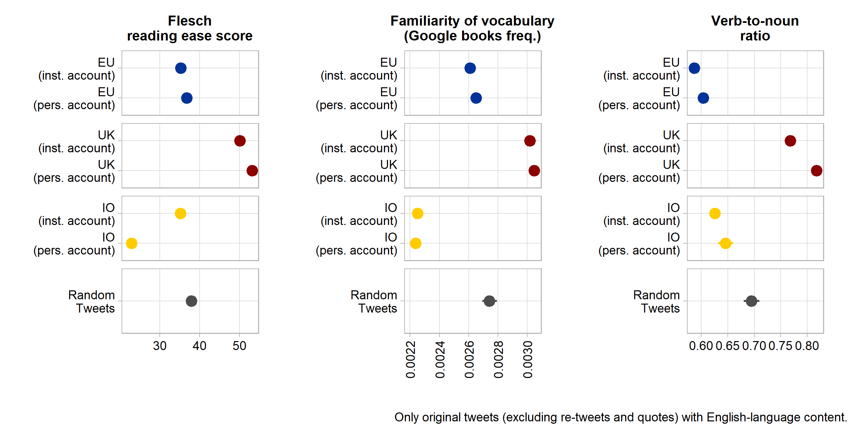

*3.1. Media usage in supranational messages on Twitter*

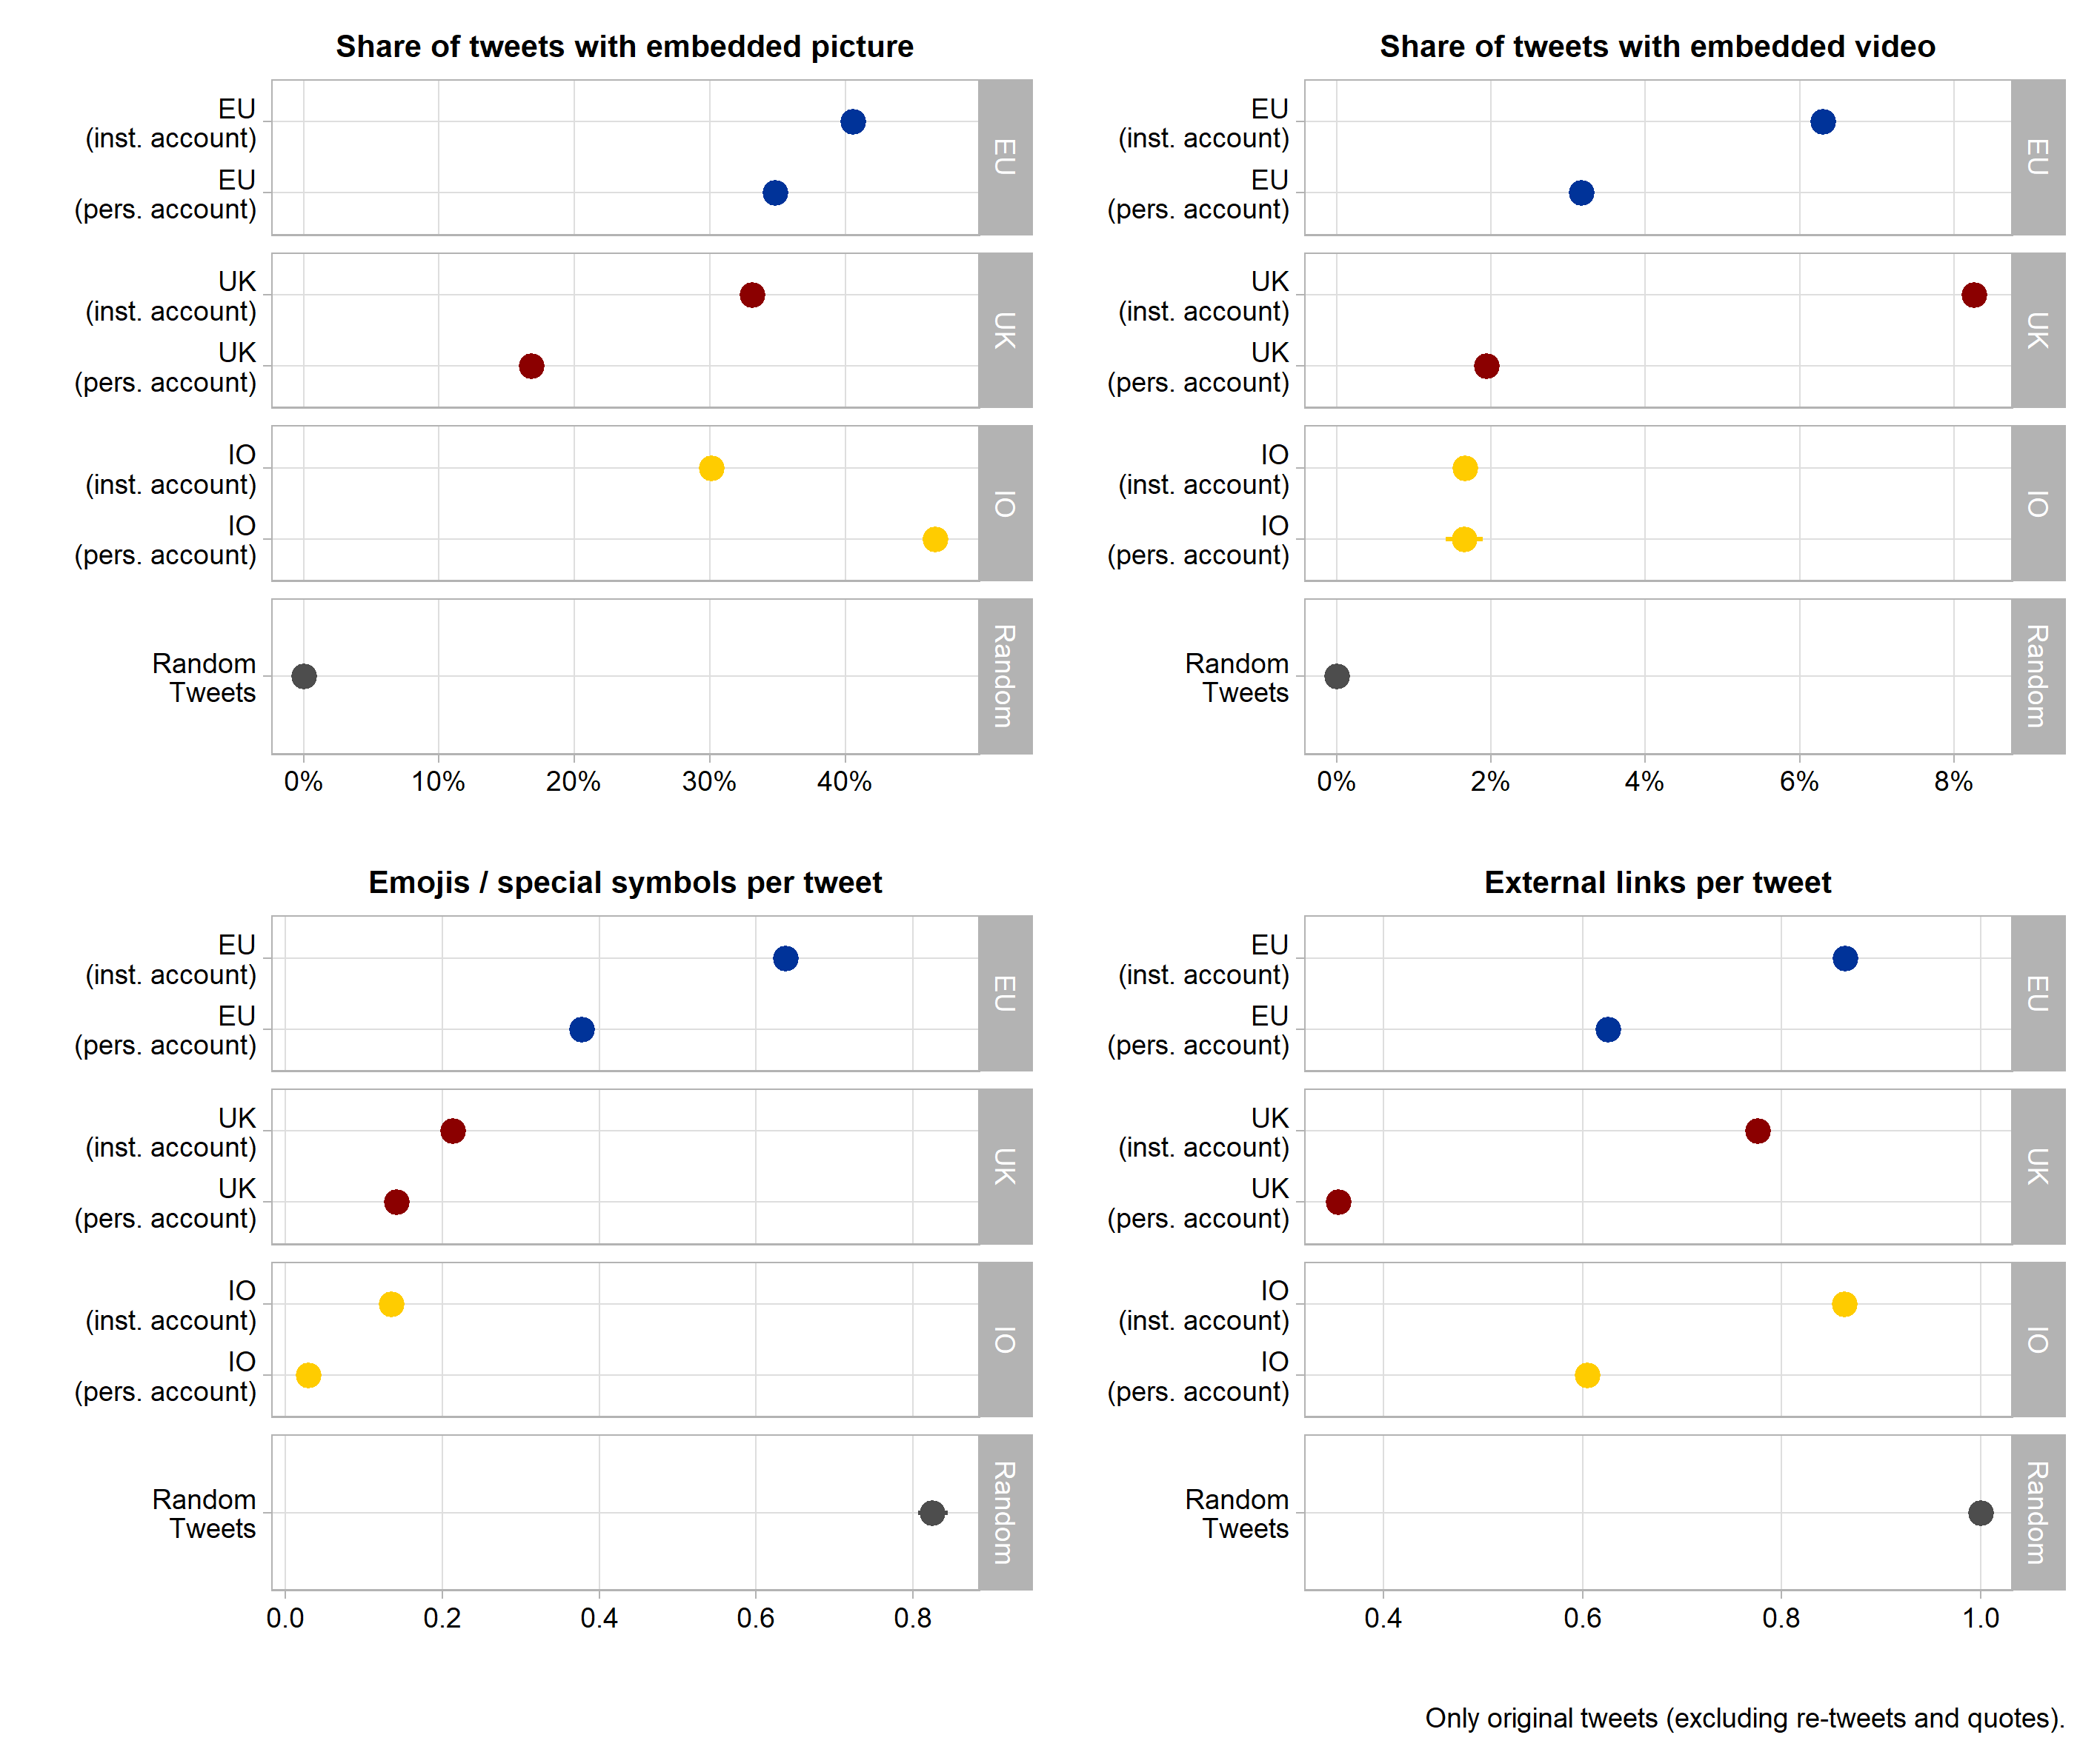

1.1.1. This Is a Second Sub-Heading (Regular)