**Politics and Governance (ISSN: 2183-2463)  
Year, Volume, Issue, Pages X–X  
https://doi.org/10.17645/pag.vXiX.XXX**

Article

**A bird’s eye view: How supranational EU actors use Twitter.**

Sina F. Özdemir1,* and Christian Rauh2

1 Department of Sociology and Political Science, Norwegian University of Science and Technology Trondheim; E-Mail: [sina.ozdemir@ntnu.no](mailto:sina.ozdemir@ntnu.no)

2 Research Unit Global Governance, WZB Berlin Social Science Center, Germany; E-Mail: [christian.rauh@wzb.eu](mailto:christian.rauh@wzb.eu); Web: [www.christian-rauh.eu](http://www.christian-rauh.eu)

* Corresponding author

**Abstract**

Against the politicization of European integration, public communication of the European Union matters. Especially for usually rather detached supranational executives, social media platforms offer unique opportunities to communicate to and to engage European citizens. Yet, how do these actors actually use social media? This article provides a bird’s eye view and quantitatively describes more than one million tweets from 115 supranational EU accounts in the 2009-2021 period, benchmarking key message characteristics against large samples of tweets from national executives, international organizations, and random twitter users. We show that supranational Twitter activity has grown markedly, relies strongly on the multimedia features the platform offers, and also outperforms other political executives on many dimensions. However, we also find that supranational interaction with other Twitter users comparatively rare and somewhat concentrated, while the high complexity of the supranational messages’ textual content limits engagement of other users. We discuss these findings in the light of the legitimacy and public accountability challenges that supranational EU actors face.

**Keywords**

European Union; social media; political communication; politicization; text analysis; ...

© Year by the author(s); licensee Cogitatio (Lisbon, Portugal). This article is licensed under a Creative Commons Attribution 4.0 International License (CC BY).

**1. Introduction: Why we should care about supranational Twitter activity**

The European Union (EU) has an increasingly precarious relationship with the citizens it governs. The politicization of European integration in public debates has markedly increased in recent years. This indicates that the EU has a veritable popular legitimacy problem. Incidences such as the failure of constitutional referenda in 2005, the raging debates about supranational authority during the Euro- and Schengen crises after 2009 and 2015, the infamous Brexit decision of 2016, and more generally the rise of Eurosceptic mobilization in national and European election campaigns clearly illustrate that the EU can no longer rely on a permissive consensus among the wider citizenry (De Wilde and Zürn 2012; Hooghe and Marks 2009; Rauh 2021a). In such controversial debates, especially the EU’s rather detached supranational institutions are frequently addressed and become targets of blame-shifting (Gerhards *et al.* 2009).

Supranational actors, however, are not only at the receiving end of such controversial debates. In principle, they can try to defend themselves in public, trying to nurture popular legitimacy of the EU by giving account of how they exercise their political authority. Faced with public politicization, thus, also political institutions beyond the level of the nation state have discovered the need to invest in public communication (Ecker-Ehrhardt 2018; Ecker-Ehrhardt 2020).

Yet, supranational EU institutions face notable obstacles in effectively communicating with the wider European citizenry. Part of these obstacles are internal. Public communication is often subject to internal conflicts and competition over limited resources (Altides 2009; Bijsmans and Altides 2007; Hartlapp *et al.* 2014: ch. 9). In institutions with delegated powers that often involve high levels of expertise, consensus-orientation, and diplomatic restraint, public outreach has traditionally not been a primary concern (Brüggemann 2010; Meyer 1999). When facing controversial public debates, moreover, supranational institutions may have incentives to avoid clear communication in their strategic efforts to calm controversial debates (Biegoń 2013; Bressanelli *et al.* 2020; De Wilde and Zürn 2012; Schimmelfennig 2020). In effect, supranational communication efforts are thus often rather inaccessible to the wider public as they use highly-codified, complex technocratic language ladened with jargon (Rauh *et al.* 2019; Rauh 2021b).

Beyond internal constraints, supranational institutions face notable communication obstacles in their environment as well. While supranational institutions are tasked to defend the European interest in their policy areas, mass-mediated public spheres tend to be fractured along national borders, languages, and media systems (Koopmans and Statham 2010; Risse 2014; Trenz 2004; Walter 2015). National media are furthermore rather selective in covering EU affairs where traditional journalistic selection logics are often biased to national interests, as well as domestic executives and their challengers (De Vreese 2001; De Vreese *et al.* 2006; Trenz 2008). Along this line, media coverage of the EU is primarily driven by controversial and contested events such as summits of the heads of state and government, EP elections, and scandals on the European level (Boomgaarden *et al.* 2013). In the environment of traditional media systems, thus, supranational institutions have a hard time to get their message across.

Against these constraints, social media platforms should be a promising channel for supranational public communication. With a view to the external constraints that supranational institutions face, social media are attractive as they allow citizens to engage with content beyond national boundaries (Bossetta et al., 2017). Social media furthermore imbue users with a degree of gatekeeping power (Wallace, 2018). The decentralized structure of these platforms, where users themselves can choose which messages will be allowed and amplified in the information environment, gives supranational EU actors some freedom to determine which issues to inject and how to best generate engagement. This allows them to circumvent traditional media selection logics to some extent, to generate attention on their preferred topics (which might create additional incentives for journalistic coverage, XYZ), and to reach out to European citizens more directly.

With a view to the internal constraints, social media are attractive to supranational communication as well. The platforms usually reward clear and concise messaging. In addition, they offer multimedia features such as pictures, videos, or symbols that may also be beneficial for accessible and engaging communication. And importantly, social media offer comparatively cost-efficient communication tools. It takes mere minutes to set up an account and they are often very easy to maintain, thus also limiting internal gatekeeping. Lastly, social media provide a low-hurdle and continuous information source for the users. Unlike static webpages of web 2.0, social media do not require the user to consciously search for information about supranational activity in the EU. Users may encounter EU messages in their timelines or could simply follow social media accounts by one click if they deem them interesting.

Social media are hardly the panacea to all the public communication ailments of the EU, but these key features should make them an attractive additional communication channels for supranational institutions willing to defend themselves in a politicized climate. Yet, to what extent and how do supranational actors actually use this potential?

While extant research has generated insights into the grand social media strategies of European institutions (Asimina and others XXX), large-scale systematic evidence on the *actual behavior of supranational actors on social media platforms* is rare (XXX). This article focusses on Twitter, a highly prominent international microblogging platform featuring lots of public and publicly visible political debate (XXX). We analyze more than one million public messages (tweets) issued by 115 supranational institutions and individual executives in the 2009-2021 period. This allows us to describe the volume, the language quality, and the multimedia usage of supranational messaging as well as the degree to which supranational actors engage and engage with other users on the platform. To put this supranational Twitter activity into perspective, we benchmark our indicators against large samples of tweets from national and international institutions and executives as well as random Twitter users.

This hitherto most encompassing description of supranational EU activity on of the key social media platforms initially shows a drastically increasing volume of supranational messaging. Both in terms of volume and multimedia usage, supranational actors outperform domestic and international actors. Yet, the text of supranational messages is comparatively less accessible which also limits the engagement of other users with these messages. XXX Sketch other findings here XXX. For the question of whether this form of public supranational communication is geared to nurturing popular legitimacy of the EU, we thus have mixed findings … XXX.

**2. Data collection: Supranational tweets and relevant benchmarks**

Our data collection starts with identifying the population of official supranational Twitter accounts, following two basic considerations. First, our interest is in supranational institutions in the narrow sense, i.e. the executive branches of the EU which control independent delegated powers. Institutions such as the European Commission or the ECB are often core addressees of public politicization and are equated with EU legitimacy more broadly in the minds of citizens (Silva *et al.* 2021). Second, we want to cover the EU polity as broadly as possible by reflecting all executive branches exercising political authority.

Accordingly, we identified the main Twitter accounts of the institutions falling under these definitions (e.g., @EU_Commission), their individual sub-branches (e.g., @EUHomeAffairs) and dedicated EU agencies (e.g., @Frontex), as well as the personal accounts of the individuals heading these institutions as Presidents (e.g., *@vonderleyen*), Commissioners (e.g., @TimmermansEU), Director-Generals (e.g., @lemaitre_eu), or agency heads (e.g., @stefanomanservi). We include only accounts that are officially verified by Twitter to be owned by the person or organization they claim to represent (as indicated by the blue check mark badge on the platform). This results *115* supranational Twitter accounts active in the beginning of 2021 (full list in Appendix XXX). For each of these accounts we then collected the full corpus of tweets the have issued between the date the respective account was created and May 3, 2021, through the Twitter API 2.0 academic track. In total, this approach gives us 1,065,203 individual supranational social media messages for analysis.

While this offers a thus far unprecedentedly broad empirical perspective supranational behavior on social media, we cannot meaningfully analyze the characteristics of these messages in isolation or some absolute sense. To see what the aggregate these messages tell us, we need to put them into perspective. Thus, we collected three additional benchmark datasets.

The first on simply is a by-and-large random sample of tweets which aims to establish what constitutes ‘normal’ behavior on the platform. To construct this benchmark, we streamed in tweets from 26 EU countries with repeated five-minute windows for a whole week through Twitter Decahose API. This generates 83,823 tweets that we can use as a baseline for typical characteristics of public messages on Twitter.

The theoretically more meaningful benchmarks, however, are geared to locate supranational social media communication within a broader population of actors holding executive political powers. After all, public politicization, legitimacy challenges, and the need for effective communication with citizens emerge from the EU’s nature as an unidentified political object, to use Delors’ famous description. On the one hand, the political authority of the EU approximates that of a executive in nation state on many accounts. On the other hand, the EU still carries significant markers of an international organization where member states delegate and control how the political authority is exercised. Two additional benchmark data sets thus focus on comparing supranational media communication to exactly these different levels of governance.

To approximate communication of national governments, we target executive political institutions and actors in the United Kingdom (UK). We identify the Twitter accounts of government ministries, executive offices, agencies and individuals who are in charge of these institutions (see appendix XXX for the full list of 168 accounts). Collecting the data analogously to the supranational EU actors above, this results in a benchmark of 1,510,064 tweets. To approximate the social media communication of international organizations, we first identified IOs that have a roughly similar policy scope as the EU, picking those organizations that are in the range of one standard deviation around the EU with regard to the number of policy areas covered as provided in the MIA data set (Hooghe *et al.* 2017). We identified their Twitter accounts along the list collected and kindly shared by Matthias Ecker-Erhardt (2020; full list in Appendix XXX). This results in 55 accounts for which we could analogously collect 294,219 individual tweets for our final benchmark. Table 1 summarizes the observations available for comparative analysis in the subsequent sections.

|  |  |  |
| --- | --- | --- |
| **Actor type** | **Twitter  accounts** | **Tweets** |
| EU (inst. account) | 70 | 789,006 |
| EU (pers. account) | 45 | 276,197 |
| UK (inst. account) | 69 | 654,520 |
| UK (pers. account) | 99 | 855,544 |
| IO (inst. account) | 48 | 269,219 |
| IO (pers. account) | 7 | 25,000 |
| Random tweets | 37,849 | 83,823 |

**Table 1:** Tweet samples available for comparative analysis

**3. Key characteristics of supranational Twitter activity in comparative perspective**

*3.1. Volume of supranational Twitter messages*

The most basic answer to our overarching question on how supranational EU actors use the public communication potential of social media lies in the volume of messages they send. Figure 1 thus shows the average number of tweets per account and day.

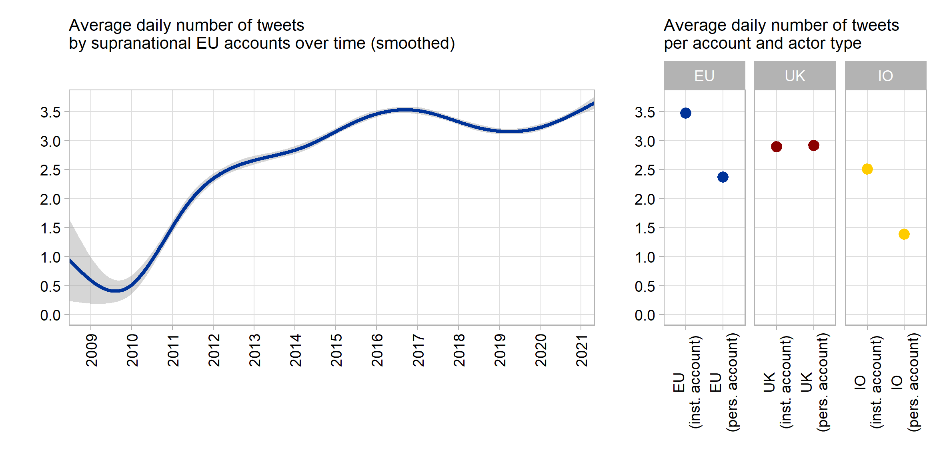

**Figure 1**: Number of tweets per day and account

The left panel initially indicates that supranational actors have markedly increased the number of messages they publish on Twitter. While there was only roughly one tweet every second day during the early phase of supranational Twitter presence this has increased almost by a factor of seven to 3 to 3.5 tweets per day more recently. The major increase in supranational Twitter messaging happened during 2010-2016, a phase of strongly surging public EU politicization amidst the Euro- and Schengen crises. It also coincides with a period in which the European Commission has reduced its output of traditional press releases notably (Rauh 2021b), possibly indicating a re-distribution of internal communication resources.

The right panel of Figure 1 furthermore highlights that this supranational tweet volume is by a large extent driven by institutional accounts, indicating a centralized and probably professionalized approach to supranational social media presence (XXX). Institutional EU accounts emit around 3.5 tweets per day, while supranational actors tweeting in personal capacity issue around one daily tweet less.

These highly aggregated averages hide significant variation within our population of supranational actors. Among the most avid tweeters are the Commission’s Directorate-General for Digital Policies (CONNECT, @DigitalEU) with 13.7 tweets per day, but also the official account of the whole EU Commission run by the spokespersons service (@EU_Commission) with 10.4 tweets a day. On the lower end of the distribution, we find the European Court of Justice (@EUCourtPress) with around one tweet every second day or, further down the line, the Euratom Supply Agency (@EuratomA) issuing a message only around very 10th day on average. Yet, this variation in the tweet volume across supranational EU actors (standard deviation is 2.58 tweets per day) is not systematically distinct from our UK benchmark sample (2.23 daily tweets) and markedly lower than in sample of tweets from international organizations (4 daily tweets).

In fact, the variation across our benchmark samples is more interesting, as the left panel of Figure 1 highlights: The volume of tweets from supranational accounts clearly exceeds the tweet volume of international organizations and actors, while it is at least on par when compared to national executives in the United Kingdom. Regarding volume, thus, we can clearly state that supranational actors try to exploit the communication potentials of this particular social medium.

*3.2. The language of supranational Twitter messages*

Is this increasing amount of supranational communication on Twitter understandable to the average European citizen? In this section we look at the language quality of the textual content of supranational tweets in comparative perspective.

This part of the analysis required extensive pre-processing of the tweets’ contents. In general, we aimed to isolate the textual content as good as possible to ensure reliable extraction of the language indicators below. To this end, we removed all non-textual symbols, media, and external links (separately analyzed in other sections below), treated hashtags as individual or multiple words (if camel cased), and ensured proper punctuation. The replication scripts provide full detail and Table 2 illustrates two random examples from the supranational EU corpus. All benchmark samples were processed alike.

| **Original tweet** | **Extracted text** |
| --- | --- |
| I fell asleep hoping to wake up from a bad dream.Europe is full of wonders that no one will bring us back. Preserving with #digitization is important for us & for future generations. Close to the Parisians. With #NotreDame we've lost a piece of our history https://t.co/hQRqMGSsq3 https://t.co/CPLs1DqEcl | I fell asleep hoping to wake up from a bad dream. Europe is full of wonders that no one will bring us back. Preserving with digitization is important for us & for future generations. Close to the Parisians. With Notre Dame we've lost a piece of our history. |
| 🤝 Sharing risk. 🌍 Maximising impact.  Today we’ve signed 4 new guarantee agreements under the EU External Investment Plan to create more 💡 opportunities for people in countries near the EU and in Africa.   Read more ➡https://t.co/YY3zPWSti4 📈 #InvestGlobal #EIP https://t.co/HvYWuoVEOC | Sharing risk. Maximising impact. Today we’ve signed 4 new guarantee agreements under the EU External Investment Plan to create more opportunities for people in countries near the EU and in Africa. Read more. Invest Global EIP. |

**Table 2:** Tweet text processing examples

English is clearly the lingua franca of supranational tweets (detected on sentence level with Google’s compact language detector 2 as implemented in the cld2 R package, Ooms and Sites 2020). In total 82% of all supranational tweets are solely written in English while 88.2% contained at least on English sentence. Other languages appear much less frequently: we detected French in about 4%, Italian and Polish in around 1.5%, as well as Italian, Swedish and German in around 1% of tweets. This seems to suggest that supranational actors do not respect linguistic diversity of the EU but that should also not be overstated. Virtually all Twitter end-user applications offer reliable auto-translation at the click of a button. More importantly, especially the European Commission retains representations in all member states, often with dedicated accounts that tweet in the country’s main languages but that are not part of our account selection here.

Here we focus on the English-language content of the tweets. We primarily want to learn whether the communication we observe is geared to nurture legitimacy and accountability of supranational politics. In this regard, very different literatures have repeatedly stressed that more political communication does not help if it does not clarify but rather obfuscates political responsibilities (Fairclough 2003; Fowler *et al.* 1979; Orwell 1946). Sending clear and easily understandable messages seems to be a particular challenge for detached, highly specialized institutions that often resort to a rather technocratic discourse (Moretti and Pestre 2015; Rauh 2021b; Thibault 1991). We thus extract three indicators for message clarity, primarily relying on the tools offered and validated by Benoit *et al.* (2019).

First, the Flesch reading ease score measures syntactic complexity of the message by a compound indicator of sentence and word length (Flesch 1948). The intuition is that higher grammatical complexity requires more cognitive effort to decipher a message, an ability that is attained primarily with progressing levels of formal education. The lower the reading ease score, the less citizens with average education levels can decipher a message. Prior research shows that reading ease is also positively associated with more engagement of social media users or journalists (Ferrara and Angino 2021; Firouzjaei and Özdemir 2020).

Second, we measure whether supranational actors use familiar vocabulary or rather specialized jargon. For each word in there tweets we capture how often it occurs in the overall Google books corpus, the broadest available representation of the general English language. The intuition is that words that are more common in the English language are better known and thus more readily understandable by a broad audience (as validated in Benoit *et al.* 2019).

Third and finally, linguists stress that texts express political agency better when they to a verbal as opposed to a nominal style (Biber *et al.* 1998: 65 pp. Thibault 1991). A nominal style – often a characteristic of academic prose – uses many nouns and nominalizations thus prioritizing abstract objects and process over action. A verbal style – often a characteristic of more conversational communication – uses many verbs, thereby clarifying who did what and also providing more information on the temporal order of events and processes. We thus capture the verb-to-noun ratio for every tweet. Figure 2 aggregates these indicators across our tweet samples.

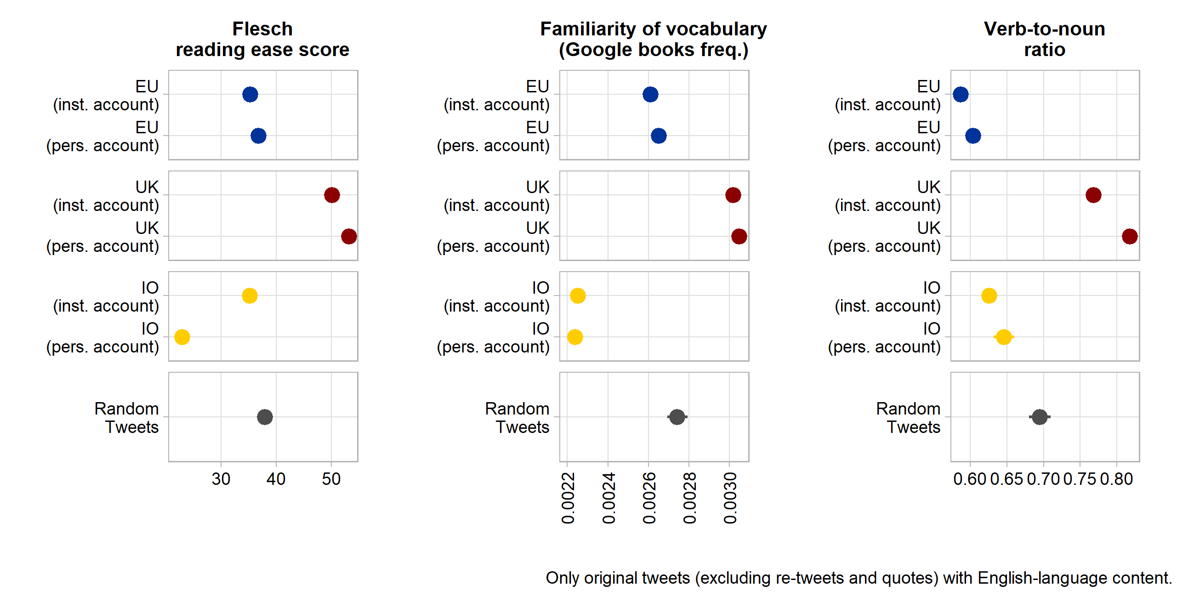

**Figure 2**: Language clarity indicators

These data show that supranational EU tweets tend to be somewhat clearer than those published by international organizations (with the notable exception of clarifying agency through a more verbal style). More importantly, however, supranational communication is clearly and significantly harder to understand citizens when compared to random messages on Twitter platform and especially when compared to the tweets of national institutions and executives from the UK. This reaffirms the impression of a very technocratic supranational communication approach that has also been shown for press releases of the European Commission (Rauh 2021b).

But also here, notable variation within the population of supranational accounts exists. Based on the standardized averages of the three language-clarity indicators, the messages by current Commission President Von der Leyen, Commissioners Timmermans and Vestager, as well as Matthew Baldwin (European Coordinator for Road Safety) are easiest to understand. The least accessible messages - on average - are sent by the European Maritime Safety Agency, by the Commission DG for Competition Policy (ironically headed by the clearly communicating Margrethe Vestager), Justice Commissioner Reynders, and the European Defence Agency. In general, the tweets from supranational actors tweeting in personal capacity are significantly easier to understand than tweets from institutional accounts.

*3.1. Media usage in supranational Twitter messages*

Beyond text, Twitter offers various multimedia features that users can exploit to attract attention and generate engagement with their messages. To what extent do supranational actors and institutions use this additional communication potential? Relying on the raw tweet texts as well as on the URL entities object available from the Twitter API, we aggregate data on multimedia usage in Figure 3.

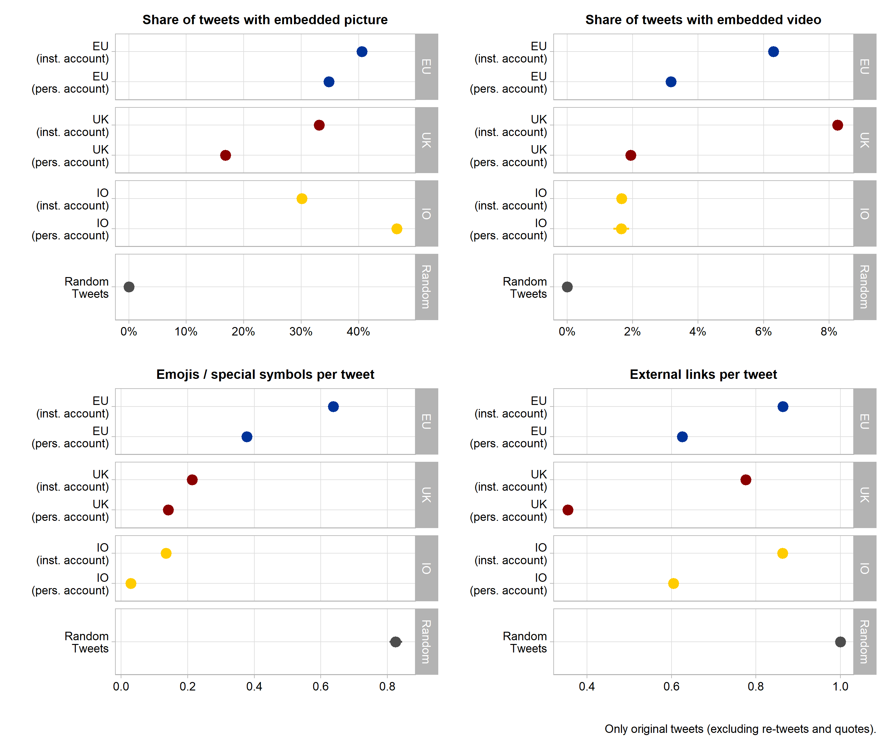

**Figure 3**: Multimedia usage

Twitter users can use pictures and graphic detail to highlight their messages in the timeline of other users. In the top left panel of Figure 3 we see that around 35 to 40% of all supranational tweets embed at least one picture. This clearly exceeds picture usage in our sample of tweets from domestic political actors as well as by institutional accounts of international organizations. Likewise, videos – we consider movie files uploaded directly to Twitter as well as embedded videos from major platforms such as YouTube, Vimeo, TikTok, and Twitch – occur frequently in supranational tweets – at least in relative terms. Institutional accounts of supranational actors feature a video in around 6% of all messages which is only surpassed by the around 8% of Tweets from domestic executive institutions in the UK. While we cannot exactly quantify this here, we note that many of these videos seem to be particularly produced for the purpose of communicating EU policies, again pointing to a professionalisation of supranational social media presence.

Furthermore, Twitter is notorious for having populated the use of special characters and especially emoticons in public communication. Including such pictograms into the tweet text – an example in Table 2 above - can encode large amounts of information and attracts visual attention, thus aiding message comprehension (Tang & Hew, 2018). The lower left panel of Figure 3 indicates that supranational EU tweeters are indeed champions of using such special symbols in their messages. Additional analyses show that the by far most used symbol is the EU flag, occurring more than 50.000 times and thus in about 5% of all supranational tweets. Flags of different individual countries occur in a combined total of about 7% of tweets. Beyond that, supranational actors like to use various pointing hand and arrow symbols, a pictogram of the globe as well as various version of checkmark symbols.

Finally, communicators can enrich their messages by supplying links to external online content. This initially facilitates further information seeking for the message recipients. In addition, external websites are directly summarized in thumbnails showing additional media from the external source along the tweet. Also with regard to this communication feature, tweets from supranational EU actors are on par or even exceed domestic and international political actors. In about 60 to 80% of all supranational message on Twitter an external online source is referred to.

Where these links lead citizens to cannot be fully ascertained by automated means as around 41% of them use URL shortening services. Yet, in the remainders we see that supranational actors primarily refer to EU websites in the europa.eu domain (35% of all external URLs), pointing message recipients especially to information from the European Commission’s servers. A sizeable share of around 5% of external links point to other social media platforms, notably Facebook, LinkedIn, and Instagram where supranational actors also seem to use services, that automatically post content across different social media accounts (the dlvr.it domain accounts for around 3% of all external links).

Based on these insights we can clearly state - both in absolute and in relative terms – that supranational public communication on Twitter goes beyond textual content, relying especially on visual information and own external online resources.

**4. Engaging and engaging with the Twitter discourse**

*4.1. Interactivity of supranational Twitter behaviour*

*4.2. User engagement with supranational messages*

**5. Discussion and conclusions**

**6. References**

1.1.1. This Is a Second Sub-Heading (Regular)