**Politics and Governance (ISSN: 2183-2463)  
Year, Volume, Issue, Pages X–X  
https://doi.org/10.17645/pag.vXiX.XXX**

Article

**A bird’s eye view: Supranational EU actors on Twitter.**

Sina F. Özdemir1,* and Christian Rauh2

1 Department of Sociology and Political Science, Norwegian University of Science and Technology Trondheim; E-Mail: [sina.ozdemir@ntnu.no](mailto:sina.ozdemir@ntnu.no)

2 Research Unit Global Governance, WZB Berlin Social Science Center, Germany; E-Mail: [christian.rauh@wzb.eu](mailto:christian.rauh@wzb.eu); Web: [www.christian-rauh.eu](http://www.christian-rauh.eu)

* Corresponding author

**Abstract**

Against the politicization of European integration, public communication of the European Union matters. Especially for usually rather detached supranational executives, social media platforms offer unique opportunities to communicate to and to engage European citizens. Yet, how do these actors actually use social media? This article provides a bird’s eye view and quantitatively describes more than one million tweets from 115 supranational EU accounts in the 2009-2021 period, benchmarking key message characteristics against large samples of tweets from national executives, international organizations, and random Twitter users. We show that supranational Twitter activity has grown markedly, relies strongly on the multimedia features of the platform, and also outperforms other political executives on many dimensions. However, we also find that supranational interaction with other Twitter users comparatively rare and somewhat concentrated, while the high complexity of the supranational messages’ textual content limits engagement of other users. We discuss these findings in the light of the legitimacy and public accountability challenges that supranational EU actors face.

**Keywords**

European Union; social media; political communication; politicization; text analysis; ...

© Year by the author(s); licensee Cogitatio (Lisbon, Portugal). This article is licensed under a Creative Commons Attribution 4.0 International License (CC BY).

**1. Introduction: Why we should care about supranational Twitter activity**

The European Union (EU) has an increasingly precarious relationship with the citizens it governs. The politicization of European integration in public debates has markedly increased in recent years. This indicates that the EU has a veritable popular legitimacy problem. Incidences such as the failure of constitutional referenda in 2005, the raging debates about supranational authority during the Euro- and Schengen crises after 2009 and 2015, the infamous Brexit decision of 2016, and more generally the rise of Eurosceptic mobilization in national and European election campaigns clearly illustrate that the EU can no longer rely on a permissive consensus among the wider citizenry (De Wilde and Zürn 2012; Hooghe and Marks 2009; Rauh 2021a). In such controversial debates, especially the EU’s rather detached supranational institutions are frequently addressed and become targets of blame-shifting (Gerhards *et al.* 2009).

Supranational actors, however, are not only at the receiving end of such controversial debates. In principle, they can try to defend themselves in public, trying to nurture popular legitimacy of the EU by giving account of how they exercise their political authority. Faced with public politicization, thus, also political institutions beyond the level of the nation state have discovered the need to invest in public communication (Ecker-Ehrhardt 2018; Ecker-Ehrhardt 2020).

Yet, supranational EU institutions face notable obstacles in effectively communicating with the wider European citizenry. Part of these obstacles are internal. Public communication is often subject to internal conflicts and competition over limited resources (Altides 2009; Bijsmans and Altides 2007; Hartlapp *et al.* 2014: ch. 9). In institutions with delegated powers that often involve high levels of expertise, consensus-orientation, and diplomatic restraint, public outreach has traditionally not been a primary concern (Brüggemann 2010; Meyer 1999). When facing controversial public debates, moreover, supranational institutions may have incentives to avoid clear communication in their strategic efforts to calm controversial debates (Biegoń 2013; Bressanelli *et al.* 2020; De Wilde and Zürn 2012; Schimmelfennig 2020). In effect, supranational communication efforts are thus often rather inaccessible to the wider public as they use highly-codified, complex technocratic language ladened with jargon (Rauh *et al.* 2019; Rauh 2021b).

Beyond internal constraints, supranational institutions face notable communication obstacles in their environment as well. While supranational institutions are tasked to defend the European interest in their policy areas, mass-mediated public spheres tend to be fractured along national borders, languages, and media systems (Koopmans and Statham 2010; Risse 2014; Trenz 2004; Walter 2015). National media are furthermore rather selective in covering EU affairs where traditional journalistic selection logics are often biased to national interests, as well as domestic executives and their challengers (De Vreese 2001; De Vreese *et al.* 2006; Trenz 2008). Along this line, media coverage of the EU is primarily driven by controversial and contested events such as summits of the heads of state and government, EP elections, and scandals on the European level (Boomgaarden *et al.* 2013). In the environment of traditional media systems, thus, supranational institutions have a hard time to get their message across.

Against these constraints, social media platforms should be a promising channel for supranational public communication. With a view to the external constraints that supranational institutions face, social media are attractive as they allow citizens to engage with content beyond national boundaries (Bossetta et al., 2017). Social media furthermore imbue users with a degree of gatekeeping power (Wallace, 2018). The decentralized structure of these platforms, where users themselves can choose which messages will be allowed and amplified in the information environment, gives supranational EU actors some freedom to determine which issues to inject and how to best generate engagement. This allows them to circumvent traditional media selection logics to some extent, to generate attention on their preferred topics (which might create additional incentives for journalistic coverage, XYZ), and to reach out to European citizens more directly.

With a view to the internal constraints, social media are attractive to supranational communication as well. The platforms usually reward clear and concise messaging. In addition, they offer multimedia features such as pictures, videos, or symbols that may also be beneficial for accessible and engaging communication. And importantly, social media offer comparatively cost-efficient communication tools. It takes mere minutes to set up an account and they are often very easy to maintain, thus also limiting internal gatekeeping. Lastly, social media provide a low-hurdle and continuous information source for the users. Unlike static webpages of web 2.0, social media do not require the user to consciously search for information about supranational activity in the EU. Users may encounter EU messages in their timelines or could simply follow social media accounts by one click if they deem them interesting.

Social media are hardly the panacea to all the public communication ailments of the EU, but these key features should make them an attractive additional communication channels for supranational institutions willing to defend themselves in a politicized climate. Yet, to what extent and how do supranational actors actually use this potential?

While extant research has generated insights into the grand social media strategies of European institutions (Asimina and others XXX), large-scale systematic evidence on the *actual behaviour of supranational actors on social media platforms* is rare (XXX). This article focusses on Twitter, a highly prominent international microblogging platform featuring lots of public and publicly visible political debate (XXX). We analyse more than one million public messages (tweets) issued by 115 supranational institutions and individual executives in the 2009-2021 period. This allows us to describe the volume, the language quality, and the multimedia usage of supranational messaging as well as the degree to which supranational actors engage and engage with other users on the platform. To put this supranational Twitter activity into perspective, we benchmark our indicators against large samples of tweets from national and international institutions and executives as well as random Twitter users.

This hitherto most encompassing description of supranational EU activity on of the key social media platforms initially shows a drastically increasing volume of supranational messaging. Both in terms of volume and multimedia usage, supranational actors outperform domestic and international actors. Yet, the text of supranational messages is comparatively less accessible which also limits the engagement of other users with these messages. XXX Sketch other findings here XXX. For the question of whether this form of public supranational communication is geared to nurturing popular legitimacy of the EU, we thus have mixed findings … XXX.

**2. Data collection: Supranational tweets and relevant benchmarks**

Our data collection starts with identifying the population of official supranational Twitter accounts, following two basic considerations. First, our interest is in supranational institutions in the narrow sense, i.e. the executive branches of the EU which control independent delegated powers. Institutions such as the European Commission or the ECB are often core addressees of public politicization and are equated with EU legitimacy more broadly in the minds of citizens (Silva *et al.* 2021). Second, we want to cover the EU polity as broadly as possible by reflecting all executive branches exercising political authority.

Accordingly, we identified the main Twitter accounts of the institutions falling under these definitions (e.g., @EU_Commission), their individual sub-branches (e.g., @EUHomeAffairs) and dedicated EU agencies (e.g., @Frontex), as well as the personal accounts of the individuals heading these institutions as Presidents (e.g., *@vonderleyen*), Commissioners (e.g., @TimmermansEU), Director-Generals (e.g., @lemaitre_eu), or agency heads (e.g., @stefanomanservi). We include only accounts that are officially verified by Twitter to be owned by the person or organization they claim to represent (as indicated by the blue check mark badge on the platform). This results *115* supranational Twitter accounts active in the beginning of 2021 (full list in Appendix XXX). For each of these accounts we then collected the full corpus of tweets the have issued between the date the respective account was created and May 3, 2021, through the Twitter API 2.0 academic track. In total, this approach gives us 1,065,203 individual supranational social media messages for analysis.

While this offers a thus far unprecedentedly broad empirical perspective supranational behavior on social media, we cannot meaningfully analyze the characteristics of these messages in isolation or some absolute sense. To see what the aggregate these messages tell us, we need to put them into perspective. Thus, we collected three additional benchmark datasets.

The first on simply is a by-and-large random sample of tweets which aims to establish what constitutes ‘normal’ behavior on the platform. To construct this benchmark, we streamed in tweets from 26 EU countries with repeated five-minute windows for a whole week through Twitter Decahose API. This generates 83,823 tweets that we can use as a baseline for typical characteristics of public messages on Twitter.

The theoretically more meaningful benchmarks, however, are geared to locate supranational social media communication within a broader population of actors holding executive political powers. After all, public politicization, legitimacy challenges, and the need for effective communication with citizens emerge from the EU’s nature as an unidentified political object, to use Delors’ famous description. On the one hand, the political authority of the EU approximates that of a executive in nation state on many accounts. On the other hand, the EU still carries significant markers of an international organization where member states delegate and control how the political authority is exercised. Two additional benchmark data sets thus focus on comparing supranational media communication to exactly these different levels of governance.

To approximate communication of national governments, we target executive political institutions and actors in the United Kingdom (UK). We identify the Twitter accounts of government ministries, executive offices, agencies and individuals who are in charge of these institutions (see appendix XXX for the full list of 168 accounts). Collecting the data analogously to the supranational EU actors above, this results in a benchmark of 1,510,064 tweets. To approximate the social media communication of international organizations, we first identified IOs that have a roughly similar policy scope as the EU, picking those organizations that are in the range of one standard deviation around the EU with regard to the number of policy areas covered as provided in the MIA data set (Hooghe *et al.* 2017). We identified their Twitter accounts along the list collected and kindly shared by Matthias Ecker-Erhardt (2020; full list in Appendix XXX). This results in 55 accounts for which we could analogously collect 294,219 individual tweets for our final benchmark. Table 1 summarizes our tweet samples.

|  |  |  |
| --- | --- | --- |
| **Actor type** | **Twitter  accounts** | **Tweets** |
| EU (inst. account) | 70 | 789,006 |
| EU (pers. account) | 45 | 276,197 |
| UK (inst. account) | 69 | 654,520 |
| UK (pers. account) | 99 | 855,544 |
| IO (inst. account) | 48 | 269,219 |
| IO (pers. account) | 7 | 25,000 |
| Random tweets | 37,849 | 83,823 |

**Table 1:** Tweet samples available for comparative analysis

**3. Key characteristics of supranational Twitter activity in comparative perspective**

*3.1. Volume of supranational Twitter messages*

The most basic answer to our overarching question on how supranational EU actors use the public communication potential of social media lies in the volume of messages they send. Figure 1 thus shows the average number of tweets per account and day.

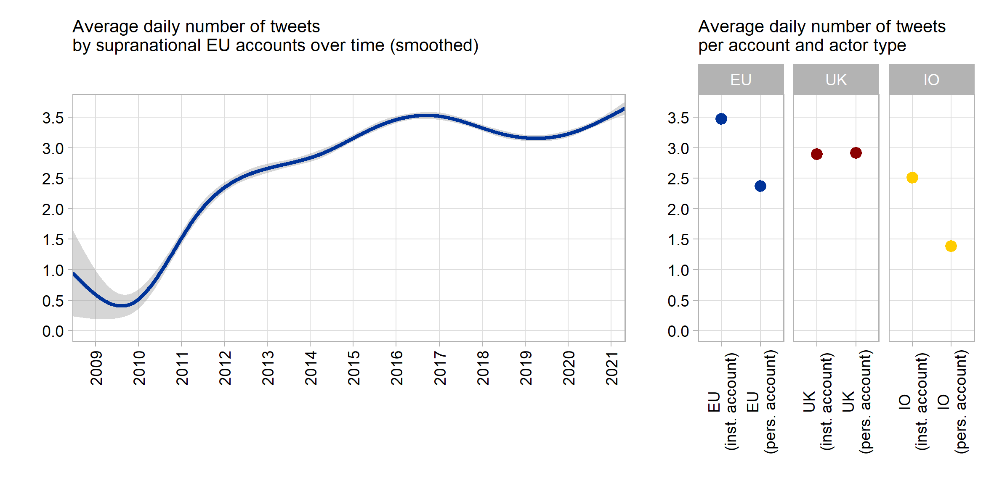

**Figure 1**: Number of tweets per day and account

The left panel initially indicates that supranational actors have markedly increased the number of messages they publish on Twitter. While there was only roughly one tweet every second day during the early phase of supranational Twitter presence this has increased almost by a factor of seven to 3 to 3.5 tweets per day more recently. The major increase in supranational Twitter messaging happened during 2010-2016, a phase of strongly surging public EU politicization amidst the Euro- and Schengen crises. It also coincides with a period in which the European Commission has reduced its output of traditional press releases notably (Rauh 2021b), possibly indicating a re-distribution of internal communication resources.

The right panel of Figure 1 furthermore highlights that this supranational tweet volume is by a large extent driven by institutional accounts, indicating a centralized and probably professionalized approach to supranational social media presence (XXX). Institutional EU accounts emit around 3.5 tweets per day, while supranational actors tweeting in personal capacity issue around one daily tweet less.

There is significant variation within our population of supranational actors. Among the most avid tweeters are the Commission’s Directorate-General for Digital Policies (@DigitalEU) with 13.7 tweets per day, or the official account of the whole EU Commission run by the spokespersons service (@EU_Commission) with 10.4 tweets a day. On the lower end of the distribution, we find the European Court of Justice (@EUCourtPress) with around one tweet every second day or, further down the line, the Euratom Supply Agency (@EuratomA) issuing a message only around very 10th day on average. Yet, this variation in the tweet volume across supranational EU actors (standard deviation: 2.58 tweets per day) is not systematically distinct from our UK benchmark sample (2.23 daily tweets) and markedly lower than in sample of tweets from international organizations (4 daily tweets).

In fact, the variation across our benchmark samples is more interesting, as the left panel of Figure 1 highlights: The volume of tweets from supranational accounts clearly exceeds the tweet volume of international organizations and actors, while it is at least on par when compared to national executives in the United Kingdom. Regarding volume, thus, we can clearly state that supranational actors try to exploit the communication potentials of this particular social medium.

*3.2. The language of supranational Twitter messages*

Is this increasing amount of supranational communication on Twitter understandable to the average European citizen? In this section we look at the language quality of the textual content of supranational tweets in comparative perspective.

This part of the analysis required extensive pre-processing of the tweets’ contents. In general, we aimed to isolate the textual content as good as possible to ensure reliable extraction of the language indicators discussed below. To this end, we removed all non-textual symbols, media, and external links (analysed separately below), treated hashtags as individual or multiple words (if camel cased), and ensured proper punctuation. The replication scripts provide full detail and Table 2 illustrates two random examples from the supranational EU corpus. All benchmark samples were processed alike.

| **Original tweet** | **Extracted text** |
| --- | --- |
| I fell asleep hoping to wake up from a bad dream.Europe is full of wonders that no one will bring us back. Preserving with #digitization is important for us & for future generations. Close to the Parisians. With #NotreDame we've lost a piece of our history https://t.co/hQRqMGSsq3 https://t.co/CPLs1DqEcl | I fell asleep hoping to wake up from a bad dream. Europe is full of wonders that no one will bring us back. Preserving with digitization is important for us & for future generations. Close to the Parisians. With Notre Dame we've lost a piece of our history. |
| 🤝 Sharing risk. 🌍 Maximising impact.  Today we’ve signed 4 new guarantee agreements under the EU External Investment Plan to create more 💡 opportunities for people in countries near the EU and in Africa.   Read more ➡https://t.co/YY3zPWSti4 📈 #InvestGlobal #EIP https://t.co/HvYWuoVEOC | Sharing risk. Maximising impact. Today we’ve signed 4 new guarantee agreements under the EU External Investment Plan to create more opportunities for people in countries near the EU and in Africa. Read more. Invest Global EIP. |

**Table 2:** Tweet text processing examples

English is clearly the lingua franca of supranational tweets (detected on sentence level with Google’s compact language detector 2 as implemented in the cld2 R package, Ooms and Sites 2020). In total 82% of all supranational tweets are solely written in English while 88.2% contained at least on English sentence. Other languages appear much less frequently: we detected French in about 4%, Italian and Polish in around 1.5%, as well as Italian, Swedish and German in around 1% of tweets. This seems to suggest that supranational actors do not respect the EU’s linguistic diversity but that should not be overstated. Virtually all Twitter end-user applications offer reliable auto-translation at the click of a button. More importantly, especially the European Commission retains representations in all member states, often with dedicated accounts that tweet in the country’s main languages but that are not part of our account selection here.

Here we focus on the English-language content of the tweets. We primarily want to learn whether the communication we observe is geared to nurture legitimacy and accountability of supranational politics. In this regard, very different literatures have repeatedly stressed that more political communication does not help if it does not clarify but rather obfuscates political responsibilities (Fairclough 2003; Fowler *et al.* 1979; Orwell 1946). Sending clear and easily understandable messages seems to be a particular challenge for detached, highly specialized institutions that often resort to a rather technocratic discourse (Moretti and Pestre 2015; Rauh 2021b; Thibault 1991). We thus extract three indicators for message clarity, primarily relying on the tools offered and validated by Benoit *et al.* (2019).

First, the Flesch reading ease score measures syntactic complexity of the message by a compound indicator of sentence and word length (Flesch 1948). The intuition is that higher grammatical complexity requires more cognitive effort to decipher a message, an ability that is attained primarily with progressing levels of formal education. The lower the reading ease score, the less citizens with average education levels can decipher a message. Prior research shows that reading ease is also positively associated with more engagement of social media users or journalists (Ferrara and Angino 2021; Firouzjaei and Özdemir 2020).

Second, we measure whether supranational actors use familiar vocabulary or rather specialized jargon. For each word in the tweets we capture how often it occurs in the overall Google books corpus, the broadest available representation of the general English language. The intuition is that words that are more common in the English language are better known and thus more readily understandable by a broad audience (as validated in Benoit *et al.* 2019).

Third and finally, linguists stress that texts express political agency better when they resort to a verbal as opposed to a nominal style (Biber *et al.* 1998: 65 pp. Thibault 1991). A nominal style – often a characteristic of academic prose – uses many nouns and nominalizations thus prioritizing abstract objects and process over action. A verbal style – often a characteristic of conversational communication – uses many verbs, thereby clarifying who did what, also providing more information on the temporal order of events and processes. We thus capture the verb-to-noun ratio for every tweet. Figure 2 aggregates these indicators across our tweet samples.

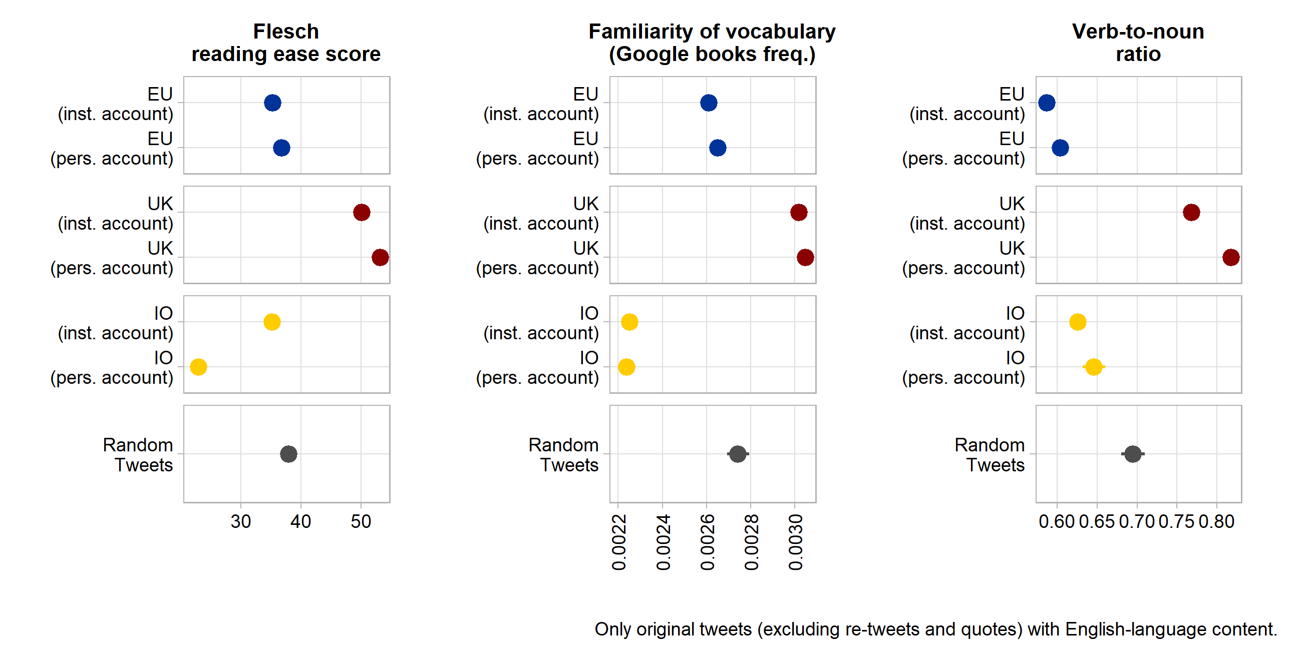

**Figure 2**: Language clarity indicators

These data show that supranational EU tweets tend to be somewhat clearer than those published by international organizations (with the notable exception of clarifying agency through a more verbal style). More importantly, however, supranational communication is clearly and significantly harder to understand citizens when compared to random messages on the Twitter platform and especially when compared to the tweets of national institutions and executives from the UK. This reaffirms the impression of a very technocratic supranational communication approach that has also been shown for press releases of the European Commission (Rauh 2021b).

But also here, notable variation within the population of supranational accounts exists. Based on the standardized averages of the three language-clarity indicators, the messages by current Commission President Von der Leyen, Commissioners Timmermans and Vestager, as well as Matthew Baldwin (European Coordinator for Road Safety) are easiest to understand. The least accessible messages - on average - are sent by the European Maritime Safety Agency, by the Commission DG for Competition Policy (ironically headed by the clearly communicating Margrethe Vestager), Justice Commissioner Reynders, and the European Defence Agency. In general, the tweets from supranational actors tweeting in personal capacity are significantly easier to understand than tweets from institutional accounts.

*3.1. Media usage in supranational Twitter messages*

Beyond text, Twitter offers various multimedia features meant to attract attention and generate engagement with messages. To what extent do supranational actors and institutions use this additional communication potential? Relying on the raw tweet texts as well as on the URL entities object available from the Twitter API, we aggregate data on multimedia usage in Figure 3.

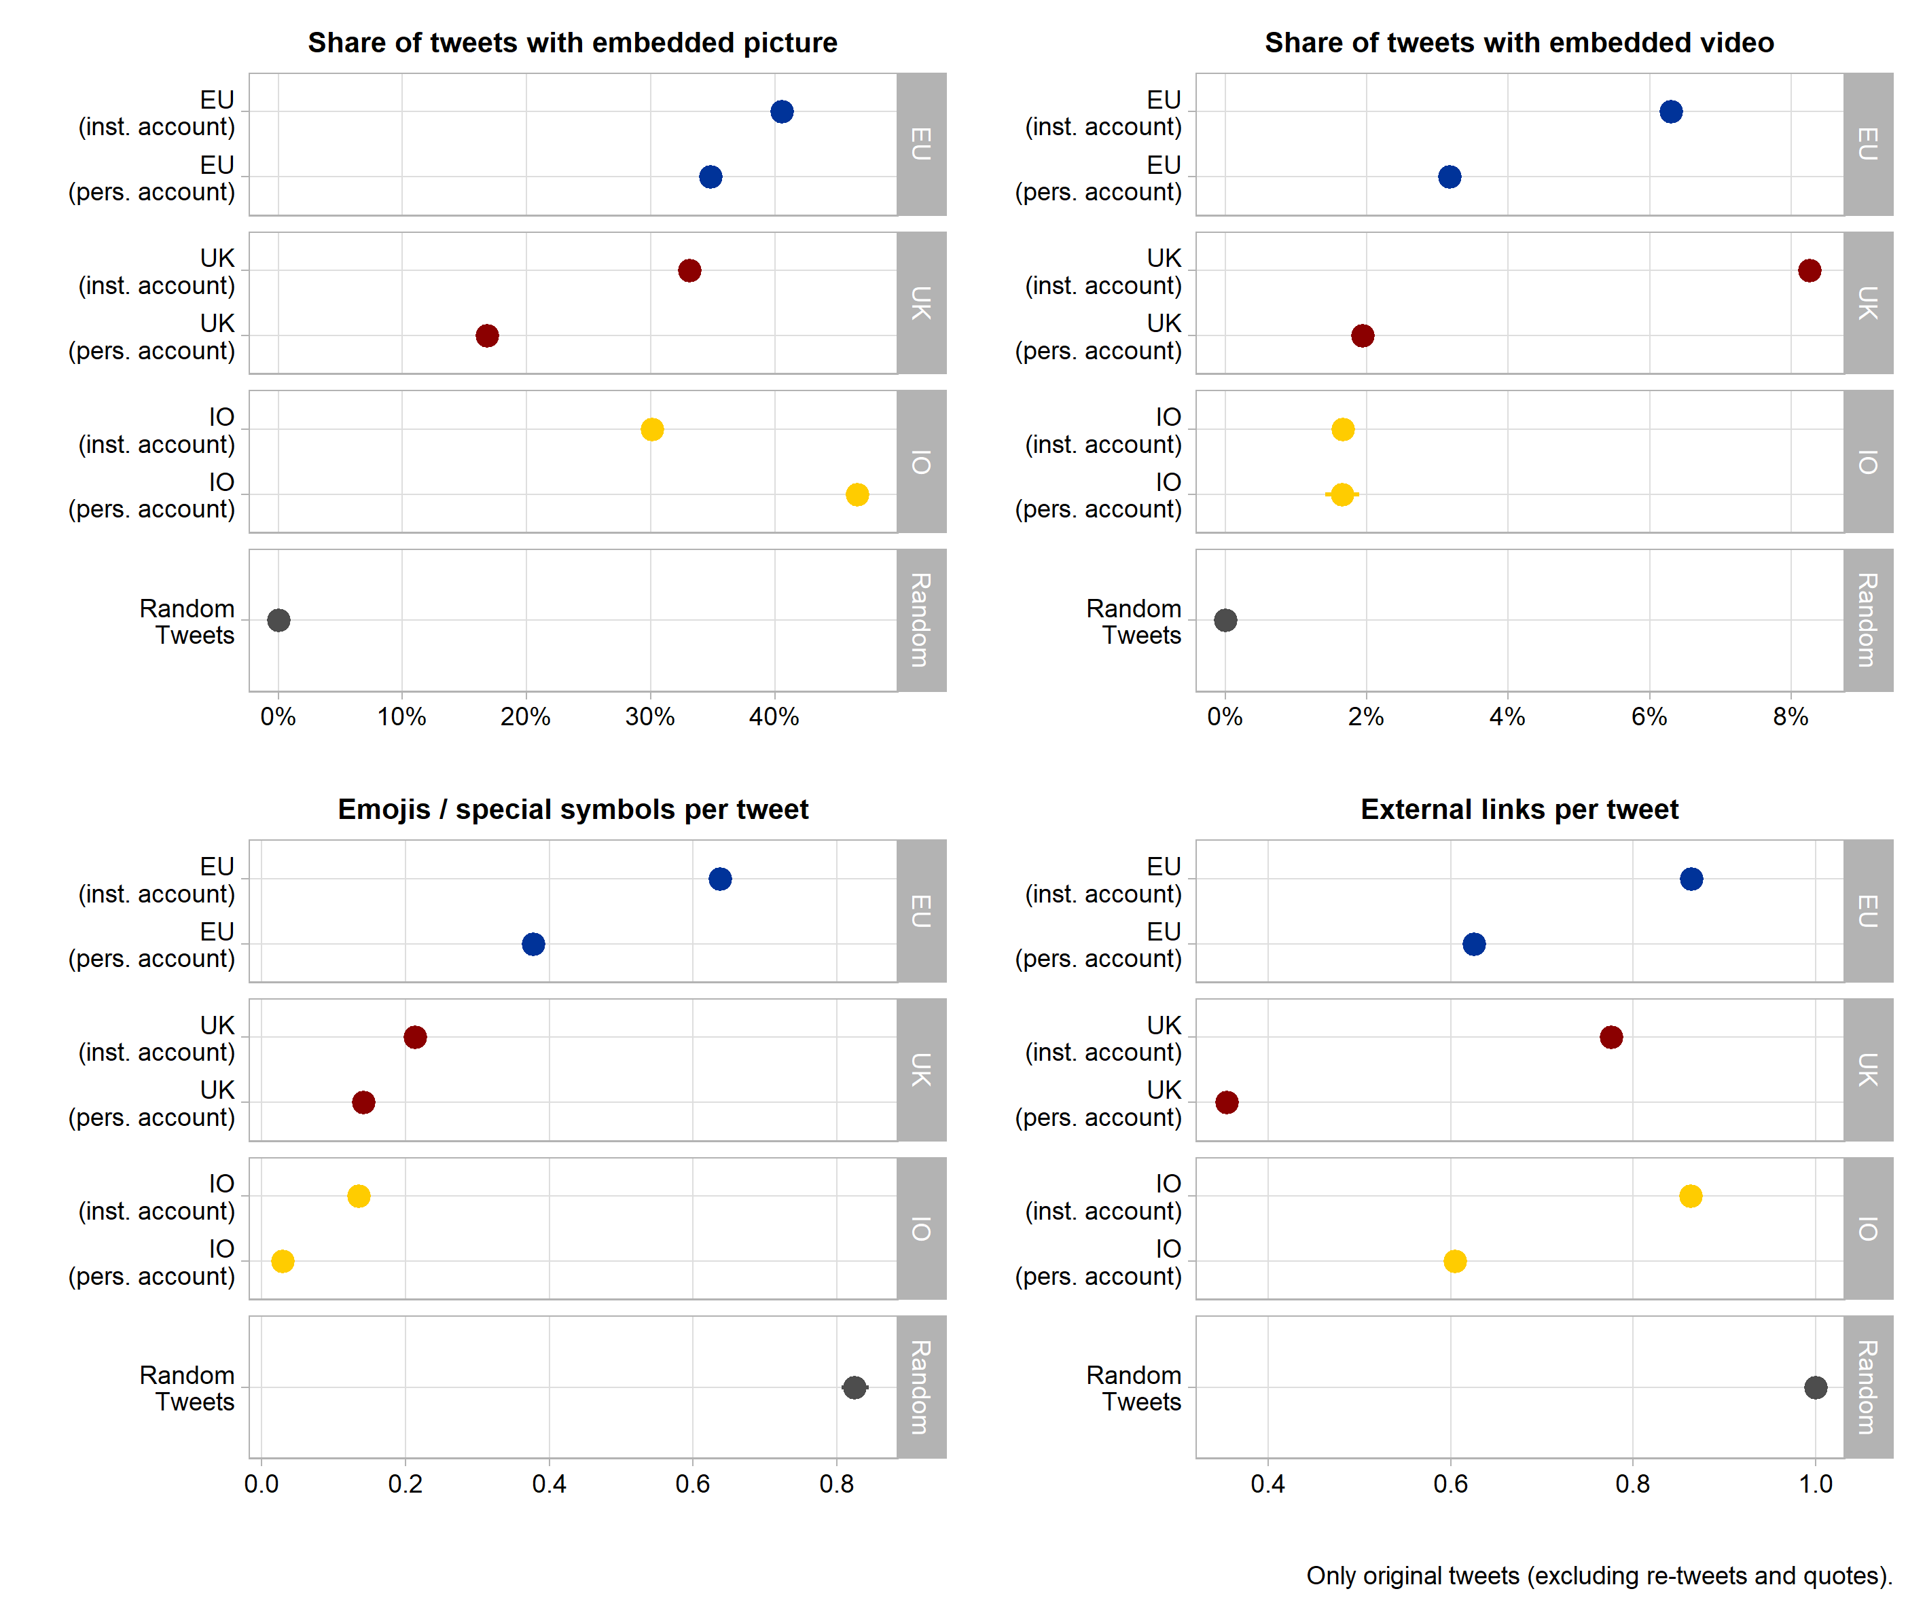

**Figure 3**: Multimedia usage

Pictures and visual detail highlight messages in the timeline of Twitter users. The top left panel of Figure 3 shows that around 35 to 40% of all supranational tweets embed at least one picture. This clearly exceeds picture usage in the tweets by domestic political actors as well as by institutional accounts of international organizations. Likewise, videos – we consider movie files uploaded directly to Twitter as well as embedded videos from major platforms such as YouTube, Vimeo, TikTok, and Twitch – occur frequently in supranational tweets – at least in relative terms. Institutional accounts of supranational actors feature a video in around 6% of all messages which is only surpassed by the around 8% of Tweets from domestic executive institutions in the UK. While we cannot exactly quantify this here, we note that many of these videos seem to be particularly produced for the purpose of communicating EU policies, again pointing to a professionalisation of supranational social media presence.

Furthermore, Twitter is notorious for having populated the use of special characters and especially emoticons in public communication. Including such pictograms into the tweet text – an example in Table 2 above - can encode large amounts of information and attracts visual attention, thus aiding message comprehension (Tang & Hew, 2018). The lower left panel of Figure 3 indicates that supranational EU tweeters are indeed champions of using such special symbols in their messages. Additional analyses show that the by far most used symbol is the EU flag, occurring more than 50.000 times and thus in about 5% of all supranational tweets. Flags of different individual countries occur in a combined total of about 7% of tweets. Beyond that, supranational actors like to use various pointing hand and arrow symbols, a pictogram of the globe, as well as various version of checkmark symbols.

Finally, communicators can enrich their messages by supplying links to external online content. This initially facilitates further information seeking for message recipients. In addition, most Twitter applications directly summarise external websites in thumbnails, showing additional media from the external source along the tweet. Also with regard to this communication feature, tweets from supranational EU actors are on par or even exceed messages from domestic and international political actors. In about 60 to 80% of all supranational Twitter messages an external online source is referred to.

Where these links lead citizens to cannot be fully ascertained by automated means as around 41% of them use URL shortening services. Yet, in the remainders we see that supranational actors primarily refer to EU websites within the europa.eu domain (35% of all external URLs), pointing message recipients especially to information from the European Commission’s servers. A sizeable share of around 5% of external links point to other social media platforms, notably Facebook, LinkedIn, and Instagram. Supranational actors also seem to use services that automatically post content across different social media accounts (the dlvr.it domain accounts for around 3% of all external links).

Based on these insights we can clearly state that supranational public communication on Twitter goes beyond textual content, relying especially on visual information and own external online resources.

**4. Supranational engagement with the Twitter discourse**

**5. User engagement with supranational messages**

A crucial question for supranational public communication on social media is whether (citizen) users engage with the messages. A necessary condition for engagement is that users see the messages in the first place. Reliable information on this is not easy to obtain, however. The research track API does not include the number of ‘impressions’ per tweet which is also only available for the last 60 days in commercial access options XXX. In addition, the algorithms by which Twitter decides which messages to show to which users with what prominence are not public knowledge.

What we know is that messages are shown at least in the timelines of users that have subscribed to follow a supranational account. Yet, historical follower count data are also not available through the Twitter APIs – only the numbers for the access day can be retrieved. Thus, we came up with a hack exploiting the Internet Archive, a non-profit organisation working for free access to online information. Their archive.org engine crawls the world wide web and takes static, timestamped snapshots of individual sites. We set up automated scripts (available at <https://github.com/ChRauh/PastTwitter>) that extract all available snapshots for each Twitter account in our samples to then scrape the follower counts from the raw html of the snapshots.

One caveat applies: the availability of archive.org snapshots is rather unequally distributed. Within our sample of 115 supranational EU accounts, we can, for example, extract 842 snapshots of the @EU_Commission profile, 548 for @EUClimateAction, or 380 for @vonderleyen. But there are five accounts with only one snapshot and seven that have never been crawled by archive.org. We linearly interpolate the daily number of followers between each measurement point, taking only the account creation date and the scraping date for accounts without snapshots. This is not very precise, but the best possible information on historical follower counts that we can think of. Figure 4 shows how many users followed supranational Twitter profiles over time.

The period of growing supranational tweet volume between 2010 and 2015 seen above was apparently followed by a period in which an increasing number of Twitter users also decided to subscribe to these accounts. But the figure also highlights that the distribution of followers across supranational accounts is extremely right skewed which has intensified over time. The by far most prominent supranational account is @EU_Commission with 1,491,799 followers as of May 3, 2021, followed by the institutional accounts of the European Council President (1,194,690 followers) and the European Central Bank (627,277). Among the most prominent personal accounts are Commission president Von der Leyen (587,814 followers), Competition Commissioner Vestager (295,615), and the High Representative for Foreign Affairs and Security Policy, Josep Borell (201,857). Personal accounts have on average 13,000 followers less than institutional accounts, but this difference is not statistically significant, indicating sizeable within-group variation. At the lower end of the distribution, we find several of Commission Directors-General as well as the Euratom Supply Agency with only 77 followers.

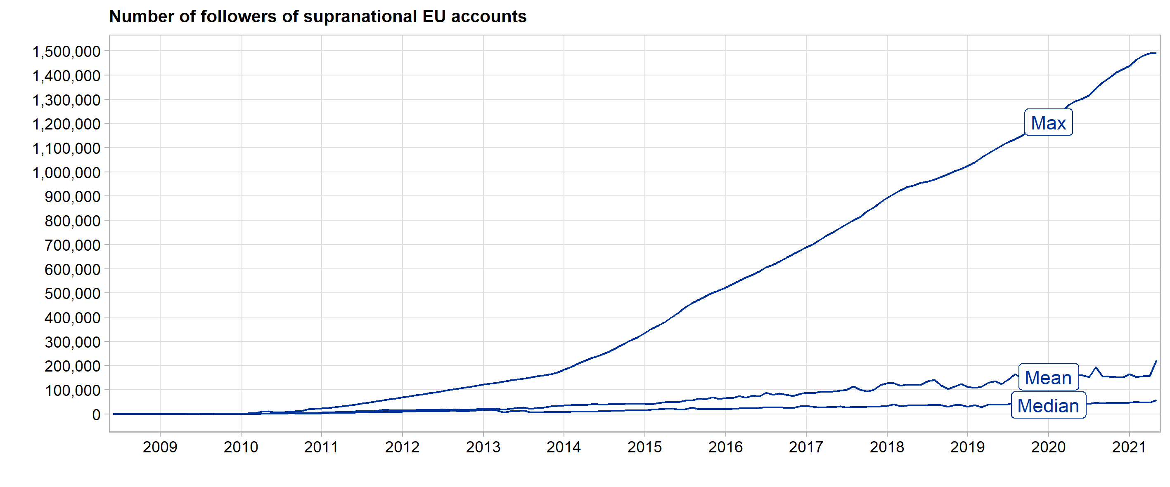

**Figure 4**: Followers of supranational Twitter accounts

But do these users actually engage with the supranational messages? Like in preceding section XXX we focus on likes, retweets, quotes and replies – this time in response to the original, self-authored tweets that supranational actors have published. Since the number of users that may have seen the tweet in the first place arguably affects the number of possible engagements, we express the counts as the share of followers an the point in time an account has issued the message. Given the imprecision in follower counts, we reduce our sample to accounts that have at least two archive.org snapshots, taking only tweets at or after the first of those snapshots into account. Figure 5 plots these engagement ratios against our equally treated benchmark samples.

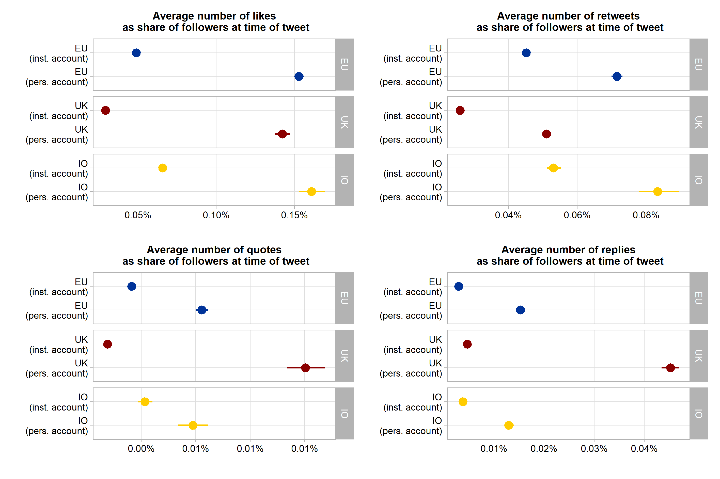

**Figure 5**: User engagement indicators

These data provide three main insights. First, supranational messages receive by and large as much direct Twitter user engagement as messages from national or international accounts by executive actors and institutions do. Supranational messages are in fact slightly more frequently liked and retweeted than those from national institutions and actors in the UK. Only UK actors tweeting in personal capacity received a markedly higher share of quotes and replies on their messages. Second, across all samples, Twitter users tend to engage more strongly with personal accounts than with institutional ones. Personalization of political messaging seems to matter on this social medium and for supranational EU actors as well. Third, direct engagement with executive tweets is not particularly high in absolute terms. On average, the number of direct engagements with supranational tweets by either liking, retweeting, quoting, or replying to it does not exceed a share of 0.14% of the number of users following the respective account.

There are a few notable exceptions to this latter rule, however. For example, in 18 tweets from our supranational sample, the overall number of direct user engagements exceeds 30% of the follower counts at the time of the message. Table 3 provides six illustrative examples for extremely ‘engaging’ supranational tweets in our sample.

| **Tweet** | **Account** | **Date** | **Followers** | **All direct engagements** |
| --- | --- | --- | --- | --- |
| Meet Mismo 🐶, a customs sniffer dog, who will tell you all about his job. #50CU #DogsWithJobs More info about the 50th anniversary of the EU #CustomsUnion: https://t.co/tD9clkog5q https://t.co/5MXpNH3Fqy | *EU_Taxud* | 2018-06-15 | 11,197 | 9,916 |
| EU values and fundamental rights must be respected by Member States and state authorities. This is why 6 town twinning applications invilving Polish authorities that adopted 'LGBTI free zones' or 'family rights' resolutions were rejected. #LGBTI #UnionOfEquality | *helenadalli* | 2020-07-28 | 9,756 | 8,036 |
| look at THIS !! The WHOLE core centre of brussels to go to 20kph for the summer from 1 May with priority to giving space to🚶‍♀️🚲 to exercise. Using the challenges of #CoronaVirus to rethink and transform mobility ... right here in Brussels... 👍👏🙏 https://t.co/RgmJNBgx89 | *Baldwin Matthew_* | 2020-04-20 | 6,102 | 4,314 |
| Wait, wait. Why is that fishing trawler towing an empty wooden boat at high seas??? https://t.co/psy2z6z9Wp | *Frontex* | 2019-06-22 | 23,214 | 11,861 |
| Today, EMA staff lowered the 28 EU flags and symbolically said goodbye to their London offices. Guido Rasi expressed his thanks to the UK for its contribution to the work of the Agency and for having been a gracious host of EMA since 1995. https://t.co/KpsBvaXt42 | *EMA_News* | 2019-01-25 | 39,251 | 18,853 |
| #ECJ: UK is free to unilaterally revoke the notification of its intention to withdraw from the EU – Case C-621/18 Wightman #Brexit https://t.co/KUOI2eQ48C | *EUCourtPress* | 2018-12-10 | 45,522 | 18,736 |

**Table 3:** Supranational tweet examples with extraordinary engagement rates

Caution is warranted when generalising from such few and outlying examples, but we note that the most engaging tweets in our sample also seem to invoke highly politicized EU policy issues. Examples are Commissioner Dalli’s stance on LGBTI rights in Poland, the Frontex tweet embedding surveillance footage from the Mediterranean Sea (leading to a heated Twitter debate about whether priority should be given to sea rescue or the fight against human trafficking), the ECJ’s announcement that the UK may revoke its withdrawal request, and the farewell note from the European Medicines Agency when finally leaving London due to Brexit. We also see that these highly engaging outliers make extensive use of some of the abstract communication characteristics we have discussed thus far, for example, clear and concise language, hashtags and emojis, as well as embedded media and external links.

We thus also take a somewhat more systematic multivariate perspective on how these abstract message characteristics are linked to direct user engagement on the platform Figure XXX thus shows the standardized coefficients of message characteristics form a linear regression model of the overall engagement ratio covering all EU, UK and IO tweets for which we have English language content and reliable information on follower counts as discussed above (341,777, 568,510, and 60,035 observations, respectively).

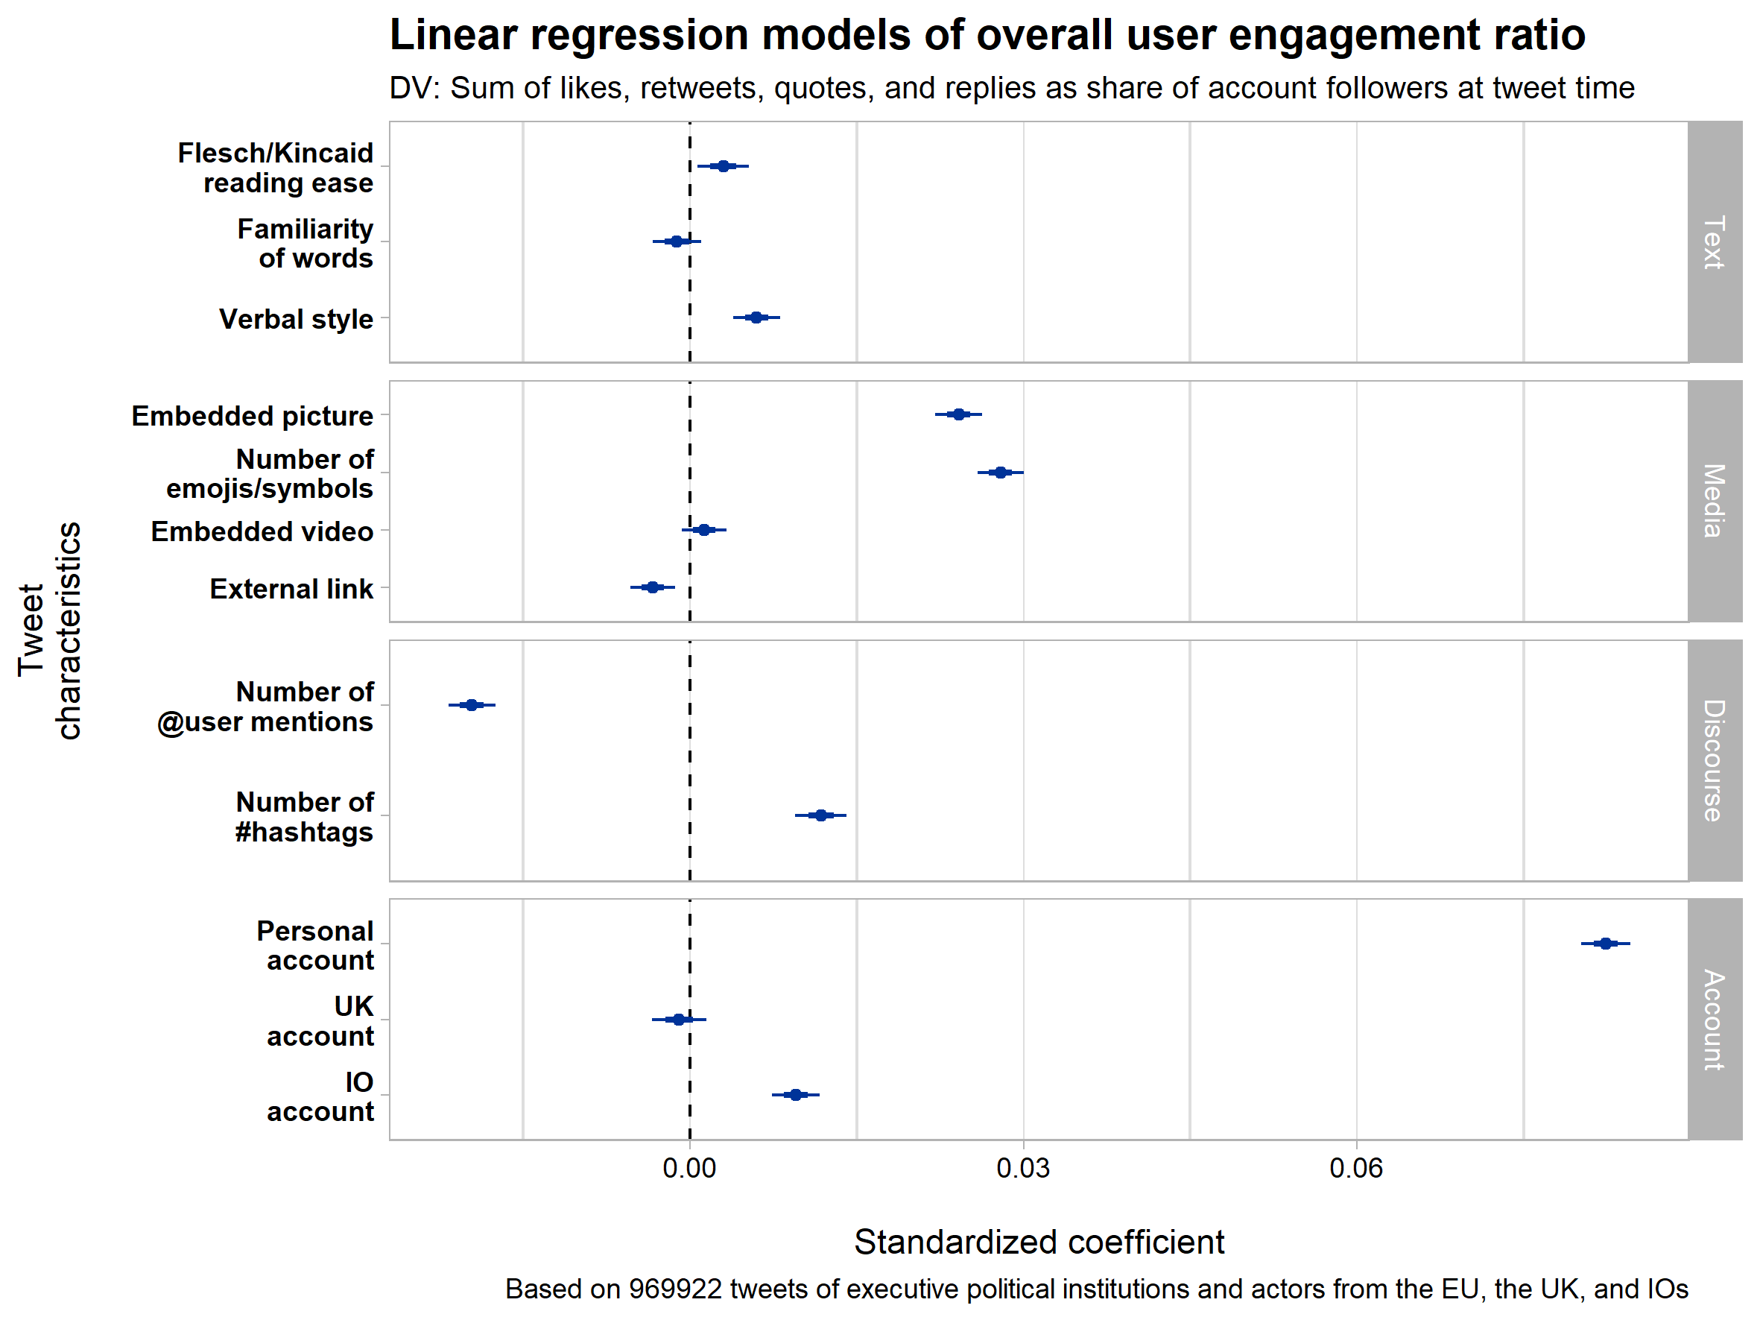

To be very clear, this should not be mistaken for a fully adequate causal model of user engagement on Twitter. Three caveats apply in particular. First, we do not have sufficient knowledge on how many users actually saw each tweet. While our dependent variable controls for immediate follower counts, the Twitter algorithms most likely make a tweet also visible to other users if the tweet creates engagement (for example by showing the message also to followers of followers who have engaged with a supranational message in the first place). Second, our qualitative examples above suggest that the topic of a tweet might account for how strongly users engage with the content. We cannot model these often context dependent message characteristics here. Third, our initial analysis lumps the different forms of direct engagement on Twitter together. While like, retweet, quote and replay ratios are positively correlated they demand different degrees of user involvement and may be thus driven by separate dynamics.

It is thus not surprising model fit and residual analysis XXX

Yet and still, this multivariate perspective gives some valuable hints on the relative importance of message characteristics and on whether and where supranational EU accounts set themselves apart. We initially see that the understandability of a tweet’s textual context is positively associated with user engagement, at least regarding verbal style and reading ease of the message. The standardized effect of the Flesch reading ease score, e.g., suggests that a 30-point change (roughly capturing the difference between high-school and college-level texts) is associated with a 1.4 percentage point increase in overall user engagement. Given an average user engagement ratio of .15% in the overall sample, this is already quite sizeable. In this light, the comparatively low levels of understandability of the text in the supranational tweets we have seen above are arguably a comparative disadvantage.

This is dwarfed, however, by the association between visual information and user engagement that our initial multivariate perspective suggested. In the sample of almost one million tweets, embedding a picture into a tweet from political actors comes with an average increase in the user engagement ratio of 2.5 percentage points. Each additional emoji or special symbol is associated with an engagement ratio that is .8 percentage points higher. Recall, that supranational EU actors favour these forms of visual communication as we have seen above. For videos, however, we find no robust association while the inclusion of other external links comes with lower user engagement on average.

The third panel looks at the discursive features tweets from executive political actors employ. When such tweets directly address specific users, the engagement by other users is usually around one percentage point lower. Hashtags, another message feature that supranational actors like to use, in contrast, seem to be associated with more user engagement: each additional one comes with an engagement rate that is around one percentage point higher than the mean.

The largest association

**6. Discussion and conclusions**

**7. References**

1.1.1. This Is a Second Sub-Heading (Regular)