**Politics and Governance (ISSN: 2183-2463)  
Year, Volume, Issue, Pages X–X  
https://doi.org/10.17645/pag.vXiX.XXX**

Article

**A bird’s eye view: Supranational EU actors on Twitter.**

Sina F. Özdemir1,* and Christian Rauh2

1 Department of Sociology and Political Science, Norwegian University of Science and Technology Trondheim; E-Mail: [sina.ozdemir@ntnu.no](mailto:sina.ozdemir@ntnu.no)

2 Research Unit Global Governance, WZB Berlin Social Science Center, Germany; E-Mail: [christian.rauh@wzb.eu](mailto:christian.rauh@wzb.eu); Web: [www.christian-rauh.eu](http://www.christian-rauh.eu)

* Corresponding author

**Abstract**

Against the politicization of European integration, public communication of the European Union matters. Especially for usually rather detached supranational executives, social media platforms offer unique opportunities to communicate to and to engage European citizens. Yet, how do these actors actually use social media? This article provides a bird’s eye view and quantitatively describes more than one million tweets from 115 supranational EU accounts in the 2009-2021 period, benchmarking key message characteristics against large samples of tweets from national executives, international organizations, and random Twitter users. We show that supranational Twitter activity has grown markedly, relies strongly on the multimedia features of the platform, and outperforms communication from other political executives on many dimensions. However, we also find a high textual complexity of supranational messages, skewed user engagement metrics, and high levels of variation across actors and messages. We discuss these findings in the light of the legitimacy and public accountability challenges that supranational EU actors face and derive four promising areas of future research on supranational social media messages.

**Keywords**

European Union; social media; political communication; politicization; text analysis; ...

© Year by the author(s); licensee Cogitatio (Lisbon, Portugal). This article is licensed under a Creative Commons Attribution 4.0 International License (CC BY).

**1. Introduction: Why we should care about supranational Twitter activity**

The European Union (EU) has an increasingly precarious relationship with the citizens it governs. The politicization of European integration in public debates has markedly increased in recent years. Incidences such as the failure of constitutional referenda in 2005, the raging debates about supranational authority during the Euro- and Schengen crises after 2009 and 2015, the infamous Brexit decision of 2016, and more generally the rise of Eurosceptic mobilization in national and European election campaigns clearly illustrate that the EU can no longer rely on a permissive consensus among the wider citizenry (De Wilde and Zürn 2012; Hooghe and Marks 2009; Rauh 2021a). In such controversial debates, especially the EU’s rather detached supranational institutions are frequently addressed, often as targets of blame-shifting (Gerhards *et al.* 2009; Harteveld *et al.* 2018).

Supranational actors, however, are not only at the receiving end of such controversial debates. In principle, they can try to defend themselves in public, possibly nurturing popular EU legitimacy by giving account of how and why they exercise their political authority. Faced with public politicization, also political institutions beyond the nation state have incentives to invest in public communication (Ecker-Ehrhardt 2018; Ecker-Ehrhardt 2020).

Yet, supranational EU institutions face notable obstacles in communicating with the wider European citizenry. Part of these obstacles are internal. Public communication is often subject to internal conflicts and competition over limited resources (Altides 2009; Bijsmans and Altides 2007; Hartlapp *et al.* 2014: ch. 9). In institutions with delegated powers that often involve high levels of expertise, consensus-orientation, and diplomatic restraint, public outreach has traditionally also not been a primary concern (Brüggemann 2010; Meyer 1999). When facing controversial public debates, moreover, supranational institutions may have incentives to avoid clear communication in their strategic efforts to calm controversial debates (Biegoń 2013; Bressanelli *et al.* 2020; De Wilde and Zürn 2012; Schimmelfennig 2020). In effect, supranational communication efforts are thus often rather inaccessible to the wider public (Rauh *et al.* 2020; Rauh 2021b).

Beyond internal constraints, supranational institutions also face notable communication obstacles in their environment. While supranational institutions are tasked to defend the European interest in their policy areas, mass-mediated public spheres tend to be fractured along national borders, languages, and media systems (Koopmans and Statham 2010; Risse 2014; Trenz 2004; Walter 2015). National media are furthermore rather selective in covering EU affairs where traditional journalistic selection logics are often biased to national interests, domestic executives, and their challengers (De Vreese 2001; De Vreese *et al.* 2006; Trenz 2008). Media coverage of the EU is primarily driven by controversial and contested events such as summits of the heads of state and government, EP elections, and scandals on the European level (Boomgaarden *et al.* 2013; Hobolt and Tilley 2014). In traditional media systems, thus, supranational institutions have a hard time to get their message across.

Against these constraints, social media platforms should be a promising communication channel for supranational actors. With a view to external constraints, social media allow citizens to engage with content beyond national boundaries (Bossetta et al., 2017). Social media furthermore imbue users with a degree of gatekeeping power (Wallace, 2018). The decentralized structure of these platforms, where users themselves can choose which messages will be allowed and amplified in the information environment, gives supranational EU actors some freedom to determine which issues to inject and how to best generate engagement. This allows them to partially circumvent traditional media selection logics, to generate attention on their preferred topics, and to reach out to European citizens more directly. Moreover, social media platforms, specifically Twitter, can act as a ‘double-barrelled gun’ for reaching out to the citizenry: recent research shows that tweets from political actors, especially highly engaging tweets, tend to be picked up by journalists to become incorporated in news articles (Cage *et al.* 2020; Oschatz *et al.* 2021), boosting their communication potential further.

With a view to internal constraints, social media are attractive to supranational communicators as well. The platforms usually reward clear and concise messaging. In addition, they offer multimedia features that are also beneficial for accessible and engaging communication. And importantly, social media offer comparatively cost-efficient communication. It takes mere minutes to set up an account and they are rather easy to maintain, thus partially mitigating the effect of internal competition over limited resources. Lastly, social media provide a low-hurdle and continuous information source for users. Unlike official webpages, social media do not require the user to consciously search for information about supranational activity in the EU. Users may encounter EU messages in their timelines from their connections on social media or they could simply follow respective accounts by a simple click.

To be sure, social media are hardly the panacea to all the public communication ailments of the EU. But their key features should make them an attractive additional communication channel for supranational institutions willing to defend themselves in a politicized climate. While there are many confounders in realizing the full potential of social media platforms for nurturing popular legitimacy, there are two cardinal duties that fall on the communicator: creating transparency and publicity (Curtin and Meijer 2006; Hüller 2007). Transparency means that public communication makes political decisions, processes, issues, and responsibilities visible to the wider audience. Via transparency, public communication provides the addresses of political authority with the necessary information to make an informed decision in democratic feed-back processes. Yet putting information about the workings of a political system out in the ether is not enough, the information also must be consumed by and engage the citizenry to become integrated in their knowledge system. In other words, communication needs to generate publicity. Publicity refers to the degree to which the audience engages with the issues, acts and processes of the political system. Extant research shows that the key precondition for transparency and publicity this is the understandability of the political messages (Bischof and Senninger 2018; Tolochko *et al.* 2019). Against this backdrop, we ask: to what extend and how doe supranational EU actors communicate on social media?

While insightful theoretical analyses and cases studies of the EU on social media exist (e.g. Barisione and Michailidou 2017; Krzyżanowski 2020; Zaiotti 2020), large-scale systematic evidence on the *actual social media behaviour of supranational actors* is rare. Extant studies focus on EU actors with direct electoral accountability, such as governmental representatives in the Council or EP members (European Parliament. Directorate General for Parliamentary Research Services. 2021; Fazekas *et al.* 2021; Haßler *et al.* 2021; Nulty *et al.* 2016; Umit 2017). This article, in contrast, studies the public communication of executive supranational institutions and the individuals heading them. We focus on Twitter, a leading social media platform that has become an integral part of political communication environment for mobilization and campaigning in the last decade (Jungherr 2016; Segesten and Bossetta 2017; Stier *et al.* 2018). We analyse the full population of public messages (tweets) issued by 115 supranational executive accounts in the 2009-2021 period. To put this supranational Twitter activity into perspective, we benchmark our respective indicators against random tweets as well as large samples of tweets from the UK executive branch and international institutions.

This hitherto most encompassing description of supranational EU activity on a key social medium shows a drastically increasing volume of supranational messaging which often outperforms domestic and international executive actors. While the text of supranational messages is comparatively hard to access for average citizens, supranational actors champion non-textual communication, enriching their messages with visual content, external links, and meta-linguistic elements such as emojis often much more than other executives do. The number of followers has been increasing strongly at least for some supranational EU actors while the rates of direct user engagement remain low in absolute terms, staying in the range observed for domestic and international actors. Against the backdrops of public politicization and communication deficits, supranational EU executives at least try to use the communication potential of social media while important shortcomings and fruitful avenues for further research remain.

**2. Data collection: Supranational tweets and relevant benchmarks**

Identifying the population of relevant supranational Twitter accounts follows two considerations. First, our interest is the executive branches of the EU which control independent delegated powers. Institutions such as the European Commission or the ECB are often core addressees of public politicization and are equated with EU legitimacy more broadly in the minds of citizens (Silva *et al.* 2021). Second, we want to cover the EU polity as broadly as possible by reflecting all executive branches exercising political authority.

Accordingly, we identified the main Twitter accounts of the institutions falling under these definitions (e.g., @EU_Commission), their individual sub-branches (e.g., @EUHomeAffairs) and dedicated EU agencies (e.g., @Frontex), as well as the personal accounts of the individuals heading these institutions such as Presidents (e.g., @vonderleyen), Commissioners (e.g., @TimmermansEU), or Director-Generals (e.g., @lemaitre_eu), for example. We include only accounts that are officially verified by Twitter to be owned by the person or organization they claim to represent (as indicated by the blue check mark badge on the platform). This results *115* supranational Twitter accounts active in the beginning of 2021 (full list in Appendix A1). For each of these accounts we collected the full corpus of tweets issued between the account creation date and May 3, 2021, through the Twitter API 2.0 academic track. This approach gives us 1,065,203 supranational social media messages for analysis.

While this offers a thus far unprecedentedly broad empirical perspective on supranational social media behaviour, we must put the characteristics of these messages into perspective. Thus, we collected three benchmark datasets. The first one simply is a by-and-large random sample of tweets which aims to establish what constitutes ‘normal’ behaviour on the platform. We streamed in tweets from 26 EU countries (excluding Malta) with repeated five-minute windows for a whole week through Twitter Decahose API. This generates 83,823 tweets that we can use as a baseline for typical characteristics of Twitter messages.

The theoretically more meaningful benchmarks are geared to locate supranational communication within a broader population of actors holding executive powers. After all, public politicization, legitimacy challenges, and the need for effective communication emerge from the EU’s nature as an unidentified political object, to use Delors’ famous description. On the one hand, the political authority of the EU approximates that of national executive branches on many accounts. On the other hand, the EU still carries significant markers of an international organization where member states delegate and control political authority. Two additional benchmark data sets thus focus on comparing supranational media communication to exactly these different levels of governance.

To approximate communication of national governments, we target executive political institutions and actors in the United Kingdom (UK). We identify the Twitter accounts of government ministries, executive offices, agencies and individuals who are in charge of these institutions (Appendix A2 for the full list). Collecting the data analogously results in a benchmark of 1,510,064 tweets. To approximate the social media communication of international organizations, we first identified IOs that have a similar policy scope as the EU, picking organizations that are in the range of one standard deviation around the EU with regard to the number of policy areas as provided in the MIA data set (Hooghe *et al.* 2017). We identified their Twitter accounts along the list collected and kindly shared by Matthias Ecker-Erhardt (2020; full list in Appendix A3). This results in 55 accounts for which we could analogously collect 294,219 tweets for our final benchmark. Table 1 summarizes our tweet populations.

|  |  |  |
| --- | --- | --- |
| **Actor type** | **Twitter  accounts** | **Tweets** |
| EU (inst. account) | 70 | 789,006 |
| EU (pers. account) | 45 | 276,197 |
| UK (inst. account) | 69 | 654,520 |
| UK (pers. account) | 99 | 855,544 |
| IO (inst. account) | 48 | 269,219 |
| IO (pers. account) | 7 | 25,000 |
| Random tweets | 37,849 | 83,823 |

**Table 1:** Tweet samples available for comparative analysis

**3. Key characteristics of supranational Twitter messages**

*3.1. Volume*

The most basic answer to our overarching question on how supranational EU actors use the public communication potential of social media lies in the volume of their messages. Figure 1 shows the average number of tweets per account and day.

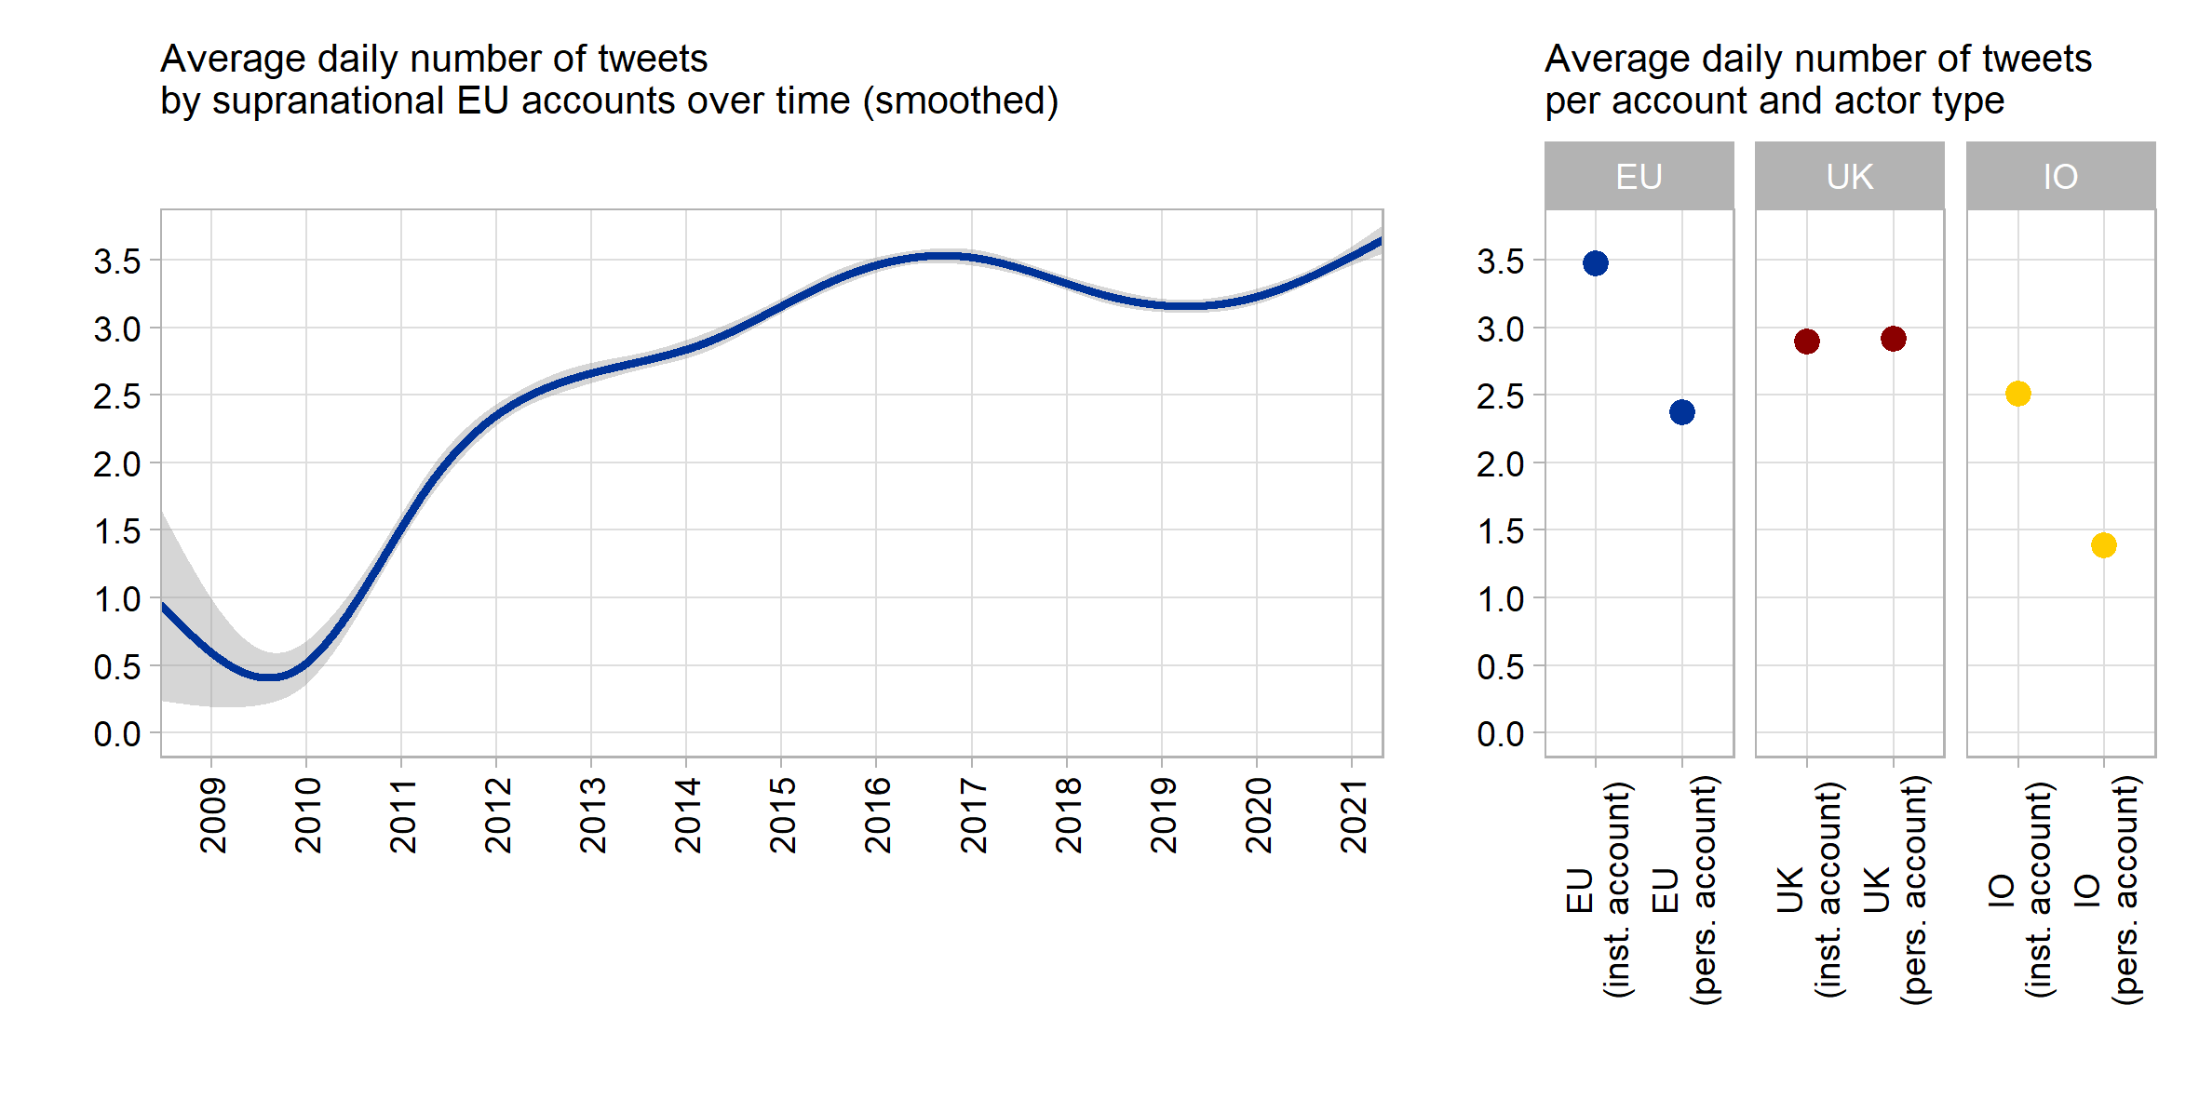

**Figure 1**: Number of tweets per day and account

The left panel initially indicates that supranational actors have markedly increased the number of messages they publish on Twitter. While there was only roughly one tweet every second day during the early phase of supranational Twitter presence, this has increased almost by a factor of seven to 3 to 3.5 daily tweets more recently. The major increase in supranational Twitter messaging happened during 2010-2016, a phase of strongly surging public EU politicization amidst the Euro- and Schengen crises. It also coincides with a period in which the European Commission reduced its output of traditional press releases notably (Rauh 2021b), possibly indicating a re-distribution of internal communication resources.

The right panel of Figure 1 furthermore highlights that this supranational tweet volume is to a large extent driven by institutional accounts, indicating a centralized and probably professionalized approach to supranational social media presence. Institutional EU accounts emit around 3.5 tweets per day, while supranational actors tweeting in personal capacity issue around one daily tweet less.

There is significant variation within our supranational population. Among the most avid tweeters are the Commission’s Directorate-General for Digital Policies (@DigitalEU) with 13.7 tweets per day, or the official account of the whole EU Commission run by the spokespersons service (@EU_Commission) with 10.4 tweets a day. On the lower end of the distribution, we find the European Court of Justice (@EUCourtPress) with around one tweet every second day or the Euratom Supply Agency (@EuratomA) issuing a message only around very 10th day on average. Yet, this variation in the tweet volume across supranational EU actors (standard deviation: 2.58 daily tweets) is not distinct from our UK sample (2.23 daily tweets) and markedly lower than in sample of international organization tweets (4 daily tweets).

In fact, the variation across our benchmark samples is more interesting, as the right panel of Figure 1 highlights: The average volume of tweets from supranational accounts clearly exceeds the tweet volume of international organizations and actors, while it is at least on par when compared to national executives in the United Kingdom. Regarding volume, thus, we can state that supranational actors try to exploit the communication potentials of this particular social medium.

*3.2. The language of supranational Twitter messages*

Our introductory discussion highlights transparency as a key criterion. So, is this increasing amount of supranational communication on Twitter understandable to the average European citizen?

Analysing the language of supranational Twitter messages requires extensive pre-processing of the tweets’ contents. We aimed to isolate the textual content to ensure reliable extraction of the language indicators below. To this end, we removed all non-textual symbols, media, and external links (analysed separately), treated hashtags as individual or multiple words (if camel cased), and ensured proper punctuation. The replication scripts provide full detail and Table 2 illustrates two random examples from the supranational EU corpus. All benchmark samples were processed alike.

| **Original tweet** | **Extracted text** |
| --- | --- |
| I fell asleep hoping to wake up from a bad dream.Europe is full of wonders that no one will bring us back. Preserving with #digitization is important for us & for future generations. Close to the Parisians. With #NotreDame we've lost a piece of our history https://t.co/hQRqMGSsq3 https://t.co/CPLs1DqEcl | I fell asleep hoping to wake up from a bad dream. Europe is full of wonders that no one will bring us back. Preserving with digitization is important for us & for future generations. Close to the Parisians. With Notre Dame we've lost a piece of our history. |
| 🤝 Sharing risk. 🌍 Maximising impact.  Today we’ve signed 4 new guarantee agreements under the EU External Investment Plan to create more 💡 opportunities for people in countries near the EU and in Africa.   Read more ➡https://t.co/YY3zPWSti4 📈 #InvestGlobal #EIP https://t.co/HvYWuoVEOC | Sharing risk. Maximising impact. Today we’ve signed 4 new guarantee agreements under the EU External Investment Plan to create more opportunities for people in countries near the EU and in Africa. Read more. Invest Global EIP. |

**Table 2:** Tweet text processing examples

English is clearly the lingua franca of supranational tweets (detected on sentence level with Google’s compact language detector 2 as implemented in the cld2 R package, Ooms and Sites 2020). In total 82% of all supranational tweets are solely written in English while 88.2% contained at least on English sentence. Other languages appear much less frequently: we detected French in about 4%, Italian and Polish in around 1.5%, as well as Italian, Swedish and German in around 1% of tweets. This seems to suggest that supranational actors do not respect the EU’s linguistic diversity but that should not be overstated. Virtually all Twitter end-user applications offer reliable auto-translation at the click of a button. More importantly, especially the European Commission retains representations in all member states, often with dedicated accounts that tweet in the country’s main languages but that are not part of our account selection.

Here we focus on the English-language content of the tweets and want to learn whether they contribute to making EU politics transparent. In this regard, very different literatures have repeatedly stressed that more political communication does not help if it does not clarify but rather obfuscates political responsibilities (Fairclough 2003; Fowler *et al.* 1979; Orwell 1946). Sending clear and easily understandable messages seems to be a particular challenge for detached, highly specialized institutions that often resort to a rather technocratic discourse (Moretti and Pestre 2015; Rauh 2021b; Thibault 1991). We thus extract three indicators for message clarity, primarily relying on the tools offered and validated by Benoit *et al.* (2019).

First, the reading ease score measures syntactic complexity of the message by a compound indicator of sentence and word length (Flesch 1948). The intuition is that higher grammatical complexity requires more cognitive effort to decipher a message, an ability that is attained primarily with progressing levels of formal education. The lower the reading ease score, the less citizens with average education levels can decipher a message. Prior research shows that reading ease is positively associated with engagement of social media users or journalists (Ferrara and Angino 2021; Firouzjaei and Özdemir 2020).

Second, we measure whether supranational actors use familiar vocabulary or rather specialized jargon. For each word in the tweets, we capture how often it occurs in the overall Google books corpus, the broadest available representation of the general English language. The intuition is that words more common in the English language are better known and thus more readily understandable by a broad audience (as validated in Benoit *et al.* 2019).

Third, linguists stress that texts express political agency better when they resort to a verbal as opposed to a nominal style (Biber *et al.* 1998: 65 pp. Thibault 1991). A nominal style – often a characteristic of academic prose – uses many nouns and nominalizations, thus prioritizing abstract objects and process over action. A verbal style – often a characteristic of conversational communication – uses many verbs, thereby clarifying who did what, also providing information on the temporal order of events and processes. We thus capture the verb-to-noun ratio for every tweet. Figure 2 aggregates these indicators across our tweet samples.

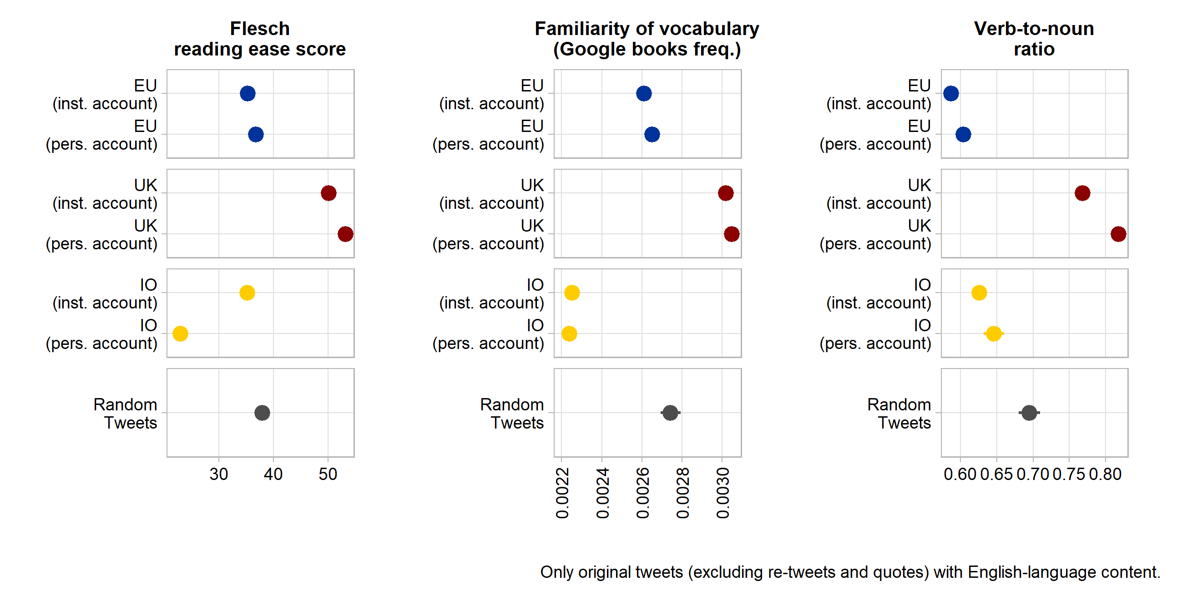

**Figure 2**: Language clarity indicators

These data show that supranational EU tweets tend to be clearer than those published by international organizations (with the notable exception of clarifying agency through a more verbal style). More importantly, however, supranational communication is clearly and significantly harder to understand for citizens when compared to random messages on the Twitter platform and especially when compared to the tweets of national institutions and executives from the UK. This reaffirms findings of a very technocratic approach to communication by supranational executive actors (Rauh 2021b).

But also here, notable variation within the supranational population exists. Based on the standardized averages of the three language-clarity indicators, the messages by current Commission President Von der Leyen, Commissioners Timmermans and Vestager, as well as Matthew Baldwin (European Coordinator for Road Safety) are easiest to understand. The least accessible messages - on average - are sent by the European Maritime Safety Agency, by the Commission DG for Competition Policy (ironically headed by the clearly communicating Margrethe Vestager), Justice Commissioner Reynders, and the European Defence Agency. Average across indicators, the tweets from supranational actors tweeting in personal capacity are easier to understand than tweets from institutional accounts.

*3.1. Media usage*

Beyond text, Twitter offers various multimedia features meant to attract attention and generate engagement with messages. To what extent do supranational actors and institutions use this additional communication potential? Relying on the raw tweet texts as well as on the URL entities object of the Twitter API, we aggregate data on multimedia usage in Figure 3.

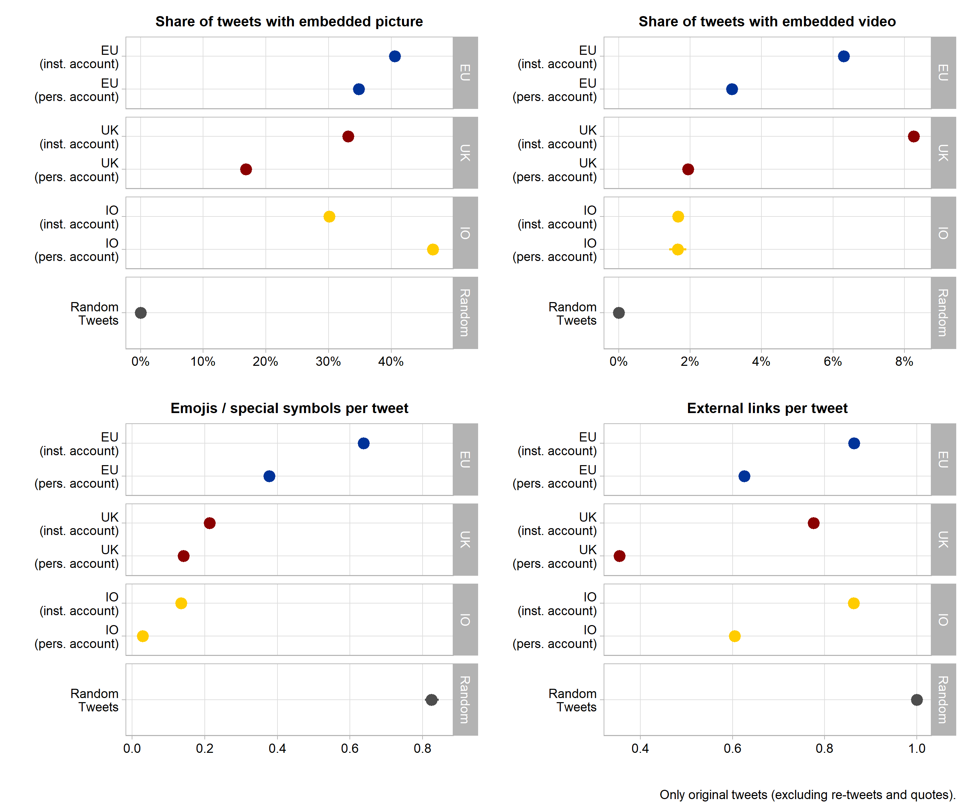

**Figure 3**: Multimedia usage

Pictures and visual detail highlight messages in the timeline of Twitter users. The top left panel of Figure 3 shows that around 35 to 40% of all supranational tweets embed at least one picture. This clearly exceeds picture usage in the tweets by domestic political actors as well as by institutional accounts of international organizations. Likewise, videos – we consider movie files uploaded directly to Twitter as well as embedded videos from major platforms such as YouTube, Vimeo, TikTok, and Twitch – occur frequently in supranational tweets – at least in relative terms. Institutional accounts of supranational actors feature a video in around 6% of all messages which is only surpassed by the around 8% of Tweets from domestic executive institutions in the UK. While we cannot exactly quantify this here, we note that many of these videos seem to be particularly produced for the purpose of communicating EU policies, again pointing to a professionalisation of supranational social media presence.

Furthermore, Twitter is notorious for having populated the use of special characters and especially emoticons in public communication. Including such pictograms into the tweet text – an example in Table 2 above - can encode large amounts of information and attracts visual attention, thus aiding message comprehension (Tang and Hew 2018). The lower left panel of Figure 3 indicates that supranational EU tweeters are indeed champions of using such special symbols in their messages. Additional analyses show that the by far most used symbol is the EU flag, occurring more than 50.000 times and thus in about 5% of all supranational tweets. Flags of different individual countries occur in a combined total of about 7% of tweets. Beyond that, supranational actors like to use various pointing hand and arrow symbols, a pictogram of the globe, as well as various version of checkmark symbols.

Finally, communicators can enrich their messages by supplying links to external online content. This initially facilitates further information seeking for message recipients. In addition, most Twitter applications directly summarise external websites in thumbnails, showing additional media from the external source along the tweet. Also, with regard to this communication feature, tweets from supranational EU actors are on par or even exceed messages from domestic and international political actors. In about 60 to 80% of all supranational Twitter messages an external online source is referred to. Where these links lead citizens to cannot be fully ascertained by automated means as around 41% of them use URL shortening services. Yet, in the remainders we see that supranational actors primarily refer to EU websites within the europa.eu domain (35% of all external URLs), pointing message recipients especially to information from the European Commission’s servers. A sizeable share of around 5% of external links point to other social media platforms, notably Facebook, LinkedIn, and Instagram. Supranational actors also seem to use services that automatically post content across different social media accounts (the dlvr.it domain accounts for around 3% of all external links).

Based on these descriptions we can state that supranational public communication on Twitter goes beyond textual content, relying especially on visual information and own external online resources.

**4. User engagement with supranational messages**

A crucial question for supranational public communication on social media is whether (citizen) users engage with the messages. A necessary condition for engagement is that users see the messages in the first place. Reliable information on this is not easy to obtain, however. The research track API does not include the number of ‘impressions’ per tweet which is also only available for the last 60 days in commercial access options. In addition, the algorithms by which Twitter decides which messages to show to which users with what prominence are not public.

What we know is that messages are shown at least in the timelines of users that have subscribed to follow a supranational account. Yet, historical follower count data are also not available through the Twitter APIs – only the numbers for the access day can be retrieved. Thus, we exploit the Internet Archive, a non-profit organisation working for free access to online information. Their archive.org engine crawls the web and takes static, timestamped snapshots of individual sites. We set up automated scripts (available at <https://github.com/ChRauh/PastTwitter>) that extract all available snapshots for each Twitter account in our samples to then scrape the follower counts from the raw html of the snapshots.

One caveat applies: the availability of archive.org snapshots is rather unequally distributed. Within our 115 supranational EU accounts, we can, for example, extract 842 snapshots of the @EU_Commission profile, 548 for @EUClimateAction, or 380 for @vonderleyen. But there are five accounts with only one snapshot and seven that have never been crawled by archive.org. We linearly interpolate the daily number of followers between each measurement point, taking only the account creation date and the scraping date for accounts without snapshots. This is not very precise, but the best possible information on historical follower counts that we can think of. Figure 6 shows how many users followed supranational Twitter profiles over time.

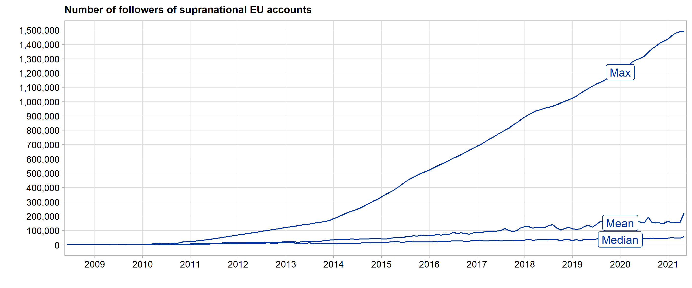

**Figure 6**: Followers of supranational Twitter accounts

The period of growing supranational tweet volume 2010-5 was followed by a period in which an increasing number of Twitter users also decided to subscribe to these accounts. The figure also highlights, however, that the distribution of followers across supranational accounts is extremely right skewed which has intensified over time. The by far most prominent supranational account is @EU_Commission with 1,491,799 followers as of May 3, 2021, followed by the institutional accounts of the European Council President (1,194,690 followers) and the European Central Bank (627,277). Among the most prominent personal accounts are Commission president Von der Leyen (587,814 followers), Competition Commissioner Vestager (295,615), and the High Representative for Foreign Affairs and Security Policy, Josep Borell (201,857). Personal accounts have on average 13,000 followers less than institutional accounts, but this difference is not statistically significant, indicating sizeable within-group variation. At the lower end of the distribution, we find several Commission Directors-General as well as the Euratom Supply Agency with only 77 followers.

How strongly do these users actually engage with the supranational messages? Clearly, we have no off-platform information on what users do with the information they receive. But we can observe their direct on-platform engagement. Twitter allows users to like messages, to amplify or contextualise them by retweets or quotes, or to publicly reply directly. We collect the counts of each of these engagements in response to each original, self-authored tweet by supranational actors. Since the number of users that may have seen the tweet in the first place affects the number of possible engagements, we express them as the percentage share of followers at the time each tweet was published. Given the imprecision in interpolated follower counts noted above, we reduce our samples to accounts that have at least two archive.org snapshots, taking only tweets at or after the first of those snapshots into account. Figure 7 plots these engagement ratios against our equally treated benchmark samples.

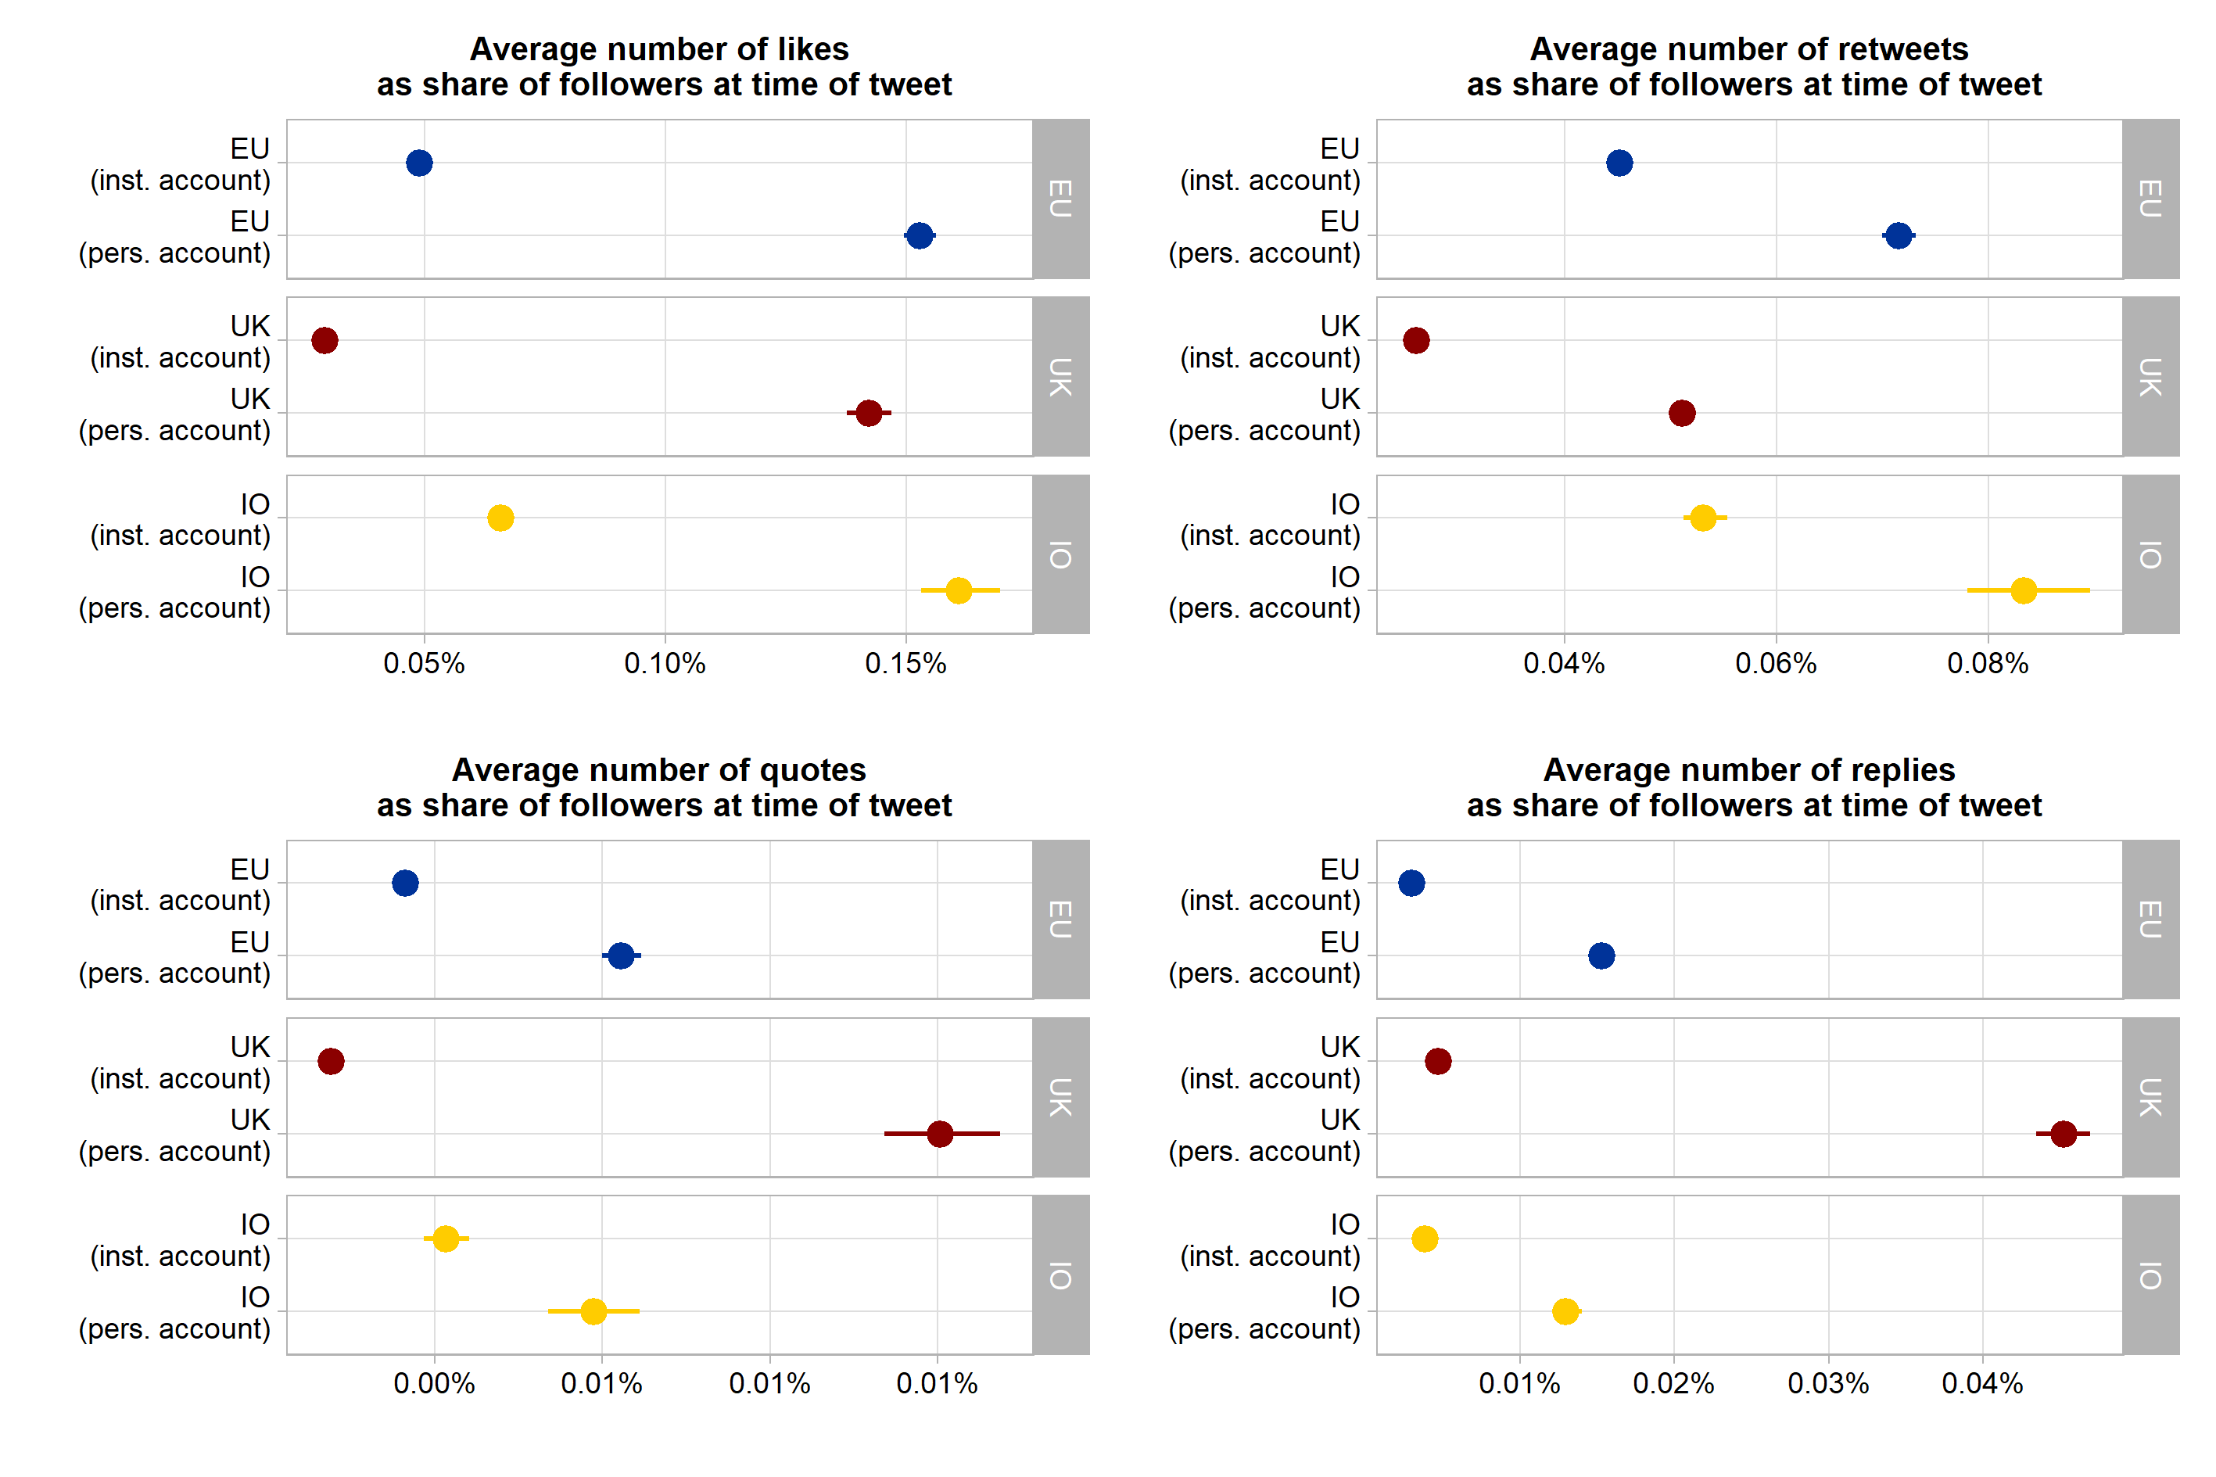

**Figure 7**: User engagement indicators

These data provide three main insights. First, supranational messages receive by and large as much direct Twitter user engagement as messages from executive actors and institutions at the national and international levels do. Supranational messages are in fact slightly more frequently liked and retweeted than those from national institutions and actors in the UK. Only UK actors tweeting in personal capacity received a markedly higher share of quotes and replies on their messages. Second, across all samples, Twitter users tend to engage more strongly with personal accounts than with institutional ones. Personalization of political messaging seems to matter on this social medium and for supranational EU actors as well. Third, direct engagement with executive tweets is not particularly high in absolute terms. On average, the number of direct engagements with supranational tweets by either liking, retweeting, quoting, or replying to it does not exceed a share of 0.14% of the number of users following the respective account.

There are a few notable exceptions to this latter rule, however. For example, in 18 tweets from our supranational sample, the overall number of direct user engagements exceeds 30% of the follower counts at the time of the message. Table 3 provides six illustrative examples for extremely ‘engaging’ supranational tweets in our sample.

Caution is warranted when generalising from such few and outlying examples, but we note that the most engaging tweets in our sample also seem to invoke highly politicized EU policy issues. Examples are Commissioner Dalli’s stance on LGBTI rights in Poland, the Frontex tweet embedding surveillance footage from the Mediterranean Sea (leading to a heated Twitter debate about whether priority should be given to sea rescue or the fight against human trafficking), the ECJ’s announcement that the UK may unilaterally revoke its withdrawal request, and the farewell note from the European Medicines Agency when finally leaving London due to Brexit.

| **Tweet** | **Account** | **Date** | **Followers** | **All direct engagements** |
| --- | --- | --- | --- | --- |
| Meet Mismo 🐶, a customs sniffer dog, who will tell you all about his job. #50CU #DogsWithJobs More info about the 50th anniversary of the EU #CustomsUnion: https://t.co/tD9clkog5q https://t.co/5MXpNH3Fqy | *EU_Taxud* | 2018-06-15 | 11,197 | 9,916 |
| EU values and fundamental rights must be respected by Member States and state authorities. This is why 6 town twinning applications invilving Polish authorities that adopted 'LGBTI free zones' or 'family rights' resolutions were rejected. #LGBTI #UnionOfEquality | *helenadalli* | 2020-07-28 | 9,756 | 8,036 |
| look at THIS !! The WHOLE core centre of brussels to go to 20kph for the summer from 1 May with priority to giving space to🚶‍♀️🚲 to exercise. Using the challenges of #CoronaVirus to rethink and transform mobility ... right here in Brussels... 👍👏🙏 https://t.co/RgmJNBgx89 | *Baldwin Matthew_* | 2020-04-20 | 6,102 | 4,314 |
| Wait, wait. Why is that fishing trawler towing an empty wooden boat at high seas??? https://t.co/psy2z6z9Wp | *Frontex* | 2019-06-22 | 23,214 | 11,861 |
| Today, EMA staff lowered the 28 EU flags and symbolically said goodbye to their London offices. Guido Rasi expressed his thanks to the UK for its contribution to the work of the Agency and for having been a gracious host of EMA since 1995. https://t.co/KpsBvaXt42 | *EMA_News* | 2019-01-25 | 39,251 | 18,853 |
| #ECJ: UK is free to unilaterally revoke the notification of its intention to withdraw from the EU – Case C-621/18 Wightman #Brexit https://t.co/KUOI2eQ48C | *EUCourtPress* | 2018-12-10 | 45,522 | 18,736 |

**Table 3:** Supranational tweet examples with extraordinary engagement rates

Beyond topics, these examples of highly engaging outliers also showcase the message characteristics that we have discussed thus far. We see, for example, clear and concise language, numerous hashtags and emojis, as well as embedded media and external links. How much these characteristics impinge on user engagement is hard to model exactly, as the proceedings of the Twitter algorithms are not known and tweet virality seems to follow partially endogenous dynamics and punctuated patterns (for example, by showing a message also to followers of followers who have engaged with a supranational message in the first place). However, a basic multivariate perspective in Appendix A4 provides some valuable initial hints. Higher readability and more verbal style of a tweet is associated with modestly higher user engagement ratios. The inclusion of hashtags comes with slightly higher engagement rates as well. The most important factor in our initial model is visual information, however: embedded pictures as well as emojis are most strongly associated with user engagement in the samples of UK, IO, and EU tweets. It must be noted, in addition, that even when controlling for such message characteristics, user engagement is markedly higher for personal accounts. Individual communication triggers more engagement with supranational messages than messages from institutional accounts.

**5. Conclusions**

In the face of public politicization, popular legitimacy challenges, and notable communication deficits, social media promise to be an attractive additional communication channel especially for the detached executive supranational actors of the European Union. Thus far, however, an aggregate picture on how these actors actually use social media has been lacking. The bird’s eye perspective on the full population of the more than one million messages from 115 Twitter accounts in the 2009-2021 period underlines strongly that supranational EU actors do indeed engage in public communication via social media.

Our encompassing description, first of all, shows that the volume of supranational social media communication has grown markedly after 2010, having reached or even exceeding the amount of social media messaging that national executives or international organizations with a comparable policy scopes provide. Second, several of the observed patterns suggest a growing professionalization of supranational social media usage. Supranational actors make extensive use of Twitter’s multi-media features, engage in cross-posting social media content, and try to garner attention to their own online resources outside of Twitter. Also in these respects, supranational EU actors are in no way inferior but often rather excel when compared to domestic and international executives on Twitter. Third, this communicative investment seems to pay off in terms of publicity. The number of users subscribing to supranational EU accounts has been growing on average, and for some actors in dramatic ways. Direct user engagement with supranational messages on the platform is not particularly high in absolute terms, but by and large corresponds to the engagement rates one can observe for executive messages form national and international actors.

Yet, our encompassing description also contains warning signs as regards the possible transparency and publicity effects of supranational communication. As has been found for other communication channels, the textual content of supranational communication is characterised by comparatively high syntactical complexity, less familiar vocabulary, and a rather nominal style that may obfuscate political agency. On this dimension, social media communication from domestic executive actors in the UK provides much clearer messaging in comparison. We also must note that the follower numbers and the engagement rates are hardly equally distributed across supranational communicators. They rather concentrate on a few selected institutional, and especially on high-profile individual accounts of supranational actors. Generally, on most of our indicators, marked variation within the sample of supranational communicators and messages can be observed.

The broad and encompassing perspective that our bird’s eye on the increasingly relevant supranational social media communication provides is thus an important, yet hardly the final step. Whether and how the communication we describe affects the precarious societal legitimacy of supranational decisions making requires further analyses. For scholars willing to dig deeper into this type of data, the patterns we show provide four informative pointers, in particular. First, the sobering findings on textual understandability highlight the need to dissect supranational messages further in terms of the claims that supranational actors make, including their relation to actual political activity. Whether these public messages are mere propaganda or genuine, transparent political accountability reporting would help us understand to what extent public communication contributes to or possibly undermines the popular legitimacy of supranational actors. Second, our qualitative examples for the most engaging tweets highlight variation across externally politicized topics and suggests that different forms and contents of user engagements may provide valuable hints on the publicity that supranational messages generate. Third, our findings highlight that especially visual content is part and parcel of supranational public communication, requiring additional forms of content analyses. Fourth and finally, especially the clearer communication and higher engagement rates that accounts of individual supranational actors generate, underline that the personalization of EU politics can also be meaningfully observed on Twitter. In any case, however, our data demonstrate that social media are a highly relevant channel for the outbound communication of supranational actors in the European Union.

**6. References**

Altides, C. (2009) *Making EU politics public: how the EU institutions develop public communication*, Baden-Baden: Nomos.

Barisione, M. and Michailidou, A. (eds) (2017) *Social media and European politics: rethinking power and legitimacy in the digital era*, London, United Kingdom: Palgrave Macmillan.

Benoit, K., Munger, K. and Spirling, A. (2019) ‘Measuring and Explaining Political Sophistication through Textual Complexity’, *American Journal of Political Science* 63(2): 491–508.

Biber, D., Conrad, S. and Reppen, R. (1998) *Corpus Linguistics: Investigating Language Structure and Use*, Cambridge ; New York: Cambridge University Press.

Biegoń, D. (2013) ‘Specifying the Arena of Possibilities: Post-structuralist Narrative Analysis and the European Commission’s Legitimation Strategies’, *JCMS: Journal of Common Market Studies* 51(2): 194–211.

Bijsmans, P. and Altides, C. (2007) ‘“Bridging the Gap” between EU Politics and Citizens? The European Commission, National Media and EU Affairs in the Public Sphere’, *Journal of European Integration* 29(3): 323–340.

Bischof, D. and Senninger, R. (2018) ‘Simple politics for the people? Complexity in campaign messages and political knowledge’, *European Journal of Political Research* 57(2): 473–495.

Boomgaarden, H. et al. (2013) ‘Across time and space: Explaining variation in news coverage of the European Union’, *European Journal of Political Research* 52(5): 608–629.

Bressanelli, E., Koop, C. and Reh, C. (2020) ‘EU Actors under pressure: politicisation and depoliticisation as strategic responses’, *Journal of European Public Policy* 27(3): 329–341.

Brüggemann, M. (2010) ‘Information Policy and the Public Sphere’, *Javnost - The Public* 17(1): 5–21.

Cage, J., Herve, N. and Mazoyer, B. (2020) *Social Media and Newsroom Production Decisions*, Rochester, NY: Social Science Research Network, doi:10.2139/ssrn.3663899.

Curtin, D. and Meijer, A. J. (2006) ‘Does transparency strengthen legitimacy?’, *Information Polity* 11(2): 109–122.

De Vreese, C. (2001) ‘“Europe” in the News: A Cross-National Comparative Study of the News Coverage of Key EU Events’, *European Union Politics* 2(3): 283–307.

De Vreese, C., Banducci, S., Semetko, H. and Boomgaarden, H. (2006) ‘The News Coverage of the 2004 European Parliamentary Election Campaign in 25 Countries’, *European Union Politics* 7(4): 477–504.

De Wilde, P. and Zürn, M. (2012) ‘Can the Politicization of European Integration be Reversed?*’, *JCMS: Journal of Common Market Studies* 50(s1): 137–153.

Ecker-Ehrhardt, M. (2018) ‘Self-legitimation in the face of politicization: Why international organizations centralized public communication’, *The Review of International Organizations* 13(4): 519–546.

Ecker-Ehrhardt, M. (2020) ‘IO Public Communication Going Digital? Understanding Social Media Adoption and Use in Times of Politicization’, in *Digital Diplomacy and International Organisations*. Routledge.

European Parliament. Directorate General for Parliamentary Research Services. (2021) *The Twitter activity of members of the European Council: a content analysis of EU leaders’ use of Twitter in 2019 20.*, LU: Publications Office, available at https://data.europa.eu/doi/10.2861/17201 (accessed June 2021).

Fairclough, N. (2003) *Analysing Discourse: Textual Analysis for Social Research*, Psychology Press.

Fazekas, Z., Popa, S. A., Schmitt, H., Barberá, P. and Theocharis, Y. (2021) ‘Elite-public interaction on twitter: EU issue expansion in the campaign’, *European Journal of Political Research* 60(2): 376–396.

Ferrara, F. M. and Angino, S. (2021) *Does Clarity Make Central Banks More Engaging? Lessons from ECB Communications*.

Firouzjaei, H. A. and Özdemir, S. F. (2020) ‘Effect of readability of political tweets on positive user engagement’, in *IEEE/ACM International Conference on Advances in Social Networks Analysis and Mining (ASONAM)*. 2020, available at https://web.ntpu.edu.tw/~myday/doc/ASONAM2020/ASONAM2020_Proceedings/pdf/papers/137_074_884.pdf.

Flesch, R. (1948) ‘A new readability yardstick.’, *Journal of Applied Psychology* 32(3): 221.

Fowler, R., Hodge, B., Trew, T. and Kress, G. (1979) *Language and Control*, London: Routledge.

Gerhards, J., Offerhaus, A. and Roose, J. (2009) ‘Wer ist verantwortlich? Die Europäische Union, ihre Nationalstaaten und die massenmediale Attribution von Verantwortung für Erfolge und Misserfolge’, *Politische Vierteljahresschrift Sonderhefte* Band 42 ‘Politik in der Mediendemokratie’: 529–558.

Harteveld, E., Schaper, J., Lange, S. L. D. and Brug, W. V. D. (2018) ‘Blaming Brussels? The Impact of (News about) the Refugee Crisis on Attitudes towards the EU and National Politics’, *JCMS: Journal of Common Market Studies* 56(1): 157–177.

Hartlapp, M., Metz, J. and Rauh, C. (2014) *Which Policy for Europe?: Power and Conflict inside the European Commission*, Oxford: Oxford University Press.

Haßler, J., Magin, M., Russmann, U. and Fenoll, V. (eds) (2021) *Campaigning on Facebook in the 2019 European Parliament Election: Informing, Interacting with, and Mobilising Voters*, Palgrave Macmillan, doi:10.1007/978-3-030-73851-8.

Hobolt, S. B. and Tilley, J. (2014) *Blaming Europe?: Responsibility Without Accountability in the European Union*, Oxford University Press, doi:10.1093/acprof:oso/9780199665686.001.0001.

Hooghe, L. et al. (2017) *Measuring International Authority: A Postfunctionalist Theory of Governance, Volume III*, Oxford, New York: Oxford University Press.

Hooghe, L. and Marks, G. (2009) ‘A Postfunctionalist theory of European integration: From permissive consensus to constraining dissensus’, *British Journal of Political Science* 39(1): 1–23.

Hüller, T. (2007) ‘Assessing EU strategies for publicity’, *Journal of European Public Policy* 14(4): 563–581.

Jungherr, A. (2016) ‘Twitter use in election campaigns: A systematic literature review’, *Journal of Information Technology & Politics* 13(1): 72–91.

Koopmans, R. and Statham, P. (2010) *The making of a European public sphere*, Cambridge: Cambridge University Press.

Krzyżanowski, M. (2020) ‘Digital Diplomacy or Political Communication? Exploring Social Media in The EU Institutions from a Critical Discourse Perspective’, in *Digital Diplomacy and International Organisations*. Routledge.

Meyer, C. (1999) ‘Political Legitimacy and the Invisibility of Politics: Exploring the European Union’s Communication Deficit’, *JCMS: Journal of Common Market Studies* 37(4): 617–639.

Moretti, F. and Pestre, D. (2015) ‘Bankspeak: The Language of World Bank Reports’, *The New Left Review* 92(MAR APR 2015): 75–99.

Nulty, P., Theocharis, Y., Popa, S. A., Parnet, O. and Benoit, K. (2016) ‘Social media and political communication in the 2014 elections to the European Parliament’, *Electoral Studies* 44: 429–444.

Ooms, J. and Sites, D. (2020) *cld2: Google’s Compact Language Detector 2*, 15 December 2020, available at https://CRAN.R-project.org/package=cld2 (accessed June 2021).

Orwell, G. (1946) ‘Politics and the English Language’, *Horizon* 13(76): 252–265.

Oschatz, C., Stier, S. and Maier, J. (2021) ‘Twitter in the News: An Analysis of Embedded Tweets in Political News Coverage’, *Digital Journalism* 0(0): 1–20.

Rauh, C. (2021a) ‘Between neo-functionalist optimism and post-functionalist pessimism: Integrating politicisation into integration theory’, in N. Brack and S. Gürkan (eds). *Theorising the Crises of the European Union*. Abingdon, Oxon: Routledge, pp. 119–137.

Rauh, C. (2021b) ‘From the Berlaymont to the citizen? The language of European Commission press releases 1985-2020’, in *International Studies Association*. 2021, available at https://www.researchgate.net/publication/350152854_From_the_Berlaymont_to_the_citizen_The_language_of_European_Commission_press_releases_1985-2020.

Rauh, C., Bes, B. J. and Schoonvelde, M. (2020) ‘Undermining, defusing or defending European integration? Assessing public communication of European executives in times of EU politicisation’, *European Journal of Political Research* 59(2): 397–423.

Risse, T. (2014) *European Public Spheres: Politics Is Back*, Cambridge: Cambridge University Press.

Schimmelfennig, F. (2020) ‘Politicisation management in the European Union’, *Journal of European Public Policy* 27(3): 342–361.

Segesten, A. D. and Bossetta, M. (2017) ‘A typology of political participation online: how citizens used Twitter to mobilize during the 2015 British general elections’, *Information, Communication & Society* 20(11): 1625–1643.

Silva, T., Kartalis, Y. and Lobo, M. C. (2021) ‘Highlighting supranational institutions? An automated analysis of EU politicisation (2002–2017)’, *West European Politics* 0(0): 1–25.

Stier, S., Bleier, A., Lietz, H. and Strohmaier, M. (2018) ‘Election Campaigning on Social Media: Politicians, Audiences, and the Mediation of Political Communication on Facebook and Twitter’, *Political Communication* 35(1): 50–74.

Tang, Y. and Hew, K. F. (2018) ‘Emoticon, Emoji, and Sticker Use in Computer-Mediated Communications: Understanding Its Communicative Function, Impact, User Behavior, and Motive’, in L. Deng, W. W. K. Ma, and C. W. R. Fong (eds). *New Media for Educational Change*. 2018, Singapore: Springer, pp. 191–201.

Thibault, P. J. (1991) ‘Grammar, technocracy, and the noun’, in E. Ventola (ed.). *Functional and Systemic Linguistics: Approaches and Uses*. Berlin: Walter de Gruyter, pp. 281–306.

Tolochko, P., Song, H. and Boomgaarden, H. (2019) ‘“That Looks Hard!”: Effects of Objective and Perceived Textual Complexity on Factual and Structural Political Knowledge’, *Political Communication* 36(4): 609–628.

Trenz, H. (2008) ‘Understanding Media Impact on European Integration: Enhancing or Restricting the Scope of Legitimacy of the EU?’, *Journal of European Integration* 30(2): 291–309.

Trenz, H.-J. (2004) ‘Media Coverage on European Governance: Exploring the European Public Sphere in National Quality Newspapers’, *European Journal of Communication* 19(3): 291–319.

Umit, R. (2017) ‘Strategic communication of EU affairs: an analysis of legislative behaviour on Twitter’, *Journal of Legislative Studies* 23(1): 93–124.

Walter, S. (2015) ‘Explaining the visibility of EU citizens: a multi-level analysis of European Union news’, *European Political Science Review* FirstView: 1–21.

Zaiotti, R. (2020) ‘The (UN)Making of International Organisations’ Digital Reputation: The European Union, the “refugee crisis,” and social media’, in *Digital Diplomacy and International Organisations*. Routledge.