Com_qual_v1

Sina Özdemir[1]

Christian Rauh[2]

5/14/2021

# Introduction

## Para 1:

* the EU is irreversably policitised. Its legitimacy is challenged on many fronts

## Para 2:

* The EU has internal and external problems with communicating its legitimacy

## Para 3:

* Social media offers unique solutions to external communication problems

## Para 4:

* What we do in the article

## Para 5:

* Organization of the article

# Legitimacy deficit of the EU

## Para 1:

* Introduction: what kind of legitimacy problem

## Para 2:

* Legitimacy deficit: input legitimacy

## Para 3:

* Legitimacy deficit: output legitimacy

## Para 3:

* Legitimacy deficit: throughput legitimacy

## Para 4:

* Legitimacy deficit: communication deficit

# Public communication and the EU’s legitimacy

## Para 1:

* Communication deficit: internal problems

## Para 2:

* Communication deficit: external problems

## Para 3:

* Attempts at remedying communication deficit

## Para 4:

* How can public communication via social media help with legitimacy deficit
  + Meritocratic legitimacy (Meyer 1999)
  + SoMe: direct communication with citizens, thus a solution to external communication problems
  + Volume: telling what the EU does helps with output legitimacy
  + Ease-of-reade: makes the EU politics comprehensible
  + Interactivity: build connection with the audience so that audience feels heard
  + Political responsiblity reporting: Helps with transparency, because now the audience knows who is responsible for what

# Data and method

## Data

We follow a purposeful sampling strategy and target historical tweets from 115 verified Twitter accounts of the EU to investigate the communication performance of the EU on social media. The accounts cover the supranational institutions of the EU, their sub-branches such as agencies, and individuals who are in charge of these institutions such as commissioners, and director generals. Graph 1 gives an overview of the account type and tweet volume. Full list of accounts and descriptions is presented in Appendix(X).

The motivation behind choosing these accounts is two-folds. First of all, the selection of accounts collectively reflects branches of the EU that exercise political authority as a polity. Thus giving us a clear picture of the EU’s public communication as a polity [CITATION HERE]. Secondly, extant research shows that executive branches of the EU (i.e supranational institutions) such as the Commission and the ECB, are often the core subjects of politicization in national media. Thus, it is often their institutional legitimacy that is questioned and equated with the overall legitimacy of the EU in citizens mind[@Silvia2021].

We target three sets of accounts to benchmark the EU’s communication quality on social media namely. The first set of accounts belong to the international organizations (IOs) which are comparable to the EU in terms of policy scope. Research shows that one of the key determinants of politicization of international political authority is breadth of the policy scope of said authority [@Rauh2019; @Zuern2018; @DeWilde2011]. While no other international organization has breadth and depth of political authority as EU, the selected international organizations are most similar to the EU in terms of number of policy areas. To identify and select these accounts, we make use of “Measuring International Authority” by Marks, Hooghie and Lenz[-@Hooghe2021] dataset. The number of policy area responsibilities of these international organization are approximately 1 sd around the EU’s number of policy area responsibilities. List of organizations and Twitter accounts are presented in the Appendix(X).

The second set of benchmark accounts belongs the UK government. More specifically, we target the current UK government ministers, ministries, executive offices, agencies and individuals who are in charge of these institutions. As aptly named by Jacques Delore, the EU is a unidentified political object [couldn’t remember the French spelling]. On the one hand, its competencies approximate that of a nation state. On the other hand, it carries significant markers of an international organization where member states guide and decide on how the political authority will be exercised. Thus, making the EU neither a fully sovereign political authority nor a platform for sovereigns to collaborate. Due to this nature of the EU, we choose to benchmark the EU’s public communication on Twitter against that of national government. However, due to resource limitations to analyze wide variety of national languages, we focus on the UK government.

Our last set of benchmarks is a random set of tweets from the EU countries. We streamed in tweets from 26 of the EU countries for a week with 5 min. windows. Our motivation is to identify a baseline for syntactic and semantic features of communication in Twitter environment in the EU.

We collect historical data from the EU, the UK and IOs using Twitter API 2.0 academic track. The total amount of data amounts up to [**TOTAL NUMBER OF TWEETS HERE**] where 1062742 is from the EU accounts, [**nrow uk here**] is from the UK accounts and [**nrow io here**] from IO accounts. The streamed tweets are collected using Twitter decahose API as this end-point was not available with API 2.0 famility at time of collection.

## Method

To examine the communication of quality we focus on three sets of indicators: message complexity, interactivity and reporting of political responsibility. Extant research has demonstrated that both semantic and syntactic complexity of political messages strongly influence political knowledge acquisition and engagement with the messages(Bischof & Senninger, 2018; Eveland et al., 2004; Spirling, 2015; Tolochko et al., 2019). Semantic complexity of a message refers to the difficulty of comprehension of the words and phrases in the message (eg: relevant vs pertinent). Syntactic complexity, on the other hand, refers to the difficulty of the structural characteristics of texts such as long noun phrases, and clauses (eg: the tall man stands next to the door vs the man who is tall and standing next to the door). Complex messages requires more cognitive resources to be processed and incorporated into the knowledge structure(Lang et al., 2007), thus reducing the knowledge acquisition and engagement with the political message. We measure semantic complexity of tweets as the average commonality of the words in the tweets by using Google books word commonality and comparing them to the most common word in English, article “the”. For syntactic complexity, we make use of Flesch ease-of-read score(Flesch, 1948) for each tweet. We create two more syntactic complexity indicators focusing on the meta-linguistic features in Twitter communication; number of hashtags and emojis normalized by number of words in a tweet. Such meta-linguistic features encode large amount of information in a few tokens, thus aid message comprehension (Tang & Hew, 2018).

We gauge the interactivity of the Twitter communication by exploiting quote, retweet and reply meta-data provided by the Twitter API. We measure the one-way interactivity by percentage share of quoted and retweeted tweets per account. Quoting refer to the activity of sharing others’ tweets with a comment while retweeting is simply sharing others’ tweet. These one-way interactivity between accounts enable public messages travel further thus find a broader audience. We measure the two-way interactivity with percentage share of replies by an account. Unlike mentions, replies are tweets targeting other tweets addressed to the account. These interactions enable a dialog between account owner and the audience.

Finally, we measure political responsibility reporting with rule-based classification method in two steps. First, we identify tweets that report on political activity and agenda using the policy dictionary from [CAP or MIA] project [precision and recall values here]. In the second step, we exploit Part-of-Speech tagging to identify responsibility reporting. To do so, we focus on grammar structures that indicate agency (an example here). We then classify tweets that contain both elements as political responsibility measure and create an aggregate measure for it as percentage share of political responsibility reporting tweets per account.

# Results and discussion

**Broad overview of the data**

## Within sample comparision: communication performance of different EU accounts

### Ease of read:

### Interactivity:

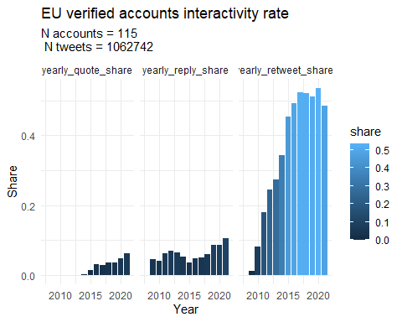

## `summarise()` has grouped output by 'Actor_type'. You can override using the `.groups` argument.

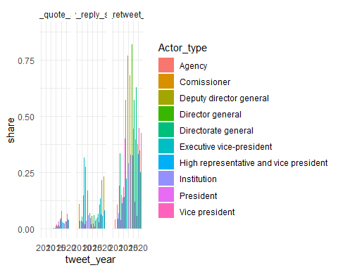 **This is not a good graph**

### Political responsiblity reporting:

## Benchmarks: communication performance of the EU compared to IOs and national governments

### Ease of read

### Interactivity

### Political responsibility reporting:

# Conclusion

# References

Bischof, D., & Senninger, R. (2018). Simple politics for the people? Complexity in campaign messages and political knowledge. *European Journal of Political Research*, *57*(2), 473–495. https://doi.org/10.1111/1475-6765.12235

Eveland, W. P., Jr., Cortese, J., Park, H., & Dunwoody, S. (2004). How Web Site Organization Influences Free Recall, Factual Knowledge, and Knowledge Structure Density. *Human Communication Research*, *30*(2), 208–233. https://doi.org/10.1111/j.1468-2958.2004.tb00731.x

Flesch, R. (1948). A new readability yardstick. *Journal of Applied Psychology*, *32*(3), 221. https://doi.org/10.1037/h0057532

Lang, A., Park, B., Sanders-Jackson, A. N., Wilson, B. D., & Wang, Z. (2007). Cognition and Emotion in TV Message Processing: How Valence, Arousing Content, Structural Complexity, and Information Density Affect the Availability of Cognitive Resources. *Media Psychology*, *10*(3), 317–338. https://doi.org/10.1080/15213260701532880

Spirling, A. (2015). Democratization and Linguistic Complexity: The Effect of Franchise Extension on Parliamentary Discourse, 1832–1915. *The Journal of Politics*, *78*(1), 120–136. https://doi.org/10.1086/683612

Tang, Y., & Hew, K. F. (2018). Emoticon, Emoji, and Sticker Use in Computer-Mediated Communications: Understanding Its Communicative Function, Impact, User Behavior, and Motive. In L. Deng, W. W. K. Ma, & C. W. R. Fong (Eds.), *New Media for Educational Change* (pp. 191–201). Springer. https://doi.org/10.1007/978-981-10-8896-4_16

Tolochko, P., Song, H., & Boomgaarden, H. (2019). “That Looks Hard!”: Effects of Objective and Perceived Textual Complexity on Factual and Structural Political Knowledge. *Political Communication*, *36*(4), 609–628. https://doi.org/10.1080/10584609.2019.1631919

1. PhD Candidate, Department of Sociology and Political Science, Norwegian University of Science and Technology
2. Prof., Global Governance Unit, Social Science Center Berlin