Linear Control Systems

Iran university of science and technology

**Capstone: Digital Inclinometer- Project Report**

**Team Members**: Sina Farhangdoust, Parmida Haddadnejad, Ghazal Mohammadi

Spring 2022

**Project Summary**

This project involves the design, implementation, and testing of a Digital Inclinometer, a device designed to measure the tilt angle of an object. The inclinometer is developed using an Arduino Uno platform and an MPU6050 sensor, which is a combination accelerometer and gyroscope. The system reads the tilt angle data from the sensor and displays it on a 16x2 LCD display. The main goal of the project is to create an efficient, reliable, and easy-to-use device that can measure tilt angles accurately in real-time. The project was completed as part of the Linear Control Systems course and integrates both hardware and software components, showcasing practical applications of control theory.

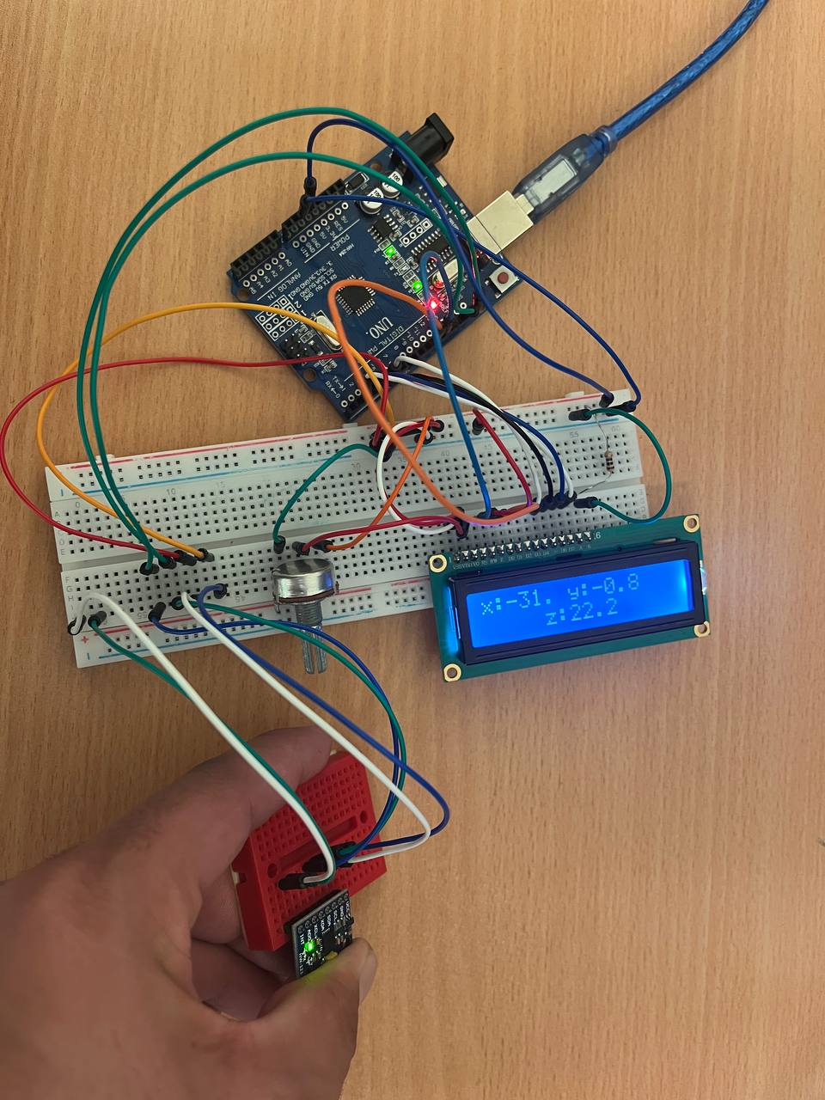

Figure 1: Assembled System

**Required Components**

* Jumper wires
* Arduino Uno board
* 16x2 LCD display
* MPU6050 sensor
* Header pins
* Resistors
* Potentiometer
* Breadboard

**Project Description**

The project involves building a system that measures and displays the angle of tilt of an object using the MPU6050 sensor, which provides both accelerometer and gyroscope data. The system interfaces with the Arduino Uno board and displays the calculated tilt angle on a 16x2 LCD screen.

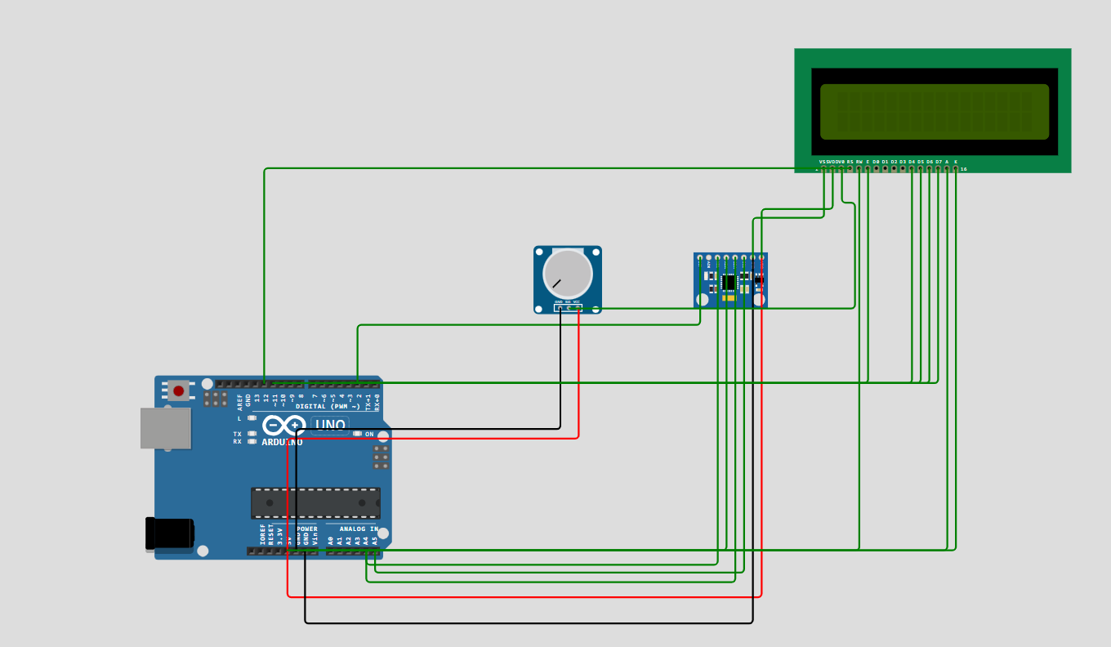

Figure 2: Wiring Connections

* **Sensor Setup**

The **MPU6050 sensor** is a **6-axis** motion-tracking device, containing both a **3-axis accelerometer** and a **3-axis gyroscope**. It is capable of measuring acceleration and angular velocity in three-dimensional space. In this project, the accelerometer component is primarily used to measure the tilt angle of the object.

To interface the sensor with the Arduino Uno, the following connections are made:

* The 5V and GND pins of the Arduino board are connected to the power and ground pins of both the sensor and the LCD display.
* The A4 pin (SCL) of the Arduino board is connected to the SCL pin of the MPU6050 sensor, while the A5 pin (SDA) of the Arduino connects to the SDA pin of the sensor.
  + The VCC and GND pins of the sensor are connected to the 5V and ground pins of the Arduino, respectively.
* **LCD Setup**

For the 16x2 LCD display, the following connections are made:

* + LCD RS pin to digital pin 12 on Arduino
  + LCD Enable pin to digital pin 11 on Arduino
  + LCD D4 pin to digital pin 5 on Arduino
  + LCD D5 pin to digital pin 4 on Arduino
  + LCD D6 pin to digital pin 3 on Arduino
  + LCD D7 pin to digital pin 2 on Arduino
  + LCD R/W pin to ground
  + LCD VSS pin to ground
  + LCD VCC pin to 5V
  + LCD LED+ pin to 5V through a 220-ohm resistor
  + LCD LED- pin to ground

In addition to these connections, a 10k potentiometer is wired to the +5V and ground pins. The wiper of the potentiometer is connected to the VO pin of the LCD (pin 3) to control the display's brightness and contrast.

**System Overview:**

The system functions by utilizing the MPU6050sensor to measure the tilt angle of an object. The accelerometer readings (in the X, Y, and Z axes) are processed by the Arduino Uno to calculate the tilt angle. The calculated angle is then displayed in real-time on the 16x2LCDscreen.

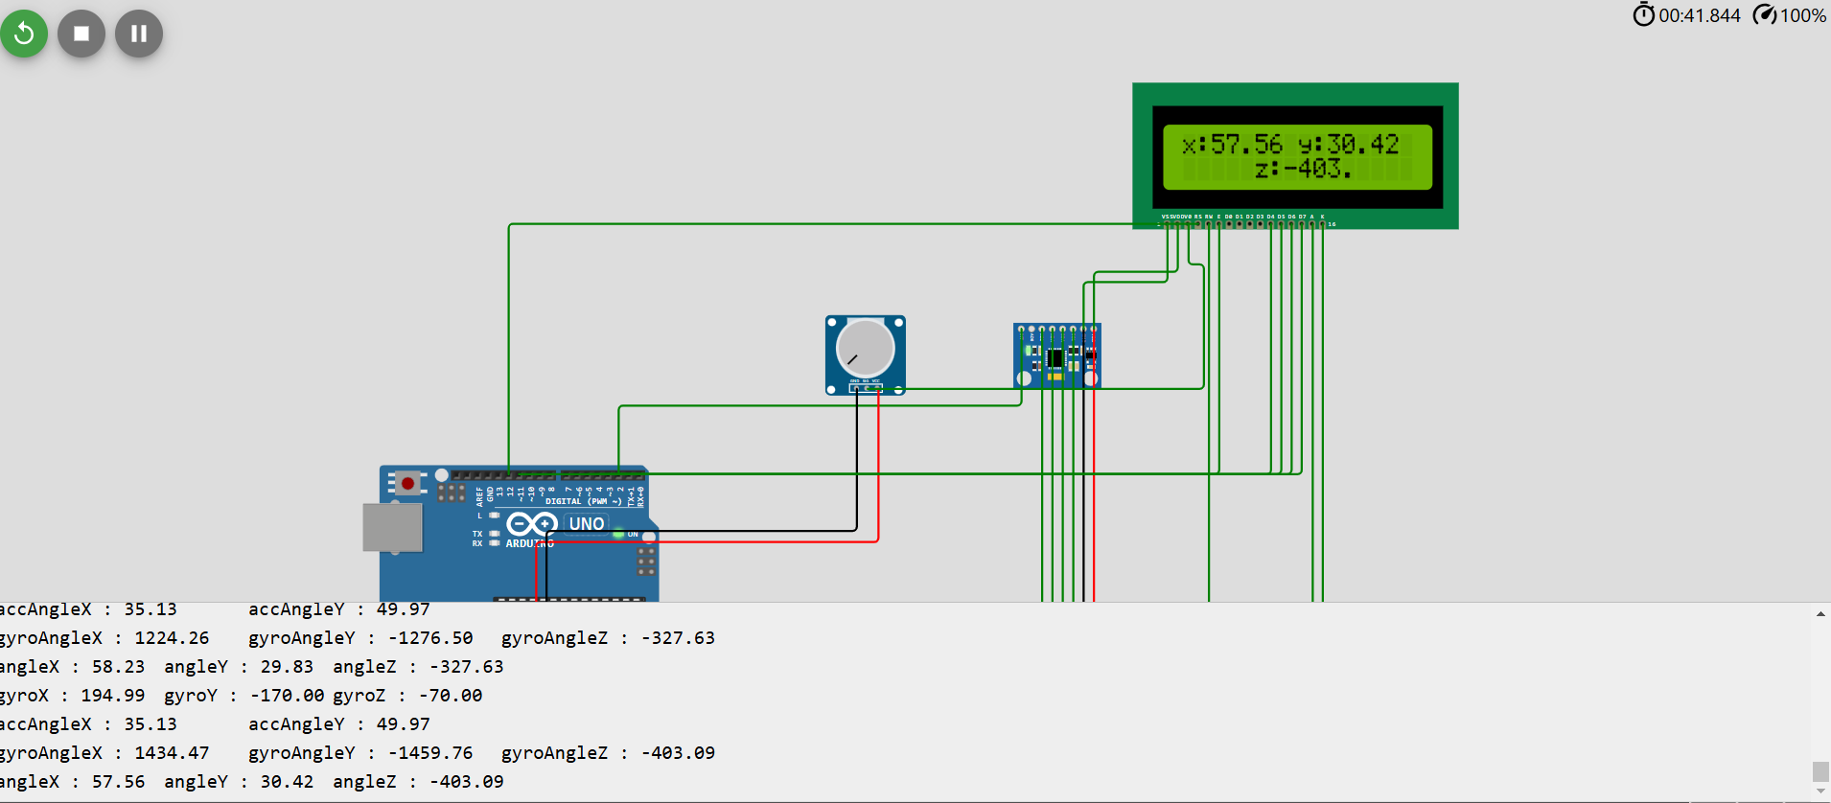

Figure 3: Simulation result of the Digital Inclinometer, showing the measured tilt angle.

The sensor data is collected using the I2C communication protocol, which allows for efficient and fast data transfer between the Arduino board and the sensor. The calculated angle value is continuously updated on the LCD display, giving the user an immediate readout of the tilt angle.

The potentiometer is used to adjust the contrast and brightness of the LCD, ensuring the display is clear and visible under various lighting conditions. The project demonstrates the integration of hardware and software and showcases practical applications of linearcontrolsystemsprinciples, such as real-time data processing and feedback display.

**Code and Libraries:**

In this project, two libraries were used to facilitate communication with the sensor and control the LCD display:

1. mpu6050_tockn.h Library:This library is specifically designed to interact with the MPU6050 sensor. It simplifies the process of communicating with the sensor over the I2C protocol, making it easier to read sensor data and calculate the tilt angles. The library allows us to retrieve raw data from the accelerometer and gyroscope, and provides functions for converting the sensor data into meaningful tilt angle values.
2. LiquidCrystal Library: This is a standard library used for controlling 16x2 LCD displays. It allows the Arduino to send text and numbers to the LCD, positioning the cursor and managing the display of messages. In this project, the LiquidCrystal library was used to continuously display the calculated tilt angle on the LCD.

**Conclusion:**

The DigitalInclinometer project successfully met its design goals. By integrating the Arduino Uno, MPU6050 sensor, and 16x2 LCD, the system accurately measures the tilt angle of an object in real-time and displays the value on an LCD screen. The project provides a valuable hands-on learning experience in sensor integration, I2C communication, and linear control systems. Through this project, the team gained a deeper understanding of how sensors and microcontrollers can be used in real-world applications for measurement and feedback systems.

This project is an excellent example of the principles learned in the Linear Control Systems course, demonstrating how sensors can be used for real-time data acquisition and display in practical engineering applications.