AUSPIFY TECHNOLOGIES

Student Management System
Software Development Internship — Task 1
Project Documentation

Organization | Auspify Technologies
Internship program | 4-Week Software Development Internship
Task | Task 1 — Student Management System
Application type | Java Swing desktop application
Storage | Local CSV file
Prepared by | Mohammed Sinan C
Date | 9/11/2026

1. Introduction
The Student Management System is a desktop application developed using Java and Swing. It helps a user maintain student records through a graphical interface. The application supports adding, viewing, updating, deleting, and searching student information. Records are stored in a local CSV file, so a separate database server is not required.

2. Objectives
- Design a simple graphical interface for student record management.
- Create and display student records.
- Allow existing student details to be updated or deleted.
- Provide search and sorting functionality.
- Validate user input before saving records.
- Persist student information between application sessions.

3. Scope and Main Features
Feature | Description | Expected behaviour
Add | Enter student details and create a record. | A new record is added and saved.
View | Display records in a table. | Student rows are visible and sortable.
Update | Select a row, edit its details and save. | The selected record is updated; its ID stays fixed while editing.
Delete | Select a row and request deletion. | A confirmation dialog appears before removal.
Search | Type a search term. | The table filters by ID, name, age, email, phone or course.
Validation | Check the entered values. | Invalid values are rejected with clear messages.
Persistence | Save changes to CSV. | Records are available after restarting the app.

4. Technologies and Requirements
- Programming language: Java.
- User interface: Java Swing.
- Data storage: UTF-8 CSV file.
- Development/runtime requirement: JDK 8 or newer.
- External libraries: none required by the documented setup.

5. System Design
The source code is separated into a data model, application logic and user interface. This separation keeps the record-handling logic independent from the Swing window and makes the repository and validation behaviour easier to test.
Layer / class | Responsibility | Key details
Model — Student.java | Represents one student. | Immutable fields: ID, name, age, email, phone and course.
Validation — StudentValidator.java | Checks and normalizes form input. | Returns field-specific validation messages and builds a Student object.
Data — StudentRepository.java | Provides record operations and CSV persistence. | Handles CRUD, search, ID generation and file operations.
UI — StudentManagementApp.java | Displays the desktop interface. | Connects user actions to validation and repository operations.

6. Data Fields and Validation
Field | Validation rule documented in the source
Student ID | Required; unique without regard to letter case; letters, digits, hyphen and underscore; maximum 15 characters.
Full name | Required; 2–60 characters; letters, spaces, period, apostrophe and hyphen.
Age | Required whole number from 5 through 100.
Email | Required; must match a basic name@example.com-style pattern; maximum 100 characters.
Phone | Required; 7–20 digits; spaces, hyphens and a leading plus sign are allowed.
Course | Required; maximum 60 characters.

7. Data Storage
The default data file is data/students.csv. Its header contains the fields id,name,age,email,phone,course. The application can also be launched with an alternate CSV path according to the README instructions. The README describes CSV escaping for values containing commas or quotation marks and a save approach that writes a temporary file before replacing the target file.
Example CSV header: id,name,age,email,phone,course

8. Installation and Execution
Requirement: install JDK 8 or newer and ensure java and javac are available in the terminal.

Windows
Open Command Prompt in the project folder and run:
run.bat
Run the automated test suite with:
run.bat test

macOS / Linux
./run.sh
./run.sh test
The project README also documents manual compilation using javac and launching sms.StudentManagementApp from the compiled output directory.

9. Project Directory Structure
StudentManagementSystem/
├── src/sms/
│ ├── Student.java
│ ├── StudentValidator.java
│ ├── StudentRepository.java
│ └── StudentManagementApp.java
├── test/sms/
│ └── StudentRepositoryTest.java
├── data/
│ └── students.csv
├── screenshots/
│ ├── 01-student-list.png
│ ├── 02-update-student.png
│ ├── 03-search.png
│ ├── 04-validation-error.png
│ └── 05-delete-confirm.png
├── run.bat
├── run.sh
├── .gitignore
└── README.md

10. Testing and Verification
The supplied project contains StudentRepositoryTest.java. The README describes 12 automated tests covering record creation and lookup, duplicate IDs, updates, deletion, save/reload, CSV special characters, search, ID generation, corrupt input lines and validation.
Manual verification performed by developer | Reported result
Application opens successfully | PASS
Add Student works | PASS
Update Student works | PASS
Delete Student works | PASS
Search works | PASS
Data saves in students.csv | PASS

11. Application Screenshots
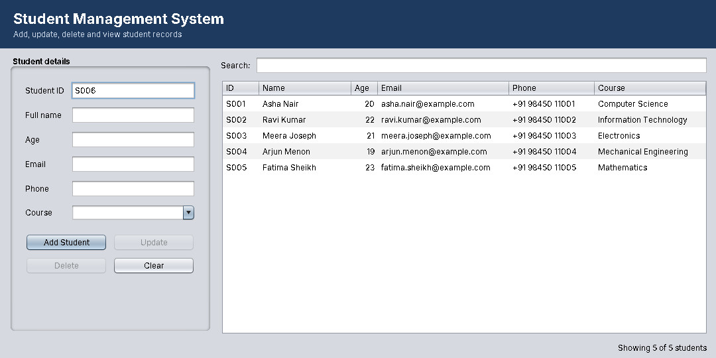
Figure 1. Main student list screen.
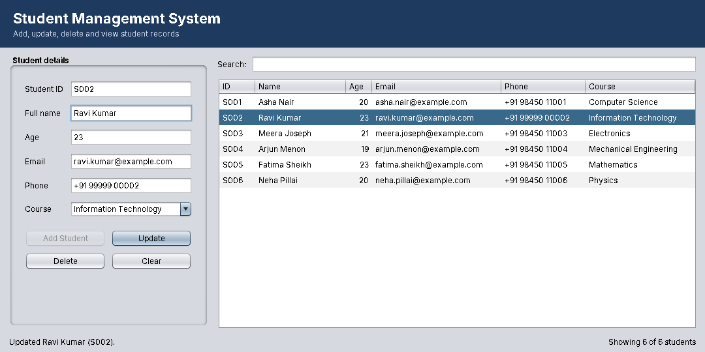
Figure 2. Updating a selected student.
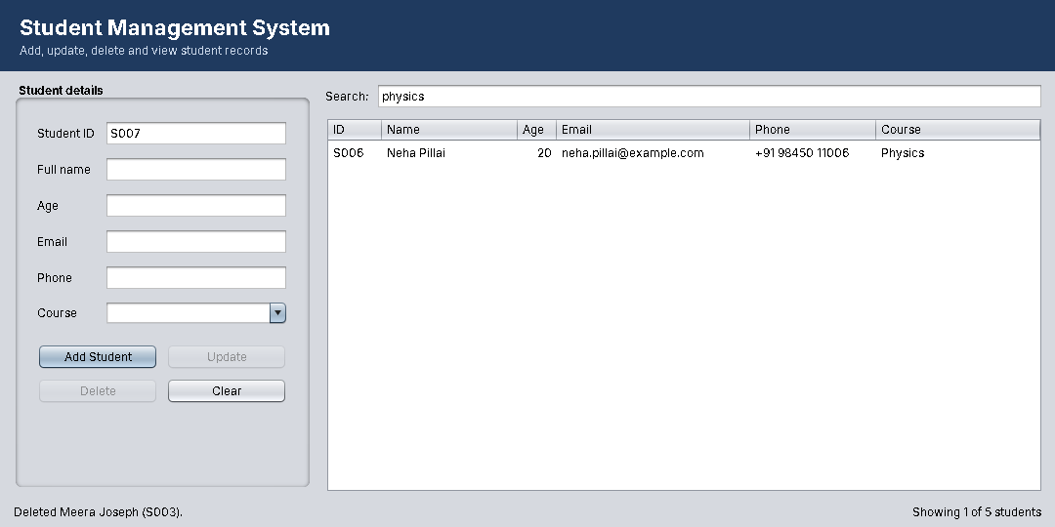
Figure 3. Searching and filtering records.
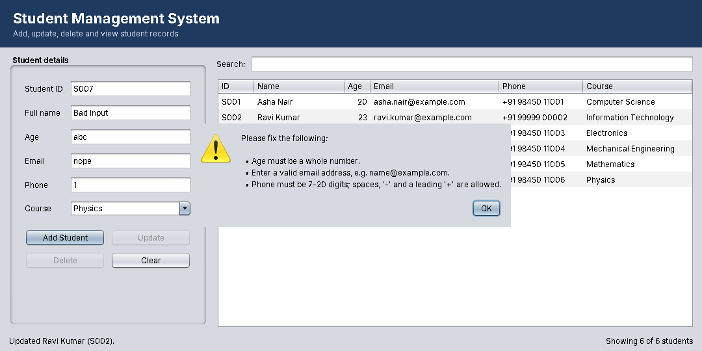
Figure 4. Input validation feedback.
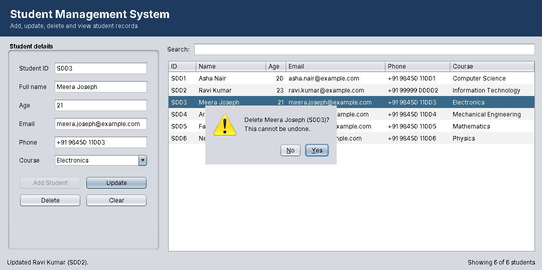
Figure 5. Delete confirmation dialog.

12. Limitations and Possible Enhancements
The current version uses a local CSV file rather than a multi-user database. Possible future improvements listed in the project README include PDF/Excel export, course filtering, additional student fields such as GPA or attendance, and migration to SQLite or MySQL using JDBC.

13. Conclusion
The project implements the five workflow steps for Task 1 in the Auspify Technologies Software Development Internship task list: interface design, student creation, update and delete operations, student information display, and application testing. The developer reported that all six manual checks passed. The supplied source archive also includes automated test code, launch scripts, sample CSV data and application screenshots.

14. Submission Details
GitHub repository: https://github.com/Sinan313/StudentManagementSystem
Submitted by: Mohammed Sinan C
Submission date: 9/11/2026

