Techolas Technologies, Calicut
Spotify Song Popularity Prediction
A Machine Learning Regression Project on Spotify's Top Songs (2010–2019)
Project Title: Analysis and Prediction of Spotify Song Popularity Using Machine Learning Techniques
Your Name: [Your Name]
Date: August 2026

1. Introduction

Problem Statement
Streaming platforms like Spotify surface millions of tracks to listeners, and popularity is one of the key signals used for recommendation, playlisting, and promotion. This project investigates how well a song's audio characteristics — tempo, energy, danceability, loudness, liveness, valence, duration, acousticness, and speechiness — along with its release year and genre, can predict its Spotify popularity score (0–100). A regression pipeline is built, tuned, and evaluated to answer this question.

Importance
Understanding what drives popularity has real value for artists, labels, and playlist curators deciding how to produce and position a track. It is also a useful diagnostic: if audio features alone cannot explain popularity well, that itself is an important, evidence-based finding about how much of a song's success is driven by factors outside the audio signal (marketing, artist fame, playlist placement, and virality).

2. Dataset Overview

Source
"Top Spotify Songs from 2010–2019, by Year" — originally published on Kaggle by Leonardo Henrique, mirrored on Zenodo under a CC-BY 4.0 license. Each row is a track that appeared in Spotify's year-end Top 10 songs list for that year.

Description
The dataset contains 603 songs and 14 columns spanning 2010–2019: title, artist, genre, release year, and 9 numeric audio features (tempo, energy, danceability, loudness, liveness, valence, duration, acousticness, speechiness), plus the target variable, popularity. There are 184 unique artists and 50 unique (fine-grained) genre labels, and 19 duplicate song titles (re-charted tracks across years).

3. Data Understanding
Standard exploratory checks (head(), tail(), shape(), info(), dtypes, describe(), isnull().sum(), and corr()) confirmed the dataset is clean and complete:
- Shape: 603 rows × 14 columns
- Missing values: 0 (none)
- All numeric columns are integer-typed (Spotify's audio features are provided as 0–100 scaled integers rather than the usual 0–1 floats in this dataset)
- popularity ranges from 0 to 99, with most tracks clustered between 50 and 85

4. Exploratory Data Analysis

4.1 Correlation Heatmap
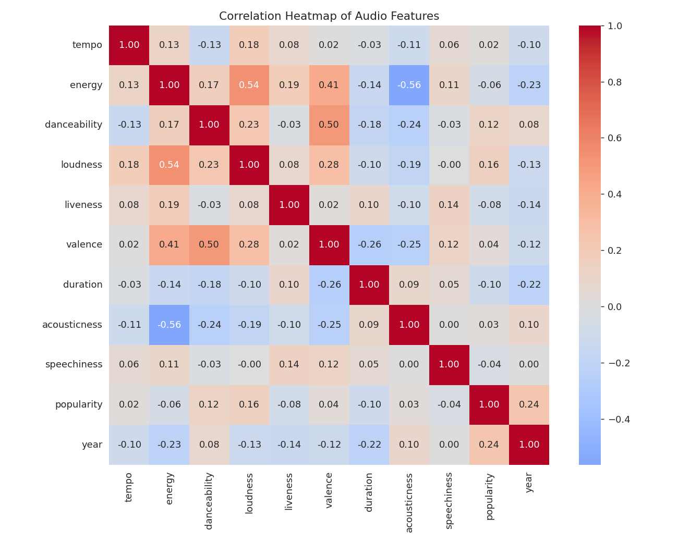
Figure 1. Correlation heatmap of all numeric audio features and popularity.
The strongest correlations with popularity are weak: year (r = 0.241), loudness (r = 0.157), danceability (r = 0.116). The most notable relationship in the whole matrix is between energy and loudness (r ≈ 0.54) — louder tracks are, unsurprisingly, more energetic-sounding.

4.2 Boxplots — Outlier Detection
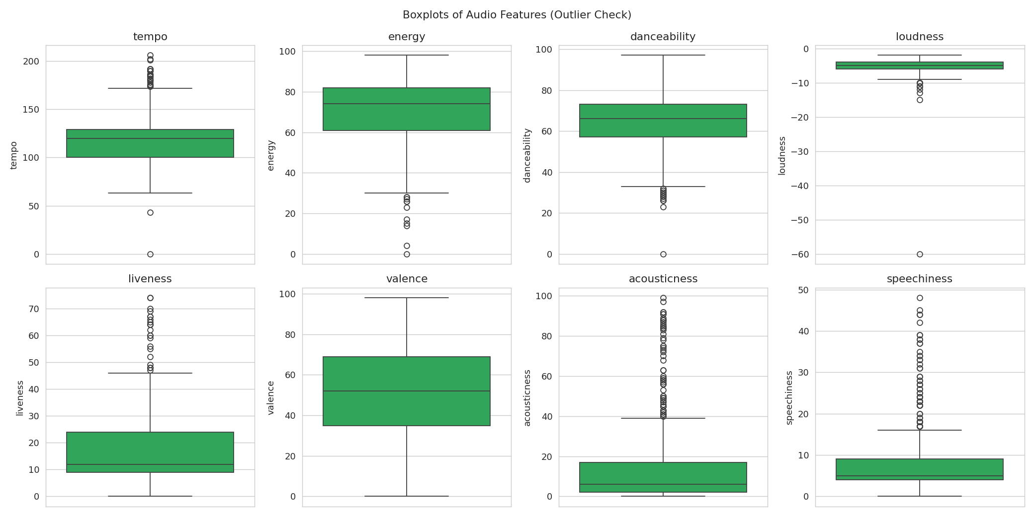
Figure 2. Boxplots of the 8 core audio features, used to identify outliers.
One track ("Million Years Ago") has tempo, energy, danceability = 0 and loudness = −60 dB — a silent/hidden-track data artifact rather than a real audio signature, and was removed in preprocessing (see Section 5).

4.3 Pairplot — Popularity vs Key Features
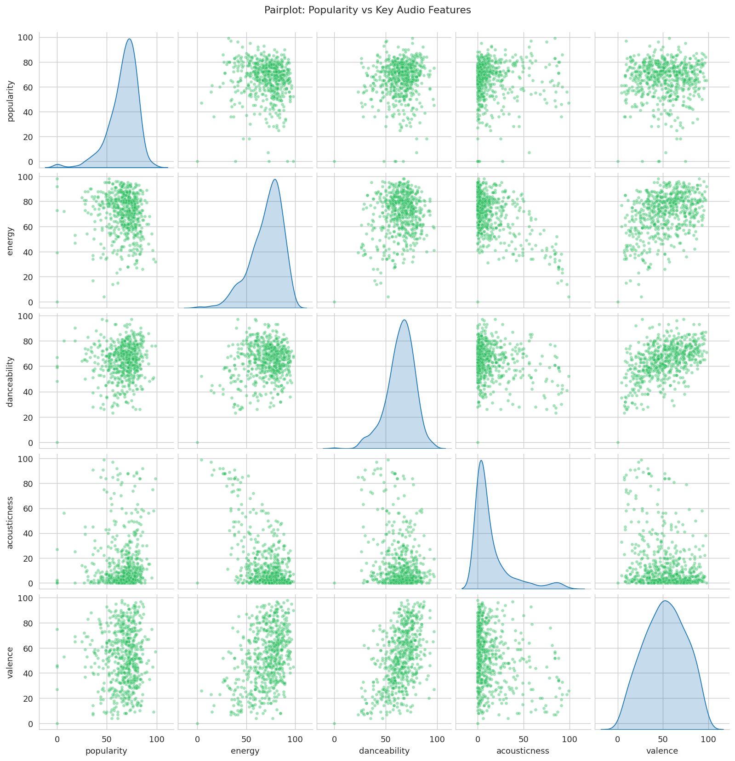
Figure 3. Pairwise relationships between popularity, energy, danceability, acousticness, and valence.

4.4 Count Plots — Genres and Songs per Year
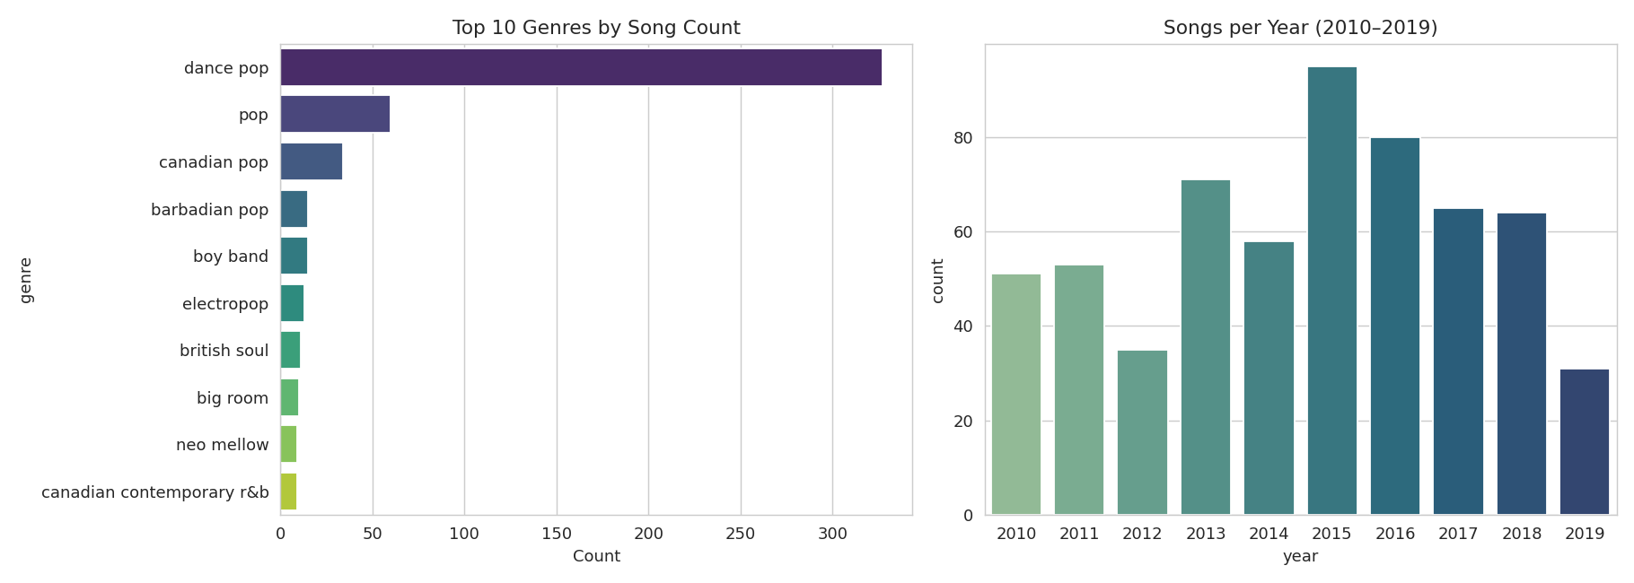
Figure 4. Top 10 genres by song count (left) and number of charted songs per year (right).
"Dance pop" dominates the dataset by a wide margin, reflecting the pop-heavy nature of year-end Top 10 playlists in this decade.

4.5 Popularity Distribution
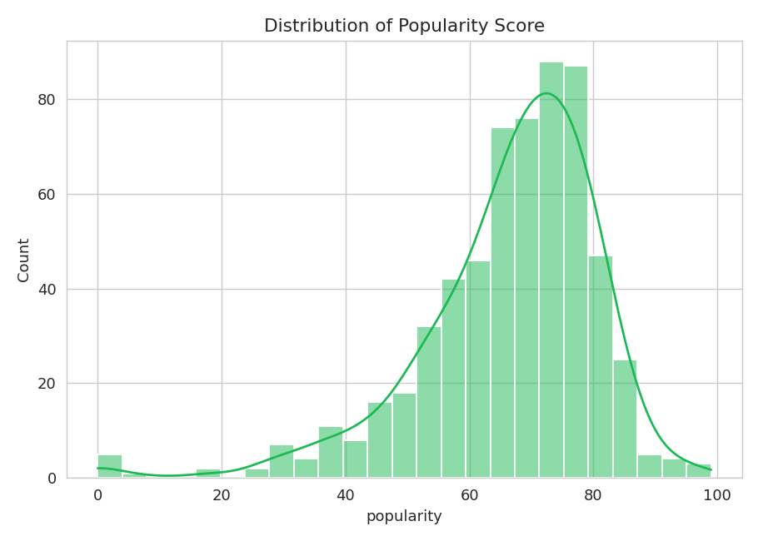
Figure 5. Distribution of the target variable, popularity.

5. Data Preprocessing
The following preprocessing steps were applied before modeling:
- Outlier removal: dropped rows with popularity = 0 (removed/blocked tracks) and loudness ≤ −30 dB (the silent-track artifact) — 5 row(s) removed.
- Categorical encoding: genre has 50+ sparse categories; genres with fewer than 8 songs were grouped into "other", yielding 12 genre groups, then one-hot encoded.
- Feature scaling: numeric features were standardized with StandardScaler, fit on the training set only to avoid data leakage.
- Train/test split: 80/20 split (random_state = 42) → 478 training rows, 120 test rows, 22 total features.

6. Hyperparameter Tuning and Cross-Validation
Hyperparameters (e.g. regularization strength, tree depth, number of neighbors) control model complexity and cannot be learned directly from training data — they must be searched over and validated. This project uses GridSearchCV with 5-fold cross-validation (shuffled KFold) and negative mean squared error as the scoring metric, so the selected hyperparameters generalize rather than overfitting a single validation split.

7. Model Building
This is a regression task (predicting a continuous popularity score), so nine regression models were trained and tuned: Linear Regression, Ridge, Lasso, K-Nearest Neighbors (KNN), Support Vector Regression (SVR), Decision Tree, Random Forest, AdaBoost, and Gradient Boosting.
- Linear Regression / Ridge / Lasso: fit a linear relationship between features and popularity; Ridge and Lasso add L2/L1 regularization to reduce overfitting and (for Lasso) perform feature selection.
- KNN: predicts a song's popularity as a (possibly distance-weighted) average of its k nearest neighbors in feature space.
- SVR: fits a regression function within an epsilon-margin tube, using kernels (linear/RBF) to capture non-linear relationships.
- Decision Tree / Random Forest: tree-based models that split on feature thresholds; Random Forest averages many trees to reduce variance.
- AdaBoost / Gradient Boosting: ensemble methods that build models sequentially, each correcting the errors of the previous ones.
Note: XGBoost was originally planned (per the project's classification/regression guideline) but could not be installed in this offline environment; Gradient Boosting was used as the closest available substitute. See Limitations.

8. Model Evaluation

Metrics
Models are compared using RMSE (Root Mean Squared Error), MAE (Mean Absolute Error), and R² Score on the held-out 20% test set.

Results
Model | RMSE | MAE | R²
Linear Regression | 12.967 | 9.71 | 0.066
GradientBoosting | 13.058 | 9.716 | 0.053
Decision Tree | 13.059 | 9.922 | 0.053
Lasso | 13.108 | 9.971 | 0.046
Ridge | 13.123 | 9.911 | 0.043
AdaBoost | 13.147 | 10.023 | 0.04
Random Forest | 13.156 | 9.888 | 0.039
SVR | 13.265 | 9.767 | 0.023
KNN | 13.475 | 10.03 | -0.009

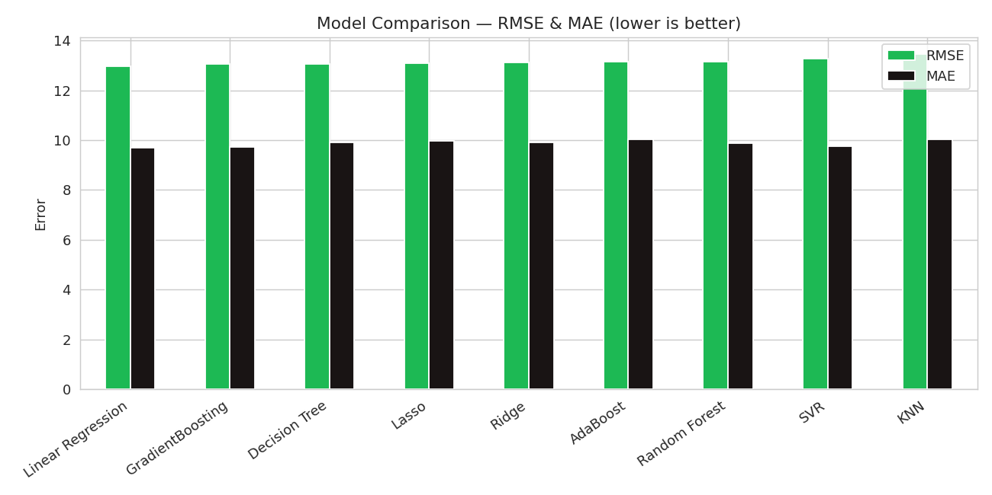
Figure 6. RMSE and MAE by model (lower is better).
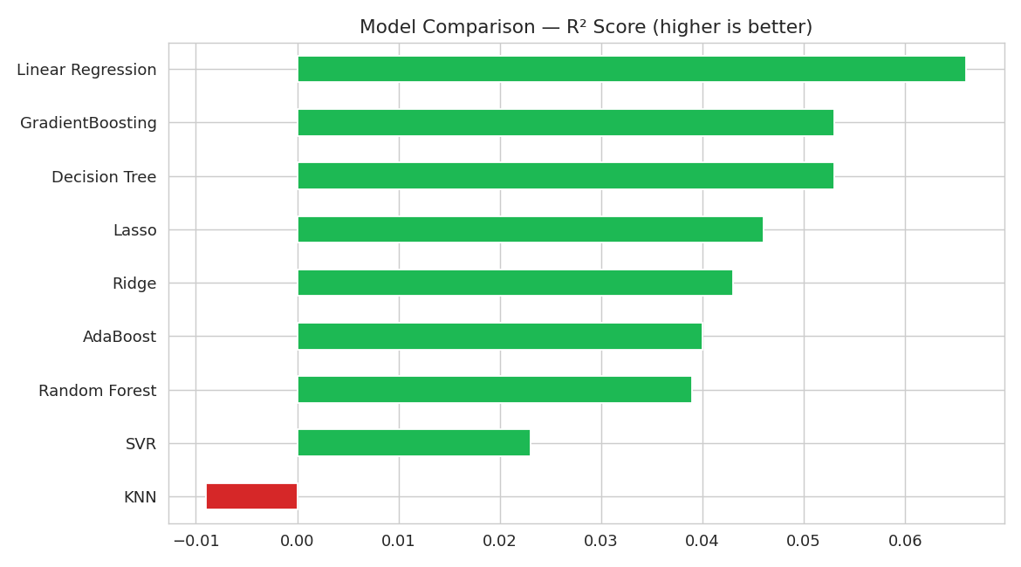
Figure 7. R² score by model (higher is better; negative means worse than predicting the mean).
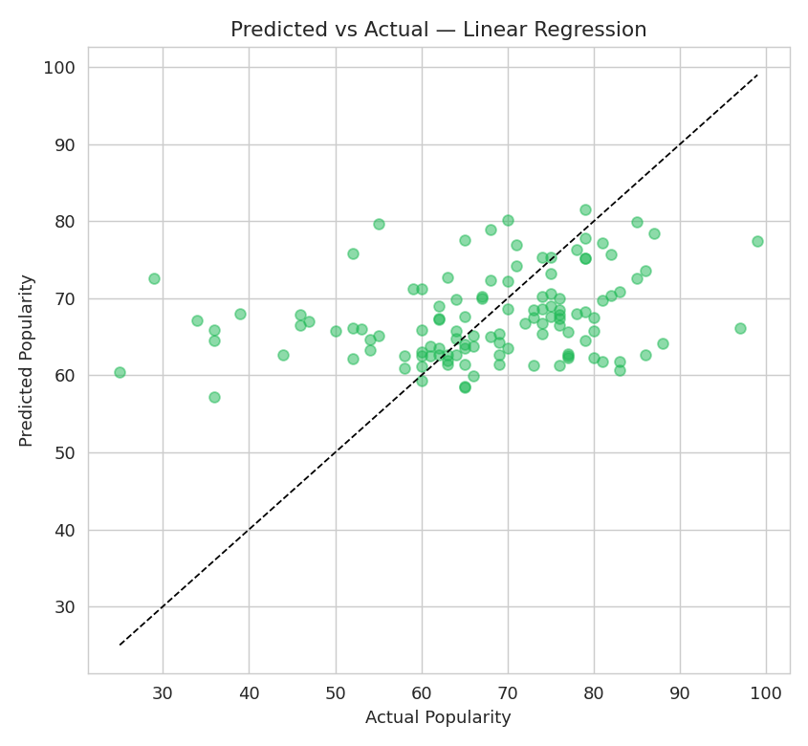
Figure 8. Predicted vs. actual popularity for the best model, Linear Regression. Points on the dashed line are perfect predictions.
The best-performing model on the held-out test set was Linear Regression, with RMSE = 12.967, MAE = 9.71, and R² = 0.066. All nine tuned models scored within a narrow R² band (roughly -0.009 to 0.066), indicating the ceiling on predictive power here is set by the available features, not by model choice.

9. Conclusion

Key Findings
- Linear Regression was the strongest of nine tuned models, but by a small margin — audio features alone explain only a small share of the variance in popularity (R² ≈ 0.066).
- year and loudness showed the (weak) strongest individual correlations with popularity.
- Energy and loudness are collinear (r ≈ 0.54), as expected physically.
- More complex models (Random Forest, Gradient Boosting) did not meaningfully outperform simple linear models — evidence that the limiting factor is signal, not model capacity.

Limitations and Improvements
- The dataset only contains songs that already reached a year-end Top 10 list, so the model can only distinguish degrees of hit songs, not hits from non-hits — a fuller dataset including non-charting songs would likely show a stronger, more meaningful relationship.
- 603 rows is a small sample for tuning nine models; a larger dataset (e.g. the ~170k-track Spotify dataset referenced in the project brief) would give more stable estimates.
- XGBoost could not be installed in this environment; a production run should include it for comparison against Gradient Boosting.
- Non-audio features — artist follower count, playlist placements, release-week streams, social media activity — would likely add substantially more predictive power than further audio feature engineering.

10. References
- Dataset: "Top Spotify Songs from 2010–2019, by Year," originally compiled by Leonardo Henrique on Kaggle; mirrored on Zenodo (CC-BY 4.0).
- Kharwal, A. (2021). Spotify Recommendation System with Machine Learning — reference article that inspired this project's framing.
- scikit-learn documentation, https://scikit-learn.org
- University of British Columbia, DSCI 522 — Spotify Track Popularity Predictor (comparable prior work predicting popularity from audio features).

