ConduVet
User Tutorial (V0.2)
A guide for Normal Users, Vetters, and Admins

About This Tutorial
ConduVet is a web application for vetting crowd-sourced tabular data. An administrator uploads Excel workbooks that contain both the data and its schema; users log in, fill in or correct the records assigned to them, and submit them. Every change is audited, backups run automatically, and the data can be downloaded at any time as a clean Excel file.
The instance title you see in the header is set by the administrator — in the examples in this guide, it appears as “CTI Data Vetting [Test].” This tutorial is split into three parts so you can read only what applies to you:
Part | Read this if you are… | What you will learn
Part 1 — Users | Normal users who logs in to review or enter records | Logging in, finding your data, editing the grid, fixing errors, and submitting
Part 2 — Vetters | Vetting users assigned to approve normal user record entries | The Vetted checkbox, vetted-lock, and your extra abilities
Part 3 — Admin | The server adminstrator who sets up and manages the instance | First-run setup, uploading files, reports, configuration, and backups

NOTE: while an “Admin” user logs in using a separate login screen, a “Vetter” uses the normal login screen. A vetter is an ordinary user who has been assigned as the Group Vetter on records belongingin to the Group. So Part 2 of this document builds on Part 1 — read Part 1 first, then add the vetter abilities on top.

Before You Begin
- Browser: any modern browser — Chrome, Firefox, Safari, or Edge.
- Connection: ConduVet runs online and needs a stable internet connection; there is no offline mode.
- Account: your administrator provides your User ID. You may sign in with an emailed PIN or a password.
- Address: open the URL your administrator gave you (use http://localhost for a local deployment). The user login screen has an Admin login → link at the bottom for administrators.

Part 1 — Normal Users
This part covers everything a normal user needs: signing in, opening your data, editing records in the grid, fixing validation errors, and submitting your work.

1.1 Logging In
The login screen shows your User ID field and two options: Login with PIN (the primary method) and Use Password (the fallback).

PIN by email (primary)
- Enter your User ID and click Login with PIN.
- A 5-digit PIN is emailed to you at userid@your-domain.
- Type the PIN and confirm. PINs expire after a short window (15 minutes by default), so check your email promptly.
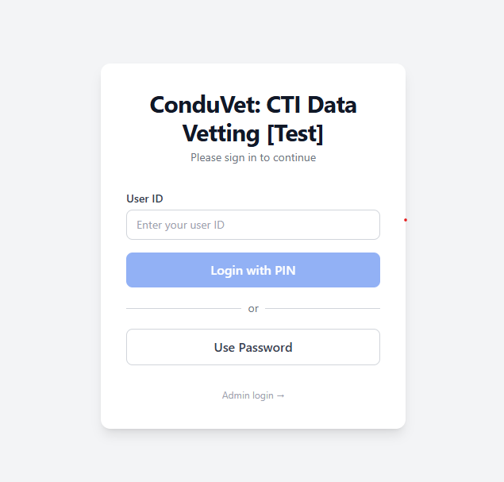
Figure 1. The login screen — enter your User ID, then choose Login with PIN or Use Password.

Password (fallback)
- On the login screen, click Use Password.
- Enter your User ID and Password, then sign in.
TIP If your PIN does not arrive, check your email spam folder. If still not able to login, switch to Use Password or contact your administrator.

1.2 Choosing a Dataset
After login you land on the dashboard, which shows one button per dataset available to you. Click a dataset button to open its data-entry screen.
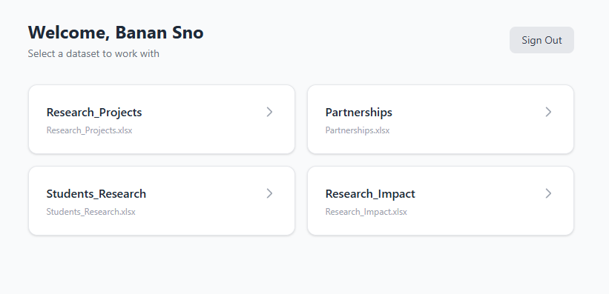
Figure 2. The user dashboard — pick a dataset to open it; Sign Out is top-right.

1.3 The Data-Entry Interface
The data-entry screen has three regions:
- Header bar — a ← Back link, the dataset name, an + Add Record button, and the Submit button (top-right).
- Data grid — your records as rows and fields as columns. Each column header has a filter icon; each row has a “duplicate” button on the left and a delete (trash) icon on the right.
- Context panel — along the bottom: “Click a cell to see field details” on the left, and the “Edit History” panel on the right. The information in this panel is context sensitive and will change as the user navigates to different fields in the Data Grid region.
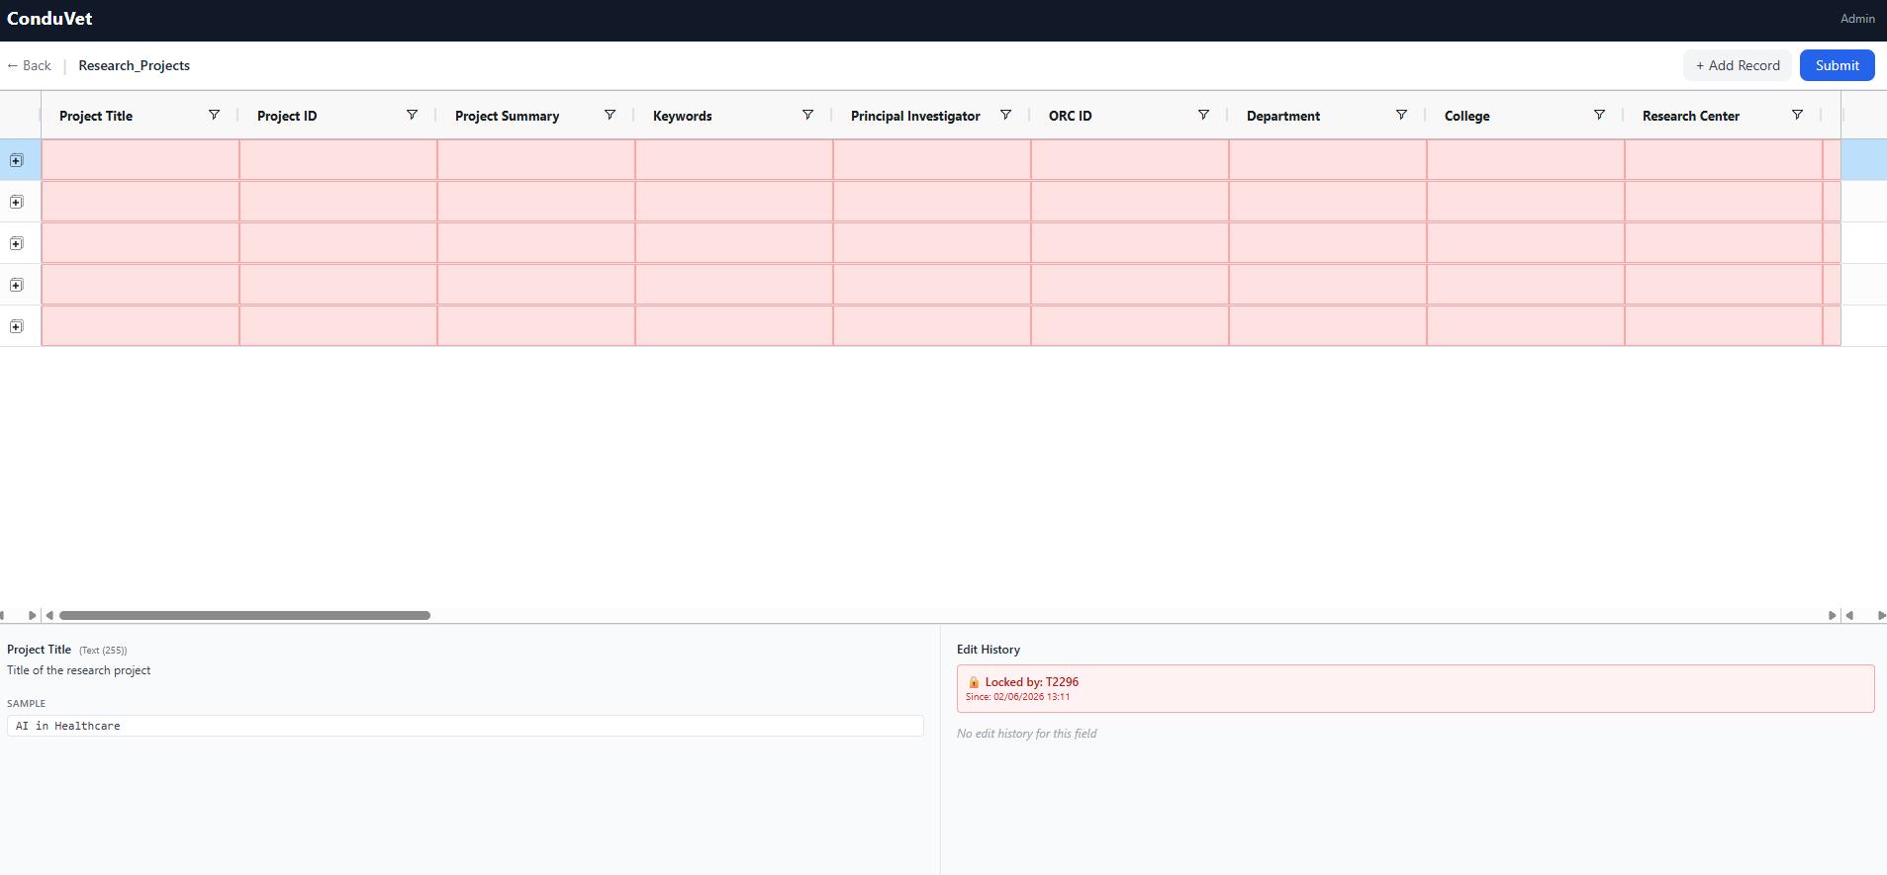
Figure 3. The data-entry grid — header (+ Add Record, Submit), the grid, and the context panel showing field details, a sample value, and edit history.

Understanding cell colours
Cell background colour tells you the state of each cell at a glance:
Colour | Meaning
White | Normal, editable cell
Light blue | You changed this cell — pending save
Light red | Validation error — hover for the message
Grey | Cannot edit (locked, vetted, or restricted)
Amber / italic | Protected field — read-only on existing records

The context panel
- Left — click a cell to see that field’s description and a sample value. This provides timely information to help the user fill in the requested information correctly.
- Right — the “Edit History” panel shows the changes for the selected cell: who changed it, when, and the old → new value. If the record is locked, this is where you see who locked it.

1.4 Editing Records
You can edit a record when you are its owner, or when its owner is set to ALL (shared records).

Navigating and editing
- Move with Tab, Shift+Tab, or the arrow keys; or click a cell.
- Start typing to edit a focused cell; press Enter or Tab to confirm and move on.
- Cell editors match the field type: text, number, date picker, dropdown (List), checkbox (Boolean), and comma-separated multi-value fields. URLs become clickable links automatically; this feature is intended to provide links to evidence but may have other uses.
- Use a column’s filter icon to narrow the rows shown

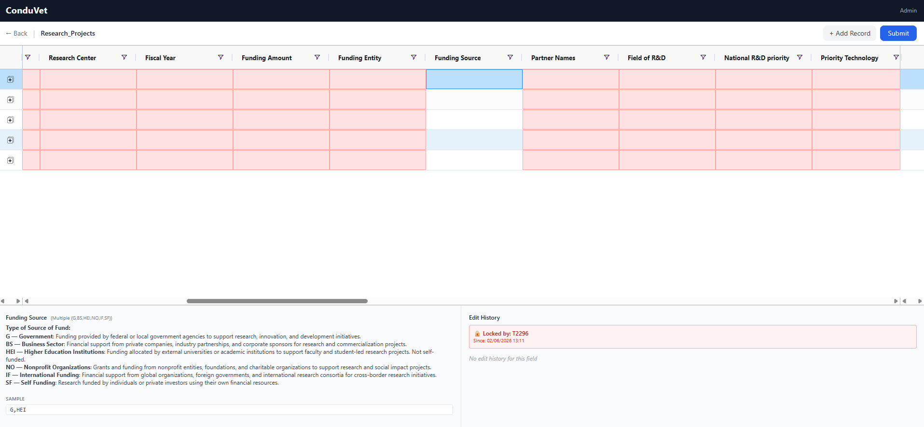
Figure 4. Click a cell to select it (highlighted blue); the context panel shows the field’s help and its allowed values.

Adding a record
- Use + Add Record to add a new blank row — owned by you, status New, and unvetted (“Vetted” unchecked).
- Or use the “duplicate” button on a row to copy it into a new record. Handy for similar entries; the copy is always unvetted.
TIP Use Ctrl/Cmd+C and Ctrl/Cmd+V to copy a value from one cell into another — handy when many cells share a value.

1.5 Deleting Records
Click the delete (trash) icon to the right of the row; a confirmation prompt appears, and the deletion is recorded in the edit history.

1.6 Validation & Fixing Errors
ConduVet checks your entries as you type and again when you submit — type, numeric range, text length, required fields (including conditional “depends-on” rules), and allowed dropdown values.
- Find the red cell.
- Hover over it to read the error (e.g. “must be between 0 and 100”, “required”, or “is not a valid date. Use DD/MM/YYYY format”).
- Correct the value — the cell turns white when the error clears.
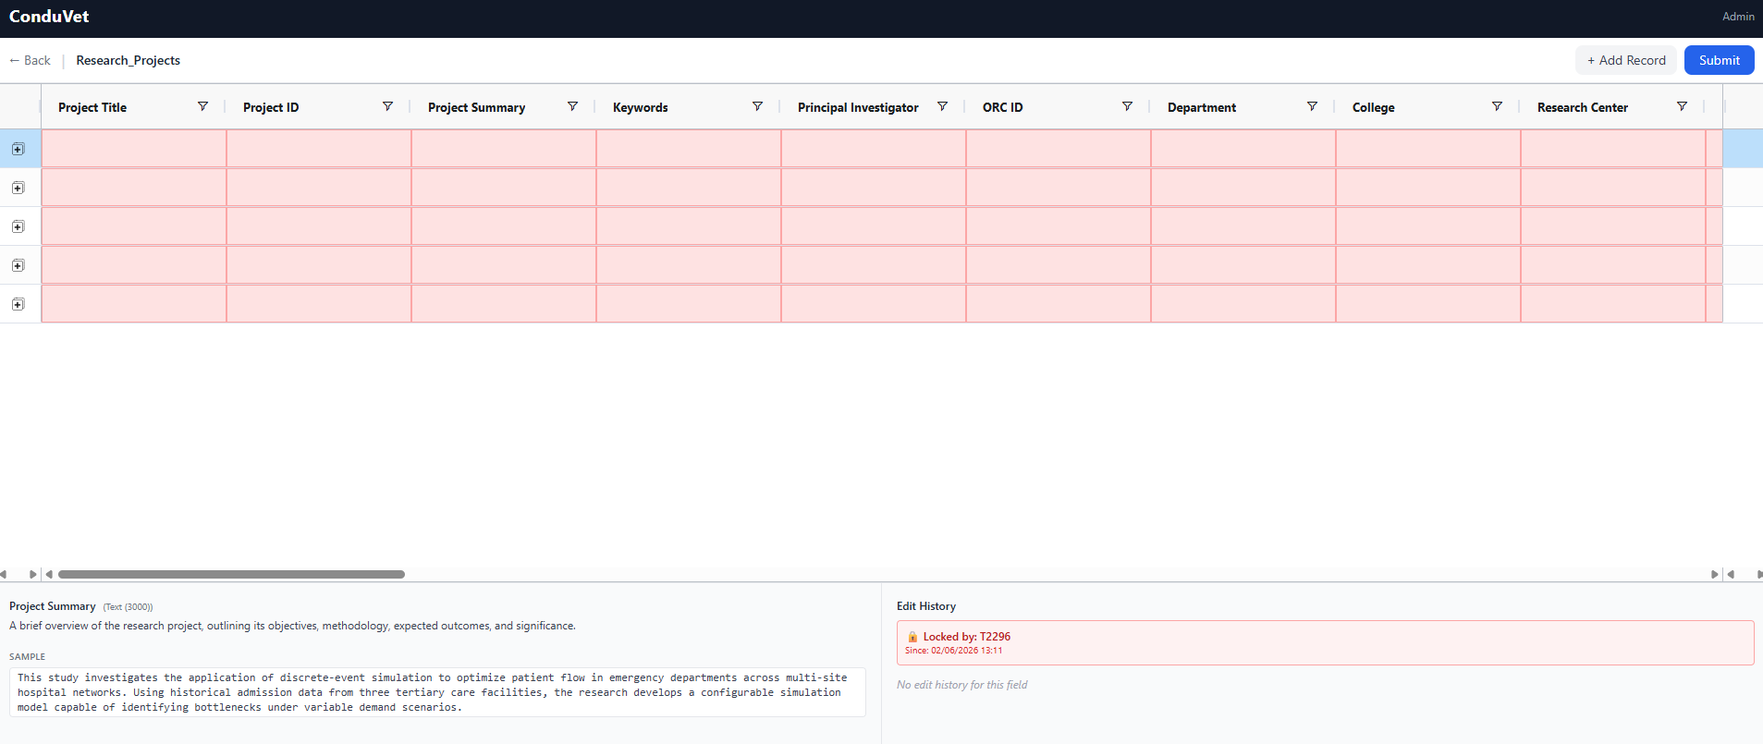
Figure 5. Cells needing input are highlighted in red; the context panel shows the field description and a sample value.

A cell is flagged for one of these reasons:
- Required field left blank — the field cannot be null (for example, “‘Project Title’ is required and cannot be left blank”).
- Wrong type or format — the value doesn’t match the field: text typed into a number field, a date in the wrong format, or a value that isn’t one of the allowed list options.
- Outside the allowed limits — a number above or below its range, or text longer than the field’s character limit.
When you click Submit while errors remain, a red summary banner appears at the top of the grid. It counts the problems (for example, “25 field error(s) in 1 record(s) must be fixed before saving”), lists the first few by name, and ends with “…and N more.” Invalid cells stay red — hover each one for its specific message. Fix them and submit again; you can dismiss the banner with the × on the right.
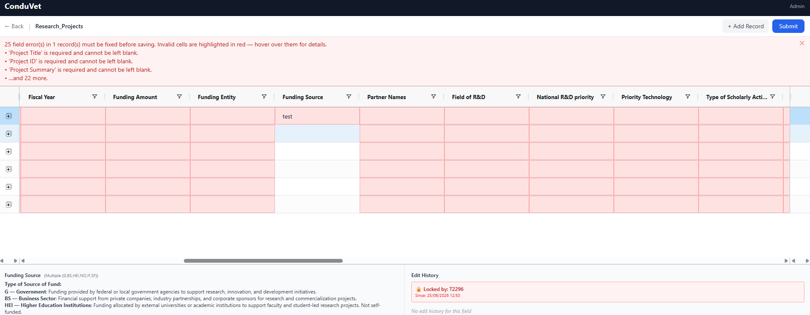
Figure 6. The on-submit error summary — the banner counts and names the problems, and the invalid cells remain highlighted in red until fixed.

NOTE Dates must match the format shown in the field description and error message — watch the separator (/, -, .). Single digits like 1/3/2024 are padded automatically.

1.7 Record Locking
When you start editing a record, it is locked to you, so no one else can change it at the same time. The lock releases when you submit, log out, or your session times out. If another user holds a record, its row is greyed out, and the Edit History panel shows who locked it — just wait for the user to complete their edits, or contact them directly to coordinate.
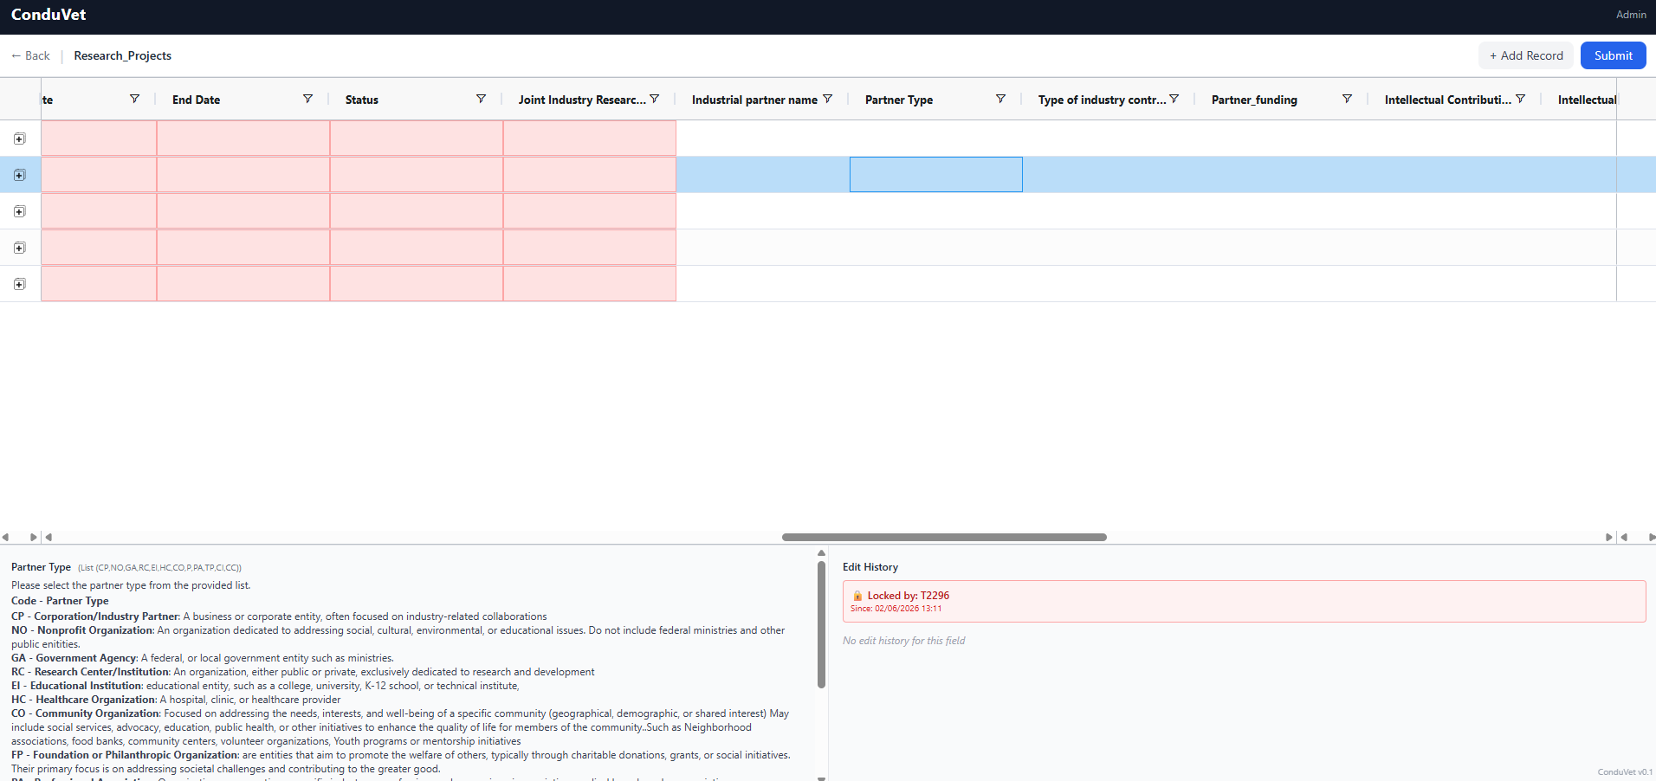
Figure 7. When a record is locked, the Edit History panel shows who holds it (here, “Locked by: T2296”).

1.8 Protected Fields
Some fields are marked protected by the administrator — stable, sensitive values such as identifiers or baseline figures. On existing records, they appear with an amber, italicized background and are read-only for owners. You can still set them when you first create a record; after you submit, they lock. If a protected field needs to change later, ask your vetter or admin. You can always copy the record into a new one and make the edit you need, inform the vetter of what you’d like to do with the original record.

1.9 Submitting Your Changes
Changes are held locally until you submit them with the Submit button at the top-right of the grid.
- Check for any red cells — fix them first.
- Review the blue (changed) cells to confirm your edits.
- Click Submit. Full validation runs; if anything fails, fix the highlighted cells and submit again.
- On success, your changes are stored, the edit history is updated with your name and timestamp, and the locks are released.
WARNING Changes are not saved automatically. If you navigate away or time out before submitting, unsaved edits are lost. Submit every few minutes.

1.10 Session & Auto-Logout
Your session ends automatically after a period of inactivity (30 minutes by default). Any click, keystroke, scroll, or mouse movement resets the timer. When it expires, you are logged out, locks release, and unsaved work is lost — so submit regularly and use Sign Out / Logout when you step away.

Part 2 — Vetters
A vetter is a user assigned to approve specific Group records. Everything in Part 1 still applies; this part adds the extra abilities you get as a vetter.

2.1 Are You a Vetter?
You are a vetter for a record if your User Group matches the record’s Group. On those records, you can edit any field, including ones the owner cannot, and once done, mark the editable Vetted checkbox.
Role | What they can do
Record Owner | Create and edit their own records; change Record Status when not vetted
Group Vetter | Edit all fields; check/uncheck Vetted; delete records belonging to the same group as the vetter
Admin | Full access to all records and fields

2.2 The Vetted Checkbox & Vetted-Lock
Scroll the grid to the right to find the Vetted, Vetter, and Record Status columns. The Vetted checkbox is how you approve a record. Only the assigned vetter can tick it; the owner sees it as read-only.
- Tick Vetted to approve the record. The record then locks for the owner — all their cells grey out, and they cannot edit until you untick it. This approach allows the vetter to focus on unvetted records and incrementally vet the assigned records without needing to recheck already vetted ones.
- You (the vetter) and the admin keep full edit access regardless. All edits are still tracked in the audit trail (History).
- Untick the box to reopen the record so the owner can make further changes.
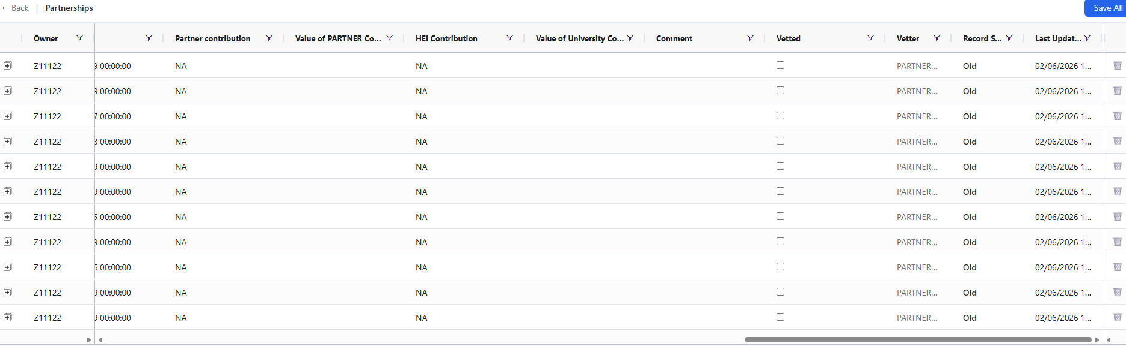
Figure 8. Scroll the grid right to reach the Vetted checkbox, Vetter, and Record Status columns.

2.3 Editing & Record Status as a Vetter
As a vetter, you can edit all fields at any time and change Record Status on a vetted record (the owner can only change status while the record is not vetted). Status values are New, Updated, Old, and Archived, and every change is logged in the Edit History panel.

2.4 Deleting Records
Click the delete (trash) icon to the right of the row; a confirmation prompt appears, and the deletion is recorded in the edit history.
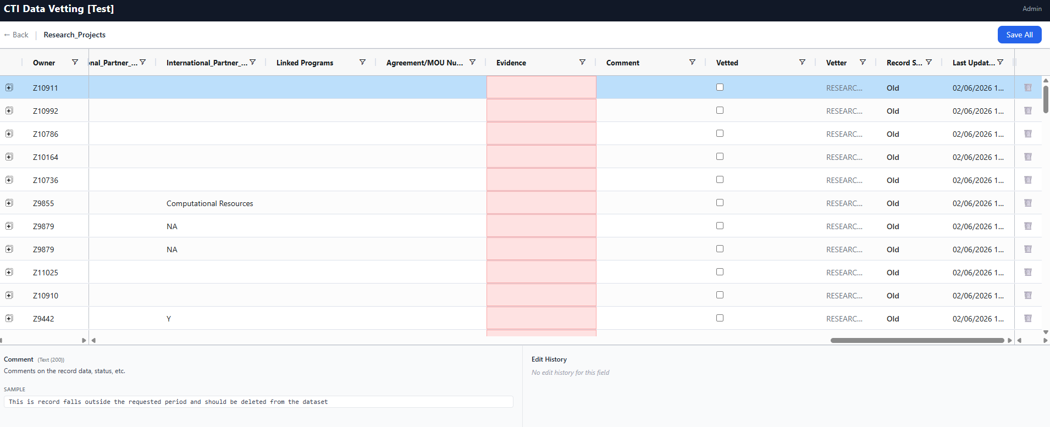
Figure 9. As the assigned vetter, use the trash icon at the right of a row to delete a record; a confirmation appears, and the deletion is recorded in the edit history.

2.5 Recommended Vetting Workflow
- Open the dataset and locate records where you are the vetter.
- Review each record against the field help in the context panel.
- Fix anything minor yourself, or set Record Status / leave it for the owner.
- Tick Vetted to approve — this freezes the record for the owner.
- If the owner later needs a change, untick Vetted, let them edit, then re-approve.
- Click Submit to save your changes.

Part 3 — Admins
Admins set up the server instance, upload data, run reports, and manage configuration and backups. The admin interface has three tabs — Files, Reports, and Configuration — with a Sign Out link in the top-right corner.

3.1 First-Run Configuration
On a brand-new server instance with no configuration, every page redirects to Admin Setup. You upload two files there.

config.yaml
Defines the instance title, admin credentials, backup location, auto-logout timeout, and email/PIN settings. Key fields:
Key | Description | Required
title | Shown in the header | Yes
admin_account | Admin username for /admin/login | Yes
admin_pass | Admin password (stored hashed) | Yes
backup_dir | Where Excel backups are written | Yes
auto_logout_minutes | Inactivity timeout (1–480, default 30) | No
smtp_config | Email server for PIN delivery | For PIN login
admin_allowed_ips | List of approved IP addresses or IP scopes for Admin login | Yes
pin_expiration_minutes | Expiriation time for the emailed login PIN | No

NOTE Without smtp_config, PIN email login is disabled and only password login works.

users.csv
One row per user, with columns userid, name, and password. The userid is the login name and is matched to record ownership (case-insensitive); the password is stored as a hash on upload.
- Open /admin/setup.
- Upload config.yaml and users.csv.
- Click Save Configuration — you are redirected to the admin login.

3.2 Admin Login
Reach the admin login from the “Admin login →” link on the user login screen, or go to /admin/login directly. Enter the admin Username and Password and click Sign In; the “← Back to user login” link returns you to the user screen. Admin sessions last 8 hours.
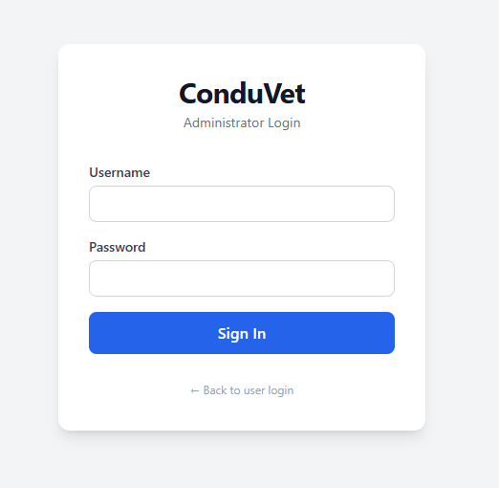
Figure 10. The Administrator Login page (Username, Password, Sign In).

3.3 Files Tab
The Files tab is where you upload and manage data workbooks. A drop zone sits at the top; uploaded files appear below as cards showing an Active badge, the record count, and the upload date, each with View / Edit, Download, and Remove buttons.

Uploading a file
- Drag a workbook onto the “Drop a file here or click to browse” zone, or click it to browse. Excel or CSV is accepted.
- ConduVet validates that the Data and Schema sheets exist and that every Schema field maps to a Data column; field-level errors are shown otherwise.
- Any Edit History sheet is imported as the audit trail.
- On success, the file appears as a card with its record count.
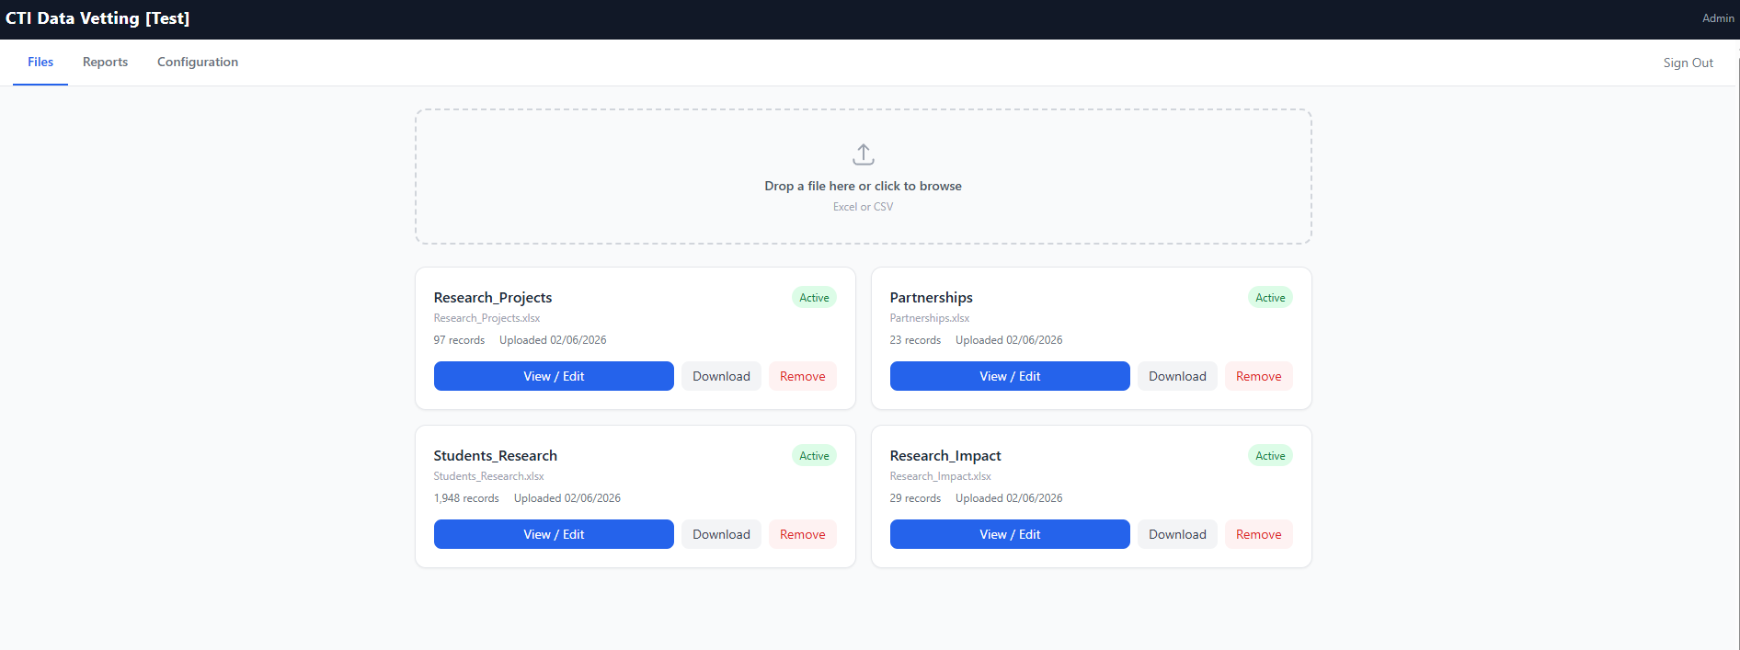
Figure 11. The Files tab — upload drop zone and uploaded-file cards with View / Edit, Download, and Remove.

Managing files
Action | Effect
View / Edit | Open the grid for that file. Admins see all records with Owner and Vetter editable, and can delete any row.
Download | Export the current state as an Excel workbook (Data + Schema + Edit History).
Remove | Soft-delete the file (data is retained in the database).

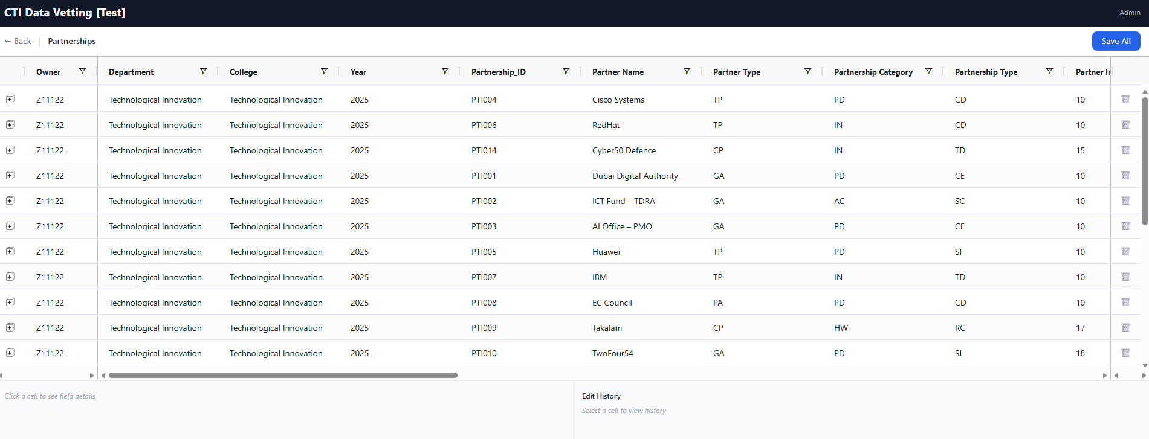
Figure 12. View / Edit opens the full grid for a file; admins see every record with the Owner and Vetter columns editable.

3.4 Reports Tab
Reports are grouped into System-Wide and File-Specific. For file-specific reports, choose a file from the dropdown, then switch between By User and By Record. Every report has a “Search all columns” box and a Download Excel button.
- Currently Logged In Users (system-wide) — active user and admin sessions.
- By User (per file) — columns: Owner, Total, New, Updated, Old, Unvetted, Delete.
- By Record (per file) — columns: ID, Owner, Record Status, Last Updated, Field Changes.
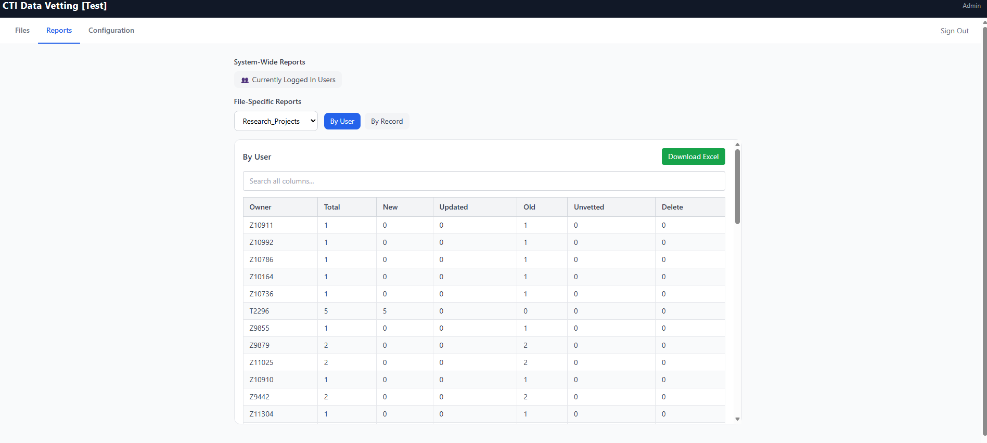
Figure 13. Reports → By User (Owner, Total, New, Updated, Old, Unvetted, Delete).

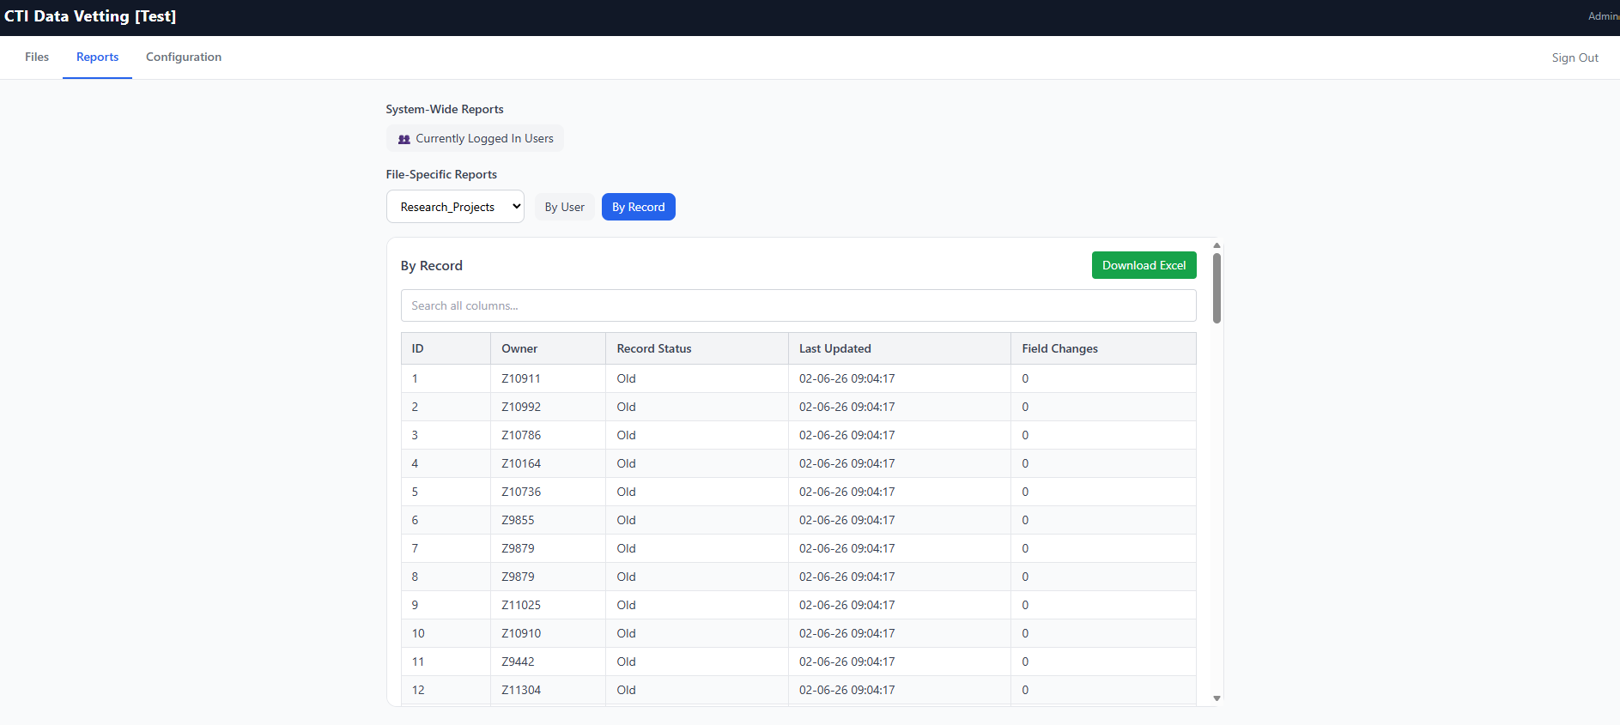
Figure 14. Reports → By Record (ID, Owner, Record Status, Last Updated, Field Changes).

3.5 Configuration Tab
The Configuration tab shows the Current Configuration (Title, Admin Account, Backup Dir, Auto-Logout) and provides two separate update cards:
- Update Configuration — upload a new config.yaml (it must contain title, admin_account, and admin_pass; auto_logout_minutes is optional) and click Update Configuration.
- Update Users — upload a new users.csv (columns userid, name, password) to replace all user accounts, then click Update Users.
WARNING Further down the tab, the Reset All Data button (Danger Zone) permanently deletes all datasets, user accounts, and the configuration, returning the app to its unconfigured state. A confirmation is required and it cannot be undone.
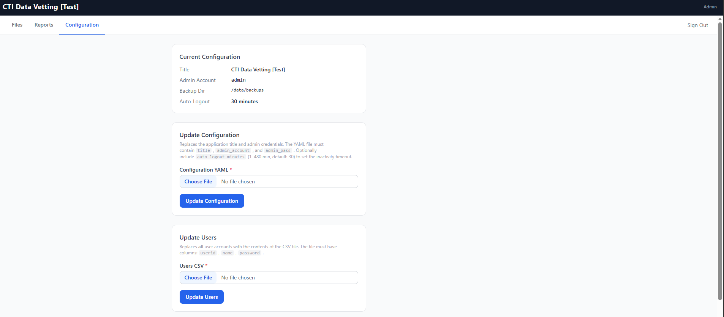
Figure 15. The Configuration tab — Current Configuration plus the Update Configuration and Update Users cards.

3.6 Automatic Backups
- A backup job runs every 2 hours for each active file.
- Each backup is a full Excel export (Data + Schema + Edit History).
- Up to 24 backups per file are kept; the oldest is dropped when a 25th is written.
- Files are named {display_name}_{YYYYMMDD_HHMM}.xlsx in the backup_dir from config.

