Policy Brief: Closing the Cumulative-Impact Blind Spot
Why Malaysia's (and Indonesia's) environmental review thresholds are missing the data centre sector's real footprint
Sinar Project PLT | Global South Alliance | For regulators, planning agencies, and legislators | July 2026
1-2 acres  typical size of a single data centre parcel in Johor | 16  facility corridors independently measured for tree cover loss | 1,540 ha  combined tree cover lost since 2001 across those corridors | 0  legislative sittings (2008-2026) that discuss this land-use impact

The problem
Malaysia's Environmental Impact Assessment (EIA) system, like Indonesia's comparable AMDAL/UKL-UPL/SPPL system, reviews developments once they cross a size threshold, measured in hectares of land or scale of activity. These thresholds were written for large, single developments: factories, ports, housing estates. Data centre parcels do not look like that. A single facility in Johor is typically only 1 to 2 acres, far under any threshold that would trigger review.
But data centres are rarely built one at a time in isolation. They cluster: several operators, several buildings, developed sequentially in the same corridor over a few years, often sharing the same grid connection point or industrial zone. Individually, none of them is large enough to require review. Collectively, they can produce a land-use and resource footprint that would clearly warrant review if it had been proposed as a single project.
No single facility ever crosses the line. The corridor does.
The evidence
An independent satellite-based analysis of 16 facility corridors across Malaysia found approximately 1,540 hectares of combined tree cover loss since 2001, some corridors showing complete (100%) loss of their year-2000 tree cover within the development footprint. A full search of the federal Dewan Rakyat and Johor State Assembly record from 2008 to 2026 found no sitting that discusses land clearing or deforestation in connection with data centre development. This is not an oversight by any single legislator: it is the predictable result of a review system where no individual facility is ever large enough to put the issue on the table.
The same structural gap exists in Indonesia's environmental review architecture, suggesting this is a general design mismatch between area-based review thresholds and this specific facility class, not a one-country problem.
Why this is bigger than a permitting gap
The transparency gap (no facility-level disclosure) and the regulatory blind spot documented above are not two separate problems: the second is what makes the first invisible. Because no facility is ever individually large enough to trigger review, the land and resource costs shown here were never disclosed to a regulator, debated by a legislature, or weighed against the RM131 billion in investment actually realised so far (against RM280 billion pledged). That combination, undisclosed resource use plus unreviewed land conversion, is the specific mechanism through which what researchers call digital colonialism operates in practice: foreign-oriented digital infrastructure whose physical costs are borne locally without local visibility or consent, independent of any single company's intent. Indonesia's comparable AMDAL gap suggests this is a structural pattern, not a one-off Malaysian drafting error, which is why the fix below is a design change rather than an enforcement campaign.
Market concentration
The same dataset also shows that this footprint is not spread evenly across the sector. Of the 49 facilities included in the resource-estimation totals, ownership resolves to 45 distinct operators, but the 5 largest account for approximately 70% of total estimated power demand, and the 10 largest account for approximately 81%. A small number of large, primarily foreign-backed infrastructure operators therefore control most of the physical resource footprint this brief describes, even though the review and disclosure gaps documented above apply uniformly across the sector regardless of operator size.
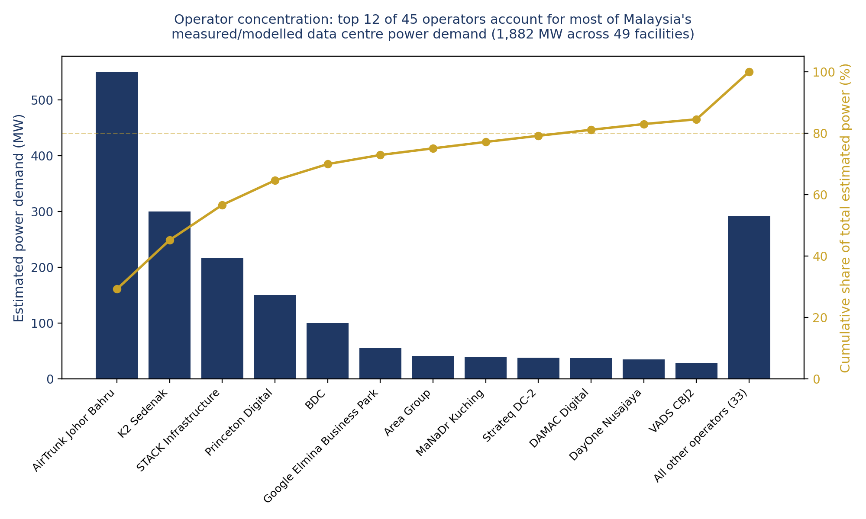
Figure: estimated power demand by operator (top 12 of 45), with cumulative share of the sector's total estimated 1,882 MW. Dashed line marks the 80% threshold.
This concentration matters for the fix proposed below: a cumulative, corridor-level review trigger and a facility-level disclosure requirement would, in practice, first surface the footprint of a small number of large operators, since they account for most of the measured demand. A regulatory response targeted at this sector would not need to reach deep into a long tail of small operators to capture most of the footprint.
What would fix it
- Add a cumulative, corridor-level assessment trigger alongside the existing per-parcel threshold: once several data centre developments within a defined radius or shared utility corridor reach a combined size that would trigger review for a single project, require that joint review, regardless of how many separate legal entities or planning applications are involved.
- Require facility-level power and water capacity disclosure as a condition of planning approval or grid/utility connection, even in coarse bands. This closes the resource-transparency gap that currently forces reliance on satellite-based estimation in the first place.
- Where state or federal incentives (tax holidays, Special Economic Zone status) are granted to data centre operators, attach a public land-use and resource reporting obligation to that incentive, so the legislature that approved the incentive can also see its downstream footprint.
- Treat this as a design fix, not an enforcement problem: existing per-parcel thresholds do not need to change. Only a cumulative trigger needs to be added alongside them.
Further reading
This brief summarises findings from the project's full Policy Audit Report and Comparative Regulatory Desk Review (Indonesia vs Malaysia), both available as companion documents, along with the underlying open dataset of 71 independently measured facilities.

