Target journal: Ecology Letters, Functional ecology

**Title: Matching evolutionary distant organisms: a systematic review on the use of cross-taxa perspective in functional ecology**

André Luís Luza1, Cesar Cordeiro, Diego Barneche, Juan Pablo Quimbayo2, Fernanda Silva, Vinicius Giglio, Thiago Mendes, Luiza Waechter1, Vitor Picolotto, Cristian Dambros1, Ronaldo Francini-Filho2, Mariana Gomes Bender1, Guilherme Longo

1 - Marine Macroecology and Conservation Lab. Universidade Federal de Santa Maria. Santa Maria - RS. Brazil.

2 - CEBIMar, USP. São Sebastião - SP. Brazil.

3 - Marine Ecology Lab. Universidade Federal do Rio Grande do Norte. Natal - RN. Brazil.

4 – UFSC

5 – AIMS

Authors’ contribution:

ALL executed the literature survey, organized the framework for filtering, extracting, and analyzing data from the surveyed papers.

ALL, CC, DB, FS, JPQ, VG, TM, LW, VP, MB, GOL fully screened the selected papers, and collected information from them.

ALL reviewed collected data, wrote the first draft, and all authors had a critical contribution to improve it through writing and analysis suggestion.

Funding:

This study was granted by CNPq. This study is part of the project ‘Brazilian reef systems in the Anthropocene’, from the Brazilian Institute *SINBIOSE*, The Brazilian center for Synthesis in Biodiversity and Ecosystem Services.

André Luza: Process number 152410/2020-1.

**Introduction**

Looking nature from the perspective of functional traits has reinvented ecology. The emergence of functional ecology has changed the focus from which species to which ecological process (Dias & Cabido 2001, McGill et al. 2006, Violle et al. 2007, 2012, Diaz et al. 2016; Bellwood et al. 2019). Functional ecology has generally contributed to the understanding of processes underlying species distribution (Pavoine & Bonsall 2011, Pausas & Verdú 2010) and diversification (Floeter et al. 2018, Siqueira et al. 2020), the strength of species coupling into food webs (Bugoni et al. 2020), and the contribution of individuals and species to community structure (Violle et al. 2007, 2012, Diaz et al. 2016, Cooke et al. 2019, Pimiento et al. 2020, Cianciaruso et al. 2009). Beyond these topics, functional ecology has revealed the biology behind extinction threat on ecological networks (Bastazini et al. 2018) and ecological communities (Cooke et al. 2019, 2020, Pimiento et al. 2020, Brodie et al. 2021, Carmona et al. 2021, Cerreta et al. 2020), with great potential to be used in conservation (Miatta et al. 2021) and restoration proposes (Carlucci et al. 2020). Although functional ecology has clearly brought new perspectives and questions to ecology (McGill et al. 2006, Mouillot et al. 2013), a major difficulty still remains: to effectively cross the boundaries imposed by taxonomy (Aubin et al. 2013). Although the field of functional ecology is intended to use a ‘taxon-free approach’ (e.g., Lavorel et al. 2008), questions such as ‘how frequently research in functional ecology crosses taxonomic barriers’ and ‘what types of approaches and traits are used when these barriers are overcome’ remain virtually unanswered.

Taking a step forward to fill this gap, Weiss & Ray (2019) recently brought to the ecological literature the concept of ‘functionally analogous traits’, which is the essence of a cross-taxa perspective. Functional analogues are traits that capture similar biological phenomena across multiple taxa (Weiss & Ray 2019). While these traits can be represented by structures of similar and/or different ontogenetic origin across organisms, they must represent a similar response to the environment and/or function in the ecosystem (Weiss & Ray 2019). For instance, in a pioneer study of cross-taxa research in functional ecology, Moretti and Legg (2009) combined traits of plants and animals to show parallel strategies across taxa regarding survival, recovery and dispersal front to disturbances. The emphasis on a cross-taxa perspective is therefore on what organisms do in the ecosystem regardless of how they do and who does it (Bellwood et al. 2019; Weiss & Ray 2019; Tavares et al. 2019). Weiss & Ray (2019) also synthesized a series of advancements in finding, selecting, collating, and comparing response traits -- those influencing organism performance (Diaz & Cabido 2001, Miatta et al. 2021) -- across taxa, as well as presented caveats and future directions in this research agenda. However, how often this approach is used in functional ecology need to be better elucidated.

Our objectives were to understand how often cross-taxa research in functional ecology crosses taxonomic boundaries, and what are the predominant methodological / analytical approaches used with cross-taxa data. More specifically, we review the ecological literature to assess i) the state of knowledge of the cross-taxa research, assessing the identity and number of taxonomic ranks being studied, and the links in the tree of life that cross-taxa research promotes, ii) whether the research uses to cross the taxonomic boundaries (combine data from different taxa using ‘functional analogous traits’), and iii) whether there are trade-offs between the number of taxa and the number of traits per study. Finally, by knowing the ‘state-of-art’ of cross-taxa research in functional ecology, we extend the framework of Mouillot et al. (2013) — regarding the response of single taxon to disturbances — to embrace cross-taxa data, which will let us closer to understand emergent properties of whole ecosystems by merging data across taxa.

**Methods**

We searched for literature of cross-taxa research in functional ecology using the main collection of studies from the Web of Science (Clarivate Analytics 2020). The keywords “ecolog*” and “funct*” and “trait*” were used to find research in ecology and functional ecology, together with the keywords “cross-tax*” or “multi-tax*” or “multiple-tax*” or “taxo*-free” that were used to find research with more than one taxon (Fig. 1). The literature survey returned 1,006 studies published from 1945 to the survey day (2020-06-08). The title, key words and abstract were screened in order to find whether studies covered multiple taxa, and covered topics in functional ecology. Several exclusion criteria were applied in this initial screening (Table S1). Duplicates (five articles) were removed at this phase. Details on the criteria applied in this first filtering phase can be found in Supporting Information Table S1. The data supporting this study was collected according to the PRISMA protocol for reporting procedures of systematic reviews (Liberati et al. 2009).

To be eligible to data extraction an article should have three main properties:

1. To be an ecological study: Research explicitly interested in the relationship between organisms and their environment.
2. To be a functional ecology study: study using traits and / or functional groups to classify species and assess their response and/or effect on the environment (Arnold 1983, Violle et al. 2007, Lavorel et al. 2008, refs). We were inclusive here by considering functional group definitions, because attributing one species into a functional group (e.g., insectivore guild) involves the knowledge on a set of species traits (e.g., feeding behavior, diet content).
3. To be cross taxa: research including community and trait data of taxa from at least one taxonomic family. We used family because organisms tend to be ecologically and evolutionarily independent units from this to superior taxonomic ranks (Wiens & Graham 2005, Hadley et al. 2009, Anderegg et al. 2018).

We extracted variables/descriptors characterizing the articles that passed by this initial filtering. All coauthors contributed with article screening and data extraction. First, from each research included in the review, we gather information regarding the traits used, always in a taxon-wise way. Thus, each entry in our data set consists of one trait per taxon and study. We standardized the name of the taxonomic ranks following the NCBI catalogue of life. The whole dataset was used to answer the question (i) (number and identity of studied taxonomic ranks, connections in the tree of life).

To answer the second question (how often cross-taxa research overcome taxonomy), the dataset was aggregated by article title to gather information on the research context, functional approach and trait type, and the use of functionally analogous traits, phylogenies and abundance. Research context refers to the major objective and application of the research, and was based on a broad list of possible contexts of research in ecology (Supporting information). Ten trait categories were defined based on the major function of a trait (see Supporting information). Functional approach could be ‘combine’, ’compare’, ’both’. Binary variables were the use of functionally analogous traits, and the use of a phylogeny.

Besides knowing which taxa and research context of cross-taxa research, we also aimed to understand the predominant approach used in the cross-taxa research. To do so we need to know how researchers use cross-taxa data. Basically, researchers use to compare data, by for instance compare diversity of e.g., birds and mammals. This kind of approach is very often used in tests of diversity congruence between/among different groups and/or finding surrogate taxa in environmental monitoring (Heino 2010). The another approach is combining data: we collate composition/trait data from different groups to e.g., find the whole richness and functional diversity of a site (e.g., ). Collating data is an approach often used in analysis of ecological space (e.g., ). We therefore classified studies using i) functional groups, quantitative traits, both (the two approaches in the same study (e.g., cite)), and ii) using compare, combine, both approaches (as we can e.g., define groups to focus the monitoring, and then collate all data to estimate the whole diversity of a site/community/ecosystem (cite)).

The number of trait categories and the number of taxa, both aggregated at the level of article title, were used to answer the question (iii) (trade-off between # of traits and # of taxa possible to be used in one research). We fitted a non-linear Poisson model to these data, in order to detect a trade-off in the relationship between number of taxa and traits.

**Results**

The systematic review resulted in a dataset with 1356 entries, comprising data of 138 taxa and 496 traits from 97 different studies (~10% of the total number of 1,006 records) (Fig. 1). We found that most cross-taxa research use data of organisms from different classes, phyla and orders (Fig. 2A), and generally use data from one to three taxonomic ranks (Fig. 2B). Tracheophyta, Aves, Eutheria, Coleoptera, and Araneae were the taxonomic ranks most often used in the cross-taxa research in functional ecology (Fig. 2C). The “phylogenetic tree” of this field of research, with taxon names standardized at the level of either class, domain or kingdom (the most often studied ranks, Fig, 1A) shows that most articles passed the barrier between animals and plants, and between invertebrates and vertebrates -- as seen by the thicker link/edges close to the root of the phylogeny (Fig. 2D). Among invertebrates, most research focus on spiders and winged insects (Neoptera). Among vertebrates, birds (Aves) and mammals (Eutheria) are the most often studied organisms (Fig. 2D).

In terms of research context, most research approaches ‘community structure’, ‘ecosystem monitoring’, and ‘ecological monitoring’ (Fig. 3A). Yet functional ecology is field of research dedicated to the development of indices and frameworks to describe the responses and functions of organisms in their environment (Petchey & Gaston 2006, Villéger et al. 2008, Mouillot et al. 2013, Mammola & Cardoso 2021), the cross-taxa research in functional ecology largely relies on taxonomic indexes such as ‘richness’ and ‘abundance’ (often used to count the number of species and individuals per functional group) rather than on functional diversity indexes (e.g., Petchey & Gaston 2006, Villéger et al. 2008). Community weighted means and FRic were the most used functional approaches used in the cross-taxa research (Fig. 3A).

Phylogenies are rarely used in cross-taxa research (Fig. 3B). Phylogeny can be an important aspect to control due to phylogenetic non-independence between organisms whereby closely related taxa are expected to have more similar responses to environmental gradients than distantly related ones (ref. ????). Also, a few studies explicitly analyze phylogenetic signal in traits (using e.g., the approach of Blomberg et al. 2003) or yet the phylogenetic structure of communities (using e.g. the approach described in Webb et al. 2002).

Consideration of abundance is frequent in this research field, where half studies used abundance in analyses (Fig. 3??). However, by checking which studies used indexes such as functional evenness, functional divergence and functional dispersion (including Rao’s entropy) that can be weight by abundance, ?% studies used abundance while the remaining set of authors did not declare the use of such a weight. Thus, the predominant approach is still to count individuals within functional groups (e.g., ) rather than weight functional indexes with abundance. In the discussion, we advocate that weighing functional indexes with abundance is a critical step in ecosystem functioning, as the strength of a function is strongly mediated by taxon abundance (ref. Benthos study).

Finally, functional analogous traits were very often used in the analyzed studies (Fig. 3B), meaning that authors have some concern to represent similar processes across taxa. However, we found that most of them compare data rather than combine trait data (Fig. 3D), meaning that authors are not exploring the full utility of the functionally analogous traits. In general, research comparing data often focus on non-quantitative traits (e.g., functional groups), and often use traits such as A, B and C. In turn, research combining data often use quantitative traits () and focus on traits A, C and D. Some research also uses both approaches. In this field, they use a mix of quantitative and non-quantitative traits such as traits A, E e F (Fig. 3D).

Finalmente, exploramos quais atributos são utilizados nestas diferentes abordagens funcionais (Fig. 19). Percebemos que dieta (*‘diet’*), habitat (*‘habitat’*), tamanho (*‘size’*) e crescimento (*‘growth’*) são os atributos mais frequentemente utilizados na pesquisa funcional *cross-taxa*. Em termos das diferentes abordagens funcionais, encontramos que tamanho, habitat e dieta foram os tipos de atributos que prevaleceram na abordagem comparativa (*‘compare’*), dieta e habitat prevaleceram na abordagem combinatória (*‘combine’*), e dieta prevaleceu na pesquisa que utiliza ambas as abordagens, comparativa e combinatória (*‘both’*) (Fig. 19). Com este estudo, aprendemos que é possível utilizar uma abordagem funcional combinando dados de peixes e bentos para uma avaliação das propriedades emergentes dos ecossistemas recifais, e potencialmente dos serviços ecossistêmicos que estes ambientes oferecem à humanidade. Esta revisão da literatura avança não somente na teoria sobre a pesquisa funcional *cross-taxa*, mas também mostra caminhos para migrar em busca da quantificação de propriedades emergentes e serviços ecossistêmicos através do uso de atributos quantitativos-chave e de fácil obtenção  (como tamanho, que pode ser obtido tanto para peixes como para bentos) em conjunção com atributos medidos de forma mais grosseira (e.g., fatores binários ou categóricos como a forma de obtenção de recursos alimentares e o hábitat ocupado).

The rare use of phylogeny is an interesting point of this research. For instance, whether a given study embraces more than one taxonomic rank, e.g., rodents and anurans, it is very likely that using the phylogeny will control the fact that rodents in a sample would likely be more similar in traits than anurans, as rodents are more closely related than anurans (). Furthermore, the non-independence between close relatives can also be an issue when comparing morphological disparity /functional diversity between groups (Guillerme et al. 2020).



**Fig 1: PRISMA workflow showing the number of studied included and excluded along the systematic review process. The literature survey was conducted on Web of Science, on 08-06-2020.**

**Fig. 2: The identity of the taxonomic ranks (A), the number of taxonomic ranks (B), the frequency per taxa studied in cross-taxa research (C), and the phylogeny of taxa composing the cross-taxa research in functional ecology (D). More than one taxon can be studied in the same article (see B)*,* so that the sum of values in A and C is larger than the total number of articles. The phylogeny was based on the taxonomic ranks of organisms studied by the cross-taxa research (obtained using the function *classification* of *taxize* package of R). We used the ranks to build a matrix of taxa (rows) by taxonomic rank (columns); the cells in this matrix had either zeros or ones depending on whether a given rank belongs to a given taxon. We submitted this matrix to the Jaccard’s distance which calculates the distance between taxa based on the overall number of unique and shared taxonomic ranks. Finally, we applied the hierarchical clustering algorithm of complete linkage on the Jaccard distances to create the phylogeny. We colored the edges of the phylogeny by searching the edge (internal links in the phylogeny) between each pair of taxa, per article. We then summed the number of articles to obtain the total number of articles per edge. Jaccard distance was calculated using the function *vegdist* of the *vegan* package, and the complete linkage clustering was obtained using the function *hclust* of the *stats* package*,* both in R programming environment. Taxonomic nomenclature follows the NCBI (*National Center for Biotechnology Information*). The literature survey was conducted on Web of Science, on 08-06-2020.**

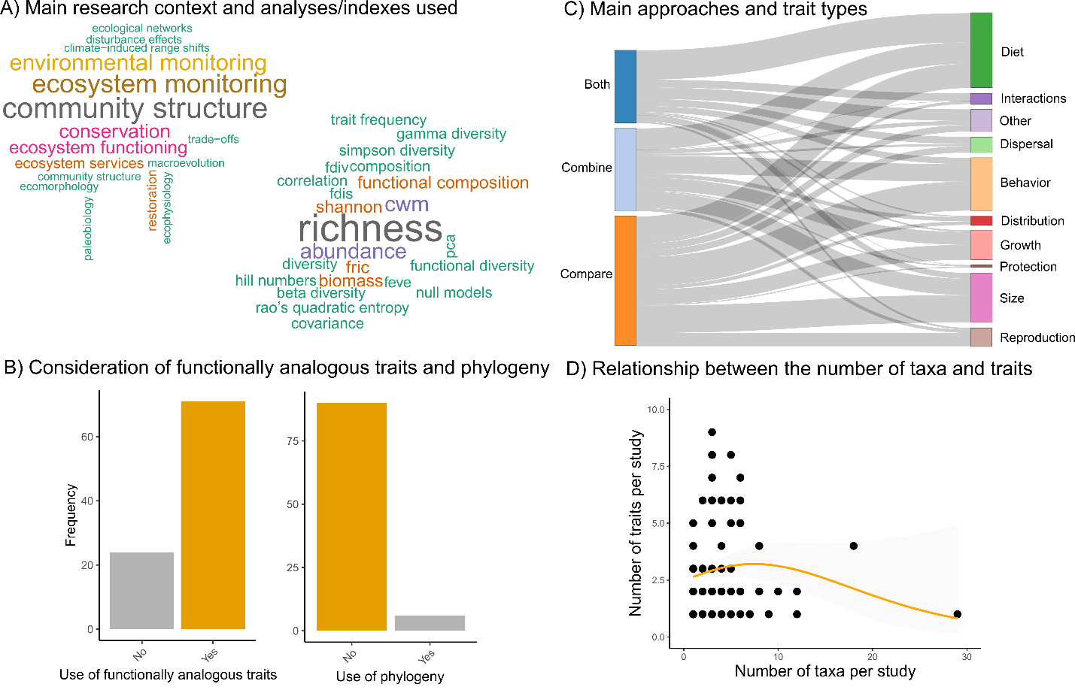

**Uso da abundancia --- índices weighed by abundance**

**Fig. 3: Main research contexts, analyses and approaches of cross-taxa research in functional ecology. In A we show word clouds (created by disassembling text data) depicting the main research contexts and analyses/indexes used in the research. In B we show how often functionally analogous traits and phylogenies (as would be expected in phylogenetic contrasts or explicit use of evolution) are used in the research. In C we show a Sankey plot showing the number of data entries (line width) that used different numbers of trait types (right labels) and functional approaches (combine cross-taxa data, compare cross-taxa data, both approaches in a same study). The three highest values in this Sankey plot are between *both* and *diet (137 entries), compare and behavior (136) and compare and size (128 entries)*. Finally, in D we show the relationship between the number of taxa and the number of traits per study, as fitted by a non-linear Poisson model. The shaded area depicts the 95% confidence interval around the non-linear trend.** **The literature survey was conducted on Clarivate Analytics Web of Science, on 08-06-2020.**

***A monitoring framework explicitly using cross-taxa research***

We found a trade-off between the number of taxa and traits within a given article. This might indicate limitation ….

Mouillot explored the biotic pressures on local communities. In the case of cross-taxa research, the effect of ecological invasions can extend farther from the effect on close relatives and spread across the whole ecosystem components. By using a cross-taxa approach one can understand the response of multiple compoentns to disturbacnes such as that one.

Redundancy across taxa.

While single-taxa research is taxonomically focused on closely related taxa (Diaz & Cabido 2001, Violle et al. 2007), cross-taxa research consists on comparing performance and function of distantly related taxa using functionally analogous response traits (Weiss & Ray 2019).

First, we advocate that the term ‘cross-taxa’ should be only used by research that crosses taxonomic boundaries, rather than researches that compare data of multi groups (which should use the term ‘multiple taxa’). Thus cross-taxa research can be defined as the ‘*research aiming to synthesize information of organism response (fitness) and effect (function) on environment NECESSARILY involving distantly related, co-occurring taxa’*.

The challenge is finding emergent properties of whole communities and ecosystems by crossing the borders of taxonomy and analyzing functionally analogous traits across taxa (Weiss & Ray 2019).

Functional ecology is moving from indexes based on dendrograms and distance matrices (eg Webb et al. 2002, Petchey & Gaston 2006) toward more sophisticated methods based on convex-hulls (Cornwell et al. 2006, Leprieur et al. 2008) and hypervolumes (Blonder et al. 2014, 2017) (reviewed by Mammola et al. 2021).

We advocate that by 1) using standardized methods to collect occurrence and trait data for several, 2) carefully thinking about the traits that can characterize functions and services across taxa (i.e., using functional analogues sensu Weiss & Ray 2019), we can test all scenarios presented in Fig. 1, and further explore other questions that go beyond particularly assessed using comparative non-functional and functional ecology approaches. Stacking information (from comparative approach of different taxa to combinative occurrence and functional data across taxa) information likely will aid to improve our knowledge about the functioning of ecological systems.

For example, one dominant research area is ecological indicator analysis (citation). If we have cross-taxa occurrence and trait data, we can elect the indicator taxa based on both local richness and functional diversity, and even elect the most functionally distinctive indicator taxa based on a combination of trait values.

We can also prioritize conservation considering multiple dimensions of biodiversity (Brum et al. 2017, Dobrovolski et al., Sobral et al.) and consider areas of importance considering species endemicity and functional distinctiveness.

And most importantly, we can evaluate which species or group is more critical to a given function and, finally, we can evaluate what combined taxa can do together relative to what can do in particular.

We advocate that using an approach combining cross-taxa data, with carreful thinking about traits and the functions they represent over different taxa can aid ecology to advance the taxonomic frontiers of data, and go beyond by achieving the understanding of the functioning of whole communities and ecosystems (ecosystem components).

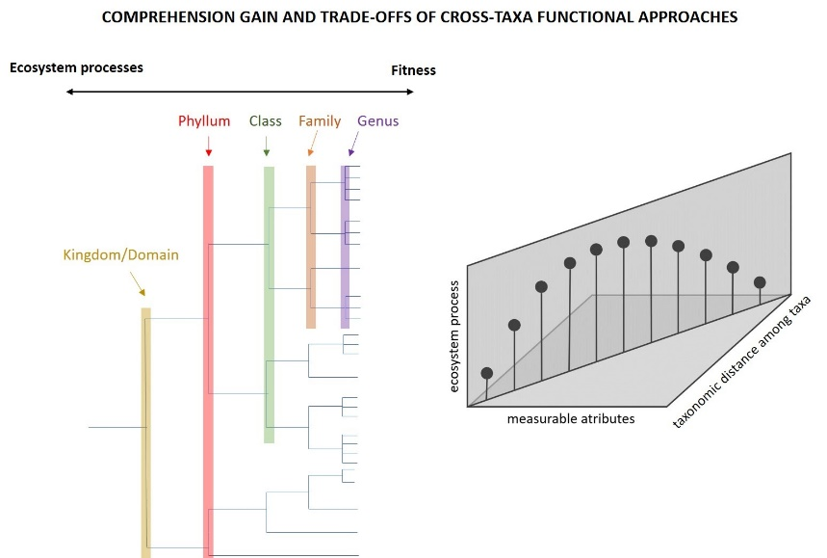

Concept:

Monitoram

Entendimento

Relacoes entre organismso

Pedro jordano – tamanho do fruto e tamanho do dispersor

**Discussion**

**Combine, compare, agrupamento dos traits dentro dos grandes grupos**

**Good examples**

Froehlich et al. 2016 Aquaculture – nice to discuss

Mori et al. 2015 nice to discuss – dispersion traits plants and other

Bruno K.C. Filgueiras – congruence on insects - fragmentation

Discuss: https://onlinelibrary.wiley.com/doi/full/10.1002/ece3.2924

Winsa et al. 2017

Combined vs. non-combined cross-taxa data

Ecosystem wide impacts of marine heat waves across marine and terrestrial ecosystems traits

– Ruthrof et al. 2018

# topicos para discussao

Metricas utilizadas – ainda sao as clássicas

Abordagens utilizadas – abordagem baseada em comparações, e assessment of congruence and indicator/surrogate táxon

Gaps em termos de táxons cobertos pela pesquisa

Pela filogenia e rankings, quais são os níveis combinados com maior frequencia

Difícil juntar táxons distantes evolutivamente – qual o desafio de fazer isto.

Hypervolume --- facilitam a pespectiva cross-taxa em uma perspectiva de trait continuo

True cross taxa – cooke, pimiento, …

SUPPORTING INFORMATION

Table S1: Questionnaire applied to filtering articles to comparative analysis and systematic review. We describe the inclusion and exclusion criteria.

|  |  |  |
| --- | --- | --- |
| Question / Inclusion | | Exclusion |
| Q1: Research in ecology? | |  |
|  | Research explicitly interested in testing the relationship between organisms and their environment. Most of studies were in the fields of community ecology and macroecology. *  texto | Research in knowledge fields such as physics, engineering, health sciences, economics. Research not directly interested in organismal-environment relationships, such as population genetics, phylogenetic systematics, taxonomy, historical biogeography, and paleontology. |
| Q2: Research in functional ecology? | |  |
|  | Research considering the relationship between traits and organismal performance and function (Arnold 1983, Violle et al. 2007), with potential implications for ecosystem services (Tavares et al. 2019). ‡ | Studies on trait evolution and ancestral character reconstruction, geometric morphometrics with focus on the mechanics of morphological structures lacking implication on community structure. Ecological networks research with focus on species rather than communities. |
| Q3: Cross-taxa research? | |  |
|  | Studies of organisms with a phylogenetic relationship at family and / or higher taxonomic ranks (e.g., clades: flowerless and flowering plants; classes: Mammalia, Aves; order: Carnivora; family: Cerambicidae). † | Studies of organisms with a phylogenetic relationship below family level |
| Q4: Literature review? | |  |
|  | Not a literature review. | Title and abstracts including the words “systematic review”, “review”, “bibliographic review” (as detailed in the PRISMA statement, Liberati et al. 2009). Data are of secondary importance in this group of study. |
| Q5: Meta-analysis? | |  |
|  | Not a meta-analysis | Title and abstracts including the word “meta-analysis” (as detailed in the PRISMA statement, Liberati et al. 2009). Data are of secondary importance in this group of study. |

* We also included studies in paleoecology, phylogeography and biogeography, with explicit test of ecological processes underlying diversity, distribution, and evolution.

‡ Most studies were about community functional diversity at local and macroecological scales (e.g., ????). We also included studies using coarse functional entities/groups with clear functional reasoning behind their definition (generalist, specialist, terrestrial, arboreal) (e.g., Pardini et al. 2009), studies on trait-mediated ecosystem services (e.g., Werling et al. 2014, PNAS), and studies on geometric morphometrics comparing the morphological and ecological trait space filled by groups of species (e.g., herbivorous, carnivorous; e.g., ????).

† Q3 Some taxa are grouped by sampling convenience (e.g., macroinvertebrates, which includes crustaceans, insects, among others). In these cases we used the highest rank embracing all taxa.

The filtering process could be influenced by reader skills, as the filtering team includes one post-doc, one doctorate student, and two under-graduate students. To minimize such influence, we first ran a leveling phase (Fig. 1) where all readers answered the six questions based on information from the 20 most cited papers. After that, we met, checked the correspondence between answers, and solved doubts. Then, we started the filtering process by 1) ordering studies according to the first author’s surname —to avoid that only one reader reads the most cited and complex studies—, 2) dividing the 1,006 studies among the four readers, 3) answering the questions (Table 1). Doubts that arose during the filtering process were registered in an online document open to the team of readers, and were resolved by AL Luza (the most experienced reader in the filtering team). Answer options were ‘NO’, ‘YES’, ‘MAYBE’, and ‘NA’. The answer ‘MAYBE’ was used when information from title and abstract were not enough to reach ‘YES’ or ‘NO’. The answer ‘NA’ was used when none answer was applicable.

Objective 1

After completely solving the ‘MAYBE’ answers -- through a quick read on the main text--, we run a final filtering cased on positive responses of Q1 to Q5 to achieve our first objective. We consider systematic reviews and meta-analysis as they can provide values and analysis, as well valuable information about available approaches to cross-taxa studies.

Articles with either positive or negative responses to functional ecology were called, respectively, ‘functional ecology research’ and ‘general ecological research’ area. Such differentiation is important because general ecological research (mostly community ecology and macroecology) assumes all taxa as ecologically different, while functional ecology explicitly considers degrees of ecological differences between taxa (Fig. 1).

Table S2: Complete set of descriptors collected in the surveyed literature.

|  |  |
| --- | --- |
| **Descriptor** | **Description** |
| PaperNumber | The number of the paper, among the 1,006 articles found in WOS survey |
| YourName | Complete name of the reader (e.g, André Luís Luza) |
| StudyAuthors | List of authors of the study being read |
| StudyTitle | Title of the study being read |
| Is it really a cross-taxa research in functional ecology? | We defined 'family' as the minimum taxonomic level to be cross-taxa (as niche conservatism used to be low above family level) |
| Are functional aspects based on traits or habitat affinities | Whether functional perspective is based on traits or rough definitions of trait (often habitat) |
| Does it declare to be ‘cross-taxa’ research? (In title, abstract, along the text) | Many studies are cross-taxa, but have no stated so. We would like to know how many articles omit such information. |
| Position of first citation of 'cross-taxa' terms ("cross-taxa", "multi-taxa", "multiple-taxa", "taxon-free") | Does the study immediately (i.e., in the title) claim to be cross-taxa? |
| Type of study | We would like to know what is the major type of study using data across taxa |
| Research context | We would like to know what is the broad ecological context in which cross-taxa data are applied |
| Detailed research context | We would like to know a more detailed context in which these data are applied |
| Key message | The take-home message (if possible, summarize it in one sentence) |
| Time-series? | Are cross-taxa data collected over time? |
| Which organisms? | Organisms under study (major groups) |
| Taxonomic level | Taxonomic level embracing the taxa being studied. Fill with The most superior level ("Division, phylum") not the inferir ("spp") |
| Which traits? | Traits used to characterize the functional structure of ecological assemblages |
| Is it an easily obtained 'soft' trait? | State if each trait is a soft (easily obtained) or 'hard trait' (hard to get) |
| Were quantitative trait values used (yes=quantitative; no=ordinal, category, binary)? | We would like to know whether the traits used are quantitative or not |
| Were abundance data used? | If counting of individuals, estimated abundance, were used in the functional analyses |
| How do authors use cross-taxa data? | We would like to know whether authors used to compare data across taxa (e.g., they run one analysis per taxon), combine data across taxa (e.g., the gather all data to estimate a global richness, functional diversity), or both alternatives |
| Do they use the same traits across taxa (are traits functionally analogous across taxa)? | We would like to know whether authors used traits that describe similar ecological functions and processes across taxa |
| Which index-analysis were used? | What kind of analyzes did the authors use? |
| Do they use phylogeny? | We would like to know how many studies explore an evolutionary perspective |
| Which ecological system? | Major ecological system under study |
| Which habitat type? | Major habitat type under study |
| Which realm? | Terrestrial and marine realm under study |