Interaction of Amino Acids and DNA Nucleobases with Copper:
a Comparative Theoretical Study

Andrey A. Buglak^{a,*}, Yaroslav Yu. Boldar^{a,b}, Ivan N. Andreevª, Afshin Farahbakhsh^{c}, Alexei I. Kononovª
ª Department of Molecular Biophysics and Polymer Physics, St. Petersburg State University, 199034 Saint-Petersburg, Russia
^{b} School of Computer Science, Physics and Technology, HSE University, 194100 St. Petersburg, Russia
^{c} Department of Chemical Engineering, Qu.C., Islamic Azad University, Quchan 9479176135, Iran

* Corresponding author. E-mail address: andreybuglak@gmail.com (Andrey A. Buglak).
© The Author(s) 2026

Abstract
In nanotechnology, amino acids (AAs) and polypeptides serve as biomolecular templates for the synthesis of copper nanoclusters (NCs) and nanoparticles, directing their size, stability, and structural geometry. To elucidate the underlying binding motifs, we performed density functional theory (DFT) calculations on all 20 proteinogenic amino acids complexed with copper, systematically analyzing their coordination preferences, electronic interactions and topology. Our computations of Cu⁺-AA binding energies (G_{b}) are in agreement with previous mass-spectrometry data. DFT calculations identified deprotonated amino acids (AAs) as the predominant sites for copper (Cu₂, Cu₈ and Cu₂₀) nucleation. Among neutral AAs, arginine, histidine, and tryptophan exhibited the strongest interactions. Moreover, we compared the binding energy of copper, silver and gold with AAs/DNA nucleobases, which led us to a conclusion that Cu atoms possess higher mobility in biopolymer matrices than Au, but lesser mobility than silver. Moreover, several hydrated ion models have been regarded. We suppose, our results are of significant importance for the studies of copper nanostructures and copper-containing proteins.

Keywords: proteinogenic amino acids, copper clusters, DFT, ligand-metal interactions, binding energy.

1. Introduction
Amino acids serve as the fundamental units of peptides and enzymes, making them essential for the living organisms. Consequently, the reactivity of 20 α-proteinogenic amino acids (AAs) has garnered global research interest in chemistry and materials science [1–3]. AAs can be categorized into different groups based on the type of side-substituent they possess. For example, charged AAs (Arg, Asp, etc.), uncharged polar AAs (Asn, Gln, Ser, Thr), hydrophobic (Ala, Phe, etc.), and special cases (Cys, Pro, Gly).
Copper (Cu) is a trace element that is also necessary for living systems, but can also be harmful [4]. Cu plays a crucial role in living organisms as it acts as a cofactor for numerous enzymes [5]. Some examples of enzymes that contain copper are cytochrome C oxidase, superoxide dismutase, tyrosinase, and amine oxidases [6]. Disruption of copper homeostasis in humans can result in neurodegenerative disorders, hepatic diseases, and other pathologies [4].
Like other coinage metals, copper can form nanoclusters (NCs), which are widely explored by modern nanotechnology. Cu NCs can be exploited in nanosensors, biomedicine, catalysis and optoelectronics [7]. Moreover, functionalization and addition of organic ligands (in particular, proteins) to Cu NCs make them biocompatible [8]. For example, albumin-templated Cu NCs can be used for long-lived fluorescence [9]. Moreover, protein-templated Cu clusters can be exploited for quantitative detection of various analytes: human serum albumin [10], creatinine [11], monovalent silver Ag(I) [12], etc. In this, regard it is important to study both empirically and theoretically the interactions between copper and proteins/individual amino acids in gas phase, water and organic solvents.
Amino acid-copper complexes represent a significant advancement in sustainable materials science, acting as highly effective, eco-friendly corrosion inhibitors [13] and antimicrobial agents [14] in coatings. They offer a green alternative to traditional, toxic inorganic inhibitors (like chromates) by utilizing biodegradable, non-toxic organic compounds that form stable protective films on metal surfaces.
Lots of classic papers are dedicated to interaction of bivalent copper, amino acids and their derivatives: Gly, Ala, Lys and His [15]; aminobutyric acids and ornithine [16]; hydrophobic proteinogenic amino acids [17]; phenylalanine and tryptophan [18]. However, systematic depictions of Cu(I)-amino acid complexes are rare. Monovalent copper is of particular interest for the luminescent nanocluster synthesis [19]. Previously, the binding energies between a copper Cu⁺ ion and proteinogenic AAs were studied in the gas phase using a kinetic mass-spectroscopy method [20]. It was found that the highest Gibbs binding energy occurs between Cu⁺ and Arg: 441.4 kJ mol⁻¹ (105.5 kcal mol⁻¹), whereas the lowest one is of Gly: 260.7 kJ mol⁻¹, or 62.3 kcal mol⁻¹. Later, these binding energies were compared with ones of other monovalent ions (Li⁺, Na⁺ and K⁺); it was found that Cu⁺ binding energies are the highest ones [21].
Copper homeostasis and copper-protein interactions play a crucial role in human health, which is supported by recent publications [22,23]. Some Cu complexes, such as trientine or Cu-aspirinate complex have been established to play a role in the prevention and treatment of cardiovascular diseases possessing significant medical perspectives [24]. Cu complexes are able to inhibit a core component of the ubiquitin-proteasome system (UPS) machinery and are offered to be Cu-containing anticancer substances [25]. Moreover, Cu homeostasis and the UPS are dysregulated in neurodegenerative diseases such as Alzheimer's disease, Parkinson's disease and amyotrophic lateral sclerosis [26].
Cu(II) complexes with amino acids and proteins have been sufficiently studied recently, which cannot be said about Cu(I). Here are some considerations why Cu(I) is also significant:
- inside cells (e.g., cytosol or lumen), where glutathione and other reducing agents dominate, Cu(I) prevails and is more biologically relevant [27,28]. Cu(II) is often sequestered or reduced to Cu(I) for uptake/transport;
- Cu(I) has higher affinity for cysteine residues, critical in sites like chaperone proteins (e.g., metallothioneins) or active sites of enzymes (e.g., superoxide dismutase). In type-1 blue copper proteins (cupredoxins), Cu(I) is common for rapid electron transfer without radical damage;
- Cu(I) can serve protective roles (e.g., binding free Cu to prevent toxicity), while excessive Cu(II) contributes to oxidative stress [29];
- Cu(I) ligated by thiols or thioethers (e.g., methionine) forms more kinetically inert complexes, reducing unwanted reactivity compared to Cu(II) [30].
As a whole, Cu(I) is often more significant in reducing, sulfur-rich sites (e.g., protein active centers, membranes), whereas Cu(II) dominates in oxidative or aqueous conditions. In essence, Cu(I) preference for sulfur ligands and stability in biological reductants make it especially critical for cellular copper handling and specialized protein functions, though both ions are indispensable. If this is tied to a specific protein or disease (e.g., Wilson's disease). Computational methods, in particular molecular docking and molecular dynamics are effectively used nowadays to simulate the bioactivity of various compounds and their metal complexes [31–33]. However, in this study we have applied mostly density functional theory calculations.
Jaque with co-authors studied the stability of copper clusters [34] and found that Cu₂ is the most stable system among Cu_{n} (n = 2−8) NCs. Moreover, Cu₂ is a magic number copper cluster [35]. Interestingly, amino acids can inhibit the corrosion of copper, which has been studied in a couple of recent papers [13,36]. Apart from silver and gold [37,38], the amino acid and nucleobase complexes of copper have not been studied systematically. Our manuscript is an attempt to fill that niche. In this regard, the aim of our study was to investigate the interactions between monovalent and bivalent copper/diatomic Cu₂ cluster, larger clusters (Cu₈ and Cu₂₀) and amino acids with different charge of side-substituent. This allowed us to make conclusions about the mobility of monovalent noble metal ions and tiny clusters in nucleoprotein matrices. Neutral diatomic clusters are pretty stable magic number systems [39] and can be named potential centers of metal nucleation. Typically, transition metal cluster complexes with organic ligands are studied by using DFT. As a whole, these calculations should shed light on the interactions of copper atoms with amino acid residues in proteins and establish which amino acid residues are responsible for the effective synthesis of Cu NCs in polypeptide templates.

2. Materials and methods
We have produced a set of low energy conformers by using the Spartan software and MMFF force field. Next, total energies have been computed with the PBE/6-31G(d) method. Top-5 most stable amino acid conformations have been appended with copper ions/clusters at S, N and O sites. The total energy of these complexes has been compared and the most stable systems have been selected for further analysis. In particular, for optimization, B3LYP functional has been applied with Grimme dispersion correction D3 [40], a so-called B3LYP-D3 method. Hessian calculations and Gibbs binding energies have been evaluated using the same B3LYP-D3 methodology (see Fig. S1 for the flowchart). B3LYP functional is largely exploited by DFT studies of transition metal complexes with organic ligands [41,42], whereas D3 dispersion correction is needed since dispersion forces are not taken into account by most of the DFT functionals. Def2-TZVP basis set [43], which proved its efficacy for similar copper-containing systems [44], was used in all the computations.
We used gas phase since dielectric constant of the gas phase (ε = 1) is close to protein media (ε = 3 [45]). As a whole, this methodology proved its efficacy in one of our previous studies on amino acid-gold complexes [38]. The reactions of copper complexation have been regarded as follows through equation 1:
AA + Cu AA-Cu (eq. 1)
The binding energy E_{b} has been calculated using the equation 2:
E_{b} = E(AA) + E(Cu) – E(AA-Cu) (eq. 2)
, where E stands for E_{total} obtained in the potential energy surface (PES) minimum. Gibbs binding energy (G_{b}) obtained using Hessian calculation also in the PES minimum and includes both enthalpy and entropy evaluated at 298 K. Gibbs binding energy was obtained according to the equation 3:
G_{b} = G(AA) + G(Cu) – G(AA-Cu) (eq. 3)
Calculations for per-hydrated copper ion and its complexes with amino acids have been performed using the same DFT-based methodology: B3LYP-D3/def2-TZVP. For details see section 3.2.
Also, several AA-Cu complexes among the most stable ones have been treated with Bader’s quantum theory “Atoms-in-Molecules” (QTAIM) [46,47]. Moreover, we have performed natural bond orbital (NBO) analysis [48] of selected Cu-AA systems. The methodology of NBO analysis for similar systems can be found in our previous publications [37,38].
All the calculations have been performed in Gaussian 16 program package [49].

3. Results and discussion

3.1 Amino acids and monovalent copper ion
First, we evaluated the binding of the Cu⁺ monovalent copper ion with 20 proteinogenic α-amino acids. We performed a small benchmark and compared the perfomance of three DFT functionals: PBE, M06L and B3LYP. PBE is efficiently used for the treatment of copper [50] and previously showed sufficient results predicting the binding energy of transition metal complexes [37]. Minnesota functional [51] have been developed recently for the thermochemistry simulations. Dispersion forces (in particular, D3) are essential to capture non-covalent attractive interactions that significantly influence the structure and stability of metal–ligand complexes, especially when organic ligands are involved [52].
Several observations can be made when comparing the experimental and theoretical binding energy. PBE-D3 method overestimates the energy of binding (E_{b}) with a root-mean-square error (RMSE) of 6.9 kcal mol⁻¹ and the Gibbs binding energy (G_{b}) by 4.5 kcal mol⁻¹ (Table S1). M06L-D3 performs slightly better: with a RMSE of of 6.5 kcal mol⁻¹ and 4.2 kcal mol⁻¹, respectively (Table S2). B3LYP-D3 performed significantly better: 5.9 kcal mol⁻¹ and 3.5 kcal mol⁻¹, respectively (Table 1). For this reason, the rest of computations have been performed using the B3LYP-D3/def2-TZVP method.
Table 1. E_{b} and G_{b} binding energies (in kcal mol⁻¹) of proteinogenic amino acids and Cu⁺ ion; minimal and maximum values are labeled with a bold font.
AA | Experiment |  | Theory |  | Residual
 | E_{b} [21] | G_{b} [21] | E_{b} | G_{b} | E_{b} | G_{b}
Ala | 74.8 | 64.8 | 78.0 | 67.8 | -3.3 | -3.0
Arg | 100.4 | 105.5 | 126.9 | 117.6 | -26.6 | -12.0
Asn | 83.9 | 75.3 | 90.2 | 80.5 | -6.3 | -5.2
Asp | 79.6 | 70.2 | 84.3 | 74.1 | -4.7 | -3.9
Cys | 79.7 | 70.1 | 84.6 | 75.3 | -4.9 | -5.2
CH₃S-SCH₃ | - | - | 60.2 | 52.1 | - | -
Gln | 90.1 | 78.9 | 96.8 | 85.1 | -6.6 | -6.2
Glu | 81.2 | 71.2 | 89.8 | 78.2 | -8.5 | -7.0
Gly | 72.8 | 62.3 | 75.5 | 65.8 | -2.8 | -3.5
His | 99.4 | 89.6 | 106.0 | 95.2 | -6.6 | -5.6
Ile | 76.9 | 66.9 | 81.7 | 70.9 | -4.6 | -4.0
Leu | 77.2 | 68.1 | 80.5 | 70.2 | -3.3 | -2.1
Lys | 106.7 | 96.0 | 115.5 | 102.1 | -8.8 | -6.1
Met | 89.6 | 79.1 | 98.2 | 88.9 | -8.6 | -9.7
Phe | 82.9 | 72.8 | 89.8 | 78.5 | -6.9 | -5.7
Pro | 76.8 | 67.8 | 82.3 | 71.8 | -5.5 | -4.0
Ser | 75.8 | 66.9 | 68.4 | 60.4 | -7.4 | 6.5
Thr | 77.0 | 68.0 | 81.5 | 71.8 | -4.5 | -3.8
Trp | 90.7 | 80.2 | 97.5 | 86.8 | -6.8 | -6.5
Tyr | 84.2 | 74.2 | 91.2 | 79.7 | -7.0 | -5.4
Val | 76.2 | 66.5 | 80.6 | 70.3 | -4.4 | -3.8
Deprotonated amino acids
Asp⁻¹ | - | - | 185.5 | 175.0 | - | -
Cys⁻¹ | - | - | 192.6 | 181.3 | - | -
Glu⁻¹ | - | - | 169.1 | 158.3 | - | -
Tyr⁻¹ | - | - | 180.2 | 168.6 | - | -
 |  |  |  | MAE | -6.2 | -4.8
 |  |  |  | RMSE | 5.9 | 3.5

The predicted Gibbs binding energy (Fig. 1) is more accurate (R² = 0.959) than the theoretical total binding energy (E_{b}) (R² = 0.891). While DFT is a powerful tool for studying metal-organic systems, its tendency to overestimate binding energies stems from the approximations inherent in the exchange-correlation functionals, the treatment of long-range interactions, and the limitations of the chosen basis sets. For this reason, we often use hybrid functionals or post-DFT methods to improve the accuracy of binding energy calculations when necessary.
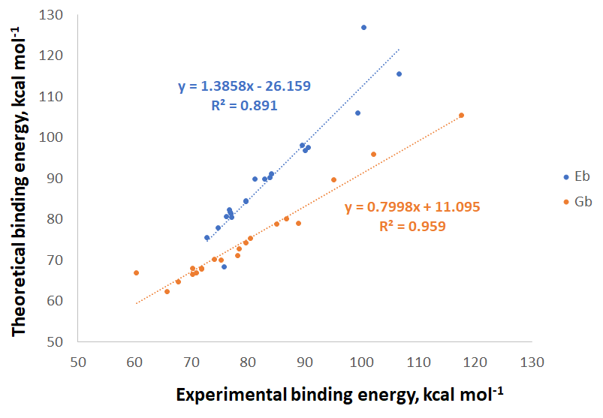
Fig. 1. Experimental [20,21] vs. predicted (B3LYP) binding energy for Cu⁺ and amino acids.
The DFT geometries of AA-Cu⁺ complexes can be obtained from the Electronic Supplementary Information (Fig. S2 and cartesian coordinates). Fig. 2 displays selected complexes for the neutral amino with the copper monovalent ion Cu⁺. Arg-Cu⁺ is the most stable system with AA⁰ participation: the copper ion is bonded with the two amino groups of argenine (one of the side chain and one of the amino group), which can be characterized by Cu-N bond distances of 1.890 Å and 1.963 Å, respectively; the N-Cu-N valence angle equals 169º. For comparison, Gly⁰-Cu⁺ complex has two weaker intracomplex bonds of 2.077 Å and 2.074 Å for the amino group and for carbonyl, respectively. The N-Cu-O angle equals to 85º.
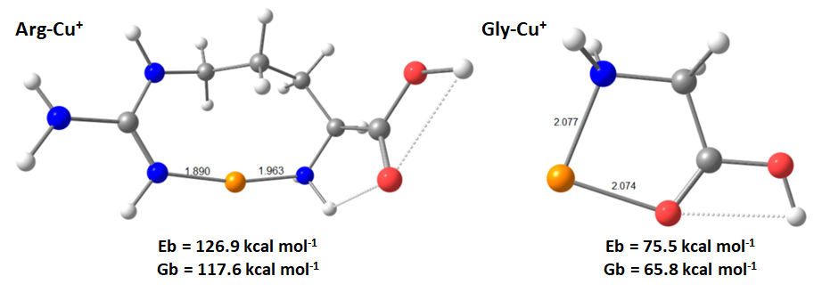
Fig. 2. Optimized geometry of the most stable (left) and the less stable (right) AA⁰-Cu⁺ complexes.
Similar to Fig. 2, the majority of the neutral amino acids form complexes with two binding sites. Nevertheless, Phe, Thr, and Tyr are the exceptions that form tridentate systems. Apparently, the efficacy of Cu binding enhances in the following order: S > N > O > C. The order of the anchoring bond strengths (Cu-S > Cu-N > Cu-O > Cu-C) can be attributed to a combination of factors [53,54] including atomic size, electronegativity, effective orbital overlap, and the nature of bonding interactions. Each of these elements contributes to the overall strength of the anchoring bonds formed by copper(I). In coordination complexes, sulfur can often stabilize the metal center more effectively than carbon due to its ability to form various coordination geometries and interactions. This results in production of Cu-S bonds for both Met-Cu⁺ and Cys-Cu⁺. In Cys-Cu⁺, Cu-S bond length equals to 2.298 Å, whereas the Cu-N bond is 2.067 Å. For comparison, in Met-Cu⁺, l(Cu-S) is 2.220 Å and l(Cu-N) is 1.985 Å.
Also, each neutral amino acid complex (except Gln-Cu⁺) possesses a Cu-N bond. Fourteen out of 20 complexes have a Cu-O bond, whereas only Phe, Tyr and Trp interact with Cu⁺ through the Cu-C bond. Tyr, Phe and Trp residues involve aromatic side-chains, which, apparently, leads to the formation of π-cation interactions. This is a well-known feature of Tyr, Trp and Phe [55]. The order of binding energies (Trp-Cu⁺ > Tyr-Cu⁺ > Phe-Cu⁺) in Rimola et al. [55] is the same as in our report. Regarding the geometry of the complex, in Phe-Cu⁺, the Cu-X bonds have the following lengths: l(Cu-N) = 2.128 Å, l(Cu-O) = 2.287 Å, which is supplemented by a π-cation binding with the aromatic ring. In Tyr-Cu⁺, l(Cu-N) equals to 2.134 Å, l(Cu-O) is 2.288 Å; as a whole the character of Tyr binding is extremely similar to Phe and the presence of the additional OH group in Tyr does not influence significantly. On contrary, in Trp-Cu⁺, the carboxyl group does not participate in copper ion binding, whereas the Cu-N bond is significantly shorter (2.005 Å) than in the previously mentioned aromatic amino acids; however, the binding energy of Trp is higher than of Phe or Tyr.
Fig. S3 depicts the process of deprotonated amino acid interaction with the copper(I). The side chains of these amino acids have been ionized to imitate the deprotonation of an amino acid residue in a protein, which cannot be done for the amino group and carboxyl which participate in peptide bond formation. Thus, all deprotonated amino acids form bidentate complexes. The order of Cu⁺ attachment to heteroatoms is as follows: S is greater than N which is greater than O. Therefore, all the amino acids bind to Cu⁺ through the amino group. In all the cases, the interactions with copper(I) are non-planar. A detailed analysis of non-planarity of amino acid-copper complexes has been provided previously by Sabolovic and Liedl [56].
The Cys⁻¹-Cu⁺ complex possesses the following geometrical parameters: l(Cu-S) is 2.205 Å, l(Cu-N) is 2.091 Å, whereas the valences angle equals 101º; thus, the Cu-X bonds shorten upon the proton loss by Cys and this leads to an enhancement of binding energy (see Table 1). The deprotonated forms of Cys⁻¹, Asp⁻¹, Tyr⁻¹ and Glu⁻¹ exhibit the largest stability in terms of binding energy. Their Gibbs binding energies are 181.3 kcal mol⁻¹, 175.0 kcal mol⁻¹, 168.6 kcal mol⁻¹ and 158.3 kcal mol⁻¹, respectively. Arginine has the highest Gibbs binding energy among the neutral amino acids, with a value of 117.6 kcal mol⁻¹. In general, the order of binding energies towards Cu⁺ can be sorted as follows: Cys⁻¹ > Asp⁻¹ > Tyr⁻¹ >> Glu⁻¹ >> Arg > Lys > His > Met, Trp > Gln > Asn, Tyr > Phe, Glu > Cys > Asp > Thr, Pro > Ile > Val, Leu > Ala > Gly > Ser (Table 1). Also, we have calculated the Gibbs binding energy of copper(I) towards a disulfide bond (CH₃S-SCH₃): 52.1 kcal mol⁻¹, which is significantly lower than the binding energies of the amino acids.
As we have shown, the B3LYP-D3/def2-TZVP method works fine for amino acid complexes of copper(I). For this reason, same method has been used for copper(II). Deprotonated forms of Asp⁻¹, Cys⁻¹, Glu⁻¹ and Tyr⁻¹ exhibit the largest stability in terms of binding energy for bivalent copper ion (Table 2). Their Gibbs free energies are 475.4 kcal mol⁻¹, 482.7 kcal mol⁻¹, 440.4 kcal mol⁻¹ and 498.0 kcal mol⁻¹, respectively. Arginine has the highest Gibbs free energy among the neutral amino acids, with a value of 352.6 kcal mol⁻¹. As a whole, the order of Gibbs binding energies towards Cu²⁺ can be arranged as follows: Tyr⁻¹ > Cys⁻¹ > Asp⁻¹ > Glu⁻¹ >> Arg > Trp > Lys > His > Tyr, Met, Gln > Asn > Phe > Glu > Cys > Thr > Pro > Ser, Leu > Ile > Asp > Val > Ala > Gly. The binding energy of cystine-like disulfide equals 240.1 kcal mol⁻¹ and 233.6 kcal mol⁻¹ for E_{b} and G_{b}, respectively.
Table 2. Amino acid binding energies of bivalent copper ion.
Amino acid | E_{b} | G_{b}
Ala | 244.6 | 234.3
Arg | 352.6 | 340.5
Asn | 290.5 | 279.0
Asp | 255.9 | 246.1
Cys | 267.2 | 256.8
Cys-Cys | 240.1 | 233.6
Gln | 305.5 | 291.9
Glu | 268.1 | 257.8
Gly | 235.6 | 225.7
His | 313.2 | 300.9
Ile | 255.1 | 247.1
Leu | 254.9 | 248.2
Lys | 320.7 | 305.5
Met | 302.5 | 292.1
Phe | 288.3 | 277.5
Pro | 261.0 | 250.8
Ser | 259.5 | 250.0
Thr | 265.0 | 254.2
Trp | 327.1 | 315.5
Tyr | 303.9 | 292.4
Val | 253.6 | 243.3
Asp⁻¹ | 486.9 | 475.4
Cys⁻¹ | 493.6 | 482.7
Glu⁻¹ | 450.3 | 440.4
Tyr⁻¹ | 510.2 | 498.0

Subsequently, we conducted QTAIM analysis for the most stable Cu⁺-AA complexes, which are presented in Table 3. The methodology for analyzing metal-AA complexes using AIM can be found in our previous publications [37,38]. The negative value of the energy density H(r) indicates that the electrostatic interactions between Cu and AA are stabilizing in all the cases. The positivity of all values of the Laplacian of electron density $∇^{2}ρ$ indicates that covalent interactions are also contributing to stabilization. This implies that the bonding between Cu and X involves both covalent and electrostatic interactions. We estimated bond energies using QTAIM theory. Bond energy was evaluated using the equation 4 [57]:
E_{bond} = -V(r) * 627.51 / 2 (eq. 4)
Table 3. Bond critical point (BCP) data (in a.u) from QTAIM analysis.
Complex | BCP | $$ρ$$ | $$∇^{2}ρ$$ | $$G(r)$$ | $$V(r)$$ | $$H(r)$$ | E_{bond},  kcal mol⁻¹
Arg-Cu⁺ | Cu−NH | 0.11200 | 0.46715 | 0.15678 | −0.19678 | −0.04000 | 61.7
 | Cu−NH₂ | 0.96061 | 0.38876 | 0.12750 | −0.15782 | −0.03031 | 49.5
Asp⁻¹-Cu⁺ | Cu−N | 0.08701 | 0.36295 | 0.11479 | −0.13884 | −0.2405 | 43.6
 | Cu−O | 0.10407 | 0.52656 | 0.16374 | -0.19584 | −0.03210 | 61.4
Cys-Cu⁺ | Cu−N | 0.07687 | 0.30690 | 0.09549 | −0.11424 | −0.01876 | 35.8
 | Cu−SH | 0.07283 | 0.19331 | 0.06865 | −0.08898 | −0.02033 | 27.9
Cys⁻¹-Cu⁺ | Cu−N | 0.07203 | 0.29213 | 0.08882 | -0.10460 | −0.01578 | 32.8
 | Cu−S | 0.08671 | 0.20028 | 0.08012 | −0.11017 | −0.03005 | 34.6
Lys-Cu⁺ | Cu−N1 | 0.09779 | 0.38815 | 0.12834 | −0.15964 | −0.03130 | 50.1
 | Cu−N2 | 0.09949 | 0.39577 | 0.13125 | −0.16357 | −0.03231 | 51.3
Arg-Cu²⁺ | Cu-NH | 0.12368 | 0.52733 | 0.18008 | -0.22833 | -0.04825 | 71.6
 | Cu-NH₂ | 0.08462 | 0.30083 | 0.09890 | -0.12259 | -0.02369 | 38.5
 | Cu-O | 0.08259 | 0.39458 | 0.11953 | -0.14042 | -0.02089 | 44.1
Cys-Cu²⁺ | Cu-NH₂ | 0.08310 | 0.27264 | 0.09093 | -0.11371 | -0.02277 | 35.7
 | Cu-SH | 0.06885 | 0.12262 | 0.04860 | -0.06655 | -0.01795 | 20.9
 | Cu-O | 0.06142 | 0.28573 | 0.08202 | -0.09261 | -0.01059 | 29.1
Cys⁻¹-Cu²⁺ | Cu-O | 0.08351 | 0.42490 | 0.12625 | -0.14628 | -0.02003 | 45.9
 | Cu-S | 0.09331 | 0.21008 | 0.08728 | -0.12204 | -0.03476 | 38.3
Tyr⁻¹-Cu²⁺ | Cu-NH₂ | 0.06561 | 0.26125 | 0.07834 | -0.09137 | -0.01303 | 28.7
 | Cu-C6 | 0.06275 | 0.17873 | 0.05811 | -0.07154 | -0.01343 | 22.4

QTAIM analyses revealed that all Cu-X bonds are partially covalent and partially electrostatic. The Arg-Cu²⁺ complex (Cu−NH bond) exhibits the highest bond energy of 71.6 kcal mol⁻¹ (Table 3), which is in line with our previous observations for gold-amino acid complexes: Arg has the largest bond energy with Au⁺ among all the neutral amino acids [38].
We should stress that our calculations have been performed for a simplified model: for most of the systems, we did not consider a per-hydrated state of the copper ion [58]. This was done to further compare the binding energies of copper(I), silver(I) and gold(I) using previously published papers [37,38]. Nevertheless, some hydrated ion models will be regarded in the next section.

3.2 Hydrated copper ions and selected amino acids
We have optimized the geometry of hydrated copper ion (both Cu(I) and Cu(II)), as well as the geometry of hydrated copper in presence of the neutral cysteine (medium binding energy), deprotonated cysteine (high binding energy) and neutral glycine (low binding) in the gas phase.
In accordance with previous publications [58], Cu(II) tends to form a planar structure with four water molecules (Fig. S4): a coordination number (c.n.) of 4 is more stable than c.n. of 5 and 6. To evaluate the stability of hydrated Cu(II) complexes (eq. 5) the following formula (eq. 6) has been applied:
${Cu}^{2+}(H_{2}O)_{m}→{Cu}^{2+}(H_{2}O)_{m-1}+H_{2}O$ (eq. 5)
ΔE(H₂O) = E(${Cu}^{2+}\left(H_{2}O)_{m-1})+E(H_{2}O\right)-E({Cu}^{2+}(H_{2}O)_{m})$ (eq. 6)
Thus, for c.n. = 4, ΔE(H₂O) and ΔG(H₂O) were determined to be 49.4 kcal mol⁻¹ and 37.0 kcal mol⁻¹, respectively. For c.n. = 5, ΔE and ΔG are 31.7 kcal mol⁻¹ and 21.0 kcal mol⁻¹, respectively; this leads to ΔΔE(H₂O) and ΔΔG(H₂O) of 17.7 kcal mol⁻¹ and 16.0 kcal mol⁻¹. For c.n. of 6, ΔE(H₂O) and ΔG(H₂O) are 25.4 kcal mol⁻¹ and 14.4 kcal mol⁻¹, respectively, which leads to ΔΔE(H₂O) and ΔΔG(H₂O) of 6.4 kcal mol⁻¹ and 6.5 kcal mol⁻¹. As a whole, we may conclude that c.n. = 4 is the most stable complex of copper(II).
Cu(I) hydrated complex has been built using the same starting geometry; however, it tends to form a non-planar geometry with one of the water molecules being located atop of the plane formed by other three water molecules and the copper ion (Fig. S4). ΔE(H₂O) and ΔG(H₂O) of this system have been determined to be as 14.6 kcal mol⁻¹ and 4.3 kcal mol⁻¹, respectively, which is significantly lower than for the similar system of copper(II). The complexes of five and six water molecules cannot be formed by copper(I). Moreover, hydrated Cu(I) and Cu(II) possess different bond distances: in [Cu(H₂O)₄]⁺, two Cu-O bonds possess the length of 2.054 Å, whereas two other Cu-O bonds are 2.261 Å each. In [Cu(H₂O)₄]²⁺ complex, Cu-O bond lengths are equal either 1.947 Å or 1.996 Å (Fig. S4).
The geometry of Cys-Cu complexes has been hydrated with two water molecules (Fig. S4). In this case, Cu(I) forms a complex with a c.n. of 4 (water molecules bonding is appended by the thiol and the amino group), whereas the c.n. of Cu(II) equals 5 (the fifth binder is the carbonyl). Both complexes are non-planar. Cu(I) forms bonds with two water molecules (l(Cu-O) equals to 2.101 Å on average), amino group (l(Cu-N) = 2.228 Å) and thiol (l(Cu-S) = 2.275 Å) of the Cys, whereas Cu(II) binds to water molecules (l(Cu-O) equals to 2.030 Å on average), amino group (l(Cu-N) = 2.051 Å), thiol (l(Cu-S) = 2.412 Å) and carbonyl (l(Cu-O) = 2.325 Å). Thus, we may conclude that Cu(II) tends to interact with water and NH₂ more intensively, whereas the Cu-S binding is more intense for Cu(I).
The geometry of Gly-Cu complexes has been hydrated also (Fig. S5). In this case, both Cu(I) and Cu(II) form complexes with a c.n. of 4, which is more effective than c.n. of 5. Cu(I) forms bonds with water molecules and bond distances equal to 1.998 Å and 2.311 Å), the amino group (l(Cu-N) = 2.028 Å) and carbonyl (l(Cu-O) = 2.440 Å). For Cu(II) and two water molecules, l(Cu-O) equals to 1.969 Å and 2.014 Å; for the amino group, l(Cu-N) = 2.035 Å; for carbonyl, l(Cu-O) = 1.944 Å). Thus, in the case of hydrated Cu(II), the binding to the carboxyl is significantly more intense that for Cu(I).
Cys⁻¹ complexes with Cu(I) and Cu(II) (Fig. S5) have a c.n. of 4 as well. Both complexes are non-planar. Cu(I) forms bonds with two water molecules with bond distances equal to 2.143 Å and 2.513 Å); for amino group, l(Cu-N) = 2.301 Å and for sulfur l(Cu-S) = 2.240 Å. Cu(II) also binds to water molecules: (l(Cu-O) equals to 2.054 Å and 2.109 Å; for the amino group, l(Cu-N) = 2.061 Å and for sulfur l(Cu-S) = 2.236 Å.
Also, we have determined ΔE and ΔG for Cys⁰, Cys⁻¹ and Gly. Thus, for Cys⁰ and copper(I), ΔE and ΔG were determined to be 43.1 kcal mol⁻¹ and 27.8 kcal mol⁻¹, respectively, which is significantly lower than in the absence of water molecules: 75.3 kcal mol⁻¹ and 84.6 kcal mol⁻¹, respectively (Table 1). For copper(II), these values are significantly higher: 148.1 kcal mol⁻¹ and 134.0 kcal mol⁻¹, respectively. But they are still significantly lower as compared to the explicit water absence: 256.8 kcal mol⁻¹ and 267.2 kcal mol⁻¹, respectively (Table 2). The rest of the data is presented in Table S3.
As a whole, the hydrated complexes of Cu(I) and Cu(II) have been compared. The coordination number of 4 is the most effective in copper ion binding, which is true for simple per-hydrated models, H₂O and Cys, H₂O and Gly, H₂O and Cys⁻¹. However, the binding with Cu(II) is more intense than for Cu(I), especially for water molecules and amino groups; the obvious reason are the additional coulombic interactions of Cu²⁺.

3.3 Interactions with a tiny Cu₂ cluster
Next, we have examined the amino acid complexes involving the tiniest neutral copper cluster Cu₂⁰. Different candidate sites stand for different copper cluster binding: side-chain, amino group and carboxyl. We have identified the most energetically favorable configurations of AA-Cu₂ systems, which are displayed in Fig. 3. All of the complexes are monodentate and mostly establish Cu-X bonds primarily with the N (the amino group).
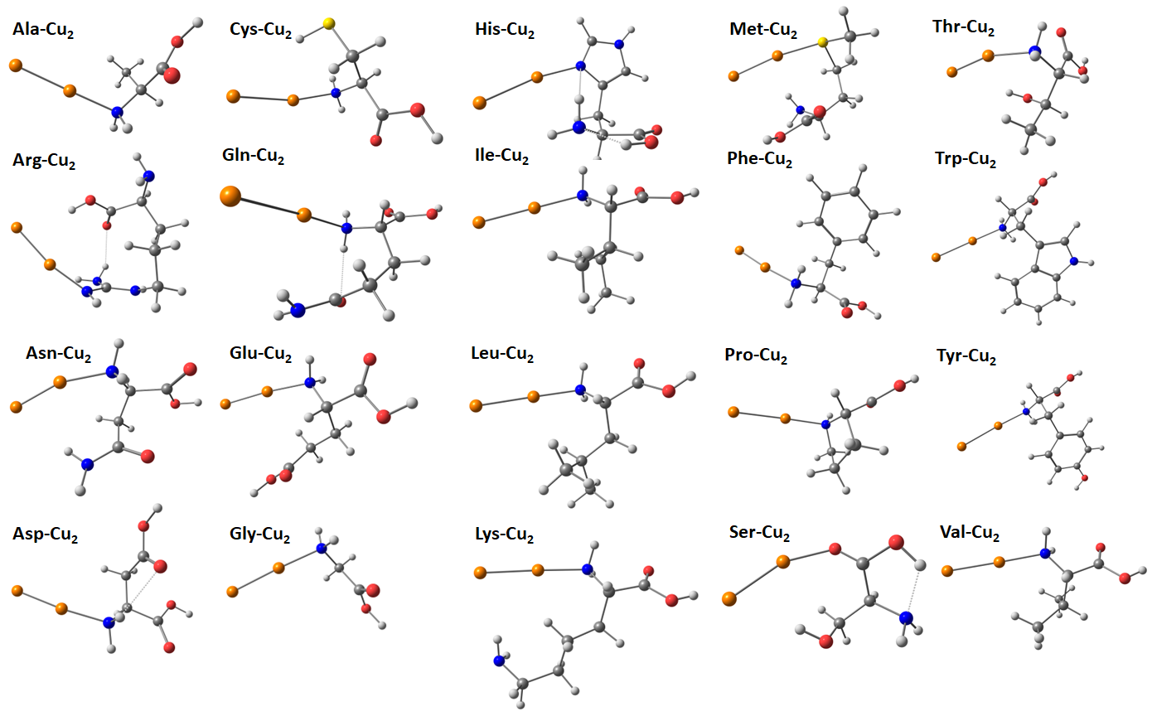
Fig. 3. Optimized geometry of the AA⁰-Cu₂ complexes.
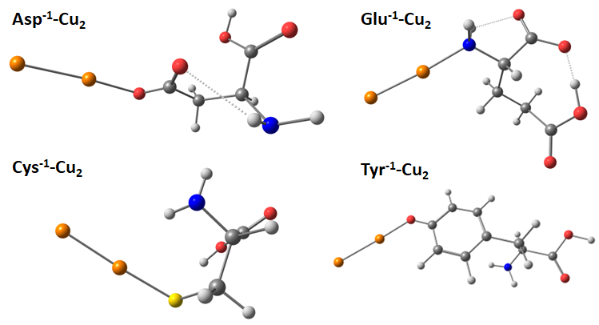
Fig. 4. Optimized geometry of the AA⁻¹-Cu₂ complexes.
Optimized geometries of the most stable AA⁻¹-Cu₂ complexes have been also obtained and presented on Fig. 4. As in the case of neutral amino acids, the ligands are monodentate in each system. Cys⁻¹ forms a bond with copper through the thiolate group, Tyr⁻¹ forms a Cu-X bond though its phenolate, Asp⁻¹ forms a bond through the carboxylate, whereas in Glu⁻¹ the amino group participates in the bonding. Thus, the functional group attaching Cu₂ is different in each case the deprotonated amino acid binds to the Cu₂. Binding energies of Cu₂ are presented in Table 4.
Table 4. E_{b} and G_{b} binding energies of 20 proteinogenic amino acids and Cu₂ cluster.
Amino acid | E_{b} | G_{b}
Ala | 21.5 | 10.7
Arg | 33.8 | 23.3
Asn | 26.7 | 15.3
Asp | 24.7 | 13.9
Cys | 22.6 | 12.6
Gln | 29.7 | 16.9
Glu | 23.4 | 12.5
Gly | 20.8 | 10.1
His | 29.7 | 17.8
Ile | 23.9 | 12.9
Leu | 24.9 | 13.3
Lys | 25.9 | 14.8
Met | 22.2 | 12.0
Phe | 25.9 | 14.5
Pro | 24.5 | 13.4
Ser | 19.4 | 9.4
Thr | 22.4 | 11.5
Trp | 26.7 | 15.3
Tyr | 26.2 | 14.8
Val | 23.6 | 12.8
Deprotonated amino acids:
Asp⁻¹ | 41.7 | 31.0
Cys⁻¹ | 45.2 | 34.8
Glu⁻¹ | 35.8 | 24.8
Tyr⁻¹ | 42.6 | 32.1

In the gas phase, the highest binding energies are possessed by deprotonated amino acids. In particular, the Gibbs binding energy of Cys⁻¹, Tyr⁻¹, Asp⁻¹ and Glu⁻¹ equals to 34.8 kcal mol⁻¹, 32.1 kcal mol⁻¹, 31.0 kcal mol⁻¹ and 24.8 kcal mol⁻¹, respectively (Table 4). For Cys⁻¹, the Cu-S bond length is 2.228 Å, which is larger than l(Cu-O) of the Tyr⁻¹ (1.920 Å), larger than l(Cu-O) of the Asp⁻¹ (1.943 Å) and l(Cu-N) of the Glu⁻¹ (2.022 Å). Nevertheless, the binding energy states that Cu-S bonding is the most effective. Among the neutral amino acids, the highest G_{b} is of Arg, with a value of 23.3 kcal mol⁻¹. Structurally, Arg interacts with the Cu₂ cluster through the side-chain (l(Cu-N) = 1.970 Å) and, additionally, though a non-conventional H-bond with the carboxyl (l(Cu···H-O) = 2.621 Å). The lowest G_{b} is 9.4 kcal mol⁻¹ for Ser. Ser-Cu₂ complex is stabilized by the Cu-O bond (the length equals 2.026 Å) and a non-conventional H-bond with the side-chain OH group (2.603 Å). As a whole, this probably signifies that Cu₂ binding with the N atoms is much more effective than the Cu-O binding. Overall, the amino acids can be arranged in the following order according to the Gibbs free binding energies of Cu₂: Cys⁻¹ > Tyr⁻¹ > Asp⁻¹ > Glu⁻¹ > Arg > His > Gln > Trp, Asn > Tyr, Lys > Phe > Asp > Pro, Leu > Ile, Val, Cys, Glu > Met > Thr > Ala > Gly > Ser (Table 4). We can assume the following causes for the energetic ordering of the amino acids: 1) the most efficient are negatively charged amino acids (Cys⁻¹, Asp⁻¹, etc.) since they possess additional Coulomb attraction towards copper atoms; 2) secondly, N-atom rich basic amino acids: Arg, Lys, etc.; 3) aromatic amino acids because of their ability to form π-cation interactions; 4) the rest of the amino acids. Similar ordering of AAs was previously established for other coinage metals: silver [37] and gold [38].
Physicochemical factors (in particular, atomic size and electronegativity) largely govern the copper-amino acid interactions. We may assume that the efficiency of bonding depends of atomic size since the strength of the bonding can be arranged as follows: Cu-S > Cu-N > Cu-O, which is the same as the atomic size S (100 pm) > N (65 pm) > O (60 pm) [59], whereas Pauling electronegativity has the opposing trend: S (2.58) < N (3.04) < O (3.44).
A study by Li et al. demonstrates that the dielectric environment within proteins is heterogeneous, with values ranging from ε = 4–6 in the protein core to as high as 20–30 near the surface [60]. This variation has a significant impact on copper coordination and binding energies. However, the protein gas phase approximation refers to simulating protein behavior in the absence of solvent, mimicking conditions found in mass spectrometry. This approach is applied to understand how proteins fold, unfold, and interact in the gas phase, which can differ significantly from their behavior in solution. Moreover, Amin and Küpper lately found that ε = 3.23 ± 0.04 [45] is the dielectric constant of protein interiors. This is why amino acid-copper systems simulated using the dielectric constant of 1 can be regard useful both for the gas phase and protein environment. Nevertheless, simulations of copper-amino acids complexes in a media with ε = 4-6, 20-30 and their comparison can be a purpose for future research.
In addition, we used QTAIM theory to establish the nature of bonding in the most stable AA-Cu₂ complexes in the gas phase (Table 5). Asp⁻¹ possesses the strongest bond with Cu₂ in terms of bond energy (49.0 kcal mol⁻¹), which is not surprising since Asp⁻¹-Cu₂ complex possesses one of the largest Gibbs binding energies (see Table 4). All the bonds are partially covalent and partially electrostatic since all BCP H(r) values are negative and all $∇^{2}ρ$ values are positive.
Table 5. BCP data (in a.u) from AIM analysis.
Complex | BCP | $$ρ$$ | $$∇^{2}ρ$$ | $$G(r)$$ | $$V(r)$$ | $$H(r)$$ | E_{bond},  kcal mol⁻¹
Asp⁻¹-Cu₂ | Cu−O | 0.08688 | 0.44753 | 0.13397 | −0.15606 | −0.02209 | 49.0
Arg-Cu₂ | Cu−N | 0.09120 | 0.38766 | 0.12333 | −0.14971 | −0.02639 | 47.0
Cys-Cu₂ | Cu−N | 0.07291 | 0.29760 | 0.09141 | −0.10842 | −0.01701 | 34.0
Cys⁻¹-Cu₂ | Cu−S | 0.08248 | 0.20260 | 0.07759 | −0.10452 | −0.02694 | 32.8
Lys-Cu₂ | Cu−N | 0.07368 | 0.30371 | 0.09337 | −0.11082 | −0.01745 | 34.8

Finally, we performed the natural bond orbital (NBO) analysis of the major AA-Cu complexes (Table 6). For example, Arg-Cu⁺ system possesses a n_{N} n*_{Cu} charge transfer with stabilization energy E⁽²⁾ equal to 40.58 kcal mol⁻¹ and an amount of charge transfer q_{CT} equal to 0.079. Overall, the largest stabilization energy is possessed by this complex. Fig. 5 presents Cys-Cu⁺ complex and its n_{N} n*_{Cu} transition: E⁽²⁾ = 29.41 kcal mol⁻¹ and q_{CT} = 0.083.
Table 6. Second-order perturbation theory study of the Fock matrix in the NBO basis for the most stable AA-Cu systems (B3LYP-D3/def2-TZVP method).
Complex | Donor (i) | Orbital Type | Occupancy | Acceptor (j) | Orbital Type | Occupancy | E⁽²⁾, kcal mol⁻¹ | q_{CT}
Arg-Cu⁺ | N | n | 1.805 | Cu-N | σ* | 0.089 | 14.09 | 0.041
Arg-Cu⁺ | N | n | 1.805 | Cu | n* | 0.107 | 40.58 | 0.079
Arg-Cu⁺ | Cu-N | σ | 1.961 | C-N | σ* | 0.035 | 11.18 | 0.019
Arg-Cu²⁺ | N | n | 0.919 | Cu | n* | 0.145 | 20.19 | 0.152
Arg-Cu²⁺ | N | n | 0.861 | Cu | n* | 0.145 | 15.09 | 0.148
Cys-Cu⁺ | N | n | 1.851 | Cu | n* | 0.087 | 29.41 | 0.083
Cys-Cu⁺ | N | n | 1.851 | Cu-S | σ* | 0.049 | 7.55 | 0.025
Cys-Cu²⁺ | N | n | 0.933 | Cu | n* | 0.057 | 14.43 | 0.076
Cys⁻¹-Cu²⁺ | O | n | 0.927 | Cu | n* | 0.035 | 10.68 | 0.058
Arg-Cu₂ | N | n | 1.819 | Cu | n* | 0.081 | 33.34 | 0.072
Arg-Cu₂ | N | n | 1.819 | Cu-Cu | σ* | 0.073 | 13.97 | 0.049
Asp⁻¹-Cu₂ | O | n | 1.839 | Cu | n* | 0.066 | 21.96 | 0.049
Asp⁻¹-Cu₂ | O | n | 1.839 | Cu-Cu | σ* | 0.075 | 15.00 | 0.057
Cys-Cu₂ | N | n | 1.866 | Cu | n* | 0.060 | 21.46 | 0.048
Cys-Cu₂ | N | n | 1.866 | Cu-Cu | σ* | 0.068 | 12.61 | 0.048
Cys⁻¹-Cu₂ | S-Cu | σ | 1.937 | Cu-Cu | σ* | 0.047 | 11.78 | 0.036
Cys⁻¹-Cu₂ | Cu-Cu | σ | 1.902 | S-Cu | σ* | 0.101 | 28.94 | 0.098

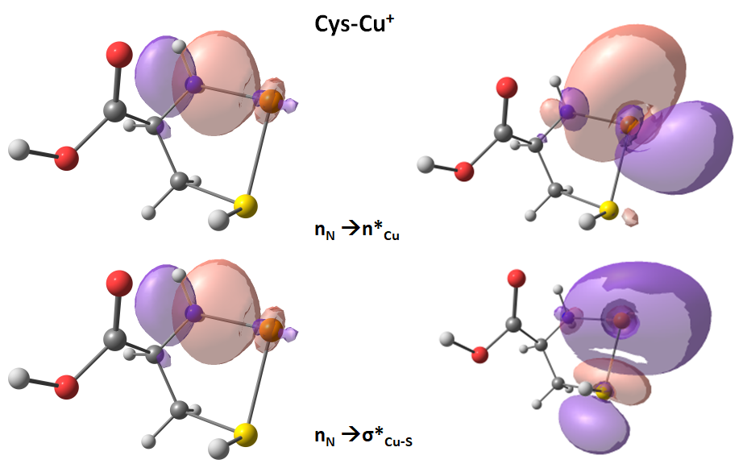
Fig. 5. Selected NBO orbitals of the Cys-Cu⁺ complex (isosurface value: ± 0.03 a.u.).
We have analyzed Arg-Cu²⁺, Cys-Cu²⁺ and Cys⁻¹-Cu²⁺ complexes of bivalent copper also. In these NBO transitions, lone pair orbitals prevail. The largest E⁽²⁾ value is observed for the Arg-Cu²⁺ system (20.19 kcal mol⁻¹), as well as the largest charge transfer (0.152).
In the Arg-Cu₂ complex, the predominant metal-ligand transitions involve the copper cluster and nitrogen atoms of the side-substituent. The n_{N} n*_{Cu} transition is characterized by E⁽²⁾ = 33.34 kcal mol⁻¹ energy and a 0.072 value of charge transfer q_{CT}. The main transition in the Asp⁻¹-Cu₂ system is a n_{O} n*_{Cu} transfer, which possesses a 21.96 kcal mol⁻¹ E⁽²⁾ energy value and a 0.049 charge transfer.
The Cys-Cu₂ system is dominated by the n_{N} n*_{Cu} transition (Fig. 6) with a 21.46 kcal mol⁻¹ of stabilization energy and a 0.048 of charge transfer. In Cys⁻¹-Cu₂ complex, major charge transfer is of metal-ligand type and occurs between the Cu-Cu bond and the S-Cu bond (σ_{Cu-Cu} σ*_{S-Cu}). It is characterized by a 28.94 kcal mol⁻¹ stabilization energy and q_{CT} = 0.098.
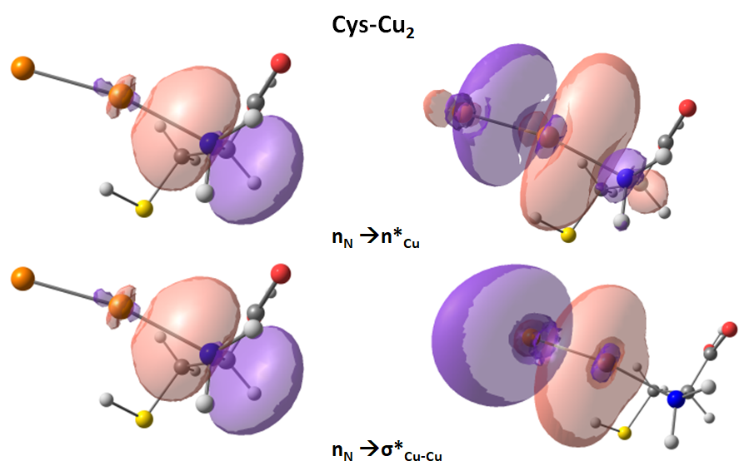
Fig. 6. Selected NBO orbitals of the Cys-Cu₂ complex (isosurface value: ± 0.03 a.u.).
As a whole, major ligand-metal and metal-ligand transitions are dominated by lone-pair n orbitals. In the case of gold-amino acid systems, bond orbitals are predominant in charge transfer transitions [38], whereas Ag-AA complexes are majorly contain lone pair orbitals [37]. Thus, it can be assumed that copper complexes with proteinogenic amino acids are similar to silver complexes to a larger extent than gold complexes.

3.4 Comparison with DNA nucleobases
Finally, we have compared the binding of amino acids and DNA nucleobases known for the most tight binding with noble metals: adenine and cytosine [38]. We have used the data for coinage metals: silver (Ag), gold (Au) and copper (Table 7). Thus, we may conclude that: 1) gold possesses the largest binding energy (both E_{b} and G_{b}) of cytosine complexes among monovalent ions: for example, the G_{b} of Ag⁺, Au⁺ and Cu⁺ are equal to 55.2 kcal mol⁻¹, 74.3 kcal mol⁻¹ and 72.9 kcal mol⁻¹; 2) binding energy is higher for monovalent ion than for the neutral diatomic cluster. In particular, the G_{b} of Cyt-Cu⁺ is 72.9 kcal mol⁻¹, whereas of Cyt-Cu₂ it is only 14.9 kcal mol⁻¹; 3) the adenine complexes are the most stable in the following order: Au > Cu > Ag. For example, Ade-Au₂, Ade-Cu₂ and Ade-Ag₂ complexes possess the following E_{b} values: 38.3 kcal mol⁻¹, 26.1 kcal mol⁻¹ and 16.9 kcal mol⁻¹, respectively.
Table 7. Gibbs free energy G_{b} and total energy E_{b} (in kcal mol⁻¹) for metal binding with amino acids and nucleobases; the table contains both literature data and results calculated in this study.
Complex | Bond | G_{b} | E_{b} | Reference
Nucleobases:
Ade-Ag⁺ | Ag-N, Ag-NH₂ | 43.2 | 52.9 | [38]
Ade-Ag₂ | Ag-N | 7.8 | 16.9 | [38]
Ade-Au⁺ | Au-N | 62.6 | 71.4 | [38]
Ade-Au₂ | Au-N | 25.3 | 38.3 | [38]
Ade-Cu⁺ | Cu-N | 61.6 | 71.3 | This study
Ade-Cu₂ | Cu-N | 15.0 | 26.1 | This study
Cyt-Ag⁺ | Ag-N, Ag-O  Ag-N, Ag-O | 55.2 | 50.1  64 | [61]
 |  |  |  | [38]
Cyt-Ag₂ | Ag-N  Ag-O |  | 11.5  22.7 | [62]  [61]
 | Ag-N | 9.3 | 21.3 | [38]
Cyt-Au⁺ | Au-N | 74.3 | 83.6 | [38]
Cyt-Au₂ | Au-N  Au-N | 26.2 | 24.2  38.2 | [63]
 |  |  |  | [38]
Cyt-Cu⁺ | Cu-N | 72.9 | 82.7 | This study
Cyt-Cu₂ | Cu-N | 14.9 | 25.5 | This study
Amino acids:
Asp⁻¹-Ag⁺ | Ag-O | 152.8 | 163.6 | [37]
Asp⁻¹-Ag₂ | Ag-O | 30.7 | 42.3 | [37]
Asp⁻¹-Au⁺ | Au-O | 169.8 | 180.9 | [38]
Asp⁻¹-Au₂ | Au-O | 41.1 | 54.5 | [38]
Asp⁻¹-Cu⁺ | Cu-N, Cu-O | 175.0 | 185.5 | This study
Asp⁻¹-Cu₂ | Cu-O | 31.0 | 41.7 | This study
Cys⁻¹-Ag⁺ | Ag-S | 151.8 | 162 | [37]
Cys⁻¹-Ag₂ | Ag-S | 30.1 | 43.1 | [37]
Cys⁻¹-Au⁺ | Au-S | 194.1 | 204.3 | [38]
Cys⁻¹-Au₂ | Au-S | 53.5 | 68 | [38]
Cys⁻¹-Cu⁺ | Cu-S, Cu-N | 181.3 | 192.6 | This study
Cys⁻¹-Cu₂ | Cu-S | 34.8 | 45.2 | This study

The geometry of nucleobase complexes with copper is presented on Fig. 7. Ade-Cu⁺ is characterized by l(Cu-N) equal to 1.900 Å, whereas Cyt-Cu+ possess l(Cu-N) and l(Cu-O) bonds equal to 2.038 Å and 2.216 Å (as one can see Cu-N bonding is much more efficient that the Cu-O bonding). In nucleobase-Cu₂ complexes, the following intra-complex bonds can be observed: in Cyt-Cu₂, l(Cu-N) equals to 2.027 Å, whereas l(Cu-N) is 1.982 in Ade-Cu₂. Thus, most of the nucleobase-Cu binding occurs through the Me-N bonds. As a whole, Cyt-Cu⁺ complex is bidentate, whereas the rest of the nucleobase-Cu systems are monodentate.
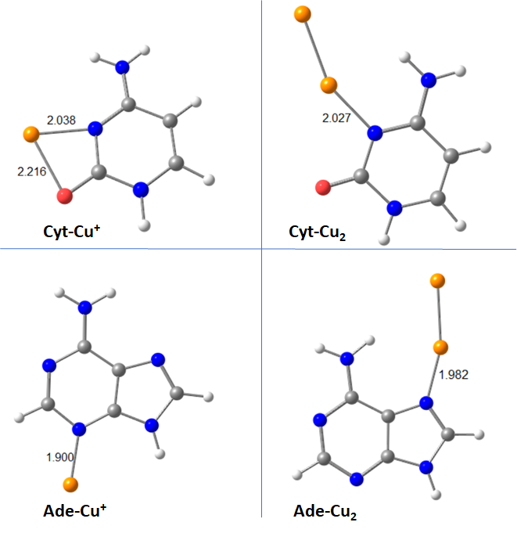
Fig. 7. The most stable complexes of cytosine, adenine, monovalent and diatomic copper (B3LYP-D3/def2-TZVP method). Bond distances are presented in angstroms.
Here are some conclusions about the data reported in Table 7. First, the binding of copper to the amino acids is more intense than to the nucleobases. For comparison: G_{b} is 72.9 kcal mol⁻¹ for Cyt and Cu⁺ and 181.3 kcal mol⁻¹ in case of Cys⁻¹ and Cu⁺; the obvious reason is the negative net charge of the amino acids. Second, the order of binding between the coinage metals and the amino acids is as Au > Cu > Ag; for example, Cys⁻¹ complexes of Au₂, Cu₂ and Ag₂ have the following G_{b} values: 53.5 kcal mol⁻¹, 34.8 kcal mol⁻¹ and 30.1 kcal mol⁻¹. In general, the interactions of copper and amino acids are intense, but not as intense as in gold-amino acid complexes. One may conclude that the mobility of neutral copper atoms in the protein environments is restricted, and copper atoms movement in polypeptides occurs to a lesser extent than in the nucleic acids. On the other hand, the activity of copper atoms in nucleic acid templates can lead to mutations and high genotoxicity of copper [64,65].

3.5 Amino acids and Cu₈/Cu₂₀ clusters
Since tiny (n = 2) clusters may be not representative for larger systems, we have also simulated AA-Cu₈ and AA-Cu₂₀ complexes of selected amino acids: Cys, Cys⁻¹ and Gly, which are medium, high and low copper binders.
In as isolated form, Cu₈ possesses C_{s} symmetry, whereas Cu₂₀ is a T_{d} tetrahedron. In particular, we optimized the geometry of the complexes and established Gibbs binding energy (Table 8). Similar to n = 2 clusters, the highest binding energies are observed for Cys⁻¹, whereas Cys⁰ and Gly possess significantly lower binding energies.
Table 8. Binding energies of Cu₈/Cu₂₀ complexes in kcal mol⁻¹.
 | E_{b}(AA-Cu₈) | E_{b}(AA-Cu₂₀) | G_{b}(AA-Cu₈) | G_{b}(AA-Cu₂₀)
Cys⁰ | 26.0 | 26.4 | 14.7 | 14.8
Cys⁻¹ | 63.7 | 65.5 | 49.0 | 51.4
Gly | 24.0 | 24.5 | 13.3 | 14.0

Most of the complexes are monodentate with major binding performed by S and N atoms, this is in agreement with the data for the tiny Cu₂ cluster. The intra-complex bond distances of AA-Cu₈ and AA-Cu₂₀ systems are presented on Fig. 8.
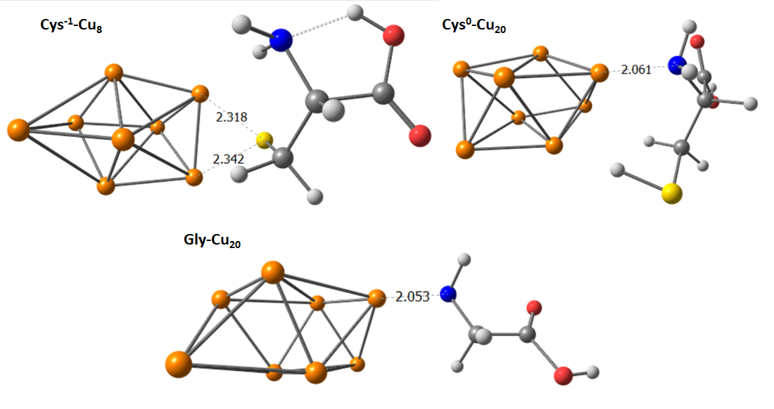
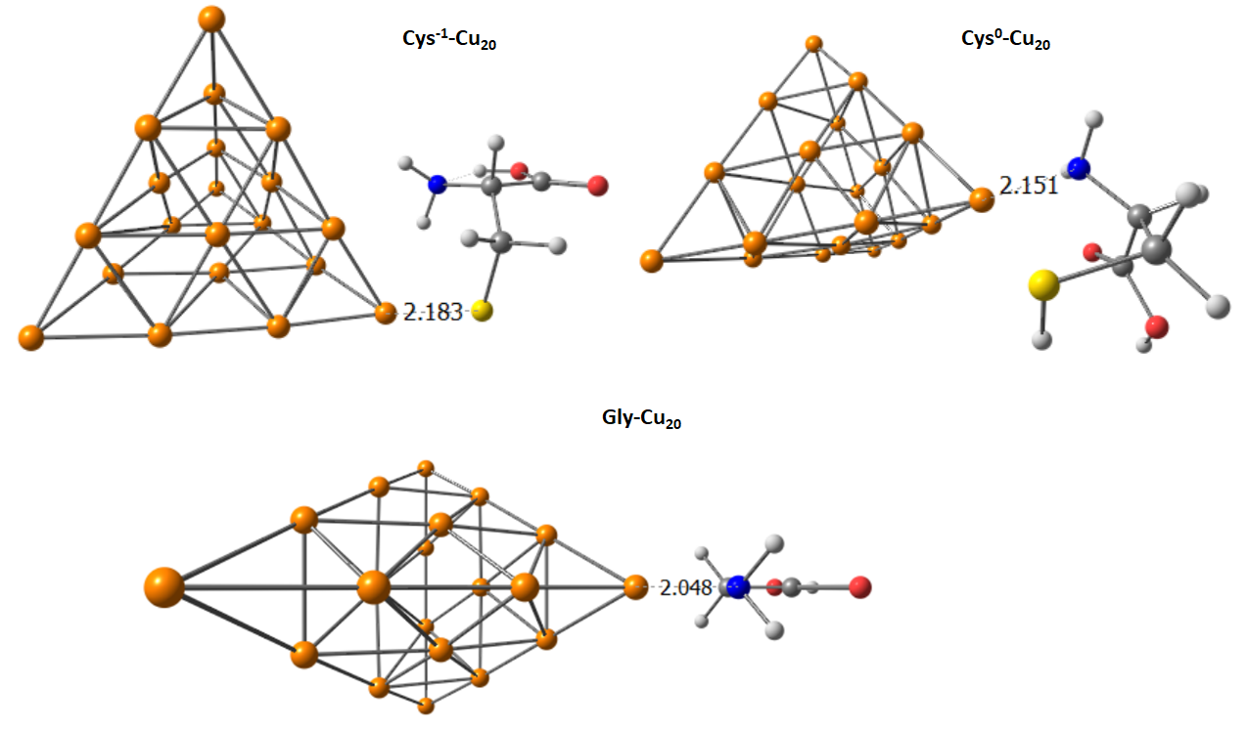
Fig. 8. Optimized geometry of AA-Cu₈ and AA-Cu₂₀ complexes. Bond distances are presented in angstroms.
The strength, selectivity, and type of copper–ligand bonding depend on various physicochemical factors, which govern how copper coordinates with ligands like amino acids, proteins, or other types of molecules. The first factor is oxidation state of copper. Monovalent copper prefers soft ligands [66] (e.g., cysteine, thioethers) and tends to form tetrahedral or linear coordination geometry. Bivalent copper preferers harder ligands [27] (e.g., nitrogen from histidine, oxygen from water or carboxylates) and usually forms square planar or distorted octahedral complexes. Secondly, the nature of ligand donor atoms plays a role. Hard-soft acid-base (HSAB) theory states that Cu(II) is a borderline hard acid, favoring N- and O-donors, whereas Cu(I) is softer, favoring S-donors. Ligand denticity and donor atom type affect complex stability (e.g., multidentate ligands like histidine-rich peptides bind strongly). Thirdly, it is coordination geometry and steric factors. Ligands must fit spatially around copper ions. Cu(I) often forms 2-4 coordinate complexes, usually tetrahedral [67]. Cu(II) shows variable coordination numbers of 4-6 [68], influenced by ligand size and flexibility. Steric hindrance from bulky ligands reduces binding affinity or changes geometry.
Fourthly, it is electronic effects: ligand field stabilization determines preferred geometry and spin states, especially in Cu(II). Jahn-Teller distortions common in Cu(II) complexes influence ligand binding energy and geometry. Ligands with π-electron donation or back-bonding capabilities can stabilize copper centers differently. Fifthly, solution conditions also influence ligand-metal interactions [69,70]. At low pH, acidic groups (carboxyl, imidazole) protonated, reducing metal coordination, whereas higher pH favors ligand deprotonation and stronger Cu binding. Solvent polarity and dielectric constant influence complex stability and solvation of metal and ligands. Moreover, redox environment determines copper oxidation state prevalence.
Sixthly, its thermodynamics and kinetics [71]. Affinity constant measures complex stability and depends on enthalpic and entropic contributions. Kinetic lability of Cu(I) complexes can be more labile/reactive, affecting the dynamics of binding and release. Seventhly, its competition and chelation [72]. Chelate effect occurs when multidentate ligands form more stable complexes. Competition with other metals or ligands influences copper bioavailability and site selectivity.

4. Conclusion
We have systematically investigated the gas-phase complexes of all 20 α-proteinogenic amino acids with multiple copper species (monovalent copper Cu⁺, bivalent copper Cu²⁺, minimal neutral diatomic Cu₂ cluster, as well as larger Cu₈ and Cu₂₀ clusters) to elucidate their binding preferences and thermodynamic stability. In particular, the binding energies for Cu⁺ of B3LYP-D3/def2-TZVP method are in agreement with experimental findings for the gas phase. Generally, topological analyses (QTAIM, NBO) are in agreement with binding energies. Moreover, the key complexes of Cu(I) and Cu(II) have been regarded in presence of explicit water.
As DFT shows, the most stable copper-AA complexes can be observed for deprotonated amino acids: Cys⁻¹, Asp⁻¹, Tyr⁻¹ and Glu⁻¹. The largest binding energy G_{b} is determined for Cys⁻¹: 181.3 kcal mol⁻¹ and 34.8 kcal mol⁻¹ for Cu⁺ and Cu₂, respectively. Among the neutral amino acids, the strongest bonding is observed for Arg: 117.6 kcal mol⁻¹ and 23.3 kcal mol⁻¹, respectively. Similar findings (the prevalence of Cys⁻¹ and Arg⁰) have been determined previously for gold and silver. Moreover, copper-amino acid complexes have been compared with amino acid/nucleobase complexes of silver and gold, which led us to an important conclusion that the mobility of copper atoms in protein environment is limited, but to a lesser extent than the mobility of gold atoms.
Copper-organic interactions are primarily governed by strong anchoring bonds involving sulfur (Cu–S), nitrogen (Cu–N), and oxygen (Cu–O), with additional stabilization provided by π–cation interactions between copper ions and adjacent aromatic or electron-rich systems: for example, Phe-Cu⁺, Trp-Cu⁺ and Tyr-Cu⁺. In addition, non-conventional H-bonds (such as C–H···X or O–H···π interactions) may contribute to structural stabilization. QTAIM analysis reveals that the Cu–X bonding character is mixed, exhibiting both partial covalent contribution and significant electrostatic components. Finally, the NBO analysis demonstrated that the strongest ground state ligand-metal charge transfer in terms of E⁽²⁾ stabilization energy is possessed by the Arg-Cu²⁺ complex.
When copper complexes are formed on protein templates, the preferred interaction sites are likely to involve deprotonated amino acid residues and neutral Arg. The present study provides insights into a simplified model of protein-copper interactions, focusing only on the gas-phase and explicit water environments. However, additional computational analyses incorporating dielectric constants (ε) between 4-6 and 20-30 are necessary to broaden the scope of the findings. Moreover, further investigations should consider the impact of secondary structural elements, which could be addressed through classical molecular dynamics simulations. Despite these limitations, the findings presented here may hold significant value for advancing experimental efforts related to the synthesis of copper NCs and nanoparticles on protein templates, as well as for deepening the understanding of copper-active enzymes.

CRediT authorship contribution statement
A.A.B.: Writing – original draft, conceptualization, visualization and analysis. Ya.Yu.B.: Visualization and analysis. I.N.A.: Soft. A.F.: Writing – review & editing. A.I.K.: Writing – review & editing, supervision, funding acquisition. All authors read and approved the final manuscript.

Funding sources
The work was supported by the Russian Science Foundation grant 25-23-00217.

Declaration of competing interest
The authors declare that they have no conflicts of interest with the contents of this article.

Abbreviations
AA = Amino Acid
DFT = Density Functional Theory
G_{b} = Gibbs binding energy
MAE = Mean absolute error
NBO = Natural Bond Orbital
PCM = Polarizable Continuum Model
QTAIM = Quantum Theory “Atoms-in-Molecules”

Appendix A. Supplementary data
Supplementary material is available on the publisher’s website along with the published article.

Data availability
Data will be made available on request.

Human and animal rights
No humans or animals were used for the studies that are the basis of this research.

References
[1] X. Li, N. Li, L. Zhao, The reactive activities of natural amino acids: key principles of peptide-templated Au cluster synthesis, Sci. Bull. 61 (2016) 1732–1738. https://doi.org/https://doi.org/10.1007/s11434-016-1195-7.
[2] C.M.C. Andrés, J.M. Pérez de la Lastra, C. Andrés Juan, F.J. Plou, E. Pérez-Lebeña, Impact of Reactive Species on Amino Acids-Biological Relevance in Proteins and Induced Pathologies., Int. J. Mol. Sci. 23 (2022). https://doi.org/10.3390/ijms232214049.
[3] A.A. Buglak, Antioxidant properties of α-amino acids: a density functional theory viewpoint, Free Radic. Res. 58 (2024) 380–387. https://doi.org/10.1080/10715762.2024.2385338.
[4] L.M. Gaetke, H.S. Chow-Johnson, C.K. Chow, Copper: toxicological relevance and mechanisms., Arch. Toxicol. 88 (2014) 1929–1938. https://doi.org/10.1007/s00204-014-1355-y.
[5] P. Wang, Y. Yuan, K. Xu, H. Zhong, Y. Yang, S. Jin, K. Yang, X. Qi, Biological applications of copper-containing materials., Bioact. Mater. 6 (2021) 916–927. https://doi.org/10.1016/j.bioactmat.2020.09.017.
[6] A. Messerschmidt, 8.14 - Copper Metalloenzymes, in: H.-W. (Ben) Liu, L.B.T.-C.N.P.I.I. Mander (Eds.), Elsevier, Oxford, 2010: pp. 489–545. https://doi.org/https://doi.org/10.1016/B978-008045382-8.00180-5.
[7] A. Baghdasaryan, T. Bürgi, Copper nanoclusters: designed synthesis, structural diversity, and multiplatform applications, Nanoscale. 13 (2021) 6283–6340. https://doi.org/10.1039/D0NR08489A.
[8] S. Shahsavari, S. Hadian-Ghazvini, F. Hooriabad Saboor, I. Menbari Oskouie, M. Hasany, A. Simchi, A.L. Rogach, Ligand functionalized copper nanoclusters for versatile applications in catalysis, sensing, bioimaging, and optoelectronics, Mater. Chem. Front. 3 (2019) 2326–2356. https://doi.org/10.1039/C9QM00492K.
[9] S. Sharma, S. Das, K. Kaushik, A. Yadav, A. Patra, C.K. Nandi, Unveiling the Long-Lived Emission of Copper Nanoclusters Embedded in a Protein Scaffold, J. Phys. Chem. Lett. 14 (2023) 8979–8987. https://doi.org/10.1021/acs.jpclett.3c01877.
[10] M. Lettieri, P. Palladino, S. Scarano, M. Minunni, Protein-templated copper nanoclusters for fluorimetric determination of human serum albumin., Mikrochim. Acta. 188 (2021) 116. https://doi.org/10.1007/s00604-021-04764-7.
[11] R. Rajamanikandan, M. Ilanchelian, Protein-protected red emittive copper nanoclusters as a fluorometric probe for highly sensitive biosensing of creatinine, Anal. Methods. 10 (2018) 3666–3674. https://doi.org/10.1039/C8AY00827B.
[12] Aarya, T. Thomas, B.R. Sarangi, S. Sen Mojumdar, Rapid Detection of Ag(I) via Size-Induced Photoluminescence Quenching of Biocompatible Green-Emitting, l-Tryptophan-Scaffolded Copper Nanoclusters, ACS Omega. 8 (2023) 14630–14640. https://doi.org/10.1021/acsomega.3c00462.
[13] D. Kumar, N. Jain, V. Jain, B. Rai, Amino acids as copper corrosion inhibitors: A density functional theory approach, Appl. Surf. Sci. 514 (2020) 145905. https://doi.org/10.1016/j.apsusc.2020.145905.
[14] X. Ma, S. Zhou, X. Xu, Q. Du, Copper-containing nanoparticles: Mechanism of antimicrobial effect and application in dentistry-a narrative review., Front. Surg. 9 (2022) 905892. https://doi.org/10.3389/fsurg.2022.905892.
[15] E.W. Wilson, M.H. Kasperian, R.B. Martin, Binding of copper(II) to potentially tridentate amino acid ligands, J. Am. Chem. Soc. 92 (1970) 5365–5372. https://doi.org/10.1021/ja00721a013.
[16] M.S. Nair, K. Venkatachalapathi, M. Santappa, P.K. Murugan, Ternary coordination complexes of copper(II) containing histamine and some amino acids, Inorg. Chem. 21 (1982) 2418–2421. https://doi.org/10.1021/ic00136a058.
[17] A. Cuevas, I. Viera, M.H. Torre, E. Kremer, S.B. Etcheverry, E.J. Baran, Infrared spectra of the copper (II) complexes of amino acids with hydroxylic residues, Afinidad. 56 (1999) 263–265.
[18] A. Stanila, A. Marcu, D. Rusu, M. Rusu, L. David, Spectroscopic studies of some copper(II) complexes with amino acids, J. Mol. Struct. 834–836 (2007) 364–368. https://doi.org/10.1016/j.molstruc.2006.11.048.
[19] S. Biswas, Y. Negishi, A Comprehensive Analysis of Luminescent Crystallized Cu Nanoclusters, J. Phys. Chem. Lett. 15 (2024) 947–958. https://doi.org/10.1021/acs.jpclett.3c03374.
[20] B.A. Cerda, C. Wesdemiotis, Gas phase copper(I) ion affinities of valine, lysine, and arginine based on the dissociation of Cu+-bound heterodimers at varying internal energies, Int. J. Mass Spectrom. 185–187 (1999) 107–116. https://doi.org/10.1016/S1387-3806(98)14132-5.
[21] J. Jover, R. Bosque, J. Sales, A comparison of the binding affinity of the common amino acids with different metal cations, Dalt. Trans. (2008) 6441–6453. https://doi.org/10.1039/B805860A.
[22] Y. Yang, J. Wu, L. Wang, G. Ji, Y. Dang, Copper homeostasis and cuproptosis in health and disease., MedComm. 5 (2024) e724. https://doi.org/10.1002/mco2.724.
[23] W. Yang, C. Xiao, J. Zheng, J. Song, X.-G. Li, Copper homeostasis and cuproptosis represent emerging targets for therapeutic intervention in inflammatory diseases, Pharmacol. Res. 221 (2025) 107988. https://doi.org/10.1016/j.phrs.2025.107988.
[24] W. Zhu, Y. Zhang, X. Luo, J. Peng, Role of copper and its complexes in cardiovascular diseases., Zhong Nan Da Xue Xue Bao. Yi Xue Ban = J. Cent. South Univ. Med. Sci. 48 (2023) 1731–1738. https://doi.org/10.11817/j.issn.1672-7347.2023.230159.
[25] X. Chen, Q.P. Dou, J. Liu, D. Tang, Targeting Ubiquitin-Proteasome System With Copper Complexes for Cancer Therapy., Front. Mol. Biosci. 8 (2021) 649151. https://doi.org/10.3389/fmolb.2021.649151.
[26] B. Zhang, R. Burke, Copper homeostasis and the ubiquitin proteasome system, Metallomics. 15 (2023). https://doi.org/10.1093/mtomcs/mfad010.
[27] J.S. Valentine, Dioxygen Reactions, in: I. Bertini, H.B. Gray, S.J. Lippard, J.S. Valentine (Eds.), Bioinorg. Chem., University Science Books, Mill Valley, California, 1994: pp. 313–523.
[28] L. Banci, I. Bertini, F. Cantini, S. Ciofi-Baffoni, Cellular copper distribution: a mechanistic systems biology approach., Cell. Mol. Life Sci. 67 (2010) 2563–2589. https://doi.org/10.1007/s00018-010-0330-x.
[29] W. Feng, S. Su, C. Song, F. Yu, J. Zhou, J. Li, R. Jia, P. Xu, Y. Tang, Effects of Copper Exposure on Oxidative Stress, Apoptosis, Endoplasmic Reticulum Stress, Autophagy and Immune Response in Different Tissues of Chinese Mitten Crab (Eriocheir sinensis), Antioxidants. 11 (2022) 2029. https://doi.org/10.3390/antiox11102029.
[30] R. Ševčík, J. Vaněk, P. Lubal, Z. Kotková, J. Kotek, P. Hermann, Formation and dissociation kinetics of copper(II) complexes with tetraphosphorus acid DOTA analogs, Polyhedron. 67 (2014) 449–455. https://doi.org/https://doi.org/10.1016/j.poly.2013.09.024.
[31] A. Barazzouq, M. Azogagh, N. Aflak, L. Bahsis, A. El Magri, O. Dehbi, M. Daoudi, D. Ouzebla, R. Hsissou, Synthesis of novel ester derivatives via transesterification catalyzed by NaF@CRA: Antiparasitic activity using molecular docking simulations, J. Mol. Struct. 1332 (2025) 141676. https://doi.org/https://doi.org/10.1016/j.molstruc.2025.141676.
[32] R. Hsissou, A. Barazzouq, S. Sibous, G. Lahlalate, M. Azogagh, L. Bahsis, N. Aflak, A. El Magri, L. Khamliche, D. Ouzebla, M. Daoudi, Synthesis of benzimidazole derivatives via K2CO3@CRA as an ecofriendly heterogeneous catalyst: Anticancer activity using molecular docking approach, Inorg. Chem. Commun. 182 (2025) 115434. https://doi.org/https://doi.org/10.1016/j.inoche.2025.115434.
[33] G. Lahlalate, Y. Riadi, A. Altharawi, A. Zeroual, T. Aldakhil, D. Ouzebla, A.S.A. Altamimi, R. Hsissou, New catalyst for synthesis of cyclic nucleosides: Insights into silyl-Hilbert-Johnson reaction, ADME survey, dynamic simulation and molecular docking studies targeting HCV, Inorg. Chem. Commun. 186 (2026) 116127. https://doi.org/https://doi.org/10.1016/j.inoche.2025.116127.
[34] P. Jaque, A. Toro-Labbé, Characterization of copper clusters through the use of density functional theory reactivity descriptors, J. Chem. Phys. 117 (2002) 3208–3218. https://doi.org/10.1063/1.1493178.
[35] P. Jaque, A. Toro-Labbé, Polarizability of neutral copper clusters, J. Mol. Model. 20 (2014) 2410. https://doi.org/10.1007/s00894-014-2410-6.
[36] B. El Ibrahimi, A. Jmiai, K. El Mouaden, R. Oukhrib, A. Soumoue, S. El Issami, L. Bazzi, Theoretical evaluation of some α-amino acids for corrosion inhibition of copper in acidic medium: DFT calculations, Monte Carlo simulations and QSPR studies, J. King Saud Univ. - Sci. 32 (2020) 163–171. https://doi.org/https://doi.org/10.1016/j.jksus.2018.04.004.
[37] A.A. Buglak, R.R. Ramazanov, A.I. Kononov, Silver cluster–amino acid interactions: a quantum-chemical study, Amino Acids. 51 (2019) 855–864. https://doi.org/10.1007/s00726-019-02728-z.
[38] A.A. Buglak, A.I. Kononov, Comparative study of gold and silver interactions with amino acids and nucleobases, RSC Adv. 10 (2020) 34149–34160. https://doi.org/10.1039/d0ra06486f.
[39] I. Chakraborty, T. Pradeep, Atomically Precise Clusters of Noble Metals: Emerging Link between Atoms and Nanoparticles, Chem. Rev. 117 (2017) 8208–8271. https://doi.org/10.1021/acs.chemrev.6b00769.
[40] S. Grimme, S. Ehrlich, L. Goerigk, Effect of the damping function in dispersion corrected density functional theory, J. Comput. Chem. 32 (2011) 1456–1465. https://doi.org/https://doi.org/10.1002/jcc.21759.
[41] M. Gaber, T.A. Fayed, M.M. El-Gamil, G.M. Abu El-Reash, Structural, thermogravimetric, B3LYP and biological studies on some heterocyclic thiosemicarbazide copper (II) complexes and evaluation of their molecular docking, J. Mol. Struct. 1151 (2018) 56–72. https://doi.org/https://doi.org/10.1016/j.molstruc.2017.09.035.
[42] T.A. Fayed, M. Gaber, G.M. Abu El-Reash, M.M. El-Gamil, Structural, DFT/B3LYP and molecular docking studies of binuclear thiosemicarbazide Copper (II) complexes and their biological investigations, Appl. Organomet. Chem. 34 (2020) e5800. https://doi.org/https://doi.org/10.1002/aoc.5800.
[43] F. Weigend, R. Ahlrichs, Balanced basis sets of split valence, triple zeta valence and quadruple zeta valence quality for H to Rn: Design and assessment of accuracy, Phys. Chem. Chem. Phys. 7 (2005) 3297–3305. https://doi.org/10.1039/B508541A.
[44] P. Liebhäuser, K. Keisers, A. Hoffmann, T. Schnappinger, I. Sommer, A. Thoma, C. Wilfer, R. Schoch, K. Stührenberg, M. Bauer, M. Dürr, I. Ivanović-Burmazović, S. Herres-Pawlis, Record Broken: A Copper Peroxide Complex with Enhanced Stability and Faster Hydroxylation Catalysis, Chem. – A Eur. J. 23 (2017) 12171–12183. https://doi.org/https://doi.org/10.1002/chem.201700887.
[45] M. Amin, J. Küpper, Variations in Proteins Dielectric Constants., ChemistryOpen. 9 (2020) 691–694. https://doi.org/10.1002/open.202000108.
[46] R.F.W. Bader, A quantum theory of molecular structure and its applications, Chem. Rev. 91 (1991) 893–928. https://doi.org/10.1021/cr00005a013.
[47] P.S.V. Kumar, V. Raghavendra, V. Subramanian, Bader’s Theory of Atoms in Molecules (AIM) and its Applications to Chemical Bonding, J. Chem. Sci. 128 (2016) 1527–1536. https://doi.org/10.1007/s12039-016-1172-3.
[48] F. Weinhold, C.R. Landis, Natural Bond Orbitals and extensions of localized bonding concepts, Chem. Educ. Res. Pr. 2 (2001) 91–104. https://doi.org/10.1039/B1RP90011K.
[49] D.J. Frisch, M. J.; Trucks, G. W.; Schlegel, H. B.; Scuseria, G. E.; Robb, M. A.; Cheeseman, J. R.; Scalmani, G.; Barone, V.; Petersson, G. A.; Nakatsuji, H.; Li, X.; Caricato, M.; Marenich, A. V.; Bloino, J.; Janesko, B. G.; Gomperts, R.; Mennucci, B.; Hratch, M.J. Frisch, G.W. Trucks, H.B. Schlegel, G.E. Scuseria, M.A. Robb, J.R. Cheeseman, G. Scalmani, V. Barone, G.A. Petersson, H. Nakatsuji, X. Li, M. Caricato, A. V Marenich, J. Bloino, B.G. Janesko, R. Gomperts, B. Mennucci, H.P. Hratchian, J. V Ortiz, A.F. Izmaylov, J.L. Sonnenberg, D. Williams-Young, F. Ding, F. Lipparini, F. Egidi, J. Goings, B. Peng, A. Petrone, T. Henderson, D. Ranasinghe, V.G. Zakrzewski, J. Gao, N. Rega, G. Zheng, W. Liang, M. Hada, M. Ehara, K. Toyota, R. Fukuda, J. Hasegawa, M. Ishida, T. Nakajima, Y. Honda, O. Kitao, H. Nakai, T. Vreven, K. Throssell, J.A. Montgomery Jr., J.E. Peralta, F. Ogliaro, M.J. Bearpark, J.J. Heyd, E.N. Brothers, K.N. Kudin, V.N. Staroverov, T.A. Keith, R. Kobayashi, J. Normand, K. Raghavachari, A.P. Rendell, J.C. Burant, S.S. Iyengar, J. Tomasi, M. Cossi, J.M. Millam, M. Klene, C. Adamo, R. Cammi, J.W. Ochterski, R.L. Martin, K. Morokuma, O. Farkas, J.B. Foresman, D.J. Fox, Gaussian16 Revision C.01, (2016) Gaussian 16, Revision C.01, Gaussian, Inc., Wallin.
[50] M. Krstić, K. Fink, D.I. Sharapa, The Adsorption of Small Molecules on the Copper Paddle-Wheel: Influence of the Multi-Reference Ground State, Molecules. 27 (2022) 912. https://doi.org/10.3390/molecules27030912.
[51] Y. Zhao, D.G. Truhlar, A new local density functional for main-group thermochemistry, transition metal bonding, thermochemical kinetics, and noncovalent interactions, J. Chem. Phys. 125 (2006) 194101. https://doi.org/10.1063/1.2370993.
[52] S. Grimme, A. Hansen, J.G. Brandenburg, C. Bannwarth, Dispersion-Corrected Mean-Field Electronic Structure Methods, Chem. Rev. 116 (2016) 5105–5154. https://doi.org/10.1021/acs.chemrev.5b00533.
[53] M. Rahm, P. Erhart, R. Cammi, Relating atomic energy, radius and electronegativity through compression, Chem. Sci. 12 (2021) 2397–2403. https://doi.org/10.1039/D0SC06675C.
[54] E. Blokker, X. Sun, J. Poater, J.M. van der Schuur, T.A. Hamlin, F.M. Bickelhaupt, The Chemical Bond: When Atom Size Instead of Electronegativity Difference Determines Trend in Bond Strength, Chem. – A Eur. J. 27 (2021) 15616–15622. https://doi.org/https://doi.org/10.1002/chem.202103544.
[55] A. Rimola, L. Rodríguez-Santiago, M. Sodupe, Cation-pi Interactions and oxidative effects on Cu+ and Cu2+ binding to Phe, Tyr, Trp, and His amino acids in the gas phase. Insights from first-principles calculations., J. Phys. Chem. B. 110 (2006) 24189–24199. https://doi.org/10.1021/jp064957l.
[56] J. Sabolović, K.R. Liedl, Why Are Copper(II) Amino Acid Complexes Not Planar in Their Crystal Structures? An ab Initio and Molecular Mechanics Study , Inorg. Chem. 38 (1999) 2764–2774. https://doi.org/10.1021/ic980471a.
[57] E. Espinosa, E. Molins, C. Lecomte, Hydrogen bond strengths revealed by topological analyses of experimentally observed electron densities, Chem. Phys. Lett. 285 (1998) 170–173. https://doi.org/https://doi.org/10.1016/S0009-2614(98)00036-0.
[58] V. Bryantsev, M. Diallo, A. van Duin, W. Goddard, Hydration of Copper(II): New Insights from Density Functional Theory and the COSMO Solvation Model, J. Phys. Chem. A. 112 (2008) 9104–9112. https://doi.org/10.1021/jp804373p.
[59] J.C. Slater, Atomic Radii in Crystals, J. Chem. Phys. 41 (1964) 3199–3204. https://doi.org/10.1063/1.1725697.
[60] L. Li, C. Li, Z. Zhang, E. Alexov, On the Dielectric “Constant” of Proteins: Smooth Dielectric Function for Macromolecular Modeling and Its Implementation in DelPhi, J. Chem. Theory Comput. 9 (2013) 2126–2136. https://doi.org/10.1021/ct400065j.
[61] I.L. Volkov, R.R. Ramazanov, E. V Ubyivovk, V.I. Rolich, A.I. Kononov, N.A. Kasyanenko, Fluorescent silver nanoclusters in condensed DNA., Chemphyschem. 14 (2013) 3543–3550. https://doi.org/10.1002/cphc.201300673.
[62] V. Soto-Verdugo, H. Metiu, E. Gwinn, The properties of small Ag clusters bound to DNA bases, J. Chem. Phys. 132 (2010) 195102. https://doi.org/10.1063/1.3419930.
[63] M.K. Shukla, M. Dubey, E. Zakar, J. Leszczynski, DFT Investigation of the Interaction of Gold Nanoclusters with Nucleic Acid Base Guanine and the Watson−Crick Guanine-Cytosine Base Pair, J. Phys. Chem. C. 113 (2009) 3960–3966. https://doi.org/10.1021/jp808622y.
[64] A. Erxleben, Interactions of copper complexes with nucleic acids, Coord. Chem. Rev. 360 (2018) 92–121. https://doi.org/https://doi.org/10.1016/j.ccr.2018.01.008.
[65] Y. Song, X. Xie, Y. Liu, Z. Zhu, L. Sun, Nanoscale Study of DNA–Cu2+ Interactions by Liquid-Cell Electron Microscopy, ACS Omega. 8 (2023) 26325–26331. https://doi.org/10.1021/acsomega.3c02823.
[66] L.-C. Königsberger, E. Königsberger, G. Hefter, P.M. May, Formation constants of copper(i) complexes with cysteine, penicillamine and glutathione: implications for copper speciation in the human eye, Dalt. Trans. 44 (2015) 20413–20425. https://doi.org/10.1039/C5DT02129D.
[67] A. Devdass, K. Talukdar, M. Zeller, R.C. Fortenberry, J.W. Jurss, Exploring different equatorial donors in a series of five-coordinate Cu(II) complexes supported by rigid tetradentate ligands, Polyhedron. 212 (2022) 115558. https://doi.org/https://doi.org/10.1016/j.poly.2021.115558.
[68] V. Chaurin, E.C. Constable, C.E. Housecroft, What is the coordination number of copper(II) in metallosupramolecular chemistry?, New J. Chem. 30 (2006) 1740–1744. https://doi.org/10.1039/b610306e.
[69] D. Manna, R. Lo, V.M. Miriyala, D. Nachtigallová, Z. Trávníček, P. Hobza, Impact of dielectric constant of solvent on the formation of transition metal-ammine complexes, J. Comput. Chem. 45 (2024) 204–209. https://doi.org/https://doi.org/10.1002/jcc.27230.
[70] M. Gabryel-Skrodzka, M. Nowak, K. Stachowiak, M. Zabiszak, K. Ogawa, R. Jastrzab, The Influence of pH on Complexation Process of Copper(II) Phosphoethanolamine to Pyrimidine Nucleosides, Materials (Basel). 14 (2021) 4309. https://doi.org/10.3390/ma14154309.
[71] C.A. Blasie, J.M. Berg, Kinetics and Thermodynamics of Copper(II) Binding to Apoazurin, J. Am. Chem. Soc. 125 (2003) 6866–6867. https://doi.org/10.1021/ja035333l.
[72] D.C. Bowman, A Colorful Look at the Chelate Effect, J. Chem. Educ. 83 (2006) 1158. https://doi.org/10.1021/ed083p1158.

