# **K8s resources**

K8s architecture

Pod:-

Deification:-

Yaml of pod

apiVersion: v1

kind: Pod

metadata:

name: nginx

spec:

containers:

- name: nginx

image: nginx:1.14.2

ports:

- containerPort: 80

Kind: it will define obje

metadt

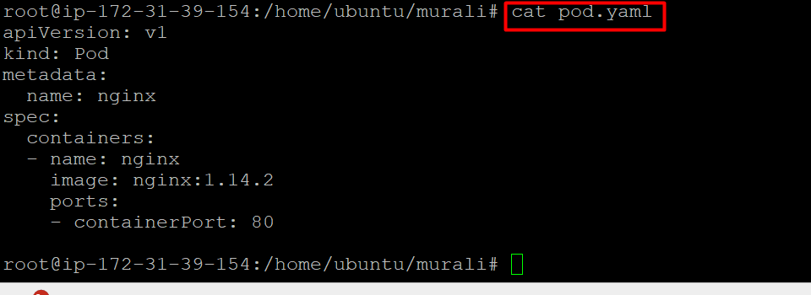

Pod commands

Kubectl get pods:- to list pods

