A Domain-Specific Language and Compiler Front-End for Describing, Validating, and Executing Data Science Pipelines
Course Code: BCSE307P — Compiler Design Laboratory
Fall Semester 2026–27

PHASE 2: Core Implementation

Prepared By:
SINCHANA B KURKURI
24BDS0352
Slot: L49+L50

Project Overview
The Data Science Pipeline DSL (Domain-Specific Language) is a custom compiler frontend designed to simplify and standardize the creation of machine learning pipelines. It addresses the complexity and boilerplate of setting up end-to-end data workflows by providing a clean, declarative language tailored specifically for tasks like loading datasets, cleaning values, selecting features, creating train/test splits, and evaluating machine learning models.

Phase 1 Recap
Before Phase 2, the project existed as a single-file prototype (initial_prototype.py) which grouped the lexer, parser, AST structures, and a semantic analyzer into one monolithic script. This early iteration proved the viability of the language grammar and logic but lacked modularity, intermediate representations, optimizations, an executor, and testing infrastructure.

Scope & Objectives
The objectives of Phase 2 focused on transforming the prototype into a structured, modular compiler architecture. The goals were to:
- Refactor the monolith into a proper Python package (ds_pipeline_dsl) with separated modules.
- Introduce an Intermediate Representation (IR) generation stage (lower_to_ir).
- Implement an Optimizer to collapse redundant statements and drop unreachable code.
- Create a Symbolic Executor to provide a human-readable execution trace.
- Expose a fully-featured Command-Line Interface (cli.py) for inspecting each compiler stage.
- Establish a rigorous automated test suite covering all compiler stages and error states.

System Architecture
The pipeline now follows a standard multi-pass compiler architecture:
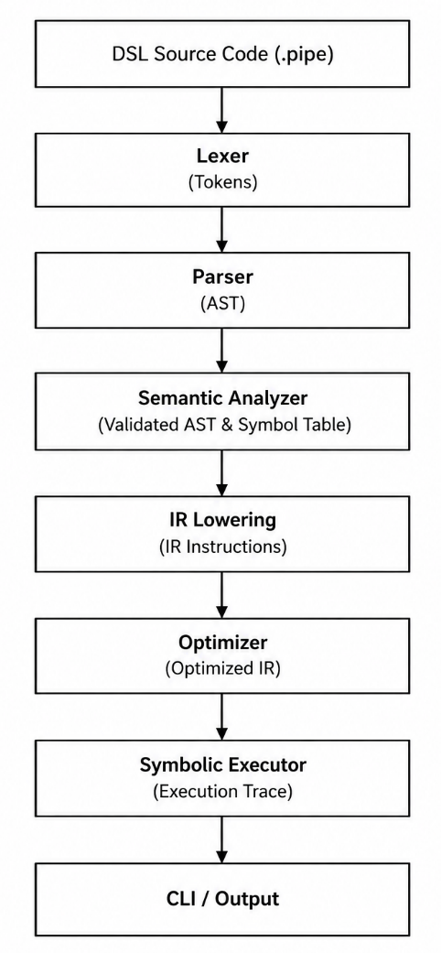

Module-wise Implementation Details

__init__.py
Purpose: Marks the src/ds_pipeline_dsl/ directory as a Python package.

ast_nodes.py
Purpose: Defines the Abstract Syntax Tree (AST) node structures.
Data Structures: Dataclasses like PipelineNode, LoadStmt, CleanStmt, SplitStmt, TrainStmt, EvaluateStmt.
Core Logic: Provides purely structural representation of a parsed pipeline and its statements.
Interaction: Instantiated by the parser and traversed by the semantic analyzer and IR lowerer.

lexer.py
Purpose: Converts a raw string of DSL code into a sequential stream of tokens.
Data Structures: A Token namedtuple and a list of regex rules defining token patterns.
Core Logic: Applies regex matches iteratively over the input string, discarding whitespace/comments and emitting Token objects. Raises a LexicalError on invalid characters.
Interaction: Feeds the resulting token list into the parser.

parser.py
Purpose: Constructs an Abstract Syntax Tree (AST) from the token stream.
Data Structures: A recursive-descent Parser class.
Core Logic: Uses peek(), advance(), and expect() methods to match tokens against the expected DSL grammar. Raises a SyntaxError_ if the tokens violate the grammar.
Interaction: Takes input from the lexer and passes its output (PipelineNode) to the semantic analyzer.

semantic.py
Purpose: Validates the logical correctness of the AST.
Data Structures: SymbolTable to track defined datasets, splits, and models.
Core Logic: Traverses the AST statements, ensuring operations are logically ordered (e.g., you cannot train before split and percentages must strictly fall between 0 and 100). Raises a SemanticError upon violations.
Interaction: Analyzes the AST produced by the parser before it is lowered to IR.

ir.py
Purpose: Lowers the hierarchical AST into a flat Intermediate Representation (IR).
Data Structures: IRInstruction dataclass containing an opcode op and a dictionary of args.
Core Logic: Maps each AST statement node into exactly one corresponding IRInstruction sequentially.
Interaction: Receives the validated AST and outputs an IR instruction list to the optimizer.

optimizer.py
Purpose: Improves the efficiency of the compiled code by transforming the IR.
Data Structures: Modifies a sequential list of IRInstruction objects.
Core Logic: Applies two passes simultaneously: collapsing immediately consecutive duplicate instructions (e.g., redundant OP_CLEAN or OP_SELECT with identical arguments) and stripping unreachable instructions that follow an OP_EVAL instruction.
Interaction: Takes unoptimized IR from ir.py and provides optimized IR to the executor.

executor.py
Purpose: Performs a symbolic execution of the optimized IR.
Data Structures: Generates and returns a list of human-readable trace strings.
Core Logic: Iterates over the optimized IR list and maps each opcode to a formatted, declarative status message.
Interaction: Acts as the final endpoint of the compilation pipeline, translating machine-like IR back to the user context.

cli.py
Purpose: Provides a user-facing command-line interface.
Data Structures: Utilizes argparse for flag evaluation.
Core Logic: Orchestrates the entire compiler pipeline. Captures specific exceptions (LexicalError, SyntaxError_, SemanticError) to display clean error messages without raw Python tracebacks, and selectively prints data from intermediate stages (--tokens, --ast, --ir, --optimized-ir, --trace).
Interaction: The entrypoint that coordinates and executes all compiler modules.

Compiler Design Concepts Applied
Concept | Implemented By Module
Lexical Analysis | lexer.py
Syntax Analysis / Parsing | parser.py
Abstract Syntax Tree | ast_nodes.py, parser.py
Semantic Analysis | semantic.py
Intermediate Code Generation | ir.py
Code Optimization | optimizer.py
Symbolic Execution | executor.py
Error Handling | cli.py, lexer.py, parser.py, semantic.py
Command-Line Interface | cli.py

Test Cases & Results
Test File | Verified Behavior | Tests | Status
test_lexer.py | Valid token generation, correct error handling for illegal characters. | 2 | Passed
test_parser.py | AST node construction, syntax error generation for missing elements. | 2 | Passed
test_semantic.py | Valid logical flows, split bounds checks, missing prerequisites (e.g., train before split). | 3 | Passed
test_ir.py | Correct generation of flat opcodes and preserved sequential ordering from AST to IR. | 1 | Passed
test_optimizer.py | Elimination of exact duplicate operations, stripping of dead code following evaluations. | 3 | Passed
test_executor.py | Proper formatting and generation of the final symbolic trace. | 1 | Passed
test_cli.py | Argument flag ingestion, pipeline stage visualization, gracefully catching and formatting compilation errors. | 3 | Passed
test_examples.py | End-to-end execution of the 4 .pipe file examples in the repository verifying expected successes and failures. | 4 | Passed
Overall Result: 19 / 19 tests passed (0.07s).

Functional Demonstration
The repository includes four .pipe files under examples/ demonstrating various scenarios. You can run them via the CLI:

1. Valid Basic Pipeline:
python -m ds_pipeline_dsl.cli examples/valid_basic.pipe
Expected Output: Prints all 5 stages (Tokens, AST, IR, Optimized IR, and Trace) concluding with the successful 6-line evaluation trace.
To only view the trace:
python -m ds_pipeline_dsl.cli examples/valid_basic.pipe --trace

2. Semantic Error (Train Before Split):
python -m ds_pipeline_dsl.cli examples/invalid_train_before_split.pipe
Expected Output: Semantic Error at line 5: training data has not been defined... (execution halts gracefully).

3. Lexical Error (Invalid Character):
python -m ds_pipeline_dsl.cli examples/invalid_lexical_error.pipe
Expected Output: Lexical Error at line 2, col 9: unexpected character '@' (execution halts gracefully).

4. Syntax Error (Missing Semicolon):
python -m ds_pipeline_dsl.cli examples/invalid_syntax_error.pipe
Expected Output: Syntax Error at line 3: expected SEMI, found CLEAN ('clean') (execution halts gracefully).

Known Limitations
- The executor is purely symbolic: Execution produces human-readable trace statements rather than performing actual machine learning operations.
- No real datasets are loaded: The compiler references data files for validation but does not read file contents.
- No real model training or prediction: The models evaluated are placeholder simulations.
- Limited Optimization: The optimizer implements solely the duplicate-collapse and unreachable-code-removal rules currently defined in optimizer.py.

Future Enhancements
- Enhanced Semantic Analysis: Add stronger dependency, reference, and argument validation to detect more pipeline errors before execution.
- DSL Construct Expansion: Introduce additional data-processing constructs and propagate them through the complete compiler pipeline.
- Advanced Optimization Passes: Extend the optimizer with additional safe transformations such as redundant-operation and dead-stage elimination.
- Comprehensive Testing and Performance Evaluation: Expand testing with complex and boundary cases, perform end-to-end integration testing, and evaluate compiler performance across pipelines of different sizes.

Source Code Access
The complete source code for this project is available on GitHub:
https://github.com/Sinchana-B-Kurkuri/A-Domain-Specific-Language-and-Compiler-Front-End-for-Data-Science-Pipelines

Conclusion
Phase 2 effectively evolved the Data Science Pipeline DSL from a proof-of-concept into a robust, structured compiler frontend. By introducing an intermediate representation, an optimization pass, and extensive testing, the ds_pipeline_dsl package sets a strong foundation for future backend execution capabilities.

