GitHub Repository and Working Model Verification
Fault-Tolerant Routing: Performance Comparison of RIP and OSPF Convergence Under Network Failures
Innovative Evaluation Practices for BCSE308P Computer Networks Lab
Fall Semester 2026–27
VIT Vellore
October 2026
Register number | Student
24BCE2479 | Harshith Reddy V
24BDS0352 | Sinchana B Kurkuri

Faculty Dr. Sreethar S
Associate Professor Grade 1

GitHub Repository Link
Open the complete public GitHub repository
https://github.com/Sinchana-B-Kurkuri/Fault-Tolerant-Routing-Performance-Comparison-of-RIP-and-OSPF-Convergence-Under-Network-Failures
This document gives the evaluator the repository location, a map of the required files, execution steps, and a screenshot walkthrough of the working model. The repository supplies executable dashboard source and saved network simulations alongside the supporting evidence.
The recorded R1–R2 link-failure recovery observations are approximately 26 s for RIP and 7 s for OSPF, each from one run. Three additional link cases are supplied estimates. The screenshots establish visible routing and ping behaviour; the reported stopwatch durations come from the source result tables.
Repository access and required file paths checked on 31 October 2026. The network screenshots are existing evidence from CNPj34.docx, rather than new experimental runs.

Repository Contents and Evaluation Requirements
Required item | Location in the repository
Complete source code | Dashboard/index.html, Dashboard/css/style.css, Dashboard/js/app.js and data.js; Scripts/generate_charts.py and validate_data.py
Network simulation files | v1_topology_base.pkt, v2_rip.pkt and v3_ospf.pkt at the repository root. These are the preserved original files.
Dashboard screenshots | Testing/dashboard_1440x900.png, dashboard_experiment_player.png, dashboard_analysis.png and responsive screenshots
Configurations and resources | Configs/ contains eight saved running-config exports. Data/ contains canonical CSV/JSON, evidence manifest and graphs. Dashboard/vendor/ contains local Chart.js and its licence.
README | README.md describes the project, software requirements, installation, execution, expected observations, provenance and limitations.
Testing and verification | Testing/ contains data validation, dashboard checks, document checks, original-file preservation and public repository verification records.
Supporting documents | Documents/ contains the final report, presentation and working model verification. README.md, Configs/ and Data/ provide execution and provenance details.

The dashboard is a static HTML, CSS and JavaScript project. It needs no database, compiled executable or Visual Studio solution. Its complete source and local dependencies are included; screenshots supplement the source.

Verified Saved Configurations
All saved Packet Tracer files identify version 9.0.1.0858. The base file has no dynamic routing process. The RIP file contains RIPv2 only, with no auto-summary. The OSPF file contains process 1 in area 0 only. Running and startup configurations match in both protocol files. No new Packet Tracer experiment was run during this review.
The actual OSPF transit statement is network 10.0.0.0 0.255.255.255 area 0, plus the local LAN /24. The saved file contains no explicit router-id commands. Configuration instructions from the guide are kept distinct from these verified saved settings.

Execution and Verification Procedure
1 Obtain the project
Open the repository link, then use Code and Download ZIP or clone the repository. Extract the entire project so relative paths and local assets remain together.
2 Open the network models
Use Cisco Packet Tracer 9.x to open the original topology, RIP and OSPF files separately. Preserve the originals. Saved configurations describe their persisted state, while historical screenshots show the experiments.
3 Run the dashboard
Double-click Dashboard/index.html in a modern browser. It works offline without installation or a server. Use F11 in the browser for full screen.
4 Optional localhost preview
From the repository root run python -m http.server 8765 --bind 127.0.0.1. Open http://localhost:8765/Dashboard/index.html. This command serves the same static files.
5 Inspect the workflow
Choose a protocol and scenario, advance the Before, Failure and Recovered path steps, and open the original screenshots. Use the topology inspector, evidence filters and assumed-values toggle.
6 Reproduce the analysis
If chart regeneration is required, install Scripts/requirements.txt, run python Scripts/validate_data.py, then python Scripts/generate_charts.py from the repository root. The dashboard itself needs no Python packages.

Evidence Reading Guide
E01–E37 are stable image identifiers from Data/evidence_manifest.csv. The following pages arrange the existing captures into a logical demonstration order. They are not a new timestamped execution log. A routing-table screenshot establishes routes and metrics, while saved-file extraction establishes configuration commands.
The dashboard diagrams and animations illustrate paths. Only the separately identified Packet Tracer screenshots document observed network behaviour. No completed ping summary supports a packet-loss percentage. Image E22 remains unconfirmed and appears only in the final flagged appendix.

Public Repository View
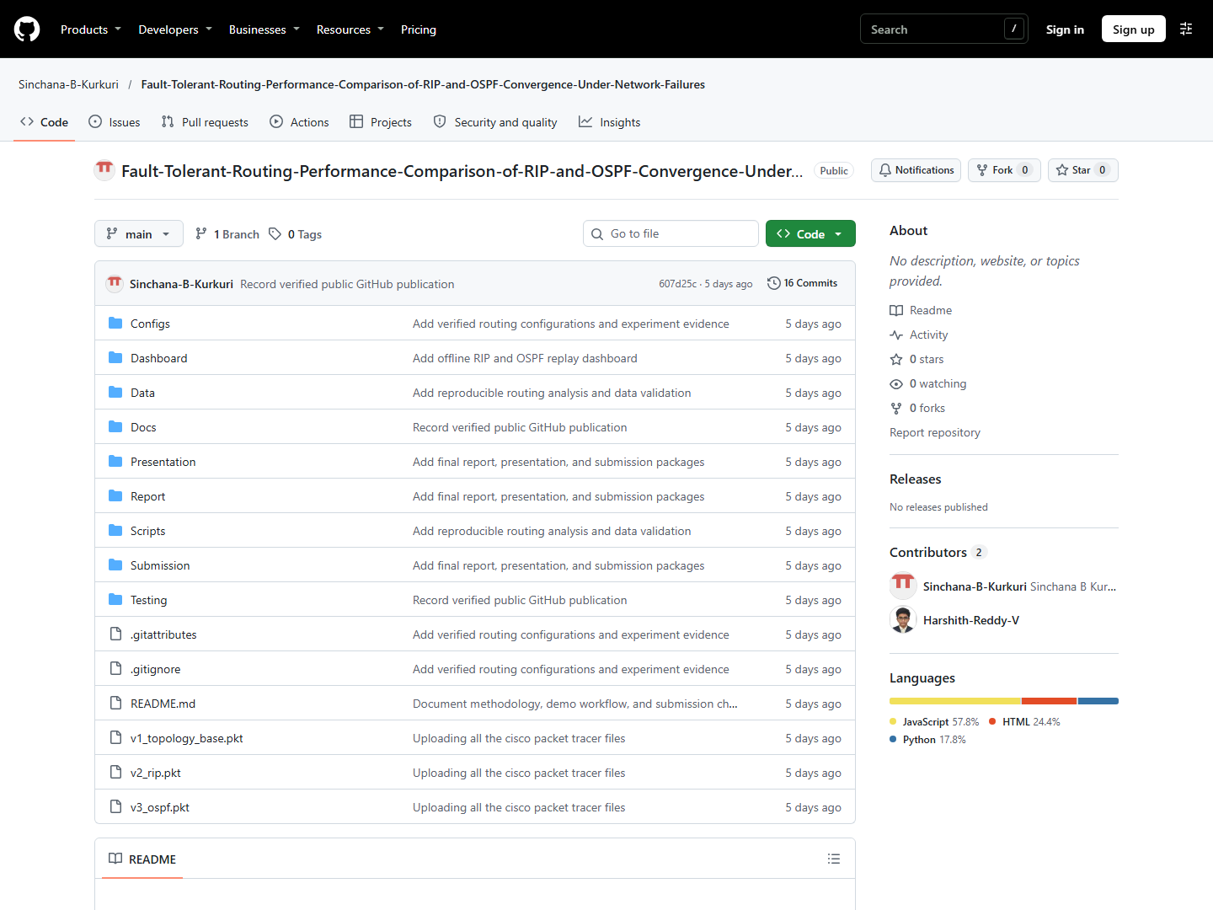
Repository view captured on 31 October 2026 before folder consolidation. The contents table gives the current local paths; this screenshot records the published revision shown.
The unauthenticated GitHub API confirmed a public repository and the required source, network, configuration, screenshot and README paths. The checked main revision was 607d25cd6d82a21db044b1a55362187f990b9c19. The repository link above points to the current main branch.

Topology and RIP Baseline

Step 01 Network topology
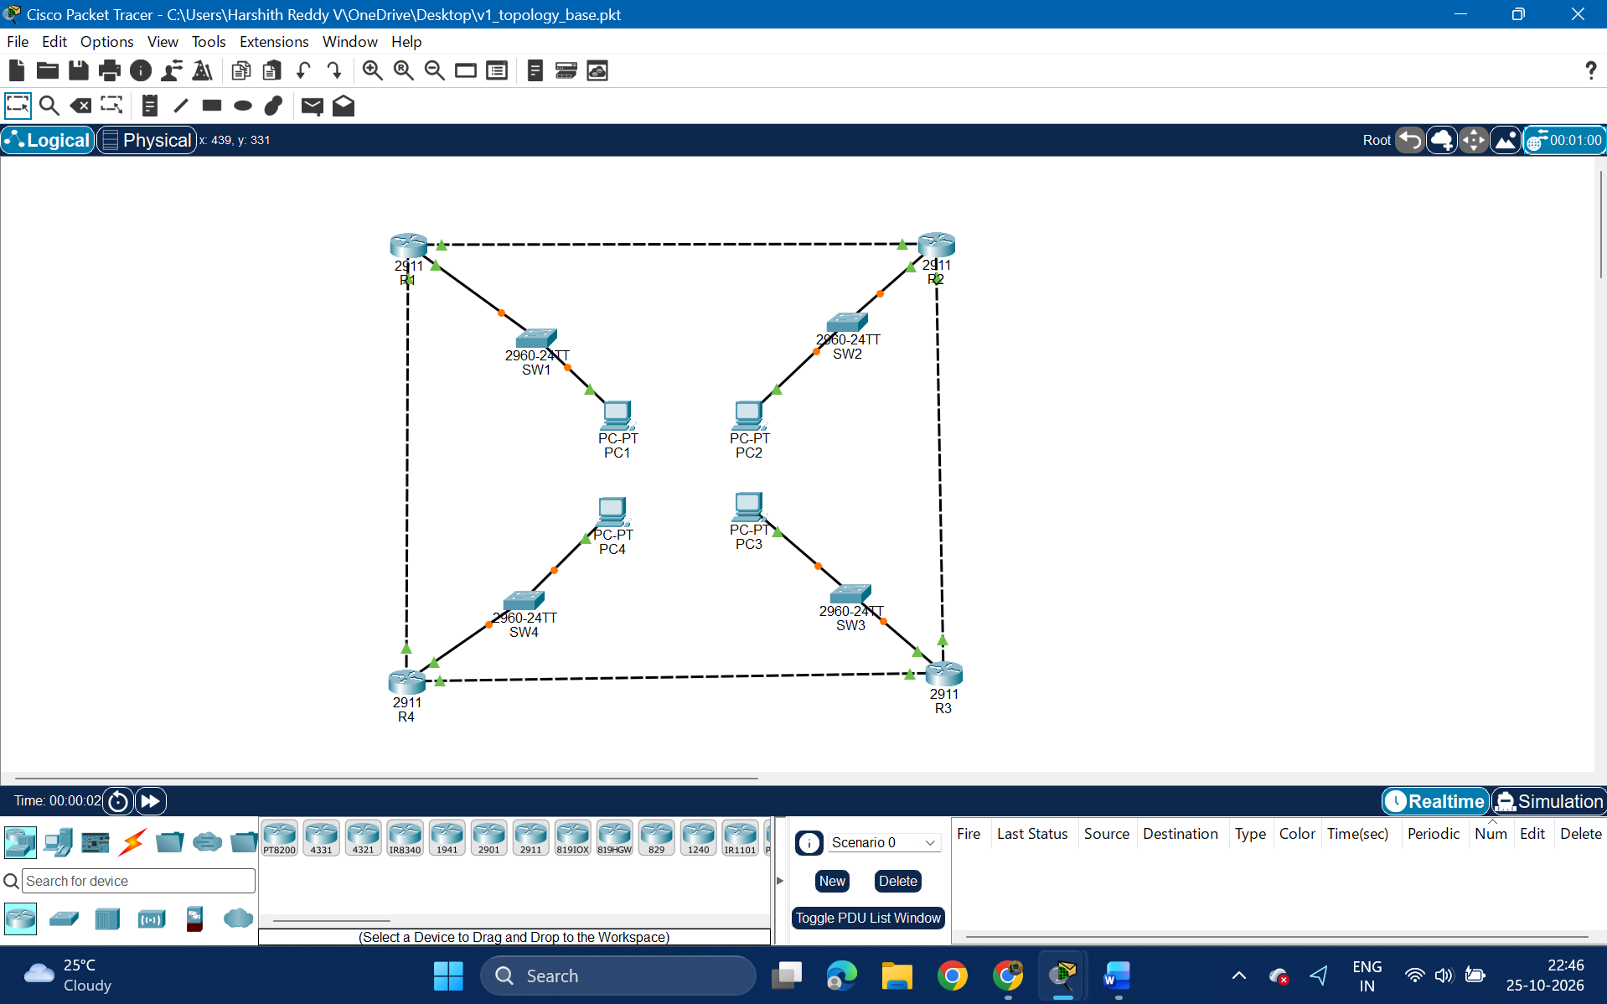
E06 Recorded evidence from Packet Tracer
The four routers form R1–R2–R3–R4–R1, with one switched PC LAN per router. This image verifies the visible topology. Interface addresses are established separately from the saved configuration files.

Step 02 RIP baseline on R1
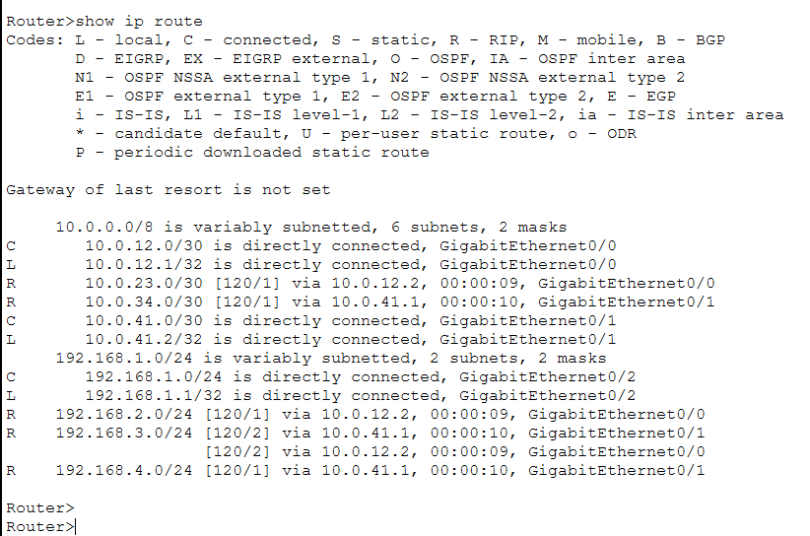
E07 Recorded evidence from Packet Tracer
The routing table shows RIP-learned remote LANs. LAN2 uses metric 1. LAN3 has equal-cost metric 2 routes through R2 and R4, so the individual active forwarding path cannot be assumed.

Topology and RIP Baseline continued

Step 03 RIP baseline on R2
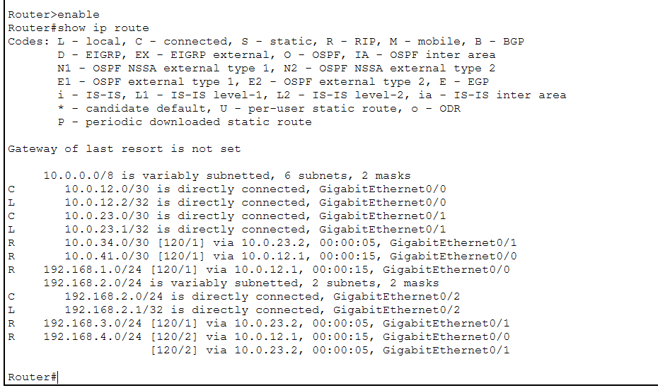
E08 Recorded evidence from Packet Tracer
The routing table shows connected subnets and RIP routes to the other LANs. LAN4 has equal-cost routes through R1 and R3.

Step 04 RIP baseline on R3
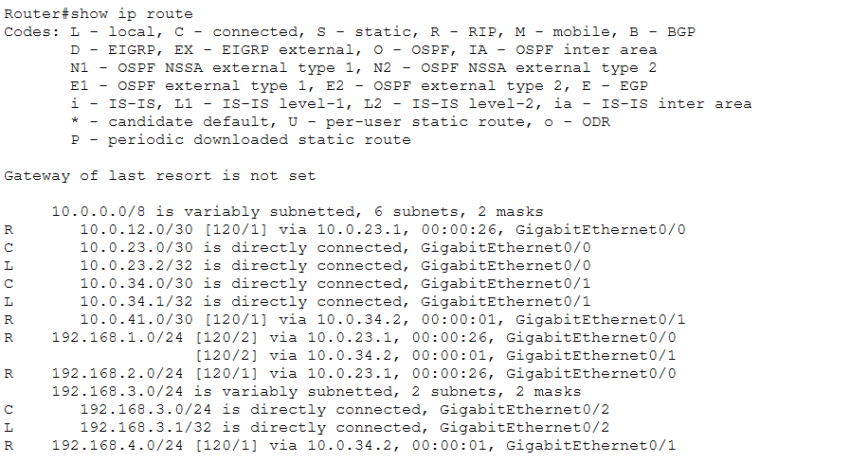
E09 Recorded evidence from Packet Tracer
The routing table shows remote LAN reachability and equal-cost routes toward LAN1 through R2 and R4.

Topology and RIP Baseline continued

Step 05 RIP baseline on R4
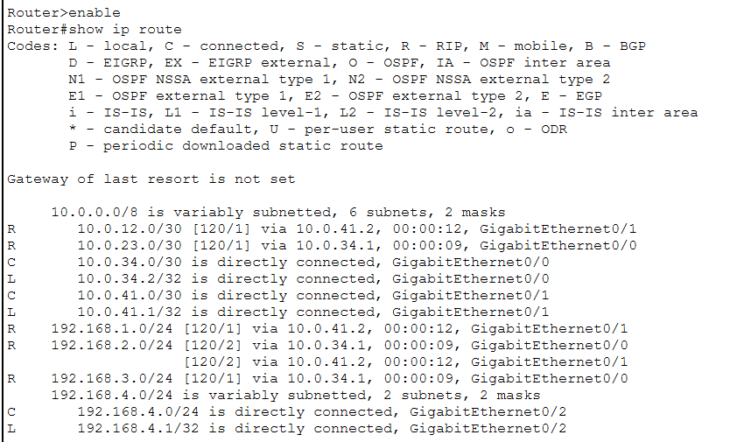
E10 Recorded evidence from Packet Tracer
The routing table shows remote LAN reachability and equal-cost routes toward LAN2 through R1 and R3.

RIP Link Failure

Step 06 Route before failure
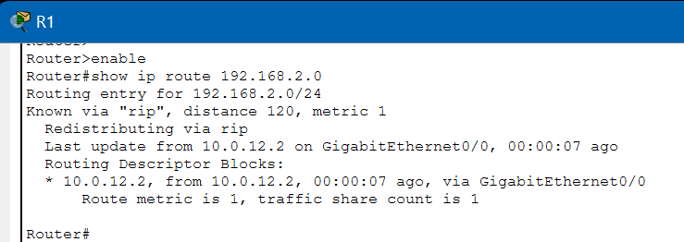
E11 Recorded evidence from Packet Tracer
R1 reaches 192.168.2.0/24 directly through next hop 10.0.12.2 on G0/0. The RIP hop metric is 1.

Step 07 Disable R1 G0/0
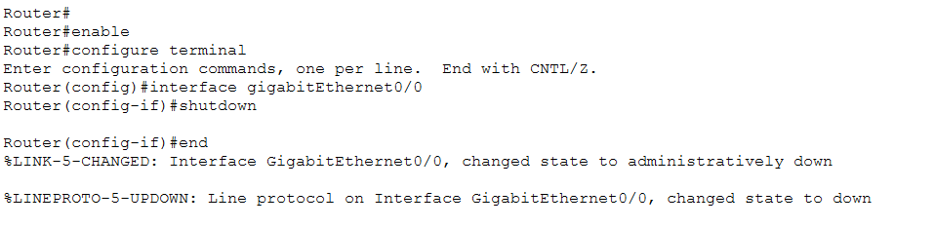
E12 Recorded evidence from Packet Tracer
The captured shutdown command brings the R1–R2 interface and line protocol down. The surrounding recorded case identifies this as the RIP link-failure test.

RIP Link Failure continued

Step 08 Observe ping interruption and recovery
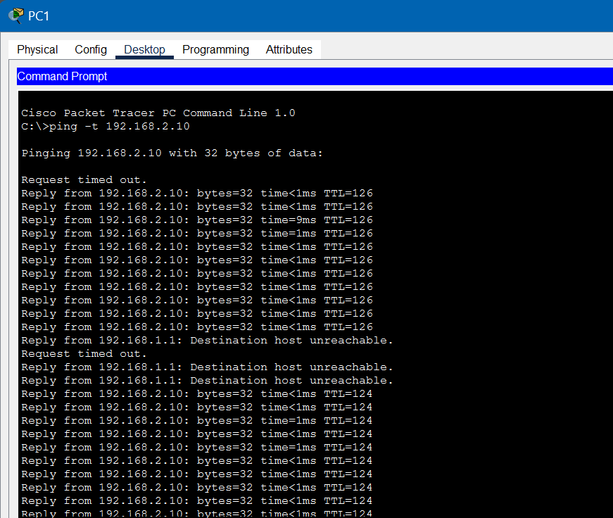
E13 Recorded evidence from Packet Tracer
PC1 continuously pings PC2. The excerpt includes unreachable responses and timeouts followed by replies with TTL 124. The source results table reports approximately 26 s OCRT, not a value read from this screenshot.

Step 09 Verify the alternate RIP route
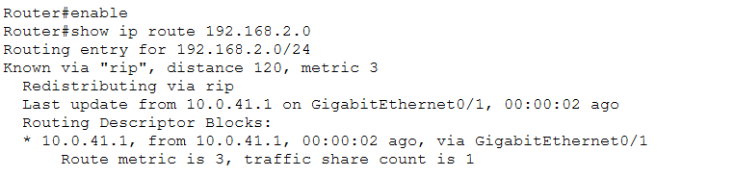
E14 Recorded evidence from Packet Tracer
LAN2 now uses 10.0.41.1 on G0/1 with RIP metric 3. This supports the alternate R1–R4–R3–R2 route after the direct link fails.

RIP Link Failure continued

Step 10 Confirm the failed link visually
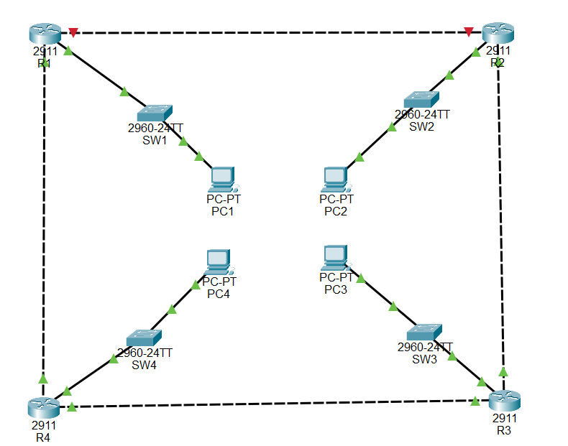
E15 Recorded evidence from Packet Tracer
The R1–R2 link is red/down and the other ring links remain green. This image supports the failure state, without independently proving timing or protocol settings.

RIP Router Failure

Step 11 Inspect the R4 power view
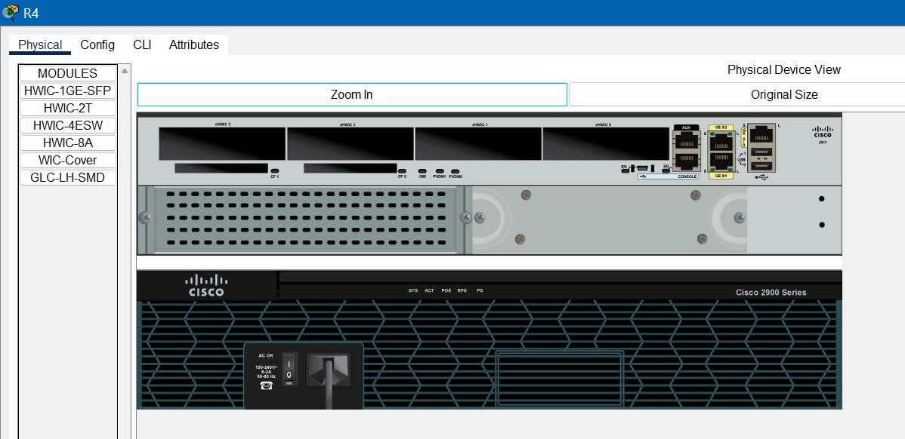
E21 Recorded evidence from Packet Tracer
The Physical device view forms part of the documented R4 failure case. The next topology image corroborates that its incident links are down. This is not a timestamped timing record.

Step 12 Confirm R4 unavailable
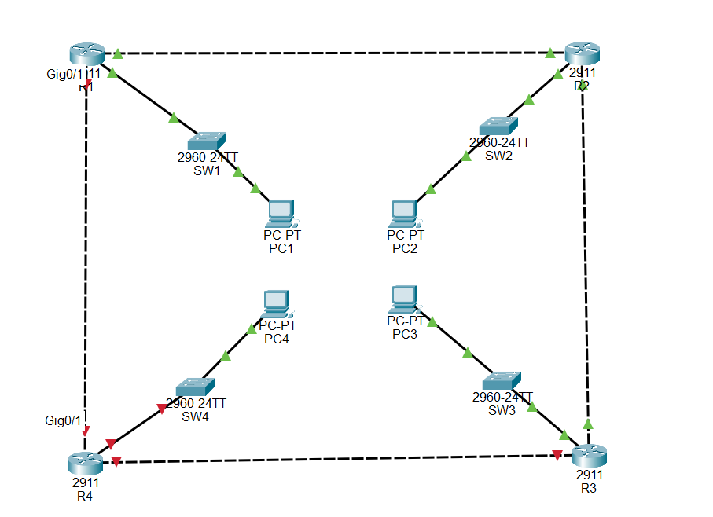
E19 Recorded evidence from Packet Tracer
All three links incident to R4 are red/down, while the surviving R1–R2–R3 path remains green. R4’s own LAN has no redundant gateway.

RIP Router Failure continued

Step 13 Observe PC1 to PC3 traffic
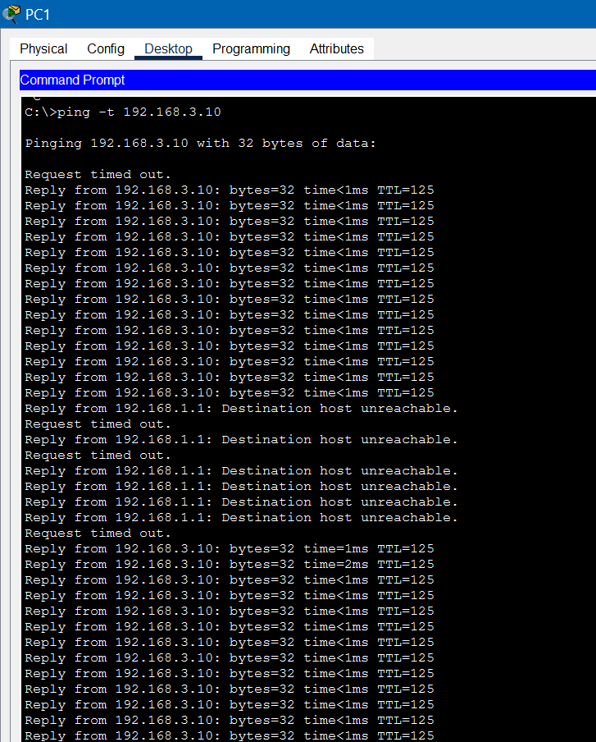
E18 Recorded evidence from Packet Tracer
The ping excerpt shows unreachable responses and timeouts followed by resumed TTL 125 replies. The later RIP run has a reported OCRT of approximately 11 s in the source table.

Step 14 Verify the surviving RIP route
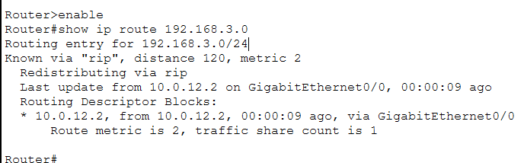
E20 Recorded evidence from Packet Tracer
R1 reaches LAN3 through 10.0.12.2 on G0/0 with metric 2. The surviving route goes through R2. Its metric equals the baseline metric, despite the failure.

RIP Link Restoration

Step 15 Re-enable the direct link
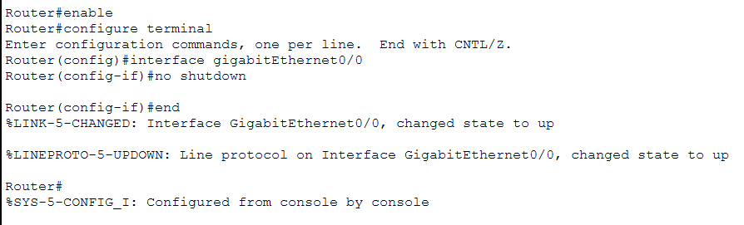
E16 Recorded evidence from Packet Tracer
The captured no shutdown command returns G0/0 and its line protocol to the up state.

Step 16 Verify the original RIP route returns
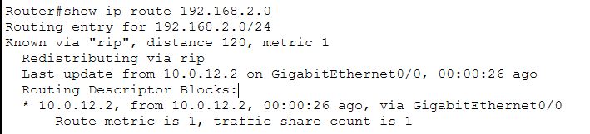
E17 Recorded evidence from Packet Tracer
LAN2 again uses next hop 10.0.12.2 on G0/0 with RIP metric 1. Restoration is supported qualitatively. A reliable RIP restoration duration was not recorded.

OSPF Baseline

Step 17 OSPF baseline on R1
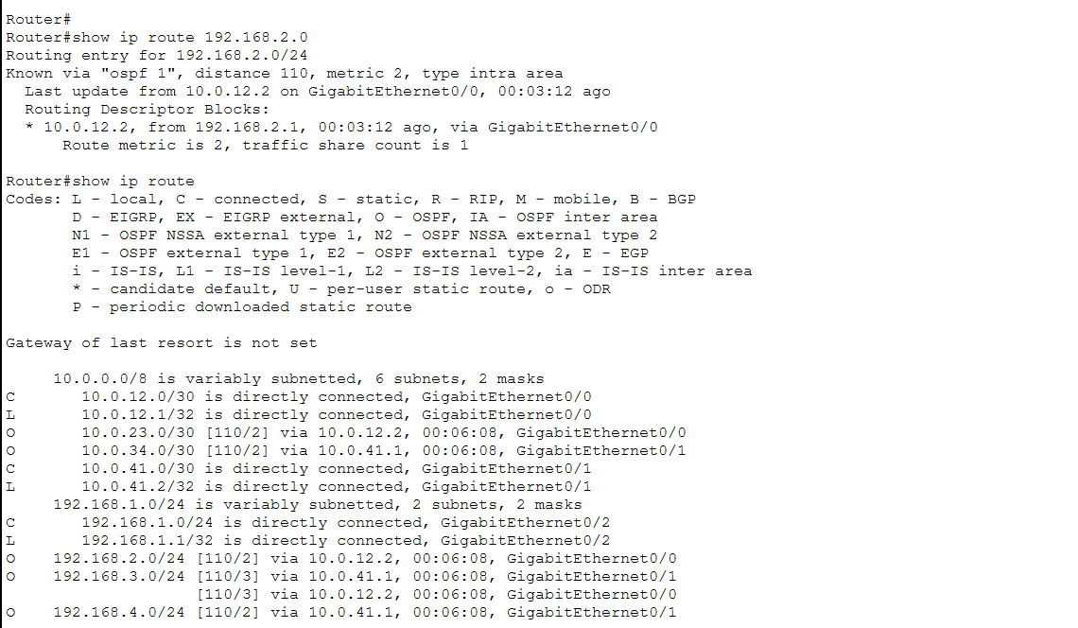
E23 Recorded evidence from Packet Tracer
OSPF process 1 supplies LAN2 at cost 2. LAN3 has equal-cost routes at cost 3 through R2 and R4. The output establishes route state rather than a full configuration transcript.

Step 18 OSPF baseline on R2
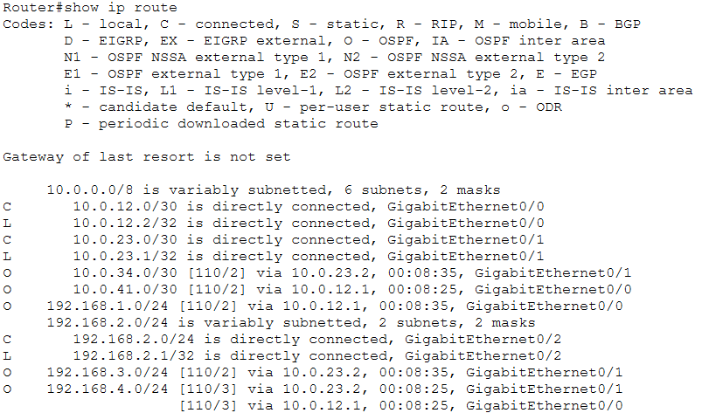
E24 Recorded evidence from Packet Tracer
The routing table shows OSPF remote routes and equal-cost cost 3 routes toward LAN4 through R1 and R3.

OSPF Baseline continued

Step 19 OSPF baseline on R3
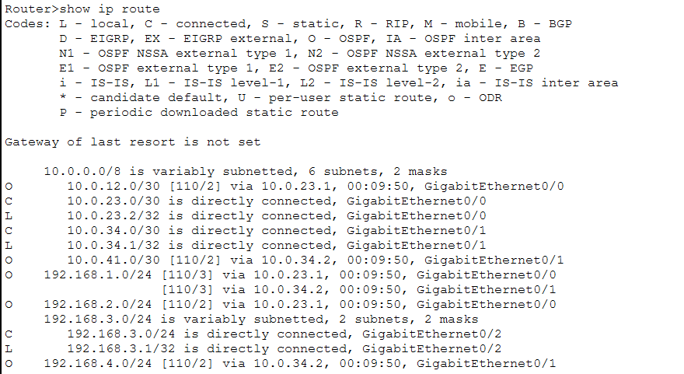
E25 Recorded evidence from Packet Tracer
The routing table shows OSPF remote routes and equal-cost cost 3 routes toward LAN1 through R2 and R4.

Step 20 OSPF baseline on R4
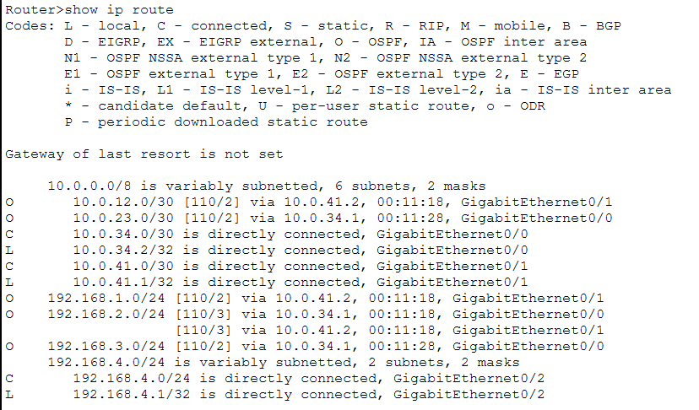
E26 Recorded evidence from Packet Tracer
The routing table shows OSPF remote routes and equal-cost cost 3 routes toward LAN2 through R1 and R3.

OSPF Baseline continued

Step 21 Verify OSPF neighbours
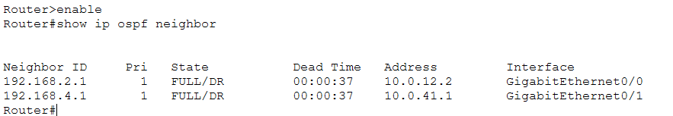
E27 Recorded evidence from Packet Tracer
R1 shows two FULL/DR neighbours with IDs 192.168.2.1 and 192.168.4.1. Their addresses are 10.0.12.2 and 10.0.41.1. Remaining Dead Time is not independent proof of a configured timer.

OSPF Link Failure

Step 22 Route before failure
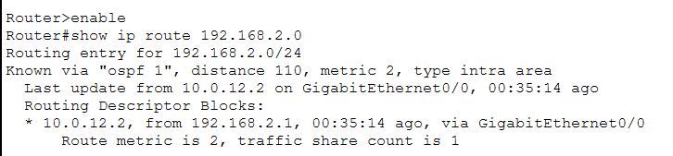
E28 Recorded evidence from Packet Tracer
R1 reaches LAN2 through next hop 10.0.12.2 on G0/0 with OSPF cost 2.

Step 23 Disable R1 G0/0
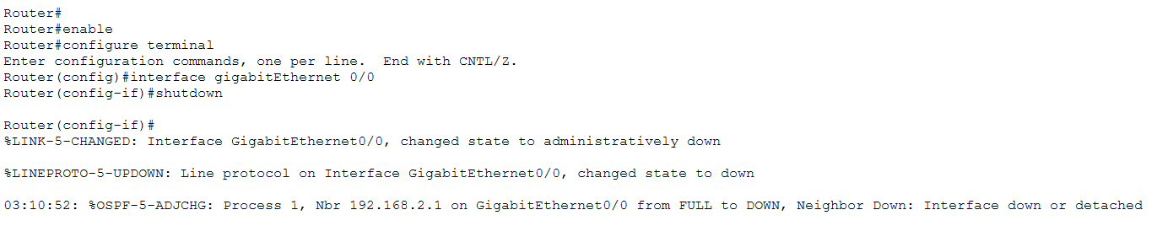
E29 Recorded evidence from Packet Tracer
The shutdown capture shows the interface going down and the OSPF neighbour changing from FULL to DOWN. This supports interface-down detection without proving that a full Dead interval elapsed.

OSPF Link Failure continued

Step 24 Observe ping interruption and recovery
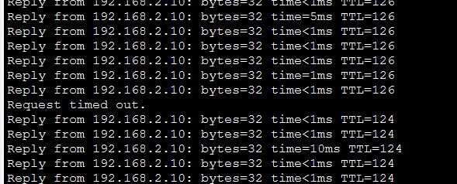
E30 Recorded evidence from Packet Tracer
The PC1 to PC2 crop shows one timeout and a change from TTL 126 replies to TTL 124 replies. The source table reports approximately 7 s OCRT. No completed packet-loss summary is shown.

Step 25 Verify the alternate OSPF route
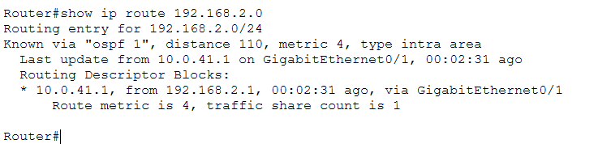
E31 Recorded evidence from Packet Tracer
LAN2 now uses 10.0.41.1 on G0/1 at cost 4. This supports the alternate route through R4 and R3 to R2.

OSPF Link Failure continued

Step 26 Confirm the failed link visually
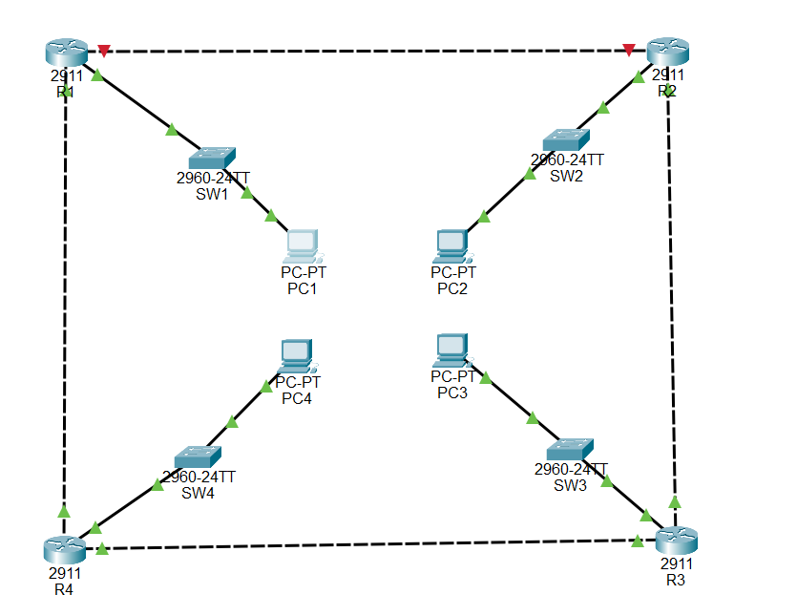
E32 Recorded evidence from Packet Tracer
R1–R2 is red/down while the other ring links remain green. Protocol association comes from the experiment context rather than protocol text in this topology view.

OSPF Router Failure

Step 27 Inspect the R4 power view
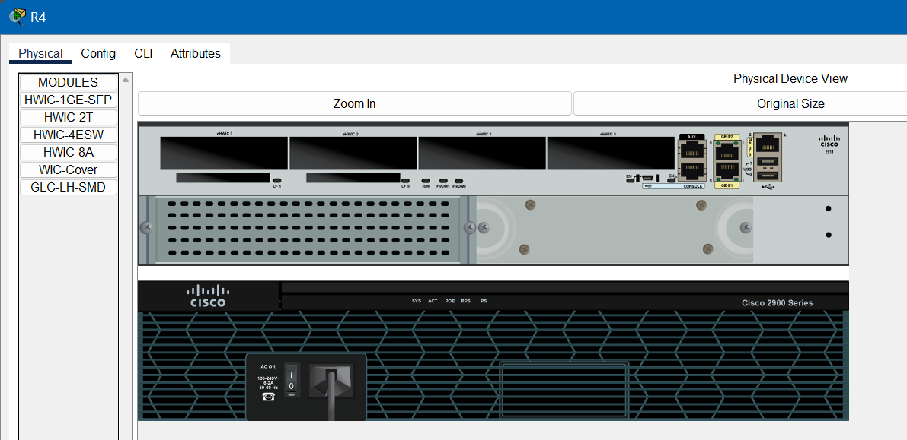
E35 Recorded evidence from Packet Tracer
The Physical view belongs to the documented OSPF R4 failure case. Corroborate the failure state with the next topology image rather than treating this as a stopwatch record.

Step 28 Confirm R4 unavailable
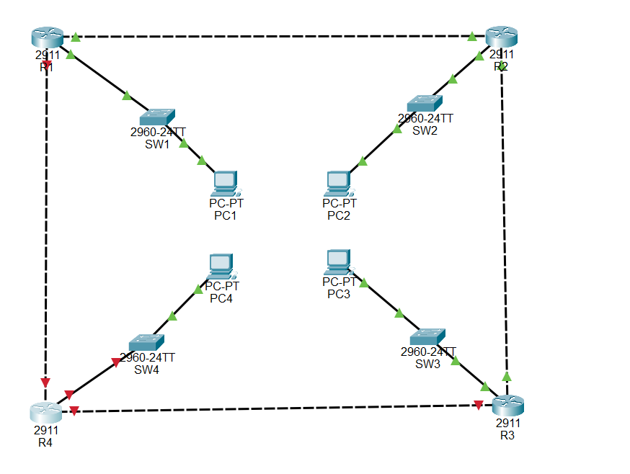
E36 Recorded evidence from Packet Tracer
The three links incident to R4 are red/down and the surviving R1–R2–R3 links remain green.

OSPF Router Failure continued

Step 29 Observe PC1 to PC3 traffic
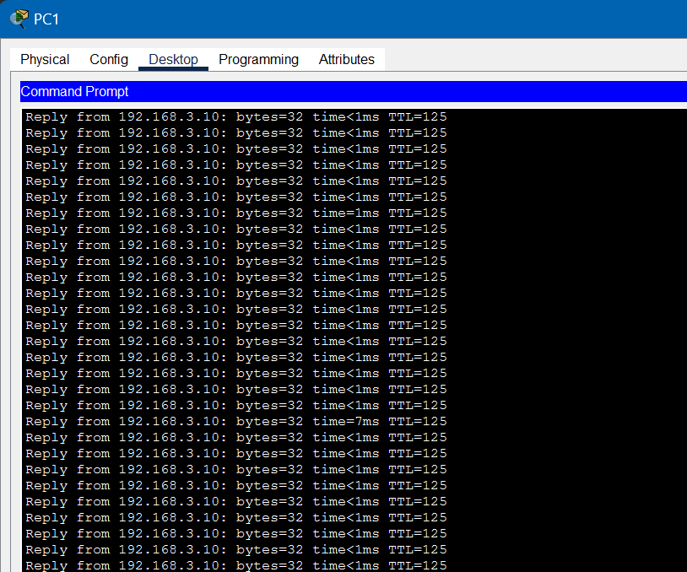
E34 Recorded evidence from Packet Tracer
The earlier OSPF run shows continuing TTL 125 replies in the visible crop. No loss was observed, so OCRT is not measurable. This is not a zero-second recovery result and is not directly comparable with the later RIP run.

Step 30 Verify the surviving OSPF route
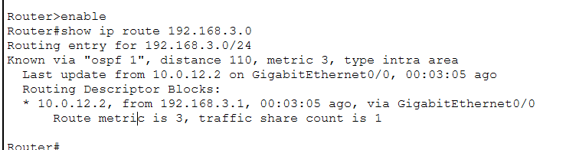
E37 Recorded evidence from Packet Tracer
R1 reaches LAN3 through 10.0.12.2 on G0/0 at cost 3. The route uses R2. Forwarding already through R2 before failure remains a possible, unverified explanation for the no-loss observation.

OSPF Link Restoration

Step 31 Record the initial direct route
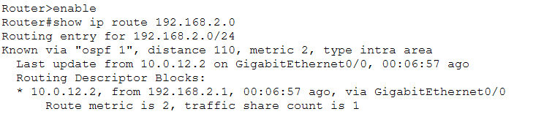
E01 Recorded evidence from Packet Tracer
The restoration sequence begins with LAN2 through 10.0.12.2 on G0/0 at OSPF cost 2.

Step 32 Place the direct link down
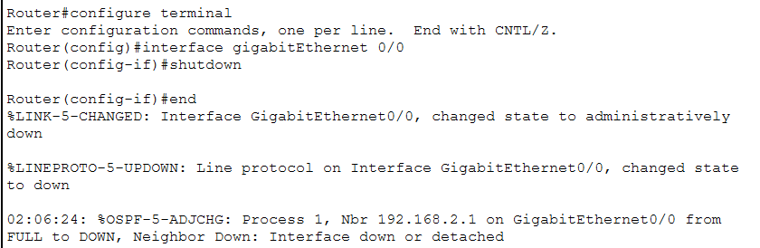
E02 Recorded evidence from Packet Tracer
G0/0 is shut down and neighbour 192.168.2.1 moves from FULL to DOWN, establishing the failure that precedes restoration.

OSPF Link Restoration continued

Step 33 Verify the detour before restoration
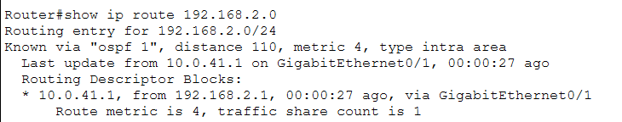
E03 Recorded evidence from Packet Tracer
LAN2 uses 10.0.41.1 on G0/1 at OSPF cost 4 while R1–R2 is unavailable.

Step 34 Re-enable the direct link
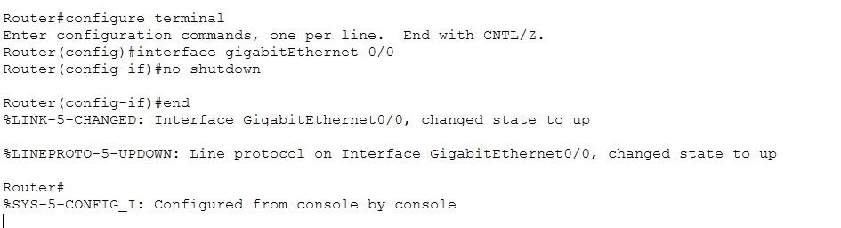
E33 Recorded evidence from Packet Tracer
The captured no shutdown action brings the interface and line protocol back up. Its OSPF association comes from the source experiment context.

OSPF Link Restoration continued

Step 35 Observe the return in ping TTL
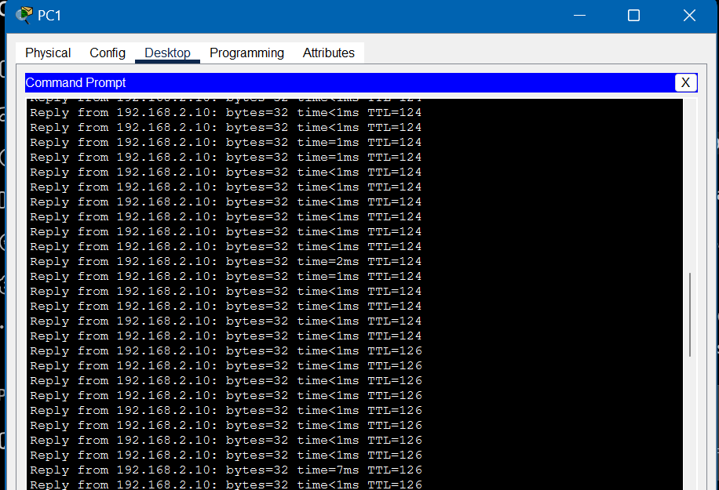
E04 Recorded evidence from Packet Tracer
Replies from PC2 change from TTL 124 to TTL 126. The reported approximately 11 s is a path-return interval from the source table, rather than outage OCRT.

Step 36 Verify the preferred route returns
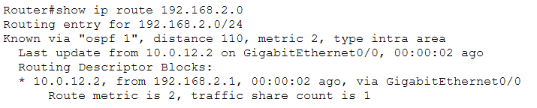
E05 Recorded evidence from Packet Tracer
LAN2 again uses 10.0.12.2 on G0/0 at cost 2. This corroborates the return to the original direct route.

Dashboard Overview
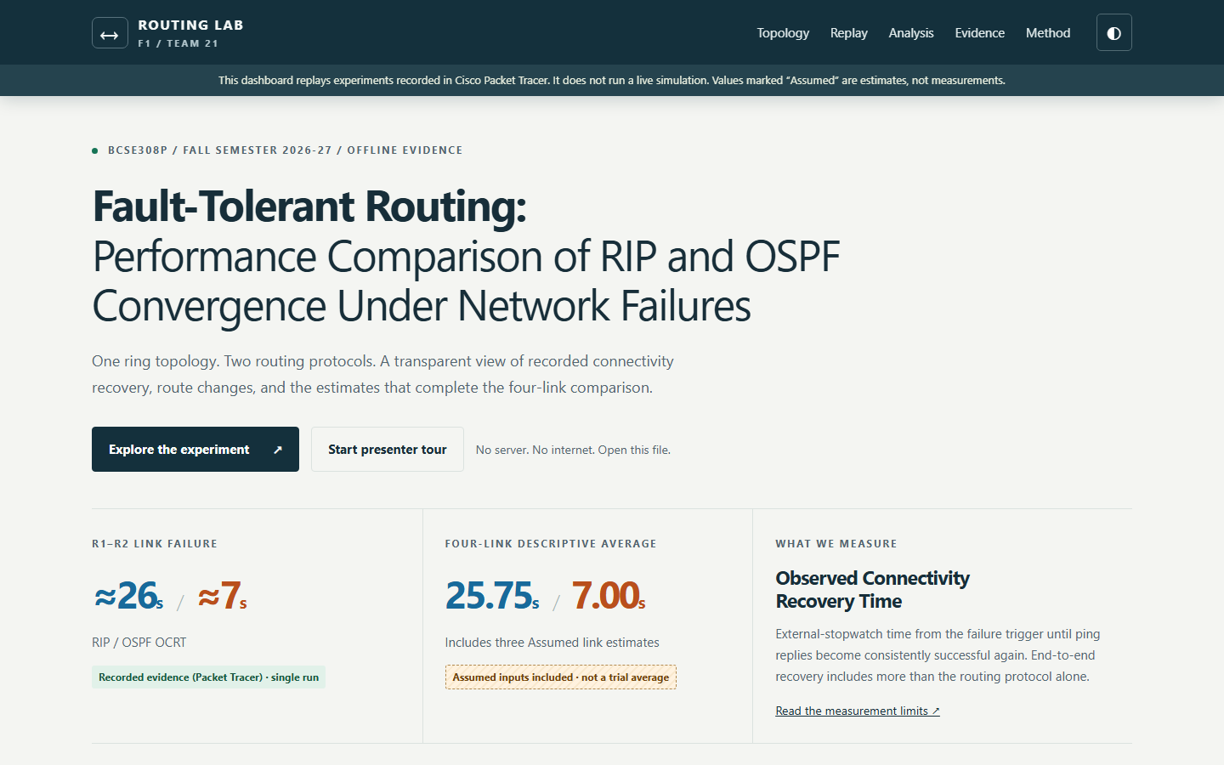
Dashboard functionality screenshot dashboard_1440x900.png
The opening page identifies the project and team, shows the recorded R1–R2 values, and labels the four-link descriptive average as including three assumed estimates. This browser interface presents evidence and does not run a live network simulation.

Experiment Player
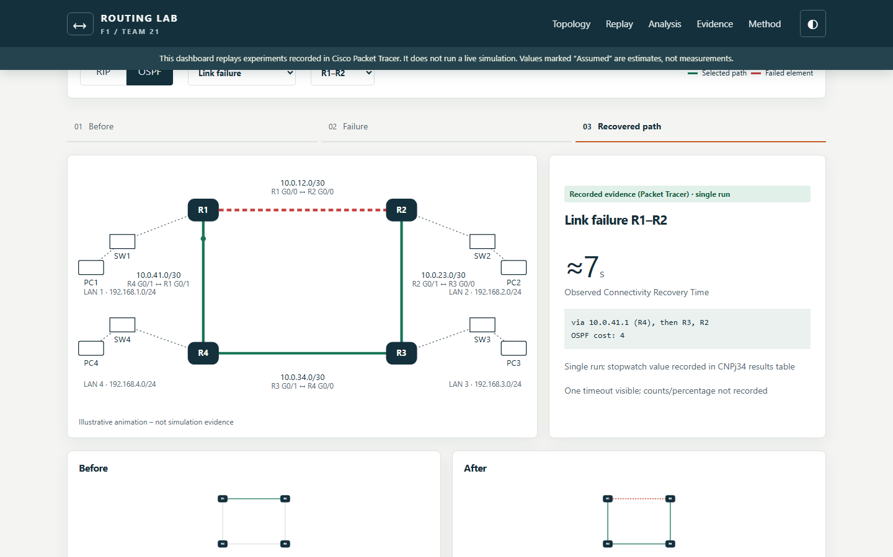
Dashboard functionality screenshot dashboard_experiment_player.png
Protocol and scenario controls select a case. The stepper shows before, failure and recovered-path states alongside the relevant original screenshots. Paths and animation are illustrative. The selected evidence can be enlarged for inspection.

Comparison Graphs and Tables
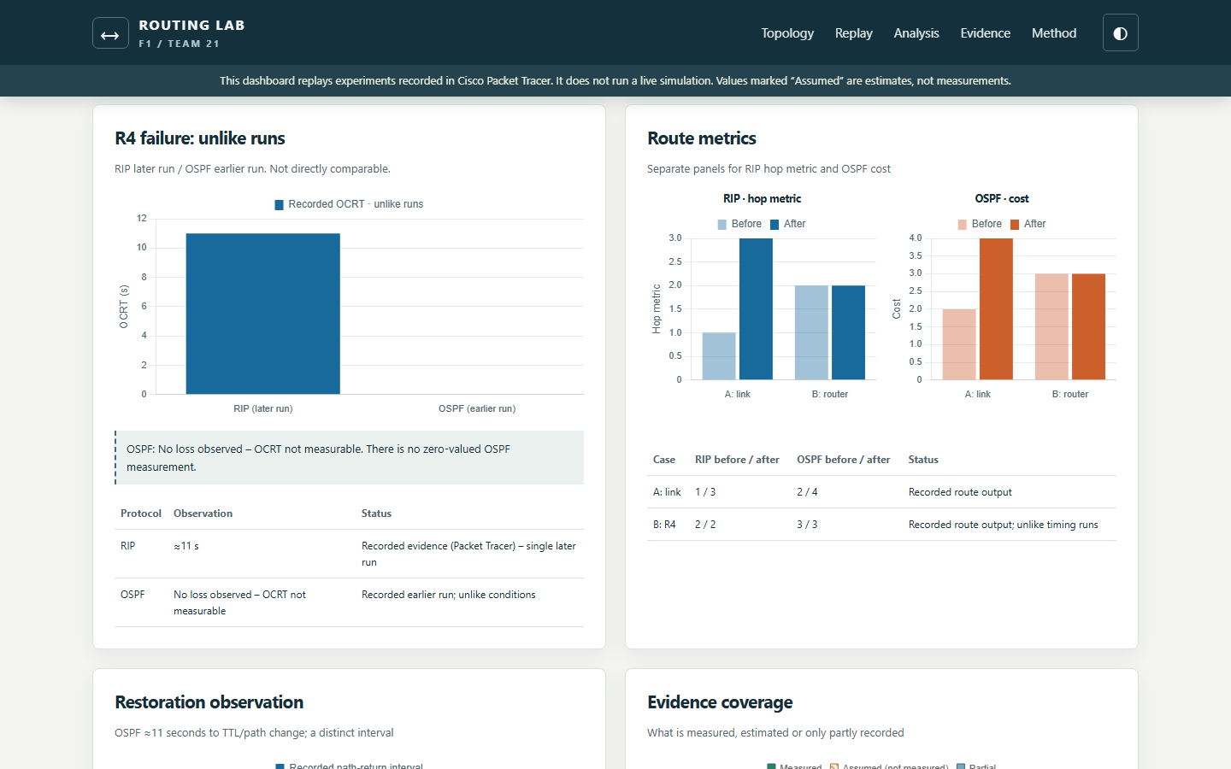
Dashboard functionality screenshot dashboard_analysis.png
The analysis view contains the supplied timings, ratios, route metrics and coverage. Hatched bars distinguish estimates. Turning off Show assumed values produces the measured-only comparison and hides the mixed four-link average.

Tablet Layout
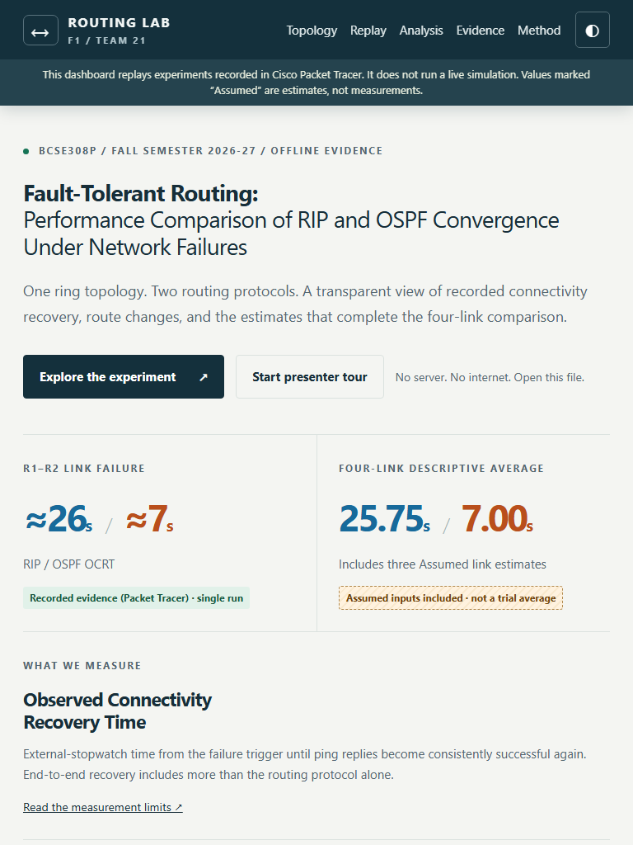
Dashboard functionality screenshot dashboard_768x1024.png
The same offline dashboard adapts to a tablet-size viewport while retaining navigation, values and evidence labels.

Mobile Layout
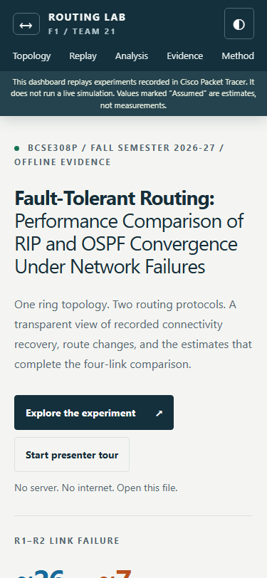
Dashboard functionality screenshot dashboard_375x812.png
The layout also adapts to a mobile-size viewport. Responsive screenshots demonstrate the frontend presentation, rather than an additional Packet Tracer experiment.

Results Used Consistently Across the Submission
Link failure | RIP | OSPF | Source status
R1–R2 | 26 s | 7 s | Recorded single run for each protocol
R2–R3 | 24 s | 6 s | Assumed estimate, not measured
R3–R4 | 28 s | 8 s | Assumed estimate, not measured
R4–R1 | 25 s | 7 s | Assumed estimate, not measured

Using all four supplied links, RIP average = (26 + 24 + 28 + 25) / 4 = 25.75 s and OSPF average = (7 + 6 + 8 + 7) / 4 = 7.00 s. The average difference is 18.75 s. Reduction of averages = (25.75 − 7.00) / 25.75 × 100 = 72.82%. The ratio of averages is 3.68. These summaries include three assumed-link estimates and are not repeated-trial means.
For the measured R1–R2 case alone, (26 − 7) / 26 × 100 = 73.08% shorter OSPF OCRT in these single runs. The corresponding estimated-case reductions are 75.00%, 71.43% and 72.00%. They inherit the assumed status of their inputs.

Verification Boundaries
OCRT includes stopwatch reaction, simulator processing, failure detection, route changes and end-to-end effects. Screenshots corroborate visible behaviour, while source tables supply the reported timings. No repeated-run variation, confidence interval or packet-loss percentage is established.
R4 failure compares a later RIP run of approximately 11 s with an earlier OSPF no-loss observation. These runs cannot support a direct numerical protocol ranking. Restoration establishes the return of both original routes. RIP restoration timing is unreliable, while OSPF’s approximately 11 s relates to TTL/path return.

Team Responsibilities
Harshith Reddy V (24BCE2479): network topology, IP addressing, RIP configuration and report Chapters 1–3. Sinchana B Kurkuri (24BDS0352): OSPF configuration, dashboard implementation, graphs and report Chapters 4–6.

Flagged Image Excluded From Restoration Proof
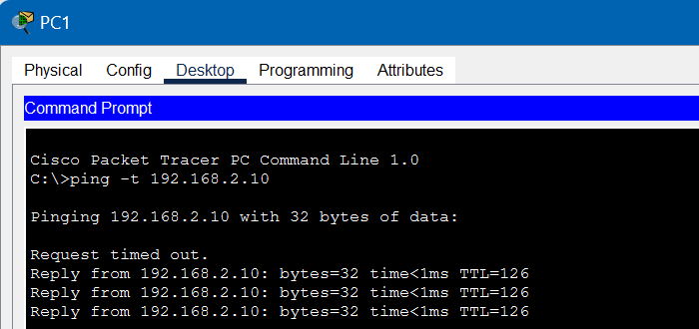
E22 Needs confirmation Excluded as restoration proof
This PC1 ping crop shows one initial timeout followed by three TTL 126 replies. It does not show a TTL transition, a restoration action or a completed ping summary. Its exact purpose cannot be matched to the restoration experiment from the available evidence. It is preserved for traceability and is not used to prove restoration timing or zero packet loss.
Source: CNPj34.docx, original image 22. The evidence manifest retains its original hash and needs-confirmation status.
GitHub repository containing the complete source and verification materials

