Innovative Evaluation Practices for BCSE308P -Computer Networks Lab
Fall Semester 2026-27
FAULT-TOLERANT ROUTING: PERFORMANCE COMPARISON OF RIP AND OSPF CONVERGENCE UNDER NETWORK FAILURES
24BCE2479 | HARSHITH REDDY V
 | B.Tech Computer Science and Engineering
24BDS0352 | SINCHANA B KURKURI
 | B.Tech Computer Science and Engineering (Data Science)

B.Tech.
in
Computer Science and Engineering
School of Computer Science and Engineering

October 2026

ABSTRACT
This project compares the fault-tolerance behaviour of RIPv2 and single-area OSPF on a four-router ring in Cisco Packet Tracer. Four Cisco 2911 routers connect four switched LANs. The study presents recorded link failure, router failure and restoration observations through an offline evidence-replay dashboard.
Observed Connectivity Recovery Time (OCRT) is the external-stopwatch interval from failure introduction until ping replies become consistently successful. For the recorded R1–R2 failure, RIP required approximately 26 seconds and OSPF approximately 7 seconds, each from a single run. Routes changed from the direct connection to the longer ring path. Three other link timings are Assumed (estimated – not measured), retained as illustrative inputs. Across the four supplied links, including those three assumptions, descriptive arithmetic averages are 25.75 seconds for RIP and 7.00 seconds for OSPF. The reduction of these averages is 72.82%; it is not a repeated-trial or statistically significant result.
For R4 failure, RIP's later run recorded approximately 11 seconds, while OSPF's earlier run showed no loss and no measurable OCRT. These runs are not directly comparable. Both protocols returned to their preferred route after link restoration. OSPF's approximately 11-second restoration interval indicates a TTL/path change rather than outage recovery.
Saved configurations were inspected without altering the original files. The dashboard distinguishes captured behaviour, assumed estimates and illustrative paths. Stopwatch reaction, simulator processing, end-to-end effects, single runs and missing loss summaries limit the conclusions. Repeated matched trials and automated timestamping form the next steps.

Certificate
This is to certify that the project report titled "Fault-Tolerant Routing: Performance Comparison of RIP and OSPF Convergence Under Network Failures" is a bonafide record of the work done by Harshith Reddy V (24BCE2479) and Sinchana B Kurkuri (24BDS0352) in partial fulfilment of the requirements of the Innovative Evaluation Practices for BCSE308P -Computer Networks Lab during the Fall Semester 2026-2027.
Name and Signature of the Students
______________________________
Harshith Reddy V — 24BCE2479
______________________________
Sinchana B Kurkuri — 24BDS0352

TABLE OF CONTENTS
Sl.No | Contents | Page No.
 | Abstract | 2
1 | 1 INTRODUCTION | 6
 | 1.1 Background and motivation | 6
 | 1.2 Problem statement | 6
 | 1.3 Objectives | 6
 | 1.4 Scope and limitations | 6
 | 1.5 Mapping to course modules and the lab experiment | 7
2 | 2 LITERATURE SURVEY | 8
 | 2.1 Overview of the existing protocols | 8
 | 2.2 Review of related work | 8
 | 2.3 Research gap and justification of novelty | 9
3 | 3 PROPOSED SYSTEM | 10
 | 3.1 System architecture and topology | 10
 | 3.2 Baseline mechanism description | 10
 | 3.3 Experimental procedure and pseudocode | 10
 | 3.4 Novelty statement | 11
 | 3.5 Assumptions and design decisions | 11
4 | 4 IMPLEMENTATION | 12
 | 4.1 Tools, platform, versions and hardware | 12
 | 4.2 Testbed setup, configuration and parameters | 12
 | 4.3 Code structure and explanation of key modules | 13
 | 4.4 Challenges and how they were handled | 14
5 | 5 EXPERIMENTAL SETUP AND PERFORMANCE EVALUATION | 15
 | 5.1 Performance metrics and rationale | 15
 | 5.2 Scenarios and parameter values | 15
 | 5.3 Results, tables and graphs | 16
 | 5.4 Analysis and discussion | 21
 | 5.5 Critical evaluation and data authenticity | 22
6 | 6 CONCLUSION AND FUTURE WORK | 23
 | 6.1 Summary of work and key findings | 23
 | 6.2 Limitations | 23
 | 6.3 Future enhancements | 23
7 | 7 REFERENCES | 24
 | APPENDIX A: CONFIGURATION LISTINGS | 25
 | APPENDIX B: EVIDENCE AND RAW RESULTS | 27
1 INTRODUCTION
1.1 Background and motivation
A routed network needs an alternate path when a link or transit router becomes unavailable. Redundant cabling supplies that path, but the routing process must also recognise the changed topology and install usable forwarding information. Temporary interruption can therefore occur even when a physical alternate route exists. This project studies that behaviour in a controlled educational setting, using RIP as the baseline and OSPF as the comparison protocol [1], [2].
1.2 Problem statement
The practical question is how recorded connectivity and route selection change after a failure on an identical four-router topology. The study compares a directly used R1–R2 link failure, a recorded R4 router failure and restoration of the original link. The comparison must retain the distinction between real timing observations, supplied estimates and missing measurements. It must also avoid treating a browser animation as evidence of a network experiment.
1.3 Objectives
The objectives are to verify the common topology and addressing, inspect the saved routing configurations, compare recorded link-failure OCRT, document alternate and restored routes, and provide an offline dashboard whose values can be traced to source tables and screenshots. A further objective is to make the methodology and limitations easy to explain during the lab demonstration and viva.
1.4 Scope and limitations
The scope is four Cisco 2911 routers, four Cisco 2960 switches and four PC-PT devices in a plain ring. Only RIPv2 and single-area OSPF are compared. Existing Packet Tracer experiments are preserved; no new experiment is claimed. The R1–R2 timings are single-run observations. The other three link timings are Assumed (estimated – not measured). No completed ping summaries or repeated-trial data support loss percentages, trial means, standard deviations or confidence intervals.
1.5 Mapping to course modules and the lab experiment
Course topic | Project application
Network layer and routing | RIP distance-vector and OSPF link-state route selection
IP addressing and subnetting | /30 transit links and /24 LANs with static PC gateways
Fault tolerance | Alternate paths following link or transit-router failure
Network simulation | Recorded Packet Tracer topology and CLI/ping observations
Performance interpretation | OCRT, protocol-specific route metrics and provenance-labelled analysis

2 LITERATURE SURVEY
2.1 Overview of the existing protocols
RIPv2 extends RIP with subnet information and supports classless routing. Its distance-vector mechanism advertises destination distances, with hop count as the metric and a bounded reachable distance [1], [3]. OSPFv2 maintains link-state information and computes routes using a shortest-path calculation. Its route metric is cumulative cost rather than RIP hop count [2]. These are established protocols; the project implements no new routing algorithm.
Cisco documents timer and configuration behaviour for RIP and OSPF [4], [5]. These references explain theory and defaults. A configured default is not itself a measured recovery time, and neither protocol specification predicts the stopwatch result for a particular Packet Tracer run.
2.2 Review of related work
Table 2.1 reviews verified primary standards and vendor documentation. Standards establish protocol mechanisms, while command references establish implementation terminology. They are not repeated-run studies of this project topology.
S.No | Authors, year | Technique | Metrics and tool | Merits | Gaps
1 | Malkin, 1998 [1] | RIPv2 specification | Hop-count routing; protocol specification | Defines classless RIP behaviour | No Packet Tracer OCRT benchmark
2 | Moy, 1998 [2] | OSPFv2 link state and SPF | Cost, LSDB and adjacency procedures | Defines route computation and failure processing | No stopwatch results for this topology
3 | Hedrick, 1988 [3] | Original RIP distance vector | Distance and routing updates | Explains RIP foundations | Predates RIPv2 extensions
4 | Cisco [4] | IOS RIP commands | Configuration and timer parameters | Maps theory to IOS settings | Defaults do not isolate observed recovery
5 | Cisco [5] | IOS XE OSPF configuration | Hello/Dead and area configuration | Explains operational settings | Vendor documentation is not this experiment

Table 2.1. Literature survey using primary, verifiable sources. The project makes no claim to outperform existing literature.
2.3 Research gap and justification of novelty
The educational gap addressed here is the connection between a routing mechanism, its visible route changes and an honestly bounded end-to-end observation. The contribution is a reproducible evidence organisation and comparison on one topology, a clearly defined OCRT metric, and an offline replay dashboard with measured/assumed status. It is a controlled lab comparison rather than an original protocol or a general performance ranking.
3 PROPOSED SYSTEM
3.1 System architecture and topology
The four routers form R1–R2–R3–R4–R1. Each router connects through its own switch to one PC. Figure 3.1 shows the original topology. The ring retains a path between surviving routers after one ring link or one transit router fails. A failed router’s own LAN is not protected by a second gateway in this design.
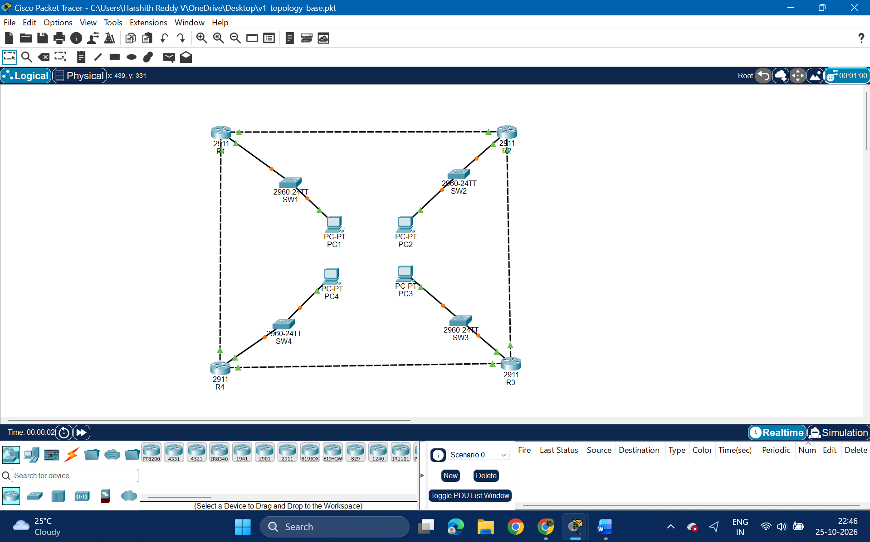
Fig. 3.1. Original ring topology with four routers, switches and PCs. Recorded evidence (Packet Tracer), E06.
3.2 Baseline mechanism description
The baseline is RIPv2. The saved RIP file contains router rip, version 2, network 10.0.0.0, the local LAN network, and no auto-summary on all four routers. RIP route output identifies learned routes with R and administrative distance 120. The R1 route to PC2’s LAN initially has hop metric 1; after R1–R2 fails it uses R4 with hop metric 3.
3.3 Experimental procedure and pseudocode
The comparison mechanism is OSPF process 1 in area 0 on the same saved addressing. The procedure below describes the recorded experiment and its analysis; it is not a new routing algorithm. The three assumed links enter only the analysis stage, without a claimed experimental run.
FOR each recorded protocol/scenario:
verify the before route; start continuous PC ping
trigger failure; start external stopwatch
after consecutive successful replies, record OCRT
preserve ping/route evidence; restore the component
END
label supplied estimates separately, with no timed trial
derive labelled arithmetic; validate evidence and replay

3.4 Novelty statement
The work contributes a side-by-side RIPv2/OSPF evidence presentation, an explicitly limited end-to-end timing definition, and an evidence-linked offline interface. The browser changes selected scenarios and illustrative paths; it does not execute a routing protocol. The underlying Packet Tracer experiments and original binary files remain unchanged.
3.5 Assumptions and design decisions
Three additional link times are retained as Assumed (estimated – not measured), based on the team’s observations of R1–R2 and expected protocol behaviour. Each assumption has zero timed trials and no associated experiment screenshot. The four-case arithmetic average requested by the team includes these estimates, so its interpretation is descriptive and illustrative. It cannot replace repeated timing of the links. Missing packet summaries are not estimated.
4 IMPLEMENTATION
4.1 Tools, platform, versions and hardware
Item | Verified or supplied value
Packet Tracer saved-file version | 9.0.1.0858, present in all three decoded file headers
Test machine (user-designated current system) | Intel Core Ultra 5 125H; 16,568,156,160 bytes RAM (approximately 16 GB installed class)
Operating system | Microsoft Windows 11 Home Single Language, 64-bit, version 10.0.26300
Frontend | HTML, CSS, vanilla JavaScript; Chart.js 4.4.8 bundled locally
Offline analysis | Python 3.12; pinned NumPy, pandas, matplotlib and seaborn in Scripts/requirements.txt
Faculty | Dr. Sreethar S, Associate Professor Grade 1

The listed system is the designated test platform. Hardware values were read from that system. Read-only decoding established saved configuration state without running Packet Tracer or changing the originals. The file inspector verifies persisted state, not the timing of earlier experiments.
4.2 Testbed setup, configuration and parameters
Link / interface pair | Network | Endpoint addresses
R1 G0/0 – R2 G0/0 | 10.0.12.0/30 | 10.0.12.1 / 10.0.12.2
R2 G0/1 – R3 G0/0 | 10.0.23.0/30 | 10.0.23.1 / 10.0.23.2
R3 G0/1 – R4 G0/0 | 10.0.34.0/30 | 10.0.34.1 / 10.0.34.2
R4 G0/1 – R1 G0/1 | 10.0.41.0/30 | 10.0.41.1 / 10.0.41.2

LAN | Router G0/2 / gateway | PC address / mask
1 | 192.168.1.1 | 192.168.1.10 /24
2 | 192.168.2.1 | 192.168.2.10 /24
3 | 192.168.3.1 | 192.168.3.10 /24
4 | 192.168.4.1 | 192.168.4.10 /24

Transit masks are 255.255.255.252 and LAN masks are 255.255.255.0. The saved PC addresses and gateways match the written IP plan. The original base file has no dynamic routing process. All four routers in v2_rip.pkt contain RIP only, while all four in v3_ospf.pkt contain OSPF only. Running and startup configurations agree in both protocol files. The base file’s running/startup contents differ, so it should be used as the preserved topology stage rather than assuming reload behaviour.
The actual OSPF commands use a broad transit match, network 10.0.0.0 0.255.255.255 area 0, plus the local LAN /24 wildcard. The guide instead lists separate /30 matches and explicit router IDs. No explicit router-id commands appear in the saved OSPF configurations. E27 shows neighbour IDs 192.168.2.1 and 192.168.4.1. These differences are recorded rather than silently substituting intended commands. Appendix A separates saved configuration excerpts from guide examples.
4.3 Code structure and explanation of key modules
Module | Role
Dashboard/index.html | Semantic sections, controls, figures, chart canvases and accessible dialog
Dashboard/css/style.css | Responsive layouts, protocol/status styling, focus states and reduced-motion rules
Dashboard/js/data.js | Local data constant mirroring CSV/JSON plus evidence and provenance
Dashboard/js/app.js | Scenario selection, illustrative SVG paths, evidence filters, lightbox and Chart.js views
Scripts/generate_charts.py | Deterministic static figures from canonical CSV, including hatched assumptions
Scripts/validate_data.py | Evidence/file hashes, mirrors, arithmetic and assumed-status invariants

The dashboard opens by double-clicking index.html. It uses no backend, runtime network request, fetch call or server. The measured-only toggle removes assumed cases and the mixed descriptive average. Experiment Player selections for assumed links show an explicit no-recorded-evidence card. E22 remains visible only in the evidence library with a needs-confirmation flag, and is not attached to restoration results.
4.4 Challenges and how they were handled
The guide’s claim that the ring removes equal-cost ambiguity does not hold for opposite LANs. E07 and E23 show R1’s equal-cost routes to LAN3 via R2 and R4. The recorded router-failure traffic is also PC1→PC3 with R4 off, rather than the guide’s PC2→PC4 example. The report preserves the performed experiment and treats the individual forwarding path as unverified.
PC ping syntax differs from IOS syntax. Captures show the PC accepting ping -t followed by the destination. Stopwatch timing is separate from simulator ping RTT, route-age fields and timeout counts. Individual interface costs are not displayed in the screenshots, so the cumulative OSPF costs are reported without asserting that the screenshots directly prove their component costs. E22’s startup timeout prevents its use as zero-loss restoration proof.
5 EXPERIMENTAL SETUP AND PERFORMANCE EVALUATION
5.1 Performance metrics and rationale
OCRT describes end-to-end service recovery as visible to continuous ping. The external stopwatch starts at failure introduction and stops at the first successful reply followed by at least one more consecutive reply. It includes detection, routing, forwarding and end-host effects. Packet behaviour is recorded qualitatively where excerpts show timeouts or unreachable responses. Loss counts and percentages require completed ping summaries, which are absent. RIP hop metric and OSPF cost are shown separately because their units differ.
Convergence values reported in this project are Observed Connectivity Recovery Times, measured via external stopwatch against Packet Tracer's simulated continuous ping — not laboratory-grade, isolated routing-protocol convergence measurements. They include human stopwatch reaction time (approx. 0.3–1 second), Packet Tracer's own simulation/event-processing delay, and end-to-end effects (link-down detection, routing recalculation, ARP refresh) rather than pure routing-protocol convergence alone. The metric remains valid for comparing RIP and OSPF because the identical method is applied to both, under identical topology and failure conditions.
The guide paragraph’s identical-conditions claim applies only where the conditions were actually matched. Exp B compares an earlier OSPF observation with a later RIP run and therefore cannot support direct protocol ranking. OSPF restoration’s TTL-change interval is a distinct path-return observation rather than outage OCRT.
5.2 Scenarios and parameter values
R1–R2 was timed in Packet Tracer; the values for the other three links are estimates assumed from the R1–R2 observations and the expected behaviour of the protocols, because OCRT differs from run to run and those links were not individually timed.
Scenario | Action / traffic | Recorded scope
A | R1 G0/0 shutdown, PC1→PC2 | R1–R2 timing and route change, one run per protocol
Illustrative link cases | R2–R3, R3–R4, R4–R1 | Supplied estimates only; no separately timed experiment
B | R4 off, PC1→PC3 | RIP later timing; OSPF earlier no-loss observation
C | R1–R2 re-enabled, PC1→PC2 | Preferred-route return; OSPF TTL change; RIP timing unreliable

5.3 Results, tables and graphs
Table 5.1 adapts the template’s baseline/proposed columns to RIP/OSPF and records provenance. “Single run” replaces the repeated-run mean ± SD expectation. The arithmetic average across supplied links appears separately and includes assumed estimates; it is not a trial average. No SD or error bars are calculated.
Scenario | Metric | RIP | OSPF | Observation | Data status
R1–R2 | OCRT | ≈26 s | ≈7 s | 73.08% shorter OSPF OCRT in these runs | Measured, single run
R2–R3 | Supplied time | 24 s | 6 s | 75.00% shorter, derived from estimates | Assumed (estimated – not measured)
R3–R4 | Supplied time | 28 s | 8 s | 71.43% shorter, derived from estimates | Assumed (estimated – not measured)
R4–R1 | Supplied time | 25 s | 7 s | 72.00% shorter, derived from estimates | Assumed (estimated – not measured)

Table 5.1. Supplied link-failure timing comparison. Assumed (estimated – not measured) applies to every numeric input and derived comparison in the three estimated-link rows.
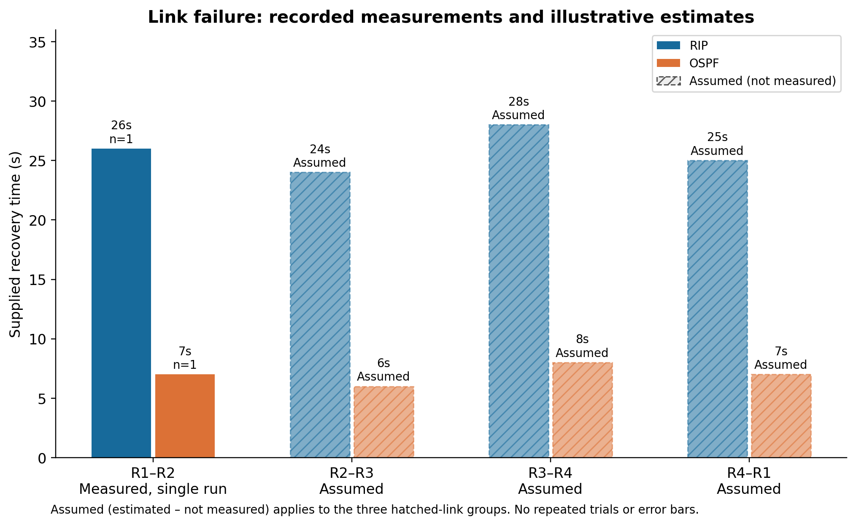
Fig. 5.1. Link timings. Solid = recorded, single run; hatched = Assumed (estimated – not measured).
Summary | RIP | OSPF | Interpretation
Arithmetic average across four links | 25.75 s | 7.00 s | Includes three Assumed (estimated – not measured) link inputs
Reduction of averages / ratio | 18.75 s difference | 72.82% / 3.68× | Illustrative descriptive arithmetic, three Assumed inputs; no repeated-trial or statistical claim

The average is (26 + 24 + 28 + 25)/4 for RIP and (7 + 6 + 8 + 7)/4 for OSPF. In both sums, the final three terms are Assumed (estimated – not measured). The 72.82% reduction uses the two averages, rather than averaging per-link percentages. Every derived result inherits its input status.
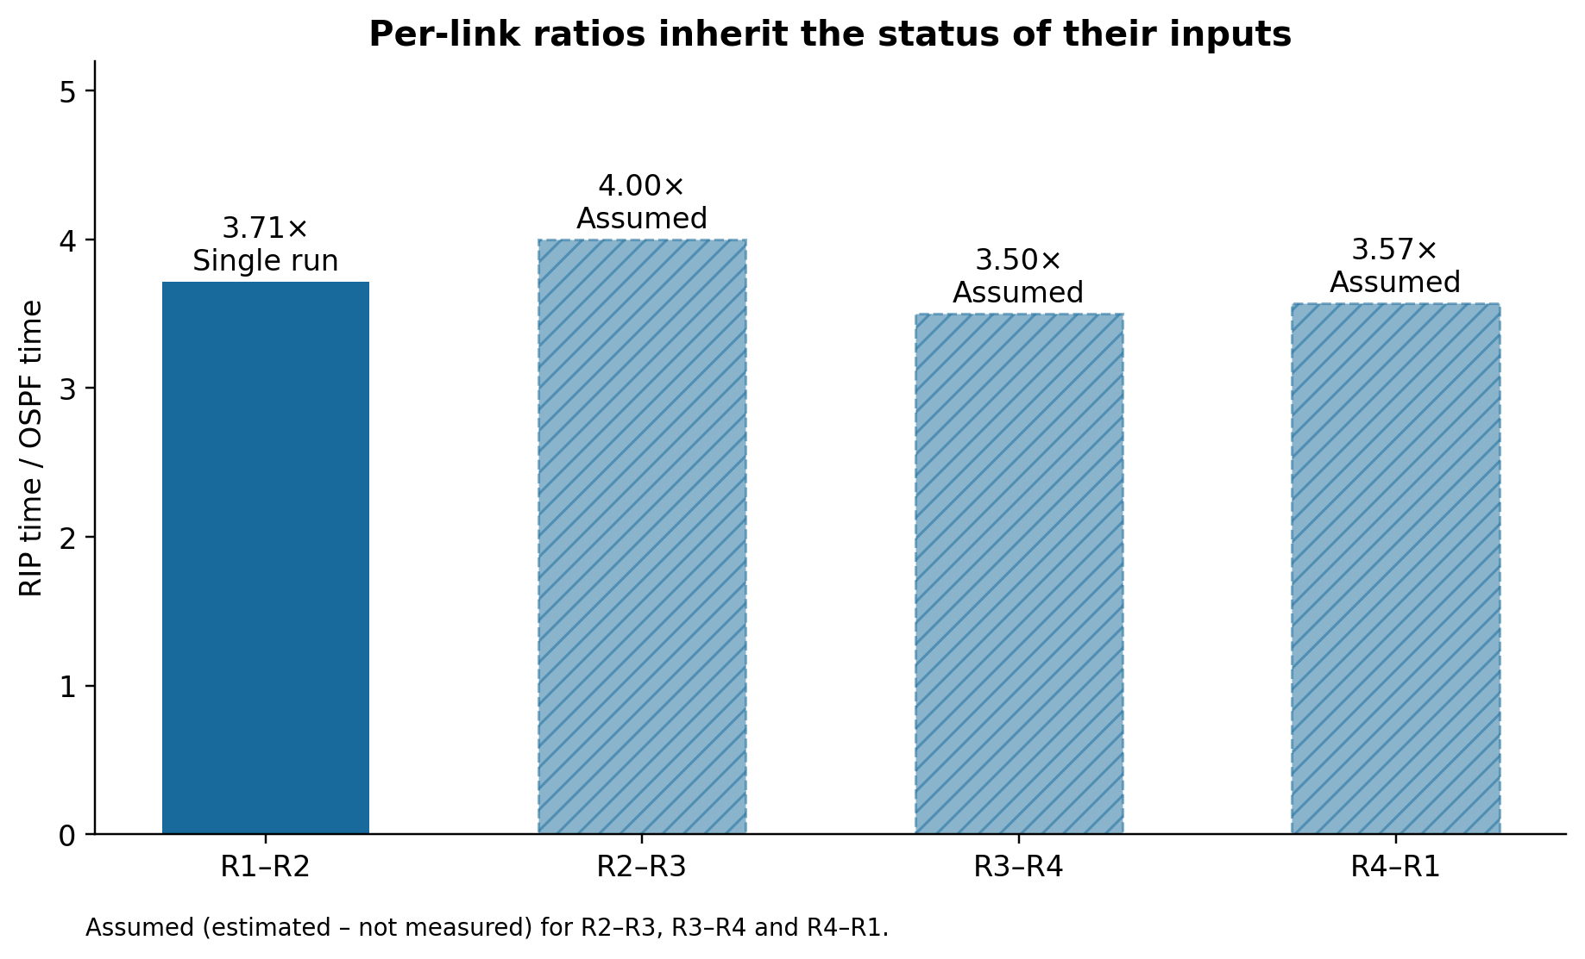
Fig. 5.2. Per-link RIP/OSPF ratios. R1–R2 is single run; other ratios use Assumed (estimated – not measured) inputs.
Figures 5.3 and 5.4 establish the before/after route change for the measured link. The stopwatch durations come from the recorded results tables; route-age fields in these screenshots are not used as timers.
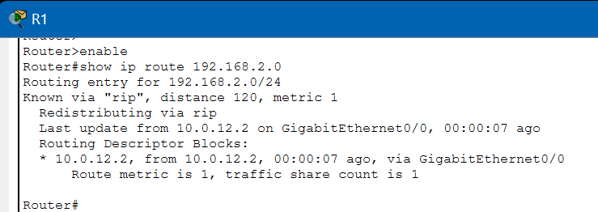
Fig. 5.3. RIP before R1–R2 failure: next hop 10.0.12.2, metric 1. Recorded evidence (Packet Tracer), E11.
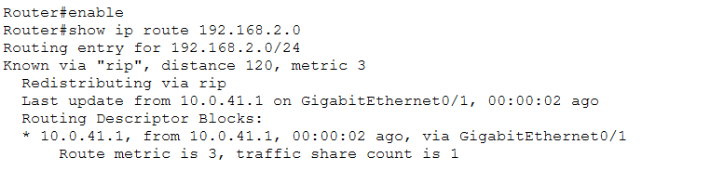
Fig. 5.4. RIP alternate route: next hop 10.0.41.1, metric 3. Recorded evidence (Packet Tracer), E14.
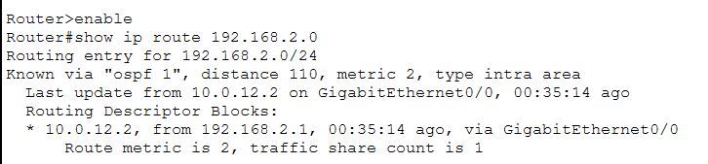
Fig. 5.5. OSPF before failure: next hop 10.0.12.2, cost 2. Recorded evidence (Packet Tracer), E28.
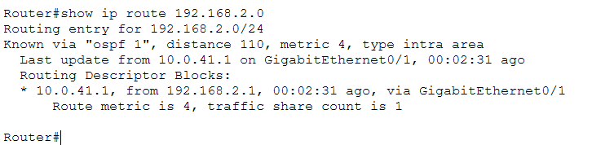
Fig. 5.6. OSPF alternate route: next hop 10.0.41.1, cost 4. Recorded evidence (Packet Tracer), E31.
Scenario | Metric | RIP | OSPF | Observation | Data status
R4 off | OCRT | ≈11 s, later run | No loss observed; OCRT not measurable, earlier run | Unlike runs; do not rank protocols | Recorded observation; RIP timed once
R1–R2 restored | Path return | Original route; time not reliable | ≈11 s to TTL 124→126 | Path-change interval, not outage OCRT | Recorded route behaviour; OSPF single interval

Table 5.2. Router failure and restoration with non-comparability and missing-timing disclosures. No numeric zero substitutes for OSPF’s no-loss observation or RIP’s unreliable restoration interval.
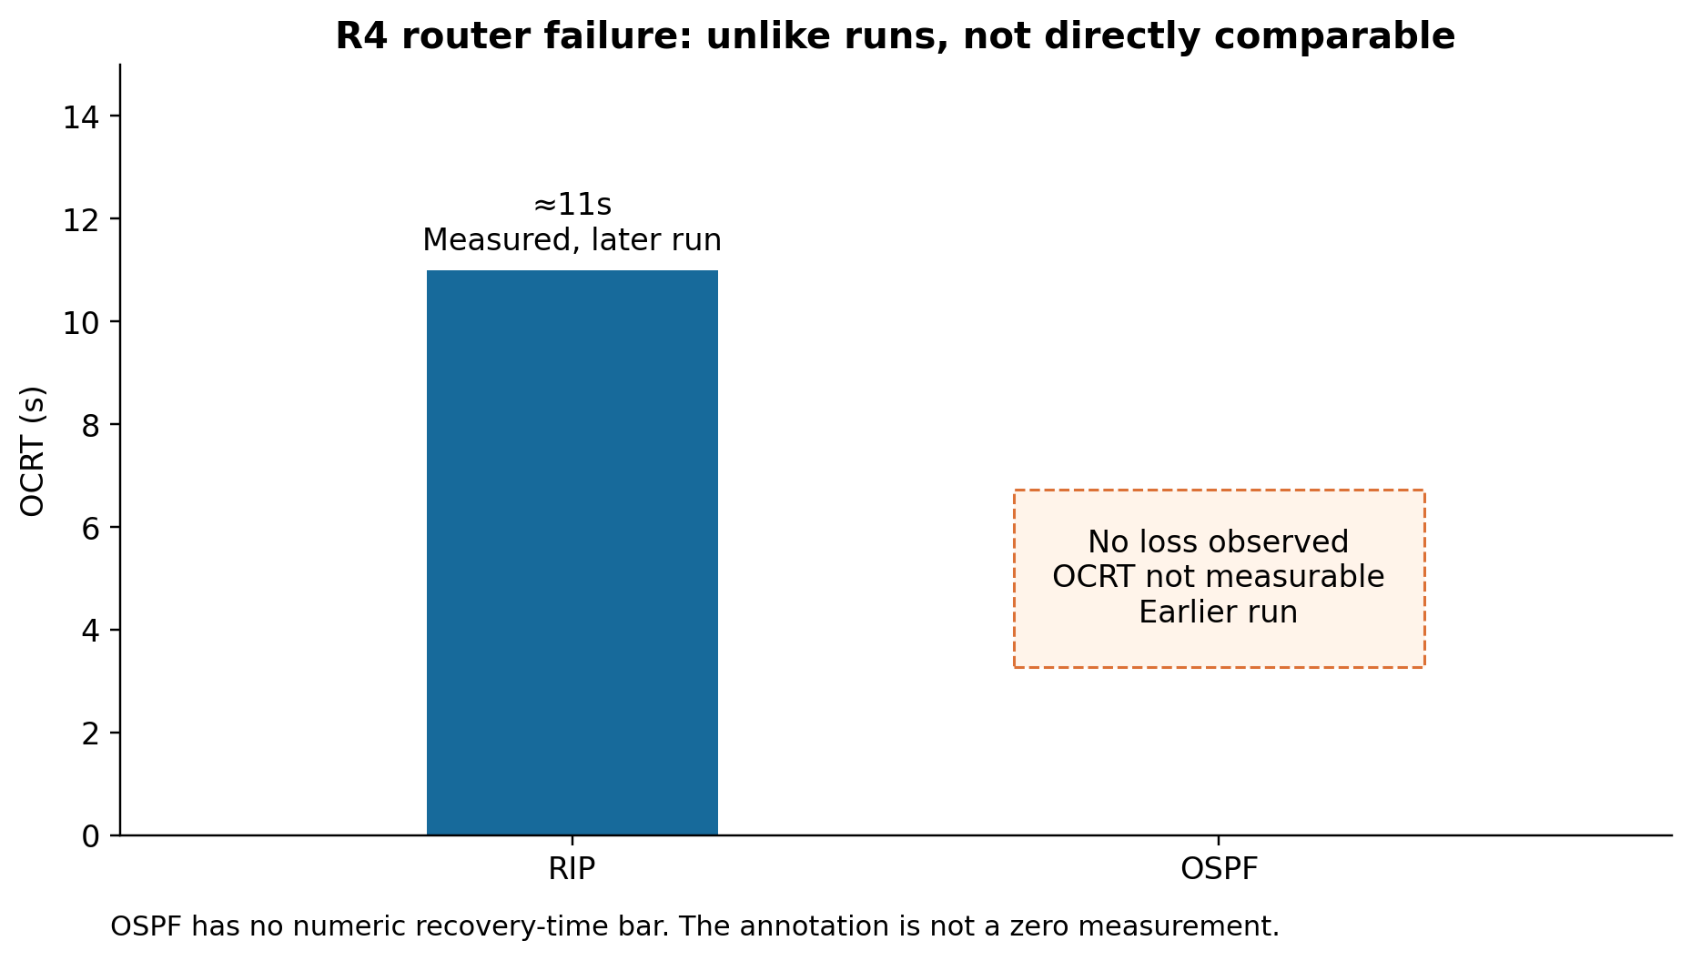
Fig. 5.7. R4 failure: RIP later run and OSPF earlier run are not directly comparable. No OSPF zero bar.
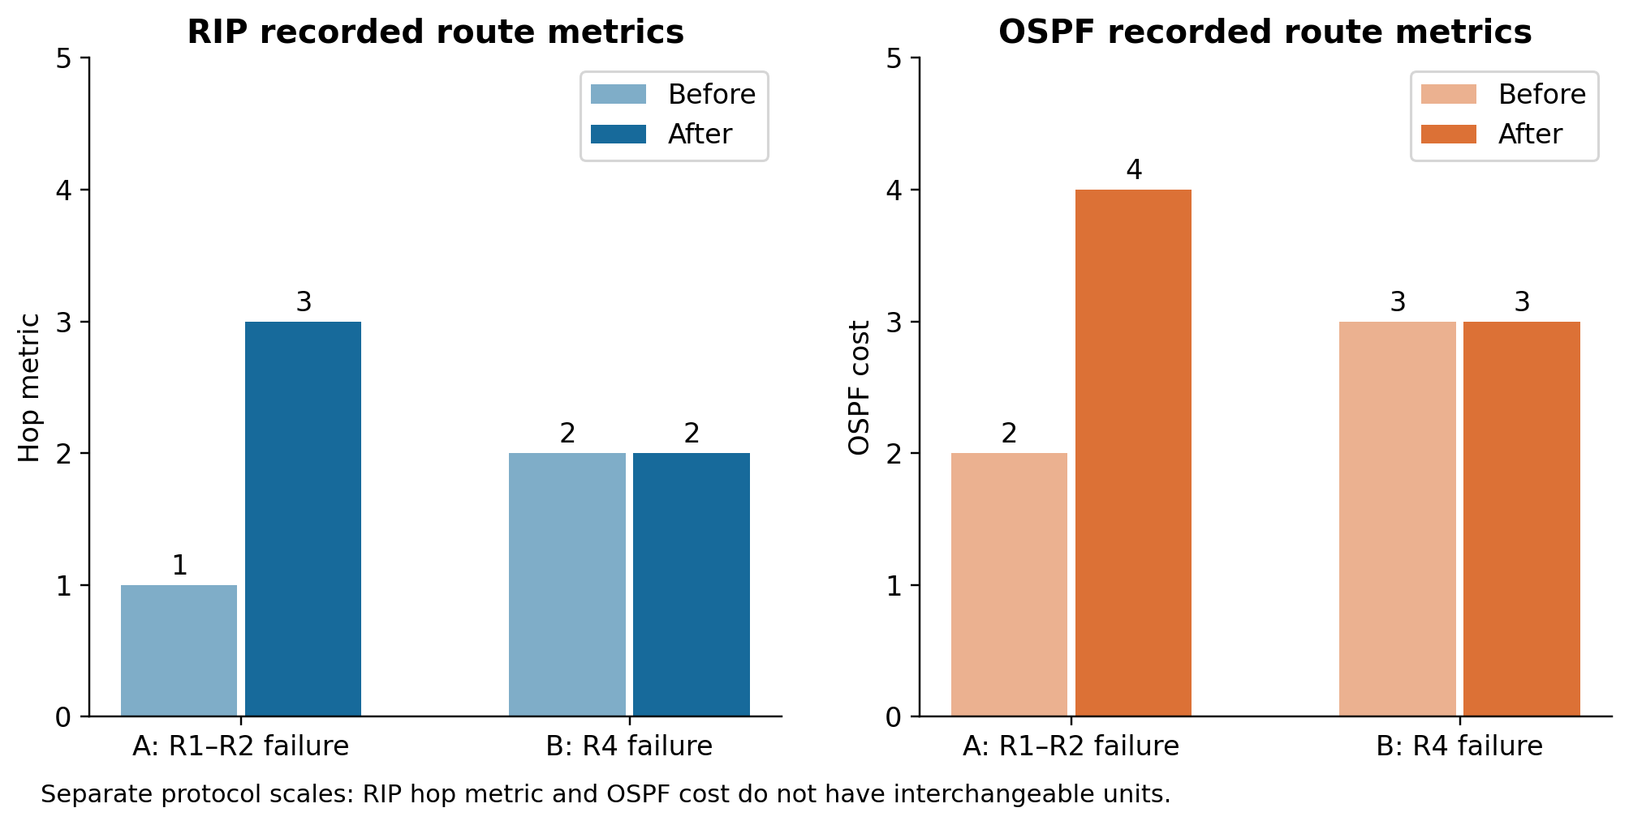
Fig. 5.8. Recorded before/after metrics on separate RIP hop-metric and OSPF-cost panels.
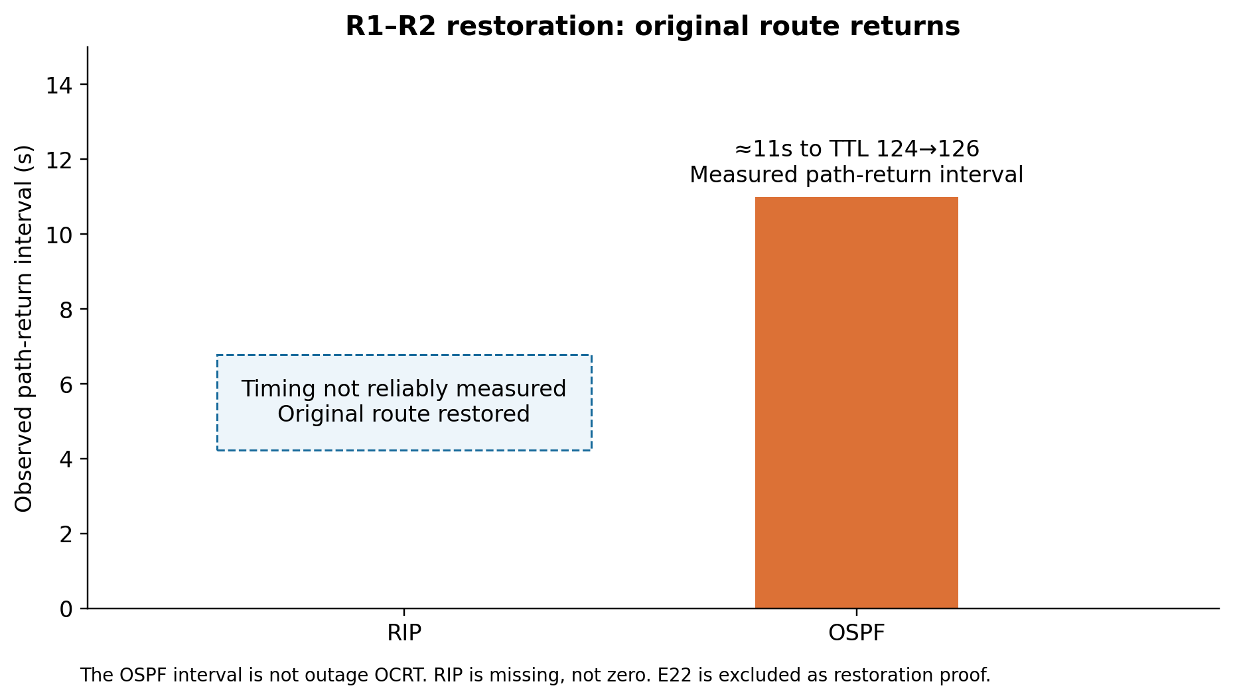
Fig. 5.9. Restored route: OSPF interval to TTL/path change; RIP timing not reliably measured.
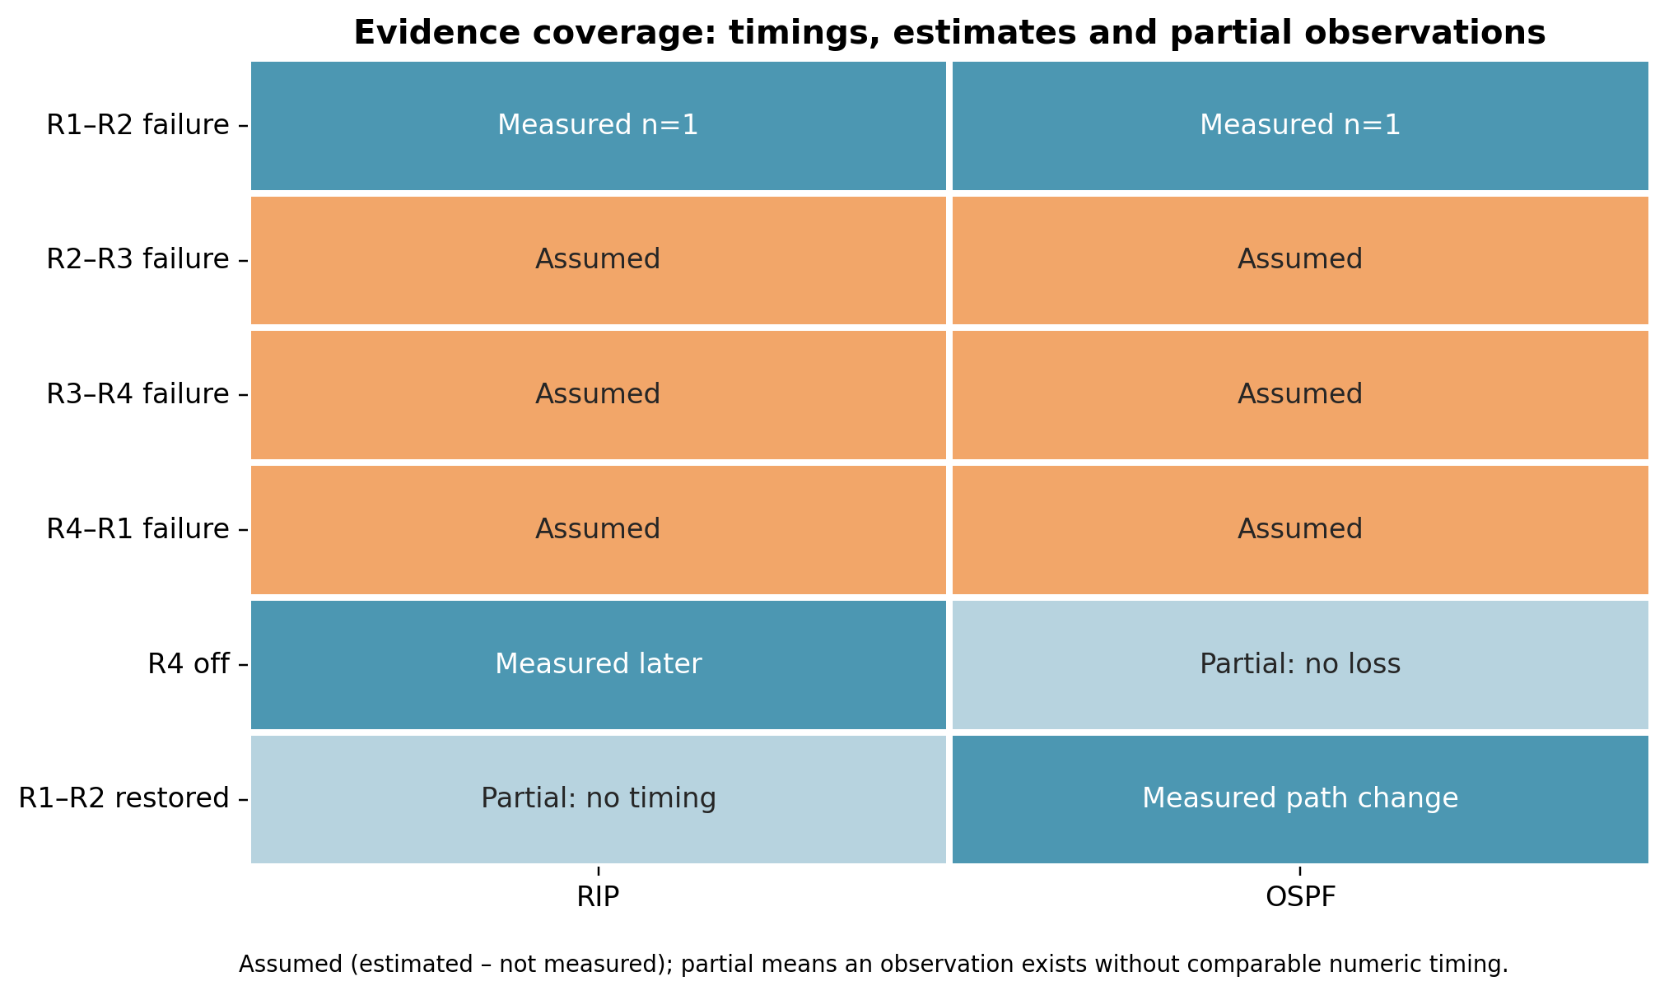
Fig. 5.10. Evidence coverage. Assumed (estimated – not measured) cases have no recorded timing evidence.
5.4 Analysis and discussion
For the recorded R1–R2 failure, OSPF’s approximately 7-second OCRT is shorter than RIP’s approximately 26-second OCRT. The per-run reduction is (26−7)/26 ×100 =73.08%, with no claim of statistical significance. RIP’s captured output contains unreachable responses and timeouts; OSPF’s captured excerpt has one timeout before replies continue. Neither excerpt supplies a completed loss summary.
RIP’s periodic/triggered distance-vector updates and OSPF’s triggered link-state processing offer a theoretical explanation consistent with the observation [1], [2], [4], [5]. The shutdown captures explicitly show OSPF reacting to interface-down, so it would be incorrect to assume that a full Dead timer necessarily expired. The experiment does not isolate the contributions of protocol processing, ARP, detection, simulator scheduling or the stopwatch operator.
All supplied link values favour OSPF numerically, but the three estimated cases cannot independently corroborate the measured comparison. Their averages and ratios describe the team’s illustrative assumptions. For router failure, equal-cost paths before R4 failure mean traffic could already have used R2. That is a plausible but unverified hypothesis for the earlier OSPF no-loss observation, not a proven explanation.
5.5 Critical evaluation and data authenticity
R1–R2 was timed in Packet Tracer; the values for the other three links are estimates assumed from the R1–R2 observations and the expected behaviour of the protocols, because OCRT differs from run to run and those links were not individually timed.
The strengths are a common verified topology, separate saved protocol configurations, visible before/after route output, preserved original images, and an offline replay linked to those sources. The main weaknesses are one timed run for each reported measurement, three assumed-link estimates, unmatched router-failure runs, missing loss summaries and the simulator/stopwatch measurement boundary. No standard deviation or confidence interval is justified by the dataset.
Statement on data authenticity and limitations: captured screenshots establish visible routing and ping behaviour; results tables supply the reported stopwatch values. Assumed (estimated – not measured) values are illustrative estimates and never carry experiment evidence IDs. E22 remains needs-confirmation and is excluded as restoration proof. Numeric gaps remain non-numeric. The mixed four-link arithmetic average was requested as a descriptive summary and cannot establish repeatability or general superiority.
6 CONCLUSION AND FUTURE WORK
6.1 Summary of work and key findings
The preserved Packet Tracer files verify a common ring with a RIP-only RIPv2 configuration and an OSPF-only process 1 / area 0 configuration. In the measured R1–R2 single runs, OCRT was approximately 26 seconds for RIP and 7 seconds for OSPF. Both protocols switched to the alternate ring route and later restored the direct route. Across four supplied links, including three Assumed (estimated – not measured) links, descriptive averages are 25.75 and 7.00 seconds, with a 72.82% reduction of averages. Those arithmetic summaries are illustrative rather than repeated-run experimental estimates.
6.2 Limitations
Single runs do not characterise variation. The other three link cases are assumed, loss percentages are missing, and the router-failure timings come from unlike runs. Stopwatch reaction and Packet Tracer event processing are inseparable from observed service recovery. OSPF’s restoration timing refers to TTL/path change. Individual active forwarding decisions were not recorded, and no event-list capture proves a particular update-timer mechanism caused the timing difference.
6.3 Future enhancements
Time every ring link independently and repeat each matched scenario at least ten times before reporting repeated-trial mean and SD. Capture the exact failure trigger, full ping summaries and automated timestamps. Verify the active forwarding path before failing a router. Subsequent work can compare tuned timers, BFD, EIGRP or multi-area OSPF and validate the observations with emulated or real routers. Both team members should repeat the complete explanation across protocols, code and limitations.
7 REFERENCES
[1] G. Malkin, “RIP Version 2,” RFC 2453, Nov. 1998, doi:10.17487/RFC2453. Available: https://www.rfc-editor.org/info/rfc2453/
[2] J. Moy, “OSPF Version 2,” RFC 2328, Apr. 1998, doi:10.17487/RFC2328. Available: https://www.rfc-editor.org/info/rfc2328/
[3] C. Hedrick, “Routing Information Protocol,” RFC 1058, Jun. 1988, doi:10.17487/RFC1058. Available: https://www.rfc-editor.org/info/rfc1058/
[4] Cisco, “Cisco IOS IP Routing: RIP Command Reference: RIP Commands,” online documentation, accessed Oct.26,2026. Available: https://www.cisco.com/c/en/us/td/docs/ios/iproute_rip/command/reference/irr_book/irr_rip.html
[5] Cisco, “IP Routing: OSPF Configuration Guide, Cisco IOS XE Release 2,” online documentation, accessed Oct.26,2026. Available: https://www.cisco.com/c/en/us/td/docs/ios-xml/ios/iproute_ospf/configuration/xe-2/iro-xe-2-book.pdf
APPENDIX A: CONFIGURATION LISTINGS
A.1 Verified saved-file excerpts. These lines were extracted read-only from the RUNNINGCONFIG elements of v2_rip.pkt and v3_ospf.pkt. They are not reconstructed from the guide or presented as configuration screenshots. Full saved running-config text for every router is provided in Configs/.
RIP routing sections for R1–R4
R1 — RIP saved configuration
router rip
version 2
network 10.0.0.0
network 192.168.1.0
no auto-summary

R2 — RIP saved configuration
router rip
version 2
network 10.0.0.0
network 192.168.2.0
no auto-summary

R3 — RIP saved configuration
router rip
version 2
network 10.0.0.0
network 192.168.3.0
no auto-summary

R4 — RIP saved configuration
router rip
version 2
network 10.0.0.0
network 192.168.4.0
no auto-summary

OSPF routing sections for R1–R4
R1 — OSPF saved configuration
router ospf 1
log-adjacency-changes
network 10.0.0.0 0.255.255.255 area 0
network 192.168.1.0 0.0.0.255 area 0

R2 — OSPF saved configuration
router ospf 1
log-adjacency-changes
network 10.0.0.0 0.255.255.255 area 0
network 192.168.2.0 0.0.0.255 area 0

R3 — OSPF saved configuration
router ospf 1
log-adjacency-changes
network 10.0.0.0 0.255.255.255 area 0
network 192.168.3.0 0.0.0.255 area 0

R4 — OSPF saved configuration
router ospf 1
log-adjacency-changes
network 10.0.0.0 0.255.255.255 area 0
network 192.168.4.0 0.0.0.255 area 0

All router display names are R1–R4, while the saved IOS hostname is Router. No explicit router-id command appears in the saved OSPF configuration. The guide’s intended explicit router IDs were not substituted into these verified excerpts.
A.2 Intended guide examples, not verified entered commands
! Guide-intended R1 example; not a transcript
router ospf 1
router-id 1.1.1.1
network 10.0.12.0 0.0.0.3 area 0
network 10.0.41.0 0.0.0.3 area 0
network 192.168.1.0 0.0.0.255 area 0

A.3 Captured CLI actions. E12/E29 show interface GigabitEthernet0/0 followed by shutdown; E16/E33 show no shutdown. Baseline screenshots show show ip route and E27 shows show ip ospf neighbor. The screenshot set does not contain full running-config commands. Saved-file extraction, rather than screenshot reconstruction, supplies the complete configuration listings.
APPENDIX B: EVIDENCE AND RAW RESULTS
B.1 Additional recorded screenshots. All 37 lossless originals are supplied in Dashboard/assets/screenshots and the submission screenshot ZIP. The manifest below maps every source image. Only selected readable figures are embedded in this report; none is used as evidence for an assumed timing.
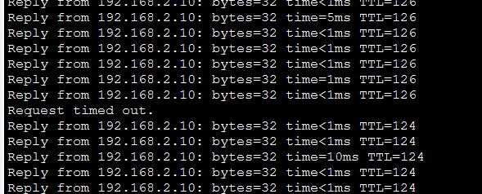
Fig. B.1. OSPF link-failure ping excerpt with one visible timeout and TTL126→124. Recorded evidence (Packet Tracer), E30.
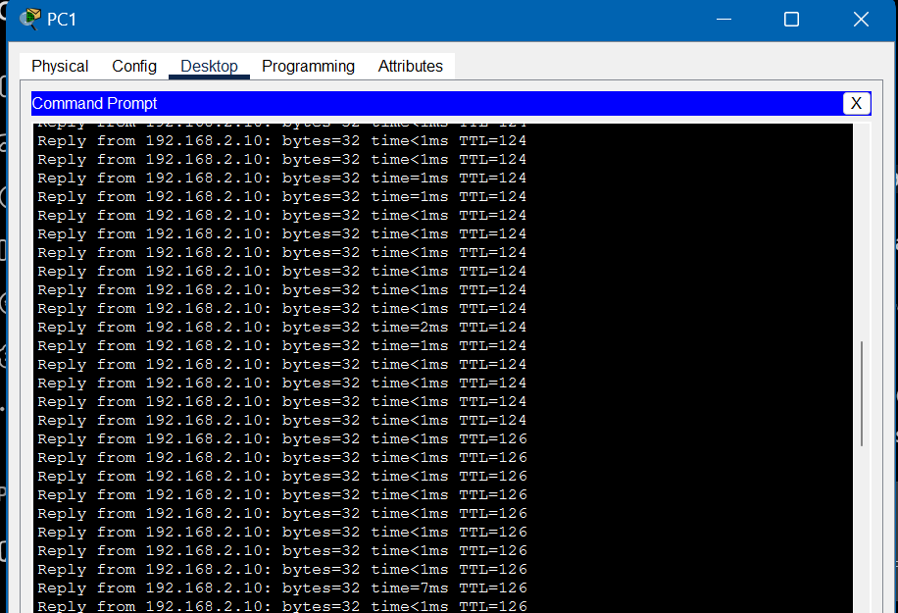
Fig. B.2. OSPF restoration TTL124→126; reported ≈11s interval is supplied by the results table. Recorded evidence (Packet Tracer), E04.
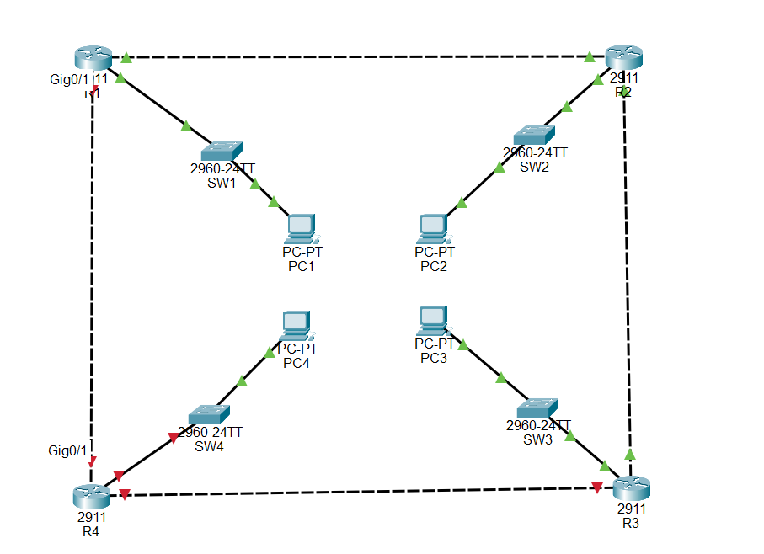
Fig. B.3. R4 unavailable, with its incident links down in the RIP test context. Recorded evidence (Packet Tracer), E19.
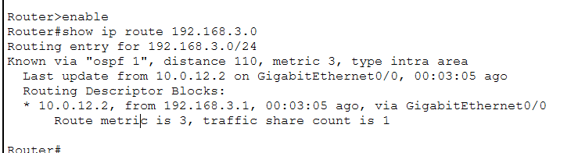
Fig. B.4. OSPF surviving route to LAN3 via R2 with cost3. Recorded evidence (Packet Tracer), E37.
B.2 Raw supplied timing rows
Case | Protocol | Value / status | Data status | Evidence IDs
A R1–R2 | RIP | 26 s | Recorded single run | E11;E12;E13;E14;E15
A R1–R2 | OSPF | 7 s | Recorded single run | E28;E29;E30;E31;E32
A2 R2–R3 | RIP | 24 s | Assumed (estimated – not measured) | None
A2 R2–R3 | OSPF | 6 s | Assumed (estimated – not measured) | None
A3 R3–R4 | RIP | 28 s | Assumed (estimated – not measured) | None
A3 R3–R4 | OSPF | 8 s | Assumed (estimated – not measured) | None
A4 R4–R1 | RIP | 25 s | Assumed (estimated – not measured) | None
A4 R4–R1 | OSPF | 7 s | Assumed (estimated – not measured) | None
B R4 | RIP | 11 s | Recorded single run | E07;E18;E19;E20;E21
C R1–R2 | RIP | Not reliably measured | Recorded qualitative observation; timing absent | E14;E16;E17
B R4 | OSPF | Not measurable | Recorded qualitative observation; timing absent | E23;E34;E35;E36;E37
C R1–R2 | OSPF | 11 s | Recorded single run | E01;E02;E03;E04;E05;E33

For OSPF C the value is a path-return/TTL interval. For B, RIP is the later run and OSPF the earlier run. The complete CSV retains routes, metrics, run notes, counts and evidence fields. No packet-loss count/percentage is recorded in a completed screenshot summary.
B.3 Evidence manifest
ID | Protocol / case / phase | Caption / confidence
E01 | OSPF / restoration / before | Initial path; confirmed
E02 | OSPF / restoration / during | Putting the r1->r2 link down; confirmed
E03 | OSPF / restoration / after link failure | New path; confirmed
E04 | OSPF / restoration / during/after | TTL change; confirmed
E05 | OSPF / restoration / after | Confirming the initial path is taken again; confirmed
E06 | Topology / baseline / proof | Topology and IP addressing; confirmed
E07 | RIP / baseline / before | R1 RIP; confirmed
E08 | RIP / baseline / before | R2 RIP; confirmed
E09 | RIP / baseline / before | R3 RIP; confirmed
E10 | RIP / baseline / before | R4 RIP; confirmed
E11 | RIP / link failure / before | RIP route before failure; confirmed
E12 | RIP / link failure / during | Disabling the r1->r2 link; confirmed
E13 | RIP / link failure / during/after | Disabling the r1->r2 link; confirmed
E14 | RIP / link failure / after | New path after r1->r2 was disabled; confirmed
E15 | RIP / link failure / proof | Visual proof that r1->r2 was disabled; confirmed
E16 | RIP / restoration / during | Restoring the r1->r2 link; confirmed
E17 | RIP / restoration / after | Verifying that its back; confirmed
E18 | RIP / router failure / during/after | RIP router failure test; confirmed
E19 | RIP / router failure / proof | Visual evidence that r4 is down; confirmed
E20 | RIP / router failure / after | Verifying the change; confirmed
E21 | RIP / router failure / proof | R4 is down; confirmed
E22 | RIP / restoration / uncertain | Restoring ping for RIP; needs-confirmation
E23 | OSPF / baseline / before | OSPF R1 baseline; confirmed
E24 | OSPF / baseline / before | R2 baseline; confirmed
E25 | OSPF / baseline / before | R3 baseline; confirmed
E26 | OSPF / baseline / before | R4 baseline; confirmed
E27 | OSPF / baseline / before | OSPF baseline neighbors; confirmed
E28 | OSPF / link failure / before | OSPF link route before ; confirmed
E29 | OSPF / link failure / during | Disabling the link; confirmed
E30 | OSPF / link failure / during/after | Pinglog of PC1; confirmed
E31 | OSPF / link failure / after | New route; confirmed
E32 | OSPF / link failure / proof | Proof that the link is down; confirmed
E33 | OSPF / restoration / during | Reenabling the link; confirmed
E34 | OSPF / router failure / during/after | Pinglog for router failure testing; confirmed
E35 | OSPF / router failure / proof | Proof that R4 is down for this test; confirmed
E36 | OSPF / router failure / proof | Proof that R4 is down for this test; confirmed
E37 | OSPF / router failure / after | Route after R4 is down; confirmed

The companion Data/evidence_manifest.csv provides original document indices, final filenames, SHA-256 hashes and human-reviewed what_it_shows descriptions for every image. Protocol assignment for a topology or PC crop can come from caption context. E22 is preserved and flagged, with no restoration result linked to it.

