My First Scraper Ds
- Subject
- 1 Solution

My First Scraper Ds
Submit directory | .
Submit file | my_first_scraper.py
Description
Introduction

HTML has been built to be "displayed". It's working very well... but when you want to build a script to collect actionable data, you are left with this:
Google search page engine HTML Euuh... I just wanted to collect all the links on the page...
It’s likely that there are libraries to navigate through the jungle. Let's scrap some Data!
Technical specifications
Static url to scrape = 'https://storage.googleapis.com/qwasar-public/track-ds/trending_14_06_2022'
Using python libraries requests and beautifulsoup4, return a CSV of the TOP 25 trending repositories from Github.
- Request (with request)
- Extract (with beautifulsoup4)
- Transform
- Format
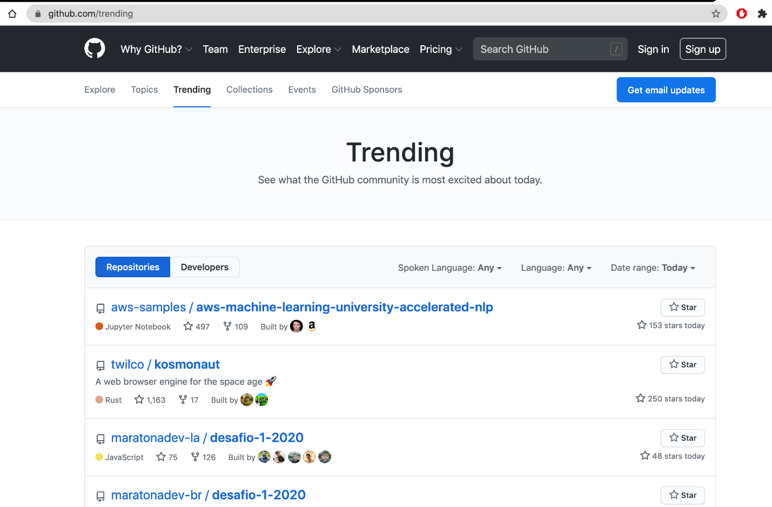
Github trending's page
Part 0: Request Write a function prototyped: def request_github_trending(url) it will return the result of Request.
Part 1: Extract Write a function prototyped: def extract(page) to find_all instances of HTML code of repository rows and return it. You should use BeautifulSoup. :-)
Part 2: Transform Write a function prototyped: def transform(html_repos) taking an array of all the instances of HTML code of the repository row. It will return an array of hash following this format: [{'developer': NAME, 'repository_name': REPOS_NAME, 'nbr_stars': NBR_STARS}, ...]
Part 3: Format Write a function prototyped: def format(repositories_data) taking a repository array of hash and transforming it and returning it into a CSV string. Each column will be separated by , and each line by \n The columns will be Developer,Repository Name,Number of Stars
Tip Google: Request get python Google: BeautifulSoup python

