Executive Summary — AI Data Storyteller
## 🎯 Executive Summary
Your dataset contains **398 records** across **9 variables**.
The analysis focuses on **Kilometer_per_liter** as the target variable, helping identify key patterns and relationships.
## 📊 Data Quality Assessment
✅ **Excellent Data Quality**: Less than 5% missing values
• Missing Values: 0.0% of all data points
• Duplicate Rows: 0 records
• Memory Usage: 0.00 MB
## 🔍 Variable Overview
• **Numeric Variables**: 0 columns for statistical analysis
• **Categorical Variables**: 0 columns for grouping and classification
## 🎯 Target Variable Analysis: Kilometer_per_liter
**Type**: Categorical
**Unique Values**: 129
**Most Common**: '5.5268681965935365' (5.0% of data)
**✅ Balanced Distribution**: Good variety across categories
## 📈 Key Statistical Findings
## 🔗 Relationship Analysis
**Strong Relationships Found**: 6 variable pairs show strong correlation
- cylinders - displacement: r = 0.951
- cylinders - weight: r = 0.896
**Moderate Relationships**: 12 variable pairs show moderate correlation
- origin - cylinders: r = -0.563
- origin - displacement: r = -0.609
## 🎯 Target-Focused Insights for Kilometer_per_liter
## 💡 Recommendations
• **Modeling Focus**: Use Kilometer_per_liter as target for predictive modeling
• **Multicollinearity**: Consider feature selection to address highly correlated variables
• **Next Steps**: Consider advanced modeling techniques based on your specific goals
## ⚡ Quick Action Items
1. **Review Data Quality**: Check the data quality assessment above
2. **Explore Relationships**: Use the correlation analysis to identify key patterns
3. **Focus on Target**: Analyze how other variables relate to Kilometer_per_liter
4. **Generate Visualizations**: Use the advanced visualization tabs for deeper insights
5. **Export Results**: Download the summary and statistics for further analysis

Visualizations
Distribution: origin
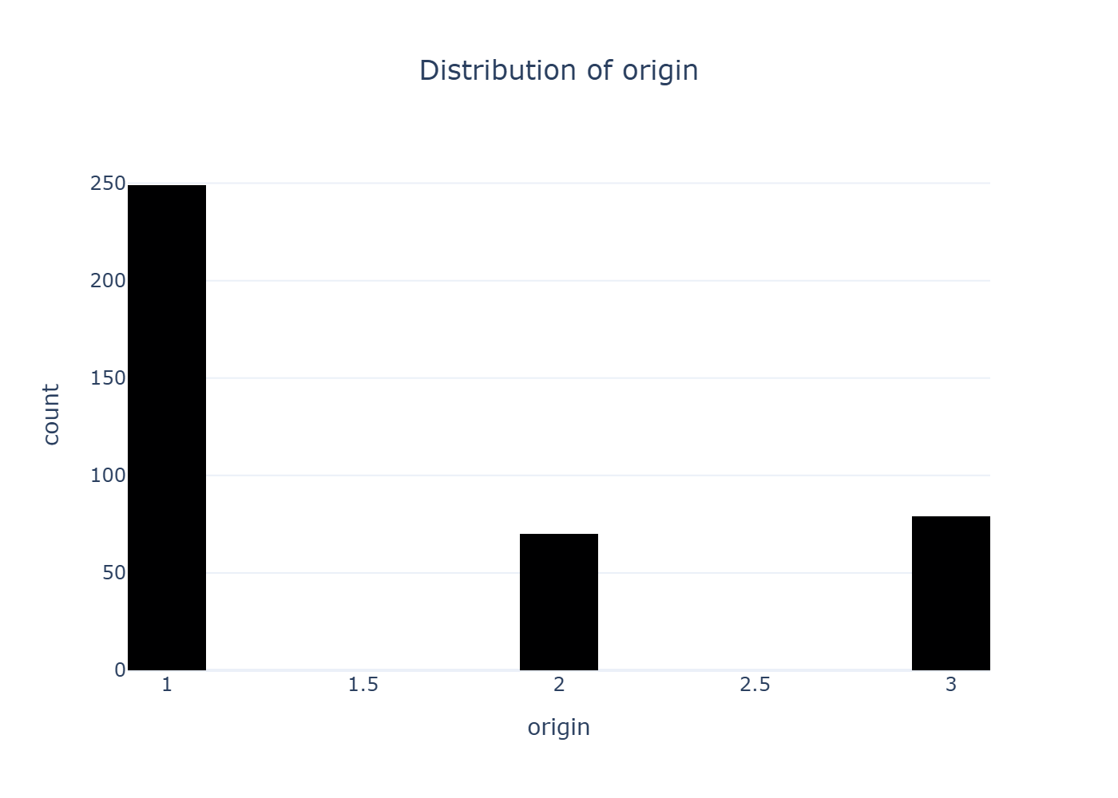
Correlation Analysis
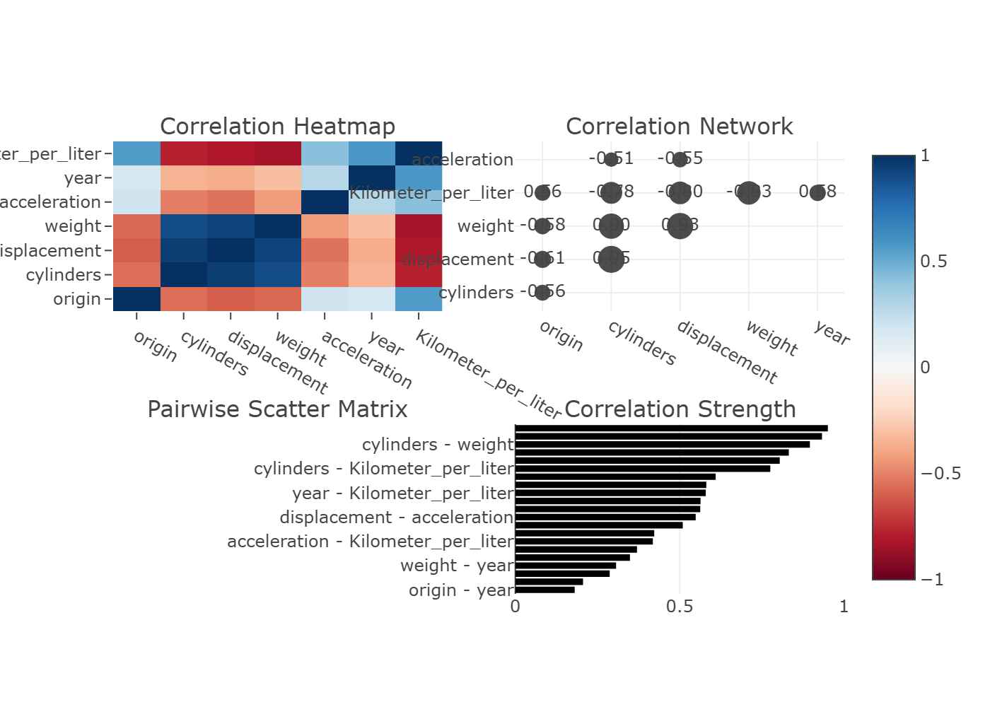
Categorical Analysis: horsepower
