**Login**

create table login

(

email varchar(30),primary key(email),

password varchar(20)

);

insert into login(Email,Password) values ('Robert670@gmail.com','Rob1@8987');

insert into login(Email,Password) values('fatimaA85@gmail.com','Rfat@6785');

**Select * from login;**

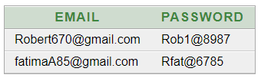

**Desc Login**

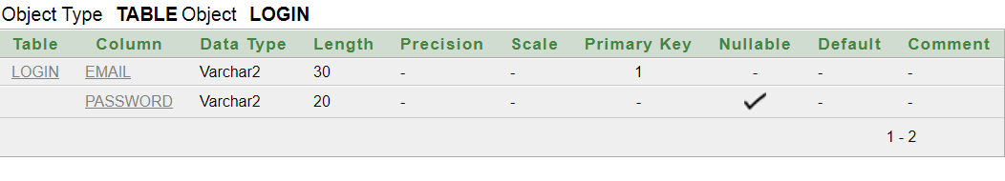

|  |  |
| --- | --- |
|  |  |

**RequestFood**

create table RequestFood

(

name varchar(30),

email varchar(30), a

ddress varchar(60),

NumberOfPeople number,primary key(email));

insert into RequestFood values('Kavana','kavana@gmail.com','Bangalore', 4);

insert into RequestFood values('Naveen','Naveen@gmail.com','Mysore', 3);

**Select * from RequestFood**

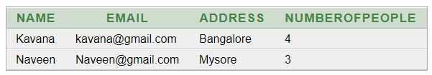

**Desc RequestFood**

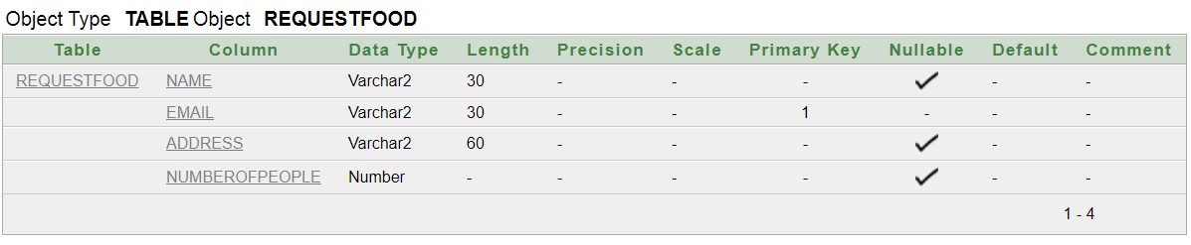

**RequestClothes**

create table RequestClothes

(

name varchar(30),

email varchar(30),

address varchar(60),

NumberOfPeople number,

primary key(email)

);

insert into RequestClothes(Name,Email,Address,NumberofPeople) values('Fatima','fatimaA85@gmail.com','RR Nagar Bangalore',2);

insert into RequestClothes(Name,Email,Address,NumberOfPeople) values('Jinappa','jinappa90@gmail.com','Yelahanka Bangalore',1);

**Select * from RequestClothes;**

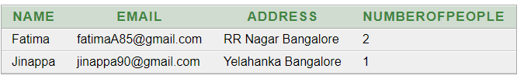

**Desc RequestClothes**

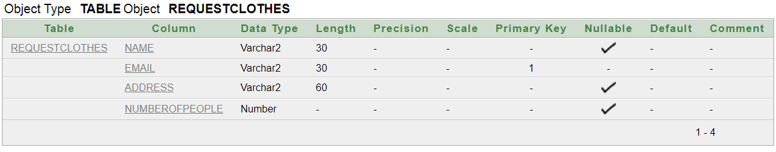

**Login Form**

|  |  |
| --- | --- |
| **Name** |  |
| **Email** | **Submit** |

**RequestFood Form**

|  |  |
| --- | --- |
| **Name** |  |
| **Email** |  |
| **Address**  **No. Of People** |  |

**Submit**

**RequestClothes Form**

|  |  |
| --- | --- |
| **Name** |  |
| **Email** |  |
| **Address**  **No. Of People** |  |

**Submit**