LAB PROGRAM 3

1. Solve 8 puzzle by Breadth First Search method (non-heuristic approach)

PSEUDOCODE:

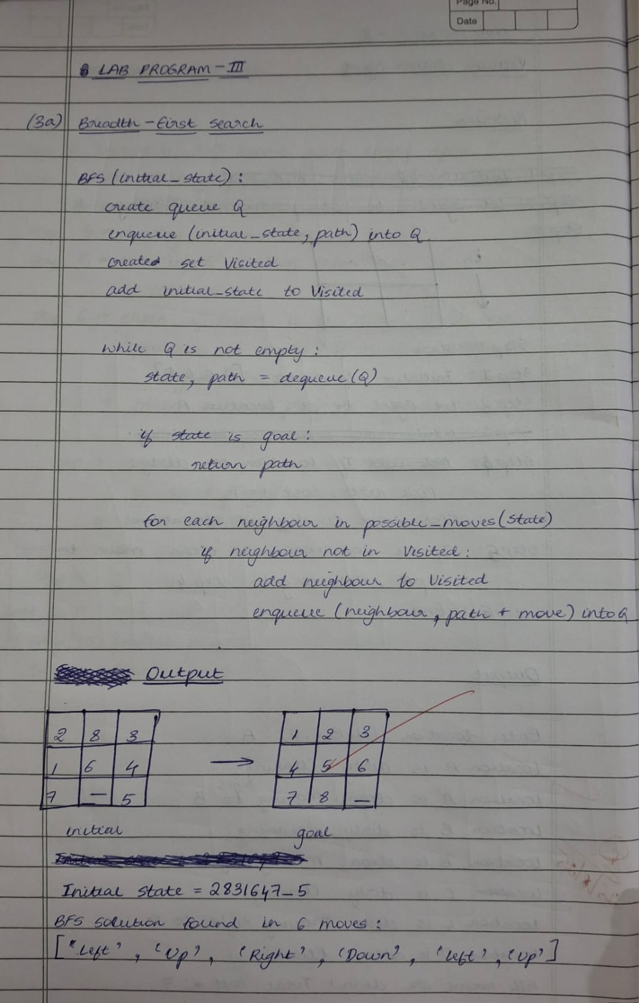

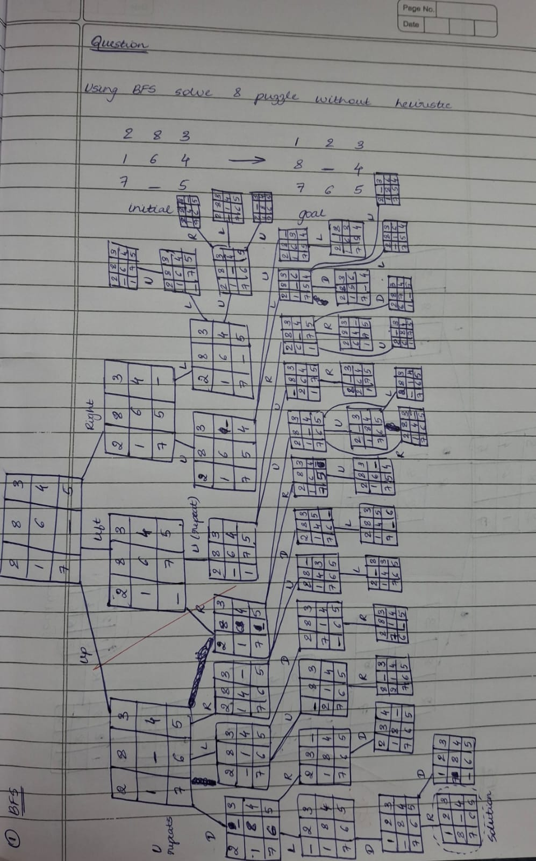

CODE:

from collections import deque

GOAL_STATE = (1, 2, 3, 8, 0, 4, 7, 6, 5)

MOVES = {

    'left': -1,

    'right': 1,

    'up': -3,

    'down': 3,

}

def is_valid_move(blank_idx, move):

    if move == 'left' and blank_idx % 3 == 0:

        return False

    if move == 'right' and blank_idx % 3 == 2:

        return False

    if move == 'up' and blank_idx < 3:

        return False

    if move == 'down' and blank_idx > 5:

        return False

    return True

def get_neighbors(state):

    neighbors = []

    blank_idx = state.index(0)

    for move, delta in MOVES.items():

        if is_valid_move(blank_idx, move):

            new_idx = blank_idx + delta

            new_state = list(state)

            new_state[blank_idx], new_state[new_idx] = new_state[new_idx], new_state[blank_idx]

            neighbors.append(tuple(new_state))

    return neighbors

def bfs(start_state):

    queue = deque([start_state])

    visited = set([start_state])

    parent = {start_state: None}

    explored_count = 0

    while queue:

        current = queue.popleft()

        explored_count += 1

        if current == GOAL_STATE:

            path = []

            while current:

                path.append(current)

                current = parent[current]

            path.reverse()

            print(f"Total states explored (breadth-wise): {explored_count}")

            return path

        for neighbor in get_neighbors(current):

            if neighbor not in visited:

                visited.add(neighbor)

                parent[neighbor] = current

                queue.append(neighbor)

    print(f"Total states explored (breadth-wise): {explored_count}")

    return None

def print_state(state):

    for i in range(0, 9, 3):

        print(state[i:i+3])

    print()

if __name__ == "__main__":

    start = (2, 8, 3,

             1, 6, 4,

             7, 0, 5)

    print("Starting BFS 8-puzzle solver...\nInitial state:")

    print_state(start)

    print("Sinchana Hemanth (1BM23CS330)")

    solution = bfs(start)

    if solution:

        print(f"Solution found in {len(solution)-1} moves:\n")

        for step_num, state in enumerate(solution):

            print(f"Step {step_num}:")

            print_state(state)

    else:

        print("No solution found.")

OUTPUT:

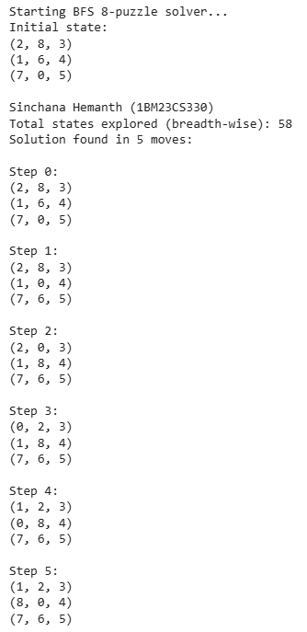

1. Solve 8 puzzle by Depth First Search method (non-heuristic approach)

PSEUDOCODE:

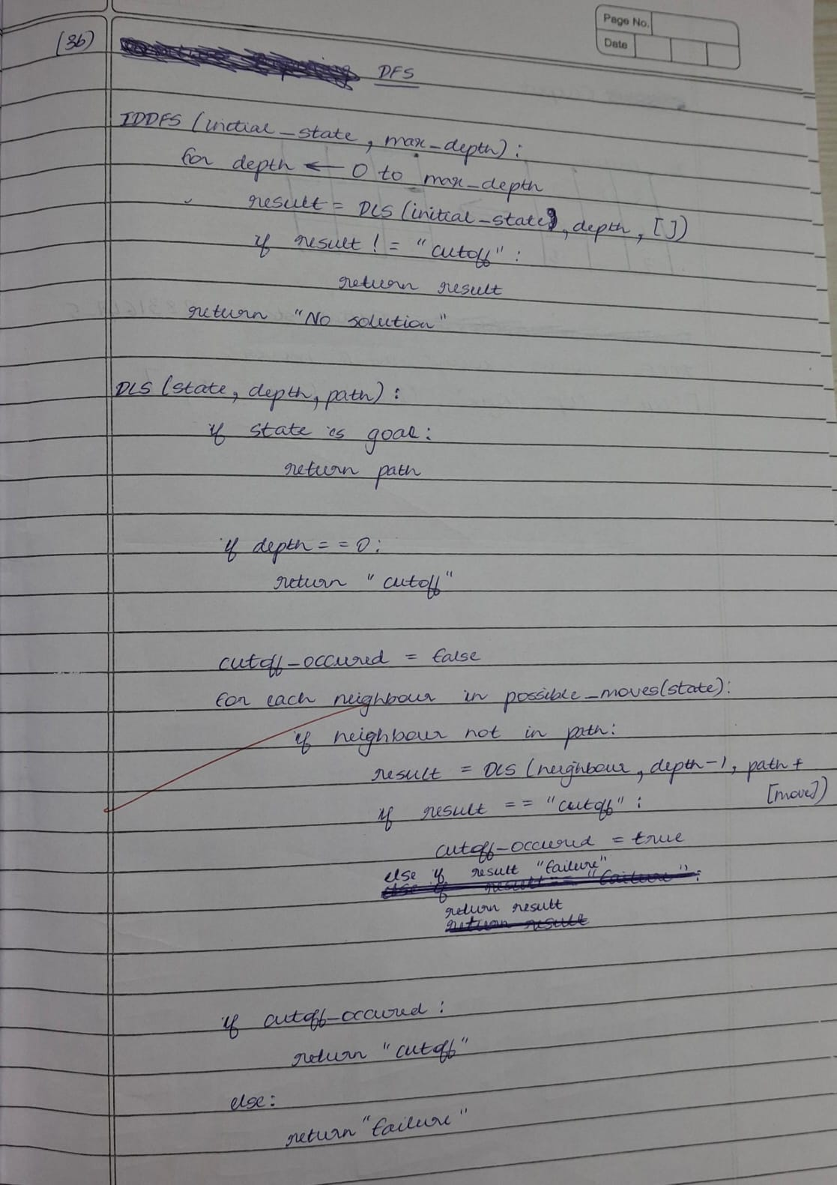

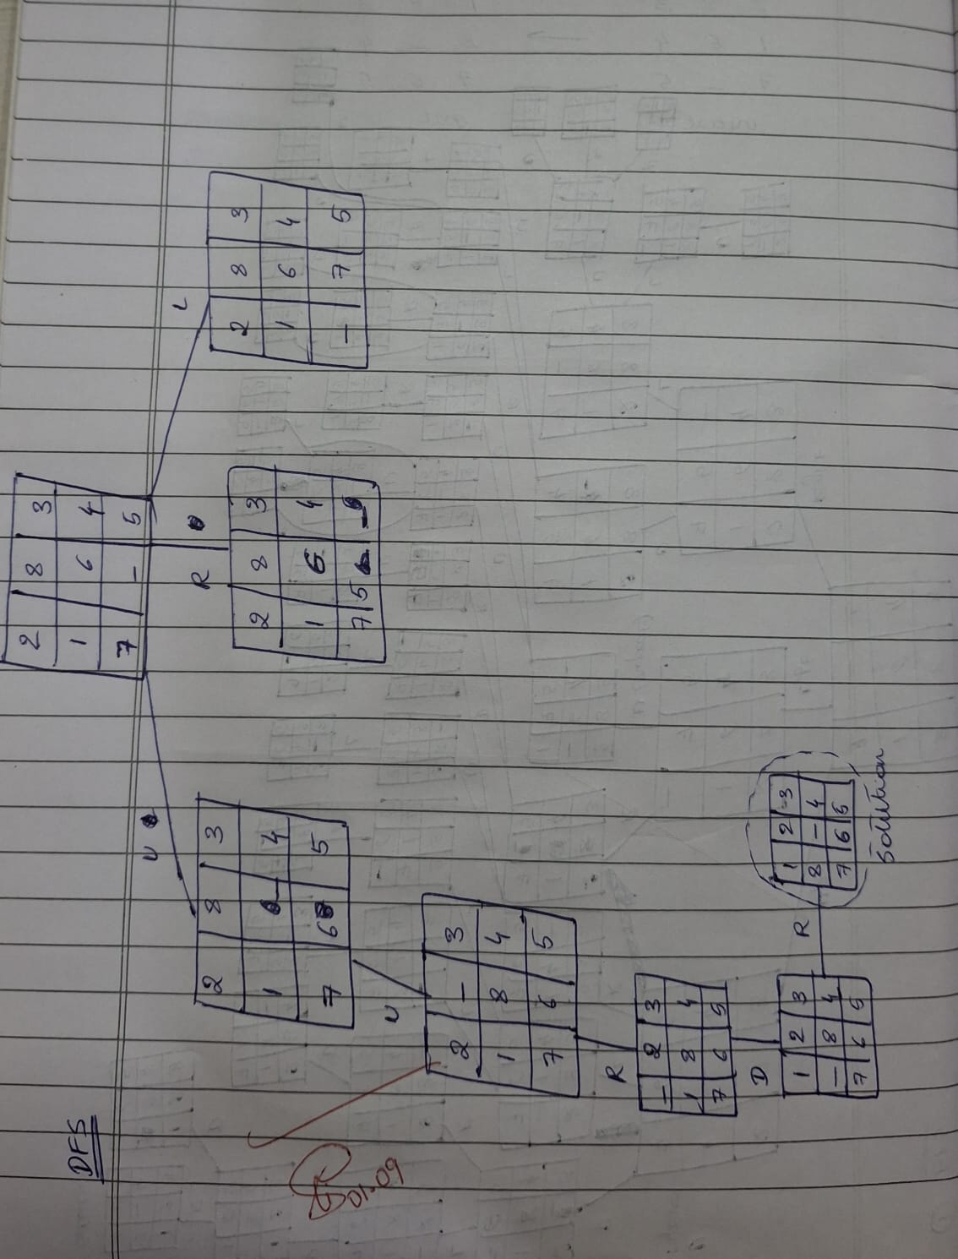

CODE:

GOAL_STATE = (1, 2, 3, 4, 5, 6, 7, 8, 0)

MOVES = {

    'left': -1,

    'right': 1,

    'up': -3,

    'down': 3,

}

def is_valid_move(blank_idx, move):

    if move == 'left' and blank_idx % 3 == 0:

        return False

    if move == 'right' and blank_idx % 3 == 2:

        return False

    if move == 'up' and blank_idx < 3:

        return False

    if move == 'down' and blank_idx > 5:

        return False

    return True

def get_neighbors(state):

    neighbors = []

    blank_idx = state.index(0)

    for move, delta in MOVES.items():

        if is_valid_move(blank_idx, move):

            new_idx = blank_idx + delta

            new_state = list(state)

            new_state[blank_idx], new_state[new_idx] = new_state[new_idx], new_state[blank_idx]

            neighbors.append(tuple(new_state))

    return neighbors

def dfs(start_state, max_depth=50):

    stack = [(start_state, 0)]

    visited = set([start_state])

    parent = {start_state: None}

    while stack:

        current, depth = stack.pop()

        if current == GOAL_STATE:

            path = []

            while current:

                path.append(current)

                current = parent[current]

            path.reverse()

            return path

        if depth < max_depth:

            for neighbor in get_neighbors(current):

                if neighbor not in visited:

                    visited.add(neighbor)

                    parent[neighbor] = current

                    stack.append((neighbor, depth + 1))

    return None

def print_state(state):

    for i in range(0, 9, 3):

        print(state[i:i+3])

    print()

if __name__ == "__main__":

    start = (1, 2, 3,

             4, 0, 6,

             7, 5, 8)

    print("Starting DFS 8-puzzle solver...\nInitial state:")

    print_state(start)

    print("Sinchana Hemanth (1BM23CS330)")

    solution = dfs(start, max_depth=20)

    if solution:

        print(f"Solution found in {len(solution)-1} moves:\n")

        for step in solution:

            print_state(step)

    else:

        print("No solution found or max depth exceeded.")

OUTPUT:  
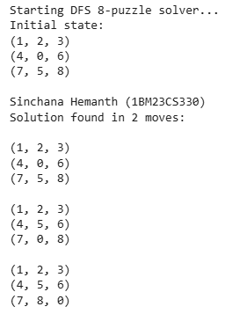

1. Solve 8 puzzles by Iterative Deepening Depth First Search (IDDFS)

PSEUDOCODE:

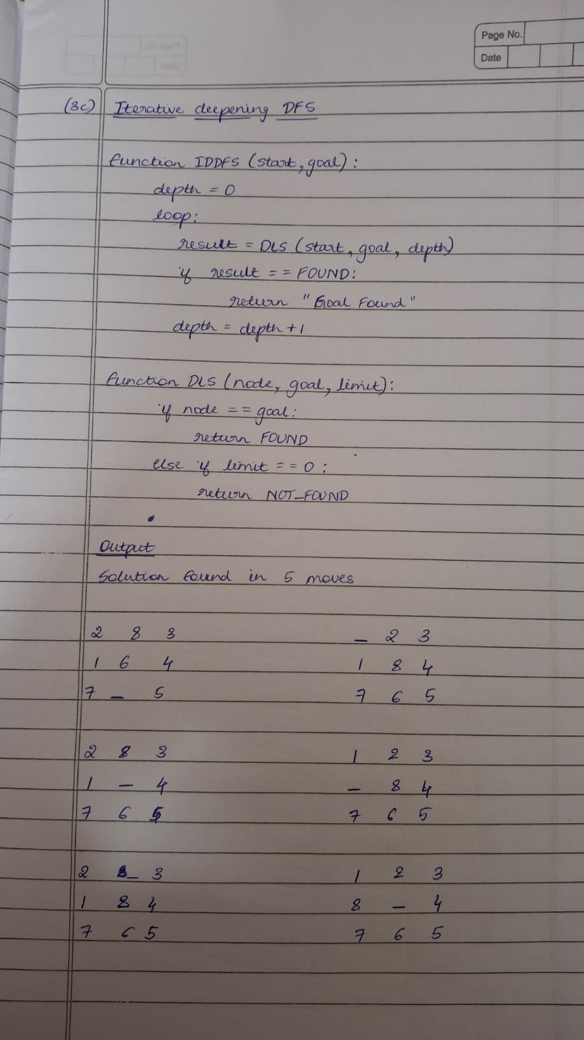

CODE:

from collections import deque

N = 3

moves = [(-1,0),(1,0),(0,-1),(0,1)]

def find_blank(state):

    idx = state.index("_")

    return divmod(idx, N)

def swap(state, i1, j1, i2, j2):

    s = list(state)

    idx1, idx2 = i1*N+j1, i2*N+j2

    s[idx1], s[idx2] = s[idx2], s[idx1]

    return tuple(s)

def expand(state):

    x, y = find_blank(state)

    children = []

    for dx, dy in moves:

        nx, ny = x+dx, y+dy

        if 0 <= nx < N and 0 <= ny < N:

            children.append(swap(state, x, y, nx, ny))

    return children

def dls(state, goal, limit, path, visited):

    if state == goal:

        return path

    if limit == 0:

        return None

    visited.add(state)

    for child in expand(state):

        if child not in visited:

            result = dls(child, goal, limit-1, path+[child], visited)

            if result is not None:

                return result

    visited.remove(state)

    return None

def iddfs(start, goal, max_depth=20):

    for depth in range(max_depth):

        visited = set()

        result = dls(start, goal, depth, [start], visited)

        if result is not None:

            return result

    return None

print("Sinchana Hemanth (1BM23CS330)")

initial = (2,8,3,1,6,4,7,"_",5)

goal    = (1,2,3,8,"_",4,7,6,5)

solution = iddfs(initial, goal, max_depth=30)

if solution:

    print("Solution found in", len(solution)-1, "moves:\n")

    for step in solution:

        for i in range(0, 9, 3):

            print(step[i:i+3])

        print()

else:

    print("No solution found within depth limit")

OUTPUT:

