VISVESVARAYA TECHNOLOGICAL UNIVERSITY
“Jnana Sangama”, Belagavi – 590 018


An Internship Report on

“Virtual Assistant for visually impaired”
Submitted in partial fulfillment for the award of degree of
Bachelor of Engineering in
Computer Science Engineering
Submitted By
T G Sarvesh
Internship Carried Out at
Varcons Technologies PVT. LTD. Bengaluru


DEPARTMENT OF COMPUTER SCIENCE AND ENGINEERING DON BOSCO INSTITUTE OF TECHNOLOGY, BENGALURU-560074

DON BOSCO INSTITUTE OF TECHNOLOGY DEPARTMENT OF COMPUTER SCIENCE AND ENGINEERING
Kumbalagodu, Bengaluru-560074


CERTIFICATE

This is to certify that the internship report entitled “Virtual assistant for visually impaired” is carried out by T G SARVESH (1DB19CS151) in partial fulfillment of the requirements for the award of Bachelor of Engineering in Computer Science and Engineering of Visvesvaraya Technological University, Belagavi during the year 2022-2023.

Signature of the Internal Guide | Signature of HOD
Mrs. HEMALATHA M  Assosiate Professor, Dept. of CSE, DBIT, Bengaluru | Dr. K. B. Shivakumar  Head of Dept., Dept. of CSE, DBIT, Bengaluru

DON BOSCO INSTITUTE OF TECHNOLOGY
Kumbalagodu, Bengaluru – 560 074.


DECLARATION
I, T G SARVESH, student of seventh semester B.E, Department of Computer Science and Engineer- ing, Don Bosco Institute of Technology, Kumbalagodu, Bangalore, declare that the internship pro- ject entitled “VIRTUAL ASSISTANT FOR VISUALLY IMPAIRED” has been carried out by me and submitted in partial fulfillment of the course requirements for the award of degree in Bache- lor of Engineering in Computer Science and Engineering of Visvesvaraya Technological Uni- versity, Belgaum during the academic year 2022-23. The matter embodied in this report has not been submitted to any other university or institution for the award of any other degree or diploma.

Date: 25/09/2022 T G SARVESH
Place: Bangalore 1DB19CS151



ACKNOWLEDGEMENT

The success and outcome of this internship required a lot of guidance and assistance from many people, and I am extremely privileged to have got this all along the completion of my internship. I thank to all those who have rendered their cherished advice and services towards the completion of the internship.
I wish to express my deep sense of acknowledgement and gratitude to my Internal guide Mrs.Hemalatha, Associate Professor, Department of Computer Science and Engineering, for the suggestions and encouragement throughout the making of the internship.
I am highly indebted to Dr. K. B. Shivakumar, Head of Department, Computer science and Engi- neering, for his kind consents and wholehearted cooperation.
I would like to thank our Principal Dr. Umashankar B. S., for his encouragement and providing an excellent working environment.
I thank all the lecturers of the dept. for their cooperation and providing with the facilities to carry out the seminar work. I would also express my thanks to all technical and non-technical staff of the Computer Science and Engineering department who have directly or indirectly cooperated with me.
Finally, I would like to express my gratitude to my parents and friends who always stood by me en- couraging in all my endeavors.

T G SAVESH (1DB19CS151)

ABSTRACT:
This project addresses the problem of sentimental analysis in twitter, that is classifying tweets ac- cording to the sentiment expressed in them: positive, negative, or neutral. Twitter is an online micro- blogging and social-networking platform which allows users to write short status updates of maxi- mum length 140 characters. It is a rapidly expanding service with over 200 million registered users – out of which 100 million are active users and half of them log on twitter on a daily basis – generating nearly 250 million tweets per day. Due to this large amount of usage we hope to achieve a reflection of public sentiment by analysing the sentiments expressed in the tweets. Analysing the public senti- ment is important for many applications such as firms trying to find out the response of their prod- ucts in the market, predicting political elections and predicting socioeconomic phenomena like stock exchange. The aim of this project is to develop a function classifier for accurate and automatic sen- timent classification of an unknown tweet stream.

Table of Contents :

SL. No | Description | Page no
1 | Company Profile | 8
2 | About the Company | 9-12
3 | Introduction | 13-14
4 | Requirement Analysis | 15
5 | Design Analysis | 16
6 | Snapshots | 17-19
7 | Implementation | 20-23
8 | Conclusion | 24
9 | References | 25

CHAPTER 1 1.COMPANY PROFILE :
A Brief History of Varcons Technologies
Varcons Technologies Pvt Ltd, was incorporated with a goal ”To provide high quality and optimal Technological Solutions to business requirements of our clients”. Every business is a different and has a unique business model and so are the technological requirements. They understand this and hence the solutions provided to theserequirements are different as well. They focus on clients re- quirements and provide them with tailor made technological solutions. They also understand that Reach of their Product to its targeted market or the automation of the existing process into e-client and simple process are the key features that our clients desire from Technological Solution they are looking for and these are the features that we focus on while designing the solutions for their clients.
Varcons Technologies, strive to be the front runner in creativity and innovation in software development through their well-researched expertise and establish it as an out of the box software development company in Bangalore, India. As a software development company, they translate this software development expertise into value for their customers through their professional solutions. They understand that the best desired output can be achieved only by understanding the clients de- mand better. Varcons Technologies work with their clients and help them to define their exact solu- tion requirement. Sometimes even they wonder that they have completely redefined their solution or new application requirement during the brainstorming session, and here they position themselves as an IT solutions consulting group comprising of high caliber consultants. They believe that Technol- ogy when used properly can help any business to scale and achieve new heights of success. It helps Improve its efficiency, profitability, reliability; to put it in one sentence ” Technology helps you to Delight your Customers” and that is what we want to achieve.

CHAPTER 2
2.ABOUT THE COMPANY :


Varcons Technologies is a Technology Organization providing solutions for all web design and development, MYSQL, PYTHON Programming, HTML, CSS, ASP.NET and LINQ. Meeting the ever increasing automation requirements, Varcons Technologies specialize in ERP, Connectivity, SEO Services, Conference Management, effective web promotion and tailor-made software prod- ucts, designing solutions best suiting client’s requirements. The organization where they have a right mix of professionals as a stakeholders to help us serve our clients with best of our capability and with at par industry standards. They have young, enthusiastic, passionate and creative Professionals to develop technological innovations in the field of Mobile technologies, Web applications as well as Business and Enterprise solution. Motto of our organization is to “Collaborate with our clients to provide them with best Technological solution hence creating Good Present and Better Future for our client which will bring a cascading a positive effect in their business shape as well”. Providing a Complete suite of technical solutions is not just our tag line, it is Our Vision for Our Clients and for Us, We strive hard to achieve it.

Varcons ofTechnologies Products. Android Apps
It is the process by which new applications are created for devices running the Android oper- ating system. Applications are usually developed in Java (and/or Kotlin; or other such option) pro- gramming language using the Android software development kit (SDK), but other development en-

vironments are also available, some such as Kotlin support the exact same Android APIs (and byte code), while others such as Go have restricted API access. The Android software development kit includes a comprehensive set of development tools. These include a debugger, libraries, a handset emulator based on QEMU, documentation, sample code, and zutorials. Currently supported devel- opment platforms include computers running Linux (any modern desktop Linux distribution), Mac OS X 10.5.8 or later, and Windows 7 or later. As of March 2015, the SDK is not available on An- droid itself, but software development is possible by using specialized Android applications.

Web Application
It is a client–server computer program in which the client (including the user interface and client- side logic) runs in a web browser. Common web applications include web mail, online retail sales, online auctions, wikis, instant messaging services and many other functions. Web applications use web documents written in a standard format such as HTML and JavaScript, which are supported by a variety of web browsers. Web applications can be considered as a specific variant of client–server software where the client software is downloaded to the client machine when visiting the relevant web page, using standard procedures such as HTTP. The Client web software updates may happen each time the web page is visited. During the session, the web browser interprets and displays the pages, and acts as the universal client for any web application. The use of web application frame- works can often reduce the number of errors in a program, both by making the code simpler, and by allowing one team to concentrate on the framework while another focuses on a specified use case. In applications which are exposed to constant hacking attempts on the Internet, security- related prob- lems can be caused by errors in the program.
Frameworks can also promote the use of best practices such as GET after POST. There aresome who view a web application as a two-tier architecture. This can be a “smart” client that performs all the work and queries a “dumb” server, or a “dumb” client that relies on a “smart” server. The client would handle the presentation tier, the server would have the database (storage tier), and the busi- ness logic (application tier) would be on one of them or on both. While this increases the scalability of the applications and separates the display and the database, it still does not allow for true speciali- zation of layers, so most applications will outgrow this model. An emerging strategy for application software companies is to provide web access to software previously distributed as local applications.

Depending on the type of application, it may require the development of an entirely different brows- er-based interface, or merely adapting an existing application to use different presentation technolo- gy. These programs allow the user to pay a monthly or yearly fee for use of a software application without having to install it on a local hard drive. A company which follows this strategy is known as an application service provider (ASP), and ASPs are currently receiving much attention in the soft- ware industry.
Security breaches on these kinds of applications are a major concern because it can involve both en- terprise information and private customer data. Protecting these assets is an important part of any web application and there are some key operational areas that must be included in the development process. This includes processes for authentication, authorization, asset handling, input, and logging and auditing. Building security into the applications from the beginning can be more effective and less disruptive in the long run.

Web Design
It is encompasses many different skills and disciplines in the production and maintenance of web- sites. The different areas of web design include web graphic design; interface design; authoring, in- cluding standardized code and proprietary software; user experience design; and search engine opti- mization. The term web design is normally used to describe the design process relating to the front- end (client side) design of a website including writing mark up.
Web design partially overlaps web engineering in the broader scope of web development. Web de- signers are expected to have an awareness of usability and if their role involves creating mark-up then they are also expected to be up to date with web accessibility guidelines. Web design partially overlaps web engineering in the broader scope of web development.

Departments and services offered
Varcons Technologies plays an essential role as an institute, the level of education, Develop- ment of student’s skills are based on their trainers. If you do not have a good mentor then you may lag in many things from others and that is why we at Varcons Technologies gives you the facility of

skilled employees so that you do not feel unsecured about the academics. Personality development and academic status are some of those things which lie on mentor’s hands. If you are trained well then you can do well in your future and knowing its importance of Varcons Technologies always tries to give you the best.
They have a great team of skilled mentors who are always ready to direct their trainees in the best possible way they can and to ensure the skills of mentors we held many skill development programs as well so that each and every mentor can develop their own skills with the demands of the compa- nies so that they can prepare a complete packaged trainee.

Services provided by Varcons Technologies Pvt Ltd
- Core Java and Advanced Java
- Web services and development
- Dot Net Framework
- Python
- Selenium Testing
- Conference / Event Management Service
- Academic Project Guidance
- On the Job Training
- Software Training

CHAPTER 3 INTRODUCTION
  - In the past few years, there has been a huge growth in the use of microblogging platforms such as Twitter. Spurred by that growth, companies and media organisations are increasingly seeking ways to mine Twitter for information about what people think and feel about their products and services.
  - Tweets are often useful in generating a vast amount of sentiment data upon analysis.
  - These data are useful in understanding the opinion of the people about a variety of topics.
  - Due to presence of non-useful characters along with useful data, it becomes difficult to im- plement models on them.
  - We aim to analyse the sentiment of tweets provided from the sentiment 140 dataset by devel- oping a machine learning pipeline involving the use of three classifiers along with using Term Frequency Inverse Document Frequency (TF-IDF).
  - The performance of these classifiers is then evaluated using accuracy and F1 score.
•

Motivation
We have chosen to work with twitter since we feel it is a better approximation of Public sentiment as opposed to conventional internet articles and web blogs. The reason is that the amount of relevant data is much larger for twitter, as compared to traditional blogging sites. Moreover the response on twitter is more prompt and also more general. Sentiment analysis of public is highly critical in mac- ro-scale socioeconomic phenomena like predicting the stock market rate of a particular firm. This could be done by analysing overall public sentiment towards that firm with respect to time and using economic tools for finding the correlation between public sentiment and the firm’s stock market val- ue. Firms can also estimate how well their product is responding in the market, which areas of the market is it having a favourable response and in which a negative response since twitter allows us to download stream of geo-tagged tweets for particular locations. If firms can get this information they can analyse the reasons behind geographically differentiated response, and so they can market their product in a more optimized manner by looking for appropriate solutions like creating suitable mar- ket segments. Predicting the results of popular political elections and polls is also an emerging appli-

cation to sentiment analysis. One such study was conducted by Tumasjan et al. in Germany for pre- dicting the outcome of federal elections in which concluded the twitter is a good reflection of offline sentiment.

Domain Introduction
This project of analysing sentiments of tweets comes under the domain of “Pattern Classification” and “Data Mining”. Both of these terms are very closely related and intertwined, and they can be- formally defined as the process of discovering “useful” patterns in large set of data, either automati- cally or semi automatically. The project would heavily rely on techniques of “Natural Language Processing” in extracting significant patterns and features from the large data set of tweets and on “Machine Learning” techniques for accurately classifying individual unlabelled data samples (tweets) according to which ever pattern model best describes them.
The features that can be used for modelling patterns and classification can be divided into two main groups: formal language based and informal blogging based. Language based features are those that deal with formal linguistics and include prior sentiment polarity of individual words and phrases and parts of speech tagging of the sentence. Classification techniques can also be divided into two categories:
Supervised vs. unsupervised and non-adaptive vs. adaptive/reinforcement techniques. Supervised approach is when we have pre labelled data samples available and we use them to train our classifier.

REQUIREMENT SPECIFICATION :

Software requirements Hardware requirements
The minimum requirements are The minimum requirements are
  - Linux/Windows operating system1. A computer with 333 MHz processor.

  - PIP32. 32 MB SD/DDR RAM

  - Anaconda

  - Google Collaboratory3. 500 MB of Hard disc space

PROBLEM STATEMENT

- Visually impaired people face a lot of problem in their daily life and rather than being dependable on another person, I have created my own artificial intelligence which consists on vision, audio and speech recognition to assist the visually impaired person. The result of this project will facilitate the movement of people who are visually impaired. It can be used efficiently with less effort by these people so that they can use it independently and easily.

- A Virtual assistance which consists of Vision, Audio and speech understanding. It also communicates with the micro-controller

- target: the polarity of the tweet (positive or negative)

- ids: Unique id of the tweet

- date: the date of the tweet(positive or negative)

- flag: It refers to the query. If no such query exists then it is NO QUERY.

- user: It refers to the name of the user that tweeted

- text: It refers to the text of the tweet

CODE THAT EXECUTED

neuralintents import from GenericAssistant
import speech_recognition import pyttsx3 as tts import sys
recognizer = speech_recognition.Recognizer() speaker=tts.init()
speaker.setProperty('rate', 150)
todo_list=['Go Shopping', 'Clean Room', 'Record Video'] def create_note():
global recognizer
speaker.say("HAI PREETHAM HOW MAY I HELP YOU")
speaker.runAndWait() done = False
while not done: try:
with speech_recognition.Microphone() as mic: recognizer.adjust_for_ambient_noise(mic,duration=0.2) audio=recognizer.listen(mic) note=recognizer.recognize_google(audio) note=note.lower()

recognizer.adjust_for_ambient_noise(mic,duration=0.2) audio=recognizer.listen(mic) filename=recognizer.recognize_google(audio) filename=filename.lower()
with open(filename,'w') as f: f.write(note)
done=True
speaker.say(f"I successfully created the note {filename}") speaker.runAndWait()
except speech_recognition.UnknownValueError: recognizer=speech_recognition.Recognizer() speaker.say("I did not understand you please try again") speaker.runAndWait()
def add_tode(): global recognizer
speaker.say("What tode you want to add?") speaker.runAndWait()
done = False while not done:
try

todo_list.append(item) done=True
speaker.say(f"I added {item} to the to do list!") speaker.runAndWait()
except speech_recognition.UnknownValueError: recognizer=speech_recognition.Recognizer() speaker.say("I did not understand.please try again!") speaker.runAndWait()
def show_todos():
speaker.say("The items on your to do list are the following") for item in todo_list:
speaker.say(item) speaker.runAndWait() def hello():
speaker.say("Hello, What can i do for you?") speaker.runAndWait()
def quit(): speaker.say("Bye") speaker.runAndWait() sys.exit(0)
mappings = { "greeting": 'hello',

SNAPSHOTS:
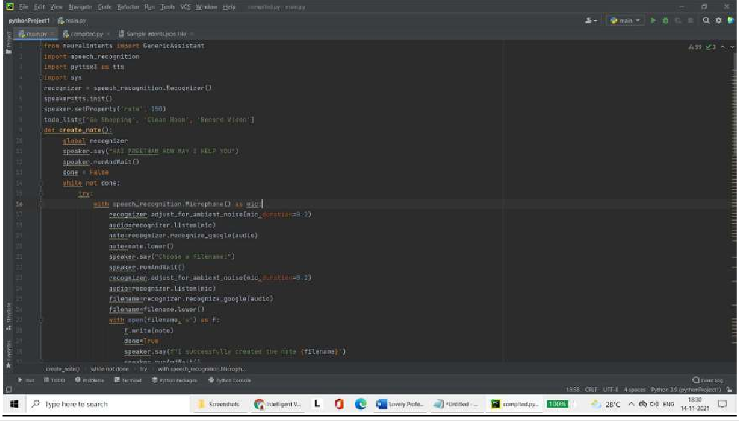

Fig 1: Graph showing relationship b/w tweets -1 and 1

Fig 2: Model Summary

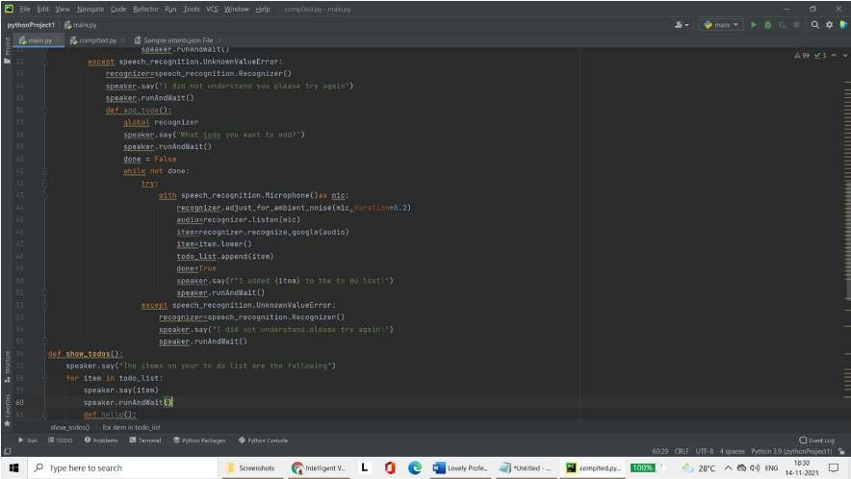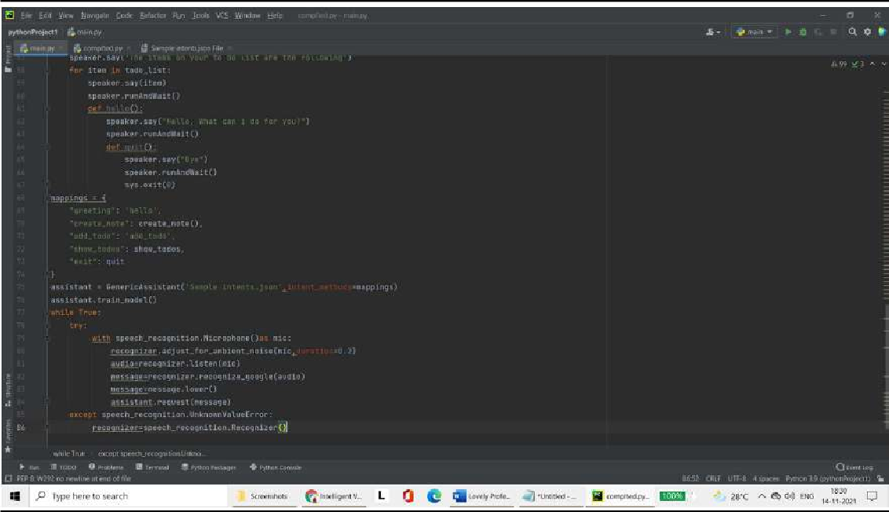

Fig 3: Accuracy of the model is 98.64

IMPLEMENTATION AND RESULT:

For both of these results we use the Naïve Bayes classification algorithm, because that is the algorithm we are employing in our actual classification approach at the first step. Furthermore all the figures reported are the result of 10-fold cross validation. We take an average of each of the 10 values we get from the cross validation.
Classes | True  Positive | False  Positive | Recall | Precision | F-  measure
Objective | 0.73 | 0.26 | 0.74 | 0.73 | 0.73
Subjective | 0.74 | 0.27 | 0.725 | 0.73 | 0.73
Average | 0.73 | 0.27 | 0.73 | 0.73 | 0.73

Table 6: Results from Objective / Subjective Classification
Classes | True  Positive | False  Positive | Recall | Precision | F-  measure
Positive | 0.84 | 0.19 | 0.86 | 0.84 | 0.85
Negative | 0.81 | 0.16 | 0.79 | 0.81 | 0.80

Average | 0.83 | 0.18 | 0.83 | 0.83 | 0.83

Table 7: Results from Polarity Classification (Positive / Negative)
In addition to the above information, we make a condition while reporting the results of polarity classification (which differentiates between positive and nega- tive classes) that only subjective labelled tweets are used to calculate these results.

However, in case of final classification approach, any such condition is removed and basically both objectivity and polarity classifications are applied to all tweets Regardless of whether they are labelled objective or subjective.

If we compare these results to those provided by Wilson et al. [16] (results are displayed in Table 2 and Table 3 of this report) we see that although the accuracy of neutral class falls from 82.1% to 73% if we use our classification instead of theirs. However, for all other classes we report significantly greater results. Although the results presented by Wilson et al. are not from Twitter data they are of phrase level sentiment analysis which is very close in concept to Twitter sentiment analysis.
Next we will compare our results with those presented by Go et al. [2]. The results presented by this paper are as follows:
Features | Naive Bayes | Max Entropy | SVM
Unigram | 81.3% | 80.5% | 82.2%
Bigram | 81.6% | 79.1% | 78.8%
Unigram + Bigram | 82.7% | 83.0% | 81.6%
Unigram + POS | 79.9% | 79.9% | 81.9%

Table 8: Positive / Negative Classification Results presented by (1-9)

If we compare these results to ours, we see that they are more or less similar. However, we arrive at comparable results with just 10 features and about 9,000 training data. In contrast to this, they used about 1.6 million noisy labels. Their labels were noisy in the sense that the tweets that contained positive emoticons were labelled as positive, while those with negative emoticons were labelled negative. The rest of the tweets (which did not contain any emoticon) were discarded from the data set. So in this way they hoped to achieve high results without human labelling but at the cost of us- ing humongous large number amount of data set.

Next we will present our results for the complete classification. We note that the best results are reached through Support Vector Machine being applied at the second stage of the classification process. Hence the results below will only pertain to those of SVM. These results use a total of two features: P(objectivity | tweet) and P(positivity | tweet). But if we include all the features employed in step 1 of the classification process, we have a list of 8 shortlisted features (3 for polarity classification and 5 for objectivity classification). The following results are reported after conducting 10-fold cross valida- tion:
Classes |  |  |  | True  Positive | False  Positive | Recall | Precision | F-measure
Objective | 0.77 | 0.27 | 0.77 | 0.75 | 0.76
Positive | 0.66 | 0.11 | 0.66 | 0.70 | 0.68
Negative | 0.60 | 0.10 | 0.59 | 0.61 | 0.60
Average | 0.70 | 0.19 | 0.703 | 0.703 | 0.703

Table 9: Final Results using SVM at Step 2 and Naive Bayes at Step 1
In comparison with these results, Koulompis et al. [7] reports average F measure of 68%. However when they include another portion of their data into their classification process (which they call the HASH data), their average F-measure drops to 65%. In contrast to this we achieve average F- measure of more than 70% which shows better performance than either of these results. Moreover we make use of only 8 features and 9,000 labelled tweets, while their process involves about 15 features in total and more than 220,000 tweets in their training set. Our unigram word models are also simpler than theirs, because they incorporate negation into their word models. However like in the case of (1-9) their tweets are not labelled by humans, but rather undergo noisy labelling in two ways: labels acquired from positive and negative emoticons and hashtags.
Finally we conclude that our classification approach provides improvement in ac- curacy by using even the simplest features and small amount of data set. However there

are still a number of things we would like to consider as future work which we mention in the next section.

CONCLUSION :

Nowadays, sentiment analysis or opinion mining is a hot topic in machine learning.
In this project, we tried to show the basic way of classifying tweets into positive or negative category using Naïve Bayes as baseline and how language models are related to the Naïve Bayes and can pro- duce better results. We could further improve our classifier by trying to extract more features from the tweets, trying different kinds of features, tuning the parameters of the naïve Bayes classifier, or trying another classifier all together.

- Upon evaluating all the models we can conclude the following details i.e.

- Accuracy: As far as the accuracy of the model is concerned Logistic Regression performs bet- ter than SVM which in turn performs better than Bernoulli Naive Bayes.

- F1-score: The F1 Scores for class 0 and class 1 are :
- For class 0: Bernoulli Naive Bayes(accuracy = 0.90) < SVM (accuracy =0.91) <Logistic Regres- sion (accuracy = 0.92)
- For class 1: Bernoulli Naive Bayes (accuracy = 0.66) < SVM (accuracy = 0.68) < Logistic Re- gression (accuracy = 0.69)

  - AUC Score: All three models have the same ROC-AUC score.

  - We, therefore, conclude that the Logistic Regression is the best model for the above-given da- taset.

REFERENCES :

- David Zimbra, M. Ghiassi and Sean Lee, “Brand-Related Twitter Sentiment Analysis using Feature Engineering and the Dynamic Architecture for Artificial Neural Networks”, IEEE 1530-1605, 2016.

- Varsha Sahayak, Vijaya Shete and Apashabi Pathan, “Sentiment Analysis on Twitter Data”, (IJIRAE) ISSN: 2349-2163, January 2015.

- Peiman Barnaghi, John G. Breslin and Parsa Ghaffari, “Opinion Mining and Sentiment Polarity on Twitter and Correlation between Events and Sentiment”, 2016 IEEE Second International Conference on Big Data Computing
Service and Applications.

- Mondher Bouazizi and Tomoaki Ohtsuki, “Sentiment Analysis: from Binary to Multi-Class Classification”, IEEE ICC 2016 SAC Social Networking, ISBN
978-1- 4799-6664-6.

