EasyWand Camera Calibration User Guide
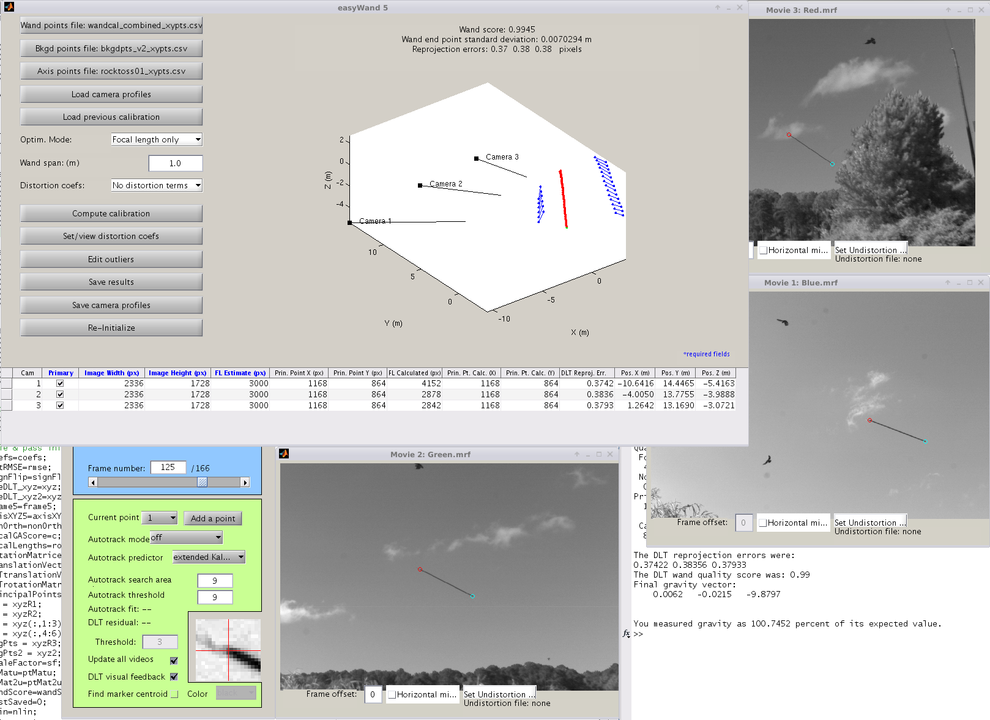
Evan Bluhm & Ty Hedrick

Table of Contents

EasyWand Camera Calibration User Guide 1
Table of Contents 2
Version 1.4 - Last revised July 31, 2017 2
Installation Information 3
Features/Limitations 4
User Interface 5
Main UI Panel (v1.0) 5
Editor Panel 11
Example/Tutorial 13
Usage/Debugging 21
Wand/background point file formats 21
Distortion model 21
Determining focal length estimates for my camera setup 21
Teleconverters and extension tubes 22
Camera order; Primary and secondary cameras 22
What not to do 23
Citing easyWand 24
References 25
Software Sources and License 26

Version 1.4 - Last revised July 31, 2017

Installation Information
A minimal installation of easyWand5 requires only that the easyWand5.m file and associated “private” directory be placed in a directory that is in the MATLAB path and that easySBA.m and its mex components also be in the MATLAB path. These are currently distributed with easyWand5 in the easyWand directory, so adding that location to the path is sufficient. The current distribution zip archive also includes this manual and tutorial data which need not be kept in the MATLAB path. Once these files are in place, run easyWand5.m using the MATLAB command line, and the graphical interface will appear.
EasyWand does not depend on any MATLAB toolboxes for its basic operations and has been tested on Windows 32bit, Windows 64bit, Linux 64bit and MacOS 64bit platforms. It has also been tested on MATLAB versions beginning with r2010b but should also run on versions as old as r2007.
Alignment of the resulting calibration to gravitational acceleration requires the spline or curve fitting toolboxes, if one of these (or the spaps function) is not available then alignment to gravity will not be available as an option.

Features/Limitations
Features:
EasyWand was created for applications in which an arbitrary arrangement of cameras is used to obtain accurate 3D reconstructions of points of interest using a “wand wave” type operation where an object of known length is moved through the camera calibration volume. In particular, easyWand allows for easy calibration of a set of cameras placed in a field setting each time the cameras are set up. Auto-calibration, i.e. calibration from the video files alone without a known 3D object, but the assumption of a set of accurately-digitized points allows for a fast and accurate calibration routine that can work with a wide variety of source videos and scenes.
The calibration routines allow for lens distortion correction, following the lens distortion model used in Bouguet's camera calibration toolbox [Bouget Calibration Toolbox]. Given sufficiently many calibration points, both radial and tangential lens distortion can be corrected in the calibration, allowing for highly-accurate reconstructions. Non-linear distortion coefficients can also be entered prior to calibration if they are already known.
The calibration is returned as both DLT coefficients (see [Kwon3D]) and as camera extrinsic information (position, orientation, focal lengths). The calibration can also be fixed to an origin and axis given as digitized points from 2 or more cameras. DLT coefficients are computed via the method suggested in [Hatze (1988)] for constructing an orthogonal transformation matrix, so the orientation angles and resulting calibration axes can be exported to a visualization program (such as Maya) for an accurate reconstruction.
EasyWand uses the open source sparse bundle adjustment routines “sba” described in [Lourakis and Argyros (2009)] as the internal calibration engine, these optimized C/C++ routines allow for rapid and accurate camera calibration with many thousands of data points and tens of cameras on modern desktop computing hardware.
EasyWand also uses the “efficient PnP” routine described in [Lepetit, V., Moreno-Noguer, F., & Fua, P. (2009)] when performing a second-pass bundle adjustment calibration.

Limitations:
EasyWand requires manual digitization of wand points. Generally, only ~30 digitized points visible in all cameras are required for an initial calibration, though the number required varies depending on the camera alignment and how many parameters (e.g. focal length) are already known. With the initial calibration in hand, more sophisticated methods of obtaining digitized points may be used to automatically generate a much larger sample for a more accurate calibration, even points digitized from the animals themselves may be fed back into the calibration routine as background points.
Cameras with non-zero skew and non-square pixels are not supported! The calibration routine used explicitly assumes that the pixel axes are orthogonal (no skew angle) and that the vertical and horizontal focal lengths are equal (square pixels).

User Interface

Main UI Panel (v1.0)
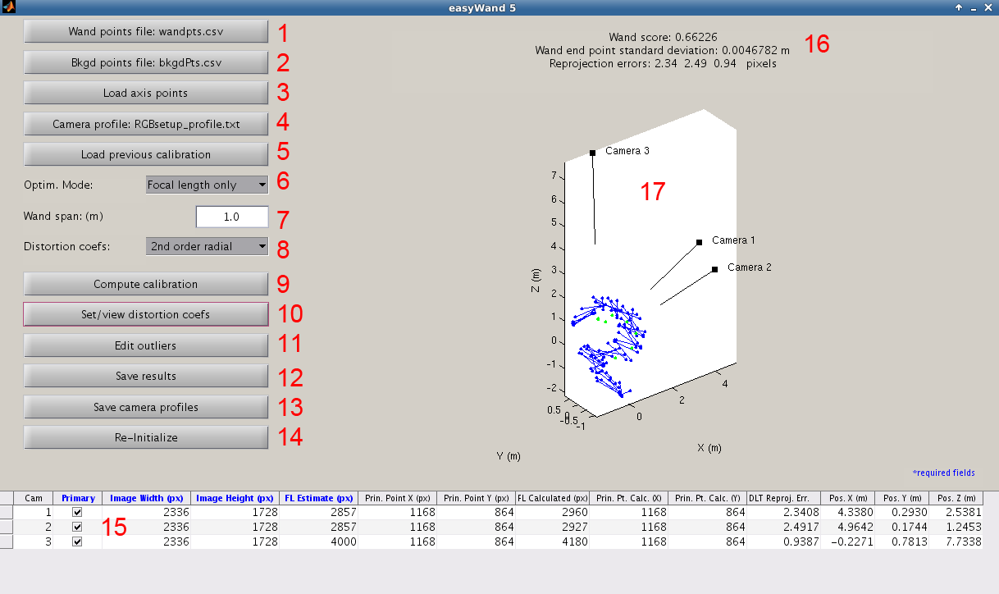

This is the main EasyWand UI panel. Each control in the interface is explained below:
- Load wand points button: Pushbutton to load in a set of digitized wand points, such as those output by DLTdv5 (see other Hedrick lab downloads at http://www.unc.edu/~thedrick/software1.html). See the function descriptions for the exact format of the digitized wand points file. Unless loading a previous easyWand calibration, this is the first step in the calibration process. Pressing the button brings up a file navigation UI for navigating to the appropriate wand points file (saved as a .csv). Canceling the navigation will return you to the UI panel. Upon successful loading of a file, the number of detected wand points will be displayed, and the pushbutton will display the file name.
Wand points themselves are a set of digitized points with 2 points marked per camera where each of the two points is one end of an object of known length. This object is commonly a wand or other length moved through the calibration volume, but may also be a set of consistent lengths on a calibration frame or other structure. In either case, the wand points array should be of N columns and M rows where N=(# of cameras)*4 and M is the number of separate views of the wand length. Ideally, the wand should be well distributed through the scene -if this is not possible, unpaired points - “background points” may be used to expand the volume.
- Load background points button: Pushbutton to load a set of digitized background points. Background points can include any number of shared points among camera views, both stationary and non-stationary. They are very helpful for adding depth of field to the calibration, as the wand points are often very localized. Background points are also important when computing nonlinear lens distortion, since such computations require a very large number of points that span the entire camera view. Lens distortion is explained further in (8). Pressing the load background points button brings up a file navigation UI located in whichever directory easyWand last loaded a file from. Upon successful loading of a file, the number of detected background points will be displayed, and the pushbutton will display the background points filename. Background points have a slightly different file format than wand points, since they are not associated by pairs; the file format is two columns for each camera and each new background point on a new row.
IMPORTANT DLTdv5 NOTE: When digitizing background points using DLTdv5, make sure to digitize each background point in a separate video frame to ensure that the inputs to easyWand are appropriately sized.
- Load axis points button: Pushbutton to load a set of digitized axis points. This is necessary if you wish for the calibration to be aligned to a particular set of axes. Otherwise, the bundle adjustment routines will impart a random orientation to the calibration, so that the calibration will be euclidean, scaled to the wand length, and centered on the wand points, but not aligned to any particular set of axes. If an axis is specified, the resulting DLT coefficients will contain the proper rotation and translation.
There are three options for specifying an axis: a plumb-line axis, a 4-point axis or gravitational acceleration. When specifying a plumb-line axis, two axis points should be digitized such that the first point dictates the origin, and the second point will be on the +Z axis. When specifying a 4-point axis, four points should be digitized such that points 1-4 correspond to the origin, the +X axis, the +Y axis, and the +Z axis, respectively. If a 4-point axis is specified, easyWand will query the user whether to optimize the axis origin by calculating an expected origin from the X, Y, and Z axes.
A gravitational axis is specified by loading a sequence of >4 digitized points representing the trajectory of an object falling under the influence of gravity. During calibration, easyWand will extract a characteristic 2nd derivative of position with respect to time and use that as the Z axis for the scene. The Z axis can be arrayed so that it either points parallel to gravity (+Z down) or antiparallel to gravity (+Z up). After loading an gravitational axis file you'll also be asked for the recording frequency and desired axis direction. While easyWand will attempt to compute a gravitational alignment for any set of axis points >4 in number, at least 20 points are desirable for a good quality alignment.
- Load camera profiles button: Pushbutton to load saved camera profiles from file. EasyWand requires information about each of the cameras in order to perform the calibration, and it is often desirable to load predetermined information about a set of cameras from file than to enter the information by hand for each calibration. EasyWand saves camera profiles in .txt files with the following format (headers excluded):
(Camera number) (Focal length) (Image width) (Image height) (Prin. point X) (Prin. Point Y) (Primary?)
1 2857 2336 1728 1168 864 1
2 2857 2336 1728 1168 864 1
3 4000 2336 1728 1168 864 0
Focal lengths, image width, image height, principal point x coordinate, and principal point y coordinate are all expressed in pixels. The primary/secondary logical tells easyWand whether to include the camera in the bundle adjustment calibration. Performing the calibration with one of the cameras as secondary (without image points from one of the cameras) can reveal sync errors or camera movement between calibration trials, but in general it is best to first run the calibration with all cameras set to primary. Users are free to write their own profile files using the above format, or use the save profiles button in the main UI (12) to save data entered into the main camera information table (14) to a file.
When the load camera profiles button is pressed, easyWand brings up a file navigation UI in whichever directory easyWand last loaded a file from. If loading of camera profiles was successful, an appropriate message is displayed and the corresponding entries in the main camera information table (14) will be filled.
- Load previous calibration button: Pushbutton to load a previous calibration for re-inspection. User must have previously saved calibration data using the save calibration button (11) or by manually exporting the UserData field from the main control panel object to a file. Calibration data is generally saved with the format “*_easyWandData.mat”. Upon successfully loading a previous calibration, the 3D visualization (16) and the main camera information table (14) will be updated accordingly.
- Calibration mode menu: A dropdown menu that determines the number of camera intrinsic parameters to optimize. There are three available calibration modes
  - Focal lengths only: Assumes principal point is exactly the center of the image (or if the user has specified an estimate of the principal points, these are kept fixed), and performs optimization of the focal lengths of all cameras. It is important to have good initial estimates of the actual focal lengths (see Usage/Debugging section for more information on where to get appropriate estimates) or to have a large number of points, or the optimization routine will not converge on a good calibration.
  - Focal lengths and principal points: Performs optimization of the focal lengths and principal points of all cameras. In general, this is not necessary, since the principal point for most cameras is very near the image center. However, it might be possible to improve a good calibration by adding these additional parameters to the optimization.
  - No camera intrinsics: Focal lengths and principal points are fixed to their initial estimates as shown in the main camera information table (14). If no principal point estimates were given, principal points are estimated at the image center. In this case, only the positions and orientations of the cameras are optimized.
- Wand span: Editable text-box showing the length of the calibration wand (in meters). This is necessary to provide a length scale to the calibration and ensure that all distances are returned in meters once the calibration is complete.
- Distortion mode menu: Dropdown menu for specifying the number of nonlinear lens distortion coefficients to optimize for during calibration. The lens distortion model is that of Bouguet's camera calibration toolbox, [Bouguet Calibration Toolbox], in which the lens distortion is characterized by five distortion coefficients. Three coefficients correspond with radial distortion (fisheye), and the other two correspond with de-centering distortion. This is usually not necessary for high-quality cameras, and can make the calibration worse if there is very little lens distortion to begin with. However, many smaller, cheaper cameras do exhibit some degree of lens distortion, and optimizing for one or two of the radial lens distortion coefficients can often improve a calibration substantially.
If distortion coefficients are computed, they will be printed to the screen during calibration. Additionally, when saving the calibration (11), easyWand will generate MATLAB Tforms containing the undistortion data for use with DLTdv5 (see other Hedrick lab downloads). See the MATLAB documentation for maketform for more information on the spatial transformation structures that are generated. These can be used to check the validity of lens distortion estimates from easyWand by digitizing points in DLTdv5, checking the reprojection error, then loading the undistortion Tforms and checking whether the reprojection errors improve. For more information on the use of DLTdv5, see the accompanying documentation.
- Compute calibration button: Pushbutton that initiates the main calibration routine. The required data and parameters to perform a calibration are:
  - While >=8 distinct wand points do contain enough information for a calibration, but ~30 wand points is a more realistic lower bound on the minimum number of wand points for a good calibration for 3 cameras.
  - Focal length estimates
  - Image width and image height
All other inputs (principal point estimates, background points, axis points) are optional, but background points are highly recommended for a good calibration. The entire calibration process should only take a few seconds. If the user has specified a 4-point axis, then easyWand will ask whether to optimize the axis origin by estimating a 3D origin position using the X, Y, and Z axes, and comparing this to the projected 3D position of the user-specified origin point. When the calibration is complete, the relevant camera extrinsic and intrinsic information will be updated in the main camera information table (14). Additional information about the calibration is written to the MATLAB command prompt.
- Set/view distortion coefficients: Pushbutton that brings up a separate editing window for manually setting the distortion coefficients or viewing the results estimated from the scene data during the calibration process.
- Edit outliers button: Pushbutton that initiates the data editing pane, in which the user can select poorly-digitized or problematic points for removal from the calibration. More information on the editor window is found in the next section.
- Save results button: Pushbutton to save calibration results. When clicked, the user will be prompted for a file name and location for the saved results. The calibration data are saved to two files: [file name]_dltCoefs.csv and [file name]_easyWandData.mat. The .csv file contains only the computed DLT coefficients, which themselves contain the relative camera orientations and positions, focal lengths, and principal points. This is used as the calibration input to DLTdv5. The .mat file contains all of the calibration information easyWand has generated, and can be loaded by easyWand to continue working on a previous calibration. If distortion coefficients were estimated during the calibration, then an additional file named [filename]_cam#Tforms.mat will be generated for each camera. These contain the nonlinear undistortion transformation corresponding with the computed distortion coefficients, and have the correct form for use in DLTdv5 to correct for lens distortion.
- Save camera profiles button: Pushbutton to save the camera intrinsic information entered into the main camera information table. EasyWand saves camera information to a .txt file in the following format (excluding headers):
(Camera number) (Focal length) (Image width) (Image height) (Prin. point X) (Prin. Point Y) (Primary?)
1 2857 2336 1728 1168 864 1
2 2857 2336 1728 1168 864 1
3 4000 2336 1728 1168 864 0
Focal lengths, image width, image height, and principal point coordinates are measured in pixels. Any necessary data that has not been filled by the user or by loading a previous calibration will be denoted as NaN (not a number). Saving the camera information to a profile is useful when many calibrations will be gathered with a fixed set of cameras. Keep in mind that when switching lenses or zooming, the focal lengths can be altered significantly.
- Re-initialize button: Pushbutton to reset all information in the easyWand control panel. In general, it is best to re-initialize the panel when moving on to a new calibration to ensure that unwanted information does not carry over to the next calibration. If the calibration data has not recently been saved to file, easyWand will prompt the user to save before resetting the calibration data.
- Main camera information table: Contains the important camera intrinsic and extrinsic information. The columns with blue, boldface headers must be filled out by the user or by loading a profile using button (12). Brief descriptions of the table columns and their significance:
  - Camera: Shows the number of each camera, determined by their order of loading into DLTdv5. These labels are used throughout the calibration.
  - Primary/Secondary (required): Cameras with a checked 'primary' box will be considered in the calibration. Unchecking a box will denote a camera as 'secondary.' Secondary cameras will not contribute any information to the bundle adjustment computation of the 3D positions of the digitized wand/background points. The positions and orientations of the secondary cameras will be estimated using the calibration obtained using the primary cameras, but these should be examined with care. Cameras with a suspected sync error or other problem should be removed from the calibration by making them secondary. If the calibration is improved once a camera is removed, then the suspect camera should be checked for sync errors or movement using DLTdv5.
  - Image width (required): The horizontal resolution of images taken by each camera. Values should be entered in pixels.
  - Image height (required): The vertical resolution of images taken by each camera. Values should be entered in pixels.
  - Focal length estimate (required): The user's best estimation of the focal length of each camera. In general, this is the focal length of the lens (usually measured in mm or cm) divided by the sensor array pixel size (usually measured in micrometers per pixel). For more information on determining the focal lengths to use in your calibration, see the related Usage/Debugging section.
  - Principal point X coordinate: The horizontal coordinate of the principal point (measured from the left side of the image), in pixels. For most cameras, this will simply be the center of the image (half the horizontal resolution). If no value is entered by the user, then easyWand assumes the principal point to be the center of the image. Note that in unusual situations the principal point location could be off the sensor, i.e. have a negative value or a value greater than the image width.
  - Principal point Y coordinate: The vertical coordinate of the principal point (measured from the bottom of the image), in pixels. For most cameras, this will simply be the center of the image (half the vertical resolution). If no value is entered by the user, then easyWand assumes the principal point to be the center of the image.
  - Calculated focal length: After the calibration has completed, the optimized focal lengths will be shown here. If optimization has been performed only on the camera extrinsics, then the user-specified estimates of the focal lengths will appear here.
  - Calculated principal point X coordinate: The horizontal coordinate of the principal point after optimization. If principal point optimization was not selected, the the original principal point estimate is shown here.
  - Calculated principal point Y coordinate: The vertical coordinate of the principal point after optimization. If principal point optimization was not selected, the original principal point estimate is shown here.
  - DLT reprojection error: After the calibration has completed, the root-mean-square reprojection error for each camera will be shown here. This is the value that the optimization process tries to minimize for all cameras, and is one of two key figures that determine the quality of a calibration. It is computed as the square root of the average pixel distance squared between digitized and re-projected points in each camera. A low DLT reprojection error indicates that the calibration is very self-consistent, and can probably be trusted.
12-14. Camera position : The estimated position of each camera. If the user has entered the wand length, then camera positions are given in the same units as the wand length. If no axis points were specified, then the camera positions are relative to the center of the cloud of digitized points, and the orientation of the axes is arbitrary. If axis points were specified by the user (3), then camera positions are given relative to that axis.
- Wand score label: After the calibration is complete, the wand quality score is computed and shown above, along with several other metrics of scene quality. The wand quality score is the standard deviation of the computed wand lengths, scaled to the mean computed wand length. A wand quality score of 1 indicates that the standard deviation of the wand lengths computed from the 3D positions of the wand points is 1% of the total wand length. In general, a wand score of 1 or less indicates a good calibration, but different applications may require more/less reconstruction accuracy. The wand end point standard deviation is the estimated uncertainty in the X,Y and Z directions for a wand tip, this may provide a better measure of scene quality if the wand length is small relative to the size of the tip markers. The pixel reprojection error from the least well calibrated camera is also displayed here; adequate pixel reprojection error varies depending on the camera application and should be compared to the expected pixel size of the animals or markers to be recorded.
- Scene visualization: After the calibration is complete, the 3D reconstruction of the scene will be shown in these axes. Wand points are plotted as blue circles connected by a blue line. Background points are plotted as green circles. Primary cameras are plotted in black, with a line extending along the camera axis. Secondary cameras are plotted in red. If axis points were given, then the axis is also plotted in red. The visualization may be rotated using the mouse.
- 2ndary camera mode: Cameras that are not marked as Primary in the Main camera information table (# 15) are calibrated in a second pass, either using direct linear transformation only or bundle adjustment. Because easyWand needs to estimate the relative position and orientation of all cameras with respect to a base camera before performing the first calibration pass, cameras that do not share much information with the base (i.e. last) camera often do not get a well-estimated initial position or orientation and therefore lead to a poor calibration output. Designating these cameras as “secondary” allows estimation of their initial parameters from the results of the first pass, using either DLT only (the only option for easyWand versions < 5.4) or bundle adjustment. Bundle adjustment produces a more accurate calibration.

Editor Panel
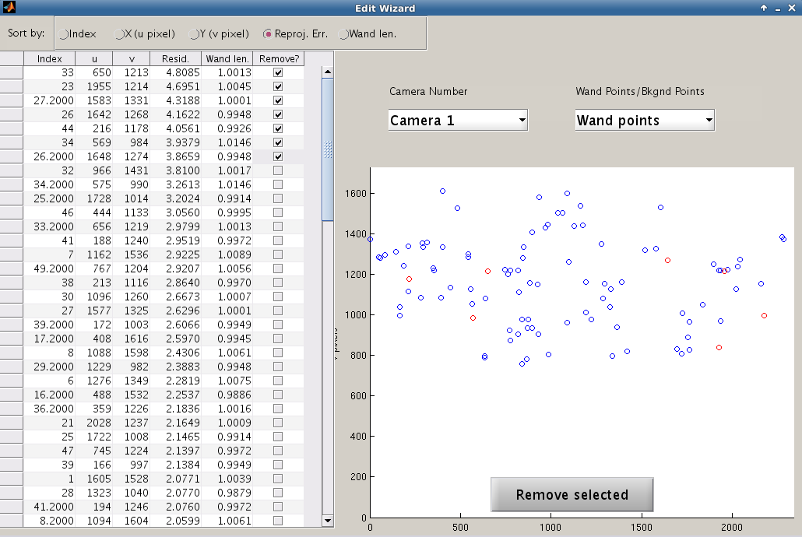
When the “Edit Outliers” button in the main control panel is pressed, the editor panel is summoned. The calibration must have been completed prior to editing outliers, so the “Edit Outliers” button is grayed-out and disabled until a calibration has been completed. The elements of the editor panel are described below:
- Sorting buttons: The editor table may be sorted by Index, X, Y, reprojection error, or wand length. The sorting buttons are implemented as radio buttons in order to avoid direct manipulation of the editor table's underlying java objects. If background points have been selected instead of wand points, then the final sorting possibility is distance from the cameras, since wand length is not a valid measurement for background points.
- Editor table: The editor table shows detailed calibration information for each digitized point. For a given camera, the following quantities are displayed:
  - Index: the row index of the point in the original data file, typically the video frame in which each point was digitized in DLTdv5. NaN rows are included (video frames for which no points were digitized), so the Index numbers may be much larger than the total number of wand points. The second wand point in each pair has an index of Index.2.
  - Pixel u: The horizontal pixel coordinate of the digitized point. For wand points, this is the location of wand point 1. The location of wand point 2 is not shown, but both points are plotted in the figure.
  - Pixel v: The vertical pixel coordinate of the digitized point. For wand points, this the location of wand point 1. The location of wand point 2 is not shown, but both points are plotted in the figure.
  - Reprojection error: This is the reprojection error, given the current calibration. It is given by the distance between the digitized point and the reprojected position of the point in the image. For wand points, this is the average of the reprojection errors of both wand points. Points with high reprojection errors are not consistent with the current calibration and the other digitized points, and may need to be removed.
  - Wand length / Distance from cameras: If wand points have been selected, this column gives the computed wand length in each video frame. Frames in which the wand length deviates significantly from the expected wand length should be checked for digitization errors. If background points are selected, the wand length computation is not possible, so the computed distance from each point to the last camera is shown instead. This is useful for examining points far from the calibration space.
  - Points marked for removal: Rows with checked boxes will be removed from the calibration. The wand points files will not be modified, but easyWand remembers which points have been marked for removal, and will save your selections along with the other calibration data (using the uda.rmpts and uda.bkrmpts variables). Points may be marked for removal either by checking the boxes in this column, or by clicking on points in the figure window.
- Camera number menu: Dropdown menu for selecting a camera to examine. The editor can only display one camera at a time, but the wand lengths / distance are calculated from the 3D reconstructions of the wand and background points, and as such are the same across all cameras.
- Wand points / Background points menu: Dropdown menu for selecting whether to view wand points or background points. If wand points are selected, the table displays wand lengths, and points are selected in pairs. If background points are selected, the table displays estimated distances to the last camera, and points may be selected individually.
- Camera view: All digitized image points for the selected camera are shown as they are seen by the camera. Blue points are to be included in the calibration; red points are to be removed. Points can be easily removed by clicking on them.
- Re-calibration button: After removing the desired outliers from the calibration, this button sends the outlier information back to easyWand, and the calibration is re-computed accordingly. If the editor window is closed by any other method, any changes made will not be saved. If points that were previously removed are unchecked in the editor window, this button also re-adds them to the calibration.

Notes:
- You need to click the “Remove selected” button to complete the process of identifying and marking points for removal. If you simply close the editor window then no removal operations will take place.
- The list of points marked for removal is available in the MATLAB data file created by easyWand during the “Save” process, the field names are rmpts and bkrmpts for the wand and background points, respectively.

Example/Tutorial

There is an example data set included with the installation files, under the directory 'tutorial.' First, start up MATLAB and navigate to the installation directory or add the installation directory to the path. Start easyWand by typing easyWand5 and pressing Enter. A new instance of easyWand should appear as shown below. Depending on your system, the fonts and control sizes may be slightly different from those shown below.

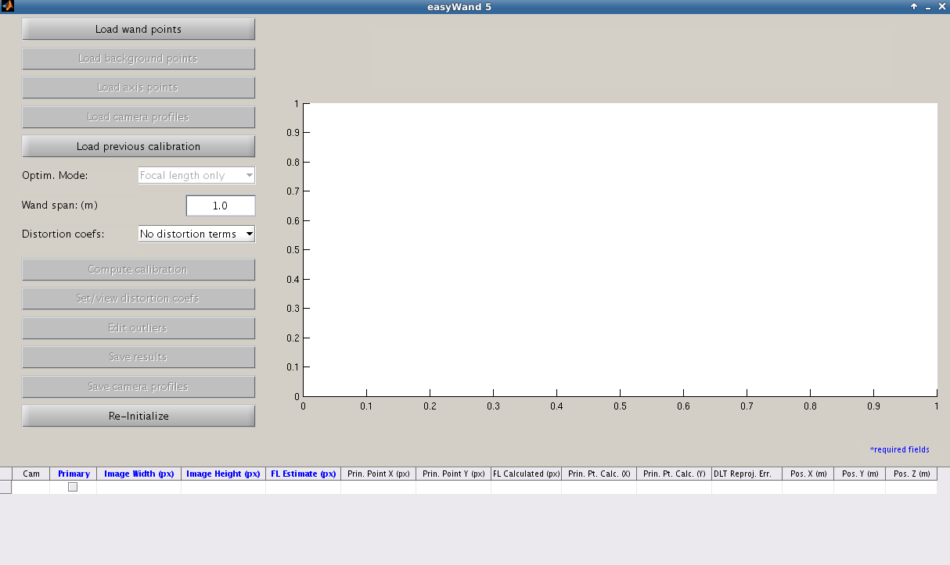
At the top of the control panel, click the “Load wand points” button to begin the calibration. Using the file navigation window, navigate to the tutorial files in the 'tutorial' directory. Select the 'wandpts.csv' file and click 'Open' or hit Enter to load the wand points.
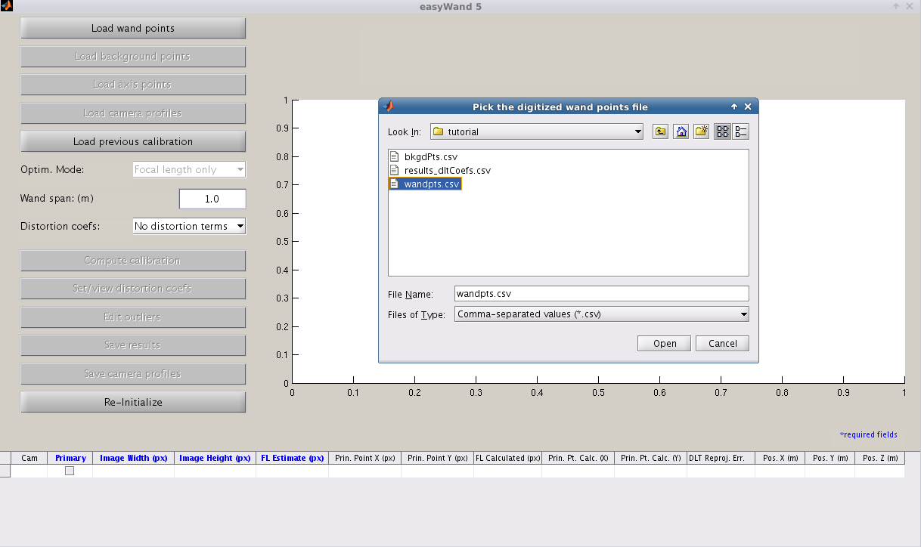
Just below the “Load wand points” button, click the now available “Load background points” button to load in the background points. As with the wand points, use the file navigation window to select the 'bkgdPts.csv' file and click 'Open' or press Enter. We won't use any axis points in this calibration, so skip the “Load axis points” button.
Since we don't have a profile file created for this camera setup yet, we will need to manually enter estimates of the camera intrinsic information into the data table. The cameras were all taking video in 2336x1728 resolution. The focal length estimate for cameras 1 and 2 was 2857 pixels, and the focal length of camera 3 was estimated to be 4000 pixels. Type the camera information into the camera table, as shown below
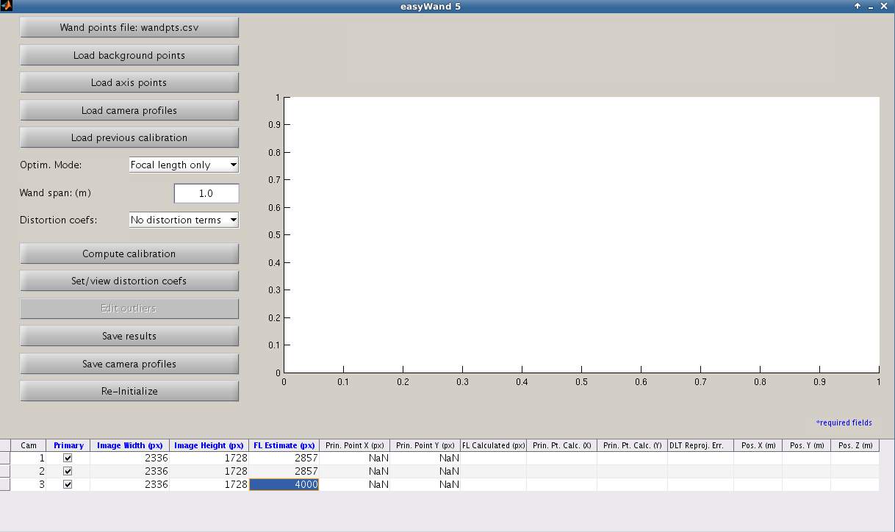
Since we don't have any reason to believe that the principal points for these cameras are off-center, we leave the principal points blank. They are assumed to be 1168 and 864 (the center of the image). We now have all the required information for a calibration.
Below the first set of buttons, we see that the optimizer is set to search for focal lengths and camera extrinsics, with no optimization of the principal points. This is fine, so we'll leave it where it is for now. Below the optimization mode menu, we can enter the wand length. Since the wand used in this calibration was actually a meter stick, we can leave the default wand length of 1 meter. We don't expect significant lens distortion in these cameras, so we leave the distortion mode menu set to leave distortion coefficients out of the optimization process. Finally, we can run the calibration by hitting the “Compute Calibration” button.
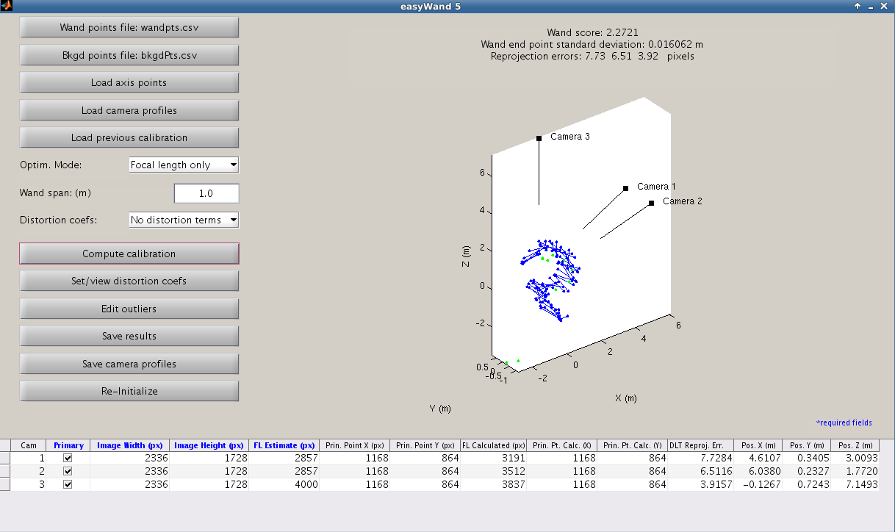
After calibration completes, the results are tabulated at the bottom of the screen, showing the optimized focal lengths, principal points, and positions of the cameras, as well as the DLT reprojection errors for each camera. At the top of the screen, the wand score and other quality measures have also been updated to reflect the quality of the current calibration. Given the camera setup, we would like to further improve the calibration score and DLT reprojection errors. We can do this by checking for poorly-digitized points using the editor window, especially if some possible erroneous points are noted in the MATLAB command window. Under the “Compute Calibration” button, open the editor window with the “Edit outliers” button.

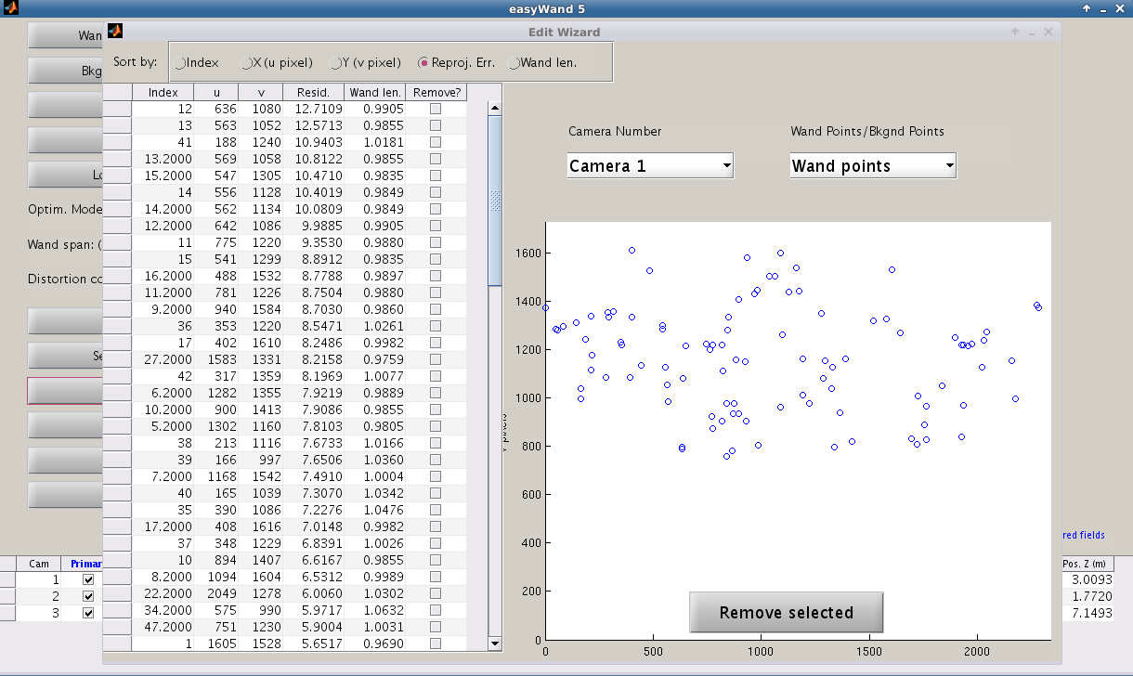
The editor window opens by default to Camera 1's viewpoint, showing the wand points in order of reprojection errors. Since none of the wand points have exceptionally high reprojection errors approximately an order of magnitude greater than the median error, we probably won't substantially improve the calibration much by removing any of them.
Next, we check the background points. At the top-right of the window, switch from viewing “Wand points” to “Background points.”

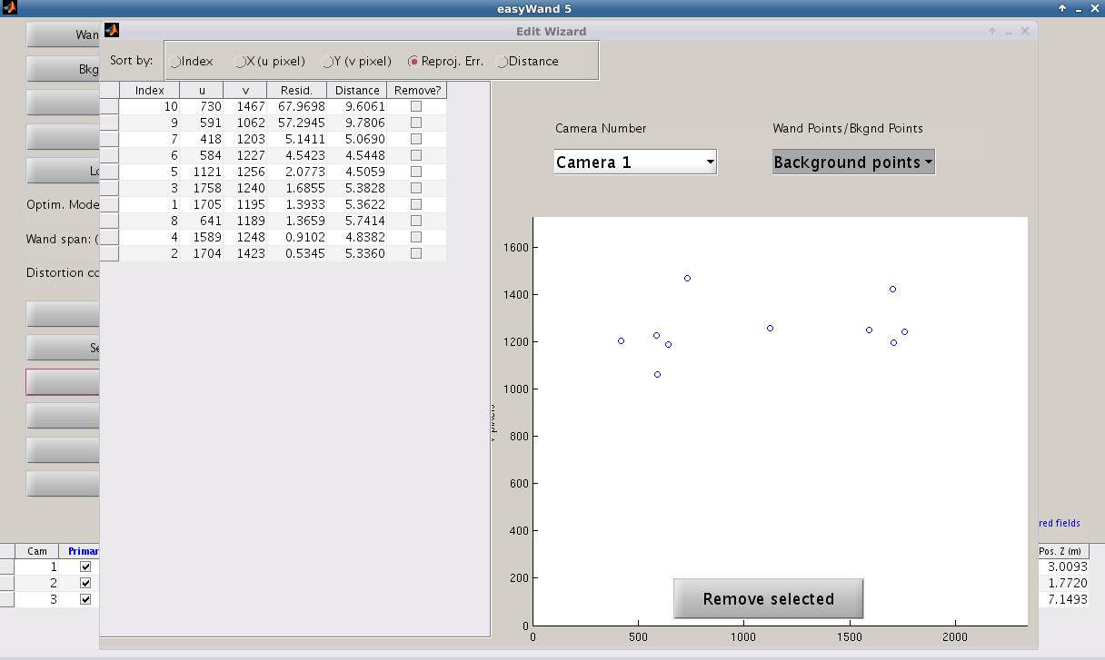
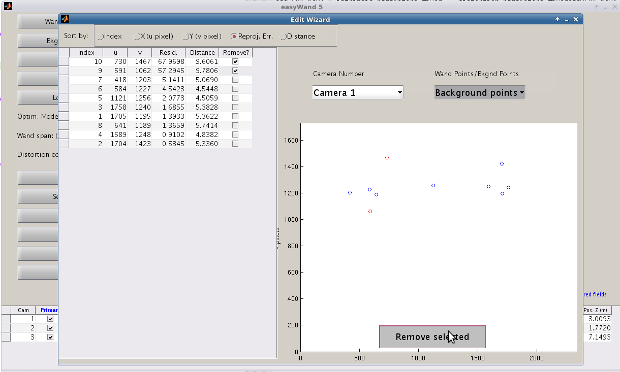
We can see that points 9 and 10 have very high reprojection errors in all cameras, indicating that they are not consistent and were probably poorly digitized. We verify this with our digitizing software, and decide to remove them from the calibration to make things easier. Check “Remove?” next to points 9 and 10 (the first two points listed in the table), and press “Remove selected” to remove them from the calibration.

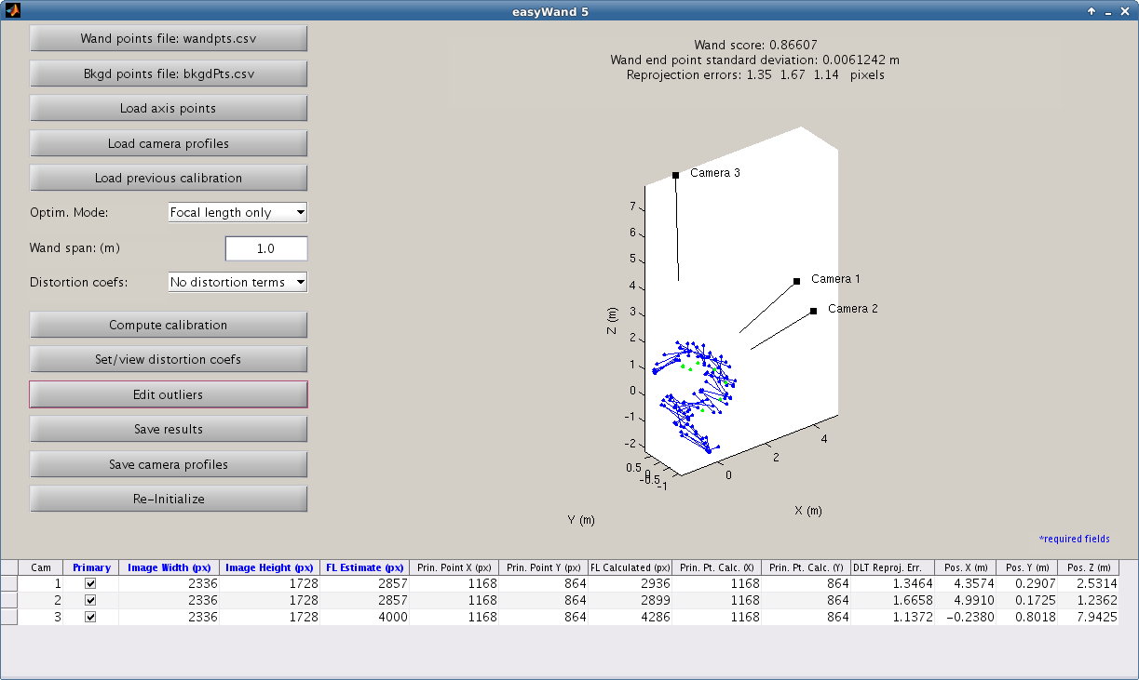
We can see that the two points that were located around [-2, 0, 3] are now gone, and the wand score and DLT reprojection errors have improved dramatically. The wand score of 0.87 and reprojection errors of around 1.5 pixels are more than accurate enough for our purposes, so we'll save the calibration results to file for use with further digitization or visualization. Beneath the “Edit outliers” button, click the “Save results” button to save the calibration to file. Give the calibration a name (no file extension is necessary) and click “Save” to save the calibration. This will create two files, one is a comma-separated text file with the direct linear transformation coefficients, the other is a MATLAB data file with all the information and results used in the calibration, this file could be re-loaded into the easyWand5 interface using the “Load previous calibration” button.
To make our lives easier in the future, we'll save the camera information to a profile file. Under the “Save Results” button, click the “Save camera profiles” button. Choose a file name (no file extension necessary) and press “Save” to store the camera information.
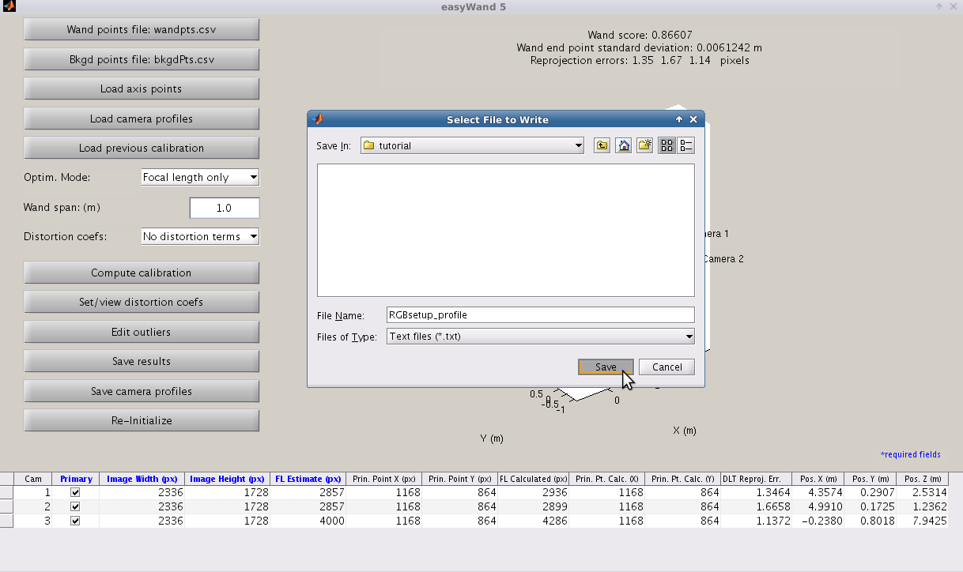
To begin a new calibration, hit “Re-initialize” and start from the top. We could also choose a different set of wand points by re-clicking the “Load wand points” button, which now shows the file name of the currently loaded wand points.

Usage/Debugging

Wand/background point file formats
Wand and background points are stored as comma separated value (.csv) files. The easiest way of ensuring properly-formatted input files is to use the digitizing tools found here. The output files from DLTdv5 have the appropriate formatting.
If you wish to use your own digitizing tools, then the appropriate convention for each row of the wand point files is:
cam1/pt1x, cam1/pt1y, cam2/pt1x, cam2/pt1y, cam1/pt2x, cam1/pt2y, cam2/pt2x, cam2/pt2y
NaN,NaN,NaN,NaN,NaN,NaN,NaN,NaN,NaN,NaN,NaN,NaN
338.6,687.3,322.0,619.7,702.9,529.7,311.4,539.5,403.2,513.4,669.2,368.9
355.7,680.7,333.4,631.4,681.4,533.1,327.0,531.8,413.4,525.3,647.5,369.9
NaN,NaN,NaN,NaN,NaN,NaN,NaN,NaN,NaN,NaN,NaN,NaN
394.0,663.6,357.9,654.4,630.4,533.7,367.5,512.3,434.9,551.4,593.0,372.5
NaN,NaN,NaN,NaN,NaN,NaN,NaN,NaN,NaN,NaN,NaN,NaN
…......

The text column header is optional, and may be included for clarity or left off. The file contains four columns for each camera – two coordinates for each wand point. The coordinates of the first wand point comprise the first half of the columns, ordered by cameras. Any missing data is labeled by NaN, and will be ignored by the calibration. NaN rows appear when the wand is not digitized in a certain video frame for whatever reason. Points which have been digitized in at least two of the cameras will be included in the calibration.

Background points and axis points files have the same format, but only have half as many columns since background points are not paired to each other. When specifying an axis, the first row is always the origin. For a 2-point axis, the second point will lie on the +Z axis. For a 4-point axis, the second-fourth rows will correspond with the +X, +Y, and +Z axis, respectively.

Distortion model
The distortion model used within easyWand is the same as the one used by [Bouguet Calibration Toolbox]. Let [u,v] be the normalized observed pixel coordinates of a point, containing lens distortion. Let kc be the distortion coefficient vector so that
kc = [kc1, kc2, kc3, kc4, kc5]
are the distortion coefficients. The undistortion transformation applied to [u,v] to obtain undistorted points [u',v'] is
u' = (1+kc1*r² + kc2*r⁴ + kc5*r⁶)u + 2*kc3*u*v + kc4*(r² + 2u²)
v' = (1 + kc1*r² + kc2*r⁴ + kc5*r⁶)v + kc3*(r² + 2v²) + 2*kc4*u*v
so that the distortion vector kc contains both radial (k1, k2, k5) and tangential (k3, k4) components.

Determining focal length estimates for my camera setup
The optimization process used by easyWand is relatively sensitive to the initial focal length estimates. In general, it can determine optimized focal lengths if the initial estimates are within 10% of the actual values. However, poor initial estimates will cause the optimization process to fail, resulting in an unusable calibration. In general, you will need to know the focal length of the lens (for instance, a 28mm Nikon lens) and the pixel size of the camera sensor (for instance, the Phantom v711 has a listed pixel size of 20 micrometers). The focal length in pixels is given by the focal length measured in meters divided by the sensor array pixel size. The focal length entered in easyWand for such a camera would then be
(28 x 10^-3 m) / (20 x 10^-6 m/pixel) = 1400 pixels
The focal length of the lens should be listed on the lens itself. In general, it will be necessary to check with the accompanying camera documentation to find the pixel size of the image sensor array. If the accompanying documentation is lost or insufficient, camera manufacturers generally list the technical specifications of their products on their website. For some cameras, the sensor area is given, but not the pixel size. In such cases, dividing the sensor area by the image resolution should give you the pixel size.

Teleconverters and extension tubes
Teleconverters and extension tubes both have an effect on the focal length. Teleconverters have a multiplicative effect on the focal length: using a 1.4x teleconverter with a 50mm lens will result in an effective focal length of (50mm)(1.4)=70mm. Extension tubes have an additive effect on the focal length. For instance, using the 8mm Nikon PK-11a with a 50mm lens will result in a 58mm focal length.
In cases where the necessary information for computing a focal length estimate is unavailable, you may try performing the calibration with a very crude estimate (~1000 pixels for wide-angle shots, ~10000 for high-zoom lenses) and set easyWand to optimize for the focal lengths (6). In some cases, this will be sufficient for the optimization process to find a good set of focal lengths, which you may take as the actual focal lengths of the cameras for future calibrations. However, the optimization will usually fail if the initial focal length estimates are not within 10-20% of their actual values. If the resulting calibration has a bad wand score (say greater than 3), you should not trust the focal length estimates without further examination. One way of verifying the focal lengths estimated by easyWand is to measure the physical distances between the cameras, and compare these distances to the estimated camera positions shown in the camera information table.
Even if this fails and you have no way of looking up estimates for your cameras, do not give up hope! At this point, the motivated user may download Bouguet's camera calibration toolbox for MATLAB [Bouguet Calibration Toolbox]. This is a general-use toolbox for accurately calculating camera intrinsic information (focal length, principal point, and lens distortion). A tutorial on the use of Bouguet's toolbox is provided with the toolbox download. This is a good option for users of small flip-cameras or webcams that may impart a large degree of lens distortion, as the checkerboard calibrations required by this toolbox provide an enormous number of calibration points, resulting in much more accurate lens distortion estimation than a wand-wave calibration. The distortion coefficients estimated by easyWand are directly comparable to those estimated by Bouguet's toolbox.

Camera order; Primary and secondary cameras
EasyWand needs to estimate the relative position and orientation of the cameras relative to the last camera in the list before performing a bundle adjustment calibration. If this calculation fails or performs poorly, calibration will not succeed. Thus, cameras that have less shared information with or are poorly positioned (i.e. has a viewpoint nearly 180 degrees with respect to) the last camera should be designated as secondary by un-checking their “primary” box in the camera table. These cameras will then be calibrated in a second pass once the initial calibration has concluded. Second pass calibration can either be via sparse bundle adjustment or direct linear transformation; bundle adjustment produces a better calibration but requires more clicked points to succeed. If the last camera is designated as secondary then the next-to-last camera is used as the base for the calibration.

What not to do
It is generally desirable to use wand points from as many locations in the calibration volume as possible; at least two wand point sets at different distances from the cameras are strongly recommended. Using wand points that are all approximately the same distance from the cameras can lead to a “better” wand score, but this occurs because the algorithm has little information available to it to estimate the score. If your wand points all come from a single location or cover little of the calibration volume, you should strongly consider including some of your animal points in the calibration set (and not using them elsewhere in the analysis) to provide greater volume coverage.

If all the wand and other calibration points lie in a single plane the data are degenerate and a calibration cannot be calculated. If the data are not exactly degenerate but have little variation in one dimension, the calibration will be difficult to calculate and may require a large number of data points.

It is difficult to improve a calibration by removing calibration or wand points with large reprojection errors. This is generally not a worthwhile approach unless you find points with an error that is an order of magnitude greater than the average. If you do find one or a few points with this problem, remove them and recalibrate. Remember that the calibration did include those points, so the error of every other point is affected by a calibration that tried to accommodate the high error points. Removing lots of points that have errors less than an order of magnitude larger tends to remove useful information from the algorithm, resulting in a calibration that has less reported error but is also less good for later data analysis because it is not as complete a representation of the cameras and their relative positions.

Compensating for optical distortion requires many (hundreds to thousands) of wand or background points. If you are using cameras that are known to have substantial optical distortion you may wish to perform a few very thorough calibrations and then manually enter those distortion coefficients for subsequent calibrations performed in the field.

Citing easyWand
Users of easyWand are encouraged to cite the forthcoming Journal of Experimental Biology methods paper describing it along with other considerations for field videography: Theriault et al. (2014) A protocol and calibration method for accurate multi-camera field videography. J. Exp. Biol. along with the SBA developers, [Lourakis and Argyros (2009]).

References
Bouguet Calibration Toolbox: J. Bouguet, Camera Calibration Toolbox for Matlab, 2010, http://www.vision.caltech.edu/bouguetj/calib_doc/

Kwon3D: Y. Kwon, Camera Calibration - DLT Method, 1998, http://www.kwon3d.com/theory/dlt/dlt.html

Hatze (1988): H. Hatze, High-precision three-dimensional photogrammetric calibration and object space reconstruction using a modified DLT-approach, 1988, J. Biomech., 21, 533-538.

Lepetit, V., Moreno-Noguer, F., & Fua, P. (2009). Epnp: An accurate o (n) solution to the pnp problem. International journal of computer vision, 81(2), 155-166.

Lourakis and Argyros (2009): M.I.A. Lourakis and A.A. Argyros, SBA: A Software Package for Generic Sparse Bundle Adjustment, 2009, ACM Trans. Math. Software, 36(1), 1-30.

Software Sources and License
EasyWand and the sparse bundle adjustment library (SBA) [Lourakis and Argyros (2009)] are both licensed under the GNU Public License (GPL). SBA is licensed under GPL v2 while easyWand and easySBA are under GPL v3. The sources for building the easySBA_mex routines which provide easy MATLAB access to the SBA routines and the SBA routines themselves are provided in the “sources” directory of the easyWand.zip archive. This archive also contains pre-built binary MEX files for all current, popular MATLAB platforms. However, should you need to compile a new version of the easySBA_mex.* files, the build operations are quite straightforward, see “building_easySBA.txt” in the sources folder.

