Region Control plugin is intended for the management of a list of regions for data segmentation purposes. It allows a user to add or remove regions, modify their colors and save and load the segmentation data. Primary purpose of regions is to describe association of every voxel with a group of other voxels, where this process of region assignment is called segmentation. Segmentation can be performed automatically or manually using other specialized plugins.

Region Management
Create New – creates a given number of new regions.
Region Table – lets the user to change the active region, modify a region color or toggle its visibility.
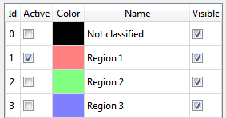
Pick Active – lets the user to select the active region by clicking on a voxel in one of orthogonal views.
Join Active – when the user clicks on a voxel which is assigned to a different region from the active one, the selected region will be merged with the active one.
Clear Active – clears segmentation data of all voxels belonging to the active region (i.e. the region number is set to zero).
Relabel – erases all unused regions in the table.
Reset – resets the region list and clears the current segmentation.
Show Regions – toggles visibility of all the regions.
Load – loads segmentation data from a file on disk.
Save – allows you to save the segmentation data to a file on disk.
Save As – saves the segmentation data to a file on disk.

