This plugin allows you to adjust coloring of different image densities when using the volume rendering.

Lookup Tables
The upper table contains list of all lookup tables, i.e. rendering modes, available to the volume renderer. It is possible to import and export lookup tables with Load and Save buttons. Restore LUTs to their defaults by loading implicit settings of the lookup tables.

Lookup Table Preview
The preview displays the current settings of the selected lookup table. Suppress Transparency checkbox can help to visualize mostly transparent lookup tables.
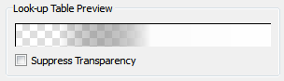

Components
Every lookup table can be a mixture of more components. These components are listed in the second table. It is possible to rename a component by double-clicking on it. The Add button creates a new component and Delete removes the selected component.

Selected Component
There is also a component preview which displays settings of a single component. It is possible to change locations of control points that define colors for specified densities. You can change an overall transparency of the selected component moving the Comp. Transparency slider. The color and the transparency of a control point can be changed using the Point Color button and the slider below.
