1. In the below elements which of them are values or an expression? eg:- values can be integer or string and expressions will be mathematical operators.

|  |  |
| --- | --- |
| * | Mathematical operator |
| 'hello' | String |
| -87.8 | Value |
| - | Mathematical operator |
| / | Mathematical operator |
| + | Mathematical operator |
| 6 | Value |

2. What is the difference between string and variable?

String – A string is a sequence of characters than can be interpreted by a script.

Ex- Hello alien

3. Describe three different data types.

1. Interger

2. Floating Point

3. Character

4. What is an expression made up of? What do all expressions do?

An expression is a combination of operators and operands which produce some value.

L = 3/3

5. This assignment statements, like spam = 10. What is the difference between an expression and a statement?

A statement doesn’t return any value , but expression which is a combination of values and operators return a value after execution.

6. After running the following code, what does the variable bacon contain?

bacon = 22

bacon + 1

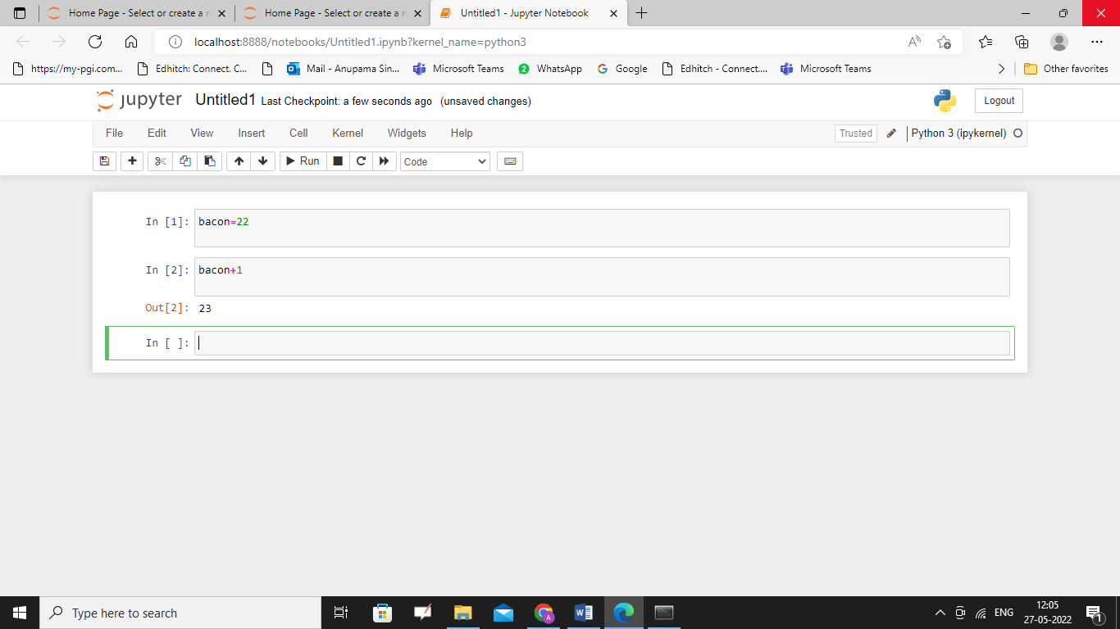

7. What should the values of the following two terms be?

'spam' + 'spamspam'

'spam' * 3

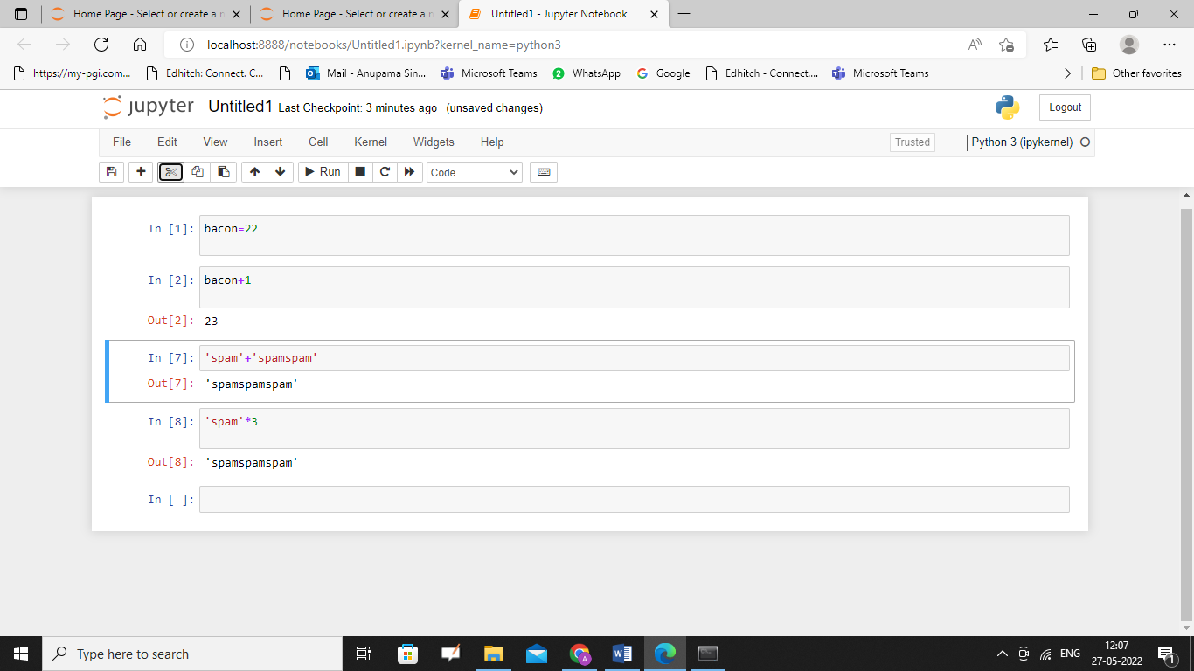

8. Why is eggs a valid variable name while 100 is invalid?

Variables names cannot start with a number.

9. What three functions can be used to get the integer, floating-point number, or string version of a value?

Int()

Float()

Str()

10. Why does this expression cause an error? How can you fix it?

'I have eaten ' + 99 + ' burritos.'

