1. What are the two values of the Boolean data type? How do you write them?

The two values of Boolean type are TRUE and FALSE

1. TRUE – 1
2. FALSE - 0

2. What are the three different types of Boolean operators?

Three types of Boolean operators are

1. AND = .(dot) operator
2. OR = + operator
3. Not – negation operator

3. Make a list of each Boolean operator's truth tables (i.e. every possible combination of Boolean values for the operator and what it evaluate ).

|  |  |  |
| --- | --- | --- |
| AND | OR | NOT |
| |  |  |  | | --- | --- | --- | | A | B | Output | | 0 | 0 | 0 | | 0 | 1 | 0 | | 1 | 0 | 0 | | 1 | 1 | 1 | | |  |  |  | | --- | --- | --- | | A | B | Output | | 0 | 0 | 0 | | 0 | 1 | 1 | | 1 | 0 | 1 | | 1 | 1 | 1 | | |  |  | | --- | --- | | A | Output | | 0 | 1 | | 1 | 0 | |

4. What are the values of the following expressions?

(5 > 4) and (3 == 5) - FALSE

not (5 > 4) – FALSE

(5 > 4) or (3 == 5) - TRUE

not ((5 > 4) or (3 == 5)) - FALSE

(True and True) and (True == False) - FALSE

(not False) or (not True) - TRUE

5. What are the six comparison operators?

Comparison operators are <,>,==,<=,>=,!=

6. How do you tell the difference between the equal to and assignment operators? Describe a condition and when you would use one.

Equal to assigns a value to a variable from right to left side. Assignment checks if two given operators are equal or not. if yes return true.

Ex: if (a==10) checks if value of a is equal to 10

A=10 ; will assign a value to variable A as 10.

7. Identify the three blocks in this code:

spam = 0

if spam == 10:

print('eggs')

if spam > 5:

**print**('bacon')

else:

print('ham')

print('spam')

print('spam')

8. Write code that prints Hello if 1 is stored in spam, prints Howdy if 2 is stored in spam, and prints Greetings! if anything else is stored in spam.

spam = 3

if spam == 1:

print('hello')

elif spam == 2:

print('howdy')

else:

print('Greetings')

print('Greetings')

print('Greetings')

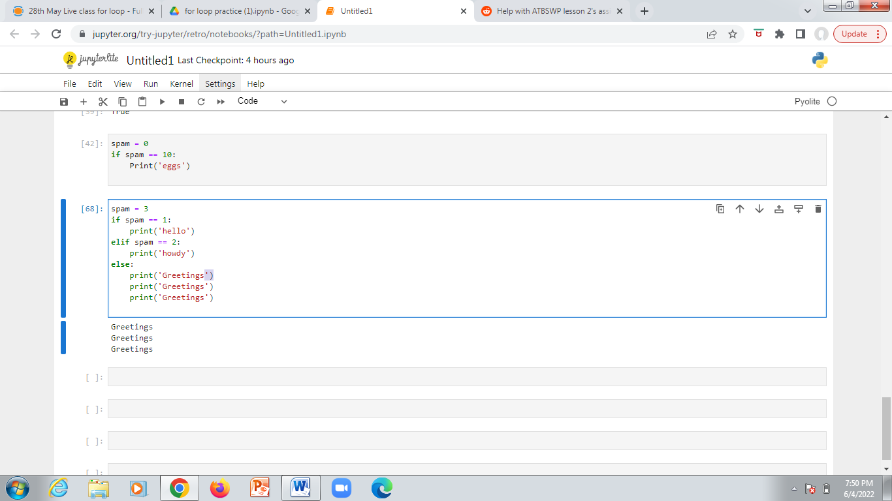

9.If your programme is stuck in an endless loop, what keys you’ll press?

To come out of an infinite loop in python we can use CTRL+C or else open a new page of jupyter notebook in which case all the variables used earlier needs to be declared again.

10. How can you tell the difference between break and continue?

1. break - leaves the loop  
 skips the execution of complete loop

2. continue – jumps to next iteration and stop the execution of current loop

11In a for loop, what is the difference between range(10), range(0, 10), and range(0, 10, 1)?

Range in for loop is of form range(start, stop, step)

1. Range (10) means – print values from 0-9
2. Range (0,10) means - start from 0 and end at 9
3. Range (0,10,1) means – start from 0 and go up to 9 in steps of 1

12. Write a short program that prints the numbers 1 to 10 using a for loop. Then write an equivalent program that prints the numbers 1 to 10 using a while loop.

FOR LOOP :

i=0

for i in range (1,11,1):

print(i)

i+=1

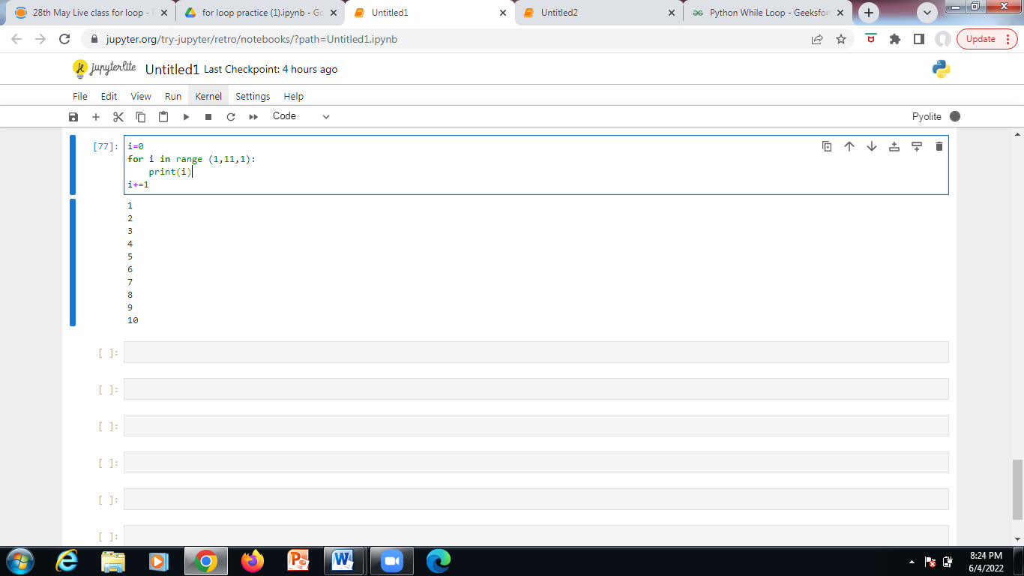

While loop :

i = 1

while (i < 11):

print(i)

i += 1

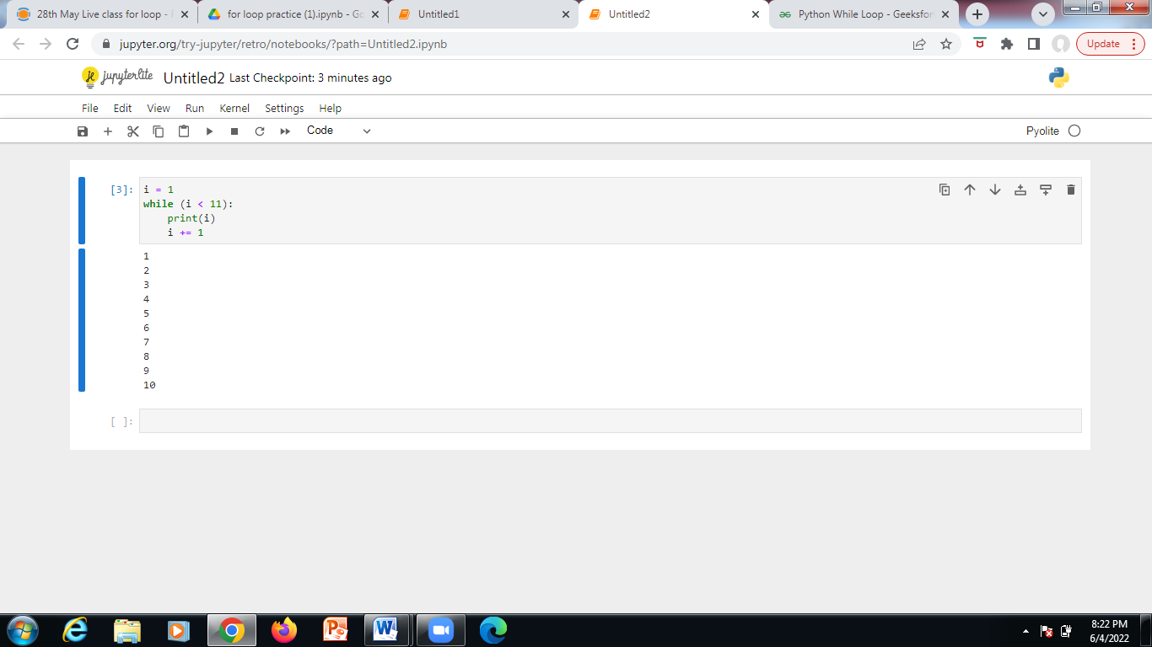

13. If you had a function named bacon() inside a module named spam, how would you call it after importing spam?

Spam – module

Bacon () – function inside spam

* We can call it by using stamen spam. bacon()