SET : 1
EMPLOYEE
- Workflow Components
- 1. Sequence: Structures the workflow logically.
- 2. Assign Activity: Initializes the variables.
- 4. Message Box Activity: Displays each variable( emp data).
Steps to Perform the Experiment
Step 1: Open UiPath Studio
1. Launch UiPath Studio.
2. Create a new project or open an existing one.
Step 2: Create a New Sequence
1. Navigate to New File > Sequence and name it employe.
2. Drag a Sequence container into the Designer Panel.
Step 3: Configure Variables
1. Open the Variables Panel at the bottom of UiPath Studio.
- 2. Add the following variables:
- Empname ->string
- Age -> int
- Salary -> double
Step 4: assign activity
- Take all 3 variables in 3 assigns
Step 5: message box
- "name :" + emp + ",age:" + age.ToString() + ",salary : " + salary.ToString()

Run the program.
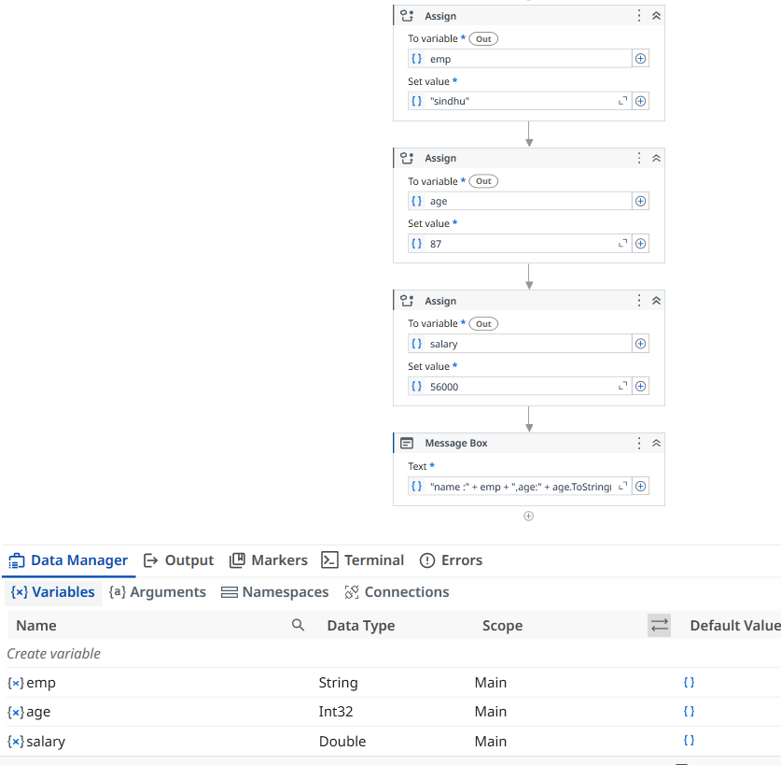

- COVID 19

- Tools Required
- ● UiPath Studio
- ● An Excel file with COVID-19 test data (e.g., details.xlsx).
- ● Microsoft Word or a compatible text editor for report formatting.
- ● Gmail or Outlook for sending emails
Workflow Components
Purpose: Convert the input text into a structured DataTable for processing.
Extract patient details like test date, region, result, test type, comments, name, and
email.
Generate a Word document containing patient-specific information and export it as a
PDF.
Attach the generated report and send it to the patient's email.
Change the background color of cells in column C to green for processed rows.

Steps to Perform the Experiment
Step 1: Open UiPath Studio
1. Launch UiPath Studio.
2. Create a new project or open an existing one.
Step 2: Create a New Sequence
1. Navigate to New File > Sequence and name it COVID-19 Report.
2. Drag a Sequence container into the Designer Panel.
Step 3: Configure Variables
1. Open the Variables Panel.
2. Add the following variables:
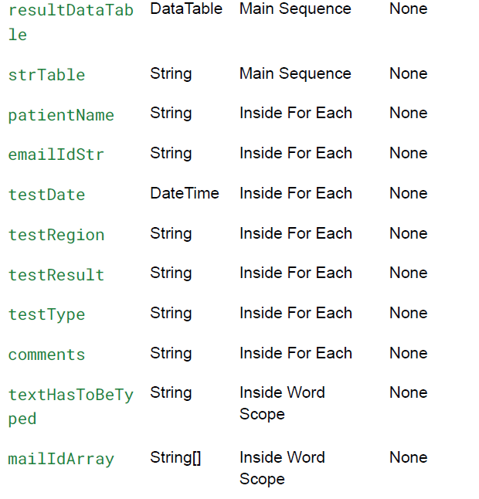

1) download covid_medical_data excel sheet
1) read range workbook -> select that excel sheet - > gives name as “sheet1” -> properties in output create “ medicaldt”
2) output data table as text -> select “medicaldt”
3) message box -> select medicaldt.ToString
4) for each row in data table - > data table : medicaldt , item name : current Row
5) inside the body get row item - > currentrow, name, “testdate”-> testdate (datetime)
6) body get row item - > currentrow, name, “region”-> testregion (string)
body get row item - > currentrow, name, “testresult” -> test result (string)
body get row item - > currentrow, name, “test type” ->test type( string)
body get row item - > currentrow, name, “comments” -> comments (string)
body get row item - > currentrow, name, “name” -> patientname (string)
body get row item - > currentrow, name, “emailed” -> emailed (string)

7) something we use ---> indicate the image -> in arguments give path

- 8) Inside DO
8)Word Application Scope activity -> Set the file path
9) Key board structure -> work in scope : covidreport-word , keyboard structure : entire page , sen key combination : ctrl+A, back
10) assign _-> cretate variable testhastobetyped , set value :
Value:"----------------------------------------------------COVID-19
Test Report----------------------------------------------------"
+ Environment.NewLine + "Patient Name: " + patientName
+ Environment.NewLine + "Test Date: " + testDate.ToString()
+ Environment.NewLine + "Test Result: " + testResult
+ Environment.NewLine + "Test Type: " + testType
+ Environment.NewLine + "Comments: " + comments
+ Environment.NewLine +
"-------------------------------------------------------"
+ Environment.NewLine + "Name: " + patientName + Environment.NewLine
+ "Email ID: " + emailIdStr

9) append text -> texthastobotyped -> on the new line
10) save document as pdf -> to give path “covid-19” -> on replace existing
11) assign -> take variable emailarray -> set value : new String[] { emailIdStr }.

12) send email -> give ur email, false , to : emailarray , subject , body :
"Hi " + patientName + "," + Environment.NewLine +
"Please find the lab report attached." + Environment.NewLine +
"Thanks"
13) 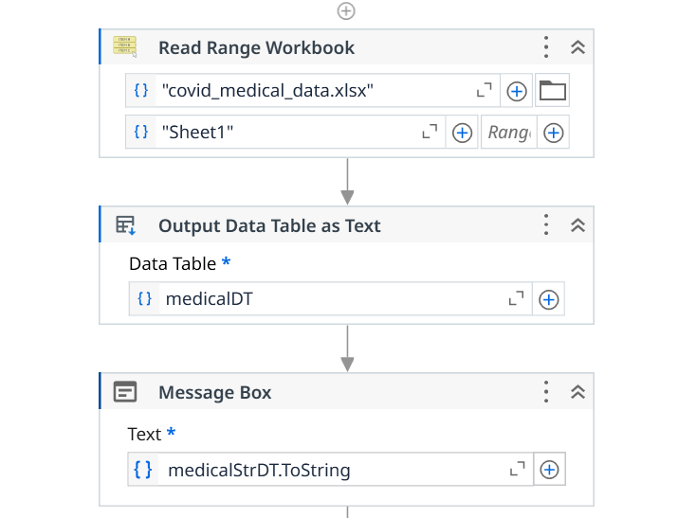 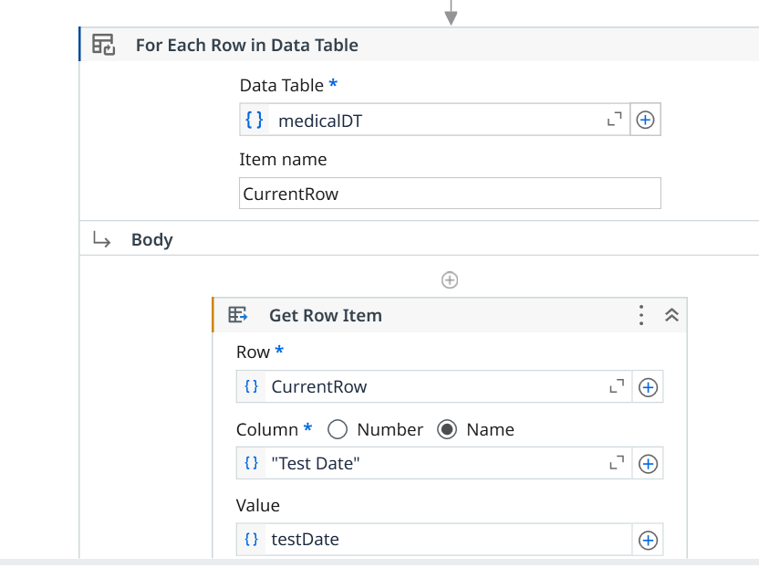 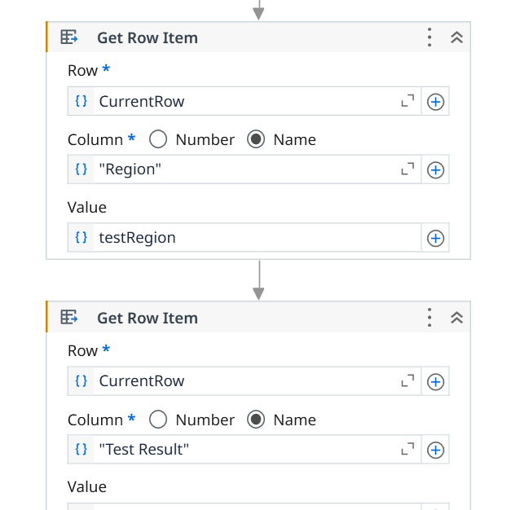 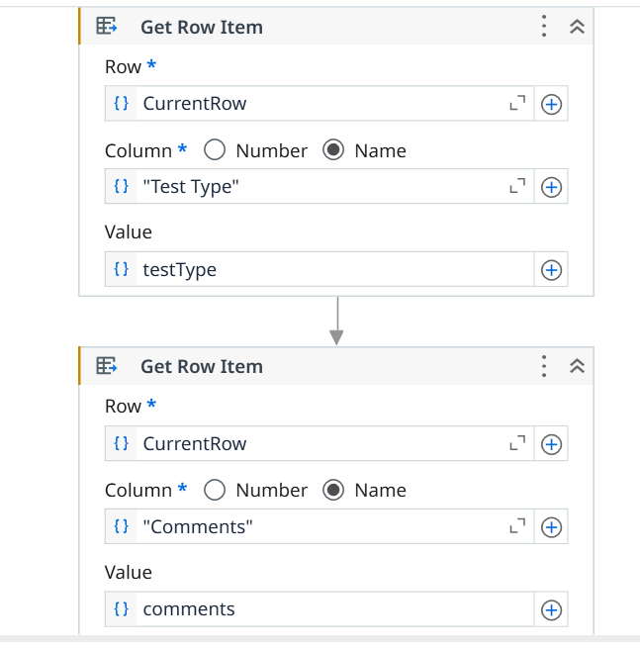 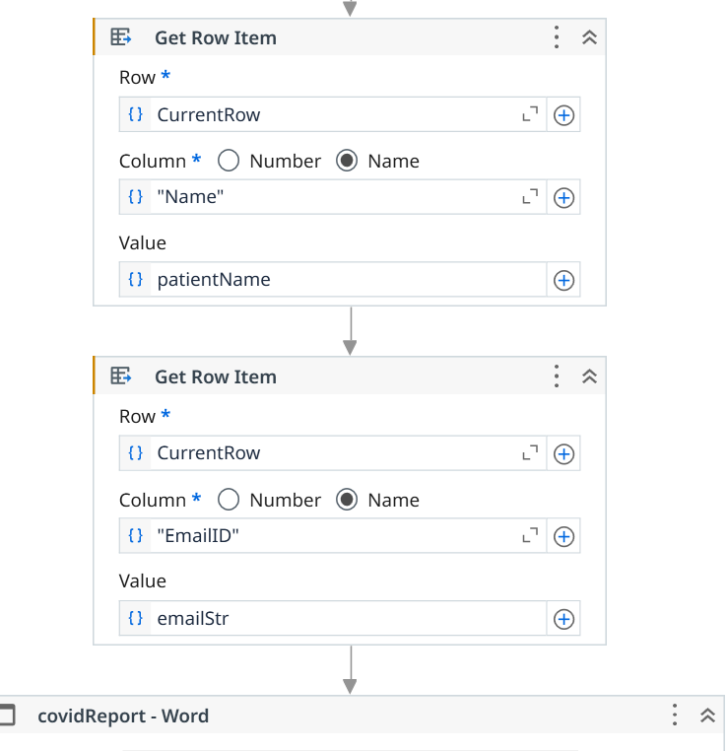 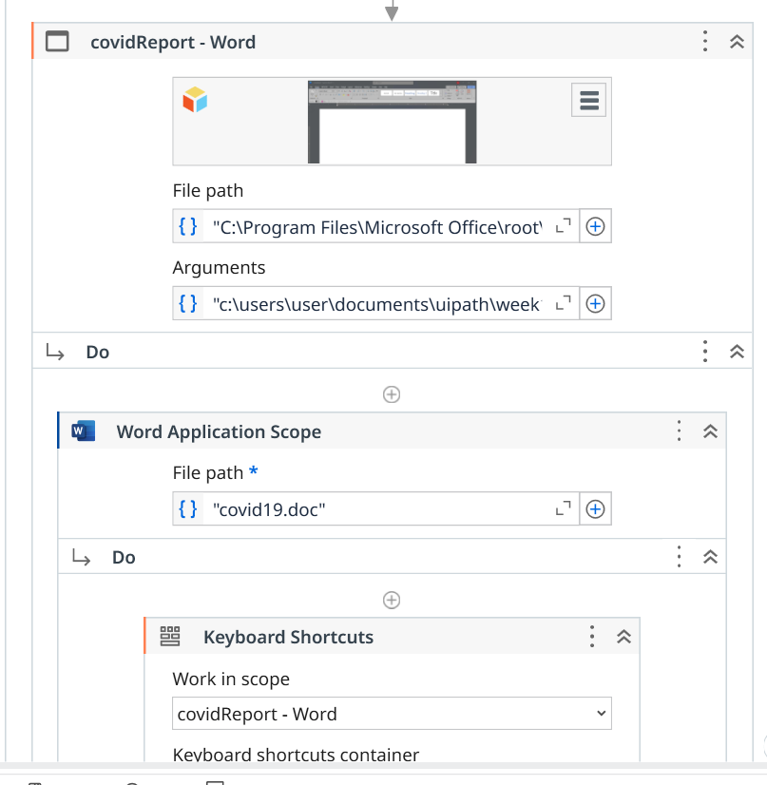 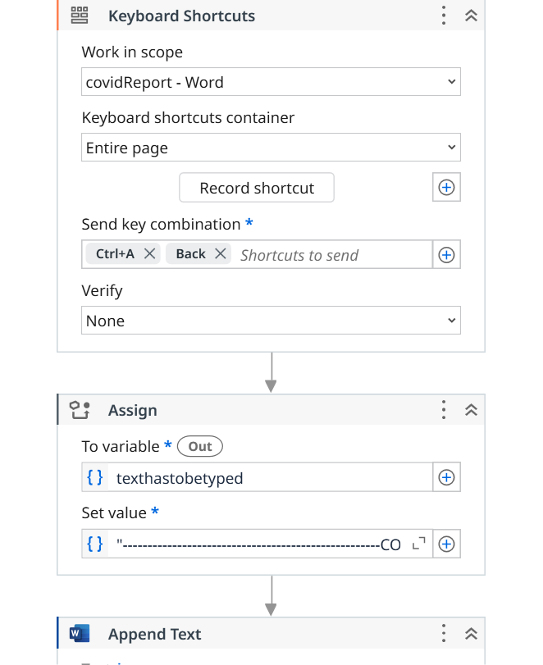 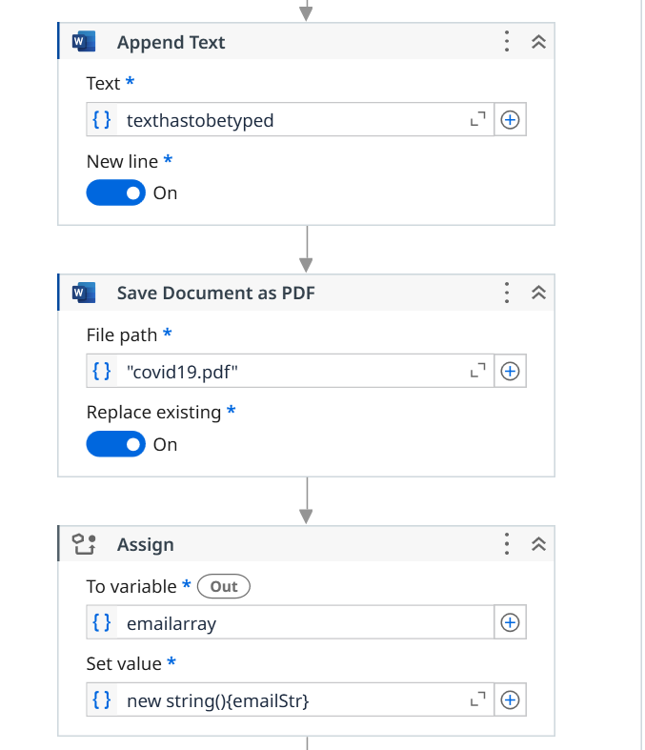 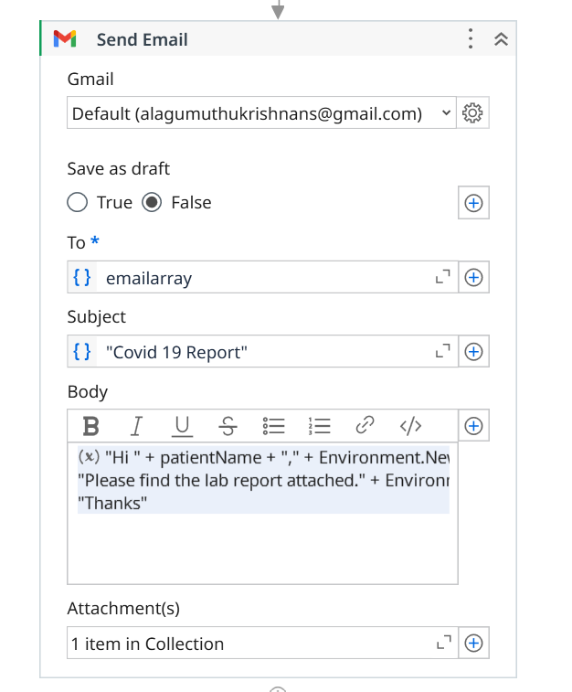

Set 2
To check odd or even numbers
- Input dialog - > create 2 variable
Num1 -int , number -string
2)input dialog – number ,
3) assign - > num1 , set value : Convert.toInt32(number)
4)if -> num1 Mod 2 = 0
Then “even” +num1.ToString()
Else “ odd”+num1.ToString()

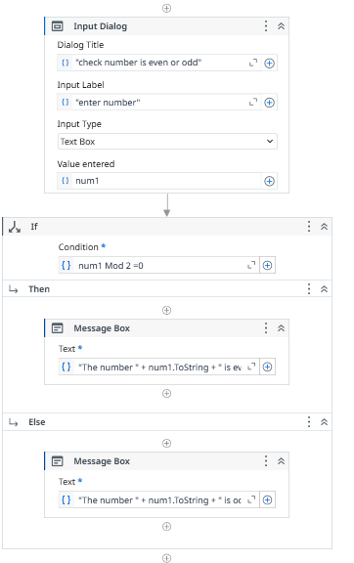
ii. To print the student grades

1) input dialog box
2) create 3 variables inputmarks: string , marks : int , grade : string
3) input dialog : intmarks
4) assign activity---
|__marks , Convert.ToInt32(inputMarks)
5) if --then if-marks , then-grade
|__else __if __then
|__else__if__then
|__else
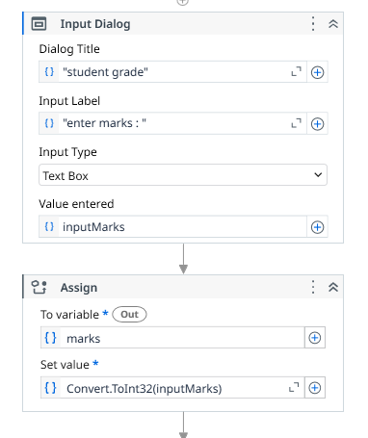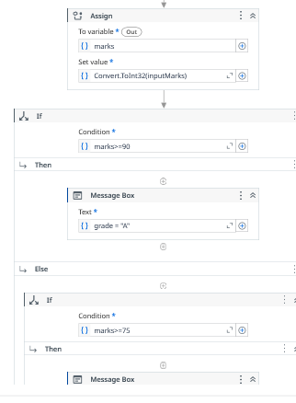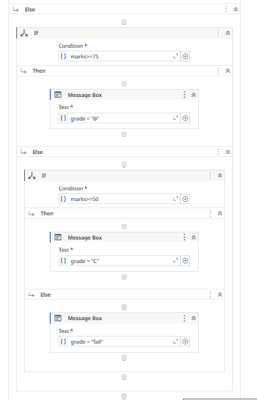

. Design a process to send automated emails with attachments using UiPath.
email automation (WEEK - 10)

read range workbook->output data table as text -> messege box -> for each row in data table -> get row item(2) ->assign(2) -> send email

1) open excel . enter 4 fields . save it ur process
2) goto UiPath studio, create new process
3) --read range work book--
|__ update it. selct ut sheet give name as "sheet1"-----click on properties in output - ctrl+k "data1".

4) ---output table as text--
\__ give table name " data1" --- click properties -> in output "mydata"
5)---message box--
|___ give "mydata.Tostring"

6)---for each row in datatable--
|___give name "data1" -> item name select "CurrentRow"
7) inside boday
|__select ---get row item
|__ currentrow , select Name , give "Name" same as excel sheet , propertirs in output give ctrl+k : username
|__ get row item
|__ currentrow, select Name, Email ,propertirs in output give ctrl+k : usermail

8) ---assign---
|__to variable: ctrl+x mail_id --> goto data manager set datatype to Array[T]->String
|__ set value : click + open in expeditor ->now String(){useremail}" ->save
9) --assign--
|__to variable : ctrl+x mail_body
|__set value : "hi"+username+environment.New Line+"this is demo for email automation"+environment.New Line +"regrads"+environment.NewLine+"sindhu"

10) goto --send mail--
|__enter ut email, ckeck false , to : mail_id , subject "Hi" ,body : mail_body. 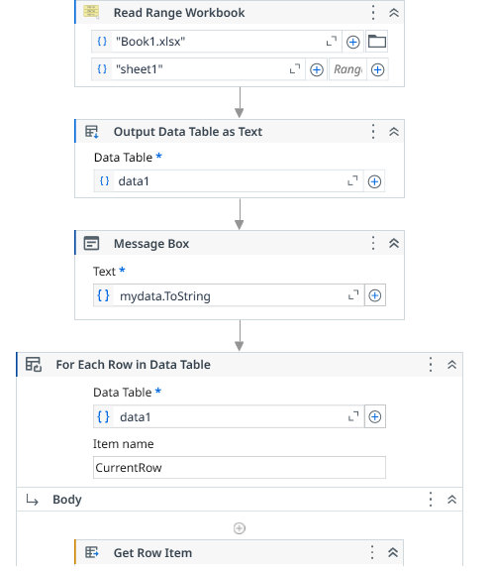 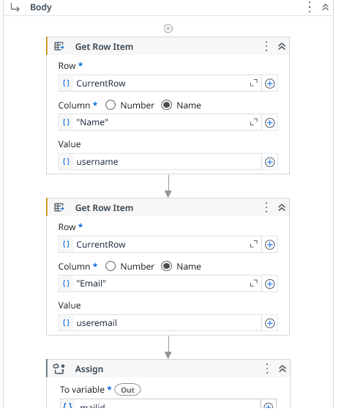 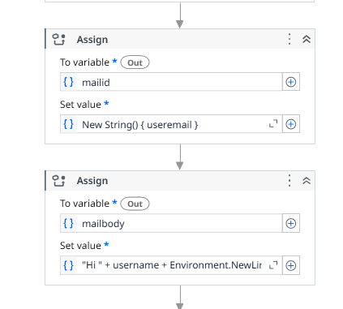 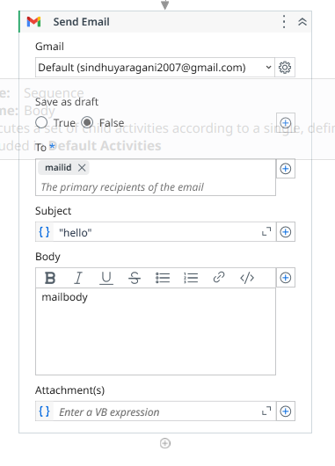
SET 3
- uses iteration (For Each/While loop) to repeat tasks.
I. To find the factorial for the given number

- take input dialog - > create 4 variable -> take inputnum
- 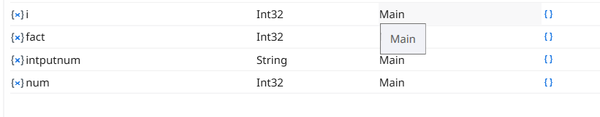
- Assign -> num , set value : Convert.ToString(inputnumber)
- Assign -> fact , set value : 7
- While - > num>0
- Inside body assign : fact , set value : fact*num
- Assign : num, set value : num-1
- Message box : fact.ToString
- 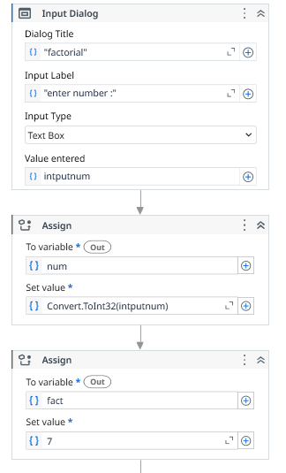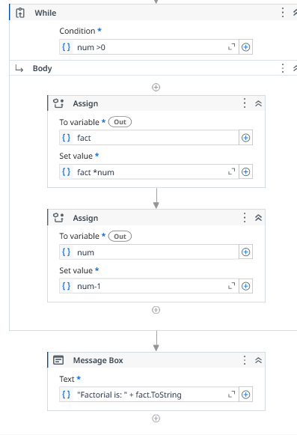
- ii.To print the countdown numbers from 10 to 1.
- ii.To print the countdown numbers from 10 to 1.
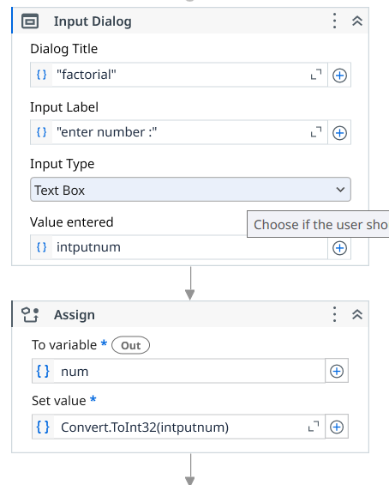

ii.To print the countdown numbers from 10 to 1.

- Assign -> create 1 varible
- While : num>=1
- In side body message box : num1.ToString
- Assign num1 -> num1-1

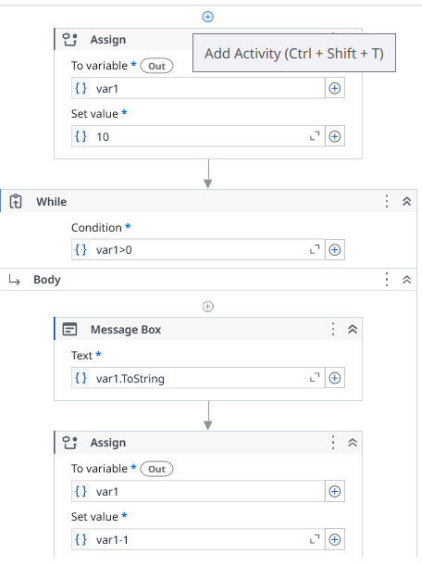

to read all PDF files from a folder

read all pdf files(WEEK - 11)

for each file in folder---message box---exctract pdf text ----message box

1) goto UiPath studio create a process
2) create a folder thatvare contain the pdf files that are to be excuted
3) in UiPath studio create & save a new process and a folder will be created
4) copy and paste thr folder with pdf files in created foleder
5) folder--demo folder--pdf
|__pdf
6) --for each file in folder----
|__ in filder : browse the folder this pdf files
|__ ckeck : include subfolders
|__filter by : "*.pdf" --- it selct only pdf files

7) – inside do message box---
|__ text: currentfile.FullName
8) ----exctract pdf text ---
|___used to exctractt text from pdf files .it store ____in properties -> ctrl+k extractfile
9) --message box---
|__ select extractfile.toString
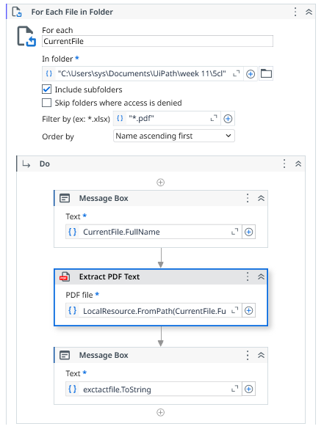

Set – 4
1(A)(I) Euclidean Distance
🎯 Goal:

Find distance between two points

🪜 Steps:
Create Variables
x1, y1, x2, y2 → Double
distance → Double
Assign Values (Assign Activity)
x1 = 2
y1 = 3
x2 = 6
y2 = 7
Calculate Distance
distance = Math.Sqrt((x2 - x1)^2 + (y2 - y1)^2)
Display Result
Use Message Box
"Distance = " + distance.ToString

2. Sixth Semester Subjects (Collection) — EASY
🎯 What you are doing:

👉 Store subjects in a list and print them one by one

🪜 Steps (VERY CLEAR)
✅ Step 1: Create Variable
Name → subjects
Type → Array of String
✅ Step 2: Store Subjects (Assign Activity)

👉 Drag Assign

subjects = {"AI","ML","Blockchain","Cloud","RPA"}

👉 This means:

You created a list of subjects
✅ Step 3: Use Loop (For Each)

👉 Drag For Each

TypeArgument → String
Value → subjects
✅ Step 4: Print Subjects

👉 Inside loop → add Write Line

item
🧠 Simple Understanding:
Array = list of items
For Each = take one item at a time
item = current subject
🔹 3. Library DataTable — EASY
🎯 What you are doing:

👉 Create a table like Excel and store book details

🪜 Steps (VERY CLEAR)
✅ Step 1: Create DataTable

👉 Drag Build Data Table

Add columns:

Column Name Type
BookNumber Int32
BookTitle String
AuthorName String
BookPrice Double
DateOfReturn DateTime
✅ Step 2: Add Data (Rows)

👉 Drag Add Data Row

Add like this:

{1,"Java","James",500,Now}

👉 Add another:

{2,"Python","Guido",600,Now}
✅ Step 3: Print Data

👉 Drag For Each Row

Input → DataTable
✅ Step 4: Inside Loop

👉 Use Write Line

row("BookTitle").ToString

👉 You can also print:

row("AuthorName").ToString
🧠 Simple Understanding:
DataTable = like Excel table
Row = one record
Column = field name
row("ColumnName") = get value

Backgroud colour

background color (WEEK -12)

excel process scope -- inside do --use excel file -- another do , set range color.

1) move the excel file whose background colour need to changed to the folder of the process
2) --- use excel file----
|__browse this excel file : select file , reference : excel , check save change - create if not exists .read format - same as project

3)goto filters --check classic --to get other activies such as set range color.

4) inside do ---set range color---
|__ System.Drawing.Color.GreenYellow
|__ enter range (A1:D5)
\__sheet1
set color the cell need to change color . mention range of colors changed , specify the sheet name.

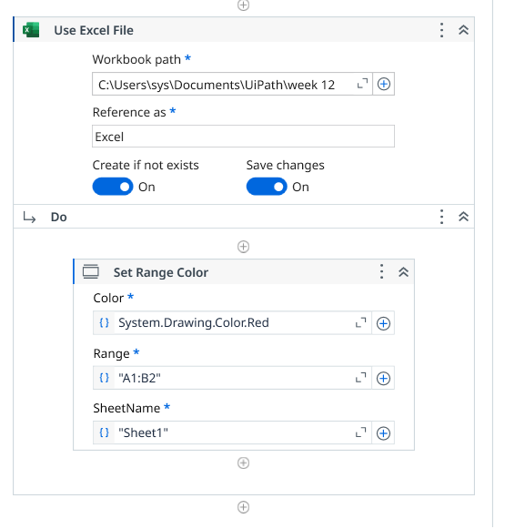

SET-5
Create a process for text manipulation, such as Read Name, Find the length, to print UpperCase, LowerCase, Title Case, and extract the substring from the main string

- Assign – create varibble
- Write line --- str.toupper
- Assign -2nd variable
- Write line – toupper
- Write line- length.tostring
- Assign – 3rd varible
- Write line-replaace (stri1)
- Write line- str(read)
- Write line – str2.substring
- 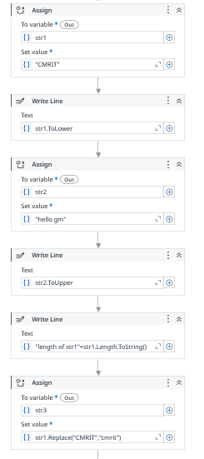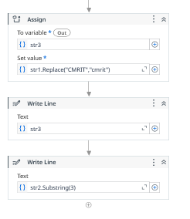

a COVID-19 report

- Tools Required
- ● UiPath Studio
- ● An Excel file with COVID-19 test data (e.g., details.xlsx).
- ● Microsoft Word or a compatible text editor for report formatting.
- ● Gmail or Outlook for sending emails
Workflow Components
Purpose: Convert the input text into a structured DataTable for processing.
Extract patient details like test date, region, result, test type, comments, name, and
email.
Generate a Word document containing patient-specific information and export it as a
PDF.
Attach the generated report and send it to the patient's email.
Change the background color of cells in column C to green for processed rows.

Steps to Perform the Experiment
Step 1: Open UiPath Studio
1. Launch UiPath Studio.
2. Create a new project or open an existing one.
Step 2: Create a New Sequence
1. Navigate to New File > Sequence and name it COVID-19 Report.
2. Drag a Sequence container into the Designer Panel.
Step 3: Configure Variables
1. Open the Variables Panel.
2. Add the following variables:


1) download covid_medical_data excel sheet
1) read range workbook -> select that excel sheet - > gives name as “sheet1” -> properties in output create “ medicaldt”
2) output data table as text -> select “medicaldt”
3) message box -> select medicaldt.ToString
4) for each row in data table - > data table : medicaldt , item name : current Row
5) inside the body get row item - > currentrow, name, “testdate”-> testdate (datetime)
6) body get row item - > currentrow, name, “region”-> testregion (string)
body get row item - > currentrow, name, “testresult” -> test result (string)
body get row item - > currentrow, name, “test type” ->test type( string)
body get row item - > currentrow, name, “comments” -> comments (string)
body get row item - > currentrow, name, “name” -> patientname (string)
body get row item - > currentrow, name, “emailed” -> emailed (string)

7) something we use ---> indicate the image -> in arguments give path

- 8) Inside DO
8)Word Application Scope activity -> Set the file path
9) Key board structure -> work in scope : covidreport-word , keyboard structure : entire page , sen key combination : ctrl+A, back
10) assign _-> cretate variable testhastobetyped , set value :
Value:"----------------------------------------------------COVID-19
Test Report----------------------------------------------------"
+ Environment.NewLine + "Patient Name: " + patientName
+ Environment.NewLine + "Test Date: " + testDate.ToString()
+ Environment.NewLine + "Test Result: " + testResult
+ Environment.NewLine + "Test Type: " + testType
+ Environment.NewLine + "Comments: " + comments
+ Environment.NewLine +
"-------------------------------------------------------"
+ Environment.NewLine + "Name: " + patientName + Environment.NewLine
+ "Email ID: " + emailIdStr

9) append text -> texthastobotyped -> on the new line
10) save document as pdf -> to give path “covid-19” -> on replace existing
11) assign -> take variable emailarray -> set value : new String[] { emailIdStr }.

12) send email -> give ur email, false , to : emailarray , subject , body :
"Hi " + patientName + "," + Environment.NewLine +
"Please find the lab report attached." + Environment.NewLine +
"Thanks"
13)         
SET – 6

a basic recording process

• Open UiPath Studio
• Create a New Process
• Go to Recording → Basic Recording

= clodse al atble .open nate pag . click on record symbol. Selct screen, give text, then + click double click
Click:
- Format → Font
Activities used:
- Click activity (for Format menu)
- Click activity (for Font option)
lick:
- File → Save As
Activities:
- Click (File menu)
- Click (Save As)

image and text automation (WEEK - 8)

get ocr test --- tesseract ocr ---log message--write message

1) open UiPath studio , create a new process
2) open ---Get OCR text-- into the work flow
3) open chrome and take the screenshot od required text.
4) click on indicate the sceen . indicate require the image.
5) select --tesseract OCR engine --
|__ its drog and drag the tesseract ocr inside get ocr engine.
\__properties -> output -> Image_text_automation
6) now click on ---log message ---
|__give output name which u gave , log level : info selct
7) select --write text file---
|__ in the write to file : give path of the text document that was created in the week - 8 fields give text as image_text_automation

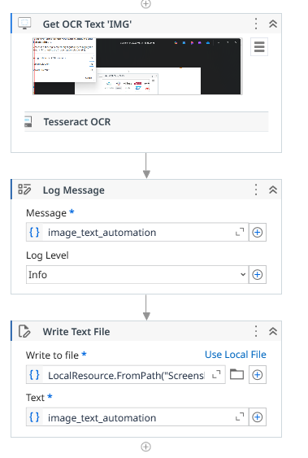

SET – 7

1---------desktop and web recording

  - Goto record
  - Click record
  - Desktop create folder select it . in side you crete another text doc,
  - Type into enter any text , select double click,
  - Stop record save it
Web recording

- Goto record or web record
- Open goggle open any website
- Select any probuct, stop recording

2----to trigger every 60 seconds

• Open UiPath Studio
• Create a New Process
• Add a Sequence activity
Variable | Type
emailTo | String
subject | String
body | String

🔹 Step 3: Assign Email Details
👉 Use Assign activities
emailTo = "example@gmail.com"
subject = "Medicine Reminder"
body = "Time to take your medicine!"

  - While ---- true
  - Inside body ---delay->00:01:00
  - : Use Message Box
  - "Please take your medicine!"

SET – 8

screen scraping data from an educational web source.

• Use Application/Browser
• Screen Scraping Wizard
• Get Text (auto-created)
• Message Box / Write Line

Use Use Application/Browser activity
- Indicate browser
- Enter URL (example):
https://www.wikipedia.org
Click:
- Design → Screen Scraping
- Indicate the text you want (e.g., heading or paragraph)
- Choose method:
  - ✔ Full Text (fast)
  - ✔ Native (recommended)
  - ✔ OCR (for images)
👉 Save output to variable:
scrapedText
Store Extracted Data
👉 Variable:
- scrapedText → String
- Use Message Box / Write Line
- scrapedText
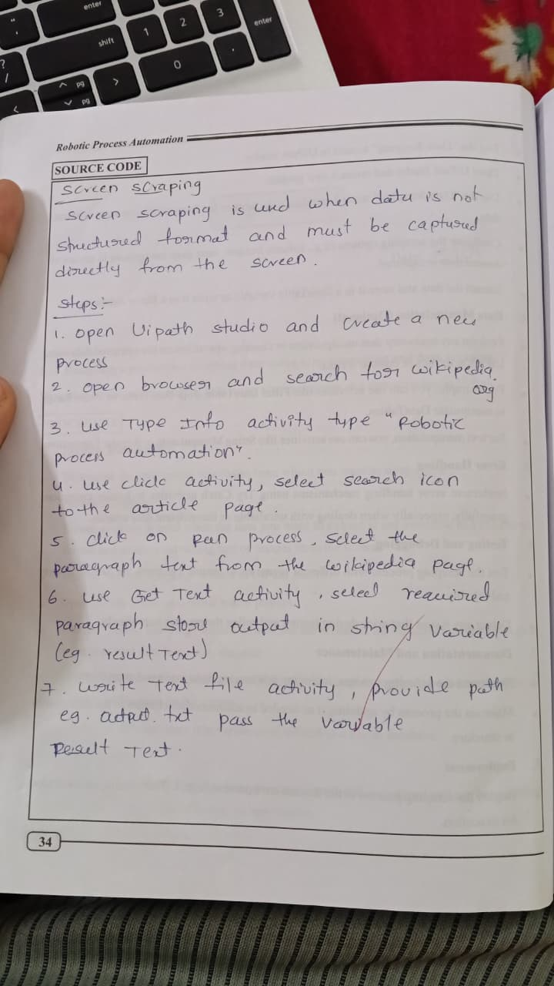

2222222222222222222222222222222222

email automation (WEEK - 10)

read range workbook->output data table as text -> messege box -> for each row in data table -> get row item(2) ->assign(2) -> send email

1) open excel . enter 4 fields . save it ur process
2) goto UiPath studio, create new process
3) --read range work book--
|__ update it. selct ut sheet give name as "sheet1"-----click on properties in output - ctrl+k "data1".

4) ---output table as text--
\__ give table name " data1" --- click properties -> in output "mydata"
5)---message box--
|___ give "mydata.Tostring"

6)---for each row in datatable--
|___give name "data1" -> item name select "CurrentRow"
7) inside boday
|__select ---get row item
|__ currentrow , select Name , give "Name" same as excel sheet , propertirs in output give ctrl+k : username
|__ get row item
|__ currentrow, select Name, Email ,propertirs in output give ctrl+k : usermail

8) ---assign---
|__to variable: ctrl+x mail_id --> goto data manager set datatype to Array[T]->String
|__ set value : click + open in expeditor ->now String(){useremail}" ->save
9) --assign--
|__to variable : ctrl+x mail_body
|__set value : "hi"+username+environment.New Line+"this is demo for email automation"+environment.New Line +"regrads"+environment.NewLine+"sindhu"

10) goto --send mail--
|__enter ut email, ckeck false , to : mail_id , subject "Hi" ,body : mail_body.    
SET - 9

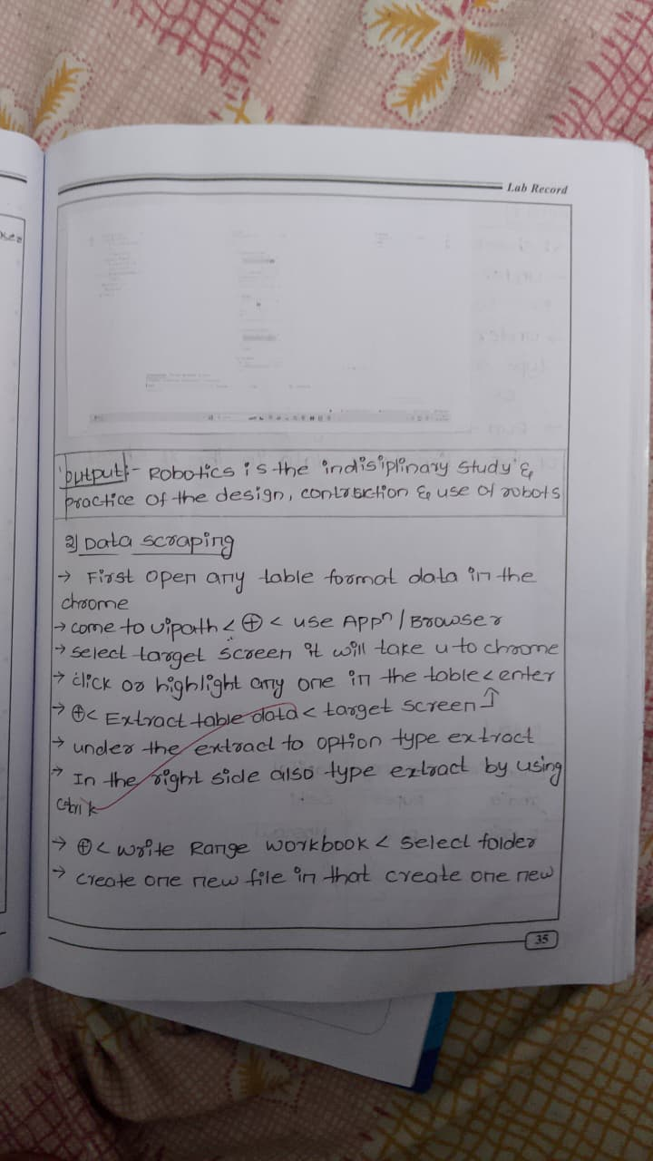
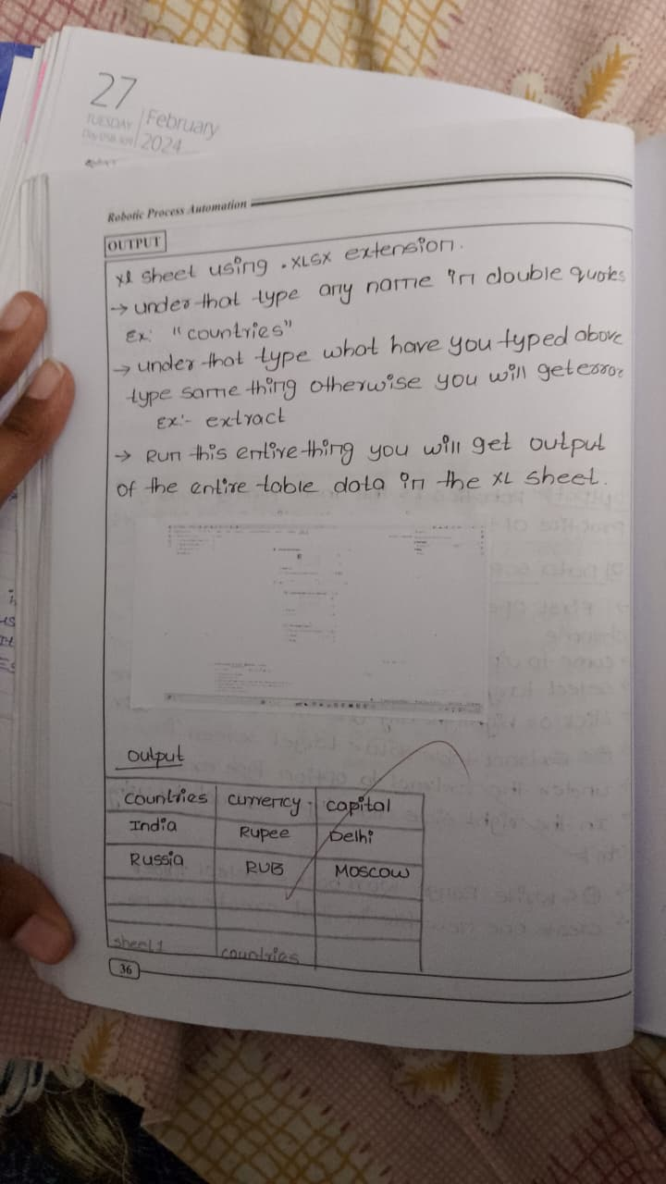

i) Quadratic Equation (Scalar Variables)
🎯 Activities Sequence (in order)
Sequence (Main container)

Assign
👉 Set values

a = 1
b = -3
c = 2

Assign
👉 Calculate discriminant

d = (b*b) - (4*a*c)

If Activity
👉 Condition:

d >= 0
▶️ Inside THEN:
Assign
root1 = (-b + Math.Sqrt(d)) / (2*a)
Assign
root2 = (-b - Math.Sqrt(d)) / (2*a)
Message Box
"Root1 = " + root1.ToString + " Root2 = " + root2.ToString
▶️ Inside ELSE:
Message Box
"Imaginary Roots"

🔹 ii) Sixth Semester Subjects (Collection)
🎯 Activities Sequence
Sequence
Assign
subjects = {"AI","ML","Blockchain","Cloud","RPA"}
For Each
TypeArgument → String
Values → subjects
▶️ Inside For Each:
Write Line
item
🔹 iii) Bank Information (DataTable)
🎯 Activities Sequence
▶️ Create Table
Sequence
Build Data Table
Add Columns:
AccountNumber (Int32)
CustomerName (String)
BankName (String)
Balance (Double)
IFSC (String)
▶️ Add Data
Add Data Row
{101,"Ravi","SBI",50000,"SBIN0001"}
Add Data Row
{102,"Priya","HDFC",75000,"HDFC0002"}
Add Data Row
{103,"Rahul","ICICI",60000,"ICIC0003"}
▶️ Display Data (Method 1 – Loop)
For Each Row in Data Table
▶️ Inside Loop:
Write Line
row("CustomerName").ToString
▶️ Display Data (Method 2 – Full Table)
Output Data Table
Input → DataTable
Output → strOutput
Message Box
strOutput
✨ FINAL STRUCTURE (VERY IMPORTANT FOR EXAM)
🔹 Quadratic
Assign → Assign → If → Assign → Message Box
🔹 Subjects
Assign → For Each → Write Line
🔹 DataTable
Build Data Table → Add Data Row → For Each Row → Write Line
(or Output Data Table → Message Box)

SET -10

image and text automation (WEEK - 8)

get ocr test --- tesseract ocr ---log message--write message

1) open UiPath studio , create a new process
2) open ---Get OCR text-- into the work flow
3) open chrome and take the screenshot od required text.
4) click on indicate the sceen . indicate require the image.
5) select --tesseract OCR engine --
|__ its drog and drag the tesseract ocr inside get ocr engine.
\__properties -> output -> Image_text_automation
6) now click on ---log message ---
|__give output name which u gave , log level : info selct
7) select --write text file---
|__ in the write to file : give path of the text document that was created in the week - 8 fields give text as image_text_automation



email automation (WEEK - 10)

read range workbook->output data table as text -> messege box -> for each row in data table -> get row item(2) ->assign(2) -> send email

1) open excel . enter 4 fields . save it ur process
2) goto UiPath studio, create new process
3) --read range work book--
|__ update it. selct ut sheet give name as "sheet1"-----click on properties in output - ctrl+k "data1".

4) ---output table as text--
\__ give table name " data1" --- click properties -> in output "mydata"
5)---message box--
|___ give "mydata.Tostring"

6)---for each row in datatable--
|___give name "data1" -> item name select "CurrentRow"
7) inside boday
|__select ---get row item
|__ currentrow , select Name , give "Name" same as excel sheet , propertirs in output give ctrl+k : username
|__ get row item
|__ currentrow, select Name, Email ,propertirs in output give ctrl+k : usermail

8) ---assign---
|__to variable: ctrl+x mail_id --> goto data manager set datatype to Array[T]->String
|__ set value : click + open in expeditor ->now String(){useremail}" ->save
9) --assign--
|__to variable : ctrl+x mail_body
|__set value : "hi"+username+environment.New Line+"this is demo for email automation"+environment.New Line +"regrads"+environment.NewLine+"sindhu"

10) goto --send mail--
|__enter ut email, ckeck false , to : mail_id , subject "Hi" ,body : mail_body.    
SET -11
- COVID 19

- Tools Required
- ● UiPath Studio
- ● An Excel file with COVID-19 test data (e.g., details.xlsx).
- ● Microsoft Word or a compatible text editor for report formatting.
- ● Gmail or Outlook for sending emails
Workflow Components
Purpose: Convert the input text into a structured DataTable for processing.
Extract patient details like test date, region, result, test type, comments, name, and
email.
Generate a Word document containing patient-specific information and export it as a
PDF.
Attach the generated report and send it to the patient's email.
Change the background color of cells in column C to green for processed rows.

Steps to Perform the Experiment
Step 1: Open UiPath Studio
1. Launch UiPath Studio.
2. Create a new project or open an existing one.
Step 2: Create a New Sequence
1. Navigate to New File > Sequence and name it COVID-19 Report.
2. Drag a Sequence container into the Designer Panel.
Step 3: Configure Variables
1. Open the Variables Panel.
2. Add the following variables:


1) download covid_medical_data excel sheet
1) read range workbook -> select that excel sheet - > gives name as “sheet1” -> properties in output create “ medicaldt”
2) output data table as text -> select “medicaldt”
3) message box -> select medicaldt.ToString
4) for each row in data table - > data table : medicaldt , item name : current Row
5) inside the body get row item - > currentrow, name, “testdate”-> testdate (datetime)
6) body get row item - > currentrow, name, “region”-> testregion (string)
body get row item - > currentrow, name, “testresult” -> test result (string)
body get row item - > currentrow, name, “test type” ->test type( string)
body get row item - > currentrow, name, “comments” -> comments (string)
body get row item - > currentrow, name, “name” -> patientname (string)
body get row item - > currentrow, name, “emailed” -> emailed (string)

7) something we use ---> indicate the image -> in arguments give path

- 8) Inside DO
8)Word Application Scope activity -> Set the file path
9) Key board structure -> work in scope : covidreport-word , keyboard structure : entire page , sen key combination : ctrl+A, back
10) assign _-> cretate variable testhastobetyped , set value :
Value:"----------------------------------------------------COVID-19
Test Report----------------------------------------------------"
+ Environment.NewLine + "Patient Name: " + patientName
+ Environment.NewLine + "Test Date: " + testDate.ToString()
+ Environment.NewLine + "Test Result: " + testResult
+ Environment.NewLine + "Test Type: " + testType
+ Environment.NewLine + "Comments: " + comments
+ Environment.NewLine +
"-------------------------------------------------------"
+ Environment.NewLine + "Name: " + patientName + Environment.NewLine
+ "Email ID: " + emailIdStr

9) append text -> texthastobotyped -> on the new line
10) save document as pdf -> to give path “covid-19” -> on replace existing
11) assign -> take variable emailarray -> set value : new String[] { emailIdStr }.

12) send email -> give ur email, false , to : emailarray , subject , body :
"Hi " + patientName + "," + Environment.NewLine +
"Please find the lab report attached." + Environment.NewLine +
"Thanks"
- 
- read, perform the data entry operation and write to excel file

- Open UiPath Studio
- Create a New Process
- Add a Sequence activity
read range workbook->output data table as text -> messege box -> in side do for each roe in table -> inside body type info(6) , click -> write range workbook

1) open UiPath
2) create new process
3) select ------read range workbook-------
4) goto manage package choose 2nd option and select 3.3.1 version and click update.
5) goto google type rpa challenge -> download the 1st link
6) goto folder -> documents -> UiPath -> process(wekk-9) -> paste downloaded file
7) goto read range workbook -> selct folder -> types " sheet1" -> click read range book properties in the output -> ctrl+k : "dt"
8) next select output name -> dt
9) click on output data table as text -> properties -> ctrl+k : "output"
10) select------message box----
11) in text -> output.toString
12) open ----use application/browser--------
13) click on indicate screen --> select entire page which you opended already (RPA challenges)
14) it has first ,last name,ph no,email
15) inside ----do----
|___add----for each row----in datatable
-data table "dt"
-item name "current row"
16) inside --body--
|__type info
|__indicate screen select all fileds 1 by 1 click validate and confirm
|__type this "Current Row(" ").toString
|__ copy and paste all fields. names from xl sheet
17) select ----click--- inside the body
|__indicate screen -> click submit button u should validate and confirm
|__write range workbook
|__select ur folder ->enter "sheet2" select table name "dt"
18) run the program u will get details in sheet 2

SET -12
email automation (WEEK - 10)

read range workbook->output data table as text -> messege box -> for each row in data table -> get row item(2) ->assign(2) -> send email

1) open excel . enter 4 fields . save it ur process
2) goto UiPath studio, create new process
3) --read range work book--
|__ update it. selct ut sheet give name as "sheet1"-----click on properties in output - ctrl+k "data1".

4) ---output table as text--
\__ give table name " data1" --- click properties -> in output "mydata"
5)---message box--
|___ give "mydata.Tostring"

6)---for each row in datatable--
|___give name "data1" -> item name select "CurrentRow"
7) inside boday
|__select ---get row item
|__ currentrow , select Name , give "Name" same as excel sheet , propertirs in output give ctrl+k : username
|__ get row item
|__ currentrow, select Name, Email ,propertirs in output give ctrl+k : usermail

8) ---assign---
|__to variable: ctrl+x mail_id --> goto data manager set datatype to Array[T]->String
|__ set value : click + open in expeditor ->now String(){useremail}" ->save
9) --assign--
|__to variable : ctrl+x mail_body
|__set value : "hi"+username+environment.New Line+"this is demo for email automation"+environment.New Line +"regrads"+environment.NewLine+"sindhu"

10) goto --send mail--
|__enter ut email, ckeck false , to : mail_id , subject "Hi" ,body : mail_body.    
Leap year

  - Input dialog
  - Assign
  - If : (year Mod 4 = 0 And year Mod 100 <> 0) Or (year Mod 400 = 0)
  - 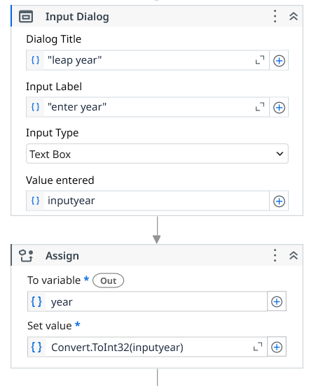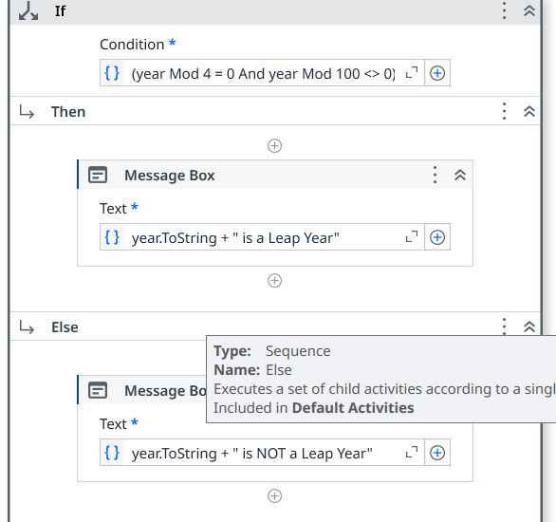

ii. To print the student grades

1) input dialog box
2) create 3 variables inputmarks: string , marks : int , grade : string
3) input dialog : intmarks
4) assign activity---
|__marks , Convert.ToInt32(inputMarks)
5) if --then if-marks , then-grade
|__else __if __then
|__else__if__then
|__else


SET -13

email automation (WEEK - 10)

read range workbook->output data table as text -> messege box -> for each row in data table -> get row item(2) ->assign(2) -> send email

1) open excel . enter 4 fields . save it ur process
2) goto UiPath studio, create new process
3) --read range work book--
|__ update it. selct ut sheet give name as "sheet1"-----click on properties in output - ctrl+k "data1".

4) ---output table as text--
\__ give table name " data1" --- click properties -> in output "mydata"
5)---message box--
|___ give "mydata.Tostring"

6)---for each row in datatable--
|___give name "data1" -> item name select "CurrentRow"
7) inside boday
|__select ---get row item
|__ currentrow , select Name , give "Name" same as excel sheet , propertirs in output give ctrl+k : username
|__ get row item
|__ currentrow, select Name, Email ,propertirs in output give ctrl+k : usermail

8) ---assign---
|__to variable: ctrl+x mail_id --> goto data manager set datatype to Array[T]->String
|__ set value : click + open in expeditor ->now String(){useremail}" ->save
9) --assign--
|__to variable : ctrl+x mail_body
|__set value : "hi"+username+environment.New Line+"this is demo for email automation"+environment.New Line +"regrads"+environment.NewLine+"sindhu"

10) goto --send mail--
|__enter ut email, ckeck false , to : mail_id , subject "Hi" ,body : mail_body.    

Backgroud colour

background color (WEEK -12)

excel process scope -- inside do --use excel file -- another do , set range color.

1) move the excel file whose background colour need to changed to the folder of the process
2) --- use excel file----
|__browse this excel file : select file , reference : excel , check save change - create if not exists .read format - same as project

3)goto filters --check classic --to get other activies such as set range color.

4) inside do ---set range color---
|__ System.Drawing.Color.GreenYellow
|__ enter range (A1:D5)
\__sheet1
set color the cell need to change color . mention range of colors changed , specify the sheet name.


SET -14

to read all PDF files from a folder

read all pdf files(WEEK - 11)

for each file in folder---message box---exctract pdf text ----message box

1) goto UiPath studio create a process
2) create a folder thatvare contain the pdf files that are to be excuted
3) in UiPath studio create & save a new process and a folder will be created
4) copy and paste thr folder with pdf files in created foleder
5) folder--demo folder--pdf
|__pdf
6) --for each file in folder----
|__ in filder : browse the folder this pdf files
|__ ckeck : include subfolders
|__filter by : "*.pdf" --- it selct only pdf files

7) – inside do message box---
|__ text: currentfile.FullName
8) ----exctract pdf text ---
|___used to exctractt text from pdf files .it store ____in properties -> ctrl+k extractfile
9) --message box---
|__ select extractfile.toString

1---------desktop and web recording

  - Goto record
  - Click record
  - Desktop create folder select it . in side you crete another text doc,
  - Type into enter any text , select double click,
  - Stop record save it
Web recording

- Goto record or web record
- Open goggle open any website
- Select any probuct, stop recording

SET -15
- COVID 19

- Tools Required
- ● UiPath Studio
- ● An Excel file with COVID-19 test data (e.g., details.xlsx).
- ● Microsoft Word or a compatible text editor for report formatting.
- ● Gmail or Outlook for sending emails
Workflow Components
Purpose: Convert the input text into a structured DataTable for processing.
Extract patient details like test date, region, result, test type, comments, name, and
email.
Generate a Word document containing patient-specific information and export it as a
PDF.
Attach the generated report and send it to the patient's email.
Change the background color of cells in column C to green for processed rows.

Steps to Perform the Experiment
Step 1: Open UiPath Studio
1. Launch UiPath Studio.
2. Create a new project or open an existing one.
Step 2: Create a New Sequence
1. Navigate to New File > Sequence and name it COVID-19 Report.
2. Drag a Sequence container into the Designer Panel.
Step 3: Configure Variables
1. Open the Variables Panel.
2. Add the following variables:


1) download covid_medical_data excel sheet
1) read range workbook -> select that excel sheet - > gives name as “sheet1” -> properties in output create “ medicaldt”
2) output data table as text -> select “medicaldt”
3) message box -> select medicaldt.ToString
4) for each row in data table - > data table : medicaldt , item name : current Row
5) inside the body get row item - > currentrow, name, “testdate”-> testdate (datetime)
6) body get row item - > currentrow, name, “region”-> testregion (string)
body get row item - > currentrow, name, “testresult” -> test result (string)
body get row item - > currentrow, name, “test type” ->test type( string)
body get row item - > currentrow, name, “comments” -> comments (string)
body get row item - > currentrow, name, “name” -> patientname (string)
body get row item - > currentrow, name, “emailed” -> emailed (string)

7) something we use ---> indicate the image -> in arguments give path

- 8) Inside DO
8)Word Application Scope activity -> Set the file path
9) Key board structure -> work in scope : covidreport-word , keyboard structure : entire page , sen key combination : ctrl+A, back
10) assign _-> cretate variable testhastobetyped , set value :
Value:"----------------------------------------------------COVID-19
Test Report----------------------------------------------------"
+ Environment.NewLine + "Patient Name: " + patientName
+ Environment.NewLine + "Test Date: " + testDate.ToString()
+ Environment.NewLine + "Test Result: " + testResult
+ Environment.NewLine + "Test Type: " + testType
+ Environment.NewLine + "Comments: " + comments
+ Environment.NewLine +
"-------------------------------------------------------"
+ Environment.NewLine + "Name: " + patientName + Environment.NewLine
+ "Email ID: " + emailIdStr

9) append text -> texthastobotyped -> on the new line
10) save document as pdf -> to give path “covid-19” -> on replace existing
11) assign -> take variable emailarray -> set value : new String[] { emailIdStr }.

12) send email -> give ur email, false , to : emailarray , subject , body :
"Hi " + patientName + "," + Environment.NewLine +
"Please find the lab report attached." + Environment.NewLine +
"Thanks"
13)         

EMPLOYEE
- Workflow Components
- 1. Sequence: Structures the workflow logically.
- 2. Assign Activity: Initializes the variables.
- 4. Message Box Activity: Displays each variable( emp data).
Steps to Perform the Experiment
Step 1: Open UiPath Studio
1. Launch UiPath Studio.
2. Create a new project or open an existing one.
Step 2: Create a New Sequence
1. Navigate to New File > Sequence and name it employe.
2. Drag a Sequence container into the Designer Panel.
Step 3: Configure Variables
1. Open the Variables Panel at the bottom of UiPath Studio.
- 2. Add the following variables:
- Empname ->string
- Age -> int
- Salary -> double
Step 4: assign activity
- Take all 3 variables in 3 assigns
Step 5: message box
- "name :" + emp + ",age:" + age.ToString() + ",salary : " + salary.ToString()

Run the program.


