When the admin first visits the website Page, a login screen is displayed, which is quite elegantly and aesthetically built. This is shifting the negative attitude of the frustrated accountant. In the Splash Screen, the accountant / admin enters their e-mail address and password that were previously listed in the database. If the credentials match the database entries, it will be authenticated to the system. If the authentication process fails, this means that the certificate is wrong, the admin / user will be faced again with the same splash screen.

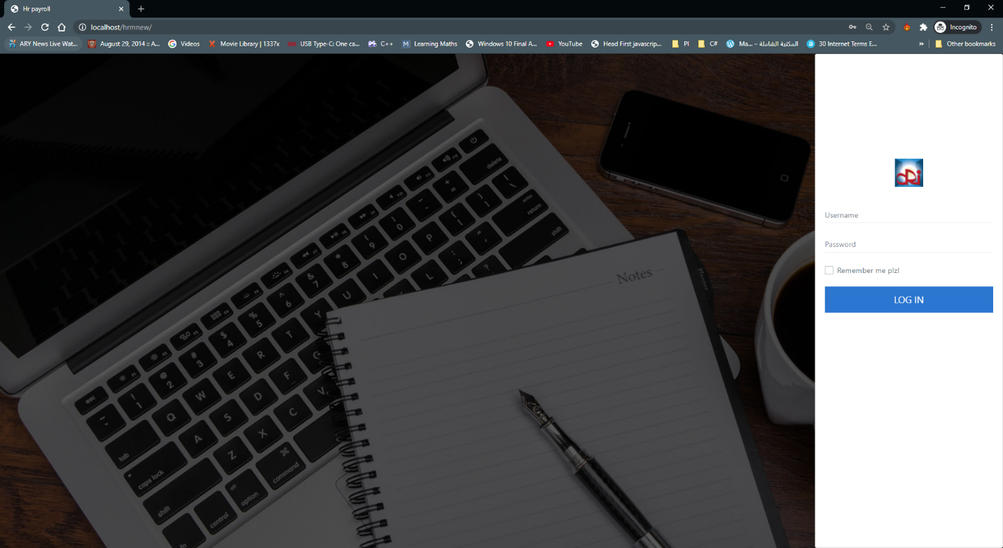

Upon completion of the authentication process, the user / admin will be logged into the framework. The first screen they showed is the Dashboard Page. By definition Dashboard means "A dashboard is a type of graphical user interface that frequently shows key performance metrics relating to a particular goal or business operation. In other words," dashboard "is another term for" development report "or" analysis. "The proposed framework dashboard is designed with various aspects in mind and would be really useful for the HRM admin.

The dashboard is designed in such a way that the admin/user can quickly says what the current status is of the company. He is presented with eh following key entities.

1. The key entities which admin will be presented with are as follows:
2. Number of employees registered
3. Number of leaves currently in the database
4. Number of currently registered projects.
5. Number of loan Applications
6. Number of Ex-employees
7. Number Loans given
8. Number of Upcoming projects
9. Number of Loan Applications
10. List of Notice Board
11. To do list
12. List of Currently Running Projects
13. List of Holidays

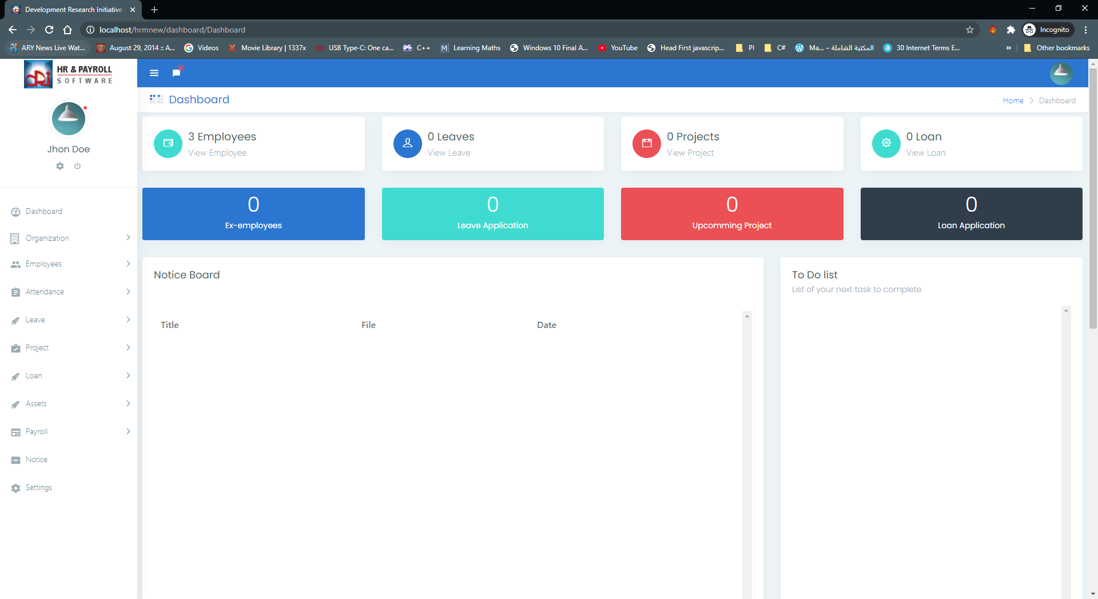

To the right of the dashboard, the admin is provided with the ability to modify / custodial his / her records. When admin clicks on the avatar, the menu opens and has three options, one for logout features, if one clicks on the tab, the session data will be deleted from the window.

My profile connection will take you to the Account Settings tab, which gives you plenty of choices to enter your details. The page is split into various sections, which are very user-friendly. After the data is entered in the necessary filed, the data will be sent to the database for persistence.

The framework configuration tab is a global setting that can alter the actions of the application.

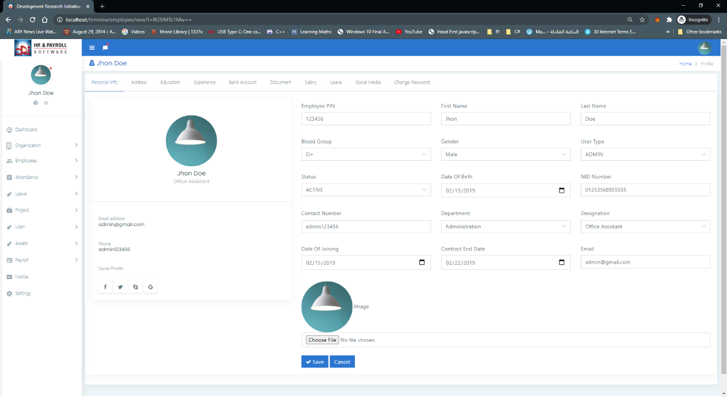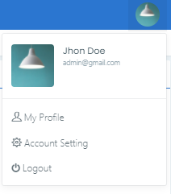

Page settings depicted in picture 45. This page includes a global environment, if you adjust any of the settings on this tab, it will extend to the entire system.

Setting the page allows you the flexibility to modify the logo of the organization, the title of the organization, the address, the phone number. This is a very useful feature to have in HRM, each organization will have its own identity on the web.

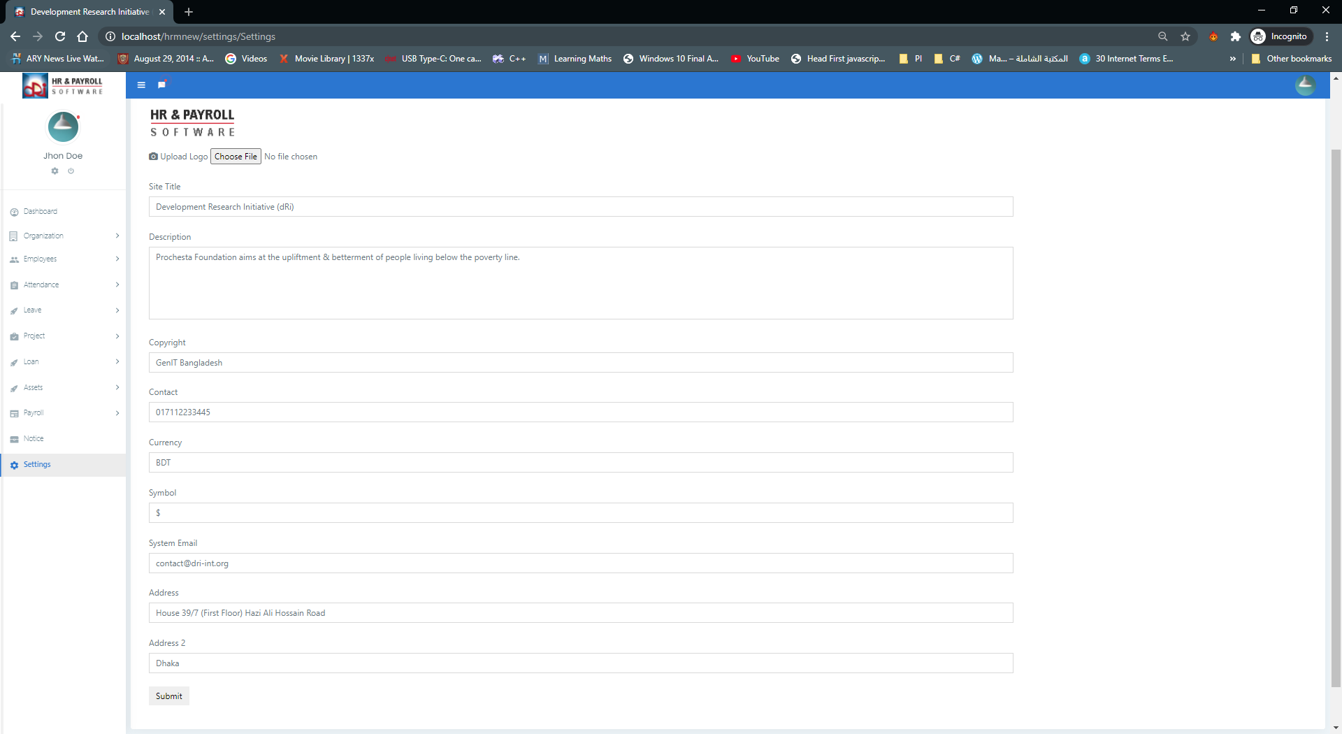

If you don’t upload the logo there will be a default log image to show, however the sample logo image must be present in your storage folder of the framework. Also, if you don’t supply any title the title will be the name of the page currently shown.

**MVC PATTERN:**

MVC Pattern is the Model-View - Controller Pattern. This design is used to distinguish the concerns of the programme.

**Model**: Model is an entity or JAVA POJO holding data. It may also have logic to upgrade the controller as the data changes.

**View**: View is a representation of the data that the model comprises.

**Controller**: Controller is working on both the interface and the view. Controls the data flow to the model object and adjusts the view as the data changes. The vision and the blueprint are kept apart.

Advantages of MVC over non-mvc coding patter:

**Faster development process:**

MVC encourages accelerated and simultaneous growth. If the MVC model is used to build some specific web application, it is likely that one programmer can work on the view and the other can work on the controller to create the business logic of the web application. As a result, the application developed using the MVC model can be finished three times quicker than the applications that are built using other architecture patterns.

**Ability to provide multiple views:**

You may create several views for a model in the MVC Package. There is an growing appetite today for innovative ways to access the application, and MVC creation is definitely a perfect solution. In addition, in this system, code replication is very minimal since it distinguishes data and business logic from the display.

### . Support for asynchronous technique:

The MVC architecture can also be combined with the JavaScript Framework. This means that MVC apps can be rendered to work with PDF files, site-specific plugins, as well as web widgets. MVC also provides an asynchronous strategy that allows developers to build an application that loads very quickly.

### The modification does not affect the entire model:

For any software application, the user experience appears to alter more often than the corporate principles of the.net production group. It is apparent that you make regular improvements to your web site, such as changing colours, fonts, screen formats, and introducing additional software features for cell phones or tablets. In comparison, inserting a new view type is very simple in the MVC template since the Model component does not rely on the view element. Therefore, any modifications to the Model would not impact the whole architecture.

### MVC model returns the data without formatting:

The MVC template returns data without any encoding. The same modules will also be used and named for use in any interface. For eg, any sort of data can be formatted with HTML, but it could also be formatted with Macromedia Flash or Dream Viewer.

### SEO friendly Development platform:

The MVC framework facilitates the creation of SEO-friendly web sites or web apps. Using this tool, it is very simple to create SEO-friendly URLs to produce further visitors to a particular application. This software architecture is widely used in testing-driven production applications. In addition, scripting languages such as JavaScript and jQuery can be combined with MVC to build feature-rich web applications.

Thus, the architecture style of the MVC is definitely a perfect approach to designing software applications. The MVC architecture is simple to incorporate as it provides various advantages. Projects that are developed with the aid of the MVC model can be conveniently implemented with less expense and with less time. Over everything, the ability to handle multiple views makes MVC the perfect architectural platform for creating web applications.

As a result, today companies are looking to develop.net software applications built on the MVC architecture for cost and time gains. There are several web development firms offering MVC software services to build web apps that fulfil any customer requirement. CodeIgniter is one such web software company that offers the most desirable output to its clients by delivering fast and highly immersive web applications using the MVC software architecture.

**Choosing MVC Framework:**

Considering the above-mentioned benefits over non-MVC programming styles. We used the CodeIgniter system. The decision was difficult to pick one of many MVC implementations. But finally, we've got to pick CodeIgniter. The decision was based on various criteria, the CodeIgniter footprint is very low relative to the other MVC system currently on the market. This will increase efficiency. The structure is for the agile method growth that is ideally tailored to our design. The documentation is well published and has an involved forum and lots of platforms.

**CodeIgniter Framework**

CodeIgniter is a flexible PHP framework with a very small footprint, designed for developers who need an simple and elegant toolkit to create full-featured web applications. CodeIgniter has been created by EllisLab and is now a project of the British Columbia Institute of Technology.

**CONCLUSION AND DISCUSSION**

This chapter of this article serves as a conclusion. It sums up the major findings from the chapter four review and also highlights the key points and then explores the methodological structure for work study and hypothesis.

**INTRODUCTION**

The chapter recommends best practices to be used for HR preparation. In tech companies, HR practitioners. Recommendations for future research will also be suggested.

**CONCLUSION**

The results of this research are focused on the review and perception of the primary data effect on HR Preparation on the work satisfaction of workers in software development organizations.

The results from the data analysis show that the existence of HR Preparation expertise, as shown by the relationship between HR Planning and the involvement of the HR Staff, could be more important in influencing the process of employee satisfaction. Furthermore, it has been established that there is a connection between the aspects of HR preparation listed by the HR management of the tech organizations and that help to improve the satisfaction of employees at work.

The job growth viewpoint of the software development workforce has clearly demonstrated that a very significant number of respondents are pleased with the information exchange practices, skills acquisition services that are organizational skills, team work and HR / orientation programmes offered by the organization that will expand their expertise to the respective fields of employment. However, others are not happy with the standard of in-house teaching. Any employees are not satisfied with the quality improvement programmes and are not willing to adopt new technology at the same time.

When evaluating job type / work load preparation in tech organizations, the findings indicate that the majority of workers clearly believe that the working hours determined by the company are more comfortable for them. Any of the workers are not in favor of working hours.

In comparison, a high number of workers are pleased with the task. They are eager to focus on their projects when they are more eager to do so. Relevant to their specifications.

It is obvious from the study that the majority of workers are pleased with the freedom at work provided by management to carry out their duties, but only a few of them do not feel comfortable with the freedom at work. In order to carry out the activities, managers should be granted ample independence and control such that they believe the outcome is 'ours' (Syptak et al., 1999). It is clear that workers are not happy with the workload and resource allocation by management for the delivery timeframes.

The study suggests that a minority (35.6 per cent) of workers are satisfied with the payment according to their roles and responsibilities and that the remaining employees are not pleased with the payment according to their roles and responsibilities. Accordingly, this study indicates that payment similar to duties and obligations is not quite satisfactory. Just a handful of the workers are happy with the advancement opportunities offered by the organization. This shows that workers do not have any prospects for growth.

It is concluded that virtually all workers are happy with the strategies and activities of the company. And only some of them (8.5%) do not appear to be happy with the policies and activities of the organization. It also demonstrates that the enforcement of the rules and obligations should be carried out equally by the management. The research reveals that only a relatively limited percentage of workers are happy with their job performance. And most of the remaining workers are not happy with the job security offered by the organization. It is also obvious from this study that there is a risk of work cuts among the workers of tech companies.

**Recommendations/Suggestions**

According to this form of study work and workload preparation, there is a substantial Effect on the productivity of workers of tech companies. When evaluating the causes of work satisfaction impacted, the tech firm management may consider the work arrangements and responsibilities allocated to it.

Employees and right to execute duties in such a manner as to delegate due responsibility to them regarding their assigned mission, which enhances their work satisfaction. Management, on the other hand, should consider employee involvement in the task and decision-making mechanism that helps to improve efficiency this is a mission. Management should also make it easier for them to put up their creativity ideas and appreciation of their contribution to the organization. When they're thinking

Employee engagement and involvement, management should also take into account compensation and remuneration conditions to arrange for them consequently.

**DIRECTIONS FOR FUTURE STUDY**

The purpose of this study was to examine the relationship between HR planning and employee job satisfaction in software organizations in.

Many modifications, simulations, and studies have been left for the future due to lack of resources (i.e. actual data trials are typically time intensive, taking several days to complete a single run). Future studies involve a closer study of existing processes, novel ideas to explore alternative approaches, or merely curiosity.

Only the web version of the HRM system has been developed. There's a lot of work going on with other novel papers.

Current change in mobile technologies demonstrates Smartphone phone is the key for the platform applied in this new age. This would improve the performance and revenue factor of the HRM Software. Since there is a very high number of smartphone devices relative to Web users.

A basic Smartphone application can be developed that can only display the data to the user and not persist the data in mobile permanent storage, which is at high risk of data breaching and constraining resources.

The creation of the RESTful API for the applications can be achieved to solve the above problems with web-services, which require more potential work. This will include the requisite endpoint and authentication capabilities for smartphone and other applications.

Restful APIs are a new way to exchange data between machine to machine. There is plenty of justification to persuade someone to use the API web services for their applications. And currently GraphQL is the best specification to incorporate the Restful API, which would significantly improve the performance factor.

In Chapter 3, all testing of the system is carried out manually. It's very tiresome and time-consuming to navigate through the user interfaces, press each and every button, place values in every input box, validate every SQL query made to the database.

All testing of the system is performed manually, which took a substantial period of time. Another idea could be automated testing process, which involves unit testing, application testing and integration testing. There are a lot of tools and previous novelties on this subject. However, it is very important to set up a testing process for such frameworks. A human tester cannot do what a computer can do with high precision with less time. Software Testing can be performed on the Stubs, which are dummy classes and the Database Seeder with some kind of Dummy Data. For this reason, there is a library known as Faker can be very helpful to build such a Testing System.

References

<http://dl.lib.mrt.ac.lk/bitstream/handle/123/12666/post-text.pdf?sequence=3&isAllowed=y>

<https://www.brainvire.com/six-benefits-of-using-mvc-model-for-effective-web-application-development/>

<https://www.tutorialspoint.com/design_pattern/mvc_pattern.htm>

<http://www.sc.ehu.es/acwbecae/ikerkuntza/these/Ch8.pdf>

<https://en.wikipedia.org/wiki/Dashboard_(business)>

https://www.tutorialspoint.com/codeigniter/index.htm