**Contents**

**Chapter 1:** Introduction 1

1.1 Scope of the Proposed System. 1

1.2 Methodology; 2

1.3 Tools 2

1.3.1 HTML 2

1.3.2 CSS 3

1.3.3 PHP 3

1.3.4 MY SQL 3

1.3.5 Bootstrap 3

1.3.6 XAMPP 3

1.3.7 Sublime text 3

1.3.8 Microsoft Office Automation (Ms Word) 3

1.3.9 Power point 4

1.3.10 Microsoft Visio 4

1.4 Literature Review 4

**Chapter 2:** Literature Review 6

2.1 HISTORY OF HRM 6

2.2 UNDERSTANDING HRM 8

2.3 Hrm Models 9

2.3.1 The Harvard Business School HRM Model 10

2.3.2 HRM Forms 11

2.4 HRM Perspectives 12

2.5 HRM Practices 14

2.6 HRM Measurements 15

2.7 The Modern Day Challenges 16

2.7.1 personnel management to human resource management 16

2.7.2 Industrial age to the information age 16

2.7.3 Financial capital to intellectual capital 17

2.7.4 Nationalization to globalization 17

2.8 How to Overcome These Challenges? 17

2.9 Proposed System for HRM 18

2.10 Why the proposed system will improve the current system? 19

2.11 Advantages of proposed system: 19

2.12 Conclusion 19

**Chapter 3:** System Analysis and Techniques 20

3.1 System Analysis 20

3.1.1 UML 20

3.2 Data Flow Diagram (DFD) 20

3.3 Overview diagram (level 0) 20

3.4 Detailed data flows: 21

3.4.1 First Level Data Flow Diagram (1st Level DFD) of Human Resource Management System: 21

3.5 Main functionalities of first level DFD (1st level DFD): 21

3.5.1 Second level data flow diagram (2nd level DFD) of human resource management system: 24

3.6 Entity Relationship Diagram (ERD) 28

3.7 Human Resource Management System entities and their attributes: 28

3.8 Human Resource Management Information Overview 29

3.9 Use case diagram 30

3.10 SEQUENCE DIAGRAM 32

3.11 Class diagram 34

3.12 MVC PATTERN: 34

3.12.1 Model: 34

3.12.2 View: 34

3.12.3 Controller: 34

3.13 Faster development process: 35

3.14 Ability to provide multiple views: 35

3.15 Support for asynchronous technique: 35

3.16 The modification does not affect the entire model: 35

3.17 MVC model returns the data without formatting: 35

3.18 SEO friendly Development platform: 36

3.19 Choosing MVC Framework: 36

3.19.1 CodeIgniter Framework 36

3.20 Methodology used for developing the framework; 37

3.21 System design 37

3.21.1 Overview: 37

3.22 HRMS architecture: 37

3.23 Description of procedures and functions: 38

3.23.1 Authentication 38

3.23.2 Authorization 38

3.23.3 Process data 38

3.24 Tools 39

3.24.1 HTML 39

3.24.2 CSS 40

3.24.3 PHP 40

3.24.4 MY SQL 40

3.24.5 Bootstrap 40

3.24.6 XAMPP 40

3.24.7 Sublime text 40

3.24.8 Microsoft Office Automation (Ms Word) 40

3.24.9 Power point 41

3.24.10 Microsoft Visio 41

**Chapter 4:** Results and discussion 42

4.1 Login Page 42

4.2 Dashboard 43

4.3 Account Settings 44

**Chapter 5:** CONCLUSION AND DISCUSSION 46

5.1 INTRODUCTION 46

5.2 CONCLUSION 46

5.3 Recommendations/Suggestions 47

5.4 DIRECTIONS FOR FUTURE STUDY 48

**Chapter 6:** References 50

**Chapter 7:** Appendices 53

7.1 Local Deployment of the Framework. 53

7.2 Code snippets from different module of the framework 54

**TABLE OF FIGURES**

Figure 3.3‑1: zero level DFD for human resource management system. 20

Figure 3.5‑1: Level 1 Data Flow Diagram for Human Resource Management System 22

Figure 3.5‑2: 2nd Level 1 Data Flow Diagram for Human Resource Manage System 22

Figure 3.5‑3: 2nd level 1 DFD Human Resource Management System 23

Figure 3.5‑4: 2nd Level DFD for Training Module in Human Resource Management System 23

Figure 3.5‑5: 2nd Level DFD Diagram for Report Module in proposed System 24

Figure 3.5‑6: 2nd Level Data Flow Diagram for Employee Module 25

Figure 3.5‑7: a 2nd Level 2 DFD for HRM about Employee Module 25

Figure 3.5‑8: b Level 2 Data Flow Diagram for Human Resource Management Employee Module 26

Figure 3.5‑9:c Level 2 Data Flow Diagram for Employee Module in HRM 26

Figure 3.5‑10:d 2nd Level DFD for Employee Module in HRM 27

Figure 3.5‑11:d Level 2 DFD Diagram for Employee Module in HRM 27

Figure 3.8‑1: Entity Relationship Diagram ERD) for Human Resource Management System (HRM) 29

Figure 3.9‑1: Use Case Diagram for Human Resource Management System 30

Figure 3.9‑2: Activity diagram for Human Resource Management System 31

Figure 3.10‑1: Sequence diagram for Human Resource Management System 32

Figure 3.10‑2: Sequence Diagram for adding Vacation of Human Resource Management System 33

Figure 3.10‑3: Sequence Diagram for salary data management 33

Figure 3.11‑1: Class Diagram for Human Resource Management System (HRM) 34

Figure 3.22‑1: Human Resource Management (HRM) Architecture Diagram 37

Figure 4.1‑1 Login page with text input field for user name and password with submit button 42

Figure 4.2‑1: Dashboard with various information for HRM Admin 43

Figure 4.3‑1: Account setting menu for user 44

Figure 4.3‑2: Account Setting page for HRM Admin logged in User 44

Figure 4.3‑3: Global Framework Setting page 45

**LIST OF ABBREVIATIONS**

Admin Administrator

Auth Authentication

CSS Cascading Style Sheet

DFD Data Flow Diagram

GUI Graphical User Interface

HR Human Recourses

HRM Human Resource Management

HTML Hypertext Markup Language

HTTP Hyper Text Transfer Protocol

HTTPS Secure Hyper Text Transfer Protocol

MS Microsoft

MVC Model view Controller

OOAD Object Oriented Analysis and Design

PHP Preprocessor Hyper Text PHP

SEO Search Engine Optimization

SQL Structure Query Language

UML Unified Modeling Language

URL Unified Resource Locator

XAMPP Cross Platform Apache, MySQL, Perl & PHP

# Introduction

Human resource administration (HRM), the administration of jobs and of individuals for the intended purposes, is a central task of any organization in which human beings are working. It is not something whose presence has to be elaborately justified: HRM is the natural result of the creation and development of an organization. Although there are a number of differences in the philosophies, methods, and management tools involved, HRM exists in some way or another.

It is one thing to challenge the relative success of specific HRM models in different contexts or their relation to improved corporate efficiency compared to other organizational assets, such as innovative manufacturing processes, promotional strategies and property acquisitions. There are main lines of research. It is quite another matter, though, to challenge the value of the HRM process itself, as if organizations could somehow thrive or expand without making a rational effort to coordinate work and handle people (Boxall and Steeneveld 1999). To wish HRM away is to wish all but the smallest of the businesses away.

With such a significant remit, there is a need for frequent assessments of the status of structured information in the field of HRM. Edited from the viewpoint of the middle of the first decade of the twenty-first century, this Handbook demonstrates a management methodology that is no longer an Adventist. Debates in the 1980s and 1990s, surrounding the introduction of HRM language, how it could be distinct from its ancestor, staff control, or how it could affect labor unions and labor relations, have given way to 'more practical issues: the effect of HRM on workplace efficiency and the work environment of workers' (Legge 2005: 221). These earlier discussions hold a central position in our comprehension of the subject, but the literature is no longer concerned with them.

## Scope of the Proposed System.

The project is used to keep the HR department schedule of every form of organization efficiently. Employees in bigger companies are huge. This paper is both useful and beneficial at that time. HR management system not only becomes the company's desire but it also becomes the company's need. The User uses an admin name and a password to access the device.

The proposed human resource management framework includes the Authentication and Authorization Facility. Authentication means the users who are permitted to use the tools of the company. Authentication ensures that authenticated users are permitted to work on whatever portion of the resource / organization they can or are required to operate.

The tradition of data availability is maintained in the proposed framework. If the total value of the organization is to be raised, the organization must plan the historical or current data in order to determine the statistic values that is only possible through the availability of data. The proposed framework therefore provides the data in digital form at any time the organization requires it.

Companies can visualize their most important Industry data with proposed framework that offers enhanced graphics, maps, graphs, metrics, and KPIs to better appreciate the wealth of insights before them.

## Methodology;

The HRMS, an online intranet system, will be used by four groups of personnel. These categories, which have different positions, can be defined as: admin, manager, HR, employee. -- user enters the main authentication page and will then be given permission by the device. Upon being approved according to their permissions (role type) users can basically query and edit the database via HRMS.

## Tools

The model proposed allowed extensive use of the following methods and technologies to achieve the desired results. Any of the technologies such as HTML, CSS , and JavaScript is used for user interface design. Although the PHP language is used to provide a connection between the user and database interfaces. MySQL is used as a database and data base management system.

### HTML

HTML stands for markup language of hypertext. HTML is the markups language. A markup language is a collection of tags for markups. The tags identify contents of the document. HTML documents have HTML tags and plain text in them. HTML documents are also known as Web Pages or Websites. Html is case insensitive. Currently HTML 5 is using in most of the web site hosted on the internet.

### CSS

CSS stands for Cascading Style Sheets. CSS defines how HTML elements are to be displayed. Styles were added to HTML 4.0 to solve a problem. CSS saves a lot of work. External Style Sheets are stored in CSS file.

### PHP

PHP stands for Hypertext Preprocessor (no, the acronym doesn't follow the name). It's an open source, server-side, scripting language used for the development of web applications. By scripting language, we mean a program that is script-based (lines of code) written for the automation of tasks.

### MY SQL

MySQL, the most popular Open Source SQL database management system, is developed, distributed, and supported by Oracle Corporation.

### Bootstrap

Bootstrap is a framework to help you design websites faster and easier. It includes HTML and CSS based design templates for typography, forms, buttons, tables, navigation, modals, image carousels, etc. It also gives you support for JavaScript plugins.

### XAMPP

XAMPP is a software distribution which provides the Apache web server, MySQL database (actually MariaDB), Php and Perl (as command-line executables and Apache modules) all in one package. ... Also provided is PhpMyAdmin which gives a GUI tool for managing your MySQL databases.

### Sublime text

Sublime Text - A sophisticated text editor for code, markup and prose. Use Multiple Selections to rename variables quickly here Ctrl+DD is used to select the next occurrence of the current word. Once created, each selection allows for full-featured editing.

### Microsoft Office Automation (Ms Word)

Microsoft Word is a widely used commercial word processor designed by Microsoft. Microsoft Word is a component of the Microsoft Office suite of productivity software, but can also be purchased as a stand-alone product.

### Power point

Microsoft PowerPoint is a professional tool for making presentations that's been around for decades. It's got a number of features that make it a powerful presentation tool.

### Microsoft Visio

Microsoft Visio is software for drawing a variety of diagrams. These include flowcharts, org charts, building plans, floor plans, data flow diagrams, process flow diagrams, business process modeling, swim lane diagrams

## Literature Review

Human capital is those that make up the workforce of a single company, community or business field. The word "human capital" should be understood as being synonymous with the term "human resources." Around the same time, however, "human resources" is generally referred to as a broader perspective, such as the expertise of people as well as economic development. Any other words that can also be used instead of "human capital" include "talent," "manpower," "labor," "workers" or "personnel."

Any section of human resources of any organization is required to conduct human resources   Admin, control of various facets of work (e.g. accordance with labor law, etc.) Any of the job requirements, certain forms of firing and recruiting, and Administration of the compensation of workers.

Any human resources officer is considered to be responsible for assessing the job-related demands of employees, employing flexible workers or retaining staff in order to fulfil those demands, attracting and educating the right staff, monitoring their jobs, handling employee relations, payrolls, salaries and compensation, planning personnel policies and documents, maintaining good morale, maintaining a high quality of efficiency, ensuring a high level of performance. Ensuring that human resources activities meet with the legislation and encouraging workers to accomplish more within their organization, human resources managers can find the idea of modeling pro software a valuable tool to provide the required human resources relevant drawings.

The human resource flowcharts system can be used to produce human resource specific sketches in the context of modeling professional diagramming and drawing tools, offering an extensive set of human resource-oriented symbols, links and photographs from the applicable stencil collections, helping to explain flowcharts, data graphics and process diagrams.

Using this method for analyzing human resource-related management processes at any level of human resource management, including recruiting, procurement process, payroll structures and human resource creation, human resource managers, like many other administrators, such as project managers, can accomplish more of their jobs by investing less time on their assignments.

The current HRM frameworks are thoroughly discussed in Chapter 2 of this paper. This framework, which adds new value and contributes in the field of human resource management, is then proposed.

The 3rd chapter of this document provides a thorough summary of the approaches used to achieve the proposed system, as well as a detailed explanation of the techniques and technologies used during the implementation of the proposed system. It also refers to the advantages and disadvantages of the technology used.

The results (interfaces) and outcomes (reports and databases) are explained in Chapter 4 of this paper. It also examines how to modify / expand the interfaces offered to the user and introduce a modern and advanced type of data visualization software.

The last but not least chapter of this paper summarizes the work completed in this paper and also offers proposals for the expansion of the structure suggested.

# Literature Review

The goal of this analysis is to examine more thoroughly the concept of HRM, its role on personnel management and its significance in the current scenario. In this "Think and Talk" age, the position of HRM has shifted with the introduction of platforms like LinkedIn, Facebook and Twitter, leaving aside the influence of globalization, technology, social change and human values. For several years, researchers and professionals have been engaged in a dialogue aimed at showing how human capital management being handled is critical to the organization’s success. Recent studies show that HRM activities affect HRM results such as turnover, tension and burnout, etc., which in turn influence corporate success metrics such as credibility, employee engagement, sales efficiency, return on investment, etc.

Human Resources Management is a collection of procedures that companies use to ensure that they have access to

Efficient labor force in order to satisfy organizational requirements. Effective organizations are those who respect, grow and maintain their human capital in order to accomplish their corporate goals and objectives. Human Resource Management Activities is a concept used by many organizations that describes the integration of typical managerial staff roles with efficiency, workforce engagement and resource planning. The goal of Human Resources is to optimize the return on investment from human capital of the enterprise and minimize financial risk. It is the responsibility of the administrators of human resources Conduct these practices in an appropriate, lawful, equitable and consistent manner.

Although there are a variety of meanings for HRM, the common element binding these meanings together is Emphasize the importance of connecting HRM policies and activities to operational efficiency.

## HISTORY OF HRM

By the end of the twentieth century, the management theory that characterized the role of staff had been developed. There have been drastic shifts. The Science Method and Public Affairs Method over the last 100 years human relations emerged and then faded, too.

Pre-World War II-Personal duties were confined to the "caregiver" role, much of which was engaged in the record keeping of employee records. The dominant strategy was the "Technical Method," the basic focus of which was to improve staff productivity using resources such as piece rate structures. As a result of relatively little government interventions in workplace relations, violations of workers, such as child labor, and poor working practices, have been widespread, resulting in the creation of a social welfare and administration department by some employers.

Post-World War II (1945-1960)-The World War II Public Relations movement stressed that workers were inspired not only by earnings, but also by social and psychological influences, such as appreciation of job successes and labor standards. The definition of job title, trade union and labor laws has developed through this time. Staff agencies tended to have different sections, such as procurement, labor affairs, wages and compensation, and political decisions.

Social problems age (1963-1980)-This time has seen an extraordinary rise in the number of labour law that has regulated different aspects of the work partnership, such as the prohibition of unfair acts, workplace health and safety, retirement insurance and tax control. It was at this time that the Human Resources Department started to be named the Human Resources Department and the field of human resource management was born. The need to comply with various workforce safety laws has made senior management mindful of the value of HRM functions. The staff role has been turned into a "protector" rather than a "caregiver" role.

Cost Efficient Period (1980 to the early 1990s) – The rising administrative workload intensified the need to satisfy a rising number of regulatory standards, while the overall organizational emphasis changed from employee governance to employee growth and engagement. In addition, there was a growing awareness within management that people's expenditures were a very significant part of their budgets. Any businesses have reported that staffing expenses are as high as 80% of their operational costs.

Emergence of Strategic HRM (1990 to the present) – The economic landscape has undergone dramatic changes in the 1990s, with growing globalization, technical breakthroughs, in particular the Internet – web-enabled technology – and hyper-competitiveness. Company process re-engineering activities have become more normal and regular with a variety of programmes, such as the correct size of staff, the lowering in management ranks, outsourcing, etc.

Firms now recognize that they are visionary and imaginative workers who hold the key to the company. Awareness offers a durable strategic advantage because, unlike other commodities, intellectual capital is impossible to replicate by rivals. As a result, the human resources role has been strategic in its significance and vision and is structured to recruit, maintain and engage talent. In and of rising significance Recognizing personnel and resources management in current organizations, Strategic HRM (SHRM) has been vital to organisational theory and practice. SHRM draws its fundamental meaning from the resource-based perspective of an organization that sees human resources as an asset.

## UNDERSTANDING HRM

Since this section has been dedicated to the concept of HRM, it is appropriate to start with the definitions provided by the founding fathers of the School of Human Resources Management, namely Beer et al . ( 1984) and Fombrum et al . ( 1984).

Beer et al . ( 1984) described HRM as including all management decisions and actions concerning the essence of the relationship between the company and the employee. Significant to note on this concept is the use of the term 'activity.' This made Beer and his colleagues the first to say that line managers are responsible for implementing successful HRM activities (Blyton and Turnbull, 1996; Armstrong, 1998).

The basic concept of HRM, which this analysis considered to be very important, is that of Miller (1987) when it described HRM as "the decisions and actions affecting the management of workers at all levels of the organization and related to the execution of strategies aimed at establishing and maintaining competitive advantages. This concept of HRM is important because it covers the key parts of the relationship between HRM activities and facets of organisational efficiency. We will see that this concept allows for the provision of HRM activities, performance expectations or techniques, and a means of bringing these two problems together in order to make these variations effective. In order to further expand on the comprehensiveness and consistency of this concept, hospital management, for example, can adopt and enforce rigorous HRM procedures, but can not suggest that operational efficiency can increase without defining performance objectives or expectations and a management strategy."

Edwin Flippo describes HRM as "planning, coordinating, overseeing, monitoring recruitment, creating, compensating, combining, sustaining and dividing human capital in order to achieve individual, corporate and social goals."

"HRM is a distinctive approach to job management that aims to gain a competitive edge through the systematic mobilization of a fully dedicated and competent workforce, using a variety of technological, operational and manpower strategies." Storey (1995: 5). While there is no agreement on the concept or features of HRM, it can be seen from the above descriptions that HRM is a hybrid of people-oriented management strategies that consider workers as assets, not costs; and its key goal is to build and retain a professional and dedicated workforce to achieve competitive advantage.

Differences in the understanding of HRM have contributed to two separate schools of thought: soft and hard versions of HRM (Storey, 1992). Soft and hard HRM are often also known as two major HRM models. Soft HRM focuses on workforce preparation, growth, interaction and involvement. It is used to describe HR roles directed at the morale , productivity and engagement of employees; hard HRM, on the other hand , focuses primarily on policy where human resources are used to accomplish corporate objectives. It is also related to cost management and headcount techniques, particularly in business processes such as downsizing, lowering salaries, limiting rest breaks, etc. (Beardwell and Claydon, 2007).

While HRM is a comparatively recent approach, this does not mean that it does not have its own origins in the old experiences applicable to human resource management. When we begin a study of the HRM models, we can find that the HRM Program has ties with other management systems, such as the Public Relations Program and the Science Management School.

## Hrm Models

This segment discusses some of the HRM models that have been described as a basis for the implementation of HRM behaviors that may be related to facets of organisational efficiency.

1. The Harvard Business School HRM Model;
2. The Michigan Business School HRM Model; and
3. The Best Practice HRM Model

### The Harvard Business School HRM Model

Harvard School has indicated that HRM has two characteristics:

* Line Managers are primarily responsible for maintaining the coordination of the strategic approach and Family policy
* The staff 's mission is to lay down rules that control the way staff operations are established and executed in ways that enable them.

It stresses the importance of the careful management of the human resource of the company in order to maintain unity and thus maximize production. The Harvard HRM paradigm views workers as tools.

Everyone has its own view of how these HRM models interpret human resource management in relation to organisational efficiency. Starting with the Harvard Business School Model and the Michigan Business School Model, the key concept of the first is to use the abilities of workers to improve facets of corporate efficiency. The second uses employees to accomplish organisational targets (Hendry and Pettigrew, 1990). For example, the Harvard Business School Model emphasizes the human component of human resource management while the Michigan Business School is perceived to be integral in the execution of corporate efficiency.

Thus, the Harvard Business School Model is generally accepted as taking its intellectual roots from the School of Human Relations, while the Michigan Business School Model tends to follow the path of the Science Management School and other models that disregard the importance of cultural problems and non-economic considerations in human resource management (Poole, 1990).

The best practice method for HRM is focused on universalism. The premise here is that the advantage of high engagement or high efficiency activities would support all companies regardless of context.

The elements of the best practices defined by Pfeffer (1998) are now commonly known, if not universally accepted:

Employment security/Job security

* Sophisticated selection / Selective hiring
* Team working and Decentralization
* High Wages linked to Organization performance
* Extensive training
* Narrow status differentials
* Communication and Employee involvement

### HRM Forms

European HRM administrators, especially in the United Kingdom, have concentrated increasingly on the distinction between soft and hard modes or variations of HRM. As Truss et al., who performed eight in-depth case studies in the United Kingdom, indicated, "Two of the most commonly accepted human resource management styles are hard and soft. These are focused on contrasting interpretations of human behavior and management strategy methods. The soft model stresses individuals and their self-orientation and puts commitment, confidence and self-regulation at the core of every strategic approach to people.

The hard paradigm, on the other hand, emphasizes the logic of strategic wellness and insists on success improvement and an instrumental approach to the management of people. The hard model is focused on conceptions of close strategic control, while the soft model is based on engagement management. A detailed review of the meanings of these two types of HRM suggests that the former is similar to the Harvard Business School Model, whereas the latter is similar to the Michigan Business School Model, both of which were described in the previous section.

This and the previous section demonstrate that there are two separate HRM types, each consisting of a number of beliefs, which are extended to categories humanism or utilitarian instrumentalism according to values of creation. The Harvard Business School Model and the HRM soft version are represented by the former method, called the developmental-humanist principle, while the Michigan Business School Model and the HRM hard version are defined by the latter view, the utilitarian-instrumentalist principle.

These two views, used to categories managerial methods, are evident in literature, but in reality, it is not easy to define any type of HRM. The assumption that organizations that implement these techniques prefer to pursue HRM methods, whether they be based on the humanist and the creation theory or the utilitarian-instructing method, conducive to the accomplishment of these strategy can be explained by Dr. Truss et al.: 'We found that there were no pure examples of either type.'

The concept of soft-hard HRM models by Guest and Storey makes the main difference between whether person or resource is the focus. Soft HRM is aligned with the campaign for public rights, the use of natural ability and McGregor's Philosophy Y outlook on people (developmental-humanism). This is tied to the principle of "a high-level interaction work framework," which "goes to contribute to ensuring that conduct, instead of managing the penalties or conditions external to the individual, is predominantly autonomous and that ties within the institutions are focused on high degree of confidence. Soft HRM is also linked to (in itself problematic) objectives of flexibility and adaptability and implies that communication plays a central role in management.

The hard HRM stresses on the other hand the "quantity, calculative and logistical aspects of handling the" headcount capital "as" fair "as any other development element." The hard HRM emphasizes the value of situational change as human resource strategies and activities are directly related to the organization’s strategic priorities (ex-).

## HRM Perspectives

Although the field has been criticized for the lack of a solid theoretical base. David Guest, a researcher not only called for a theory on HRM, one for performance and one for how both issues are linked to achieve clear understanding of HRM 's impact on the organization’s performance. In addition, he criticized the field for lacking a solid theoretic foundation. In 2001 David Guest reported, 'We threaten (or promise) that this region will be colonized by the economists unless we can establish our own more concrete theory as industry gradually recognizes the importance of human capital and social assets.

Delery and Doty have defined three groups of researchers and the approaches they have taken of theoretical HRM in a detailed literature review. The first group of 'universalists' investigators were named, the second as 'Contingency' and the third one as 'Configurational.' Gäste called these modes HRM theories respectively as analytical, functional and normative.

The first group of 'universalist' researchers were identified by Delery and Doty primarily because of their curiosity in defining 'best practice' HRM policies. "These scholars," Delery and Doty observed. It should be proposed that some human resources activities are better than others and that all organizations should follow certain best practices. "Through these methods, scholars dealing with investigating the connection between HRM practices and corporate metrics would chart and capture the field and identify the realities of both topics. Pfeffer argued that improved use of HRMs (e.g. work stability, domestic advancement, and education and development) would result in enhanced efficiency and benefit for organizations. Osterman proposed that there are a range of HRMs (e.g., task rotation teams, Quality Circle and maximum quality management) that contribute to better corporate performance. It is also believed that such HRM strategies would possibly contribute to improved corporate efficiency.

Delery and Doty 's second theorization group consists of scholars who follow an immediate approach. These scientists claim that the effectiveness of HRM policies relies on the connection between human resources policy and other facets of the organization, in line with the early framework for the contingency viewpoint of organisational philosophy. For example, studies taking that view have found that different policy on human resources can be expected at various points in the life cycle of an enterprise. The group has argued that the success of HRM activities relies on significant environmental factors. Therefore, this group believes that it needs to work between these environmental conditions and HRM activities to enhance the organisational efficiency.

Hendry and Pettigrew published some of the most successful studies in this area. Identifying significant environmental sources of HRM was their primary concern. They viewed HRM as the dependent variable when considering the world as the independent variable. Their immediate goal was therefore to decide to what degree HRM activities were acceptable. Their primary goal was then to examine the correlation of a suitable match with a strong organization.

A third group of HRM theories were described by Delery and Doty as following a configuration approach. Delery and Doty acknowledged that this is a more nuanced approach which involves researchers who aim to It is often said that this group of investigators approach their subject from a more analytical viewpoint and a significant number of the phenomena they are investigating may not actually be empirically measurable.

This group of researchers suggests that particular HRM activities have been established by organizations that are particularly effective in enhancing organization’s efficiency (such as internal promotion, knowledge exchange, decentralization and coherent employees). Configuration theories thus concluded that an organization must build an HRM structure that ensures both horizontal and vertical compatibility in order to maximize the facets of organisational results. The first refers to the internal continuity of the strategies and procedures of the organization on HRM, while the second refers to the coherence of the HRM structure with other operational features, including a full plan on efficiency.

The theory that HRM is related to organisational success is a common topic of all three theoretical viewpoints in HRM. While the literature has numerous assumptions that both HRM and success are related, this is not very empirically tested and the theoretical basis on which these ties are based is found to be insufficient. Therefore, more scientific advances and analytical studies are required to further understand the role of the application of human resources management in producing and retaining corporate efficiency and competitive advantage.

## HRM Practices

Effective companies, by developing a cool atmosphere in which their workers can continue to enhance, enhance their technical abilities, practice ingenuity and gain greater work fulfilment, are those who respect, grow and cultivate their human resources in order to meet their corporate priorities and objectives.

Researchers have over the years introduced several HRM activities, which can strengthen and improve the efficiency of organizations. These activities concentrate on workforce development based on business values, concentration on comportment, personality and necessary professional requirements for the job, performance-specific incentives and staff leadership to encourage teamwork, among others. An order to boost the outcomes of the company, Pfeffer suggested seven HRM activities.

The practices proposed by Pfeffer are:

1. Employment security.
2. Selective hiring of new personnel.
3. Self-managed teams and decentralization of decision making as the basic principles of organizational design.
4. Comparatively high compensation contingent on organizational performance
5. Extensive training
6. Reduces rank and obstacles like attire, accent, requirements for offices and pay disparities at various levels.
7. Extensive sharing in the whole enterprise of financial and results information.

## HRM Measurements

The main problem for HRM researchers is identifying reasons for HRM activities which can be related to corporate success metrics. Measuring HRM activities is "one of the most challenging analytical problems in some ways, as the guest indicated." This can be attributed to the difficulty of handling human capital, which are clearly affected by many influences, e.g. global effects on HRM strategies and procedures, technical progress, and the lack of clear HRM philosophy. Therefore, when choosing strategies for researching practices in HRM, HRM researchers need to be careful.

For HRM researchers, the key task is to establish explanations for HRM practices related to organisational performance measures. Measuring HRM operations, as the guest said, is "in several respects one of the most daunting research issues" because of the difficulties in managing HRC which is strongly shaped by several variables, such as global impact on strategies and procedures of HRM, technological advancement and the absence of a consistent HRM ideology. Consequently, HRM researchers need to be careful when considering methods for HRM testing activities.

With respect to the implementation of specific designs of respondents, Gerhart et al. submitted proof that measurements related to HR activities from individual respondents are accurate. The reliability of single raters was incredibly poor. Wright et al. repeated the findings substantially. These two papers (composed of four studies) together indicated that the reliability of individual raters may be near zero. In its response to the article by Gerhart et al., Huselid and Becker argued that in many cases the best positioned, and therefore only qualified single respondents (i.e. senior HR leaders) were to provide information on HR experience across a range of occupations. This led to the conversation of the most reliable source of knowledge of HR work.

Huselid and Becker have argued as a most reliable source of HR realistic results, using senior HR managers. Nevertheless, they argued that the constructively to be calculated need not generally be applied HR activities directly in the business rather than HR regulations. This prompted Gerhart etc. to propose that the use of workers as basis of HR activity data is a more rational solution if one wants to analyses individual activities. The method survey methodology was then used to evoke the opinions of educational schools and administrators to the degree that their company puts considerable focus on HRM activities.

## The Modern Day Challenges

The challenges derive from the changes that have taken place in recent decades. It is also best to first understand the improvements. The biggest developments that follow are that have undermined the conventional way of doing business.

* change from personnel management to human resource management
* change from the industrial age to information age.
* change from financial capital to intellectual capital
* change from nationalization to globalization

### personnel management to human resource management

The new streams of sustainable competitive opportunities for global business organizations, their innovation and talent, their inspirations and aspirations, their dream and optimism are at the heart of their work. To make use of this strategic advantage, companies need to develop people's interest in organizations, their expertise and excitement. The paradigm change would have the following consequences: creating a modern society in which people are an organization of greatest value; incorporating people core management; incorporation and engagement in strategic management and human resources management.

### Industrial age to the information age

The modern era centered on manual work, materials and natural resources in particular. The age of technology is comprehensive understanding, based on intelligence, facts, understanding and operation. From concentrating on goods to concentrating on innovations and knowledge exchange, the emphasis has shifted.

The implications of the move from the Industrial age to the Information age are-

1. The modern era centered on manual work, materials and natural resources in particular. The age of technology is comprehensive understanding, based on intelligence, facts, understanding and operation. From concentrating on goods to concentrating on innovations and knowledge exchange, the emphasis has shifted.
2. Introducing a digital lifestyle in which rising numbers of people use the internet for their everyday activities
3. The design of online or e-learning that enhances the training and development process within organizations
4. Forms in company and working environments for workers
5. Increased flexibility of employees and
6. Shift in the role of specialist human resources and business management.

### Financial capital to intellectual capital

The value of financial capital was the comparatively rare asset in the last century. Financial resources are nowhere more constrained and technology readily imitated. Only individuals in this decade will maintain a company's competitive edge. That's because people have three things, namely their capacity to generate rarity, merit and inimitability, that can offer a sustainable advantage. Intellectual capital consists of three elements, namely: human resources intellectual capital, intellectual property and intellectual property; human capital gained through practice, creation, and management of expertise.

The implications of this shift in paradigm are:

* 1. Introduction of intellectual capital principles, human capital and control of information
  2. the creation of an information sharing culture
  3. the empowerment of employees
  4. the creation of a learning culture
  5. the creation of a new source of competitive advantage in which employees with their knowledge and skills are at the heart of the organization

### Nationalization to globalization

International economies offer people a better chance to tap into ever-larger opportunities worldwide. It ensures that more money moves, innovations can be made available. Cheaper imports and wider markets for export. However, economies do not inherently mean the profits are spread by all. The results of the transition into a competitive economy are the following: businesses have access to a globalized workforce; the roles of a corporation will vary across the world through an internationally disarticulated method of labor and development, the way workers are hired and selected is being changed.

## How to Overcome These Challenges?

Its people's mind instead of their paws, which are important to the organization’s success and development. The digital economy has key assets that dedicated workers generate innovative innovations, produce value and drive growth.

It is important for the organizations to create an atmosphere marked by long-term economic growth, to ensure that the workers of the company are respected, to ensure a sense of belonging in the group, to encourage an attitude of camaraderie and that any employee can achieve his or her full personal, technical and artistic capacity. It is crucial to bear in mind that organizations need to encourage collaboration, functional groups and other types of social learning to create productive human resources. The flow of materials and the flow of in must be given the same priority.

Every employee in the company plays an important role in making information employees. Global preparation and advancement are necessary because individuals, roles and institutions, frequently vary significantly from one company to another in a global environment. The greatest comparative advantage of technology is the ability to adapt and apply it effectively. Leaders must be respected with knowledge-sharing individuals. This concept should be expressed in the principles and structure of an organization.

As businesses step on from globalization, digital technology and e-commerce, HRM has a major role to play. The HRM should incorporate online learning into its current growth and training functions.

## Proposed System for HRM

The decision to appoint the best skilled hands for the project is an important topic in the section for human resources management systems. The coordinator of the human resource department should report on the staff who have the expertise needed for the project mission. The decision in making analysis about the employee’s skills is a prime important before booting in.

The new HR module framework is the best programme to be implemented into the human resources management system automation to support organizations with their skillful human resource management needs. In addition to the curriculum, qualifications, expertise and job details the new framework offers comprehensive general employee information.

It facilitates the management of human capital by adding, displaying and reviewing the information of its staff and provides numerous reports on its skills and experience.

## Why the proposed system will improve the current system?

In order to improve the performance and organization of the HRMS on the website via designing these pieces, the full spectrum of human resources management services:

* Rules section.
* Compute the net salary after adding salary, promotions percentage and loans.
* Detailed reports section.
* Direct email communication.
* Statistical data charts.
* Training section
* Vacations section
* Salary
* Attendance

## Advantages of proposed system:

* Improved organization and efficiency of the full system of administration and human resources facilities.
* To build and enhance the new framework and provide employees with a common point of touch in order to follow protocols for handling human resources or to inquire for clarity.
* Expand the human resources framework scope to encompass all human resources programmes, including human resources training, monitoring of results, and Internet procurement processes.
* Trend analysis and monitoring are possible with human resources management system

## Conclusion

HRM is the central factor that unites the new era with the organization’s strategic management. Strategic management may discuss the implementation of the human center management, intellectual capital, human capital and information management, but these concerns are applied in the enterprise by means of preparation, recruiting and selection through human resources management. It makes sure that new technologies (internet and e-commerce) are dealt with and integrated in current courses for training and development.

# System Analysis and Techniques

## System Analysis

### UML

The world standard notation for OOAD is Universal Modeling Language (UML). It can be used in object modelling as a basic specialization language. Described by the OMG, the de-facto standard for developing object-driven software applications was already developed. The UML is a basic design language for the representation of structures in the field of software engineering.

In order to overcome the design and architecture problems, the UML was invented

Functional systems. Dynamic structures. The underlying aims or purposes behind UML modelling are:

* Built an easy-to-use vocabulary for visual modelling the configuration of a device
* Ensure extensibility
* Be independent of the language and medium for modelling a structure regardless of the framework built and introduced language and platform
* Require best practices in accordance with industry expectations
* Enable object orientation, structures and template creation and implementation.

## Data Flow Diagram (DFD)

A flow diagram is a flow diagram that helps you to display a device data pipeline and monitor how the data flows from the component to the component. This is an ideal method of discovering redundancies and maximizing device efficiency and flexibility.

## Overview diagram (level 0)

This diagram reveals that two individuals are the human resources department the owner and personnel. Actor asks to log in and performs his tasks as seen (see ).

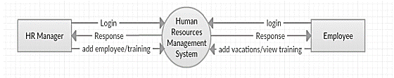

Figure ‑: zero level DFD for human resource management system.

## Detailed data flows:

### First Level Data Flow Diagram (1st Level DFD) of Human Resource Management System:

Level 1 (DFD) illustrates (see Figure 3.5‑1) how a system is divided into sub-systems (processes), which interact with one or more data streams from or through an external entity and together provide the entire purpose of the entire human resources management system. It also describes the internal data stores of the law of the human resource, presence, training, holiday, wage, which displays the flow of information between separate portions of compensation, presence, HR regulation, training, which system holiday. A more comprehensive overview of 1st Level DFD components is given by DFD Level 1.

## Main functionalities of first level DFD (1st level DFD):

* The Personal Resource Officer checks into the system and handles all human resources management system activities.
* Personnel management will add to the wage, benefits, the position of human resources and training documents, edit and erase them.
* Personnel administration may handle all job information, attendance and holidays.
* Personnel administrators may also provide staff surveys, compensation, performance, preparation and holidays
* Personnel managers should check at employee information, attendance, preparation and holidays
* Human resources manager can apply different level of filters on report of, training, and vacation
* Manager of personnel services can apply different filters levels to the study, training and holidays
* The manager for human resources will monitor employee data, compensation, training and holiday details

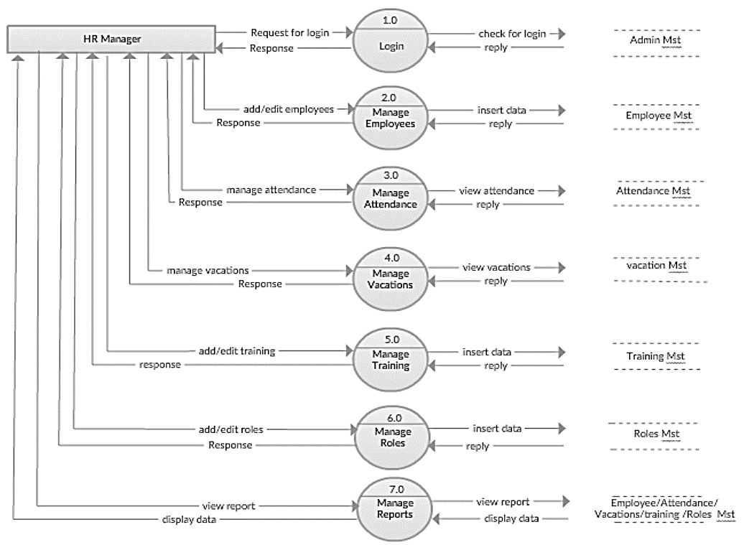

Figure ‑: Level 1 Data Flow Diagram for Human Resource Management System

This diagram Figure 3.5‑2 illustrates the key functionalities managers can regulate by the system suggested.

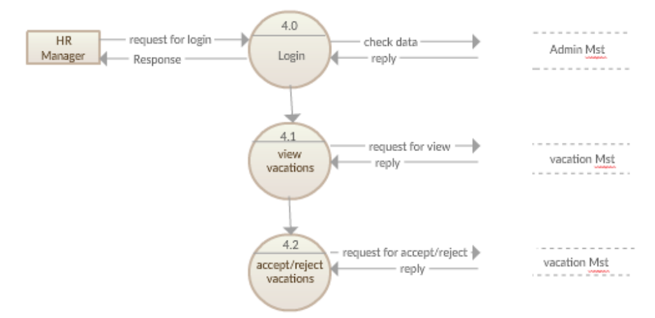

Figure ‑: 2nd Level 1 Data Flow Diagram for Human Resource Manage System

In figures (Figure 3.5‑3) through (Figure 3.5‑5) show detailed level 1 DFD for the human resources manager functionalities that proposed system will develop.

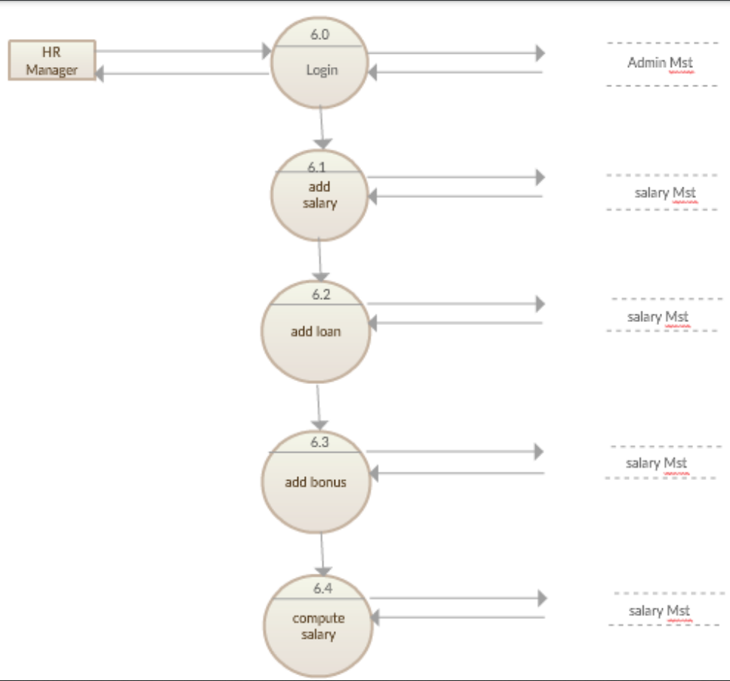

Figure ‑: 2nd level 1 DFD Human Resource Management System

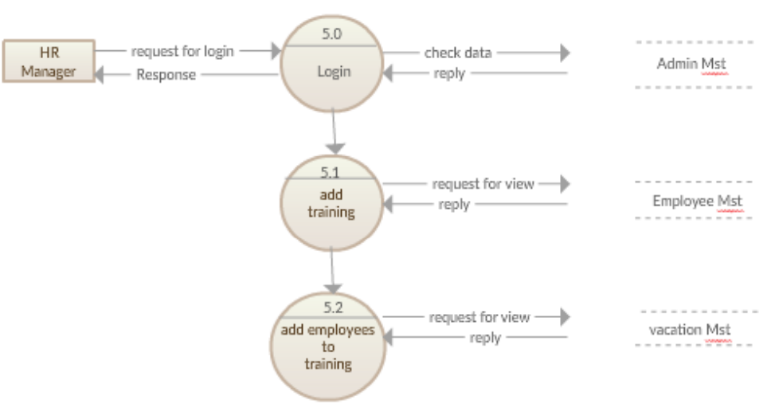

Figure ‑: 2nd Level DFD for Training Module in Human Resource Management System

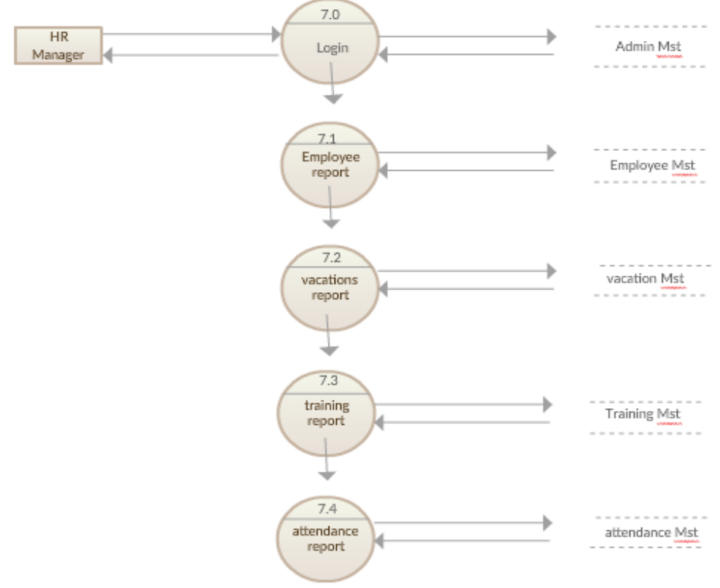

Figure ‑: 2nd Level DFD Diagram for Report Module in proposed System

### Second level data flow diagram (2nd level DFD) of human resource management system:

Level 2 of the DFD then deepens into the human resources level 1 DFD. More features of human resources can be needed to obtain the appropriate degree of information on the operation of human resources.

Main functionalities of second level DFD (2nd level DFD):

* Employee logins to the system and manage some the functionalities of human resource management system
* Employee can edit, change password and view his/her profile.
* Employee can view all details data of training, salary, attendance and vacation
* Employee can also add and confirm vacation.
* Employee can add attendance/leave data and confirm it.
* Employee can confirm going to training that human resources manager asked him/her to go.

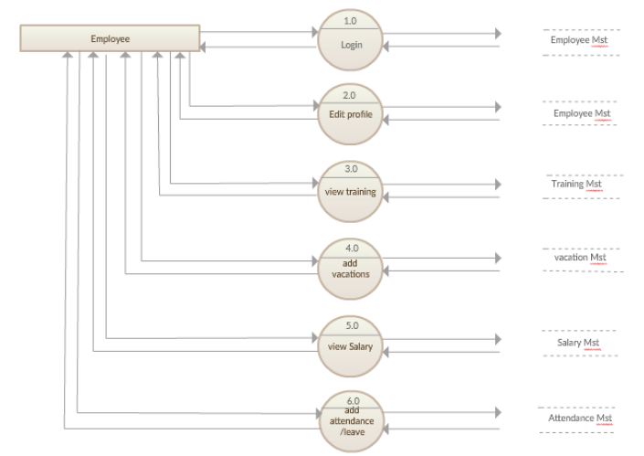

Figure ‑: 2nd Level Data Flow Diagram for Employee Module

This diagram illustrates the key features that can be managed by each company employee in the proposed framework.

Detailed level 2 DFD for each employee features that the proposed framework establishes in figures (Figure 3.5‑7 a) through (Figure 3.5‑10 d).

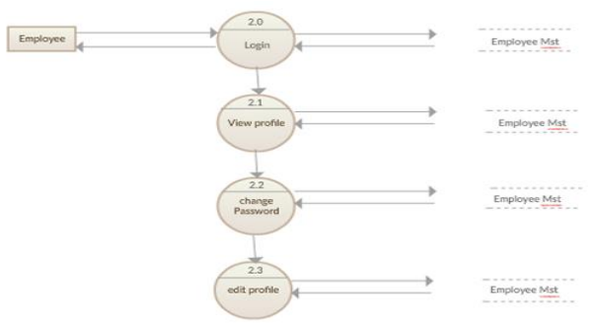

Figure ‑: a 2nd Level 2 DFD for HRM about Employee Module

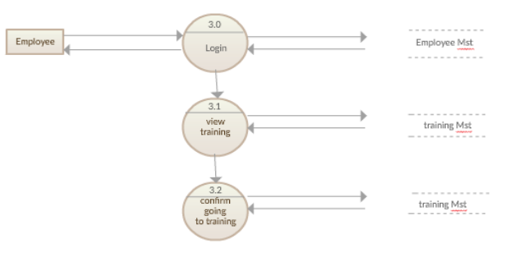

Figure ‑: b Level 2 Data Flow Diagram for Human Resource Management Employee Module

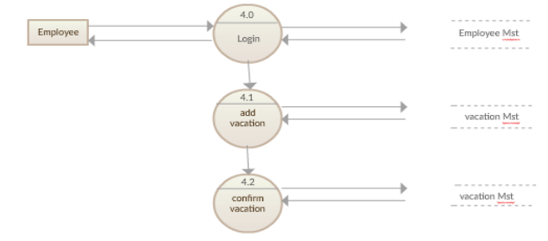

Figure ‑:c Level 2 Data Flow Diagram for Employee Module in HRM

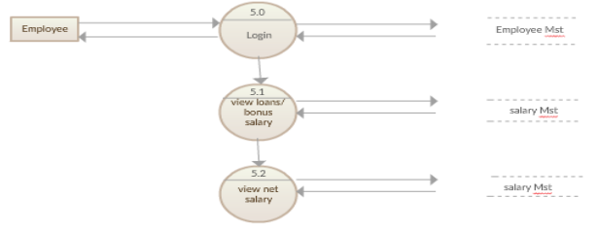

Figure ‑:d 2nd Level DFD for Employee Module in HRM

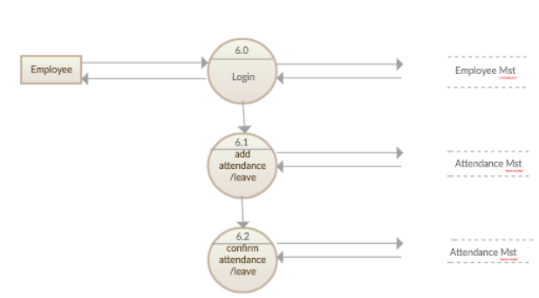

Figure ‑:d Level 2 DFD Diagram for Employee Module in HRM

## Entity Relationship Diagram (ERD)

The ER diagram depicts the concept of an organization overseeing the human resources department. The human resource management system organisational diagram displays the graphic database table resources and the interaction between preparation, programmes, staff, compensation etc. it uses hierarchical data and to identify the connections between structured data classes on the features of human resource management systems. Employees, recruitment, offices, pay and compensation are the primary bodies of the human resources management system.

## Human Resource Management System entities and their attributes:

* **Employee Entity**: Attributes of Employee are employee_id, employee_name, employee_mobile, employee_email, employee_username, employee_password, employee_address.
* **Trainings Entity**: Attributes of Trainings are training_id, training_employee_id, training_registration, training_name, training_type, training_year, training_description
* **Vacation Entity**: Attributes of vacations are vacation_id, vacation_employee_id, vacation_from_date, vacation_type, vacation_to_date
* **Departments Entity**: Attributes of Departments are department_id, department_name, department_type, department_description
* **Salary Entity**: Attributes of Salary are salary_id, salary_employee_id, salary_amount, salary_total, salary_type, salary_description
* **Attendance Entity**: Attributes of Attendance are attendance_id, attendance _employee_id, attendance_date
* **Evaluation Entity**: Attributes of Evaluation are eval_id, employee_id, eval_value,notes

## Human Resource Management Information Overview

As shown in Figure (Figure 3.8‑1), we find that the database schema of the human resources management system contains seven tables.

* The employee descriptions are kept in the employee tables of each table
* The main keys and single keys of each agency (assignments, vacations, wages, trainings, employees) are.
* The holiday company, the pay has blinded workers and international main training firms.
* Both salaries and offices, both vacations and workers there are One-to-One and One relationship.
* Both employee agencies, compensation is uniform and the number of papers is limited.
* We also carried out indexing for fast query execution on each table of human resources management tables

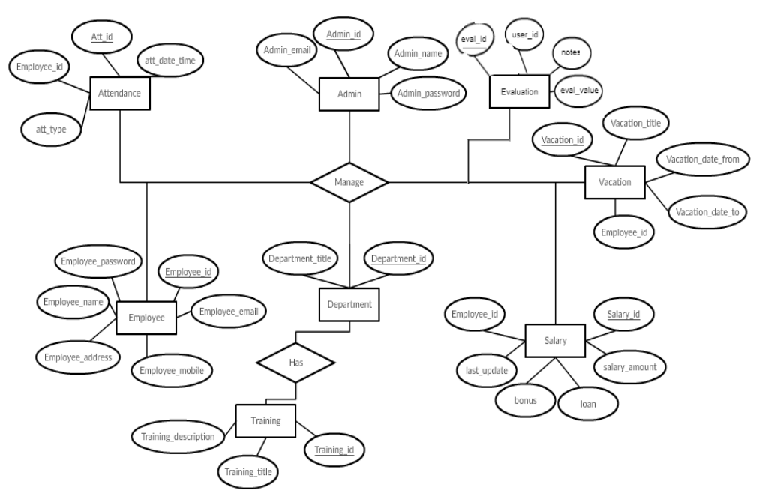

Figure ‑: Entity Relationship Diagram ERD) for Human Resource Management System (HRM)

## Use case diagram

As can be seen in figure (Figure 3.9‑1) the system manager and the employee share a range of operations.

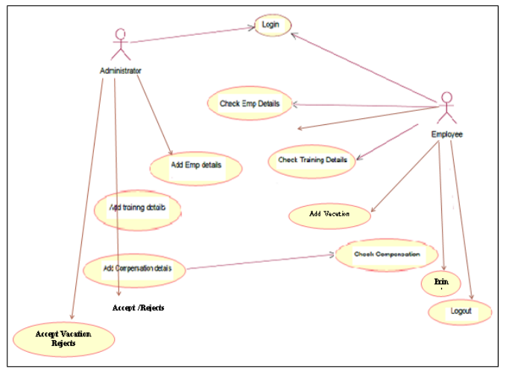

Figure ‑: Use Case Diagram for Human Resource Management System

As shown in Figure (Figure 3.9‑2), a system manager may create a holiday for the employee who is a part of the proposed scheme. If an error happens, the machine alerts the administrator.

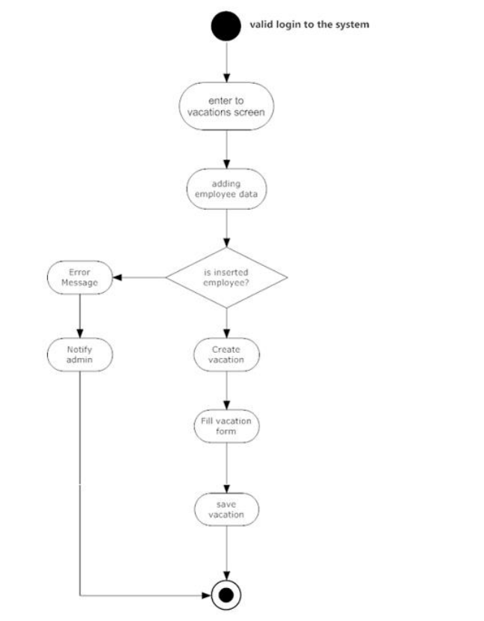

Figure ‑: Activity diagram for Human Resource Management System

## SEQUENCE DIAGRAM

The administrator and the employee will go through the proposed system until correct credentials are reached, as seen in figure (Figure 3.10‑1).

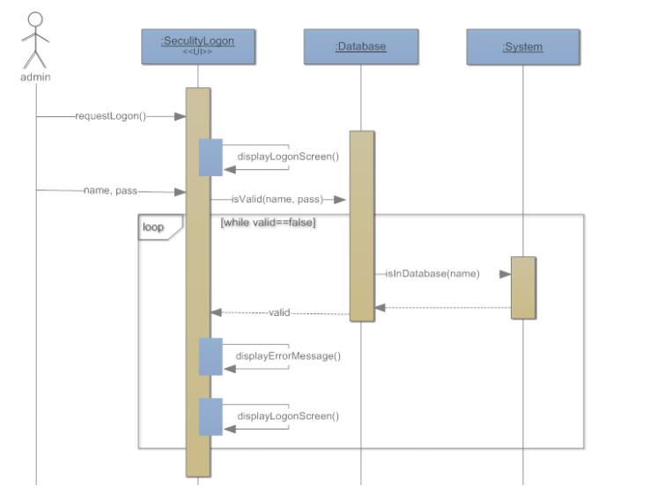

Figure ‑: Sequence diagram for Human Resource Management System

In the case of the employee in figure (Figure 3.10‑2), the system is able to order holiday and to complete the required details.

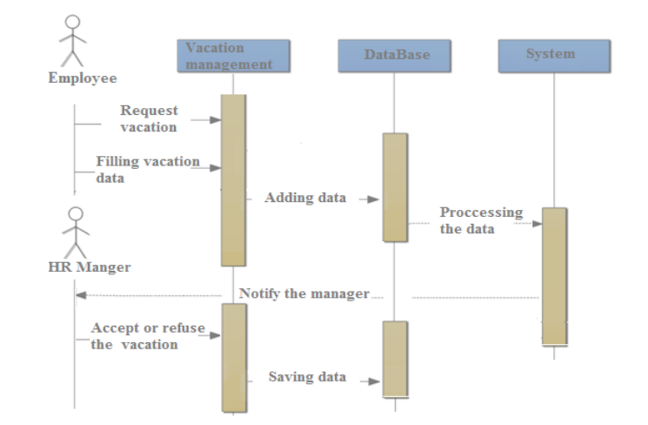

Figure ‑: Sequence Diagram for adding Vacation of Human Resource Management System

The HR manager will oversee the employee's pay by picking a worker who will then apply credit or bonus to the wage details. As seen in figure (Figure 3.10‑3). The pay details of the employee can be accessed.

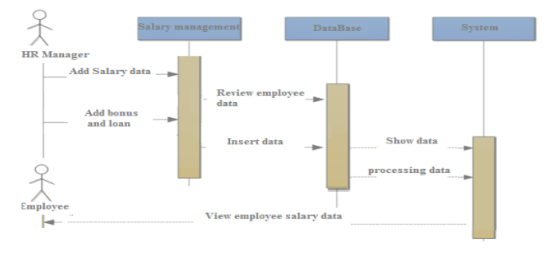

Figure ‑: Sequence Diagram for salary data management

## Class diagram

The structure includes eight groups of relationships as seen in Figure (Figure 3.11‑1). Column name and procedures are specified in-section.

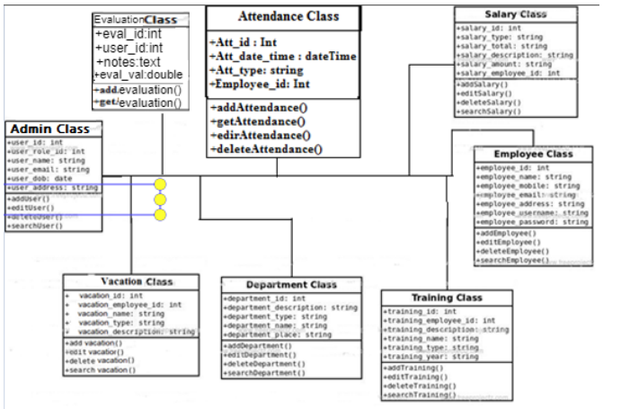

Figure ‑: Class Diagram for Human Resource Management System (HRM)

## MVC PATTERN:

MVC Pattern is the Model-View - Controller Pattern. This design is used to distinguish the concerns of the programmes.

### Model:

Model is an entity or JAVA POJO holding data. It may also have logic to upgrade the controller as the data changes.

### View:

View is a representation of the data that the model comprises.

### Controller:

Controller is working on both the interface and the view. Controls the data flow to the model object and adjusts the view as the data changes. The vision and the blueprint are kept apart.

Advantages of MVC over non-MVC coding patter:

## Faster development process:

MVC encourages accelerated and simultaneous growth. If the MVC model is used to build some specific web application, it is likely that one programmer can work on the view and the other can work on the controller to create the business logic of the web application. As a result, the application developed using the MVC model can be finished three times quicker than the applications that are built using other architecture patterns.

## Ability to provide multiple views:

You may create several views for a model in the MVC Package. There is an growing appetite today for innovative ways to access the application, and MVC creation is definitely a perfect solution. In addition, in this system, code replication is very minimal since it distinguishes data and business logic from the display.

## Support for asynchronous technique:

The MVC architecture can also be combined with the JavaScript Framework. This means that MVC apps can be rendered to work with PDF files, site-specific plugins, as well as web widgets. MVC also provides an asynchronous strategy that allows developers to build an application that loads very quickly.

## The modification does not affect the entire model:

For any software application, the user experience appears to alter more often than the corporate principles of the.net production group. It is apparent that you make regular improvements to your web site, such as changing colours, fonts, screen formats, and introducing additional software features for cell phones or tablets. In comparison, inserting a new view type is very simple in the MVC template since the Model component does not rely on the view element. Therefore, any modifications to the Model would not impact the whole architecture.

## MVC model returns the data without formatting:

The MVC template returns data without any encoding. The same modules will also be used and named for use in any interface. For example, any sort of data can be formatted with HTML, but it could also be formatted with Macromedia Flash or Dream Viewer.

## SEO friendly Development platform:

The MVC framework facilitates the creation of SEO-friendly web sites or web apps. Using this tool, it is very simple to create SEO-friendly URLs to produce further visitors to a particular application. This software architecture is widely used in testing-driven production applications. In addition, scripting languages such as JavaScript and jQuery can be combined with MVC to build feature-rich web applications.

Thus, the architecture style of the MVC is definitely a perfect approach to designing software applications. The MVC architecture is simple to incorporate as it provides various advantages. Projects that are developed with the aid of the MVC model can be conveniently implemented with less expense and with less time. Over everything, the ability to handle multiple views makes MVC the perfect architectural platform for creating web applications.

As a result, today companies are looking to develop.net software applications built on the MVC architecture for cost and time gains. There are several web development firms offering MVC software services to build web apps that fulfil any customer requirement. CodeIgniter is one such web software company that offers the most desirable output to its clients by delivering fast and highly immersive web applications using the MVC software architecture.

## Choosing MVC Framework:

Considering the above-mentioned benefits over non-MVC programming styles. We used the CodeIgniter system. The decision was difficult to pick one of many MVC implementations. But finally, we've got to pick CodeIgniter. The decision was based on various criteria, the CodeIgniter footprint is very low relative to the other MVC system currently on the market. This will increase efficiency. The structure is for the agile method growth that is ideally tailored to our design. The documentation is well published and has an involved forum and lots of platforms.

### CodeIgniter Framework

CodeIgniter is a flexible PHP framework with a very small footprint, designed for developers who need a simple and elegant toolkit to create full-featured web applications. CodeIgniter has been created by EllisLab and is now a project of the British Columbia Institute of Technology.

## Methodology used for developing the framework;

## System design

### Overview:

The production period of programmes applies to a sequence of phases or stages and all stages of the system in which a number of steps and the major phase falls below.

* Plan
* Analysis
* Design
* Implementation

## HRMS architecture:

Four groups of workers will use HRMS, an integrated intranet system. The following categories may be described as, admin, boss, hr, employee. -- user reaches the main page of authentication and the code grants them permission afterwards. Users can effectively query and edit the database using HRMS after being approved according to their permissions (role type).

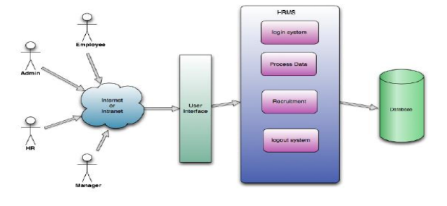

Figure ‑: Human Resource Management (HRM) Architecture Diagram

As seen in Figure 3.22‑1, the HRMS architecture where HRMS executes certain essential tasks. These functions form the base of the system as a whole.

## Description of procedures and functions:

This section discusses the core tasks and data flow of HRMS. The key features of the project, such as authentication system, processing of personal data, recruiting, are explained step by step.

### Authentication

* **Login** **user**: can login to the HRMS system with his/her username and password.
* **Logout** **user**: can logout from the HRMS system.
* **Login** **failure**: if the user does not exist in the database or the user did not get authorized by the HRMS admin yet.

### Authorization

* **User role check**: after logging in, the user role will be checked from the database and the user interface will be created according to that role/roles.

### Process data

* **Display:** The database content can be accessed by users with specified roles. More precisely, workers can only access their personal records. Managers may not only see their personal details, but also the details of staff who work under their scope. Administrative and HR can show personal data and information for all employees.
* **Edit:** a user can edit personal details on his / her own. The manager can edit personal details of the employees only, with the exception of the type of user position. With the exception of user position sort, HR will edit all employee records. Admin can edit all details pertaining to the user position class of all employees.
* **Search:** The management position form customer is able to check for the folder contents of his / her workers covered. The functions of the HR and admin will check in the database for all personnel records. Unique keywords indicating employee characteristics, information, abilities, capabilities etc. will be checked.
* **Report:** The key aim of this function is to filter the search method contents. As we described in the search function above, for example. The HR would like to receive a briefing from those special personnel who know "php." By clicking the appropriate checkbox for each employee, you will access the list of employees obtained from the output of the search function. Or a manager position form will get a report by clicking the checkbox from any or all of the workers who work under its jurisdiction. All other positions, including admin, HR and boss, may use the function except for employee job form.
* **Update Authentication:** Only the admin form may user can use this feature. Administrator can change a user's function class. For instance, a worker has earned a promotion and may change his position from the position of employee to the role of manager. This authentication system can be modified by the administration.

For this project we have chosen the Agile Software Development Paradigm which is:

Agile development of software refers to software development methodologies based around the concept of iterative development, where demands and solutions are created through cooperation between cross functional, self-organized teams. The overall advantage of Agile growth is that teams can produce performance better, more efficiency and more predictability and the ability to adapt to change. The Agile methodologies Scrum and Kanban are two of the most often employed.

For the fast product delivery, we have code, test and implementation pattern used.

The HRMS, an online intranet system, will be used by four groups of personnel. These categories, which have different positions, can be defined as: admin, manager, HR, employee. -- user enters the main authentication page and will then be given permission by the device. Upon being approved according to their permissions (role type) users can basically query and edit the database via HRMS.

## Tools

The model proposed allowed extensive use of the following methods and technologies to achieve the desired results. Any of the technologies such as HTML, CSS , and JavaScript is used for user interface design. Although the PHP language is used to provide a connection between the user and database interfaces. MySQL is used as a database and data base management system.

### HTML

HTML stands for markup language of hypertext. HTML is the markups language. A markup language is a collection of tags for markups. The tags identify contents of the document. HTML documents have HTML tags and plain text in them. HTML documents are also known as Web Pages or Websites. Html is case insensitive. Currently HTML 5 is using in most of the web site hosted on the internet.

### CSS

CSS stands for Cascading Style Sheets. CSS defines how HTML elements are to be displayed. Styles were added to HTML 4.0 to solve a problem. CSS saves a lot of work. External Style Sheets are stored in CSS file.

### PHP

PHP stands for Hypertext Preprocessor (no, the acronym doesn't follow the name). It's an open source, server-side, scripting language used for the development of web applications. By scripting language, we mean a program that is script-based (lines of code) written for the automation of tasks.

### MY SQL

MySQL, the most popular Open Source SQL database management system, is developed, distributed, and supported by Oracle Corporation.

### Bootstrap

Bootstrap is a framework to help you design websites faster and easier. It includes HTML and CSS based design templates for typography, forms, buttons, tables, navigation, modals, image carousels, etc. It also gives you support for JavaScript plugins.

### XAMPP

XAMPP is a software distribution which provides the Apache web server, MySQL database (actually MariaDB), Php and Perl (as command-line executables and Apache modules) all in one package. ... Also provided is PhpMyadmin which gives a GUI tool for managing your MySQL databases.

### Sublime text

Sublime Text - A sophisticated text editor for code, markup and prose. Use Multiple Selections to rename variables quickly here Ctrl+DD is used to select the next occurrence of the current word. Once created, each selection allows for full-featured editing.

### Microsoft Office Automation (Ms Word)

Microsoft Word is a widely used commercial word processor designed by Microsoft. Microsoft Word is a component of the Microsoft Office suite of productivity software, but can also be purchased as a stand-alone product.

### Power point

Microsoft PowerPoint is a professional tool for making presentations that's been around for decades. It's got a number of features that make it a powerful presentation tool.

### Microsoft Visio

Microsoft Visio is software for drawing a variety of diagrams. These include flowcharts, org charts, building plans, floor plans, data flow diagrams, process flow diagrams, business process modeling, swim lane diagrams

# Results and discussion

After the code has been deployed on a local apache web server, we'll take you through the numerous coding snippets and user interfaces from here in the chapter.

We assume it will be very beneficial for the understanding of the framework.

## Login Page

When the admin first visits the website Page, a login screen is displayed (see Figure 4.1‑1), which is quite elegantly and aesthetically built. This is shifting the negative attitude of the frustrated accountant. In the Splash Screen, the accountant / admin enters their e-mail address and password that were previously listed in the database. If the credentials match the database entries, it will be authenticated to the system. If the authentication process fails, this means that the certificate is wrong, the admin / user will be faced again with the same splash screen.



Figure ‑ Login page with text input field for user name and password with submit button

## Dashboard

Upon completion of the authentication process, the user / admin will be logged into the framework. The first screen they showed is the Dashboard Page (see Figure 4.2‑1). By definition Dashboard means "A dashboard is a type of graphical user interface that frequently shows key performance metrics relating to a particular goal or business operation. In other words," dashboard "is another term for" development report "or" analysis. "The proposed framework dashboard is designed with various aspects in mind and would be really useful for the HRM admin. The dashboard is designed in such a way that the admin/user can quickly say what the current status is of the company. He is presented with eh following key entities.

1. The key entities which admin will be presented with are as follows:
2. Number of employees registered
3. Number of leaves currently in the database
4. Number of currently registered projects.
5. Number of loan Applications
6. Number of Ex-employees
7. Number Loans given
8. Number of Upcoming projects
9. Number of Loan Applications
10. List of Notice Board
11. To do list
12. List of Currently Running Projects
13. List of Holidays

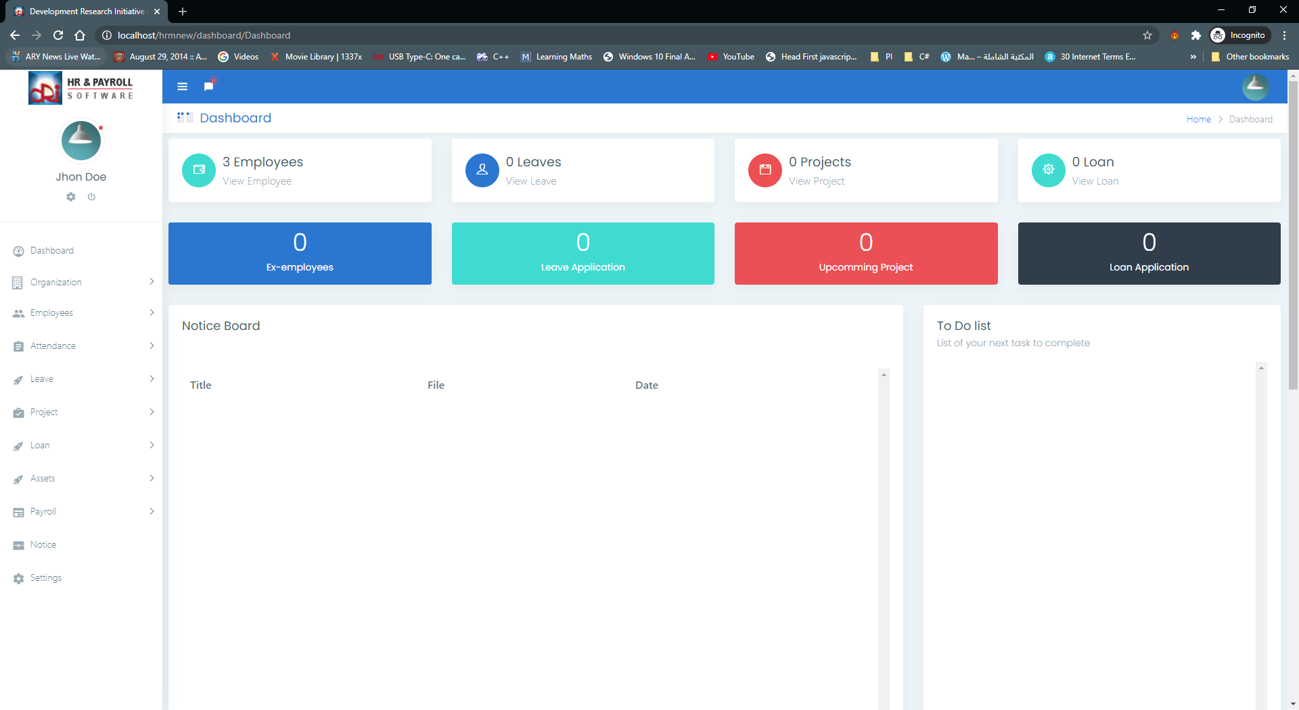

Figure ‑: Dashboard with various information for HRM Admin

## Account Settings

To the right of the dashboard, the admin is provided with the ability to modify / custodial his / her records. When admin clicks on the avatar (see Figure 4.3‑1), the menu opens and has three options, one for logout features, if one clicks on the tab, the session data will be deleted from the window.

My profile link will take you to the Account Settings tab (see Figure 4.3‑2), which gives you plenty of choices to enter your details. The page is split into various sections, which are very user-friendly. After the data is entered in the necessary filed, the data will be sent to the database for persistence. The framework configuration tab is a global setting that can alter the actions of the application.



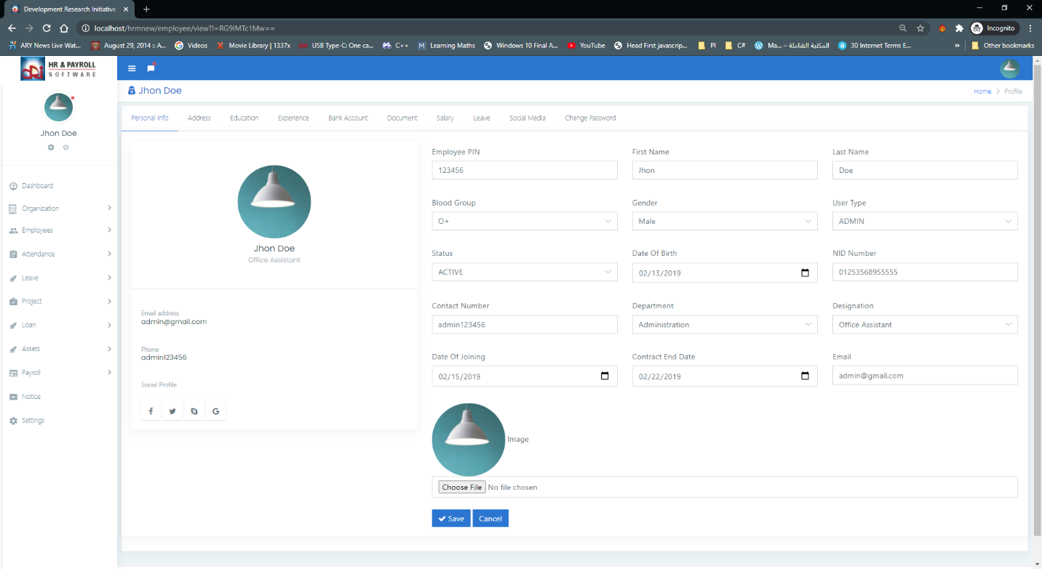

Figure ‑: Account setting menu for user

Figure ‑: Account Setting page for HRM Admin logged in User

Page settings depicted in picture (see Figure 4.3‑2). This page includes a global environment, if you adjust any of the settings on this tab, it will extend to the entire system.

Setting the page allows you the flexibility to modify the logo of the organization, the title of the organization, the address, the phone number. This is a very useful feature to have in HRM, each organization will have its own identity on the web.

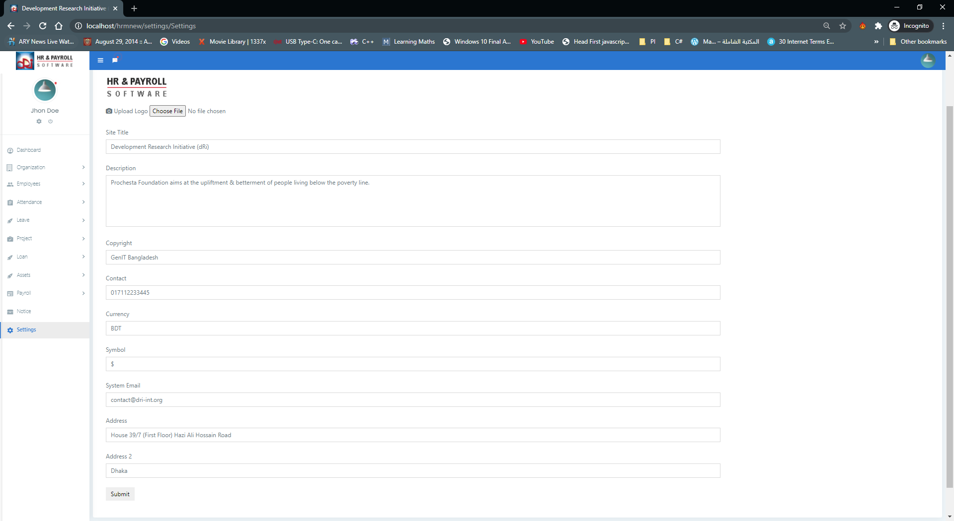

Figure ‑: Global Framework Setting page

If you don’t upload the logo there will be a default log image to show, however the sample logo image must be present in your storage folder of the framework. Also, if you don’t supply any title the title will be the name of the page currently shown.

# CONCLUSION AND DISCUSSION

This chapter of this article serves as a conclusion. It sums up the major findings from the chapter four review and also highlights the key points and then explores the methodological structure for work study and hypothesis.

## INTRODUCTION

The chapter recommends best practices to be used for HR preparation. In tech companies, HR practitioners. Recommendations for future research will also be suggested.

## CONCLUSION

The results of this research are focused on the review and perception of the primary data effect on HR Preparation on the work satisfaction of workers in software development organizations.

The results from the data analysis show that the existence of HR Preparation expertise, as shown by the relationship between HR Planning and the involvement of the HR Staff, could be more important in influencing the process of employee satisfaction. Furthermore, it has been established that there is a connection between the aspects of HR preparation listed by the HR management of the tech organizations and that help to improve the satisfaction of employees at work.

The job growth viewpoint of the software development workforce has clearly demonstrated that a very significant number of respondents are pleased with the information exchange practices, skills acquisition services that are organizational skills, team work and HR / orientation programmes offered by the organization that will expand their expertise to the respective fields of employment. However, others are not happy with the standard of in-house teaching. Any employees are not satisfied with the quality improvement programmes and are not willing to adopt new technology at the same time.

When evaluating job type / work load preparation in tech organizations, the findings indicate that the majority of workers clearly believe that the working hours determined by the company are more comfortable for them. Any of the workers are not in favor of working hours.

In comparison, a high number of workers are pleased with the task. They are eager to focus on their projects when they are more eager to do so. Relevant to their specifications.

It is obvious from the study that the majority of workers are pleased with the freedom at work provided by management to carry out their duties, but only a few of them do not feel comfortable with the freedom at work. In order to carry out the activities, managers should be granted ample independence and control such that they believe the outcome is 'ours' (Syptak et al., 1999). It is clear that workers are not happy with the workload and resource allocation by management for the delivery timeframes.

The study suggests that a minority (35.6 per cent) of workers are satisfied with the payment according to their roles and responsibilities and that the remaining employees are not pleased with the payment according to their roles and responsibilities. Accordingly, this study indicates that payment similar to duties and obligations is not quite satisfactory. Just a handful of the workers are happy with the advancement opportunities offered by the organization. This shows that workers do not have any prospects for growth.

It is concluded that virtually all workers are happy with the strategies and activities of the company. And only some of them (8.5%) do not appear to be happy with the policies and activities of the organization. It also demonstrates that the enforcement of the rules and obligations should be carried out equally by the management. The research reveals that only a relatively limited percentage of workers are happy with their job performance. And most of the remaining workers are not happy with the job security offered by the organization. It is also obvious from this study that there is a risk of work cuts among the workers of tech companies.

## Recommendations/Suggestions

According to this form of study work and workload preparation, there is a substantial Effect on the productivity of workers of tech companies. When evaluating the causes of work satisfaction impacted, the tech firm management may consider the work arrangements and responsibilities allocated to it.

Employees and right to execute duties in such a manner as to delegate due responsibility to them regarding their assigned mission, which enhances their work satisfaction. Management, on the other hand, should consider employee involvement in the task and decision-making mechanism that helps to improve efficiency this is a mission. Management should also make it easier for them to put up their creativity ideas and appreciation of their contribution to the organization. When they're thinking

Employee engagement and involvement, management should also take into account compensation and remuneration conditions to arrange for them consequently.

## DIRECTIONS FOR FUTURE STUDY

The purpose of this study was to examine the relationship between HR planning and employee job satisfaction in software organizations in.

Many modifications, simulations, and studies have been left for the future due to lack of resources (i.e. actual data trials are typically time intensive, taking several days to complete a single run). Future studies involve a closer study of existing processes, novel ideas to explore alternative approaches, or merely curiosity.

Only the web version of the HRM system has been developed. There's a lot of work going on with other novel papers.

Current change in mobile technologies demonstrates Smartphone phone is the key for the platform applied in this new age. This would improve the performance and revenue factor of the HRM Software. Since there is a very high number of smartphone devices relative to Web users.

A basic Smartphone application can be developed that can only display the data to the user and not persist the data in mobile permanent storage, which is at high risk of data breaching and constraining resources.

The creation of the RESTful API for the applications can be achieved to solve the above problems with web-services, which require more potential work. This will include the requisite endpoint and authentication capabilities for smartphone and other applications.

Restful APIs are a new way to exchange data between machine to machine. There is plenty of justification to persuade someone to use the API web services for their applications. And currently GraphQL is the best specification to incorporate the Restful API, which would significantly improve the performance factor.

In Chapter 3, all testing of the system is carried out manually. It's very tiresome and time-consuming to navigate through the user interfaces, press each and every button, place values in every input box, validate every SQL query made to the database.

All testing of the system is performed manually, which took a substantial period of time. Another idea could be automated testing process, which involves unit testing, application testing and integration testing. There are a lot of tools and previous novelties on this subject. However, it is very important to set up a testing process for such frameworks. A human tester cannot do what a computer can do with high precision with less time. Software Testing can be performed on the Stubs, which are dummy classes and the Database Seeder with some kind of Dummy Data. For this reason, there is a library known as Faker can be very helpful to build such a Testing System.

# References

<http://dl.lib.mrt.ac.lk/bitstream/handle/123/12666/post-text.pdf?sequence=3&isAllowed=y>

<https://www.brainvire.com/six-benefits-of-using-mvc-model-for-effective-web-application-development/>

<https://www.tutorialspoint.com/design_pattern/mvc_pattern.htm>

<http://www.sc.ehu.es/acwbecae/ikerkuntza/these/Ch8.pdf>

<https://en.wikipedia.org/wiki/Dashboard_(business)>

https://www.tutorialspoint.com/codeigniter/index.htm

Becker, B. E., & Huselid, M. A. (2006). Strategic human resource management: Where do we go from here? Journal of Management, 32(6), 898–925.

Becker, B. E., Huselid, M. A., & Ulrich, D. (2001). The HR scorecard: Linking people, strategy, and performance. Boston: Harvard Business School Press.

Beckers, A. M., & Bsat, M. Z. (2002). A DSS classification model for research in human resource information systems. Information Systems Management, 19(3), 41–50.

Bussler, L., & Davis, E. (2001/2002). Information systems: The quiet revolution in human resource management. Journal of Computer Information Systems, 42(2), 17–20.

Greer, C. (1995). Strategy and human resources: A general managerial perspective. Englewood Cliffs, NJ: Prentice Hall.

Haiyaf Salih Al- Amri ( No 2001).Human Resource Management practices and Performance Indicators in Hospitals

Huselid, M. A., Becker, B. E., & Beatty, R. W. (2005). The workforce scorecard: Managing human capital to execute strategy. Boston: Harvard Business School Press.

Huselid, M. A., Jackson, S. E., & Schuler, R. S. (1997). Technical and strategic human resource management effectiveness as determinants of firm performance. Academy of Management Journal,40, 171–188.

Kavanagh, M. J., Gueutal, H. G., & Tannenbaum, S. I. (1990). Human resource information systems. Boston: PWS-Kent.

Lawler, E. E., & Mohrman, S. A. (2003). HR as a strategic business partner: What does it take to make it happen? Human Resource Planning, 26(3), 15–29.

Lengnick-Hall, C. A., & Lengnick-Hall, M. L. (2006). HR, ERP, and knowledge for competitive advantage. Human Resource Management, 45(2), 179–194. [12]. Martinsons, M. G., & Chong, P. K. C. (1999). The influence of human factors and specialist involvement on information systems success. Human Relations, 52(1), 123–152. [13]. Ngai, E. W. T., & Wat, F. K. T. (2004). Human resource information systems: A review and empirical analysis. Personnel Review, 35(3), 297–314.

Porter, M. E. (1990). The competitive advantage of nations. Boston: Free Press.

Roberts, B. (1999). Calculating return on investment for HRIS. HR Magazine, 44(13), 122– 127.

Roehling, M. V., Boswell, W. R., Caligiuri, P., Feldman, D., Graham, M. E., Guthrie, J. P., et al.(2005). The future of HR management: Research needs and directions. Human Resource Management, 44(2), 207–216.

Smith, A. F., & Kelly, T. (1997). Human capital in the digital economy. [18]. Mohan Thite and Michael J.Kavanagh- Human resource management and human resource information system .chapter-1

M. Goldsmith, & R. Beckhard (Eds.), The organization of the future (pp. 199–212). San Francisco: Jossey-Bass.

Sprague, R. H., & Carlson, E. D. (1982). Building effective decision support systems. Englewood Cliffs,NJ: Prentice Hall.

Thite, M. (2004). Managing people in the new economy. New Delhi, India: Sage. Ulrich, D., & Smallwood, N. (2005). HR‟s new ROI: Return on intangibles. Human Resource Management, 44(2), 137–142.

Walker, A. J. (1982). HRIS development: A project team guide to building an effective personnel information system. New York: Van Nostrand Reinhold.

Wendy H.Rennie (August 2003):The role of Human resource management and human resource professional in the new economy

Wright, P., McMahan, G., Snell, S., & Gerhart, B. (1998). Strategic human resource management:

Building human capital and organizational capacity (Technical report). Ithaca, NY: Cornell University. ww.cipd.co.uk/hr-resources/factsheets/history-hr-cipd.aspx

# Appendices

## Local Deployment of the Framework.

In order to deploy this framework locally you have to follow the following step by step procedure.

Step 1: First Install the XAMPP package from the respective website. This package is a software suit for web related technologies. The suit contains Apache Web Server which is required if you want to run PHP scripts in your local computer. PHP Language Compiler. Perl Language Compiler and other goodies.

Step 2: After Installing the above software suit, a new folder named XAMPP will be created in C:/xampp/. If you don’t have changed the installation destination. Inside C:/xampp/ directory there will be another directory named /htdocs. Copy this all of this project files into this directory so the path will be like this C:/xampp/htdocs/project_folder.

Step 3: After completing step 2 go to the web browser and type the URL “localhost/phpMyAdmin”, the database page will be shown create a new database or import the supplied one (in the CD packed with this project).

Step 3: After step 3 go to the web browser and open the URL “localhost/your_project_folder_name and hit enter. The index page will be shown on the browser. Login to the framework with the proper credentials.

## Code snippets from different module of the framework

