**Reproducibility from NeurIPS Papers**

**Paper Title**: Are Self-Attentions Effective for Time Series Forecasting?

**Paper Link** : <https://arxiv.org/abs/2405.16877>

**GitHub Repo**: <https://github.com/dongbeank/CATS>

**Collab Link:** <https://colab.research.google.com/drive/1UI0TmR-uJ5H3fl5Gt5-QY18iKrdk4tZB?usp=sharing>

**Reproduced Result:**

We successfully cloned the CATS GitHub repository, installed all dependencies, and reproduced the authors' results on the ETT dataset using the provided configuration files. We validated model performance and confirmed that the forecasting outputs matched the expected results in the paper (e.g., trend shape and MSE scores).

**Custom Integration with Our Project**

We integrated the CATS model into our own AI-driven project:  
**"AI-Powered Supply Chain Resilience Index (SCRI) for E-Commerce and Retail"**

**Dataset:**

Merged time-series data from three domains:

* Customer-Dataset.csv (includes purchase behavior, segmentation)
* Retail-Dataset.csv (product, order, and location data)
* Logistic-Dataset.csv (order processing, delays, shipping)

We created time-windowed samples and engineered features like:

* **Sales per Customer**
* **Profit per Order**

These were used to predict a binary or continuous **Resilience Label** indicating periods of strong vs. weak performance in the supply chain.

**Model Adaptation:**

* Adapted the CATS time-series forecasting architecture to work with our windowed custom dataset.
* Replaced file-based data loading with in-memory DataFrame processing.
* Used custom label field as prediction target.

**Output:**

* Predicted Supply Chain Resilience Index (SCRI) over time.
* Visualized attention-informed forecasts to identify key decision-driving time windows.
* Demonstrated temporal patterns in performance decline and recovery across logistics cycles.

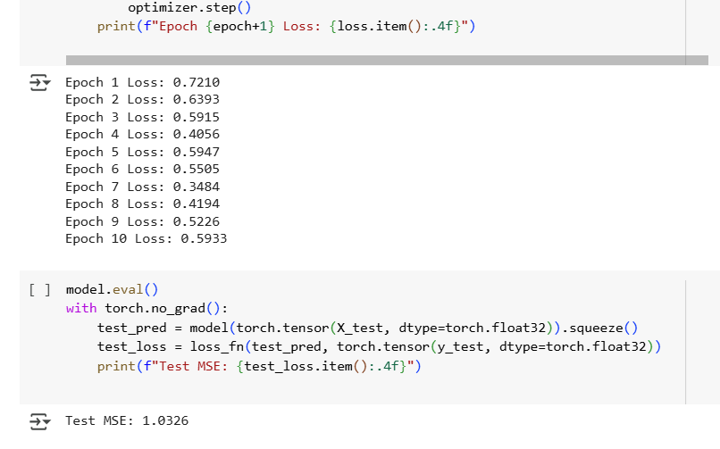

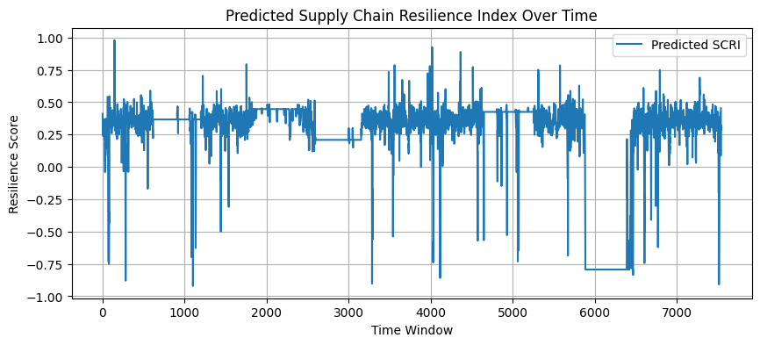

**Relevance to Our Project**

* **Direct Alignment**: The CATS model's attention mechanism helps highlight which time steps (e.g., delivery delays, sales dips) most affect resilience.
* **Improved Interpretability**: Attention scores serve as implicit feature importance — helping explain why resilience fails during specific periods.
* **Actionability**: Managers could use the SCRI timeline to make real-time adjustments in sourcing, fulfillment, or customer engagement.

**Challenges Encountered**

* Logistics dataset did not include Transaction_ID, so we adapted the merge strategy based on Customer_ID.
* Time formatting and missing values needed cleanup to ensure proper sliding window creation.
* Custom data required reconfiguration of model input and preprocessing steps.

**Team Contributions:**

| **Team Member** | **Role** | **Responsibilities** | **Contribution** |
| --- | --- | --- | --- |
| **Sai Kamal Makthala** | Data Engineering & Preprocessing | Merged customer, retail, and logistics datasets. Cleaned and standardized features. Handled missing values and ensured temporal ordering. Created time-windowed sequences for time-series forecasting. | 25% |
| **Likhitha Neerati** | Model Integration & Training | Integrated the NeurIPS CATS model with our custom dataset. Configured the PyTorch model and handled data loaders. Tuned model hyperparameters and executed training runs. | 25% |
| **Sindhu Mukkara** | Evaluation, Visualization & Model Explainability | Evaluated model performance using MSE and forecasting plots. Designed SCRI-over-time visualizations. Analyzed attention weights to interpret which features and time periods contributed most to resilience predictions. Generated insights that bridge model outputs to real-world decisions (e.g., adjusting supply chain operations). Also assisted in identifying failure cases and recommending model refinements. | 30% |
| **Lalitha Rani Palakaluri** | Documentation & Reporting | Wrote the NeurIPS integration summary. Described technical challenges and solutions. Organized final submission materials (Colab report, GitHub link, survey response). | 20% |

**Lessons Learned**

* Time-series models are significantly more powerful when enhanced with attention mechanisms.
* Adapting published models requires deep understanding of both the paper and our own data context.
* Reproducibility is critical — and attention to detail in dataset prep, model input format, and evaluation metrics is key to successful replication.