Assignment 2
Name: G.Sindhuja
ID : BCT-50252

- Employee Onboarding System
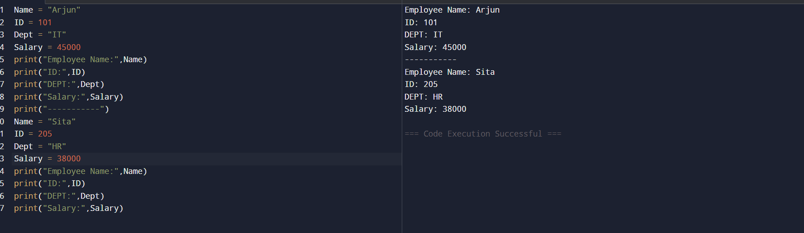
- E-Commerce Product Details

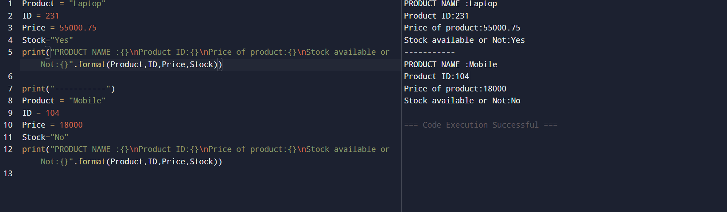
- Bank Account Creation
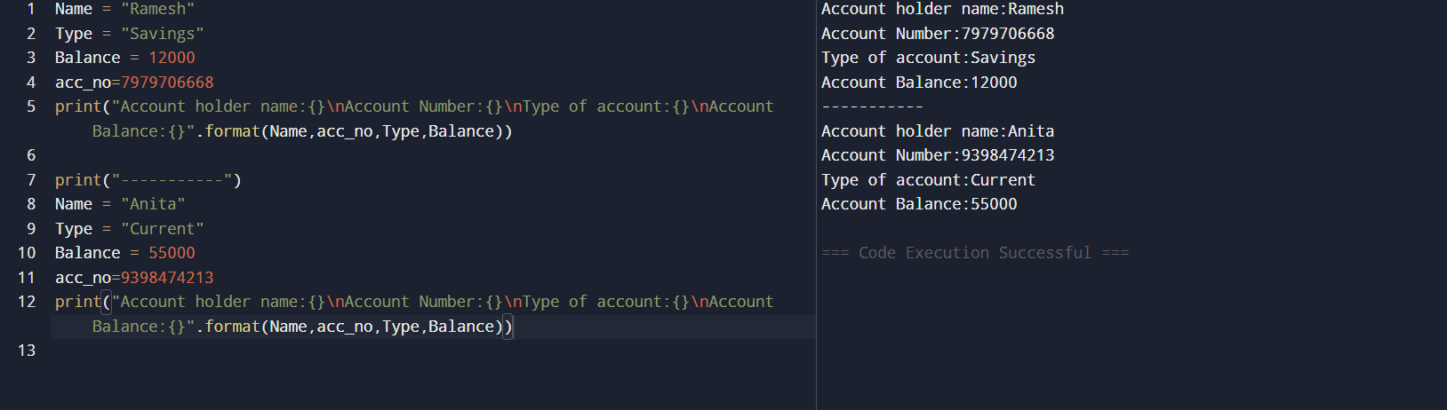
- Student Registration Portal
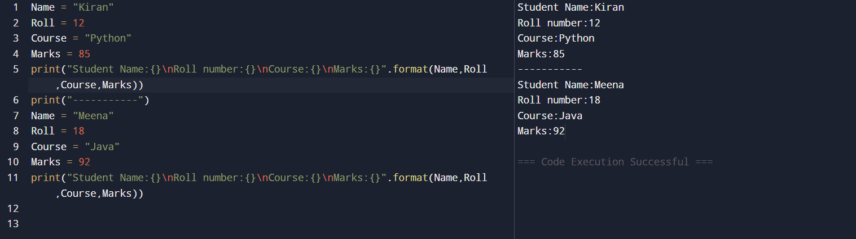
- Salary Slip Generator

- Online Food Order App
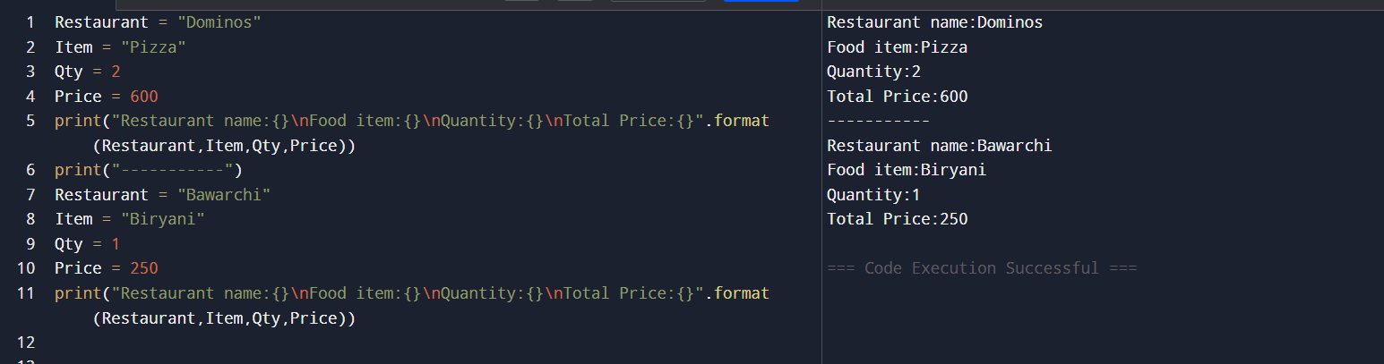
- Hospital Patient Record
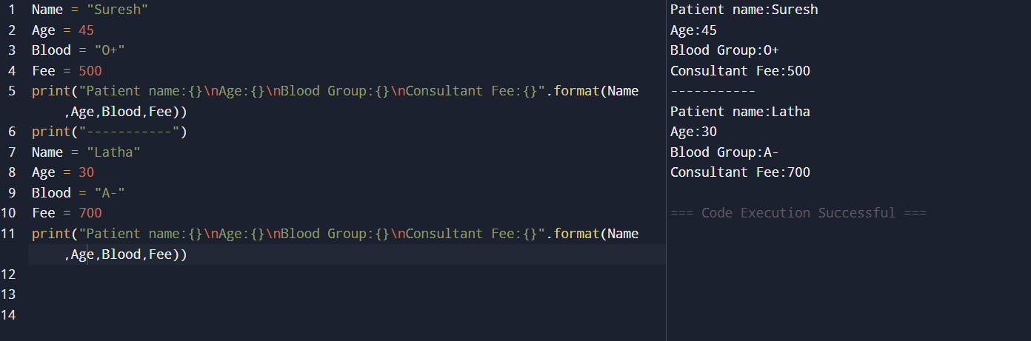
- Variable Naming Validation
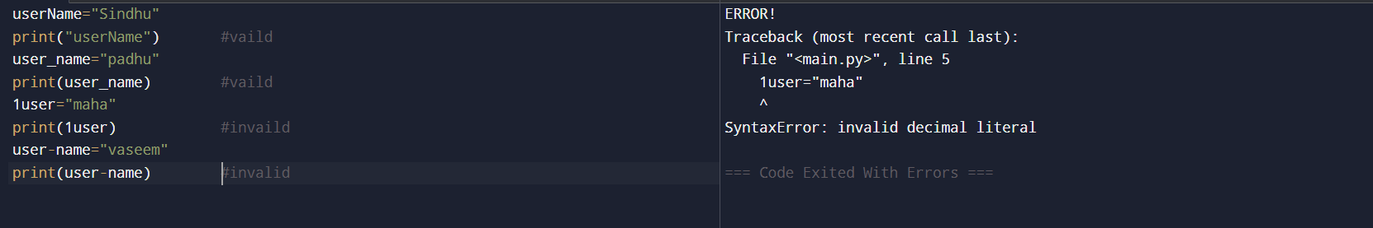
- Multiple Assignment in Company Project
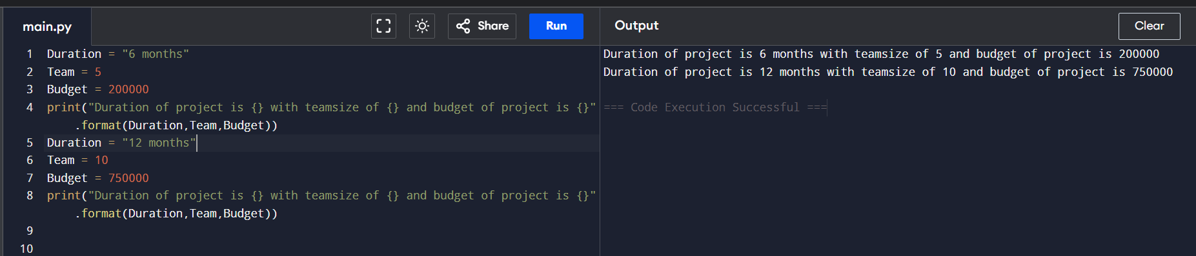
- User Login Module
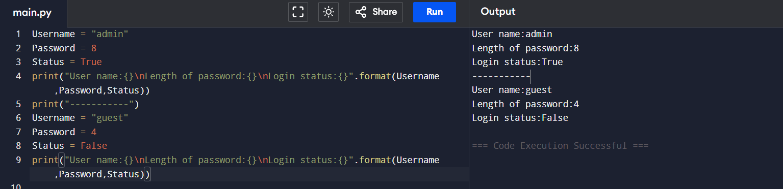
- Delivery Tracking System
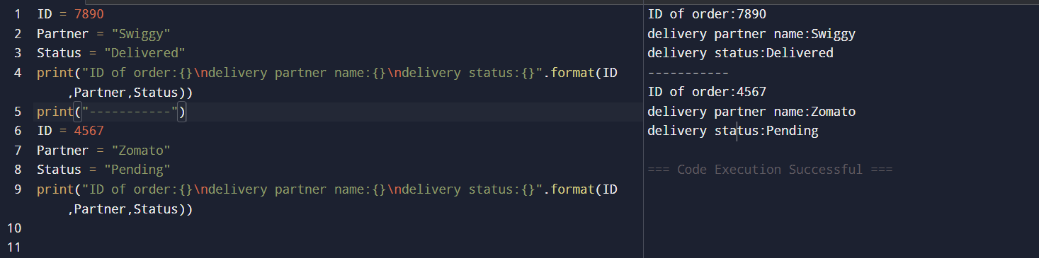
- IT Asset Management
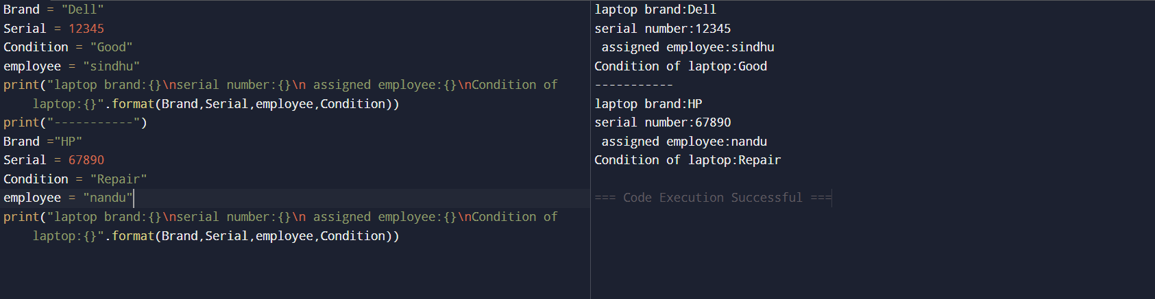
- Variable Without Assignment
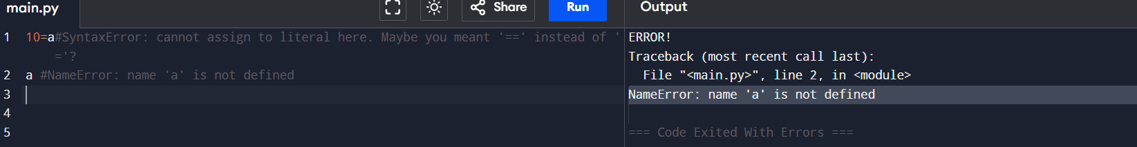
- Keyword Usage in Variables
Answer: Keywords cannot be used as variables.
- Financial Application Values
