Assignment-1
Name: Sindhuja
ID: BCT-50252

Advanced Print Statement Questions (Real-Time Scenarios)

Bank Transaction Summary
Print masked account number, name, amount, and status.
Test Case:
name='Ravi Kumar', acc_no='9876541234', amount=5000, status='SUCCESS'
Expected Output:
Account: ****1234
Name: Ravi Kumar
Amount: ₹5000
Status: SUCCESS
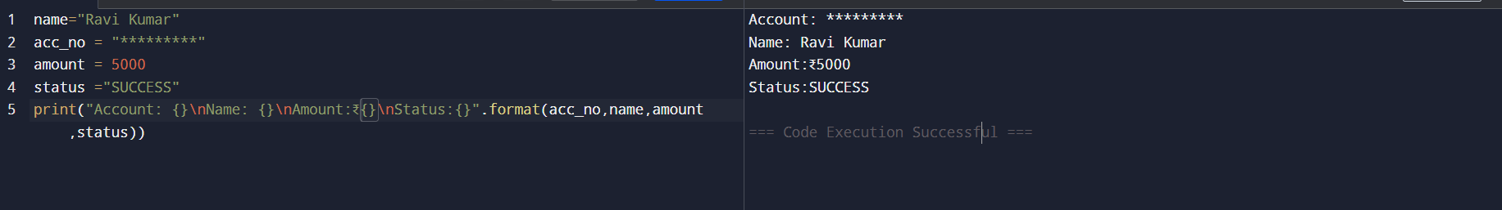

E-Commerce Invoice
Print product invoice.
Test Case:
product='Wireless Mouse', qty=2, price=750
Expected Output:
Total Amount: ₹1500
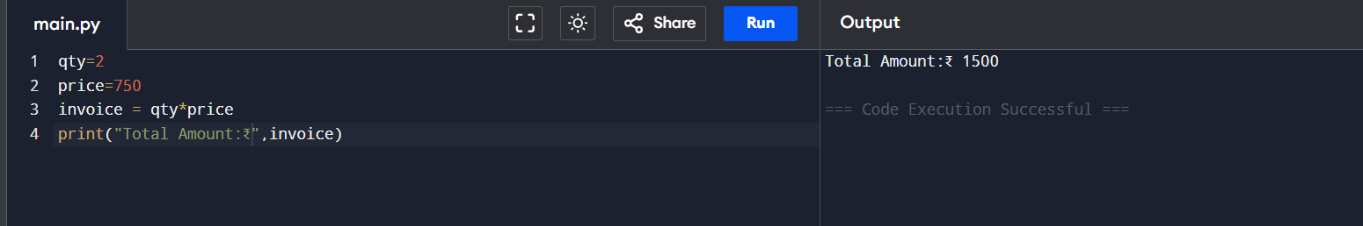

Employee Payslip
Print gross salary, tax, and net salary.
Test Case:
employee='Anita', salary=60000
Expected Output:
Net Salary: ₹54000
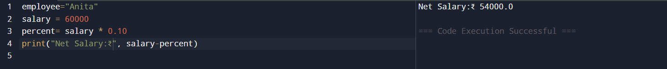

Student Result Report
Print marks, average, and result.
Test Case:
name='Rahul', marks=[78,85,90]
Expected Output:
Average: 84.33
Result: PASS
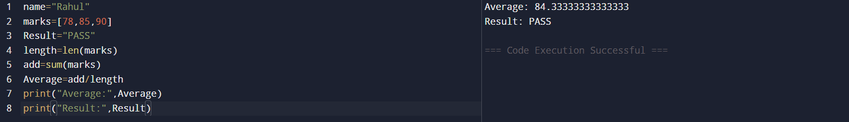

Login Activity Log
Print user login status.
Test Case:
user='admin', ip='192.168.1.10', status=True
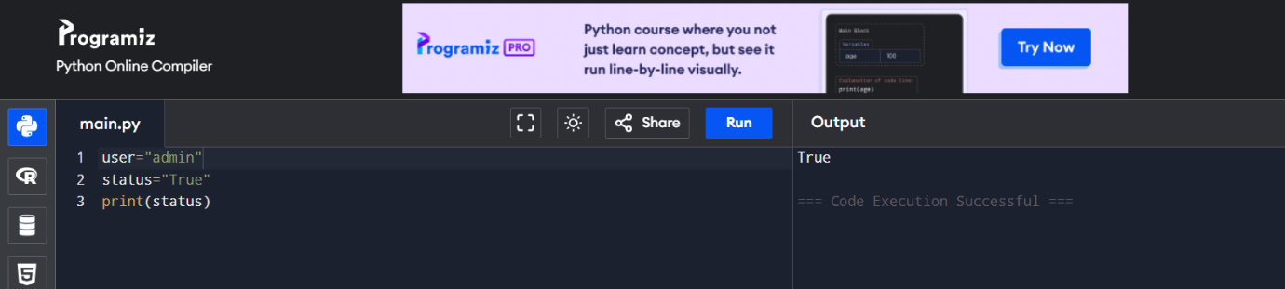

Flight Ticket Print
Print passenger ticket details.
Test Case:
name='Suresh', flight='AI-203', seat='12A'
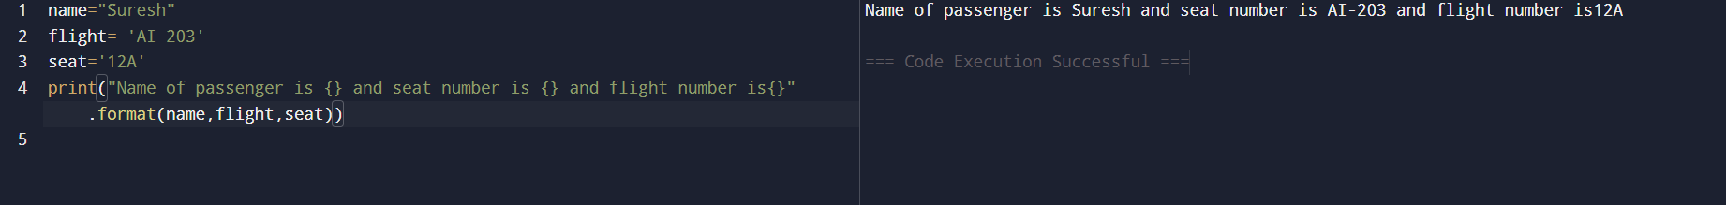

Online Order Status
Print order tracking details.
Test Case:
order_id=45678, status='Out for Delivery'
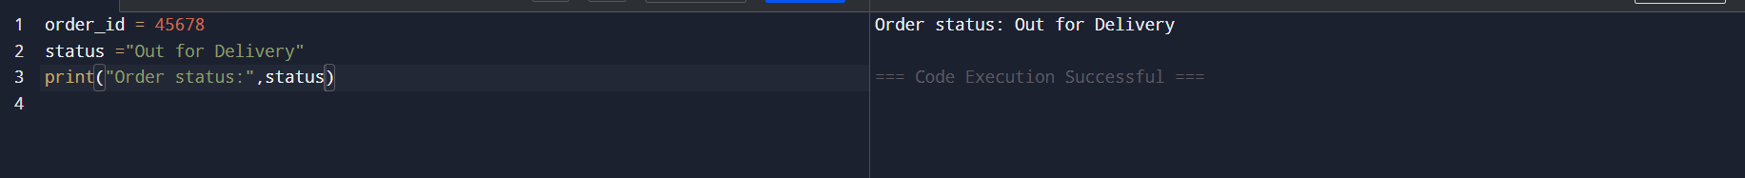

Server Health Monitor
Print CPU & Memory usage.
Test Case:
cpu=68, memory=72
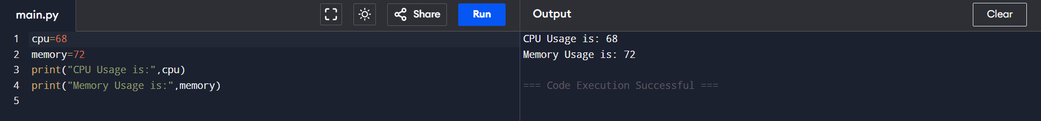

Movie Ticket Bill
Print movie bill.
Test Case:
movie='Inception', tickets=3, price=200
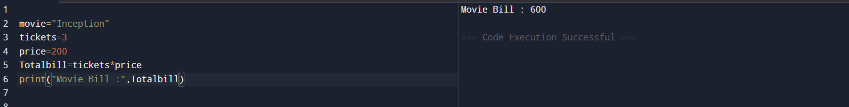

Cloud Storage Usage
Print storage usage.
Test Case:
used=45, total=100
