LAB REPORT: Defensive Security Intro

📌 Basic Information
─────────────────────────────────────────────
Platform: TryHackMe
Room Name: Defensive Security Intro
Room URL: https://tryhackme.com/room/defensive-security-intro
Date Completed: 09-06-2026
Time Spent: 1hr
Difficulty Level: Beginner
My Score: 100%

🎯 Learning Objectives
─────────────────────────────────────────────
What I wanted to learn from this lab:
1. Understand what defensive security means
2. Learn Blue Team fundamentals and responsibilities
3. Identify key defensive security tools and technologies
4. Understand threat monitoring and detection basics

📖 Key Concepts Learned
─────────────────────────────────────────────
1. What is Defensive Security?
- Security focused on protecting systems
- Also called Blue Team operations
- Goal: Prevent, detect, and respond to attacks

2. Blue Team Fundamentals
- Blue Team Roles:
- SOC Analysts monitor and respond to threats
- DFIR (Digital Forensics & Incident Response) specialists
- Threat Hunters proactively search for threat
Blue Team | Red Team
Protect systems | Test security by attacking
SOC, DFIR | Penetration Testing
Detect & respond | Simulate real attacks

3. Key Defensive Security Tools
- SIEM Tools:
- Splunk - Log analysis and alerting
- Elastic Stack - Open-source SIEM
- Network Security:
- Wireshark - Packet analysis
- Snort - Intrusion detection
- Firewalls - Traffic filtering

- Endpoint Security:
- EDR tools - Endpoint detection
- Antivirus/Antimalware

4. Threat Monitoring Basics
- What to Monitor:
- Network traffic anomalies
- Login failures and suspicious authentication
- File system changes
- Process execution patterns

- Detection Methods:
- Signature-based detection (known threats)
- Anomaly-based detection (unknown patterns)
- Behavioral analysis"]

## 🛠️ Tools & Technologies Mentioned
─────────────────────────────────────────────
List all tools from the room:
- SIEM: Splunk, Elastic
- Network: Wireshark, Snort
- Endpoint: EDR, Antivirus

## 📸 Screenshots
─────────────────────────────────────────────
- Task completion
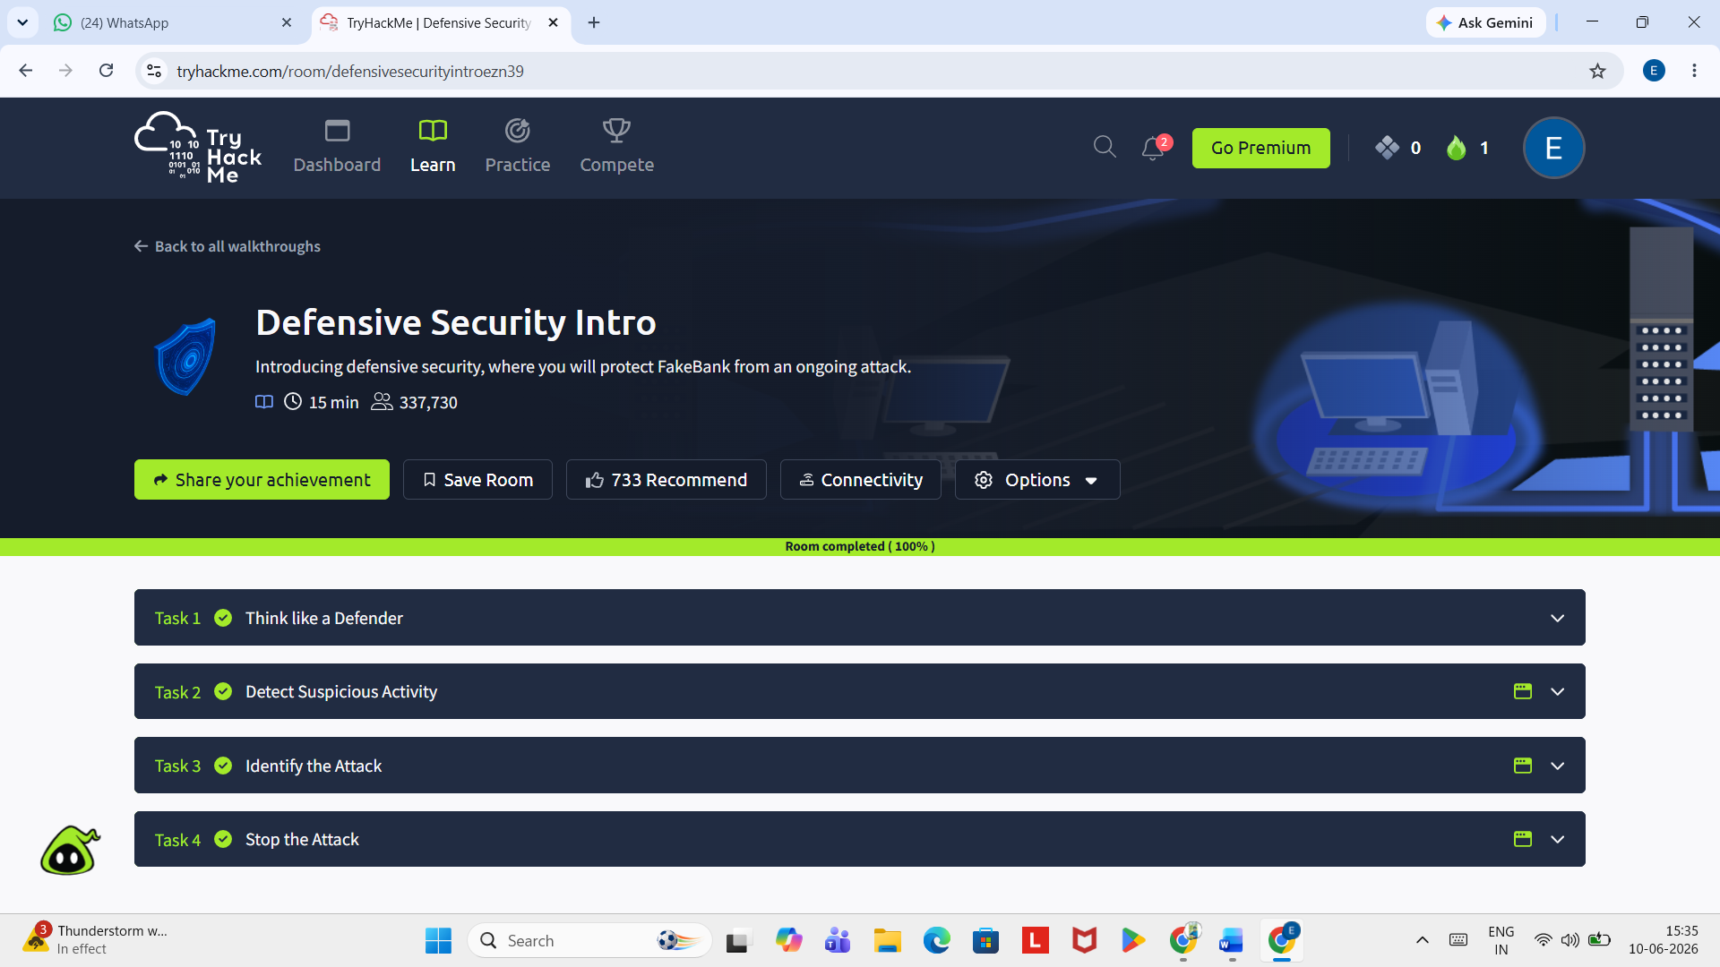

- Key tools overview

- Screenshot of defensive security tools section
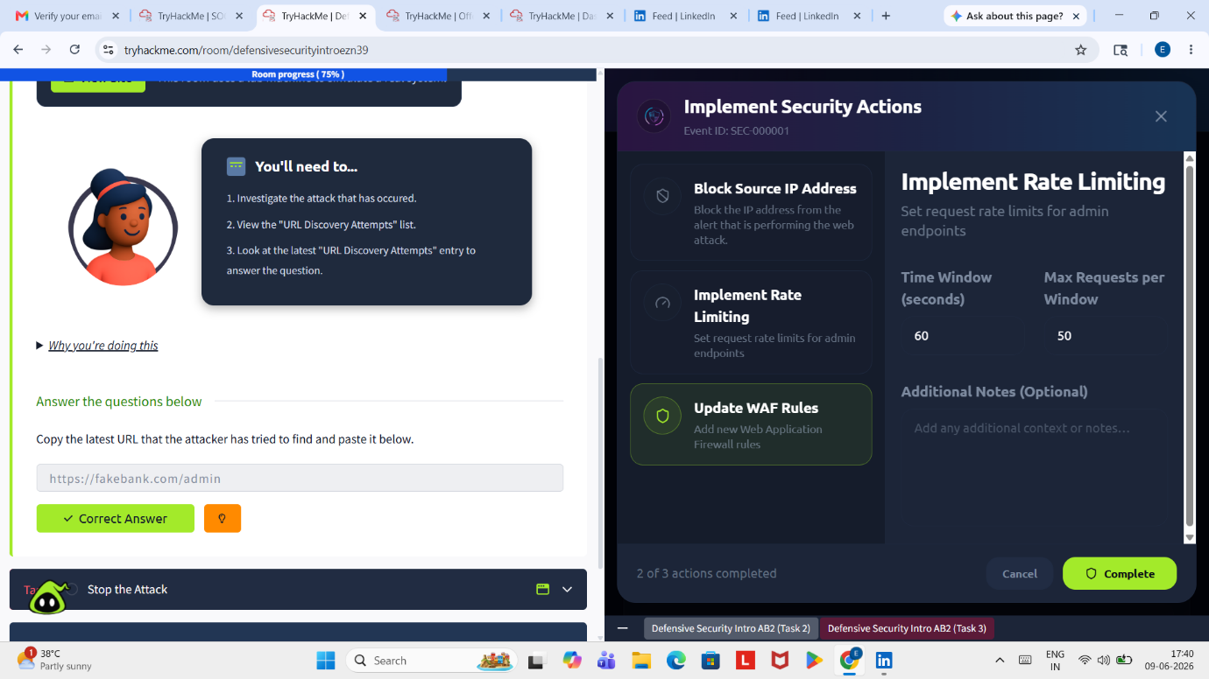

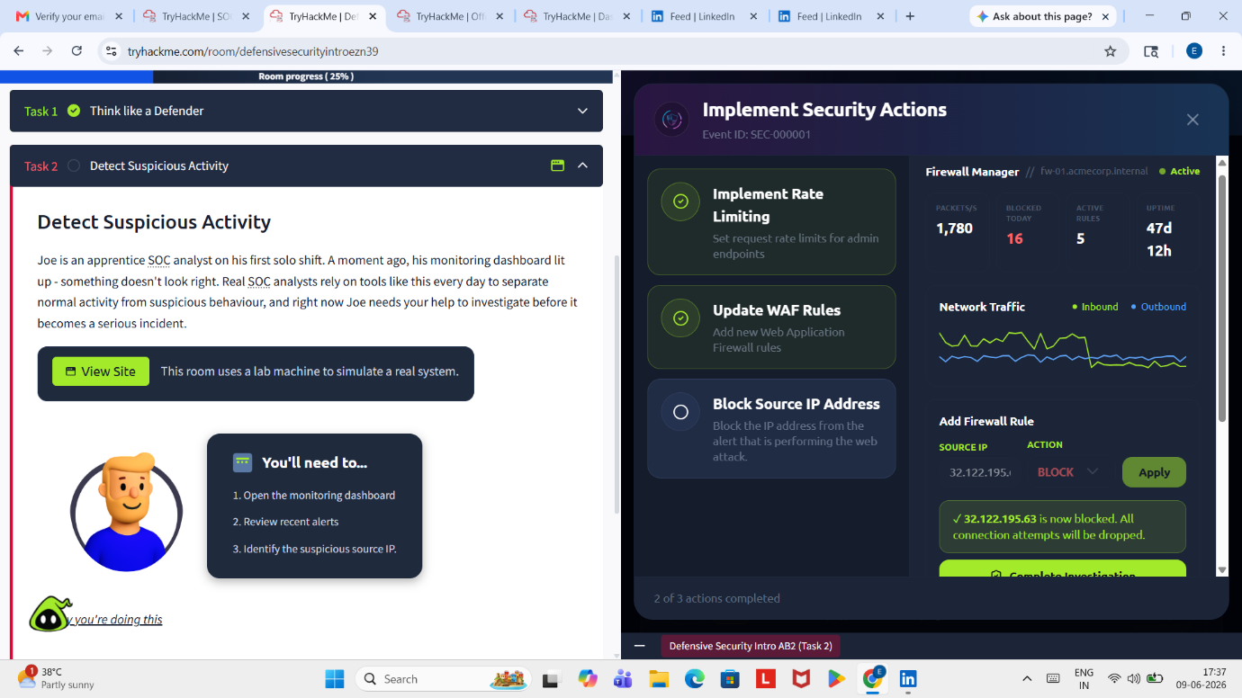

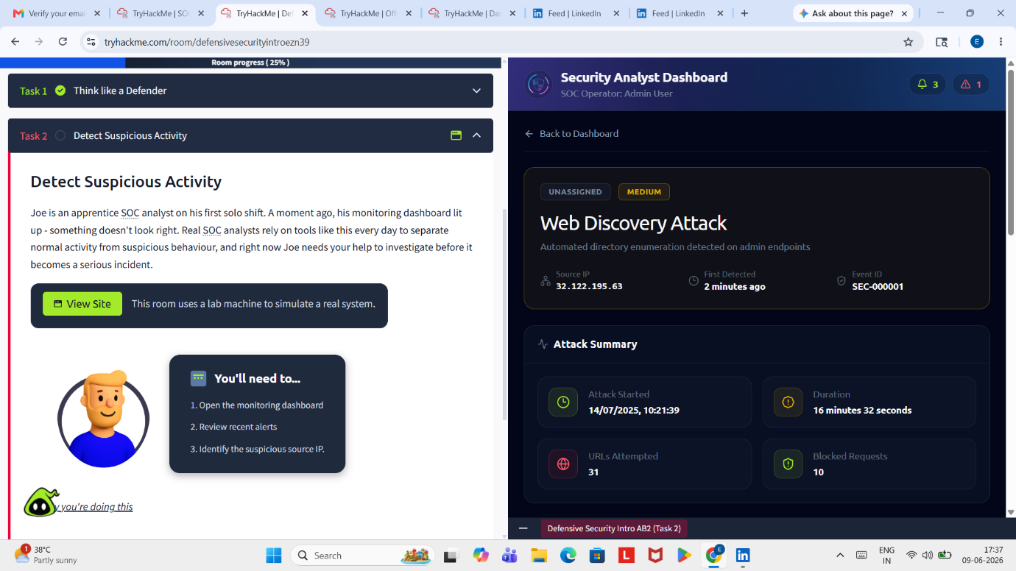

## 💡 Key Takeaways
─────────────────────────────────────────────
From this lab, I learned:

1. Defensive security = Blue Team operations (protection-focused)
2. Key roles: SOC Analyst, DFIR specialist, Threat Hunter
3. Main tools: SIEM (Splunk, ELK), Network monitoring (Wireshark), EDR
4. Monitor: Network traffic, login failures, file changes, processes

## 📚 Additional Resources
─────────────────────────────────────────────
- TryHackMe Room: [Defensive Security Intro] (https://tryhackme.com/room/defensive-security-intro)

## 🏆 Self-Assessment
─────────────────────────────────────────────
Confidence Level: ⭐⭐⭐⭐☆
Understanding: I understand defensive security basics, ready to practice SIEM tools
Next Steps: Introduction to SIEM

## 📝 Notes for Future Reference
─────────────────────────────────────────────
- This was my third SOC lab on TryHackMe
- All tasks completed successfully (100%)
- Ready to move to hands-on labs: Introduction to SIEM

Author: Sindhu Eppakayala
Date: 09-06-2026

